MongoDB Checkpoint

DataBase: contact

Collection: contactlist

Data:

The initial data to be inserted into the database”

[{"last name":"Ben Lahmer","first name":"Fares","email":"fares@gmail.com","age":26},{"last name":"Kefi","first name":"Seif","email":"kefi@gmail.com","age":15},{"last name":"Fatnassi","first name":"Sarra","email":"sarra.f@gmail.com","age":40},{"last name":"Ben Yahya","first name":"Rym","age":4},{"last name":"Cherif","first name":"Sami","age":3}]

1. Step one: create the database:

Command lines:

Use contact

Db.contactlist.insertMany([data])

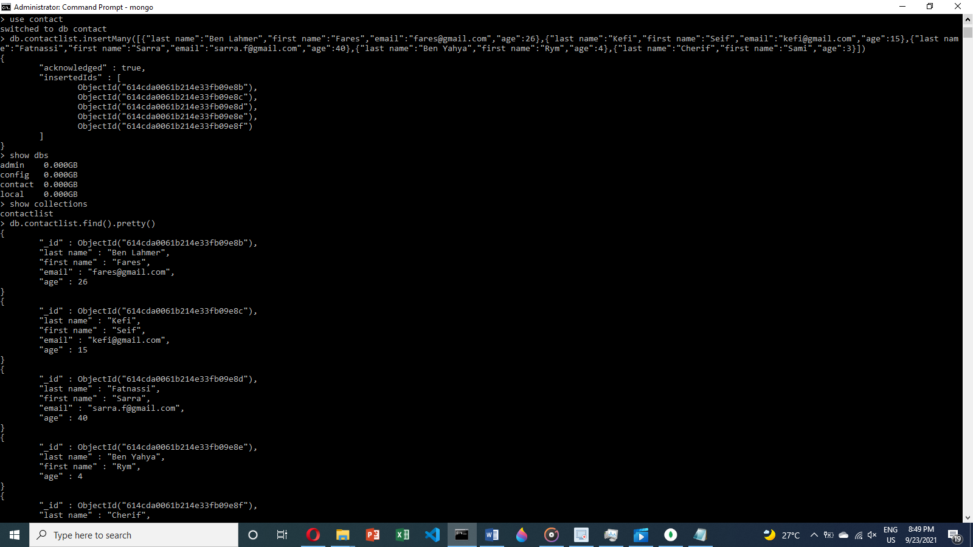

Database content:

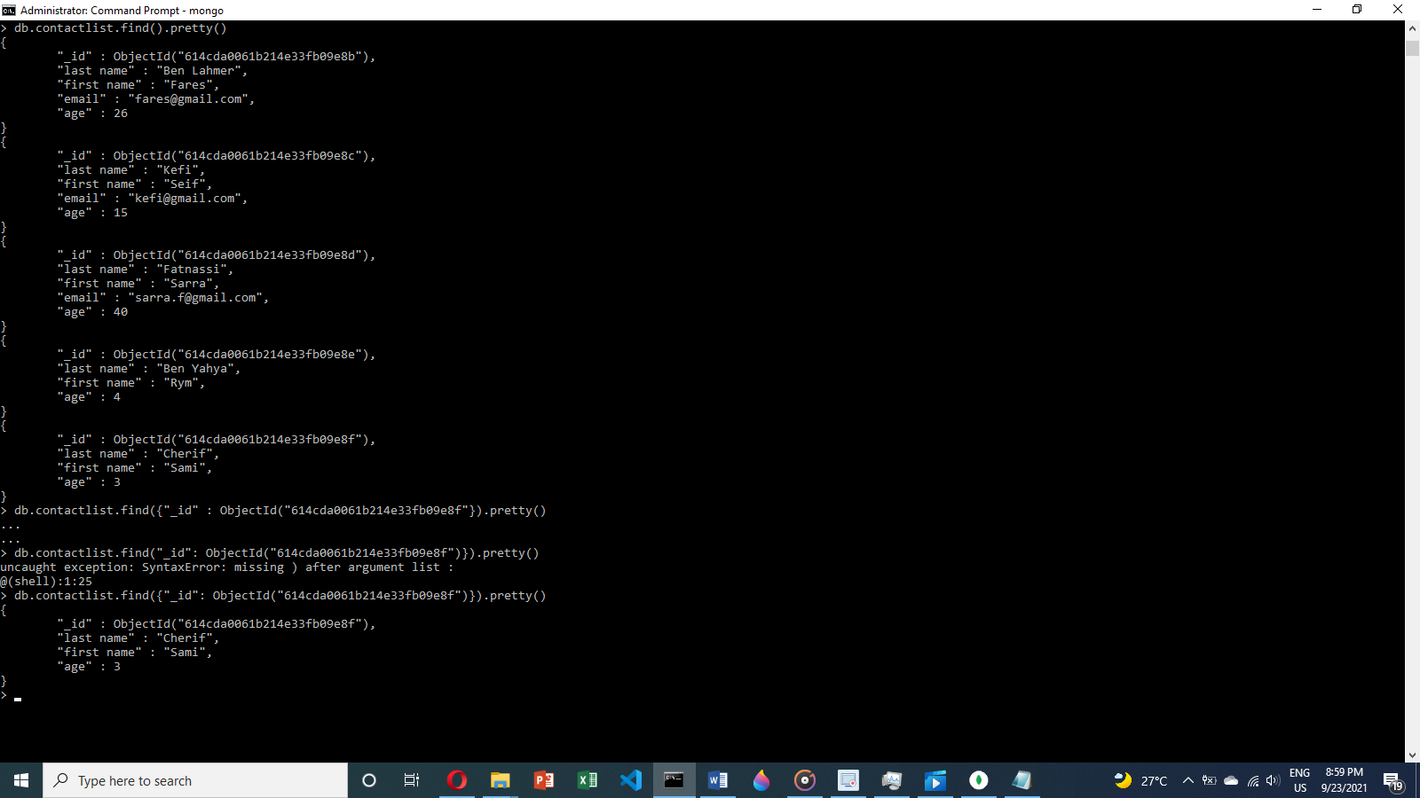

1. Step two: Display all the information about only one person using his ID

Command line:

Db.contactlist.find({criteria})

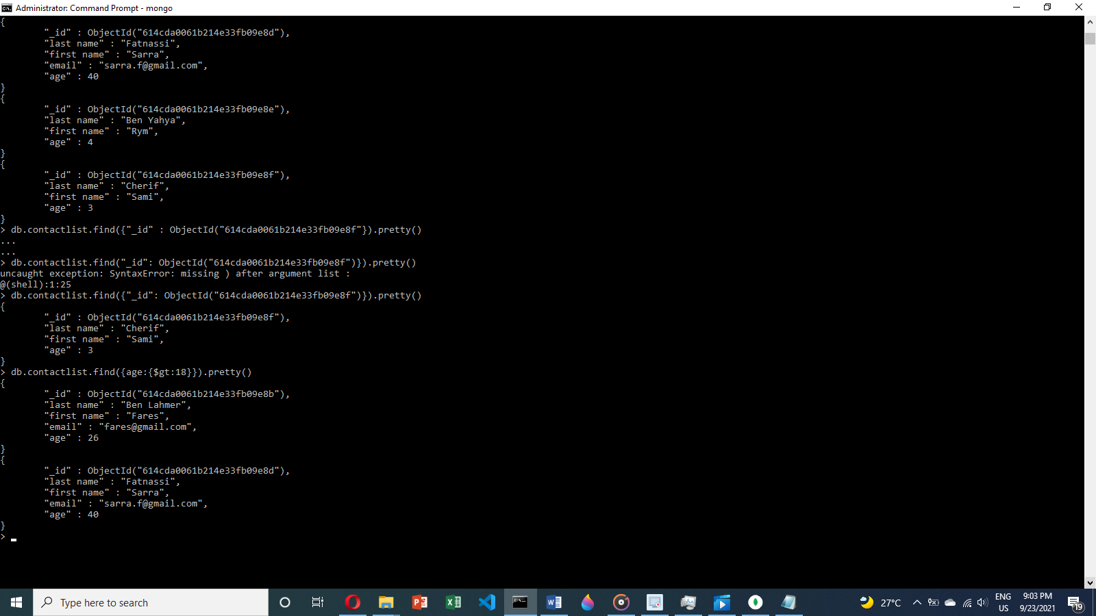

1. Step three: Display all the contacts with an age >18

Command line:

Db.contactlist.find({criteria:{condition}})



1. Step four: Display all the contacts with an age>18 and name containing "ah"

Command line:

Db.contactlist.find({$and:[{criteria1:{condition1}},{criteria2:{condition2}}]})

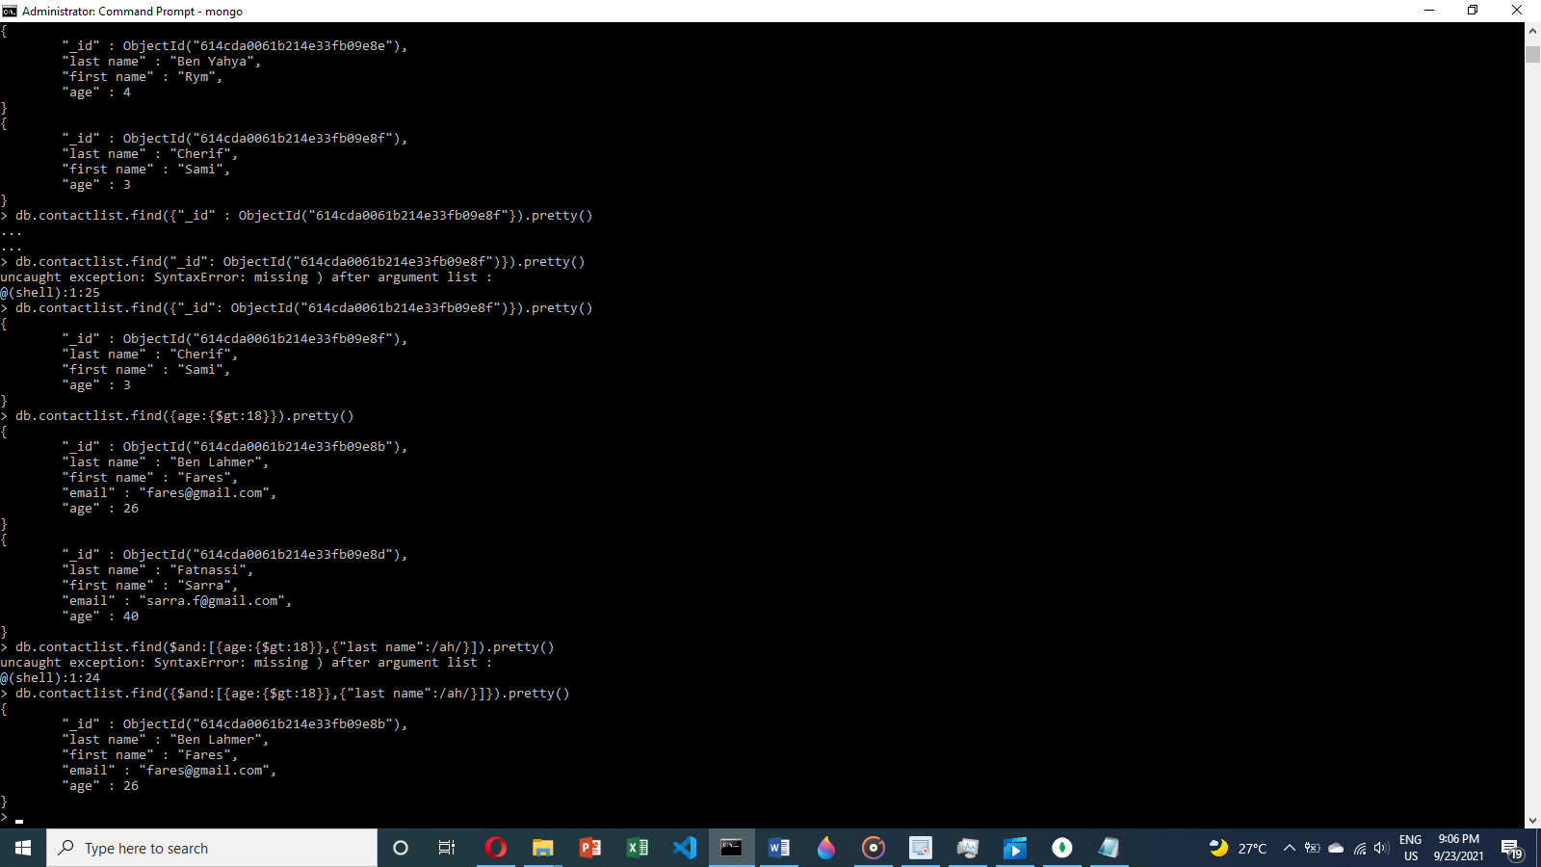

1. Step five: Change the contact's first name from"Kefi Seif" to "Kefi Anis"

Command line:

Db.contactlist.update({element id},{$set:{field: the change}})

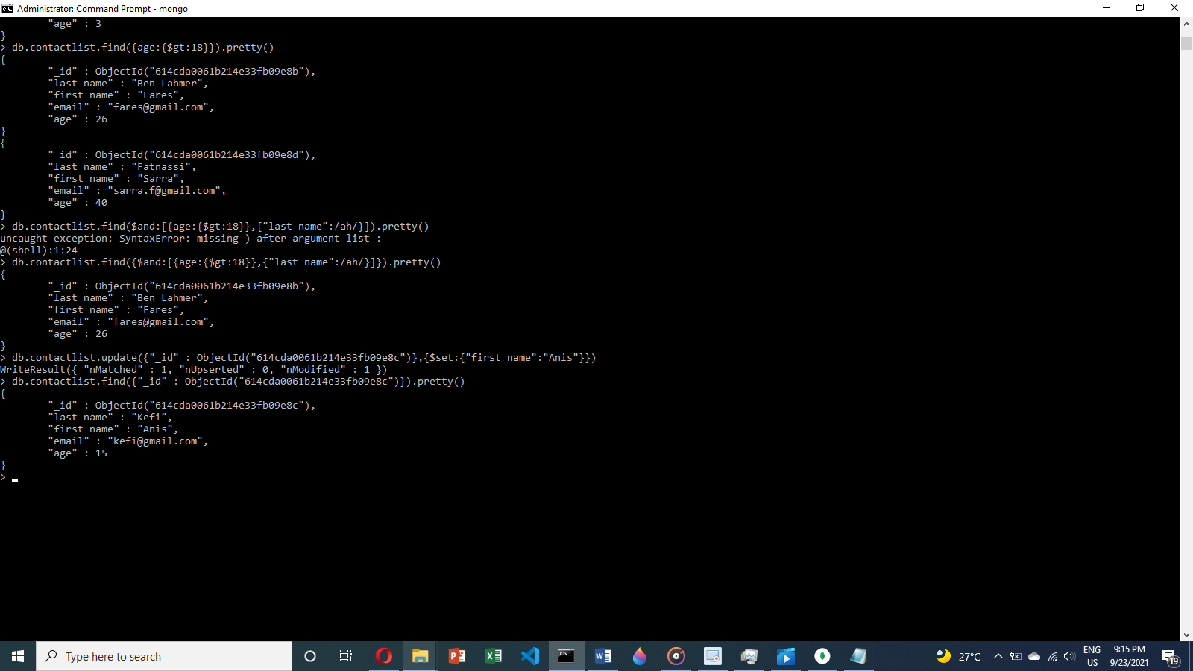

1. Step six: Delete the contacts that are aged under <5

Command line:

Db.contactlist.deleteMany({criteria})

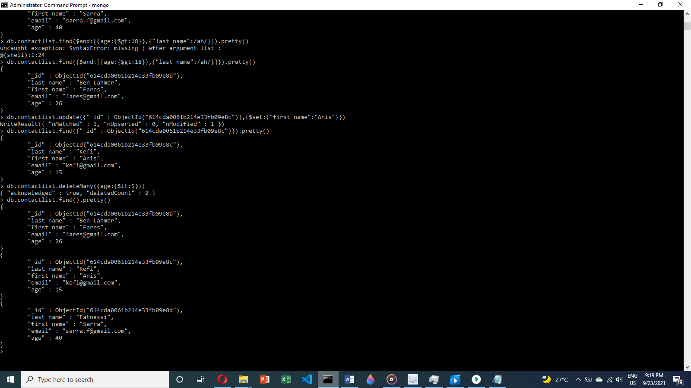

1. Step seven: Display all of the contacts list

Command line:

Db.contactlist.find().pretty()

