Fields_Name.m

Has the name of the fields (now 13)

In config those that need to be processed are provided:

config_plot.txt

#number of field to plot -1:means all

9

#fields to plot

Nfstrength_mean Sfstrength_mean c00 c10 c11 c20 c21 c22 bulkModulus

normalization={...

{1,''}

{1e6,'[\textrm{Mpa}]'}

{1e9,'[\textrm{Gpa}]'}

}

statVarables={...

{1,'min','\textrm{min}'}

{2,'mean','\textrm{mean}'}

{3,'max','\textrm{max}'}

{4,'stdDiv','textrm{stdDiv}'}

}

This refers to stat files, for example:

(Sstat_SVE).OSstat

RVE Nsve NstatVar Load

2 486 4 2

SVEid MIN MAX MEAN StdDiv

1 0.475539 0.589204 0.535731 0.037633

MicroStruct_type: for UST it’s the RVE number, OSU may have something similar

overlapPersent is there but to activate it, the code must be modified

….

#Plots(val-PDFsve)

0

#list {fields} {BCs} {SVE_Sizes}

#Plots(sve-val)

0

#list {fields} {BCs} {SVE_Sizes}

#Plots(teta-val)

0

#list {fields} {BCs} {SVE_Sizes}

#Plots(case-percentFaiulPhase)

not read

config_plot.txt, end

All data is read from file (AllFld_SVE).OAllFld where there is no angular dependency, for example for strength only the mean values over angles are saved for any SVE

Plot type 1 - size effect:

Config for it is:

Config_SizeEff.txt

This is the single field that size effect plot is done for

#fld id(y-axis)

9

if 1

%first check the config file ->"Config_SizeEff.txt"

plotGrpoup_SVEsize_Val_sizeEff(statPlotFlag,CR);%plotting size effects

end

* Size effect plot ^. It plots mm (min/max) and sdiv (added substracted from mean value).
* It combines all data sets with the same SVE size. Good: because if there are multiple RVEs that generate the save SVE size they are combined here.
* For separate Voronoi and Square we need to process data again with different config file
* Type is something that we can read all SVEs, maybe use types 10+ for square and < 10 for Voronoi, then in the block above can choose what to include and what not to.

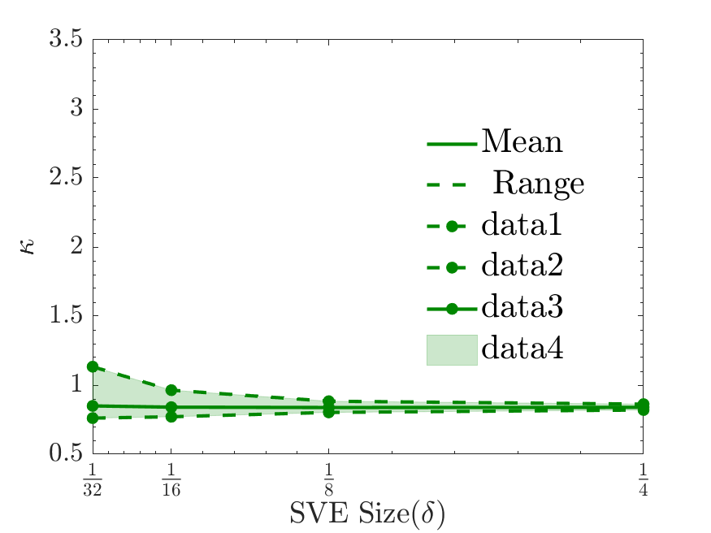 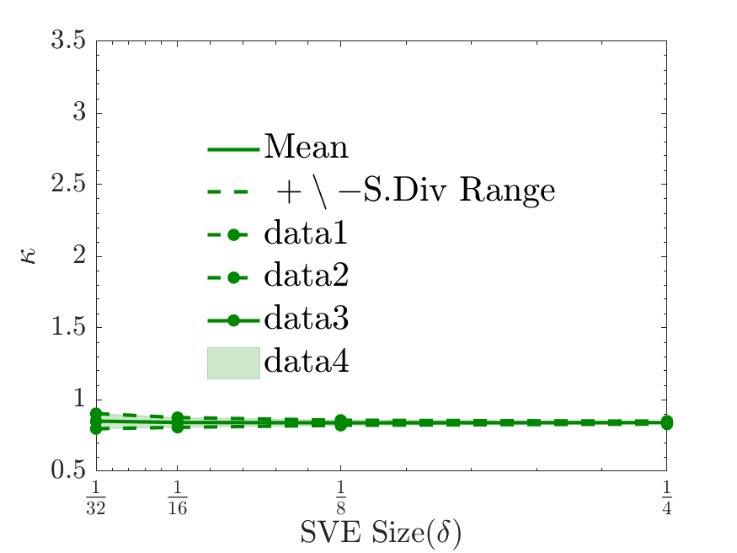

2. PDF plots

Config file:

config_fldPDF.txt

3. Convergence PDF

if 1

config_convPDF.txt

plotGrpoup_Val_PDFsveID_Converg(CR);

end

#partitioning type (1 or 2)

2

One is ½ x ½ one is 1x1/2

2 is 1/2x1/2