If C++ does not compile refer to:

<https://stackoverflow.com/questions/42777424/visual-studio-2017-errors-on-standard-headers>

I got the errors to go away by installing the Windows Universal CRT SDK component, which adds support for legacy Windows SDKs. You can install this using the Visual Studio Installer:

[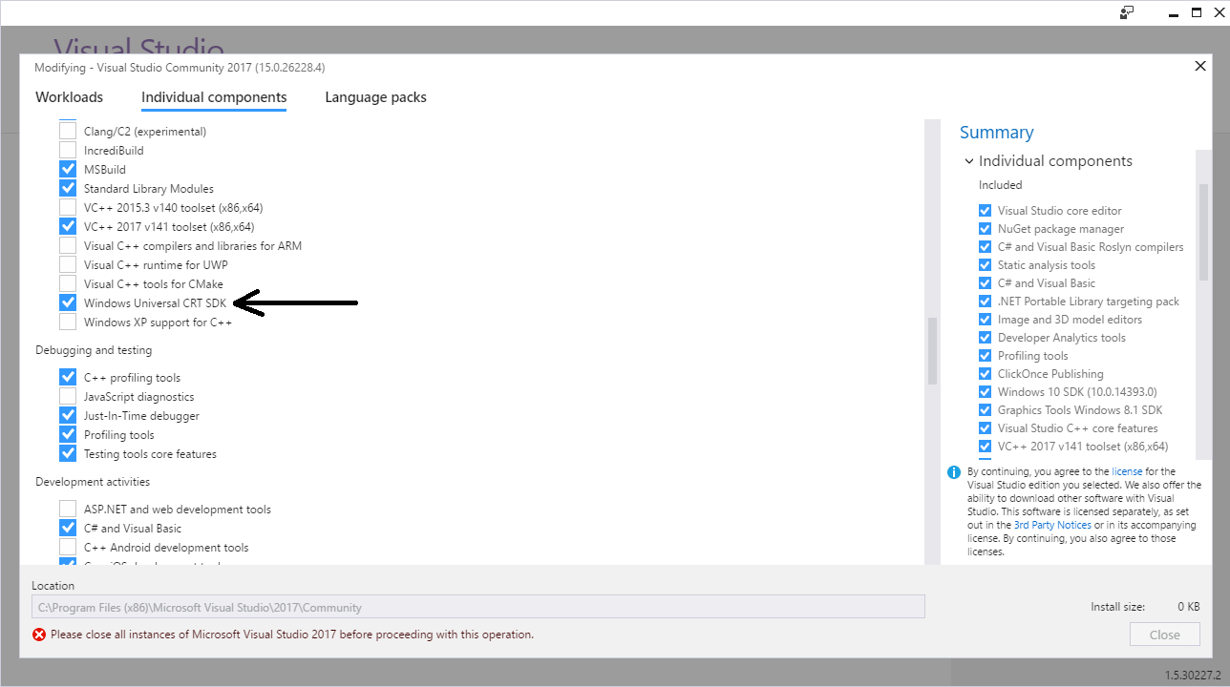](https://i.stack.imgur.com/o411J.png)

If the problem still persists, you should change the Target SDK in the Visual Studio Project : check whether the Windows SDK version is 10.0.15063.0.

In : Project -> Properties -> General -> Windows SDK Version -> select 10.0.15063.0.

Then errno.h and other standard files will be found and it will compile.

[share](https://stackoverflow.com/a/42778079)[improve this answer](https://stackoverflow.com/posts/42778079/edit)

[edited Jun 8 '18 at 19:20](https://stackoverflow.com/posts/42778079/revisions)

[[https://lh4.googleusercontent.com/-xiupsUyk5ZQ/AAAAAAAAAAI/AAAAAAAAAAA/sPZgdYzoOhs/photo.jpg?sz=32](https://stackoverflow.com/users/4096470/dave-mackersie)](https://stackoverflow.com/users/4096470/dave-mackersie)

[Dave Mackersie](https://stackoverflow.com/users/4096470/dave-mackersie)