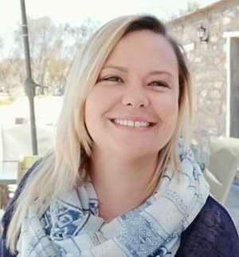 **CURRICULUM VITAE**

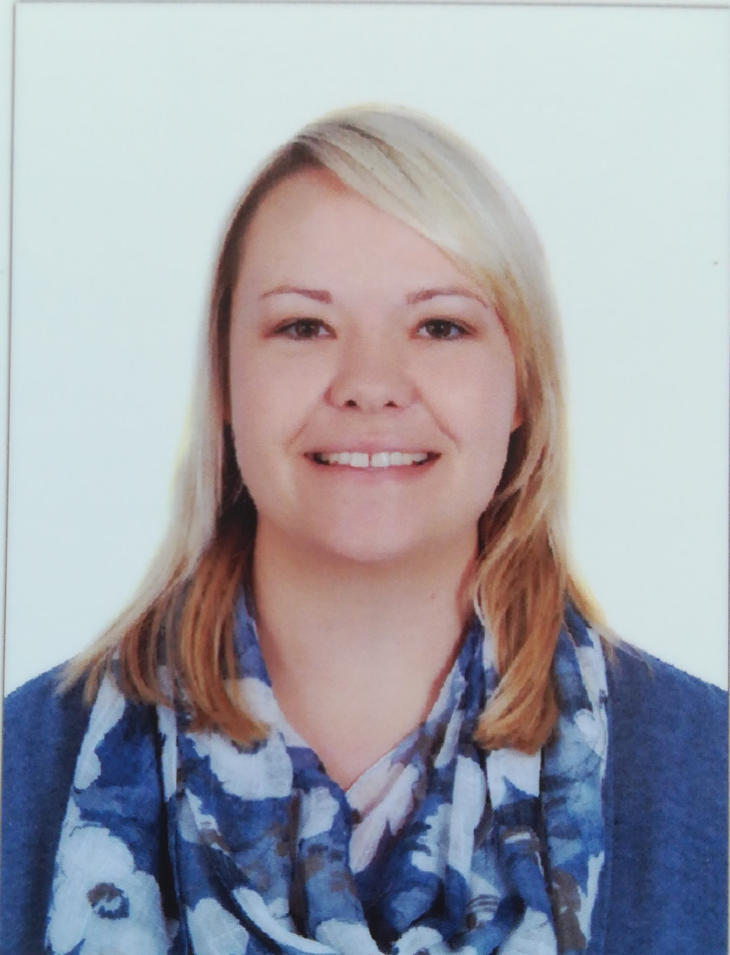

**PERSONAL DETAILS**

**Surname:** Visagie

**First Names:** Christina Alida

**Date of Birth:** 23 June 1991

**Gender:** Female

**Nationality:** South African

**Driver Licence**:

South Africa Code B

UAE driver’s license

**Marital Status:** Unmarried

**Dependents:**  None

**SKILLS**

* Classroom Management
* Administration
* Organizational
* Develop Lesson plans

**SPORTS**

Netball

Swimming

Tennis

**Full name: Christina Alida Visagie**

**Subject:** Foundation Phase

**Mobile number:** +971 50 2724 254

**Email address:** visagie.christina@gmail.com

**Years of experience:** 6 years

**Skype ID:** visagie.christina

**Address:** Al Jurf 2, Ajman, UAE

**PERSONAL PROFILE**

I have been a General Primary Teacher for the past 6 years; working as a KG Homeroom teacher for 2 years and 6 months in the UAE, Grade 3 teacher for 2 years and 8 months and 1 year as a kindergarten teacher in Taiwan. I have worked in schools with different cultures and socio-economic backgrounds, both in South Africa and in Taiwan.

Aside from teaching I have been a member of a range of committees that organized events and activities including plays, class excursions, prize giving evenings, spelling competitions, cross-country and athletics events. I have been grade head of my grade for a year and I am involved with special needs children.

I am in my sixth year of teaching and enjoying every minute of it. Every opportunity to guide a learner along his/her educational path is a challenge I look forward to.

I am very passionate about making a difference in children's lives, not only in the classroom but also in their everyday lives. I like to plan ahead so I can be well prepared. I get along easily with other teachers and work well together in groups. The child always comes first and I just want to give the best for every learner in my class or in my team. I am willing to give my 110%.

**EDUCATION**

Jan 2011– Dec 2014 **Bachelor of Education in General Education**

**(Bed (GenED))**, ***Cape Peninsula University of Technology (CPUT) Wellington Campus***

* + Grade R – 3
  + Foundation phase Mathematics
  + Foundation phase Afrikaans
  + Foundation phase English
  + Foundation phase Life Orientation

Jan 2005 – Dec 2009 **Senior Certificate (Grade 12) with endorsement**

***Calvinia High School, South Africa***

* + Afrikaans Language
  + English First Additional Language
  + Mathematics
  + Life Orientation
  + Tourism
  + Geography
  + Life Sciences

**Certificate of Completion**

**Hamdan Bin Mohammed Smart University hereby certifies that**

**Christina Visagie**

**has completed the**

**Be an Online Tutor in 24 Hours Course**

**CAREER HISTORY**

**Name of School: Ajman American Private School, Ajman, UAE**

***Classroom Teacher for Kindergarten 1***

**September 2019 – Present**

* Do lesson planning for all subjects, Tracking progress and Student skill reports.
* Teach the class, groups and individual students as well as guiding, motivating and directing learners to their fullest potential.
* Maintain good order, behavior and respect for others, while creating a stimulating and interactive learning environment.
* Develop relationships with and between students conducive to optimum learning.
* Build and maintain co-operative relationships with parents.

**Name of School: Diyar International Private School, Dibba Al Fujairah, UAE**

***Classroom Teacher for Kindergarten 1***

**September 2018 – August 2019**

* Do lesson planning for all subjects, Tracking progress and Student skill reports.
* Teach the class, groups and individual students as well as guiding, motivating and directing learners to their fullest potential.
* Maintain good order, behavior and respect for others, while creating a stimulating and interactive learning environment.
* Develop relationships with and between students conducive to optimum learning.
* Build and maintain co-operative relationships with parents.

***Name of school: Marvin Park Primary, Macassar, South Africa***

***Classroom Teacher for Grade 3***

***January 2016 – August 2018***

* Do lesson planning for all subjects, Tracking progress and Student skill reports.
* Teach the class, groups and individual students as well as guiding, motivating and directing learners to their fullest potential.
* Maintain good order, behavior and respect for others, while creating a stimulating and interactive learning environment.
* Develop relationships with and between students conducive to optimum learning.
* Build and maintain co-operative relationships with parents.
* Guide and mentor a student teacher during her practicum.

***Name of school: Kid Castle, Taiwan***

***Classroom Teacher for Kindergarten 1***

***From April 2015 – Desember 2015***

* Do lesson planning for all subjects, Assessments, Tracking progress and Student reports.
* Teach the class, groups and individual students as well as guiding, motivating and directing learners to their fullest potential.
* Maintain good order, behavior and respect for others, while creating a stimulating and interactive learning environment.
* Develop relationships with and between students conducive to optimum learning.
* Build and maintain co-operative relationships with parents.

**REFERENCES**

School: Ajman American Private School, UAE

Contact name: **Ms. R. Jeftha**

Grade Level Leader (GLL)

Number: +971 54 755 3756

Email address:

[ruth.isabel@ajmanamericanschool.com](mailto:ruth.isabel@ajmanamericanschool.com)

School: Ajman American Private School, UAE

Contact name: **Ms. Nicola**

Head of Department (Kindergarten)

Number: +971 50 185 9773

Email address: [nicola.east@ajmanamericanschool.com](mailto:nicola.east@ajmanamericanschool.com)

School: Diyar International Private School, UAE

Contact name: **M. T.M. Harness**

Head of Department (Kindergarten)

Number: +971 56 464 9760

Email address: [tinamharness@gmail.com](mailto:tinamharness@gmail.com)

***Name of school: J.J. Booysen Primary, Loxton, South Africa***

***Classroom Teacher for Grade 3***

***From January 2015 - April 2015 (Contract)***

* Do lesson planning for all subjects, Assessments, Tracking progress and Student reports.
* Teach the class, groups and individual students as well as guiding, motivating and directing learners to their fullest potential.
* Maintain good order, behavior and respect for others, while creating a stimulating and interactive learning environment.
* Develop relationships with and between students conducive to optimum learning.
* Build and maintain co-operative relationships with parents.