Project Title

Software Engineering Course Project

Project Design Specification Document



Group ID

Name Roll Number

Name Roll Number

Instructor

Dr. Hamid Abdul Basit

Session 2012-2013

Department of Computer Science

Lahore University of Management Sciences

Lahore

Contents

Project Design Specification Document 3

Use Case Diagram 3

System Architecture 4

System Sequence Diagrams 5

Domain model 6

Sequence diagrams 7

Class diagram 8

(Class Diagram using Entity, Boundary and Control Symbols) 8

(Design Class Diagram with Attributes and Methods ) 8

Collaboration Diagrams 9

State charts 10

DB Schema/ ERD 11

SiteMap 12

Human Interface Design 13

Screens 13

Navigation Flow 14

# Project Design Specification Document

Note: All Diagrams should be in Visio

## Use Case Diagram

Revised use case diagram showing all use cases in one diagram. Use of includes and extends where appropriate.

## System Architecture

## 

## System Sequence Diagrams

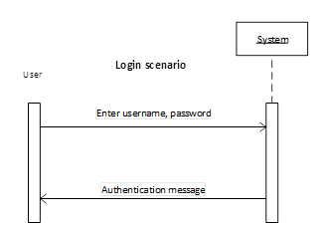

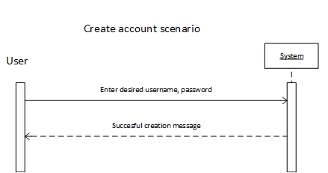

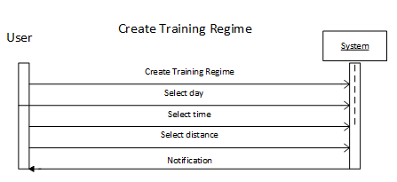

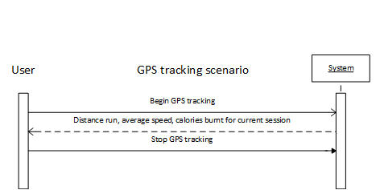

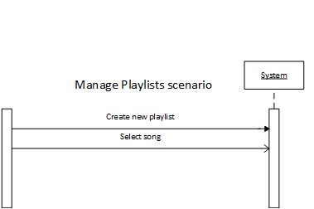

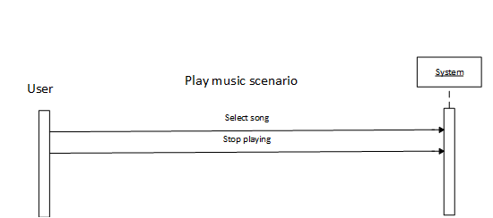

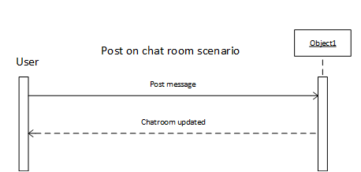

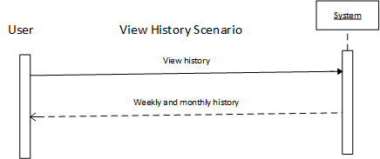

## Domain model

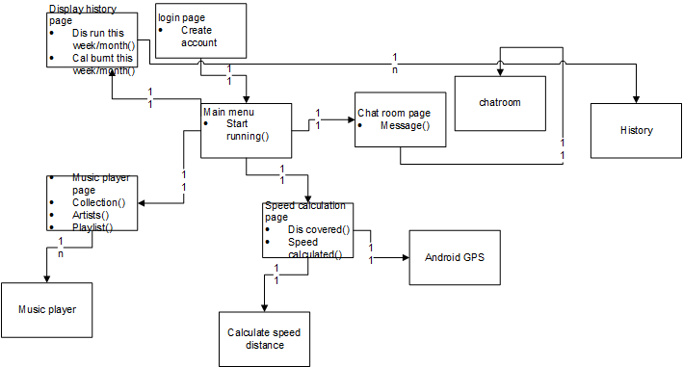

## Sequence diagrams

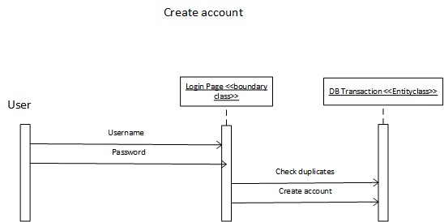

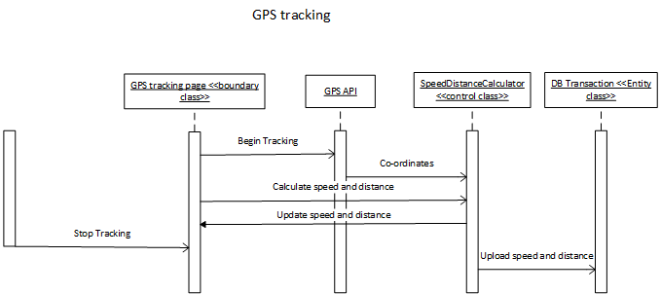

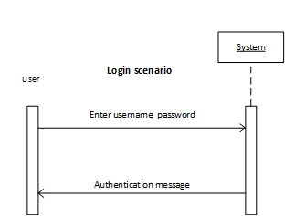

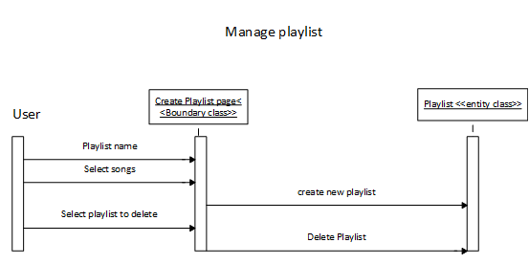

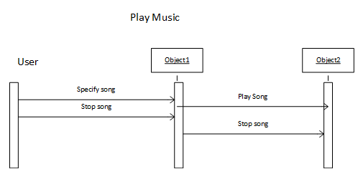

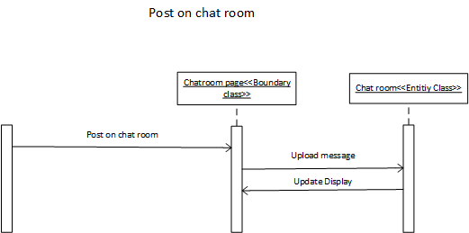



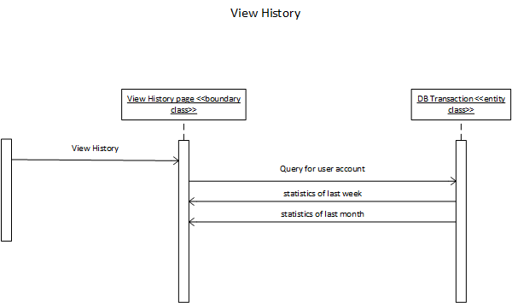

## Class diagram

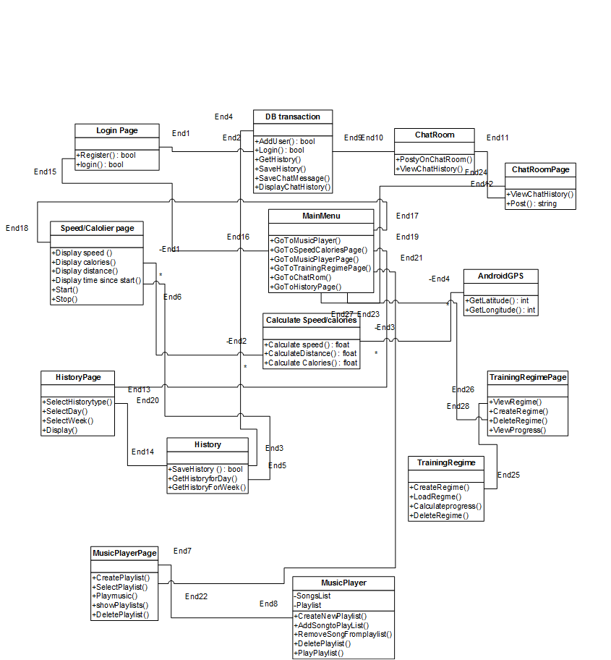

## Collaboration Diagrams

#### Login

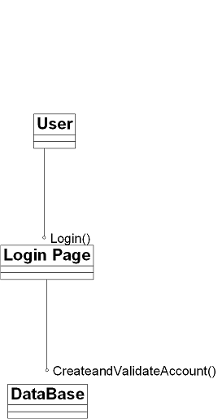

#### Create Training Regime

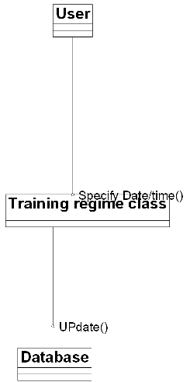

#### GPS Tracking

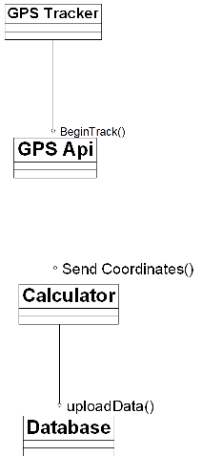

#### Login

#### 

#### Manage Playlist

#### 

#### Play Music

#### 

#### Post on Chat Room

#### 

#### View History



## State charts

One for each use case

#### Calculate Speed distance

#### 

#### Login/Register



#### History



#### Music Player



#### Post on Chat Room



#### Training Regime



## Human Interface Design

### Screens

#### Welcome message

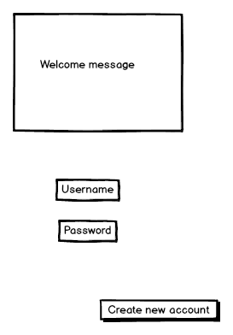

#### Basic Info

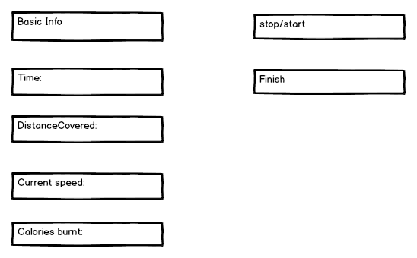

#### Main Menu

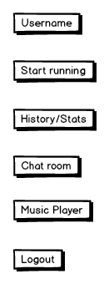

#### Create Account

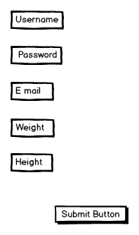

#### Chat Room

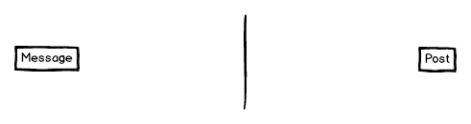

#### Music Menu

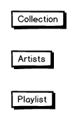

#### History page

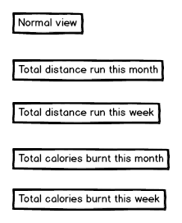

### Navigation Flow

