# Introduction

In recent years, the implementation of Natural Language Processing (NLP) has revolutionized the way we interact with legal texts, making it easier to analyze and comprehend complex legal language. One significant advancement in this field is the development of Language Model-powered (LM) chatbots, with ChatGPT being at the forefront. With its vast training data and powerful capabilities, ChatGPT has had a profound impact on global users, providing them with intelligent conversational agents capable of understanding and responding to their queries. The integration of LM-powered chatbots has extended beyond the legal domain, finding applications in various fields. However, it is in the realm of legal discourse where these chatbots truly shine, leveraging their expertise to assist users in navigating complex legal terms and processes.

بنان بدها تكمل

# Literature review

The use of machine learning (ML) techniques in the legal domain has long history with it a lot of research have integrated the two domains in many fields such as Legal document review [1], [2] ,Legal prediction[3] , Legal writing [4] and Legal compliance [5] . Prompting can be used to improve the performance of LLMs in different criteria, explore the effectiveness of using prompts in the task of legal judgment prediction (LJP). [6] They conduct experiments using data from the European Court of Human Rights and the Federal Supreme Court of Switzerland, comparing different prompts with multilingual language models (LLMs) such as mGPT, GPT-J-6B, and GPT-NeoX-20B. The results demonstrate that zero-shot prompt engineering can improve LJP performance with LLMs, yielding better macro-averaged F1 scores, precision, and recall compared to simple baselines. However, the performance of zero-shot learning still falls short of current supervised state-of-the-art results in the field. The paper also highlights the following key findings: prompting can enhance LLM performance in legal judgment prediction, multilingual LLMs can be effective even with training data in a single language, and while zero-shot learning holds promise, further improvements are needed to achieve state-of-the-art outcomes. The authors conclude by emphasizing the potential value of prompting for legal professionals and the accessibility benefits of multilingual LLMs in the field of legal natural language processing (NLP). [7] In an experiment, Rabee built a fictitious law professor who had a normal week of duties including teaching and community service planned out for her. then they used ChatGPT prompts for each task to test how well the system worked. For six of the seven tasks given, ChatGPT was able to produce workable first drafts in just 23 minutes. The most common tasks, including making a practice exam question or preparing a class handout, showed ChatGPT to be the most proficient at. ChatGPT struggled with more complex tasks, especially those that had to do with education, although it still had the potential to save time in some cases. The experiment's findings indicate that ChatGPT, especially service-related jobs, has a lot of promise for reducing some components of the workload for law faculty. Additionally, ChatGPT may enable law professors to spend less time on specific teaching responsibilities, giving up more time for them to concentrate on pedagogy and create innovative teaching strategies. Finally [8] design and implementation of two immigration chatbots to advise their users about immigration legal questions and cases. One answers immigration-related questions, and the other answers legal questions from NBC employees. Both chatbots use supervised learning to learn embeddings for their answers.

# Data set:

In our project we used 4 resources as an input for our chatbot we used three official documents which they are Law No. (20) Of 2017 On Cooperative Associations, النظام الداخلي, النظام الداخلي للاسكان.also we created two set of questions and answer dataset which we will discuss more about them in section…

## Formal Legal Documents

In order to give the chatbot the legal context that it needs to answer legal question we needed to provide it with the legal documents that the lawyers and Legal advisors depend on and use to answer legal questions but we made some reformatting for these documents where we only kept the necessary articles and definitions these legal documents are

* شرح مبسط عن القانون سطر سرطين مع ذكر عدد القرارات الي فيه
* شرح عن النظام الداخلي للجمعيات
* شرح عن النظام الداخلي لجمعيات الاسكان

## Question And Answers data

In order to support the chatbot to better understand the legal questions we created two other dataset which contains a json file of questions about the Decree – Law No. (20) Of 2017 On Cooperative Associations the two dataset are as following:

### Human generated question answer dataset:

We asked the legal advisor of the Cooperative Work Agency to create a dataset contains 40 question and answer about different articles from the Decree – Law No. (20) Of 2017 On Cooperative Associations The questions and answers cover the basic topics, including the definition of a cooperative association, the requirements for forming a cooperative association, the rights and responsibilities of cooperative members, and the role of the CWA in regulating cooperative associations.

### Chatgpt Generated Question and Answers

We used the ChatGPT API to generate 5 questions and their corresponding answers for each article of Law No. (20) of 2017 on Cooperative Associations. However, we needed to customize the answers to simulate the response of a real legal advisor. This involved starting the answer by referring to the article number in the law. To achieve this, we utilized the following prompt structure, as shown in graph 2: we first requested the generation of the question and answer, then provided the article itself, and finally, to control the output, we asked ChatGPT to create a dictionary with two keys: "question" and "answer". After ChatGPT generated the dictionary, we appended it to another dictionary to collect the data. This process resulted in 350 questions and their corresponding answers.

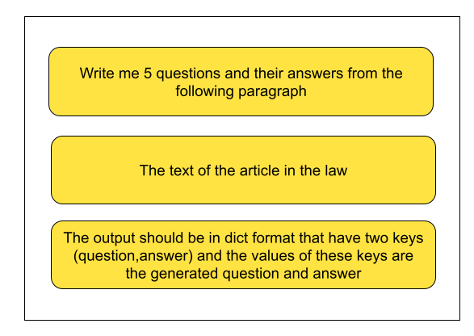

As we can see the output as following we have two key question and its answer both of them in Arabic language

{"question":"ما هي الشروط التي يجب توافرها للجمع في العضوية بين جمعيتين تعاونيتين من ذات التخصص الواحد في نفس المحافظة؟",

"answer":"- لا يجوز الجمع في العضوية بين جمعيتين تعاونيتين من ذات التخصص الواحد في نفس المحافظة."

}

# Methodology:

Since we were dealing with a huge amount of text data, we could not insert all of it into the ChatGPT chatbot. The maximum number of tokens for ChatGPT GPT-3 is 4096 tokens, and we had 93k tokens in our data, which was a significant difference. We needed a way to reduce the number of tokens so that they could be inserted into the ChatGPT API. The answer was LlamaIndex. LlamaIndex is a good choice for creating an index of documents for use with an LLM. First, LlamaIndex is designed to be efficient at processing large amounts of data. Second, LlamaIndex provides a number of features that make it easy to use with LLMs, such as the ability to generate vectors for each document and the ability to store the vectors in a format that can be easily retrieved.In our case with the legal documents, we used LlamaIndex to create an index of all the legal documents and question answer data that we had. We then generated vectors for each document. The vectors were then stored in the index so that they could be quickly retrieved when needed. After that, we used the LlamaIndex query engine, which used ChatGPT in the background to help us answer our legal questions. Graph 1 represents the comprehensive pipeline that we implemented for our case study, clearly demonstrating the use of LlamaIndex with ChatGPT and the subsequent vector generation and indexing of the legal documents.

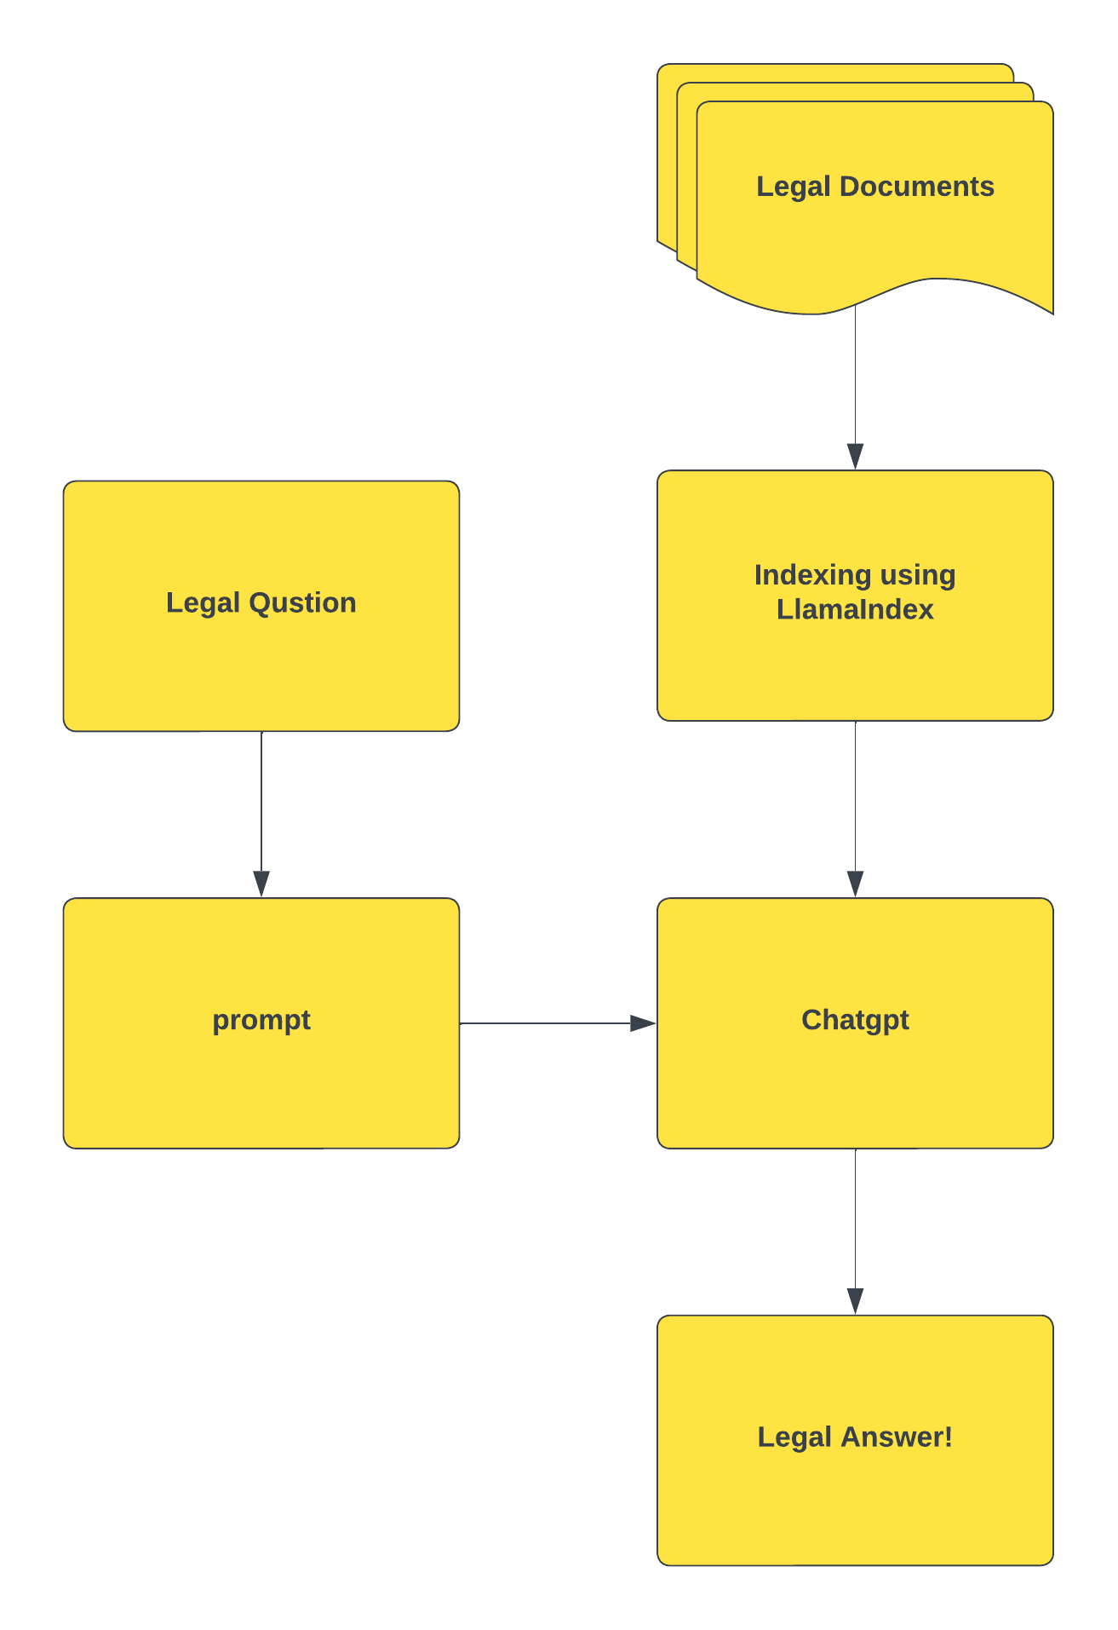

1. Since we are dealing with huge amount of text data and not all the data can be insered into the chatgpt chatbot since the maximum number of token for chatgpt gpt3 is 4096 token and the total token we have on hour data is 93k token which is huge difrrent
2. so we need a way to reduce the number of token to be able to be insereted into the chatgpt api and the answer was LlamaIndex.
3. llmindex is a good choice for creating an index of documents for use with an LLM. First, llmindex is designed to be efficient at processing large amounts of data. Second, llmindex provides a number of features that make it easy to use with LLMs, such as the ability to generate vectors for each document and the ability to store the vectors in a format that can be easily retrieved.
4. So in our case with the legal documents we used llmindex to create an index of all the legal documents and question answer data that we have ande then we generated vectors for each document. The vectors are then stored in the index so that they can be quickly retrieved when needed in a shape of json file.
5. After that we used the query LlamaIndex query engine which used chatgpt in the background to help us answer our legal question

# Conclusion

# Future work

[1] C. J. Mahoney e-Discovery Cleary Gottlieb Steen, H. D. LLP Washington, J. Zhang, N. Huber-Fliflet, P. Gronvall, and H. Zhao, “A framework for explainable text classification in legal document review,” *ieeexplore.ieee.org*, Accessed: May 20, 2023. [Online]. Available: https://ieeexplore.ieee.org/abstract/document/9005659/

[2] F. Wei, H. Qin, S. Ye, … H. Z.-C. on B. D. (Big D., and undefined 2018, “Empirical study of deep learning for text classification in legal document review,” *ieeexplore.ieee.org*, Accessed: May 20, 2023. [Online]. Available: https://ieeexplore.ieee.org/abstract/document/8622157/

[3] R. Sil and A. Roy, “A Novel Approach on Argument based Legal Prediction Model using Machine Learning,” *Proceedings - International Conference on Smart Electronics and Communication, ICOSEC 2020*, pp. 487–490, Sep. 2020, doi: 10.1109/ICOSEC49089.2020.9215310.

[4] T. Phelps and K. Ashley, “‘ Alexa, Write a Memo’: The Promise and Challenges of AI and Legal Writing,” *Legal Writing: J. Legal Writing Inst.*, vol. 26, p. 329, 2022.

[5] S. Mandal, R. Gandhi, and H. Siy, “Modular Norm Models: A Lightweight Approach for Modeling and Reasoning about Legal Compliance,” in *2017 IEEE 15th Intl Conf on Dependable, Autonomic and Secure Computing, 15th Intl Conf on Pervasive Intelligence and Computing, 3rd Intl Conf on Big Data Intelligence and Computing and Cyber Science and Technology Congress(DASC/PiCom/DataCom/CyberSciTech)*, 2017, pp. 657–662. doi: 10.1109/DASC-PICom-DataCom-CyberSciTec.2017.115.

[6] D. Trautmann, A. Petrova, and F. Schilder, “Legal Prompt Engineering for Multilingual Legal Judgement Prediction,” *arXiv preprint arXiv:2212.02199*, 2022.

[7] T. Pettinato Oltz, “ChatGPT, Professor of Law,” *Professor of Law (February 4, 2023)*, 2023.

[8] M. Queudot, É. Charton, and M.-J. Meurs, “Improving access to justice with legal chatbots,” *Stats (Basel)*, vol. 3, no. 3, pp. 356–375, 2020.