**Nickel Final Test (FT) Program Instructions For THETA_Y Assessment**

|  |
| --- |
| Table of Contents |
| Table of Contents 1  1. REVISION HISTORY 2  2. RUNNING THE PROGRAM 3 |

# REVISION HISTORY

|  |  |  |  |  |
| --- | --- | --- | --- | --- |
| Revision | Date | Author | Contributors | Change Description |
| Rev 1.0 | 10/15/2020 | TRT |  | Original |
|  |  |  |  |  |
|  |  |  |  |  |
|  |  |  |  |  |
|  |  |  |  |  |
|  |  |  |  |  |
|  |  |  |  |  |
|  |  |  |  |  |
|  |  |  |  |  |
|  |  |  |  |  |
|  |  |  |  |  |
|  |  |  |  |  |
|  |  |  |  |  |
|  |  |  |  |  |
|  |  |  |  |  |
|  |  |  |  |  |
|  |  |  |  |  |
|  |  |  |  |  |
|  |  |  |  |  |
|  |  |  |  |  |
|  |  |  |  |  |
|  |  |  |  |  |
|  |  |  |  |  |

# RUNNING THE PROGRAM

Follow these steps to run the program for THETA_Y assessment:

* Make sure the short helmet Nickel machine is turned on and that the USB is connected. The surface chem FT computer is used for multiple Nickel machines so the USB may or may not be connected. Also make sure that the USB from any other Nickel machines have been disconnected from the computer.
* Chewie may be on and connected to the Nickel machine. If Chewie is on, check to make sure that it is disconnected. The button circled in blue below should say ‘CONNECT’ if Chewie is disconnected.

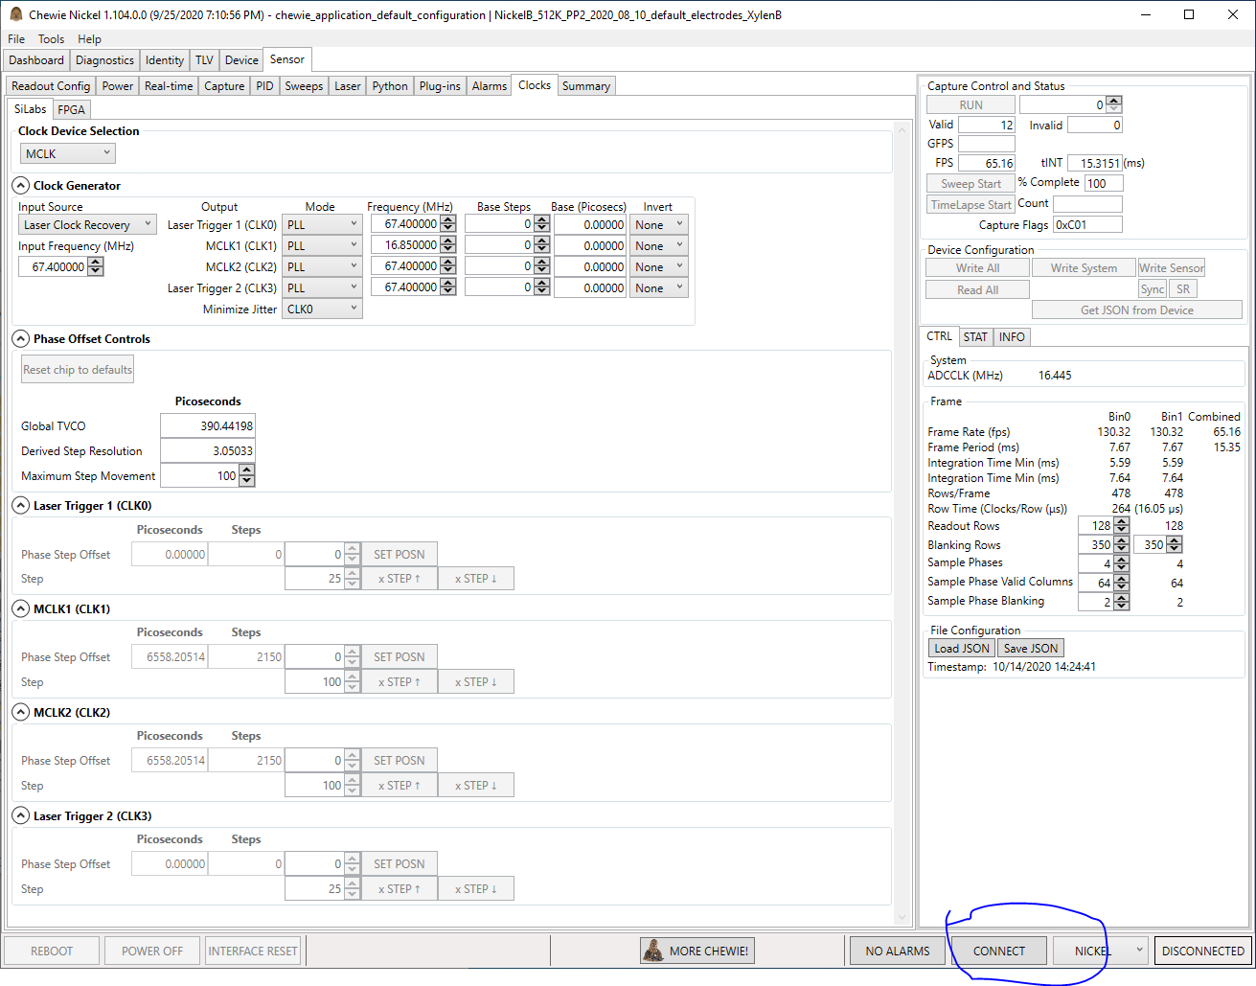

* Insert a chip into the socket.
* Double click on the ‘FT.bat’ icon on the desktop of the computer.

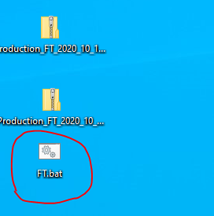

* A new cmd window will appear.

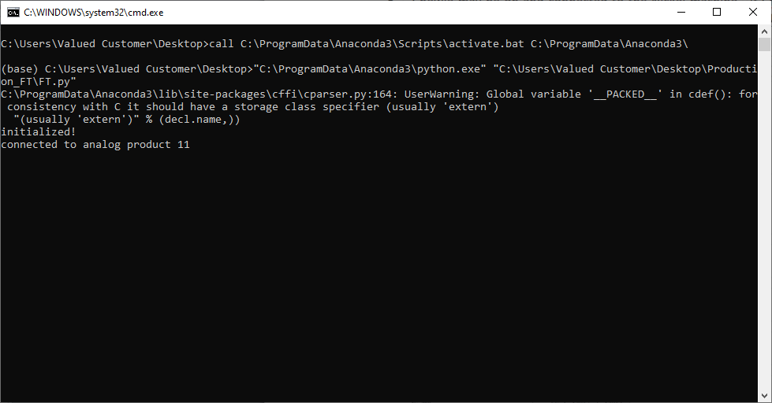

* If the GUI window below appears, start up the laser by clicking ‘OK’.

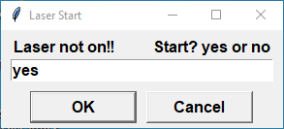

* If the GUI window below appears, make sure a chip is in the socket and the lid is closed. Click ‘OK’.

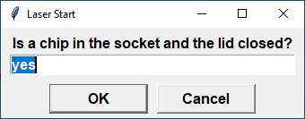

* If the GUI window below appears, align the laser by clicking ‘OK’.

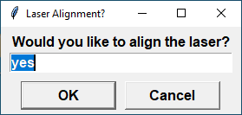

* At some point the main GUI window will appear. The full version of the GUI with no buttons hidden is shown below.

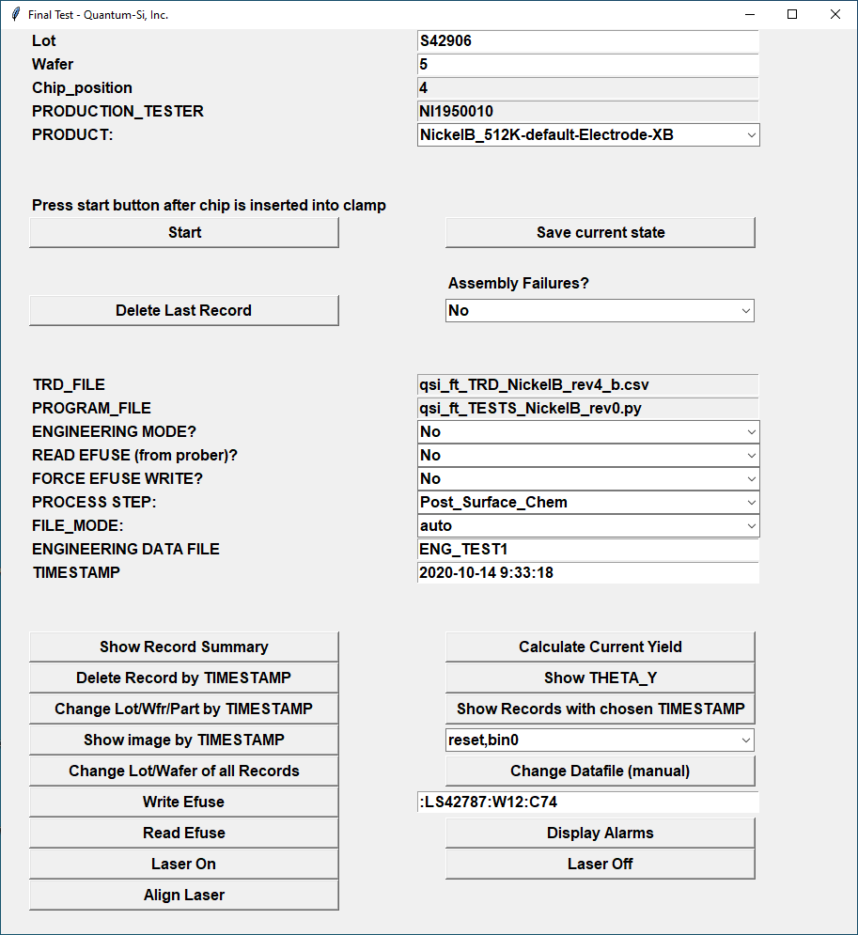

* There are only a few buttons that you will need to use for THETA_Y assessment. These are circled in the image below.

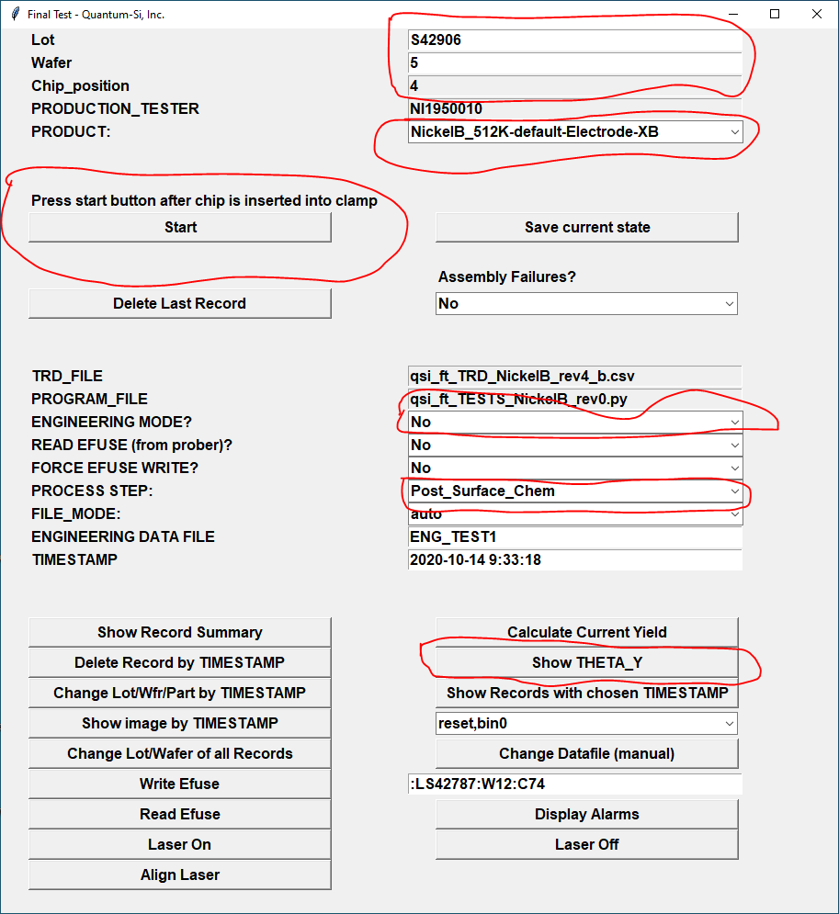

* Check that the **‘Lot’** and **‘Wafer’** text boxes have the correct information in them. Because illuminated tests require masks giving the positions of pixels with apertures over them, there is a cross-check done to make sure that this information is present.
* Check to make sure that the correct ‘**PRODUCT’** is selected in the pull down menu.
* Check to make sure that **‘ENGINEERING MODE?’** has been set to **‘No’**.
* Check to make sure that **‘PROCESS STEP:’** has been set to **‘Post_Surface_Chem’**.
* At this point (with a chip in the socket), click the **‘Start’** button and the test will begin.
* You will immediately be asked to give the part number of the chip. Enter this information and press OK.

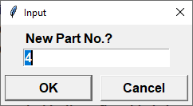

* If aperture mask information for this lot/wafer information is not available, the following window will appear. Contact test engineering if this occurs so the mask information can be entered.

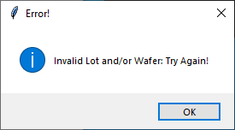

* The test will continue running. You can monitor test progress in the cmd window, as shown below.

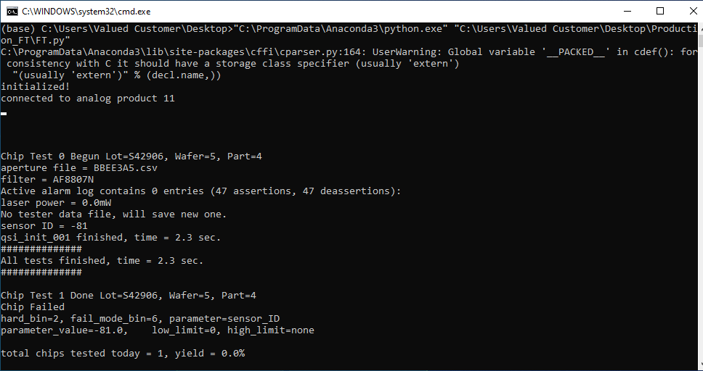

* After the test is finished, a window will appear that gives binning information for this part. Here is an example binning window.

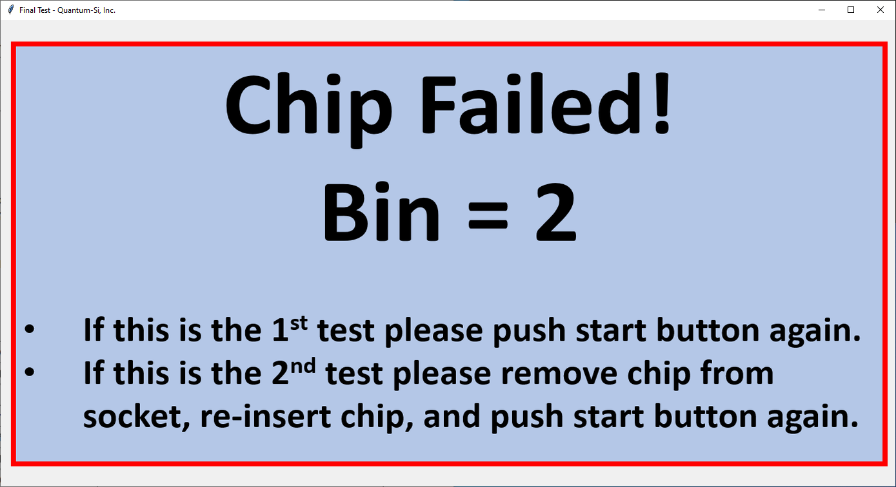

* The bins are:
  + Bin1 = pass
  + Bin2 = electrical failure
  + Bin3 = vref adjustment failure
  + Bin4 = dark image quality failure
  + Bin5 = laser alignment failure
  + Bin6 = MCLK scan failure
* If the chip fails, I recommend removing the chip from the socket, re-inserting the chip, and running the test again.
* Place the chip in the appropriate tray according to hard bin value.
* Close the binning window, insert the next chip, and press the **‘Start’** button for the next test.
* After all tests are finished, click the **‘Show THETA_Y’** button. A list of THETA_Y values for the current testing session will appear in the cmd window.

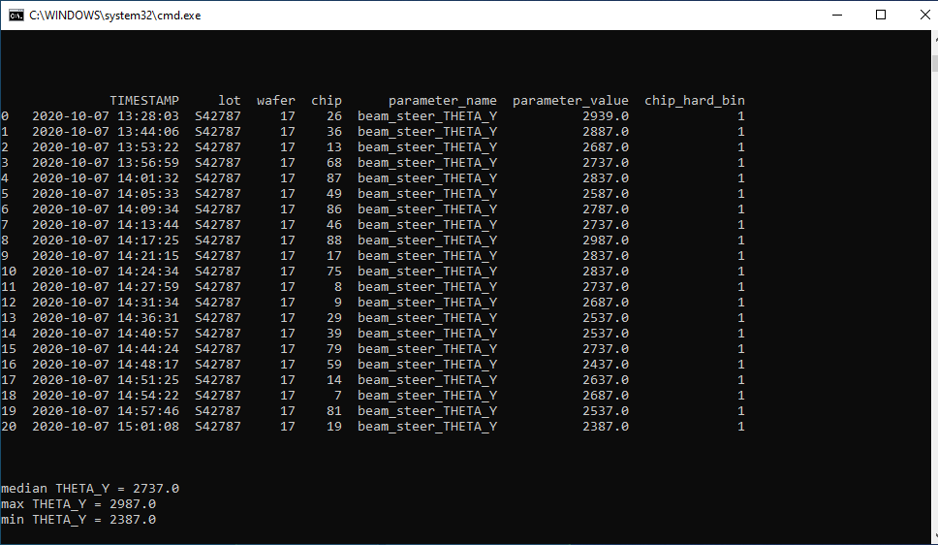

* Currently THETA_Y has min= 2386 to max = 4049 range on the short helmet FT machine in surface chem. A median value of THETA_Y around 3200 with no parts hitting near the min/max values is desired.