Playwright POM & CLI Assignment
Sauce Demo - data-driven login tests

Implementation summary
The page objects use Sauce Demo locators for the username, password, login button, error message, and inventory title. The login test reads the three required cases from data/users.json and checks either that the inventory page loads or that a non-empty error message appears.
The generated POM approach provided reusable page objects and the core Sauce Demo selectors. I adjusted file imports and data-loading code, and corrected the inventory-loaded method name so the CLI data-driven tests could run.
Verification: npm run test:login - 3 passed (1 valid login, 2 expected login errors; Chromium).

Project folder structure
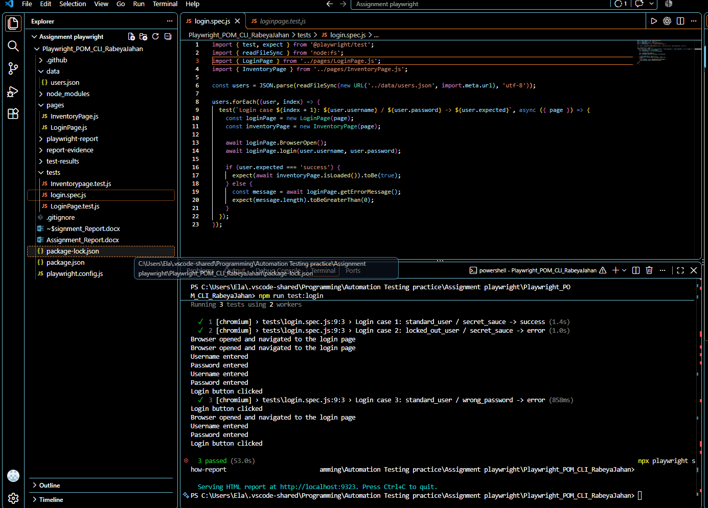
Evidence image generated from the current project directory listing.

CLI test result
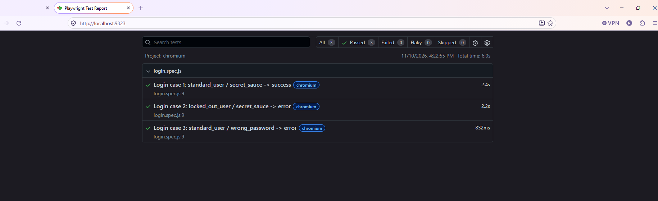
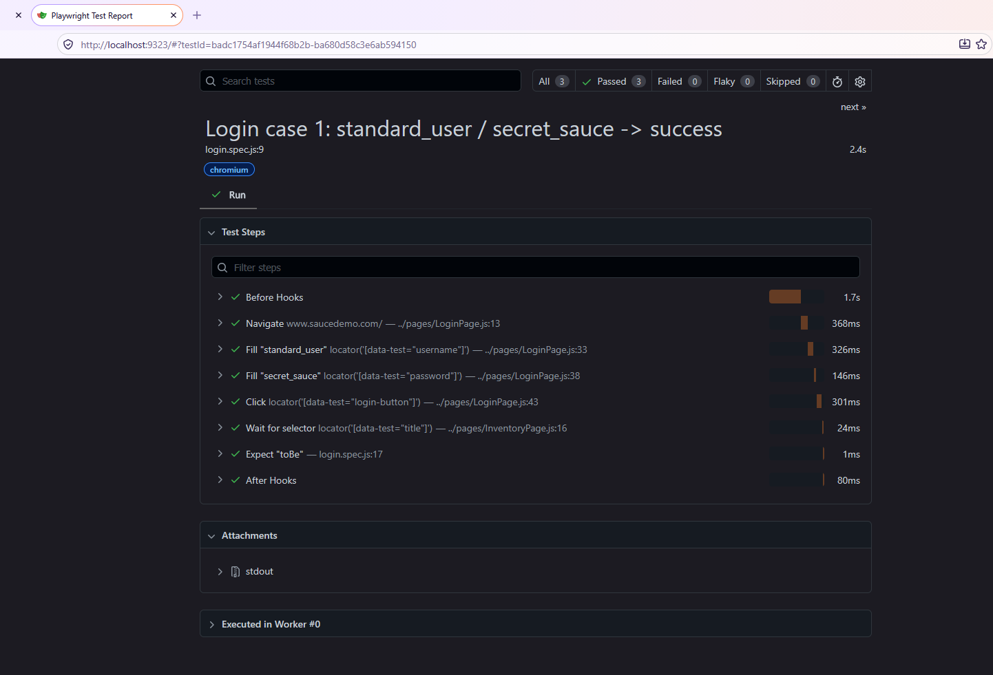
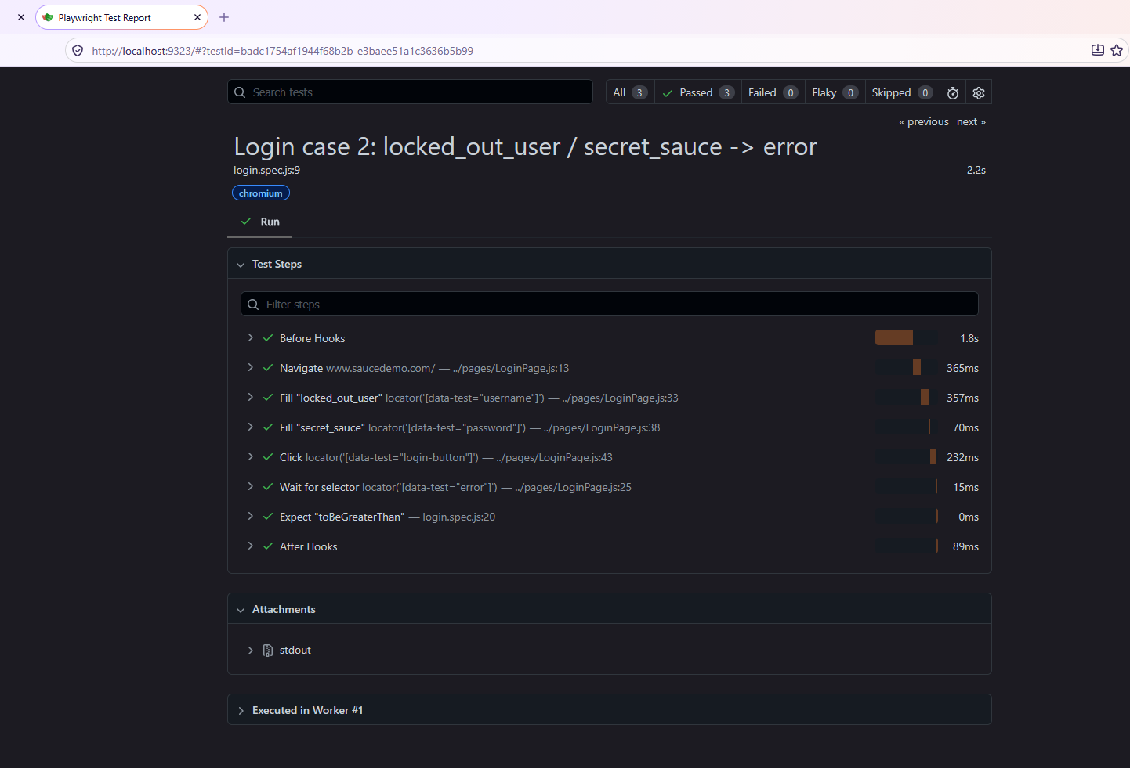
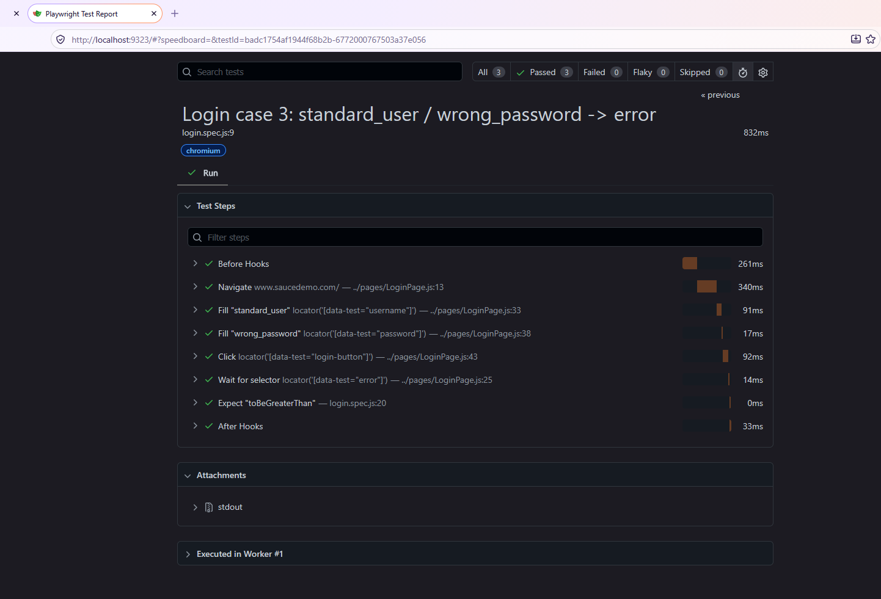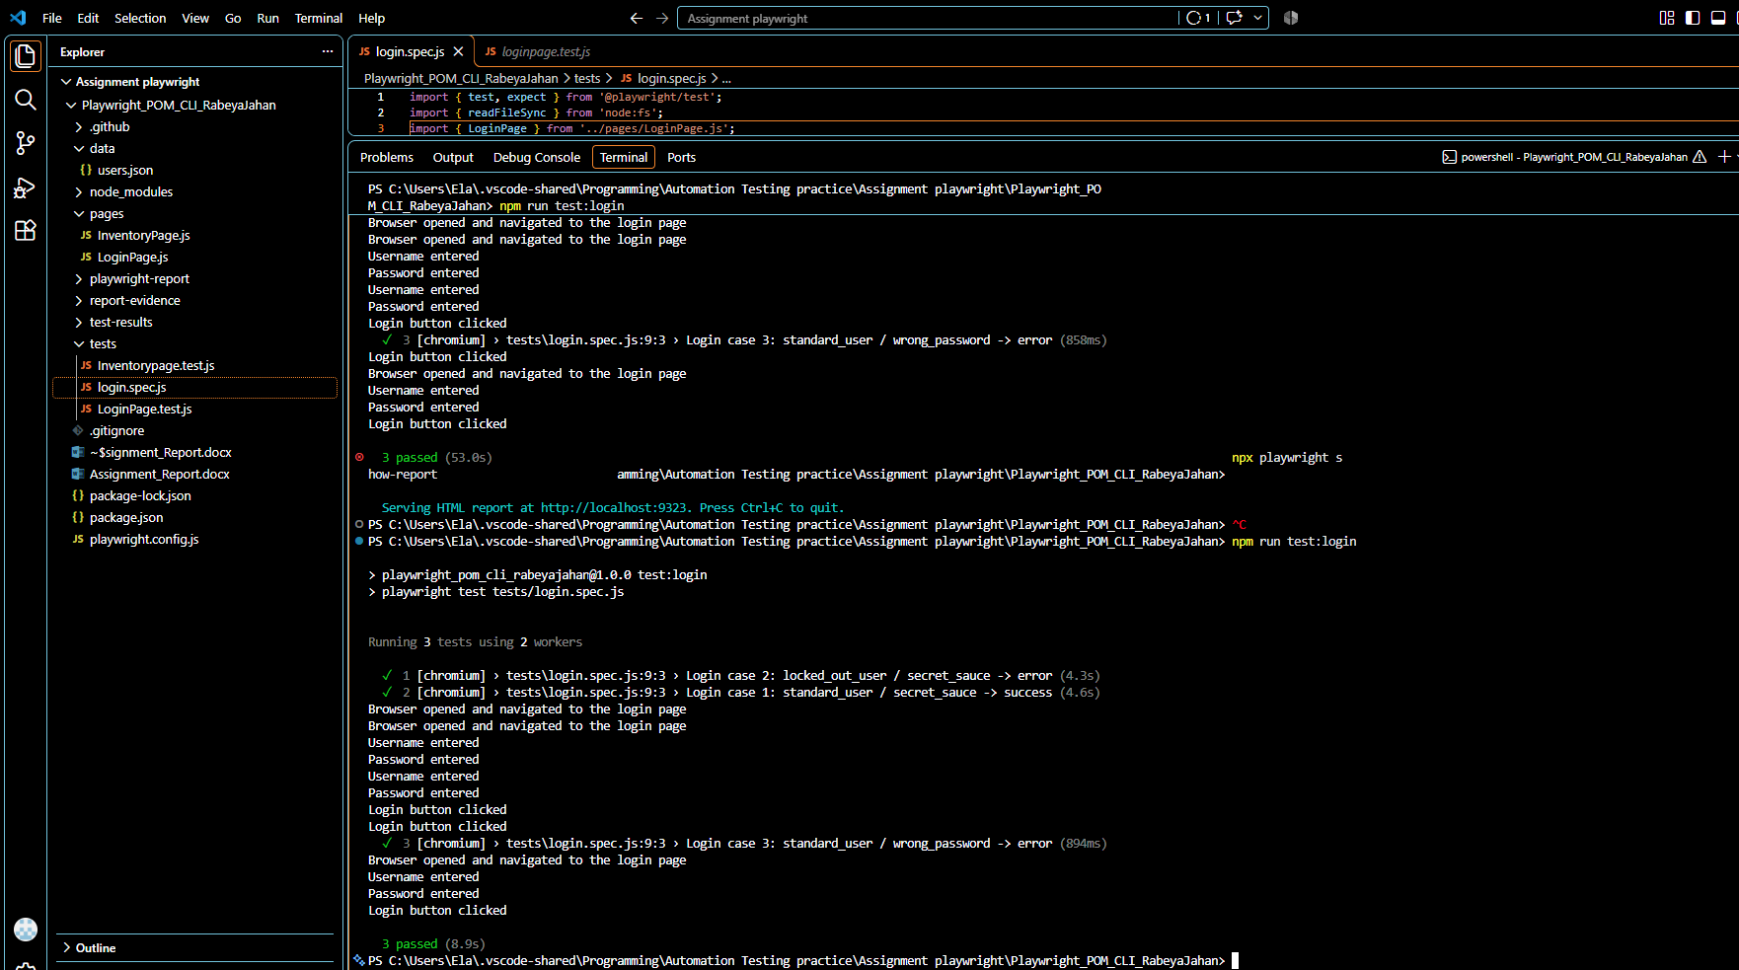
Evidence image rendered from captured npm output & Playwright Report; it is not a desktop screenshot.

Submission links
GitHub repository: add the repository URL after pushing the project.
Google Drive folder: add the share link (Anyone with the link can view) after uploading this report and project.

