Growth fitness, not drug tolerance, explains most pre-treatment prediction of cancer cell fate
Rabeya Noor^{1*} and Khairum Jahan Roza²
¹Department of Computer Science and Engineering, Daffodil International University, Daffodil Smart City, Birulia, Savar, Dhaka 1216, Bangladesh
²Kumudini Women's Medical College, Mirzapur, Tangail, Bangladesh
*Correspondence: rabeyanoor.dev@gmail.com

Abstract
Background. Some cancer cells survive treatment without genetic change, and many studies suggest they can be recognised in advance from their gene expression. Sister-cell lineage tracing tests this: one daughter of a dividing cell is sequenced before treatment, the other is treated, and the treated sister's fate labels the sequenced cell. However, a cell whose sister survives may simply be a cell that grows well. How much of the predictable signal reflects drug tolerance rather than general growth fitness has not been measured. We measured it in the ReSisTrace experiment, which includes an identically processed untreated arm.
Results. We built an evaluation that compares each drug-arm predictor with a fitness model trained on the untreated arm at equal training size, and bounds what any predictor can reach given that sisters differ. Applied to 32,642 pre-treatment ovarian cancer cells, a simple linear model predicted the sister's fate (AUROC 0.72–0.75), far above published methods on the same task (0.50–0.60), and neither a graph neural network nor two single-cell foundation models did better. Yet the fitness model, which never saw a drug, predicted drug-arm fates almost as well (0.70–0.73). The drug-specific gain was about 0.02 AUROC: positive in every arm, too small for this experiment to separate reliably from zero, and at most about 0.05. Point estimates placed most of it with the particular drug, not with treatment in general. A score that uses no labels recovered much of the signal, which marked a proliferative, low-stress state, and a link to homologous-recombination-deficient states reported with these data was as strong in untreated cells. In a second lineage system with six treatments, pre-treatment clone size outpredicted gene expression under every treatment, and in 11 patients the fitness state was depleted, not enriched, after chemotherapy.
Conclusions. Most of what a pre-treatment transcriptome predicts about a cancer cell's fate is general growth fitness, not drug tolerance. Claims that pre-existing states predict drug tolerance should therefore be tested against an untreated arm processed in the same way. We provide the evaluation as an open-source Python package, persist.fitadj, which applies to any lineage-tracing design with such an arm.
Keywords: drug tolerance; lineage tracing; single-cell RNA-seq; sister cells; cell fate prediction; non-genetic resistance

Background
Cancer therapy often fails because some cells survive it, and survival does not always need a mutation. Sharma et al. (2010) described a small, reversibly drug-tolerant subpopulation in several cancer cell lines, which individual cells enter and leave at low frequency. Such persister cells can later acquire genetic resistance (Hata et al., 2016; Ramirez et al., 2016), and non-genetic resistance is now recognised as a broad class of adaptive mechanisms (Marine et al., 2020; Soragni et al., 2025). A central question is therefore whether the cells that survive were already different before the drug was given. If they were, their state could be measured, and perhaps targeted, in advance. In this study we test that assumption directly. Using a sister-cell experiment in ovarian cancer cells, which also contains untreated cells, we ask how much of what a cell's state before treatment predicts about its sister's survival is tolerance of the drug, and how much is general growth fitness. We find that it is mostly growth fitness.
Several studies suggest that survivors were indeed different beforehand. In melanoma, rare cells expressing resistance markers at high levels were more likely to become resistant, and drug exposure then made this transient state stable (Shaffer et al., 2017). Such fluctuations can last for several divisions (Shaffer et al., 2020), can be traced back to rare drug-naive precursors (Emert et al., 2021), largely decide which resistant type a clone forms (Goyal et al., 2023), and can be modulated before treatment to reduce resistance (Harmange et al., 2023). Tracing barcoded clones through six treatments in parallel, Schaff et al. (2026) found that clones resistant to one treatment were more likely to resist others, with high CD44 marking multi-treatment resistance. From time-lapse lineages, Iyer et al. (2025) inferred that survival is largely biased by states present before the drug and inherited over two to three generations.
Other studies point the other way. In colorectal cancer, barcoding and modelling fitted a scenario in which all cells, not a rare subpopulation, can enter a diapause-like persister state (Rehman et al., 2021). In organoids followed through sequential treatments, resistance arose from transient plasticity rather than stable selection (Oliveira et al., 2025). Live-cell imaging has long shown that fate is only partly inherited: sisters diverge quickly in their response to death signals (Spencer et al., 2009), and survival depends on the dynamics of p53 rather than a fixed threshold (Paek et al., 2016). Part of a cell's fate is therefore decided after treatment begins, which limits what any pre-treatment measurement can predict.
Lineage barcodes read out by single-cell RNA sequencing make it possible to link a cell's state to the fate of its relatives at scale (Wagner and Klein, 2020). They have revealed primed fate potential in haematopoiesis (Weinreb et al., 2020; Wang et al., 2022), heritable clonal dominance in leukaemia (Fennell et al., 2022; Gutierrez et al., 2021), distinct cycling and non-cycling persister lineages under osimertinib (Oren et al., 2021), and a rare IGFBP2-high subpopulation sufficient for afatinib tolerance (Pellecchia et al., 2024). Most of these designs, however, label whole clones. A surviving clone may contain cells in quite different states, and a large clone is more likely to be seen again simply because it has more cells.
ReSisTrace avoids both problems (Dai et al., 2024). Barcoded cells divide once and the two sisters are separated: one is sequenced before treatment and the other is treated. Each sequenced cell is therefore labelled by its own sister's fate rather than by the fate of a clone. The design also includes an untreated control arm that goes through the same synchronisation, splitting and re-plating steps, which the authors added to assess the confounding effect of growth fitness in the experiment. They found transcriptomic differences between control cells whose sisters were recovered and those whose sisters were not, and concluded that pre-resistance signals should be assessed against this fitness signal (Dai et al., 2024). Their analysis used differential expression signatures, which they then used to predict pre-sensitising drugs. They did not build classifiers or report how well a cell's fate could be predicted.
Computational tools for single-cell drug response were built for a different problem. scDEAL transfers drug-response knowledge from bulk cell-line data to single cells (Chen et al., 2022), and SCAD does the same with adversarial domain adaptation (Zheng et al., 2023). Beyondcell scores cells against collections of drug signatures (Fustero-Torre et al., 2021), and CaDRReS-Sc uses a recommender system to predict response from single-cell signatures (Suphavilai et al., 2021). A recent benchmark of nine such methods used the ReSisTrace olaparib arm as ground truth (Shen et al., 2026). When pre-treatment cells were compared with post-treatment survivors, the best method reached a mean AUROC of 0.869. When only pre-treatment cells with sister-derived labels were used, most methods fell to 0.50–0.55 and the best, scDEAL, to about 0.6. The authors concluded that current models capture drug-induced changes rather than intrinsic resistance. Neither this benchmark nor the methods it evaluated compared their predictions with the untreated control arm, so a score on such a task cannot say whether a method has learned tolerance of the drug or general growth fitness.
This leaves three questions open. First, how much does a cell's pre-treatment transcriptome say about its sister's fate when a model is trained directly on the lineage labels? Second, how much of that signal is specific to the drug, rather than the growth and recovery advantage that the control arm was designed to reveal? Third, what is the best performance one could hope for, given that the label belongs to a different cell? We answer each question on the ReSisTrace data (Fig. 1a). We then test the answers against technical confounders, a second lineage-tracing system, two further lineage data sets, bulk tumours and patients. Our contributions are fourfold. First, we separate drug-specific tolerance from general growth fitness by comparing each predictor with a model trained on the untreated arm, at equal training size, and split what remains into a part shared with other treatments and a part unique to the drug. Second, we bound the best performance achievable given that sisters are not identical, and check both estimators on synthetic data where the true answer is known. Third, we re-score the pathway and HRD findings of the original study against its untreated arm. Fourth, we release the evaluation as a reusable Python package.

Results

Study design and terms used
We use a few terms throughout. An arm is one condition of the experiment: carboplatin, olaparib, NK cells, or the untreated control, each run in two replicates. A pre-treatment cell is pre-resistant if its treated sister was recovered after treatment and pre-sensitive otherwise. Cells that share a lineage barcode form a family, and every evaluation kept whole families on one side of the split, so a model is never tested on a relative of a cell it was trained on. Performance is reported as AUROC, where 0.5 is chance and 1 is perfect. The fitness model is the model trained on the untreated control arm: in that arm a sister is recovered without any drug, only by growing back after handling, so the model captures growth fitness rather than drug tolerance.
We used the authors' processed labels. After excluding 4,369 cells without a detected lineage label, 32,642 pre-treatment cells remained: 29,540 pre-sensitive and 3,102 pre-resistant, exactly the counts in the original report (Table S15). Pre-resistant cells made up 7.8–11.2% of labelled cells in the drug arms and 14.7–14.9% in the control arm (Fig. 1b). The cells formed 29,437 families, and within every family all cells carried the same label.
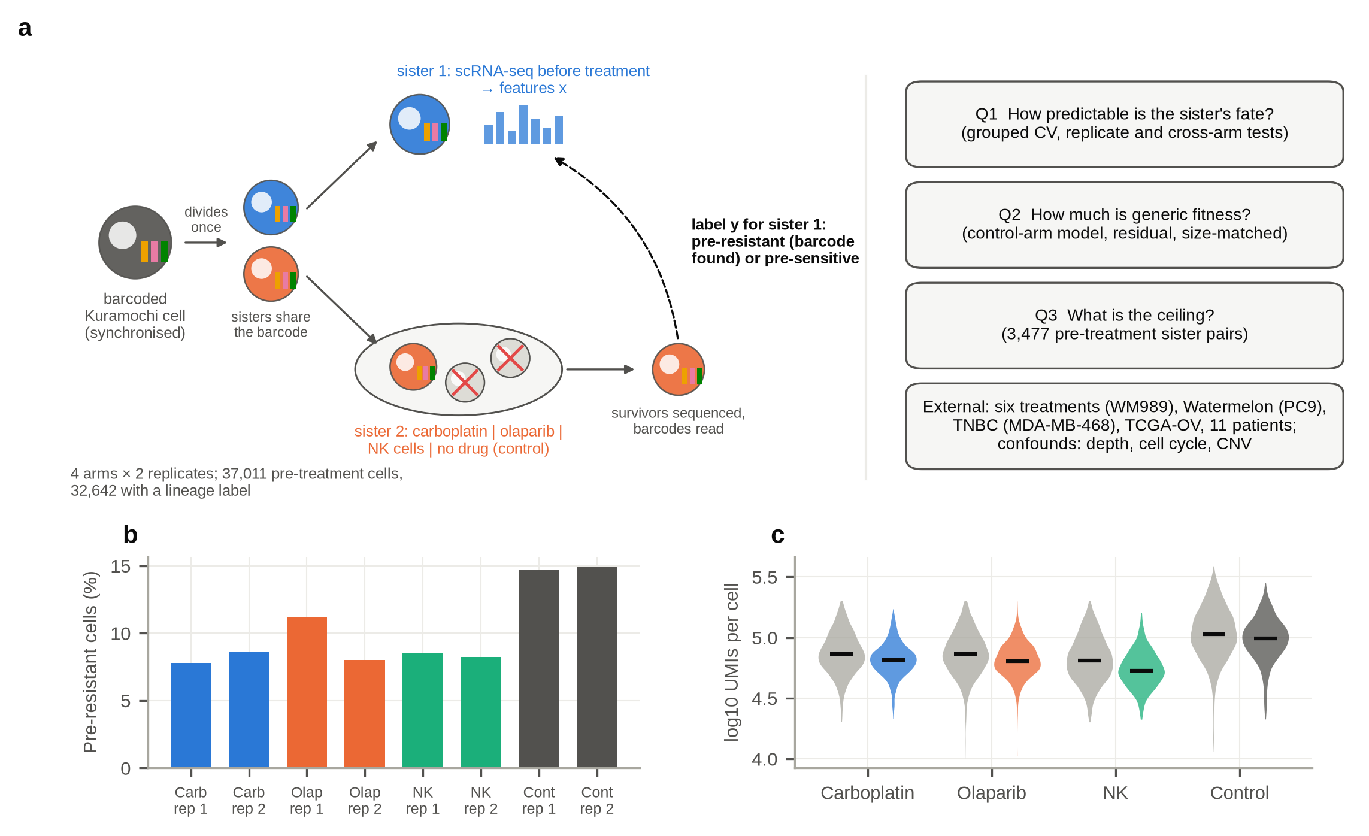
Fig. 1 | Study design and data. a, ReSisTrace design and the questions addressed in this study. b, Fraction of labelled pre-treatment cells that are pre-resistant in each sample. c, UMIs per cell for pre-sensitive (grey) and pre-resistant (coloured) cells in each arm; bars mark medians.

A cell's state before treatment predicts its sister's fate
We first asked whether the pre-treatment transcriptome carries any information about the sister's fate. It does. A logistic regression on 50 principal components of gene expression reached AUROC 0.747 for carboplatin, 0.744 for olaparib, 0.723 for NK cells and 0.708 for the control (Fig. 2a, Table S1).
This signal passed three checks. First, when the model was retrained on labels shuffled between families within each sample, AUROC fell to around 0.50, and none of 100 such refits reached the observed value in any arm (p < 0.01, the smallest p-value 100 permutations allow; Table S2). Second, training on one replicate and testing on the other gave 0.70–0.76 (Fig. 2b). Third, restricting the analysis to cells without a sister in the pre-treatment sample, as the original authors did, gave slightly higher values (carboplatin 0.754, olaparib 0.753, NK 0.737, control 0.720).
Technical factors explain only part of the signal. Pre-resistant cells had fewer UMIs than pre-sensitive cells in every arm, including the control (Fig. 1c), and a model using only technical covariates (sequencing depth, number of detected genes, mitochondrial fraction and cell-cycle scores) reached 0.59–0.65 (Fig. 2a). To make sure the main signal was not technical, we removed these covariates from the expression data before computing the principal components. Removing cell-cycle scores changed nothing (0.707–0.748). Removing depth and mitochondrial content as well lowered AUROC only modestly (carboplatin 0.723, olaparib 0.727, NK 0.680, control 0.704).
This simple model does much better than published methods. On the same olaparib task, under the protocol of the published benchmark (all pre-resistant cells against an equal number of randomly drawn pre-sensitive cells, three draws), it reached 0.739–0.756 with ordinary five-fold cross-validation and 0.734–0.747 with families kept together (Fig. 2c), against the 0.50–0.60 reported by Shen et al. (2026). Keeping families together lowered AUROC by less than 0.01, so the gap is not caused by sisters leaking between training and test sets. It comes from training directly on the lineage labels rather than transferring knowledge from bulk drug-response data. Table S20 lists the inputs, labels and protocol behind each value; the published methods were not rerun here.
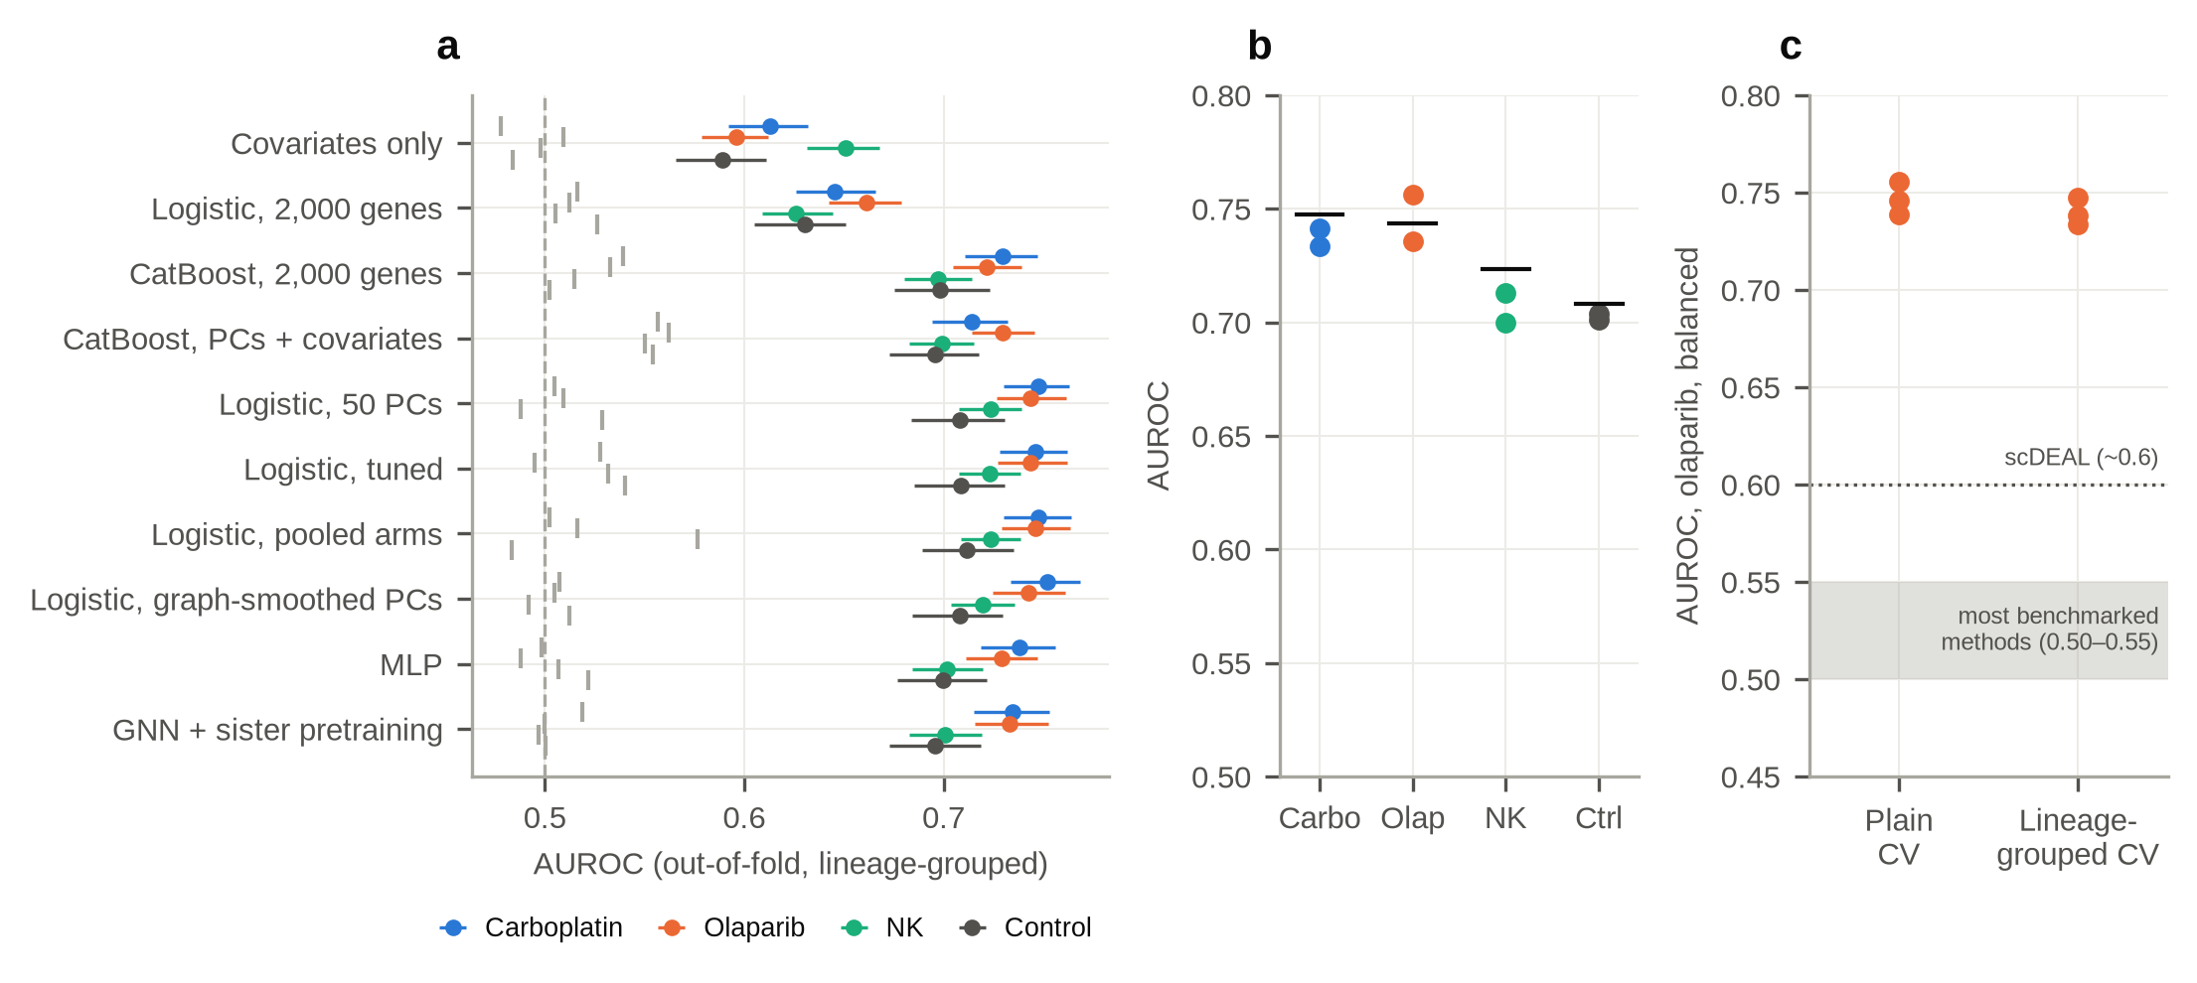
Fig. 2 | The pre-treatment state predicts a sister's fate. a, Out-of-fold AUROC (lineage-grouped five-fold cross-validation) for each model and arm; error bars are 95% family-bootstrap intervals; grey ticks show the same models retrained on family-level shuffled labels (one to five permutations per model). b, Replicate hold-out AUROC (dots) for the PCA-logistic model; bars show within-arm AUROC. c, Olaparib under the benchmark protocol of Shen et al. (2026), with ordinary and lineage-grouped cross-validation (three balanced draws each); the shaded band and dotted line mark the values reported for existing methods in that study.

More complex models do not predict better
If a more flexible model could find more signal, the values above would understate what the data contain. We found no such gain. Tuning the regularisation strength and the number of components changed AUROC by at most 0.002, and adding labelled cells from the other arms by at most 0.004. Gradient boosting was slightly worse (0.70–0.73), and linear models on 2,000 individual genes were worse still (0.63–0.66). A graph neural network, which lets each cell draw on information from cells in similar states and was pretrained to place sisters close together, reached 0.696–0.734, below logistic regression in every arm, and no setting in a sweep of its hyperparameters did better (Fig. S1, Tables S1, S18; Supplementary Note 1). Cell embeddings from Geneformer, a transformer pretrained on 104 million human transcriptomes and continually pretrained on about 14 million cancer transcriptomes (Theodoris et al., 2023; Chen et al., 2026), reached 0.671–0.683, and embeddings from scGPT, a transformer pretrained on 33 million human cells (Cui et al., 2024), reached 0.673–0.693 (Table S17; these two models are not shown in Fig. 2a). Models ranging from a linear classifier to a 104-million-parameter transformer thus recover the same signal and no more. The limit lies in the information, not in the model.

Most of the signal is not specific to the drug
This is the central test of the paper. If the pre-treatment state encoded tolerance of a particular drug, a model trained on one drug should transfer poorly to an unrelated drug, and the fitness model, which never saw any drug, should transfer worst of all. Neither was the case. All twelve transfers between arms gave AUROC 0.69–0.74 (Fig. 3a). The fitness model scored 0.725 on carboplatin, 0.713 on olaparib and 0.697 on NK labels, within 0.02–0.03 of the models trained on those arms (Fig. 3b). In the other direction, drug-arm models predicted the control labels with 0.69–0.70, close to the control model's own 0.708. The scores of the drug and fitness models were strongly correlated (Spearman 0.80–0.82).
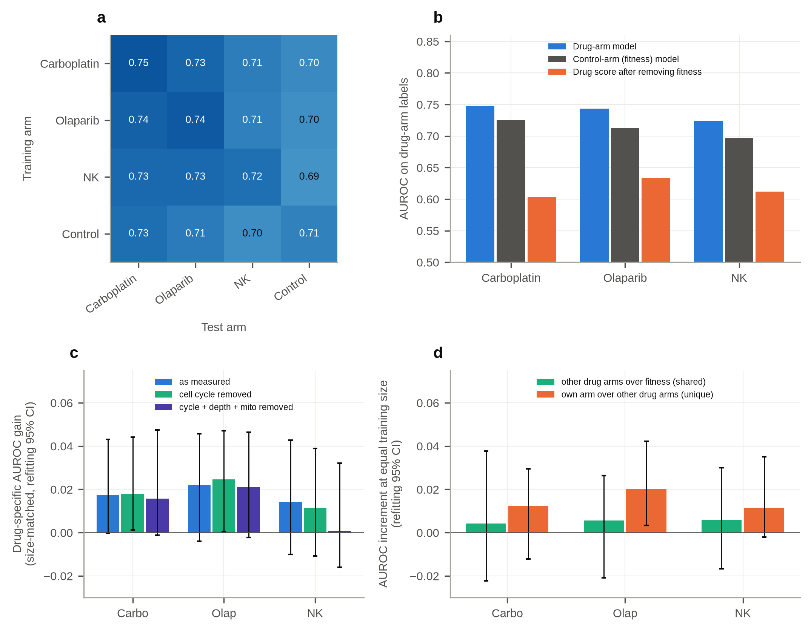
Fig. 3 | Most of the signal is shared with the untreated control. a, AUROC of PCA-logistic models trained on one arm and tested on another; the diagonal shows within-arm cross-validation. b, For each drug arm: AUROC of the drug-arm model, of the control-arm (fitness) model applied to drug-arm cells, and of the drug score after within-sample regression on the fitness score. c, Drug-specific AUROC gain over the fitness model with training size matched (ΔAUROC), under three preprocessing variants; error bars are 95% intervals from 200 bootstrap replicates that refit the whole procedure (Table S27). Narrower intervals that only resample the evaluation are listed in Table S19. d, With every model trained at the control arm's size, the AUROC gain on each drug arm's labels of a model trained on the other two drug arms over the fitness model (green, shared with other treatments) and of the arm's own model over the other-arm model (orange, unique to the drug); the two add up to the drug-specific gain. Error bars are refitting 95% bootstrap intervals (Table S28).
A drug-specific part does exist, but it is small. To measure it, we defined the drug-specific gain: how much better a model trained on a drug arm's own labels predicts those labels than the fitness model does. The control arm has fewer labelled cells (4,183) than the drug arms (8,942–10,123), which by itself would favour the drug models, so we trained the drug models on random sets of whole families of the same size as the control arm, repeated ten times (Methods). With training size matched in this way, the gain was 0.014 for carboplatin, 0.025 for olaparib and 0.017 for NK cells, and it varied by only 0.003–0.004 across the ten training sets (Fig. 3c, Table S19). Two other measures agree. Adding the drug model's score to a model that already contained the fitness score improved the fit in every arm (likelihood-ratio p < 10⁻²⁵). And the part of the drug score not explained by the fitness score still reached AUROC 0.60–0.63, or 0.64–0.66 within quintiles of the fitness score. In these cells, the drug score therefore carries information that the fitness score does not, but it adds only one to three points of AUROC to a signal of 0.72–0.75.
Whether this gain would reappear in a new experiment is harder to establish, because the experiment is too small to resolve it. A design calculation shows that, with 3,879 labelled control families, the experiment can detect a gain of about 0.025 to 0.028 with 80% power, and every estimate falls below that. As expected from this, in the main analysis intervals that account for refitting the models do not exclude zero. When we repeated the whole procedure inside each of 200 bootstrap samples, refitting both models each time, the estimates were 0.017 for carboplatin (95% CI −0.0002 to 0.043), 0.022 for olaparib (−0.004 to 0.046) and 0.014 for NK (−0.010 to 0.043) (Table S27); the point estimates differ slightly from those above because the random training sets differ. Across all nine combinations of arm and preprocessing variant, the gain exceeded 0.01 in eight and was close to zero in the ninth (NK with all technical covariates removed, 0.001). Two intervals only just excluded zero, both with cell cycle removed (carboplatin 0.001 to 0.044, olaparib 0.0004 to 0.047). With nine overlapping comparisons and lower ends this close to zero, we do not count these as detections. The three-model bootstrap behind Fig. 3d, which draws its own training sets, gave total-gain intervals that excluded zero for olaparib (0.007 to 0.051) and NK (0.001 to 0.049) but not for carboplatin (−0.007 to 0.042) (Table S28). Whether an interval clears zero therefore depends on the random training sets, which is what an effect at the edge of detection looks like. Simpler intervals that resample only the evaluation, without refitting, do exclude zero in all three arms, but our simulations show that such intervals are too narrow (see below). The best summary is a drug-specific gain of about 0.02 AUROC that is consistent in sign but that this experiment cannot reliably separate from zero. The same intervals also bound it from above, which is the more useful statement here: even at their upper ends, the gain is at most 0.043 to 0.046 AUROC, less than a fifth of the 0.22 to 0.25 by which the drug-arm models exceed chance. The data therefore do not merely fail to detect a large drug-specific component; they exclude one larger than about 0.05 AUROC.
The result did not depend on preprocessing or on how expression was represented. Removing cell cycle left the gain essentially unchanged (0.014, 0.025, 0.014). Removing depth and mitochondrial content as well gave 0.012 for carboplatin, 0.021 for olaparib and 0.003 for NK cells, so for NK cells nothing drug-specific remained. We also replaced the principal components with Harmony-corrected components (Korsunsky et al., 2019), components of analytic Pearson residuals (Lause et al., 2021), the latent space of scVI (Lopez et al., 2018), or the Geneformer or scGPT embeddings. Across these five representations, drug-arm models reached 0.671–0.746, the fitness model 0.627–0.722 on the same labels, and the drug-specific gain, by the simpler five-repeat estimate (Methods), was 0.013–0.049 (Table S17). The largest gains came from scGPT (0.030–0.049). Its fitness model was also the weakest (0.627–0.658), and a weaker fitness baseline leaves more of the shared signal to be counted as drug-specific, as the density substitute shows below; its drug-arm models were still below the linear model on principal components. The pattern was the same in every case: most of the signal was shared with the fitness model, and a smaller part was specific to the drug.
Is that smaller part tied to the particular drug, or does it reflect surviving treatment in general? A model trained on the other two drug arms, at the same training size, separates the two, because it has learnt from treated cells but never from this drug (Fig. 3d, Table S28). It improved on the fitness model by only 0.004 for carboplatin and 0.006 for olaparib and NK cells, whereas each arm's own model added a further 0.012, 0.020 and 0.012. By these point estimates, two thirds to four fifths of the gain beyond fitness was unique to the drug and a fifth to a third was shared with the other treatments. The split is less certain than the gain itself: in refitting bootstrap intervals the shared part spanned zero in every arm (for example −0.021 to 0.026 for olaparib), and the drug-unique part excluded zero only for olaparib (0.020, 95% CI 0.003–0.042; carboplatin −0.012 to 0.029, NK −0.002 to 0.035). Olaparib, the only targeted agent of the three, thus had the clearest drug-unique component.

A label-free score recovers much of the shared signal
We found a clue to what the shared signal is by accident. A model trained on shuffled labels should score about 0.5 on the true labels, and logistic regression did (mean 0.500–0.501 over 100 shuffles). Gradient boosting on the principal components and technical covariates, trained on shuffled labels, scored 0.550–0.562 on the true labels in every arm. A flexible model can apparently pick up something about how cells are arranged in expression space that is related to the labels, without learning the labels themselves.
We therefore tested a simple score that uses no labels at all: how crowded a cell's neighbourhood is, measured as the mean distance to its 15 nearest neighbours in principal-component space within its own sample. Pre-resistant cells lay in denser, more typical regions. This density score alone reached AUROC 0.70 for carboplatin, 0.69 for olaparib, 0.63 for NK cells and 0.67 for the control (Fig. S2), and 0.63–0.69 after removing cell cycle, depth and mitochondrial content. It correlated with the supervised model's score (Spearman 0.54–0.70; Table S4). Cells in common states therefore tend to have sisters that are recovered, with or without a drug, and cells in unusual states tend to lose them. The control arm shows the same pattern as the drug arms, as expected for a fitness effect. The effect is specific to the sister design: in the two clone-level data sets described below, the same score reached only 0.53 and 0.57 (Table S13). A practical consequence is that shuffled-label controls for flexible models cannot be assumed to sit at 0.5, and each model should be compared with its own null.

The fitness state is proliferative; the drug-specific state cycles more slowly
We next asked which genes and pathways make up the two components. Comparing pre-resistant with pre-sensitive cells within each sample gave 1,128–1,265 replicate-consistent differentially expressed genes in the drug arms and 639 in the control arm (Table S7). Most were shared: more than a thousand genes per drug arm also appeared in the control comparison, and only 57 (carboplatin), 221 (olaparib) and 140 (NK) differed significantly from it (Table S8). Mitochondrial transcripts ranked near the top in every arm, including the control, in line with the depth difference above; they were excluded from all signatures, together with ribosomal genes.
The shared fitness component is a proliferative, low-stress state. In the control arm, cells whose sisters were recovered had higher MYC-target, mTORC1, E2F and fatty-acid-metabolism programmes, and lower TNF-α/NF-κB, TGF-β, interferon, p53 and apoptosis programmes (Fig. 4a, Table S9), which fits an advantage in re-plating and regrowth. The drug-specific component points the other way. After the control comparison was subtracted, E2F targets, mitotic spindle and MYC targets were lower in pre-resistant cells in all three drug arms, and for carboplatin and NK cells so were the G2-M checkpoint and DNA repair. Among cells that are otherwise fit, those whose sisters survived a drug were relatively less proliferative. This agrees with the original report that DNA replication was associated with pre-survival only in the control condition (Dai et al., 2024). A pre-specified panel of 28 marker genes gave the same picture at the level of single genes (Fig. S3, Table S16, Supplementary Note 2). The CDK inhibitors CDKN1A, CDKN1B and CDKN1C were markedly lower in recovered cells of the control arm, and CDK1, PCNA, MCM2 and E2F1 were lower in pre-resistant cells of all three drug arms, although only CDK1 and PCNA for NK cells passed correction. Senescence-associated secretory genes were not higher, so the drug-specific state looks like slower cycling among otherwise fit cells rather than senescence. Genes unique to one drug, judged against the other two drug arms rather than against the control, were few (8 for carboplatin, 4 for olaparib and 48 for NK cells; Table S29), and neither pathway hypothesis fixed before this test held after correction. DNA-repair genes were higher in olaparib pre-resistant cells, as expected if cells proficient in homologous recombination resist PARP inhibition, but only nominally (p = 0.042, adjusted 0.094); for NK cells, allograft-rejection genes were nominally lower (p = 0.047, adjusted 0.094) and interferon-γ response genes did not differ. The part of the signal unique to a drug is therefore spread thinly across many genes rather than concentrated in a known mechanism.
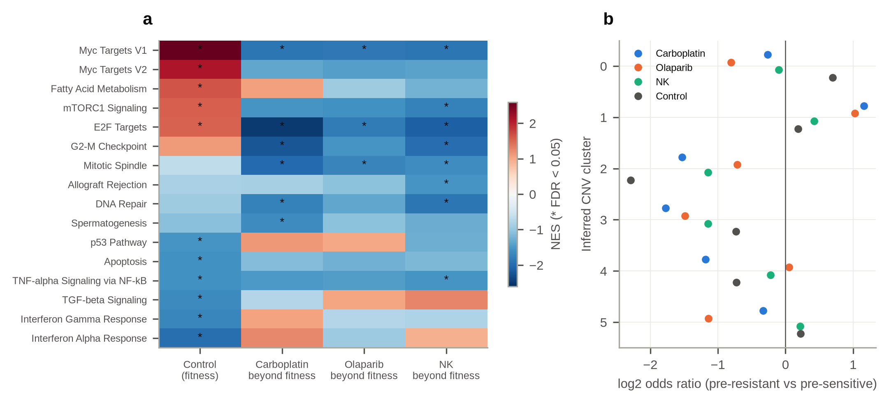
Fig. 4 | Biology of the shared and drug-specific components. a, Normalised enrichment scores of Hallmark gene sets for the control contrast (fitness) and for each drug contrast after subtracting the control contrast; asterisks mark FDR < 0.05. b, Odds ratios for inferred copy-number clusters among pre-resistant versus pre-sensitive cells in each arm.
Copy-number differences do not explain the signal. The original study reported a copy-number subclone enriched among pre-resistant cells (Dai et al., 2024). Per-cell subclone calls are not public, so we inferred copy-number profiles with infercnvpy and clustered them. The largest cluster reproduced the published enrichment in the carboplatin (odds ratio 2.24), olaparib (2.04) and NK (1.34) arms but not in the control arm (1.14, p = 0.14; Fig. 4b, Table S11). Cluster identity alone predicted the labels poorly (AUROC 0.54–0.60), the expression model kept most of its performance within clusters (0.69–0.72), and expression added strongly to a model containing cluster identity (likelihood-ratio p < 10⁻⁵⁰ in every arm; Table S12, Supplementary Note 3). Copy number thus explains a small and largely treatment-specific part of the labels, not the shared signal.

The original study's pathway and HRD findings, revisited
The same comparison can be applied to the biology reported with these data. Dai et al. (2024) described pre-resistant cells as marked by proteostatic and mRNA-surveillance programmes, and found their pre-resistance signatures negatively connected to a signature of homologous-recombination deficiency (HRD), which suggested that HRD-like states prime cells for sensitivity to olaparib and carboplatin. Their published fold changes include the untreated arm, so each finding can be scored there as well (Table S30, Methods). The mRNA-surveillance programmes were present without any drug: nonsense-mediated decay, cytoplasmic translation and protein targeting to the ER were enriched among control cells whose sisters were recovered (normalised enrichment scores 1.64–1.76, p < 0.001), though less than in the drug arms (1.75–2.25). They stayed enriched after the control fold change was subtracted (1.51–2.28, p ≤ 0.008), and the unfolded protein response, which did not differ in the control arm (p = 0.54), was lower beyond it in all three drug arms (p ≤ 0.013). These programmes therefore combine a fitness part with a part that goes beyond it, in line with the small drug-specific component estimated above.
The HRD connection did not separate the arms in this way. With the HRD signature from the isogenic COV362 cell pair, the connectivity in the untreated arm (−1.52) was as strong as in the drug arms (−1.54 to −1.76), so on its own it is not evidence of priming for a DNA-damaging drug. With the HRD signature derived from TCGA tumours, neither its up- nor its down-regulated genes were enriched in any arm (all p > 0.3). The connection persisted after subtracting the control fold change (−1.41 to −1.73), which leaves room for a drug-related part, but that part does not single out the two DNA-damaging treatments: as the original authors also noted, the NK arm showed the strongest connection. Our reanalysis supports their proteostatic findings in part and suggests that the HRD link is largely shared with recovery without a drug.

Sister discordance caps predictability
The label belongs to the sister, not to the sequenced cell. No model can see the treated sister's own state, so even a perfect model of the sequenced cell has a ceiling. We estimated this ceiling from 3,477 pairs of sisters from 2,939 families in which both sisters were sequenced before treatment.
Sisters are similar but not identical. Along the leading principal components their states were strongly correlated (mean intraclass correlation 0.75 over components 1–10, against 0.00 for random pairs from the same sample; Fig. 5a, Table S6), and the most heritable direction, estimated on held-out families, reached 0.93. Much of this shared variation is probably cell-cycle phase, which the protocol synchronises, so it does not by itself bound fate prediction.
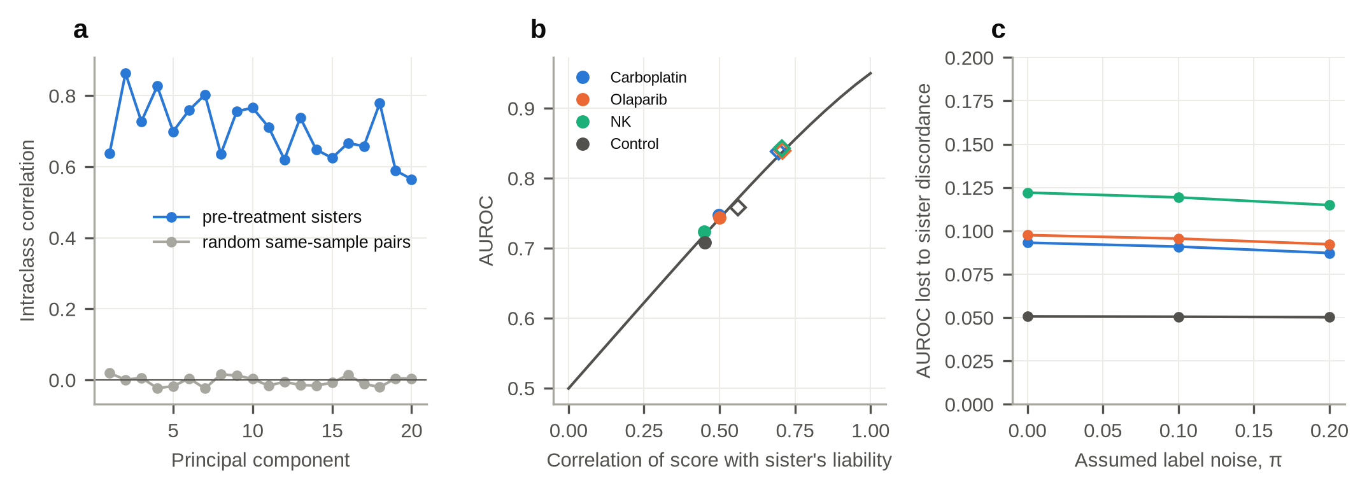
Fig. 5 | Sister discordance caps predictability. a, Intraclass correlation of principal-component scores between pre-treatment sisters and between random same-sample pairs. b, Expected AUROC as a function of the correlation between score and sister liability under the bivariate-normal model with label noise π = 0.1 (line), with each arm's observed PCA-logistic AUROC (dots) and the AUROC implied if the treated sister's own state were scored (diamonds). c, AUROC lost to sister discordance as a function of assumed label noise π.
A tighter bound comes from each model's own score. The scores of the principal-component model correlated 0.63–0.81 between pre-treatment sisters. We combined this correlation with the observed AUROC in a latent-liability model, allowing 10% of pre-sensitive labels to be wrong, a value within the error range estimated by the original authors, who found that on average more than 80% of pre-sensitive labels were correct (Dai et al., 2024). The result is the AUROC the same score would reach if it could be applied to the treated sister itself: about 0.84 in the drug arms and 0.76 in the control arm (Fig. 5b). Reading the wrong cell therefore costs 0.09–0.12 AUROC in the drug arms and 0.05 in the control arm (Fig. 5c, Table S5), and the estimate changed little for assumed label noise between 0 and 20%. Our simulations show that this estimate can only err upwards (see below), so these costs are upper bounds. Even with the treated cell in hand, a large part of fate would remain unexplained, in line with live-cell studies showing that fate is only partly inherited (Spencer et al., 2009; Paek et al., 2016).

In a second lineage system, clone size predicts better than cell state
ReSisTrace is the only design we know of that carries an untreated arm through the whole protocol, so the fitness model cannot be rebuilt elsewhere. A related question can still be asked wherever clone size before treatment is known, because a lineage that has grown larger before any drug is, by definition, one that grows well. Schaff et al. (2026) barcoded WM989 melanoma cells, profiled an untreated sample, and split the remaining cells across six treatments: the targeted drugs dabrafenib and trametinib, CoCl2, acidic medium, and the chemotherapies cisplatin and doxorubicin. Surviving cells were sequenced with their barcodes, so every untreated cell carries six labels at once. We obtained 7,165 untreated cells from 1,359 lineages, of which 30.6% (trametinib) to 78.3% (acidic medium) lay in a lineage detected again after treatment. As in all clone-level data, the label is detection, not survival: a lineage can go undetected because its cells died or simply because it was not sampled.
Clone size won in every treatment. It predicted detection with AUROC 0.68–0.90, against 0.54–0.66 for a logistic model on 50 principal components (Fig. 6a). Adding expression to clone size raised AUROC by at most 0.04, and for four treatments not at all. Once the part of the expression score explained by clone size was removed, it fell to 0.44–0.59 (Fig. 6c), and it no longer added significantly to clone size for cisplatin (p = 0.46) or doxorubicin (p = 0.15), although it still did for the other four treatments (p < 10⁻⁸; Table S22). The two targeted drugs stood out: they were the treatments in which clone size mattered least (0.70 and 0.68) and expression added most (0.04 and 0.03), matching the weak clone-size correlations that the original authors reported for exactly these two. This does not contradict the original study, which showed that clone size is not the only determinant of resistance and that some small clones became highly resistant. It puts the two predictors side by side: as a predictor of whether a lineage is detected again, its size before treatment is worth far more than its transcriptional state, except in part under MAPK inhibition.
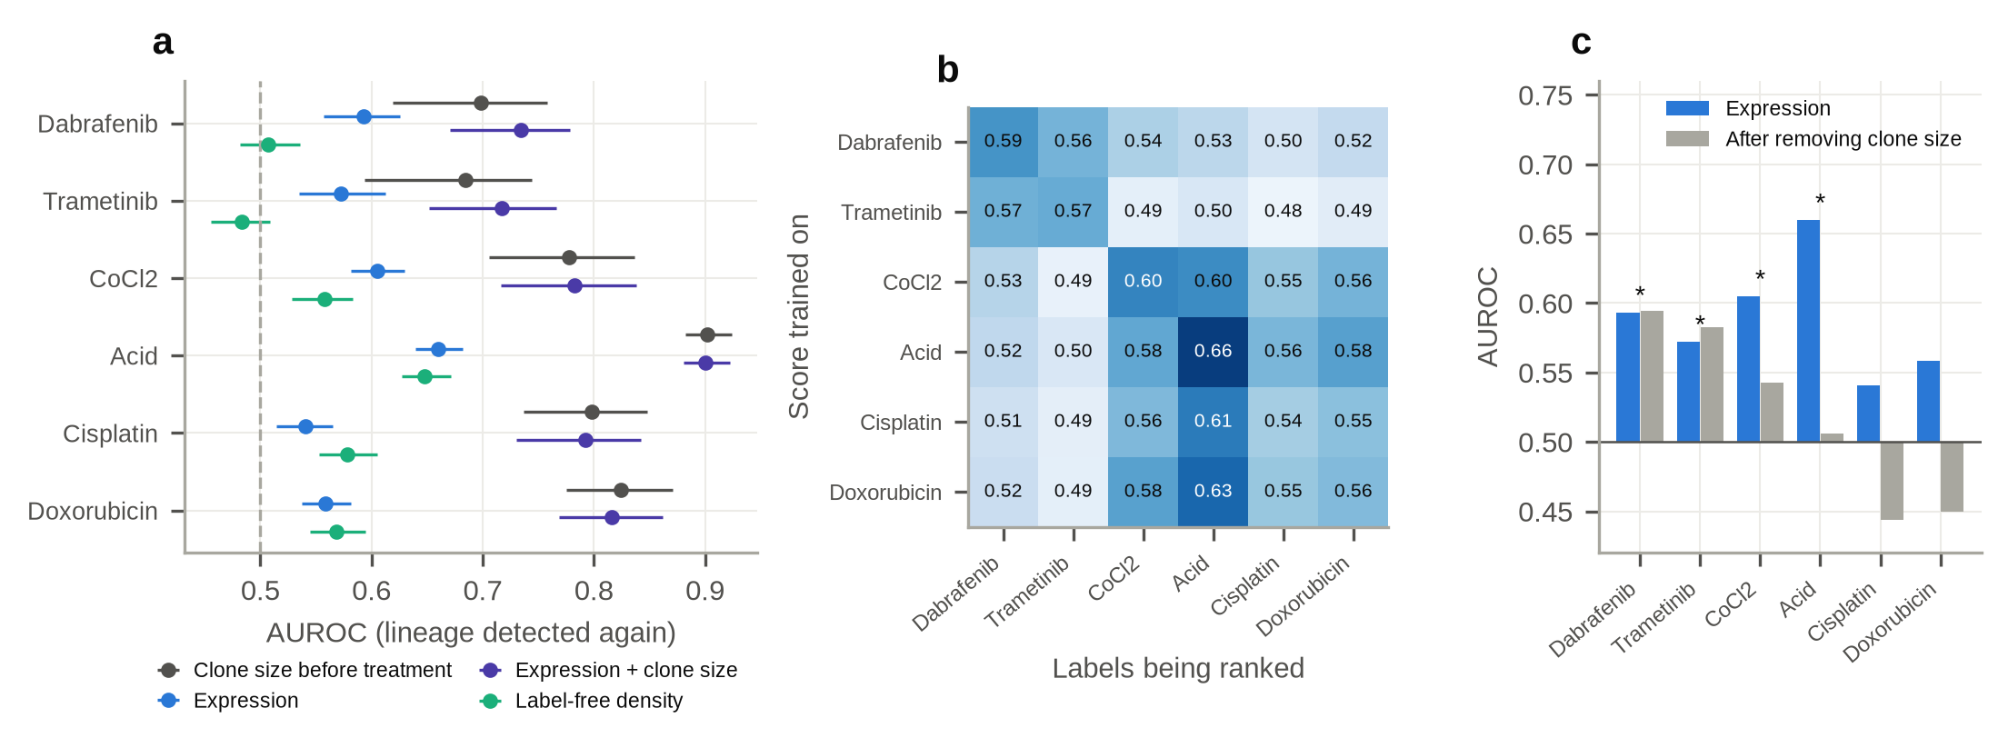
Fig. 6 | A second lineage system with six treatments (Schaff et al., 2026). a, AUROC for predicting whether an untreated cell's lineage is detected again after each treatment, using clone size before treatment, expression (50 principal components), both, and the label-free density score; lineage-grouped cross-validation, error bars are 95% lineage-bootstrap intervals. b, AUROC when the out-of-fold score trained on one treatment's labels is used to rank another treatment's labels. c, Expression AUROC before and after residualising on log clone size; asterisks mark treatments in which expression added to clone size (likelihood-ratio p < 0.05).
Predictions transferred only between similar treatments (Fig. 6b). Scores trained on one treatment's labels ranked another treatment's labels at 0.48–0.63, in two blocks: the two MAPK inhibitors transferred to each other (0.565 and 0.568) better than to anything else, and the four stress and chemotherapy arms transferred among themselves (0.548–0.627). The original authors saw the same grouping in the transcriptomes of resistant cells; here it appears in what can be predicted beforehand.
An independent reanalysis agrees. While this work was in preparation, Aviv (2026) released a preregistered reanalysis of the same data, which also found that "clone abundance dominates". It then asked a different question: for a given clone, under which of the six conditions is it detected? Holding clone abundance and condition identity fixed, a model in which the effect of cell state differed between conditions ranked the conditions within a clone better than a model with one shared state effect, by 0.052 in within-clone AUROC (95% CI 0.037–0.066, permutation p < 0.001). The two analyses fit together. Averaged over conditions, state is worth little next to size; once size and condition are fixed, a small condition-specific part remains. That figure is not directly comparable with the drug-specific gain we measure in ReSisTrace (0.014–0.025), because it ranks conditions within one clone rather than cells within one arm, but the two point the same way: in both systems, the part of the pre-treatment state that is specific to the treatment is small next to the part that is not.
The ceiling analysis could not be repeated here. Cells that share a lineage in the untreated sample descend from one barcoded cell through about five doublings of growth (20 days; Schaff et al., 2026), not one division, and they share far less state: the mean intraclass correlation over the first ten principal components was 0.18, against 0.75 for ReSisTrace sisters, and model scores correlated only 0.17–0.21 between clone-mates, against 0.63–0.81. Extrapolating from such weak correlations failed openly: in three of the six treatments the implied correlation exceeded one (Table S23). We therefore report no ceiling for this data set. Only the sister design, in which the two cells are one division apart, makes the bound estimable.

Other lineage data, tumours and patients show the same pattern
The same ordering held in two further clone-level data sets. In the Watermelon data (PC9 lung cancer cells treated with osimertinib; Oren et al., 2021), 5,087 barcoded cells from 2,993 lineages were labelled by whether their lineage was observed again at day 14. Clone size alone predicted this label with AUROC 0.76. Expression alone reached 0.61, added only 0.01 to clone size, and reached 0.58 among lineages with a single cell, where clone size carries no information (Fig. 7a). In triple-negative breast cancer cells treated with afatinib (Pellecchia et al., 2024), 1,541 untreated barcoded cells from 448 lineages were labelled by whether their lineage was among the authors' drug-tolerant expanded persisters after 40 days (55.9% positive). Clone size gave 0.88, expression 0.64, and both together 0.88 (Fig. 7b). In both data sets, ReSisTrace models applied without refitting scored close to chance (0.49–0.52 and 0.54–0.57), and the density score reached only 0.533 and 0.570. Among the 237 single-cell lineages of the breast cancer data, the ReSisTrace fitness model transferred best (0.64, 95% CI 0.53–0.76), which fits the idea that what transfers is fitness rather than drug tolerance, but the subset is small and we do not rely on it.
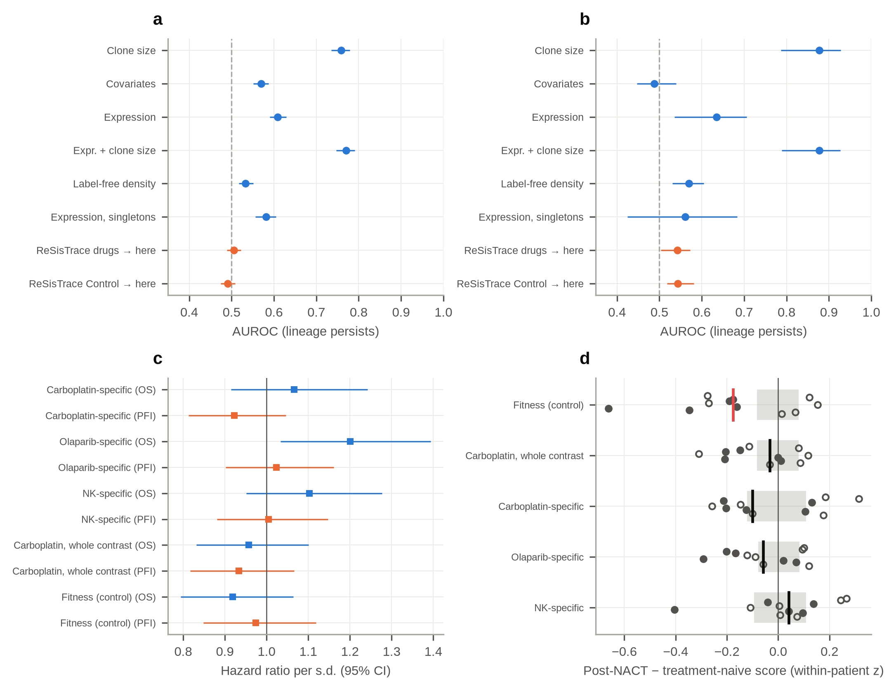
Fig. 7 | External and clinical checks. a,b, AUROC for predicting lineage persistence from untreated cells in Watermelon (a) and triple-negative breast cancer (b), using clone size, technical covariates, expression, the label-free density score, expression within singleton lineages, and zero-shot transfer of ReSisTrace models; error bars are 95% lineage-bootstrap intervals. c, Hazard ratios per standard deviation of signature score for overall survival and progression-free interval in TCGA-OV; the fitness, whole-contrast and drug-specific signatures are defined in Methods (Differential expression and pathways). d, Change in signature score from treatment-naive to post-treatment malignant cells in 11 patients with high-grade serous ovarian cancer receiving neoadjuvant platinum–taxane chemotherapy (Zhang et al., 2022); one dot per patient, filled where both samples came from the same anatomical site; the vertical line is the median (red for the fitness signature, the only one with Wilcoxon p < 0.05) and the grey band spans the mean ± 2 s.d. of the medians of 200 expression-matched random gene sets.
In bulk tumours, the signatures did not predict outcome. In 303 primary ovarian tumours from TCGA, we tested five signatures (defined in Methods; gene lists in Table S10) against overall survival and progression-free interval, 10 tests in all. Only the olaparib-specific signature showed a nominal association with overall survival (hazard ratio 1.20 per s.d., 95% CI 1.03–1.39, p = 0.017), and it did not survive correction for multiple testing (FDR 0.17). No signature was associated with progression-free interval (all p > 0.2; Fig. 7c, Table S14).
In patients, the fitness state was depleted after chemotherapy. Bulk survival data are an indirect test; a more direct one asks whether cancer cells that persist through chemotherapy in patients carry the pre-resistant states. Zhang et al. (2022) sequenced malignant cells from 11 patients with high-grade serous ovarian cancer before and after three cycles of neoadjuvant platinum–taxane chemotherapy (8,806 malignant cells). If treatment selected the ReSisTrace carboplatin states, post-treatment cells should score higher on them than the same patient's treatment-naive cells. They did not. The carboplatin whole-contrast and carboplatin-specific signatures rose in only 5 of 11 patients (Wilcoxon p = 0.24 and 0.83), within the range of random gene sets matched in size and expression. The fitness signature moved the other way. It was lower after treatment in 7 of 11 patients (median change −0.18 within-patient s.d.; Wilcoxon p = 0.042), lower than for all 200 matched random gene sets (two-sided p = 0.005), and lower in all five patients whose two samples came from the same anatomical site (Fig. 7d, Table S21). No signature change was associated with the platinum-free interval (all p > 0.3). The proliferative, low-stress state that predicts recovery in a culture dish is therefore depleted, not enriched, in tumours after chemotherapy. This fits the view that it marks the ability to regrow after handling rather than tolerance of the drug. Post-treatment tumour samples also differ in ways a sister design does not capture, such as drug-induced changes, stroma and sampling site, so this is a consistency check rather than a validation.

Without an untreated arm, the drug-specific gain cannot be measured reliably
The comparison at the centre of this paper needs an untreated arm, and almost no study has one. We therefore asked whether something built from the treated arms alone can stand in for it. ReSisTrace is the only data set in which this can be checked, because the real control arm is there for comparison. We tried two substitutes that use no control-arm labels: the label-free density score, and a model trained on the other drug arms. In this comparison, all gains were computed without the size matching used above, so the values for the real control arm are slightly larger than those reported earlier.
Neither substitute reproduced the control arm, and they failed in opposite directions (Fig. S4, Table S26). Measured against the real control model, the drug-specific gain was 0.022 for carboplatin, 0.031 for olaparib and 0.027 for NK cells. Measured against the density score, it was roughly two to three times larger (0.043–0.090), because density is a weaker measure of fitness and leaves more of it to be counted as drug-specific. Measured against the other drug arms, it nearly vanished (0.0045–0.0065). This was mostly a matter of training size: those models learnt from two to five times as many labelled cells as the control model, and at equal training size a model trained on the other drug arms took up only a fifth to a third of the gain (Fig. 3d).
In all three arms, the true value lay between the two substitutes, so where no untreated arm exists, reporting both may give a rough bracket: the other-arm baseline as a low estimate and the density score as a high one. This ordering is not guaranteed, however. In the second lineage system, the two substitutes gave a sensible bracket only for the two MAPK inhibitors (0.007–0.025 and 0.086–0.089); for the other four treatments they crossed or turned negative (−0.024 to 0.033 and −0.038 to 0.047). A substitute can show that a pre-resistance signal is mostly fitness, but it cannot say by how much.

The estimators, checked against a known answer
All of the above rests on two estimators: the size-matched drug-specific gain and the sister ceiling. To check them, we simulated sister experiments in which the true answer is known. The simulations set how much of survival is general fitness, how much is drug-specific, how similar sisters are, and whether fate depends on the treated cell's own state or only on the state the sisters share. We ran the full analysis blind on 25 independent experiments for each setting (Fig. S5, Methods, Table S24).
The drug-specific gain was estimated accurately (Fig. S5a). With no drug-specific effect, the estimate was −0.001 and only 2 of 25 experiments gave an interval excluding zero, close to the 5% expected. When an effect was present, it was recovered with a bias of +0.001 to +0.005, and with a bias below 0.003 at every level of label noise tried (0, 10 and 20%). A technical confound acting on both the measurement and the chance of recovery, imitating the sequencing-depth effect in the real data, did not bias it either (−0.002, against a true gain of 0.015).
Simple intervals were too narrow (Fig. S5b). Intervals that resample families but do not refit the models covered the true value in only 52% to 88% of experiments instead of 95%, with or without the depth confound; they were too narrow by a factor of 1.2 to 1.9. This is why we quote intervals from the slower bootstrap that refits the whole procedure. It is also a general caution: a bootstrap placed around a cross-validated score measures how much the evaluation would move, not how much the whole procedure would move.
The ceiling was accurate when its assumption held and erred upwards when it did not (Fig. S5c). When fate depended on the treated cell's own state, as the estimator assumes, the implied AUROC was within 0.005 of what a model actually achieved on that cell. As fate shifted towards depending only on the state the sisters share, the estimate drifted upwards, by 0.052 at the halfway point and by 0.114 at the extreme. The error is one-sided, which we also show analytically (Methods), so the sister costs reported above are upper bounds.

Discussion
We asked whether a cancer cell's transcriptome before treatment predicts whether its sister survives, and how much of that prediction is about the drug. The pre-treatment state is predictive: a simple model reaches AUROC 0.72–0.75, far above published methods on the same task. But most of the signal is not about the drug. A model trained on cells that never saw a drug predicts drug-arm fates nearly as well; a score that uses no labels recovers much of the same signal; and the shared component is a proliferative, low-stress state that fits an advantage in growing back after handling. The drug-specific remainder is biologically coherent, pointing to slower cycling among otherwise fit cells, and it is positive in every arm, but it is worth one to three points of AUROC and this experiment cannot reliably separate it from zero once the uncertainty of fitting is counted. Point estimates suggest that most of that remainder is tied to the particular drug rather than to being treated at all, because a model trained on the other treated arms, at the same size, recovered only a fifth to a third of it, although this split is less certain than the gain itself and was clear only for olaparib.
Put simply, a common view, supported by several studies, is that a few cancer cells are already equipped, before any drug is given, with a special ability to survive that drug. Our results point to a more ordinary explanation for most of what can be predicted in advance: the cells whose sisters survived were, on the whole, cells that were fit before treatment, growing well and under little stress. Handling in the laboratory is itself a strain, because cells are synchronised, split and re-plated, and fitter cells tend to recover from it whether or not a drug follows. That is why a model trained only on untreated cells predicts survival under a drug almost as well as a model trained on the drug arm itself. A drug-specific part may still exist, since the gain was small but positive in every arm, but it is too small for this experiment to confirm, and it is at most a minor part of what the pre-treatment state reveals.
This matters because, without an untreated arm, a model that picks out cells with a growth or recovery advantage will look like a resistance predictor, and will even appear to generalise across drugs. Transfer between drugs is often read as evidence for a shared tolerance programme; here it reflects a shared fitness programme. This is relevant to recent reports of multi-treatment resistance. Schaff et al. (2026) showed that pre-treatment clone size was not the only determinant of resistance, but their design had no drug-free arm carried through the same culture, so a shared growth advantage could not be measured there. That CD44 marked resistance in opposite directions for different treatments shows that not all of the overlap can be generic fitness; a matched untreated arm would show how much is. The same check applies to the biology reported with such data. Scored against the untreated arm, the mRNA-surveillance programmes of the original ReSisTrace study were partly fitness and partly drug-related, whereas their link to HRD-like states was as strong without any drug and so cannot by itself support priming for DNA-damaging agents.
The same care applies to benchmarks. Our simple model reached about 0.74 on the olaparib task on which transfer-learning methods scored 0.50–0.60 (Shen et al., 2026), and this held under the benchmark's own balanced protocol. That does not make the pre-treatment state a strong predictor of olaparib tolerance: most of the extra signal comes from the fitness axis that the control arm reveals. A method's AUROC on this task says little about drug specificity unless it is compared with a fitness model. More generally, a benchmark that scores fate prediction on drug-arm labels alone rewards fitness and tolerance equally; including a model trained on the untreated arm as a reference method would make such benchmarks informative about what a method has actually learned.
The pattern is not a quirk of one protocol. A second system, with six treatments, a different cancer type and a different barcoding scheme, gave the same ordering: how much a lineage had grown before treatment mattered more than what its cells were expressing. Aviv (2026) reached the same conclusion about abundance independently, and then showed that a small condition-specific component remains once abundance and condition are held fixed. Read together, the dominant axis is not about the drug, and the part that is about the drug is real but small. A study that reports only the first will conclude that there is nothing there; one that reports only the second will overstate what a pre-treatment profile can do. In all three clone-level data sets, clone size predicted whether a lineage would be seen again much better than expression did, so expression-based claims from clone-level labels need clone size as a baseline. The patient cohort points the same way from the other direction: cells that survived platinum-based chemotherapy were no higher on the carboplatin signatures than the same patients' untreated cells, and were lower on the fitness signature. A state that marks recovery in a culture dish need not mark survival in a patient.
What should future studies do? The clearest answer is to carry an untreated arm through the same protocol, and to report the gain of drug-arm models over a model trained on that arm, with training size matched, next to the raw AUROC. Where that is impossible, we found no reliable substitute. A label-free density score inflated the gain roughly two- to three-fold, and a baseline built from the other treated arms almost erased it, largely because it had more training data than the untreated arm. Together they bracketed the true value in all three ReSisTrace arms, but not in four of the six treatments of the second system. A substitute can indicate that a reported pre-resistance signal is mostly fitness, but not by how much. Studies should also expect a ceiling: because sisters are not identical, even a perfect model of the sequenced cell loses an estimated 0.09–0.12 AUROC at most in the drug arms. Finally, the synthetic experiments gave a methodological lesson. Bootstrap intervals that do not refit the model covered the truth well below their nominal rate, so anyone putting a bootstrap around a cross-validated score should refit inside each replicate or check the interval's coverage against a known answer first. The main steps, namely the fitness baseline, the size-matched gain with a family bootstrap interval, the family permutation null and the sister ceiling, are provided as a small package that applies to any lineage-tracing design with an untreated arm; the slower refitting interval is provided as a separate script.
This study has limitations. First, ReSisTrace labels are noisy: cells whose sister was lost or only partially matched are counted as pre-sensitive, and our ceiling handles this only through an assumed noise level. Second, the ceiling rests on a simplified Gaussian liability model that assumes a single linear score, so it is approximate and, as shown above, an upper bound. Third, our copy-number clusters were inferred from expression and only weakly separated; they reproduced the published enrichment pattern, but they are not the original subclone calls, and copy number measured from DNA in the same cells, which this data set does not provide, would be needed to exclude a copy-number contribution completely. Fourth, differential expression treated the cells of a sample as independent observations. Because 90% of families consist of a single labelled cell, holding 81% of labelled cells, sisters add little dependence, but gene-level p-values may be slightly optimistic; all classifier evaluations kept families together. Fifth, all main analyses use one ovarian cancer cell line, and the external checks rely on clone-level labels, on bulk tumours, and on a patient cohort of 11 in which the two samples are different pieces of tissue rather than sisters, so a negative result there has several possible causes. Sixth, the second system has no drug-free arm, so clone size stands in for fitness there, and lineage detection stands in for survival. Our barcode assignment there is also simpler than the original authors', so our clone counts are not identical to theirs, although the conclusions held across the thresholds we tried. Finally, we tested one graph architecture with modest tuning, and used both foundation models as frozen feature extractors rather than fine-tuning them. A different design might do better, but the near-identical performance of very different models, from logistic regression to a 104-million-parameter transformer, suggests that the information, not the model, is the limit.

Conclusions
A cancer cell's transcriptome before treatment predicts whether its sister survives well above chance, and far better than transfer-learning methods suggested on the same data. Most of that signal, however, is not about the drug. It is shared with cells that were never treated, it tracks a proliferative, low-stress state and how typical a cell is, and in a second lineage system its counterpart, clone size, outweighs expression under every treatment. The drug-specific remainder is small, consistent in sign and below what the experiment can resolve; point estimates place most of it with the particular drug rather than with treatment in general, clearly so only for olaparib, and it is spread thinly across many genes rather than concentrated in a known mechanism. The imperfect similarity of sisters caps what any model of the sequenced cell can reach. No substitute built without an untreated arm measured that remainder reliably. Studies that claim a pre-existing state predicts drug tolerance should therefore carry an untreated arm through the same protocol and report the gain over it, with training size matched; the package provided here does this for any design with such an arm.

Methods
Data. ReSisTrace count matrices and cell metadata were downloaded from GEO (GSE223003; 16 samples covering four arms, two replicates and pre/post time points). Only pre-treatment cells were modelled. Labels (drugSens), within-sample sister families (sisters) and families linking pre-resistant cells to their surviving sisters (prer_r_group) were used as provided by the authors. In the authors' pipeline, a pre-treatment cell is pre-resistant if its lineage label matches a post-treatment cell perfectly, and pre-sensitive otherwise (including partial matches). We defined families as connected components over shared sisters or prer_r_group identifiers within each sample. Cells had already been quality-filtered by the authors, and we applied no further filtering.
Preprocessing. Samples were aligned to the union of 34,353 genes, with genes absent from a sample set to zero counts. Counts were normalised to 10,000 per cell and log-transformed with Scanpy (Wolf et al., 2018). Cell-cycle scores used the gene lists of Tirosh et al. (2016). Highly variable genes were ranked by normalised dispersion within each sample, and the 2,000 with the best median rank were kept after excluding mitochondrial and ribosomal genes. Expression was z-scored within each sample and clipped at ±10. For the regress and regress_all variants, covariates were regressed out within each sample: cell-cycle scores for regress, plus log counts, log detected genes and mitochondrial fraction for regress_all. Fifty principal components were computed on all pre-treatment cells. This step uses no labels.
Evaluation. We used three designs: (i) five-fold stratified group cross-validation within each arm, with replicates pooled and families as groups; (ii) training on one replicate and testing on the other; (iii) training on one arm and testing on each other arm. AUROC and AUPRC were computed on pooled out-of-fold predictions, with 95% confidence intervals from 500 family-level bootstrap resamples. Label-shuffled controls permuted training labels at the family level within each sample. Writing $σ$ for a permutation that reassigns family labels within a sample, the null is that the joint law of (features, labels) is invariant under $σ$, which preserves both the number of positives per sample and the fact that sisters share a label; permuting cells instead would break the second and make the null too easy to reject. The exact permutation test refitted the model on 100 draws of $σ$ using the same folds, and the reported $p$ is $(1+\#\{b:A_{b}≥A_{\text{obs}}\})/101$.
Models. Logistic regression (scikit-learn; Pedregosa et al., 2011) used balanced class weights and C = 0.05 unless tuned. The tuned variant chose C from {0.005, 0.02, 0.05, 0.2, 1} and the number of components from {10, 20, 30, 50} by three-fold grouped inner cross-validation. The pooled variant added all labelled cells from arms other than the test arm to the training set. CatBoost (Prokhorenkova et al., 2018) used 800 iterations, depth 6 and balanced class weights. The graph was a symmetric 15-nearest-neighbour cosine graph built within each sample on the principal components and row-normalised. The graph-smoothed baseline replaced each cell's components with the average of its own and its neighbours' values (weight 0.5). The graph network consisted of a two-layer MLP encoder (128 → 64), two residual mean-aggregation layers and a linear output. It was trained full-batch with weighted binary cross-entropy and AdamW (learning rate 10⁻³), with early stopping on the AUPRC of a grouped 15% validation split, on the subgraph of the samples in each split. Contrastive pretraining used the NT-Xent loss (temperature 0.1) over pre-treatment sister pairs from all samples, excluding cells in the test set, plus an augmentation-only term on unpaired cells (weight 0.5). The encoder was then fine-tuned at 0.3 times the learning rate.
Alternative representations. To test whether the results depend on the representation, the 50 principal components were replaced by (i) Harmony-corrected components (harmonypy, batch = sample), (ii) 50 principal components of analytic Pearson residuals (θ = 100) computed per sample on raw counts of the same 2,000 genes (Scanpy), or (iii) a 30-dimensional scVI latent space (scvi-tools, batch = sample, up to 100 epochs with early stopping) trained on the same raw counts. The logistic and fitness analyses were then rerun unchanged. Two further representations from single-cell foundation models, Geneformer and scGPT, are described in the next two paragraphs.
Foundation-model embeddings. We also represented each cell by Geneformer (Theodoris et al., 2023), using the cancer-tuned V2 model with 104 million parameters (Geneformer-V2-104M_CLcancer, continually pretrained on about 14 million cancer transcriptomes; Chen et al., 2026). Raw counts of each pre-treatment cell were rank-value encoded as in Geneformer: counts were scaled to 10,000 per cell, divided by each gene's median in the pretraining corpus, and genes were ranked, keeping the top 4,094 plus the <cls> and <eos> tokens (16,019–16,517 genes per sample were in the model vocabulary). The cell embedding was the mean over gene positions of the penultimate hidden layer (768 dimensions), Geneformer's default. The model was used without fine-tuning, so the embedding does not see the labels. The forward pass ran in half precision on one NVIDIA T4 GPU (Kaggle). Embeddings were z-scored within each sample, as the principal components were, and the logistic and fitness analyses were rerun unchanged.
scGPT embeddings. We also represented each cell with scGPT (Cui et al., 2024), using the whole-human checkpoint, pretrained on 33 million normal human cells. The input was the raw counts of the 5,005 genes stored for every pre-treatment cell, of which 4,682 are in the scGPT vocabulary. Cells were embedded as in scGPT's own cell-embedding routine (version 0.2.4): a <cls> token is prepended, each cell's non-zero counts are binned into 51 bins, at most 1,200 genes per cell are kept (sampled at random beyond that, as in scGPT), and the L2-normalised output at the <cls> position is the 512-dimensional cell embedding. The model was not fine-tuned. Because the scGPT package imports a library (torchtext) that no longer installs with current PyTorch, the model and data-collator source files of the 0.2.4 release were loaded directly; all encoder weights were loaded, and only the classification head, which is not used for embeddings, was not. The forward pass ran on one NVIDIA T4 GPU (Kaggle). Embeddings were z-scored within each sample and analysed exactly as the Geneformer embeddings.
Fitness analysis. Throughout, fitness is defined operationally as what predicts a sister's recovery without any drug: the score of a PCA-logistic model trained on the lineage labels of the untreated control arm. Formally, let $A$ be a learning algorithm, $D_{k}$ a training sample of $k$ labelled families and $f_{A,D}$ the resulting score. Writing $A(f)$ for the AUROC of a score $f$ against the drug arm's labels, the quantity we estimate is
$$Δ_{k} = E_{D_{k}^{\text{drug}}}​\left[A​\left(f_{A,D_{k}^{\text{drug}}}\right)\right] − E_{D_{k}^{\text{ctrl}}}​\left[A​\left(f_{A,D_{k}^{\text{ctrl}}}\right)\right],$$
the expected advantage of training on the drug arm's own labels over training on untreated labels, at a common training size $k$. Both expectations are over the draw of training families, which is why $k$ is fixed at the labelled control arm's size and why the interval must resample that draw rather than only the cells used for evaluation. $Δ_{k}$ depends on $k$: a larger experiment would estimate a larger quantity, since the drug model has more room to exploit what is specific to its arm. Technical covariates (sequencing depth, detected genes, mitochondrial fraction, cell-cycle scores) are not part of this definition and were handled separately by regression. For each drug arm, the fitness score was the prediction of this model trained on all labelled control cells. We report the drug model's out-of-fold AUROC; the fitness model's AUROC on the drug-arm labels; the AUROC of the drug logit after within-sample linear regression on the fitness logit; the mean AUROC within fitness-score quintiles; a one-degree-of-freedom likelihood-ratio test for adding the drug logit to a model containing the fitness logit; and the size-matched specificity index (ΔAUROC). For the latter, the drug model was fitted by the same lineage-grouped five-fold cross-validation, but each training fold was reduced to a random set of whole families containing as many cells as the labelled control arm (4,183), so that the drug model never had more training data than the fitness model. Out-of-fold drug scores and the fitness score were then compared on all drug-arm cells, and ΔAUROC was averaged over 10 random reductions. Its 95% confidence interval came from 1,000 paired family-level bootstrap resamples: each resample reweighted whole families, and the seed-averaged ΔAUROC was recomputed with both scores on the same resampled cells. We used this bootstrap rather than a DeLong test because sisters are not independent observations. It resamples families to re-score models that were fitted once, so it describes how much the evaluation would move and not how much the whole procedure would move; in the synthetic experiments it covered the truth less often than its nominal rate, and this interval, listed in Table S19, should therefore be read as a lower bound on the uncertainty. The repository also provides a slower interval that refits the fitness model and the capped out-of-fold drug model inside every replicate (scripts/28_delta_refit_bootstrap.py); this is the interval quoted in Results. It used 200 replicates that resampled whole families separately in the control arm and the drug arm, three training subsamples per replicate, and the basic (pivotal) interval, because resampling with replacement leaves fewer distinct families to train on and can shift the replicate distribution away from the estimate. The one-sided p-value is the fraction of resamples with ΔAUROC ≤ 0. An earlier, simpler estimate (five random training sets, scored on the held-out drug-arm cells) gave similar values and is reported in Table S3.
Fitness, general treatment and the particular drug. To ask whether the gain over the fitness model is shared between treatments, three PCA-logistic models were compared on each drug arm's labels, all trained on random sets of whole families totalling as many cells as the labelled control arm (4,183): the fitness model, trained on the control arm; a model trained on the pooled labels of the other two drug arms, which never sees the arm being scored; and the arm's own model, scored out of fold with lineage-grouped five-fold cross-validation as above. The general-treatment gain is the AUROC of the second minus that of the first, the drug-unique gain the AUROC of the third minus that of the second, and the two add up to the size-matched drug-specific gain. Point estimates averaged five training subsamples. Intervals came from 200 bootstrap replicates that resampled families separately in the control arm, the scored arm and the other arms, refitted all three models (three subsamples each) and used the basic interval. General treatment here means whatever the treated arms share and the control arm lacks, which includes differences in handling as well as biology. We first tried a single multi-task logistic model with shared, treated-arm and per-arm blocks of weights, but its fit hardly changed across block penalties (mean AUROC 0.7285–0.7299) while the split between the treated-arm and per-arm blocks moved from one extreme to the other, so the penalties rather than the data decided the split; we did not use it.
Genes unique to one drug. For drug arm $k$, the replicate-combined z-scores of the drug contrast were compared with the mean of the other two drug arms, $z_{\text{unique}}=(z_{k}−{\overset{‾}{z}}_{j≠k})/\sqrt{1.5}$, which is standard normal under the null when the three arms' z-scores are independent. Genes with FDR < 0.05, the same sign in both replicates of arm $k$ and the same sign as the drug contrast were called drug-unique, and $z_{\text{unique}}$ was used for preranked Hallmark GSEA. Before running the test we fixed two hypotheses: enrichment of DNA repair for olaparib and carboplatin, and of interferon-γ response or allograft rejection for NK cells. These four tests were corrected among themselves (Benjamini–Hochberg).
Published claims. Per-gene log2 fold changes (pre-resistant versus pre-sensitive, every arm including the control) and the HRD-versus-HR-proficient fold changes from TCGA and from the isogenic COV362 pair were taken unchanged from Supplementary Data 2 and 4 of Dai et al. (2024). Gene Ontology terms (Ashburner et al., 2000) named in their claim, from the Enrichr GO Biological Process 2021 library (Kuleshov et al., 2016), were tested by preranked GSEA (GSEApy, 1,000 permutations) on each arm's fold change and on each drug arm's fold change minus the control's, which is their own control-contrast signature. For HRD, the 100 genes with the largest and the 100 with the smallest fold change among those with adjusted p < 0.05 formed up- and down-sets, scored in the same way, and connectivity was $({NES}_{\text{up}}−{NES}_{\text{down}})/2$ when the two sets moved in opposite directions and 0 otherwise, the rule of the PharmacoGx connectivity score (Smirnov et al., 2016) that the original study used, after the Connectivity Map (Lamb et al., 2006). Their gene sets and enrichment implementation differed from ours, so our values approximate theirs rather than reproduce them. The analysis was repeated on our z-scores (Table S30).
Synthetic experiments. To check the estimators against a known answer we generated lineage experiments from a model in which every quantity they estimate has a closed form. A family carries a latent state $z∼N(0,I_{10})$, and its two sisters are measured with independent noise,
$$x_{A}=z+s ε_{A}, x_{B}=z+s ε_{B}, ε∼N(0,I_{10}),$$
so that sisters correlate at $1/(1+s^{2})$ in each dimension. Whether the treated sister survives follows a liability built from
$$u=f x_{B}+(1−f) z, L=a u_{1}+b u_{2}+\sqrt{1−a^{2}−b^{2}} η, η∼N(0,1),$$
with $b=0$ in the control arm, so dimension 1 is a generic fitness axis and dimension 2 is drug-specific. The parameter $f$ decides whether fate is driven by the treated cell's own realised state ($f=1$, which is what the ceiling assumes) or only by the state the sisters share ($f=0$). A cell is a positive when $L$ exceeds its $(1−p)$ quantile, and a fraction of true positives is then flipped to negative to imitate a sister that was not recovered. Because every variable is jointly Gaussian, the best possible score of the sequenced sister is the linear predictor $E[L∣x_{A}]=x_{A}^{⊤}β$ with $β=Cov(x_{A})^{−1}Cov(x_{A},L)$, which has a closed form. Without the depth confound it is proportional to $a x_{A1}+b x_{A2}$ for the drug arm and to $x_{A1}$ for the fitness model; with it, both also read the shared depth term from the remaining dimensions. The population value of every reported quantity therefore follows from one large draw. We swept the drug-specific strength (including zero), label noise, the number of families, sister similarity, a sequencing-depth confound, and f, running 25 independent experiments per setting and comparing the framework's estimates with the population values.
Experiment design. The standard error of the size-matched gain was calibrated on those runs as
$$se(Δ) = \frac{κ}{\sqrt{n_{\text{eff}}}}\sqrt{\frac{p_{0}(1−p_{0})}{p(1−p)}}, n_{\text{eff}}=\frac{2}{ 1/n_{\text{drug}}+1/n_{\text{control}} },$$
where $n_{\text{drug}}$ and $n_{\text{control}}$ are family counts, $p$ is the label prevalence and $p_{0}=0.1$ the prevalence at which $κ$ was calibrated. The effective size is the harmonic mean because the drug model is trained down to the control arm's size, so adding drug families alone stops helping. The constant $κ$ was fitted to the spread of the estimate across independent synthetic experiments rather than to the width of the reported interval, which the same study shows is too narrow. The resulting calculator returns the families per arm needed to detect a given gain at a given power, and is provided in the package; planning grids for a range of effect sizes, label prevalences and arm splits are in Table S25.
Ceiling. Write $S_{A}$ for a model's score on the sequenced sister and $S_{B}$ for the same model's score on its treated sibling, and $L_{B}$ for the latent liability that decides whether the treated sister survives: it survives when $L_{B}$ exceeds a threshold set by the arm's prevalence $p$. Sister concordance is the symmetrised Pearson correlation
$$c = corr(S_{A},S_{B})$$
taken over pre-treatment sister pairs after a rank-based inverse-normal transform of the scores, which makes the Gaussian liability model applicable. The most concordant linear direction was found by solving the generalised eigenproblem between the symmetrised sister cross-covariance and the total covariance (ridge ${10}^{−2}$), with five-fold cross-validation over families.
A fraction $π$ of observed negatives are really positives whose sister was not recovered. Such a cell contributes a coin flip rather than a signal, so the observed AUROC is a mixture of the true one and $1/2$:
$${AUROC}_{\text{obs}} = (1−π) AUROC + 1/2π.$$
Inverting this gives the noise-corrected value. Under the bivariate-normal model the AUROC of a score against a dichotomised liability is a monotone function $g$ of their correlation, so
$$ρ_{\text{obs}} = g^{−1}​\left(AUROC\right), ρ_{\text{obs}}=corr(S_{A},L_{B}),$$
which we evaluate by bisection on a large simulated sample. The step that turns this into a bound is the assumption that the sequenced sister bears on its sibling's fate only through the state the two share, that is $S_{A}⟂L_{B}∣S_{B}$. Under it,
$$ρ_{\text{fate}} = corr(S_{B},L_{B}) = \frac{ρ_{\text{obs}}}{c}, {AUROC}_{\text{if sister seen}} = g​\left(ρ_{\text{fate}}\right),$$
and the sister cost is the difference between that and the observed AUROC.
The assumption is not innocuous, and when it fails the error has a known sign. Taking $(S_{A},S_{B},L_{B})$ jointly Gaussian and standardised, and writing $ρ_{AB⋅B}$ for the partial correlation of $S_{A}$ and $L_{B}$ given $S_{B}$,
$$ρ_{\text{obs}} = c ρ_{\text{fate}} + ρ_{AB⋅B} \sqrt{(1−c^{2})(1−ρ_{\text{fate}}^{2})}.$$
The conditional-independence assumption is exactly $ρ_{AB⋅B}=0$, in which case $ρ_{\text{obs}}/c$ recovers $ρ_{\text{fate}}$ and the bound is tight. Whenever the sequenced sister carries information about its sibling's fate beyond the sibling's own score — which is what happens when fate is driven by the state the two share rather than by the treated cell's own realised state — that partial correlation is positive, so $ρ_{\text{obs}}>c ρ_{\text{fate}}$, and since $g$ is increasing the estimate exceeds the truth. The reported ceilings are therefore upper bounds on what a perfect model of the treated cell could achieve, and the sister costs are upper bounds on what is lost by reading the wrong cell; neither is understated. Fig. S5c measures the size of this error as the driver of fate is moved from the cell's own state to the shared one, and tests/test_ceiling_bound.py checks the ordering numerically. The estimate is not identifiable at all when $ρ_{\text{obs}}≥c$, since $ρ_{\text{fate}}$ would have to exceed one; those cases are flagged as saturated and not reported, which is what happens in three of the six treatments of the second data set.
Typicality score. For each cell, we computed the mean Euclidean distance to its 15 nearest neighbours in the 50-component space among cells of the same sample, and used its negative as a label-free score. The direction (denser = pre-resistant) is the only choice made with reference to the labels.
Differential expression and pathways. Wilcoxon tests compared pre-resistant with pre-sensitive cells within each sample. Replicate z-scores were combined by Stouffer's method, and genes with opposite signs in the two replicates were flagged. Drug-specific genes had FDR < 0.05 for the drug contrast and for the difference from the control contrast, $z_{\text{diff}}=(z_{\text{drug}}−z_{\text{control}})/\sqrt{2}$, which is the standardised difference of two approximately independent z-scores, and consistent signs. Preranked GSEA (Subramanian et al., 2005; GSEApy, Fang et al., 2023) used the MSigDB Hallmark collection (Liberzon et al., 2015) with 1,000 permutations. Signatures took up to 50 genes in each direction with FDR < 0.05, ranked by z-score, after removing mitochondrial and ribosomal genes. The fitness signature used the control contrast; the whole-contrast signature of a drug arm used its drug contrast without reference to the control; and the drug-specific signature of a drug arm used only its drug-specific genes, ranked by z_diff (carboplatin 25 up and 31 down, NK 16 up and 50 down, olaparib 50 and 50).
Copy-number clusters. Genes detected in at least 10% of cells in every sample and located on GENCODE v44 autosomes or chromosome X (11,883 genes) were normalised and log-transformed. Each sample was analysed with infercnvpy (https://github.com/icbi-lab/infercnvpy; window of 100 genes, step 10), following the approach of InferCNV (Patel et al., 2014), against one fixed reference panel of 200 random cells from each pre-treatment sample. Profiles were pooled, reduced to 20 principal components and clustered by k-means, with k from 2 to 8 chosen by silhouette. Enrichment was tested with Fisher's exact test and Benjamini–Hochberg correction. Confound tests compared grouped out-of-fold predictions from cluster identity, expression and both, within-cluster AUROC, and a likelihood-ratio test for expression beyond cluster identity.
Second lineage system. Matrices for the nine samples of Schaff et al. (2026) were taken from GEO (GSE279162). Lineage barcodes are stored there as features of type "Custom" alongside the genes, so no separate barcode file is needed. Barcodes with at least five UMIs across all samples were kept, and those whose per-cell count vectors were near-parallel (cosine at least 0.55), which arise when sequencing errors split one barcode in two, were merged by connected components; this left 2,118 barcode groups, the largest containing nine barcodes. A cell was assigned the barcode holding at least two UMIs and more than half of its barcode UMIs, and was left unassigned otherwise, so a cell split evenly between two barcodes is dropped rather than guessed. This is simpler than the authors' Bayesian assignment and our clone counts are not identical to theirs; the results below were repeated at merge thresholds of 0.70 and 0.85 and at a stricter assignment rule (three UMIs, 60%) and did not change materially (Table S22). A lineage counted as surviving a treatment if any cell in that treatment's sample carried it. Clone size is the number of untreated cells with that lineage. Expression was log-normalised (10,000 counts per cell); the 2,000 genes with the highest dispersion (variance over mean) were z-scored and reduced to 50 principal components. Unlike the two other external data sets, this data set therefore uses its own variable genes rather than those of ReSisTrace. Logistic models were evaluated with five-fold cross-validation grouped by lineage, and the label-free density score was computed in the same principal-component space.
Patient data. Count data and cell annotations for 11 patients with high-grade serous ovarian cancer sampled before and after neoadjuvant platinum–taxane chemotherapy were obtained from GEO (GSE165897; Zhang et al., 2022), and the platinum-free interval and chemotherapy response score from Table 1 of that paper. Only cells the authors annotated as malignant epithelial cells were used (8,806 of 51,786). Counts were normalised to 10,000 per cell and log-transformed, and genes detected in fewer than 1% of malignant cells were dropped. Each gene was z-scored within patient across that patient's treatment-naive and post-treatment cells, so that patient identity, which dominates this data set, cannot drive the comparison. A signature score was the mean z of its up-genes minus the mean z of its down-genes, and each patient contributed one number: the mean score of their post-treatment cells minus the mean score of their treatment-naive cells. Significance was assessed in two ways: a Wilcoxon signed-rank test over the 11 patients, and a comparison with 200 random gene sets drawn to match the up- and down-sets in size and in mean expression (20 expression bins), which controls for the global transcriptional change that chemotherapy itself produces. As a sensitivity check we repeated the comparison in the five patients whose two samples came from the same anatomical site.
External data. For Watermelon (GEO GSE150949), barcoded day-0 cells were labelled by the presence of their lineage barcode in any day-14 sample. For the triple-negative breast cancer study (GEO GSE228382), per-cell lineage annotations are not in GEO. We therefore exported the authors' Seurat object (figshare, doi:10.6084/m9.figshare.24787458) to plain files with a short R script. Untreated day-0 cells with a lineage barcode were labelled with the authors' DTPE_lineages annotation. For each data set we evaluated lineage-grouped cross-validation of clone-size, covariate and expression models, and zero-shot transfer of ReSisTrace logistic models using shared highly variable genes, z-scored within each data set. For TCGA-OV, RSEM expression and curated survival endpoints (Liu et al., 2018) were obtained from UCSC Xena. Five signatures were tested: the fitness signature, the three drug-specific signatures and the whole-contrast carboplatin signature. Primary tumours were scored by the mean z-score of up-genes minus down-genes, and Cox models (lifelines; Davidson-Pilon, 2019) were fitted per standard deviation of score.
Software. The evaluation is packaged as the Python module persist.fitadj, which takes plain arrays, so any representation and any scikit-learn classifier can be used. fitness_adjusted_report(X, y, families, arms, control="Control") returns, for each drug arm, the AUROC of the drug-arm model and of the fitness model, the residual AUROC, the likelihood-ratio test, and the size-matched drug-specific gain with its family bootstrap interval. family_permutation_null(X, y, families, samples) gives the family-level permutation test. sister_ceiling(auroc, sister_concordance(scores, pairs), prevalence) gives the AUROC expected if the treated sister itself were scored, and the sister cost. The interval returned by the package is the faster evaluation-only one; the refitting interval quoted in Results is computed by scripts/28_delta_refit_bootstrap.py. The module is tested in tests/test_fitadj.py.
Use of large language models. The authors used a large language model to assist with writing code and text, checked all analyses and text, and take full responsibility for the content.

Declarations
Ethics approval and consent to participate. Not applicable. Only publicly available, previously published data were analysed.
Consent for publication. Not applicable.
Availability of data and materials. All data analysed are public: ReSisTrace (GEO GSE223003), Watermelon (GSE150949), the triple-negative breast cancer study (GSE228382, with figshare 24787458), the second lineage system (GSE279162), the patient cohort (GSE165897), and TCGA-OV through UCSC Xena. The code is available at https://github.com/rabeyanoor/SisFate under the MIT licence, and a release will be archived at Zenodo with a DOI on acceptance. The fitness-adjusted evaluation described here (control-arm baseline, size-matched ΔAUROC with a family-level bootstrap interval, family permutation null and sister ceiling) is packaged as a small module, persist.fitadj, that takes plain arrays and any scikit-learn classifier, so it can be applied to other lineage-tracing designs that include an untreated arm. The repository contains the analysis package, one numbered script per analysis step, the configuration file (configs/default.yaml, which fixes the random seed and all hyperparameters), a locked Python environment (uv.lock, exported as requirements.lock.txt; Python 3.12, NumPy 2.5, scikit-learn 1.9, Scanpy 1.12, PyTorch 2.14 CPU) and a single script (scripts/run_all.sh) that regenerates every result, figure and supplementary table from the public data on a laptop CPU; only the Geneformer and scGPT forward passes used a GPU (a Kaggle T4; the kernel scripts are included). Every metric is appended to a results table together with a hash of the configuration that produced it. All result tables underlying the figures and text, including full differential expression and gene-set enrichment results, are provided as Supplementary Tables S1–S30 (Supplementary_Tables.xlsx).
Competing interests. The authors declare that they have no competing interests.
Funding. This research received no specific grant from any funding agency in the public, commercial or not-for-profit sectors.
Authors' contributions. RN conceived the study, carried out all analyses and wrote the manuscript. KJR contributed to the biological interpretation of the results. Both authors read and approved the final manuscript.
Acknowledgements. We thank the authors of the ReSisTrace, Watermelon, triple-negative breast cancer, multi-treatment melanoma and ovarian cancer patient studies for making their data publicly available, and The Cancer Genome Atlas Research Network.

References
All references were checked against Europe PMC, NCBI PMC, arXiv, JMLR, Crossref or DataCite between 25 September and 3 October 2026. For the 30 studies marked ✓, the full text was retrieved and the statements cited above were checked against it; the others were checked against their abstracts, or, for Ashburner et al. (2000), which has none, against its bibliographic record.
Ashburner M, Ball CA, Blake JA, et al. Gene Ontology: tool for the unification of biology. Nat Genet 25, 25–29 (2000). doi:10.1038/75556
Aviv H. Pretreatment transcriptional state carries condition-specific information about future clonal detection in a lineage-traced melanoma line. Zenodo (2026). doi:10.5281/zenodo.22850050 ✓
Chen H, Venkatesh MS, Gómez Ortega J, et al. Scaling and quantization of large-scale foundation model enables resource-efficient predictions in network biology. Nat Comput Sci 6, 450–463 (2026). doi:10.1038/s43588-026-00972-4
Chen J, Wang X, Ma A, et al. Deep transfer learning of cancer drug responses by integrating bulk and single-cell RNA-seq data. Nat Commun 13, 6494 (2022). doi:10.1038/s41467-022-34277-7 ✓
Cui H, Wang C, Maan H, Pang K, Luo F, Duan N, Wang B. scGPT: toward building a foundation model for single-cell multi-omics using generative AI. Nat Methods 21, 1470–1480 (2024). doi:10.1038/s41592-024-02201-0
Dai J, Zheng S, Falco MM, et al. Tracing back primed resistance in cancer via sister cells. Nat Commun 15, 1158 (2024). doi:10.1038/s41467-024-45478-7 ✓
Davidson-Pilon C. lifelines: survival analysis in Python. J Open Source Softw 4, 1317 (2019). doi:10.21105/joss.01317
Emert BL, Cote CJ, Torre EA, et al. Variability within rare cell states enables multiple paths toward drug resistance. Nat Biotechnol 39, 865-876 (2021). doi:10.1038/s41587-021-00837-3 ✓
Fang Z, Liu X, Peltz G. GSEApy: a comprehensive package for performing gene set enrichment analysis in Python. Bioinformatics 39, btac757 (2023). doi:10.1093/bioinformatics/btac757
Fennell KA, Vassiliadis D, Lam EYN, et al. Non-genetic determinants of malignant clonal fitness at single-cell resolution. Nature 601, 125-131 (2022). doi:10.1038/s41586-021-04206-7
Fustero-Torre C, Jiménez-Santos MJ, García-Martín S, et al. Beyondcell: targeting cancer therapeutic heterogeneity in single-cell RNA-seq data. Genome Med 13, 187 (2021). doi:10.1186/s13073-021-01001-x ✓
Goyal Y, Busch GT, Pillai M, et al. Diverse clonal fates emerge upon drug treatment of homogeneous cancer cells. Nature 620, 651-659 (2023). doi:10.1038/s41586-023-06342-8 ✓
Gutierrez C, Al'Khafaji AM, Brenner E, et al. Multifunctional barcoding with ClonMapper enables high-resolution study of clonal dynamics during tumor evolution and treatment. Nat Cancer 2, 758-772 (2021). doi:10.1038/s43018-021-00222-8 ✓
Harmange G, Hueros RAR, Schaff DL, et al. Disrupting cellular memory to overcome drug resistance. Nat Commun 14, 7130 (2023). doi:10.1038/s41467-023-41811-8 ✓
Hata AN, Niederst MJ, Archibald HL, et al. Tumor cells can follow distinct evolutionary paths to become resistant to epidermal growth factor receptor inhibition. Nat Med 22, 262-269 (2016). doi:10.1038/nm.4040 ✓
Iyer A, Alva A, Granada AE, Chakrabarti S. Inheritable cell-states shape drug-persister correlations and population dynamics in cancer cells. PLoS Comput Biol 21, e1013446 (2025). doi:10.1371/journal.pcbi.1013446 ✓
Korsunsky I, Millard N, Fan J, et al. Fast, sensitive and accurate integration of single-cell data with Harmony. Nat Methods 16, 1289–1296 (2019). doi:10.1038/s41592-019-0619-0
Kuleshov MV, Jones MR, Rouillard AD, et al. Enrichr: a comprehensive gene set enrichment analysis web server 2016 update. Nucleic Acids Res 44, W90–W97 (2016). doi:10.1093/nar/gkw377
Lamb J, Crawford ED, Peck D, et al. The Connectivity Map: using gene-expression signatures to connect small molecules, genes, and disease. Science 313, 1929–1935 (2006). doi:10.1126/science.1132939
Lause J, Berens P, Kobak D. Analytic Pearson residuals for normalization of single-cell RNA-seq UMI data. Genome Biol 22, 258 (2021). doi:10.1186/s13059-021-02451-7
Liberzon A, Birger C, Thorvaldsdóttir H, et al. The Molecular Signatures Database hallmark gene set collection. Cell Syst 1, 417–425 (2015). doi:10.1016/j.cels.2015.12.004
Liu J, Lichtenberg T, Hoadley KA, et al. An integrated TCGA pan-cancer clinical data resource to drive high-quality survival outcome analytics. Cell 173, 400–416 (2018). doi:10.1016/j.cell.2018.02.052
Lopez R, Regier J, Cole MB, Jordan MI, Yosef N. Deep generative modeling for single-cell transcriptomics. Nat Methods 15, 1053–1058 (2018). doi:10.1038/s41592-018-0229-2
Marine JC, Dawson SJ, Dawson MA. Non-genetic mechanisms of therapeutic resistance in cancer. Nat Rev Cancer 20, 743-756 (2020). doi:10.1038/s41568-020-00302-4
Oliveira EA, Milite S, Fernandez-Mateos J, et al. Epigenetic heritability of cell plasticity drives cancer drug resistance through a one-to-many genotype-to-phenotype paradigm. Cancer Res 85, 2921-2938 (2025). doi:10.1158/0008-5472.CAN-25-0999 ✓
Oren Y, Tsabar M, Cuoco MS, et al. Cycling cancer persister cells arise from lineages with distinct programs. Nature 596, 576-582 (2021). doi:10.1038/s41586-021-03796-6 ✓
Paek AL, Liu JC, Loewer A, et al. Cell-to-Cell Variation in p53 Dynamics Leads to Fractional Killing. Cell 165, 631-642 (2016). doi:10.1016/j.cell.2016.03.025 ✓
Patel AP, Tirosh I, Trombetta JJ, et al. Single-cell RNA-seq highlights intratumoral heterogeneity in primary glioblastoma. Science 344, 1396-1401 (2014). doi:10.1126/science.1254257 ✓
Pedregosa F, Varoquaux G, Gramfort A, et al. Scikit-learn: machine learning in Python. J Mach Learn Res 12, 2825–2830 (2011).
Pellecchia S, Franchini M, Viscido G, et al. Single cell lineage tracing reveals clonal dynamics of anti-EGFR therapy resistance in triple negative breast cancer. Genome Med 16, 55 (2024). doi:10.1186/s13073-024-01327-2 ✓
Prokhorenkova L, Gusev G, Vorobev A, Dorogush AV, Gulin A. CatBoost: unbiased boosting with categorical features. NeurIPS (2018). arXiv:1706.09516
Ramirez M, Rajaram S, Steininger RJ, et al. Diverse drug-resistance mechanisms can emerge from drug-tolerant cancer persister cells. Nat Commun 7, 10690 (2016). doi:10.1038/ncomms10690 ✓
Rehman SK, Haynes J, Collignon E, et al. Colorectal Cancer Cells Enter a Diapause-like DTP State to Survive Chemotherapy. Cell 184, 226-242.e21 (2021). doi:10.1016/j.cell.2020.11.018 ✓
Schaff DL, White PE, Cote CJ, et al. Pre-existing cell states predict resistance to multiple treatments. Cell Genom 6, 101191 (2026). doi:10.1016/j.xgen.2026.101191 ✓
Shaffer SM, Dunagin MC, Torborg SR, et al. Rare cell variability and drug-induced reprogramming as a mode of cancer drug resistance. Nature 546, 431-435 (2017). doi:10.1038/nature22794 ✓
Shaffer SM, Emert BL, Reyes Hueros RA, et al. Memory Sequencing Reveals Heritable Single-Cell Gene Expression Programs Associated with Distinct Cellular Behaviors. Cell 182, 947-959.e17 (2020). doi:10.1016/j.cell.2020.07.003 ✓
Sharma SV, Lee DY, Li B, et al. A chromatin-mediated reversible drug-tolerant state in cancer cell subpopulations. Cell 141, 69-80 (2010). doi:10.1016/j.cell.2010.02.027 ✓
Shen L, Sun X, Zheng S, et al. Predicting Pre-treatment Resistance or Post-treatment Effect? A Systematic Benchmarking of Single-Cell Drug Response Models. bioRxiv (2026), version 2. doi:10.64898/2026.04.10.717709 ✓
Smirnov P, Safikhani Z, El-Hachem N, et al. PharmacoGx: an R package for analysis of large pharmacogenomic datasets. Bioinformatics 32, 1244–1246 (2016). doi:10.1093/bioinformatics/btv723
Soragni A, Knudsen ES, O'Connor TN, et al. Acquired resistance in cancer: towards targeted therapeutic strategies. Nat Rev Cancer 25, 613-633 (2025). doi:10.1038/s41568-025-00824-9 ✓
Spencer SL, Gaudet S, Albeck JG, et al. Non-genetic origins of cell-to-cell variability in TRAIL-induced apoptosis. Nature 459, 428-432 (2009). doi:10.1038/nature08012 ✓
Subramanian A, Tamayo P, Mootha VK, et al. Gene set enrichment analysis: a knowledge-based approach for interpreting genome-wide expression profiles. Proc Natl Acad Sci USA 102, 15545–15550 (2005). doi:10.1073/pnas.0506580102
Suphavilai C, Chia S, Sharma A, et al. Predicting heterogeneity in clone-specific therapeutic vulnerabilities using single-cell transcriptomic signatures. Genome Med 13, 189 (2021). doi:10.1186/s13073-021-01000-y ✓
Theodoris CV, Xiao L, Chopra A, et al. Transfer learning enables predictions in network biology. Nature 618, 616–624 (2023). doi:10.1038/s41586-023-06139-9
Tirosh I, Izar B, Prakadan SM, et al. Dissecting the multicellular ecosystem of metastatic melanoma by single-cell RNA-seq. Science 352, 189-196 (2016). doi:10.1126/science.aad0501 ✓
Wagner DE, Klein AM. Lineage tracing meets single-cell omics: opportunities and challenges. Nat Rev Genet 21, 410-427 (2020). doi:10.1038/s41576-020-0223-2 ✓
Wang SW, Herriges MJ, Hurley K, et al. CoSpar identifies early cell fate biases from single-cell transcriptomic and lineage information. Nat Biotechnol 40, 1066-1074 (2022). doi:10.1038/s41587-022-01209-1
Weinreb C, Rodriguez-Fraticelli A, Camargo FD, et al. Lineage tracing on transcriptional landscapes links state to fate during differentiation. Science 367, eaaw3381 (2020). doi:10.1126/science.aaw3381 ✓
Wolf FA, Angerer P, Theis FJ. SCANPY: large-scale single-cell gene expression data analysis. Genome Biol 19, 15 (2018). doi:10.1186/s13059-017-1382-0
Zhang K, Erkan EP, Jamalzadeh S, et al. Longitudinal single-cell RNA-seq analysis reveals stress-promoted chemoresistance in metastatic ovarian cancer. Sci Adv 8, eabm1831 (2022). doi:10.1126/sciadv.abm1831 ✓
Zheng Z, Chen J, Chen X, et al. Enabling Single-Cell Drug Response Annotations from Bulk RNA-Seq Using SCAD. Adv Sci (Weinh) 10, e2204113 (2023). doi:10.1002/advs.202204113 ✓

Additional files
Additional file 1. Supplementary Notes 1–3 and Supplementary Figs. S1–S5 (at the end of this document).
Additional file 2. Supplementary Tables S1–S30, all result tables underlying the figures and text (Supplementary_Tables.xlsx).

Supplementary Information
Additional file 1 for: Growth fitness, not drug tolerance, explains most pre-treatment prediction of cancer cell fate

Supplementary Notes
Supplementary Note 1. Graph model and hyperparameter sweep. We built a cell–cell k-nearest-neighbour graph within each sample and trained a GraphSAGE-style network (Hamilton et al., 2017). Its encoder was optionally pretrained with a contrastive loss (Chen et al., 2020) that pulls pre-treatment sisters together, excluding test cells. The idea was that sister pairs mark the heritable part of the state, which is what the ceiling analysis says a predictor must use. Across three seeds, sister-pair pretraining improved a matched MLP slightly in every arm (by 0.004–0.014; MLP 0.700–0.738, pretrained MLP 0.708–0.742). Message passing over the graph did not help: the graph network with pretraining reached 0.696–0.734 (seed s.d. ≤ 0.005), slightly below the pretrained MLP and below logistic regression (0.708–0.747) in every arm (Fig. S1). In replicate hold-out, the graph network scored 0.68–0.74, against 0.70–0.76 for logistic regression. Smoothing features over the same graph before logistic regression changed AUROC by at most 0.005. A one-at-a-time sweep of the graph network without pretraining over the number of layers, hidden width, dropout, learning rate, weight decay and neighbourhood size (Table S18) gave 0.727–0.739 for carboplatin, 0.722–0.733 for olaparib, 0.695–0.714 for NK and 0.667–0.700 for control, never above logistic regression. The neural models therefore recovered the same signal as the linear model, and no more.
Supplementary Note 2. Pre-specified marker panel and the IGF axis. To check this at the level of individual genes, we fixed a panel of 28 marker genes in advance, covering proliferation, G1 arrest, senescence, quiescence and previously reported persister markers (Fig. S3; 24 were among the retained genes). In the control contrast, recovered cells expressed markedly less of the CDK inhibitors CDKN1A (p21; z = −4.8, FDR < 10⁻⁴), CDKN1B and CDKN1C, which fits a proliferative fitness state. Beyond the control contrast, the replication and mitosis genes CDK1, PCNA, MCM2 and E2F1 were lower in pre-resistant cells in all three drug arms (z between −1.2 and −4.3). Individually, however, only CDK1 and PCNA for NK cells passed correction (FDR 0.017 and 0.003). Senescence-associated secretory genes (IL6, CXCL8, SERPINE1) were not higher in pre-resistant cells, and CDKN1C was only modestly and non-significantly higher. The drug-specific state therefore looks like slower cycling among otherwise fit cells rather than senescence, although at the level of single genes the evidence is weak.
Among the drug-specific genes were several members of the insulin-like growth factor axis. IGFBP7 and IGF2BP1 were drug-specific for both carboplatin (FDR 0.002 and 0.015) and olaparib (FDR 0.001 and < 0.001), and IGF2 for olaparib (FDR < 0.001). None was drug-specific for NK cells: IGFBP7 passed the test of difference from the control contrast (FDR 0.039) but not the drug contrast itself, so it is starred in Fig. S3 without being called drug-specific (Table S16), and IGFBP2 itself was not drug-specific in any arm (in the olaparib arm it was differentially expressed, FDR 0.012, but not significantly differently from the control contrast, FDR 0.78). IGF-1 receptor signalling supports drug-tolerant persisters (Sharma et al., 2010), and IGFBP2 confers afatinib tolerance in triple-negative breast cancer (Pellecchia et al., 2024). We note the overlap as a hypothesis, not a finding. CD44, which marked multi-treatment resistance in melanoma (Schaff et al., 2026), was lower, not higher, in pre-resistant cells in all three drug arms (FDR ≤ 3 × 10⁻⁶) and was not differentially expressed in the control arm (FDR 0.45). The difference from the control contrast was significant for olaparib and NK cells (FDR 0.006 and 0.007) but not for carboplatin (FDR 0.12). In melanoma, CD44-high cells resisted MAPK inhibitors and hypoxic stress, whereas CD44-low cells were more resistant to doxorubicin (Schaff et al., 2026), so the direction of a pre-existing marker may depend on the kind of stress.
Supplementary Note 3. Inferred copy-number subclones. Dai et al. (2024) reported that InferCNV subclone A was enriched among pre-resistant cells under all treatment conditions, especially carboplatin and olaparib. Its signature was also positively associated with the treatment pre-resistance signatures and negatively with the control pre-survival signature. Per-cell subclone calls are not public, so we inferred copy-number profiles ourselves with infercnvpy (11,883 genes, 970 genomic windows) and clustered them (k = 6, chosen by silhouette). The clusters were only weakly separated (silhouette 0.21). Still, the largest cluster reproduced the published pattern: it was over-represented among pre-resistant cells in the carboplatin (odds ratio 2.24), olaparib (2.04) and NK (1.34) arms (all FDR < 10⁻³), but not in the control arm (1.14, p = 0.14).
Cluster identity alone predicted the labels poorly (AUROC 0.54–0.60). Within clusters, the expression model kept most of its performance (0.69–0.72), and expression added strongly to a model that already contained cluster identity (likelihood-ratio p < 10⁻⁵⁰ in every arm). Copy-number composition thus accounts for a small, largely treatment-specific part of the labels. It is one plausible source of the drug-specific component, but not of the shared transcriptional signal.

Supplementary Figures
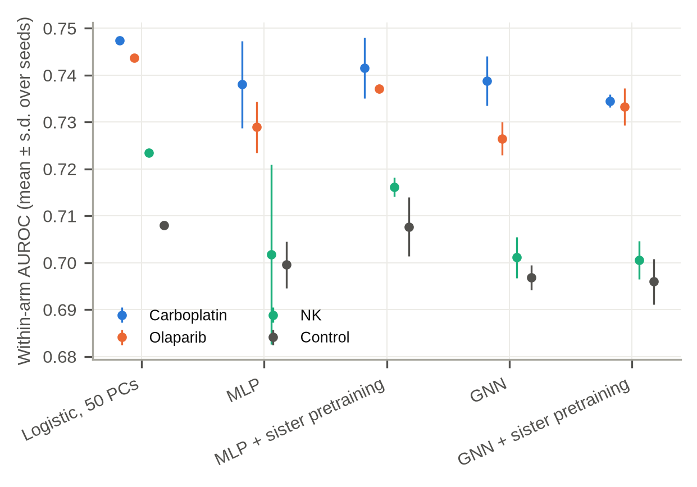
Supplementary Fig. 1 | Graph model ablation. Within-arm AUROC for logistic regression, an MLP, an MLP with sister-pair pretraining, the graph network, and the graph network with pretraining (mean ± s.d. over seeds).
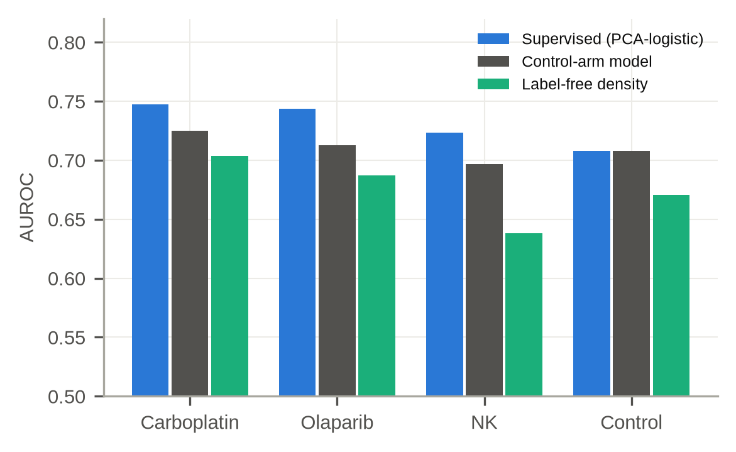
Supplementary Fig. 2 | Label-free typicality. AUROC of the local-density score (negative mean distance to the 15 nearest neighbours within the sample), compared with the supervised PCA-logistic model and the control-arm (fitness) model, for each arm.
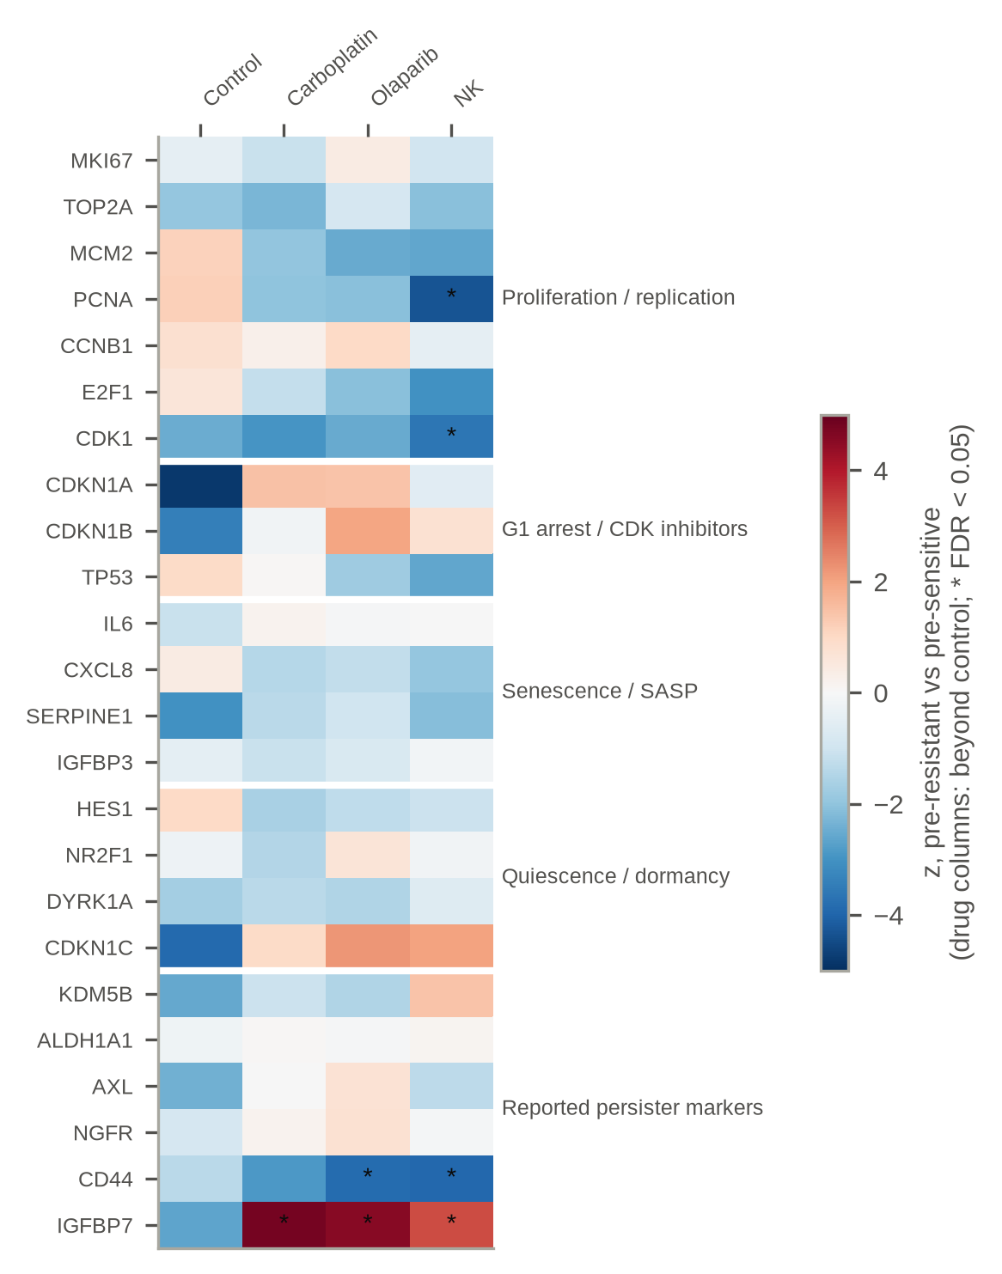
Supplementary Fig. 3 | Pre-specified marker panel. z-scores for pre-resistant versus pre-sensitive cells. The control column shows the control (fitness) contrast; the drug columns show the difference from the control contrast, $z_{\text{diff}}=(z_{\text{drug}}−z_{\text{control}})/\sqrt{2}$. Asterisks mark FDR < 0.05 for z_diff. Genes not among the 5,005 retained genes (CDKN2A, RB1, GLB1, KDM5A) are omitted.
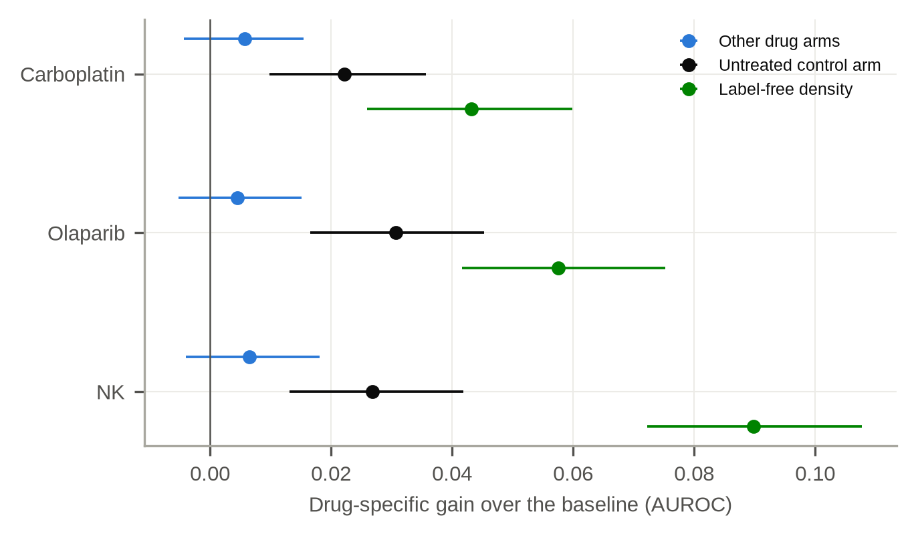
Supplementary Fig. 4 | Substitutes for an untreated arm. For each drug arm of ReSisTrace, the drug-specific gain measured against the real control-arm model (black) and against two substitutes that use no control-arm labels: a model trained on the other drug arms (blue) and the label-free density score (green). Error bars are 95% family-bootstrap intervals. The control-arm value lies between the two substitutes in every arm.
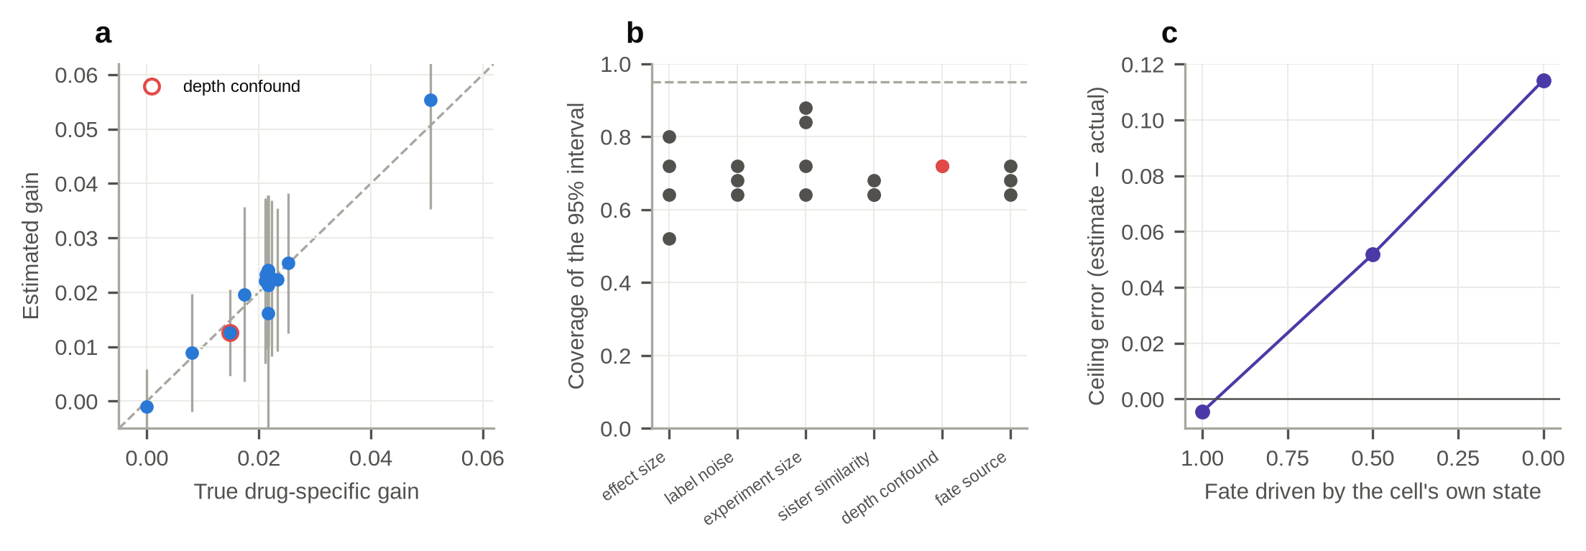
Supplementary Fig. 5 | The estimators checked against a known answer. a, Estimated against true drug-specific gain across synthetic settings; the line is equality and bars are the spread over 25 independent experiments. b, Coverage of the nominal 95% interval that resamples families without refitting the models, in each setting; the dashed line is 0.95. c, Estimated minus actual AUROC if the treated sister were scored, as fate moves from depending on the treated cell's own state (left, the estimator's assumption) to depending only on the state the sisters share (right).

References
Chen T, Kornblith S, Norouzi M, Hinton G. A simple framework for contrastive learning of visual representations. ICML (2020). arXiv:2002.05709
Dai J, Zheng S, Falco MM, et al. Tracing back primed resistance in cancer via sister cells. Nat Commun 15, 1158 (2024). doi:10.1038/s41467-024-45478-7 ✓
Hamilton WL, Ying R, Leskovec J. Inductive representation learning on large graphs. NeurIPS (2017). arXiv:1706.02216
Pellecchia S, Franchini M, Viscido G, et al. Single cell lineage tracing reveals clonal dynamics of anti-EGFR therapy resistance in triple negative breast cancer. Genome Med 16, 55 (2024). doi:10.1186/s13073-024-01327-2 ✓
Schaff DL, White PE, Cote CJ, et al. Pre-existing cell states predict resistance to multiple treatments. Cell Genom 6, 101191 (2026). doi:10.1016/j.xgen.2026.101191 ✓
Sharma SV, Lee DY, Li B, et al. A chromatin-mediated reversible drug-tolerant state in cancer cell subpopulations. Cell 141, 69-80 (2010). doi:10.1016/j.cell.2010.02.027 ✓

