MODULE 2 | AUTONOMOUS VEHICLES | PROJECT
Functional Architecture for a Level 4 Autonomous Vehicle
Perception, Decision-Making and Control Modules, with Safety Supervision, Interfaces and Verification Plan
Topic chosen: Option 1, Introduction to Autonomous Vehicles and Levels of Autonomy. Project: design a functional architecture for a Level 4 autonomous vehicle, detailing perception, control and decision modules.
Deliverables: (1) operational design domain and safety requirements, (2) sensor suite and coverage, (3) functional architecture diagram with six numbered data flows, (4) detailed perception, decision and control designs with algorithms and equations, (5) behaviour state machine, (6) safety and fallback architecture, (7) latency budget, scenario walk-throughs and a verification plan.
Nature of the work: This is a design study. Numerical values are design targets used to size the architecture and are not measurements from a built vehicle.

1. Introduction and Scope
A Level 4 (L4) vehicle drives itself completely within a defined operational design domain (ODD) and does not rely on a human to take over. That last point is what separates L4 from L3 and is the single biggest driver of the architecture in this report: if the system cannot continue, it must bring the vehicle to a safe stop by itself. Every design choice below follows from that requirement.
This report defines the ODD, derives the safety and timing requirements, and then presents a modular functional architecture with three core chains (perception, decision and planning, control) wrapped by an independent safety and supervision layer.

1.1 Where Level 4 sits among the SAE levels
Level | Name | Who drives / who is the fallback | Real-world examples | What it needs
L0 | No automation | Human drives; system may warn | Blind-spot or collision warning | Basic sensors, warning logic
L1 | Driver assistance | Human drives; system helps with steering OR speed | Adaptive cruise control, lane keeping alone | Radar or camera, simple control loops
L2 | Partial automation | Human supervises constantly; system steers AND controls speed | GM Super Cruise, Tesla Autopilot / FSD (Supervised) | Camera + radar, driver monitoring
L3 | Conditional automation | System drives in its ODD; human must take over when asked | Mercedes-Benz Drive Pilot (approved in Germany and some US states) | Redundant perception, takeover management, LiDAR common
L4 | High automation | System drives and is its own fallback inside the ODD; no human needed | Waymo and Baidu Apollo Go geofenced robotaxi services | Full 360 degree multi-sensor suite, HD maps, redundant compute and actuators, remote assistance
L5 | Full automation | System drives anywhere a human could | No commercial system today | Everything in L4 plus unrestricted ODD and generalisation
Table 1: SAE J3016 levels summarised. Examples are illustrative.

2. Operational Design Domain and Requirements

2.1 Operational design domain
The ODD is stated first because every requirement and test refers to it. The target service is a geofenced urban and suburban robotaxi or shuttle.
Dimension | Inside the ODD | Outside the ODD (triggers MRC or remote help)
Roads | Mapped urban and suburban streets, marked lanes, signalised junctions, roundabouts | Unmapped roads, unpaved roads, active road works without remote guidance
Speed | Up to 60 km/h (design maximum 80 km/h on arterials) | Motorway speeds above design maximum
Weather | Clear, overcast, light to moderate rain, night with street lighting | Heavy snow, dense fog, severe storms, sensor icing
Traffic | Vehicles, cyclists, pedestrians, e-scooters, parked vehicles | Police-directed traffic (needs remote assistance), unmapped closures
Connectivity | Cellular link for remote assistance and map updates | Loss of link is tolerated for a limited time; MRC if fault also occurs
Table 2: ODD definition.

2.2 Top-level safety goals
ID | Safety goal | Architectural response
SG1 | Avoid collisions with vulnerable road users and vehicles within the ODD | Redundant sensing, tracking, prediction, independent safety check
SG2 | Never command unintended acceleration or steering | Command limits, plausibility checks, independent monitor
SG3 | On any critical fault, reach a minimal risk condition without human help | Fallback compute channel, redundant brake and steering, MRC manager
SG4 | Recognise when the ODD is being left and react before it is left | ODD monitor for weather, map coverage and geofence
Table 3: Safety goals that drive the design.

2.3 Derived timing requirement: how far must the vehicle see?
The perception range must exceed the distance needed to stop. Stopping distance is the distance travelled during the system latency plus the braking distance:
d_stop = v * t_latency + v^2 / (2 * a)
Using a total sense-to-actuate latency of 0.35 s (from the latency budget in Section 8) and two braking levels, an emergency level of 8 m/s^2 (dry road) and a comfort level of 3 m/s^2, the required range is:
Speed | Latency distance | Braking distance (8 m/s^2) | Stop, emergency | Stop, comfort (3 m/s^2)
30 km/h | 2.9 m | 4.3 m | 7.3 m | 14.5 m
40 km/h | 3.9 m | 7.7 m | 11.6 m | 24.5 m
60 km/h | 5.8 m | 17.4 m | 23.2 m | 52.1 m
80 km/h | 7.8 m | 30.9 m | 38.6 m | 90.1 m
100 km/h | 9.7 m | 48.2 m | 57.9 m | 138.3 m
Table 4: Stopping distance versus speed (0.35 s latency, dry road).
Design consequence: at the 60 km/h ODD limit a comfortable stop needs about 52 m of reliable detection, and at 80 km/h about 90 m. The sensor suite therefore targets reliable detection of pedestrians and vehicles beyond 100 m ahead, with 200 m or more for the forward long-range sensors to leave margin for wet roads and perception dropouts. Wet roads lower achievable deceleration, so the planner reduces speed in rain rather than relying on dry-road braking.

3. Sensor Suite and Coverage
No single sensor works in every condition, so the suite combines three complementary technologies plus positioning and vehicle-state sources. Redundancy is by overlap: every direction that matters is covered by at least two independent sensing principles.
Sensor | Qty | Coverage (design target) | Strengths | Weaknesses
LiDAR (roof) | 1 | 360 degrees, ~200 m | Accurate 3D geometry, works at night | Rain, fog and dust degrade returns; cost
LiDAR (corner) | 4 | ~120 degrees each, ~30 m | Removes near-field blind spots | Short range
Cameras | 8 | Tele 30 deg ~200 m; wide 120 deg ~80 m; side and rear ~60 m | Colour and texture: traffic lights, signs, lane paint, pedestrian pose | Glare, low light, poor direct depth
Radar (long, front) | 1 | +/-10 deg, ~250 m | Direct speed via Doppler, weather tolerant | Low angular resolution, clutter
Radar (corner) | 4 | ~90 deg each, ~120 m | Cross-traffic and blind-spot speed measurement | Poor at classifying static objects
Ultrasonic | 12 | Ring, under 5 m | Cheap low-speed parking and creeping | Very short range
GNSS-RTK + IMU | 1 | Dual antenna | Absolute position, heading, dead reckoning | GNSS outages in tunnels and urban canyons
Wheel speed / steering angle | - | Via vehicle bus | Odometry for the localisation filter | Slip and calibration error
Table 5: Sensor suite. Ranges are design targets, not datasheet values for a specific product.
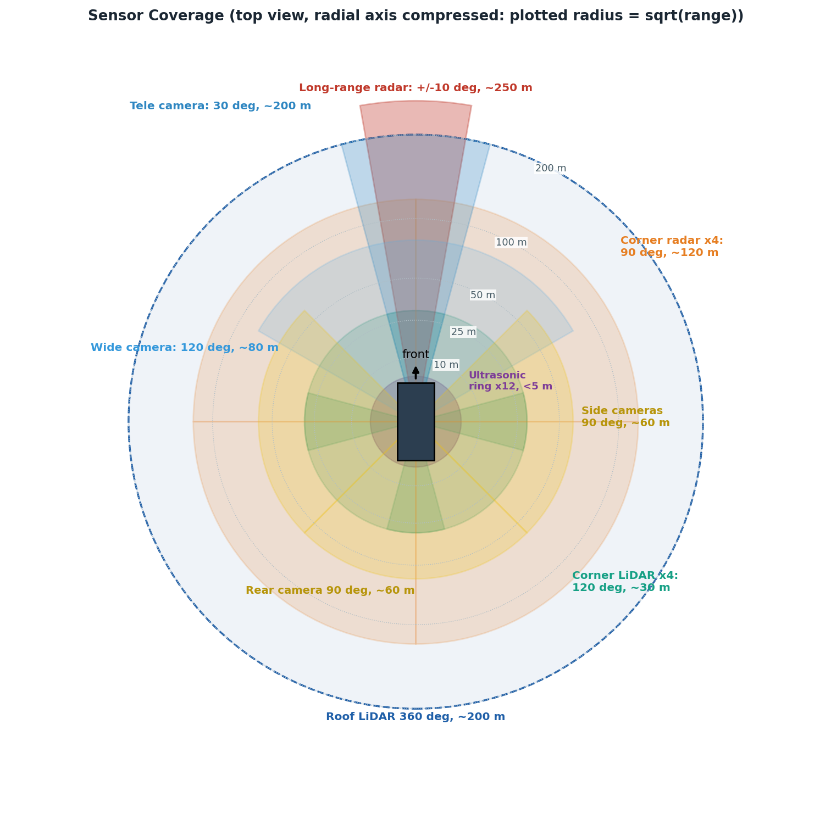
Figure 1: Top-down sensor coverage. The radial axis is compressed (sqrt scale) so near and far sensors fit on one plot; the range rings are true distances.

Figure 2: Level 4 Functional Architecture
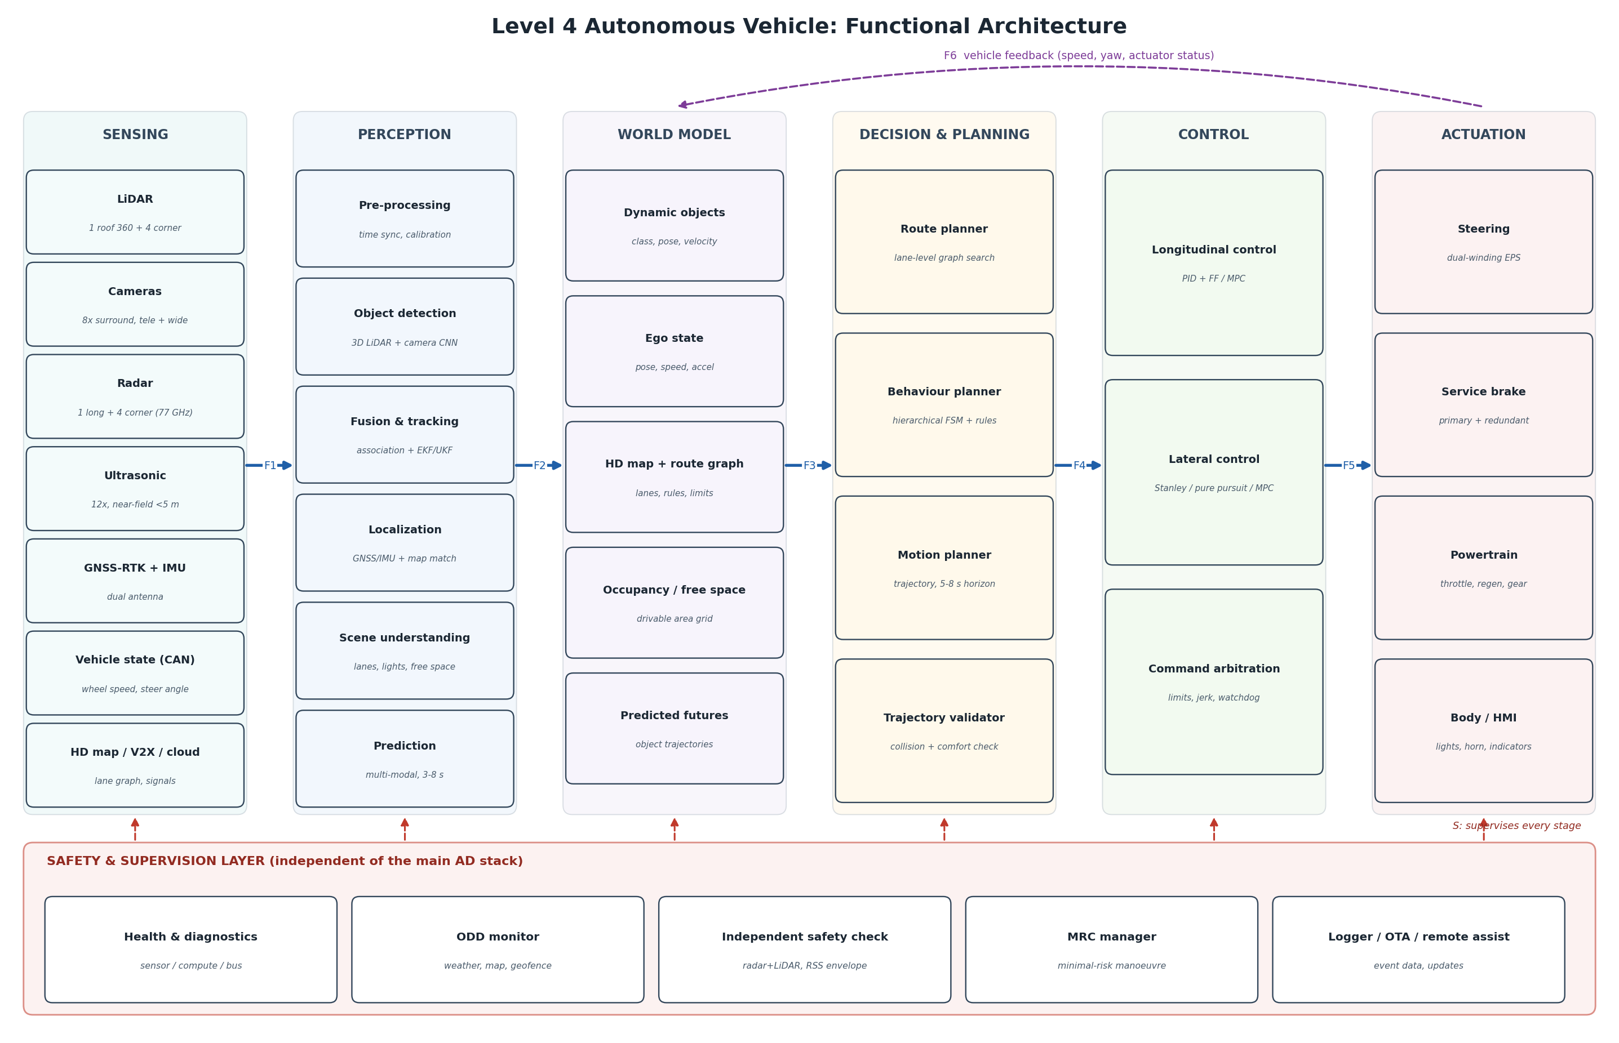
Data flows F1 to F6 are defined in Table 6. The safety and supervision layer runs on separate hardware and supervises every stage.

4. Functional Architecture
Figure 2 (previous page) shows the architecture as a left-to-right pipeline of six stages: sensing, perception, world model, decision and planning, control, and actuation. The vehicle state returns from actuation to the world model (F6), closing the loop. Underneath sits a safety and supervision layer that is deliberately independent of the main stack, so a software fault in the driving logic cannot disable its own watchdog.

4.1 Data flows between stages
ID | From to To | Content | Typical rate | Latency budget
F1 | Sensing to Perception | Point clouds, images, radar detections, GNSS/IMU, vehicle CAN, map and V2X data | 10-20 Hz LiDAR, 30 Hz camera, 20 Hz radar, 100+ Hz IMU | < 30 ms
F2 | Perception to World Model | Tracked objects (class, pose, velocity, uncertainty), ego pose, lanes, signals, free space, predicted trajectories | 10-20 Hz | < 140 ms
F3 | World Model to Decision | Consistent scene snapshot at a single timestamp, route graph, rules | 10 Hz | < 5 ms
F4 | Decision to Control | Validated trajectory: sampled (x, y, heading, curvature, speed, acceleration) over 5-8 s | 10 Hz | < 90 ms
F5 | Control to Actuation | Steering angle, brake and drive requests, gear, lights | 50-100 Hz | < 10 ms
F6 | Actuation to World Model | Measured speed, yaw rate, steering angle, actuator health | 100 Hz | < 10 ms
Table 6: Data flows in Figure 2.

5. Perception Module
Perception converts raw signals into a consistent, timestamped description of the world: what is around the vehicle, where the vehicle is, and what will happen next. It has six functional blocks.
Block | Function | Typical methods | Output
Pre-processing | Time synchronisation (PTP), intrinsic and extrinsic calibration, LiDAR motion compensation, ground removal, noise filtering | gPTP clocks, calibration files, ego-motion deskew | Aligned sensor frames
Object detection | Find and classify vehicles, pedestrians, cyclists and other objects in each modality | PointPillars or CenterPoint on LiDAR; YOLO-family CNN on images; radar clustering | Boxes with class, confidence, velocity
Fusion and tracking | Associate detections across sensors and time, estimate state and uncertainty, manage track life cycle | Hungarian or JPDA association; EKF or UKF with CTRV motion model | Object tracks with covariance
Localization | Estimate ego pose in the map frame | EKF over GNSS-RTK, IMU and wheel odometry; LiDAR map matching (NDT or ICP) | Pose, heading, confidence
Scene understanding | Lane geometry, traffic lights and signs, drivable area | Lane and light CNNs cross-checked against HD map | Lanes, signal states, occupancy grid
Prediction | Forecast likely motion of each agent for the planning horizon | Intent classification plus multi-modal trajectory models constrained by lanes | Several trajectories per agent with probabilities
Table 7: Perception blocks.

Design points that matter for L4
- Fusion level. Detection runs per sensor and fusion happens at track level (late fusion) with a shared uncertainty model. If one sensor fails, the others still produce tracks, which supports graceful degradation.
- Uncertainty is a first-class output. Every track and the pose carry covariance. The planner uses it to widen safety margins when perception is unsure, and the health monitor uses it to detect degradation.
- Localization is cross-checked. GNSS and LiDAR map matching are compared. Disagreement beyond a threshold marks localization as degraded and reduces the permitted speed.
- Occlusion awareness. The occupancy grid tracks unknown space, so the planner can slow for blind driveways or parked-vehicle gaps instead of treating unseen space as empty.

6. Decision and Planning Module
The decision chain is split into three layers running at different rates. This hierarchy keeps discrete traffic-rule reasoning separate from continuous trajectory optimisation, which makes each part testable.
Layer | Rate | Job | Method
Route planner | On demand | Find a lane-level route from origin to destination and re-route on closures | Dijkstra or A* on the HD-map lane graph
Behaviour planner | 10 Hz | Choose the manoeuvre: follow, change lane, yield, stop, overtake, emergency brake | Hierarchical finite state machine with rule checks (right of way, speed limit, gap acceptance)
Motion planner | 10 Hz | Generate a smooth, collision-free trajectory that executes the chosen manoeuvre | Frenet-frame polynomial lattice or optimisation; cost on safety, comfort (jerk), progress and rule compliance
Trajectory validator | 10 Hz | Independently verify the trajectory against predicted occupancy and vehicle limits before release | Collision and kinematic feasibility check, RSS-style distance rule
Table 8: Decision and planning layers.

6.1 Behaviour state machine
The behaviour planner is a finite state machine (FSM). An FSM is chosen for the top level because its behaviour is explicit, auditable and easy to verify against traffic rules, which matters for safety argumentation. Figure 3 (next page) shows the states and transitions; Table 9 lists the guard conditions.

Figure 3: Behaviour Planner State Machine
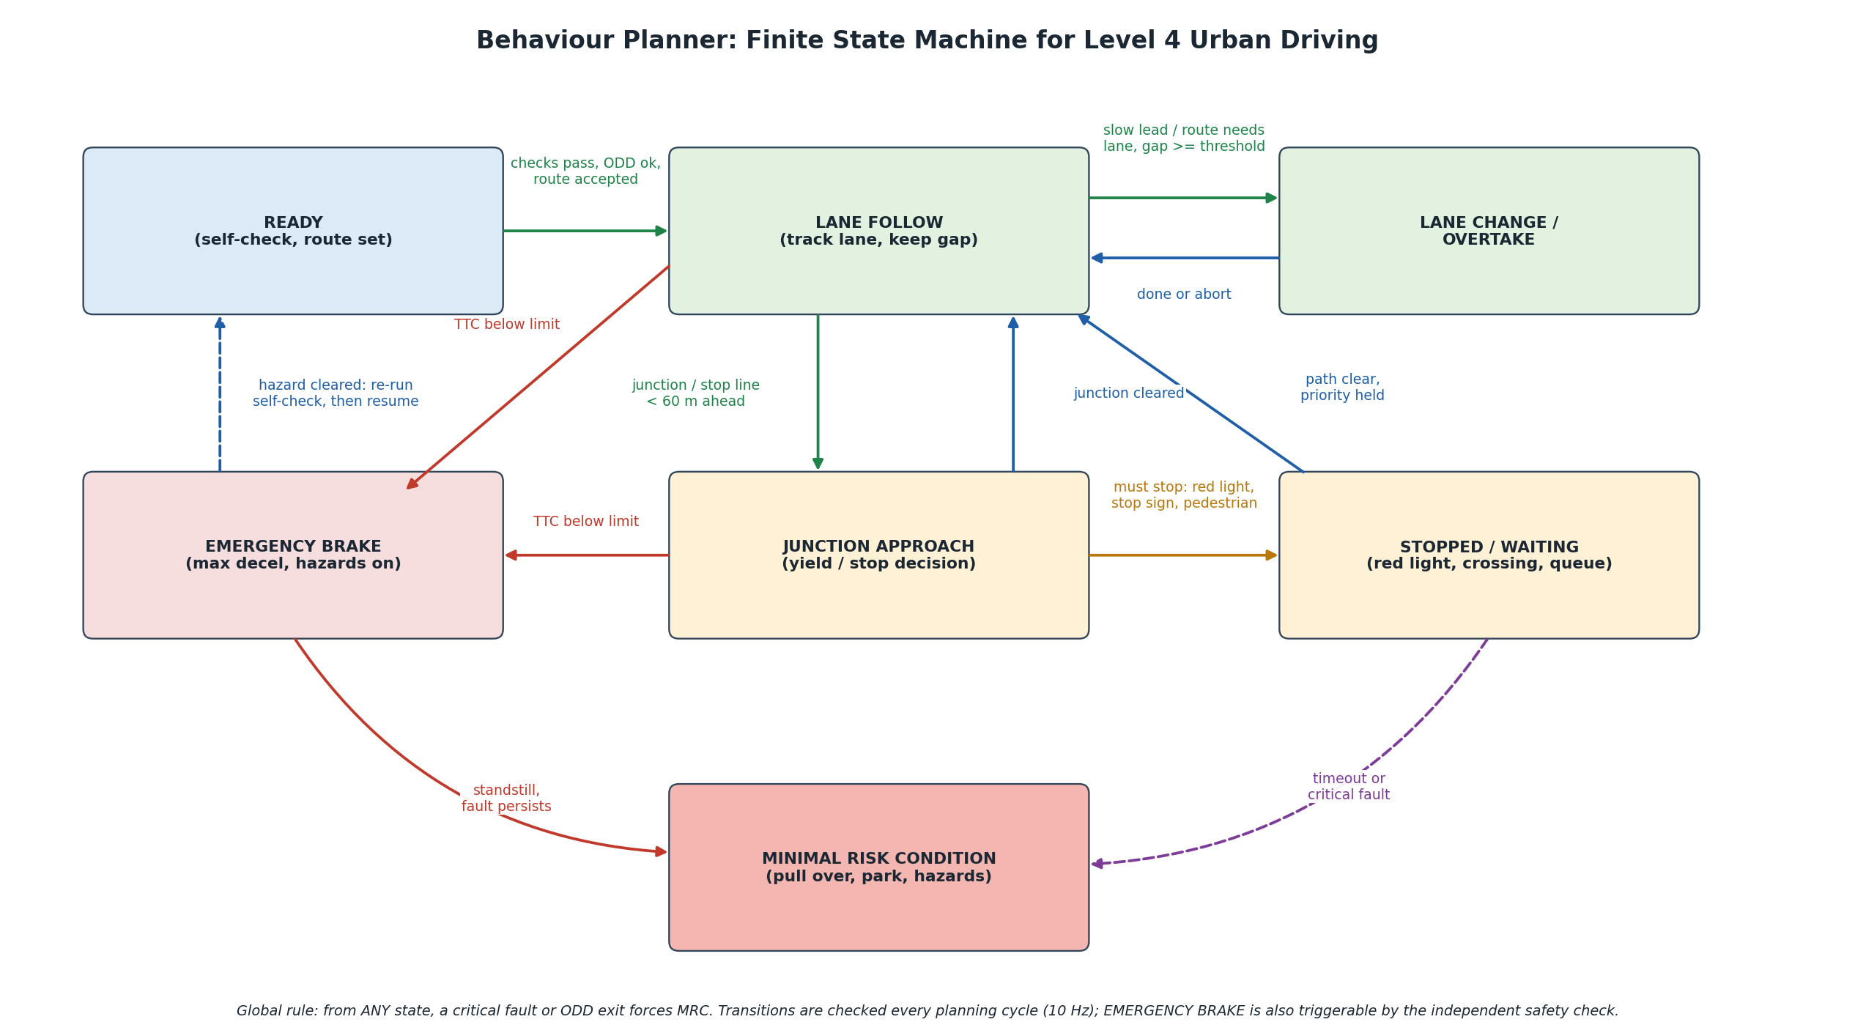
Solid arrows are normal transitions; the dashed purple arrow and the global rule at the bottom show the fault paths to the minimal risk condition (MRC).

Transition | Guard condition | Notes
READY to LANE FOLLOW | Self-check passed, ODD valid, route accepted, localization healthy | Only entry into autonomous driving
LANE FOLLOW to LANE CHANGE | Slow lead vehicle or route needs another lane AND target gap exceeds threshold AND no fast-approaching vehicle behind | Abort allowed while the manoeuvre is less than half complete
LANE FOLLOW to JUNCTION APPROACH | Junction, stop line, crossing or roundabout within about 60 m on the route | Speed profile is planned to be able to stop at the line
JUNCTION APPROACH to STOPPED | Red light, stop sign, pedestrian in or entering crossing, or blocked exit | Stop before the line with comfortable deceleration
STOPPED to LANE FOLLOW | Green signal or clear crossing AND right of way held AND exit space free | Creep speed first if visibility is limited
Any driving state to EMERGENCY BRAKE | Time to collision below limit or independent safety check triggers | Full braking, hazard lights on
EMERGENCY BRAKE to MRC | Vehicle at standstill and fault persists | Hazard cleared and healthy returns to READY for re-check
Any state to MRC | Critical fault or ODD exit | Pull over if space and speed allow, otherwise stop in lane with hazards
Table 9: Transition guards for Figure 3.

6.2 Safety distance rule used by the validator
The validator applies a responsibility-sensitive-safety (RSS) style minimum following distance. For a rear vehicle (ego) behind a front vehicle travelling in the same direction, the minimum safe longitudinal gap is:
d_min = v_r*rho + 0.5*a_acc*rho^2 + (v_r + rho*a_acc)^2 / (2*b_min) - v_f^2 / (2*b_max)
where v_r and v_f are rear and front speeds, rho is the response time, a_acc is the maximum acceleration the rear vehicle may apply during the response time, b_min is the minimum braking the rear vehicle is guaranteed to apply, and b_max is the maximum braking the front vehicle may apply. If the planned gap is smaller than d_min, the trajectory is rejected and the behaviour planner is told to slow. The values of rho, a_acc, b_min and b_max are tuning parameters that would be calibrated for the ODD.

7. Control Module
Control turns the validated trajectory into actuator commands. Longitudinal and lateral control are separated for clarity, but they share a single command arbitration stage that enforces limits before anything reaches the vehicle.

7.1 Longitudinal control
- Tracks the speed and gap profile from the trajectory.
- Structure: feed-forward acceleration from the plan plus a PID (or MPC) correction on speed error, with anti-windup.
- Converts a requested acceleration into throttle or regenerative torque or brake pressure, using a calibrated vehicle map.
- Limits: comfort jerk of about 2 m/s^3 and deceleration up to 3 m/s^2 in normal driving; up to about 8 m/s^2 only in EMERGENCY BRAKE.

7.2 Lateral control
Lateral control tracks the path with a steering angle command. Two classical geometric controllers are shown because they are simple, robust and easy to tune; a model predictive controller can replace them where tighter tracking or higher speeds require it.
Pure pursuit steers toward a look-ahead point on the path:
delta = atan( 2 * L * sin(alpha) / l_d )
with wheelbase L, look-ahead distance l_d (usually scaled with speed) and angle alpha between the vehicle heading and the look-ahead point.
Stanley controller combines heading error and cross-track error:
delta = psi_e + atan( k * e / v )
with heading error psi_e, cross-track error e at the front axle, speed v and gain k. The steering angle is clipped to the physical range and rate-limited so it never exceeds what the steering actuator can follow.

7.3 Command arbitration and actuator interface
- Rate and magnitude limiters on steering, acceleration and jerk, so a software error cannot request an unsafe value.
- Plausibility check against measured vehicle state (F6). A request the vehicle cannot follow raises a fault.
- Watchdog and heartbeat: if the command stream stops or is late, the actuation layer holds a safe state and the MRC manager takes over.
- Arbitration between the primary command channel and the fallback channel: the fallback overrides only when the safety layer declares a primary fault.
- Actuators are redundant: dual-winding electric power steering, and a primary plus secondary braking path, each on separate power feeds.

8. Latency Budget
The end-to-end budget in Table 10 is what justifies the 0.35 s used in Section 2.3. It should be verified with timestamps measured on the target hardware.
Stage | Budget | Comment
Sensor capture and pre-processing | 30 ms | Includes time sync and deskew
Object detection | 60 ms | GPU inference, sensors processed in parallel
Fusion and tracking | 20 ms | Association and filter update
Prediction | 30 ms | Runs on tracked objects and map
Behaviour and motion planning | 80 ms | Within a 100 ms planning cycle
Trajectory validation | 10 ms | Independent check
Control computation | 10 ms | 50-100 Hz loop
Actuator response | 100 ms | Brake build-up is the dominant term
Total sense-to-actuate | 340 ms | Rounded to 0.35 s in Table 4
Table 10: Latency budget (design target).

9. Safety and Fallback Architecture
An L4 system must be safe when parts of it fail, because there is no driver to catch it. The architecture uses independent redundancy and a small, simple supervisor that can act even if the main stack is misbehaving.

9.1 Redundancy strategy
Domain | Redundancy | Purpose
Compute | Primary AD computer plus a secondary fallback channel with reduced perception (radar and LiDAR) and a simple planner able to perform MRC; safety microcontroller as arbiter | Survive a primary compute or software failure
Sensing | Overlapping coverage from LiDAR, camera and radar; no single sensor is the only source for any critical direction | Survive one sensor failure or one weather-sensitive modality degrading
Power | Two independent supply paths for safety-critical loads | Survive a supply or wiring fault
Communication | Redundant vehicle network paths for actuator commands | Survive a bus fault
Actuation | Dual-winding steering motor; primary and secondary braking circuits | Retain steer and brake authority after a single fault
Table 11: Redundancy by domain.

9.2 Graceful degradation
Fault or condition | Detection | Response
One camera fails | Health monitor, missing frames | Continue with reduced speed; other cameras, radar and LiDAR cover the direction
Roof LiDAR fails | Missing returns, diagnostics | Limit speed, avoid complex manoeuvres, pull over at the next safe place
Localization confidence drops | Covariance growth, GNSS and map-match disagreement | Reduce speed, then stop safely if not recovered
Heavy rain or fog beyond the ODD | ODD monitor and sensor range statistics | Slow down and end the trip at a safe location
Primary compute fault | Watchdog and heartbeat loss | Fallback channel performs MRC
Primary brake circuit fault | Actuator diagnostics | Switch to secondary brake, then MRC
Loss of cellular link | Link monitor | Continue autonomously; do not depend on remote help for safety
Table 12: Example fault responses.

9.3 Standards that shape the design
- ISO 26262 (functional safety): hazard analysis, ASIL allocation and safety mechanisms for electrical and electronic faults.
- ISO 21448 (SOTIF): risk from performance limits without a fault, such as a perception miss in unusual conditions. This is critical for L4 perception.
- UL 4600: safety-case framework for autonomous products, requiring documented evidence that the system is safe.
- ISO/SAE 21434 and UNECE R155 / R156: cybersecurity and secure software updates.

10. Scenario Walk-throughs

10.1 Pedestrian steps into a crossing at 40 km/h
- Camera and LiDAR both detect a person at the kerb 35 m ahead; radar confirms motion. Fusion creates a confirmed track.
- Prediction gives two likely futures: waits, or enters the crossing. The second has high probability.
- The behaviour planner moves from LANE FOLLOW to JUNCTION APPROACH (crossing within 60 m) and plans a stop at the line.
- The pedestrian enters the crossing. The guard STOP condition becomes true. The trajectory decelerates at about 3 m/s^2, inside the comfort limit, because the distance is sufficient (Table 4 gives about 24.5 m for a comfort stop from 40 km/h).
- If the pedestrian had appeared later so that time to collision fell below the limit, the independent safety check would trigger EMERGENCY BRAKE at up to 8 m/s^2.
- When the crossing is clear and the exit is free, the state returns to LANE FOLLOW and the vehicle resumes.

10.2 Unprotected left turn with oncoming traffic
- Route planner marks the turn; behaviour planner enters JUNCTION APPROACH and stops or slows at the yield line.
- Prediction estimates arrival times of oncoming vehicles at the conflict point.
- The planner accepts a gap only if the time gap exceeds the vehicle's crossing time plus a safety margin, with the margin enlarged when track uncertainty is high.
- If no gap appears, the vehicle waits (STOPPED). If the wait exceeds a timeout, the system requests remote assistance rather than forcing the turn.

10.3 Roof LiDAR failure while driving
- Health monitor flags missing LiDAR returns within a few cycles.
- Supervisor lowers the allowed speed and disables lane changes; camera and radar keep tracking objects, with wider safety margins.
- The route planner is asked for the nearest safe pull-over location; the MRC manager executes the stop.
- Remote operations and the fleet back end are notified, and the event data is logged for analysis.

11. Verification and Validation Plan
Evidence should be gathered at increasing realism, with the same scenario definitions reused at each stage so results can be compared.
Stage | Method and tools | Example metrics (targets)
Module tests | Unit and integration tests for perception, planning, control; replay of recorded data | Detection recall and precision by class and range; tracking error; planner feasibility rate
Simulation (SIL) | CARLA or similar with OpenSCENARIO test suites; weather and lighting variations; fault injection | Collision count, minimum time to collision, rule violations, success rate per scenario class
Hardware-in-the-loop | Real compute and actuators with simulated sensors and vehicle | Latency p50 and p99 against Table 10; fault-response timing
Closed track | Pedestrian dummies, cut-ins, occluded crossings, sensor blinding, brake fault injection | Stopping distances versus Table 4; MRC reached within defined time and distance
Supervised public road | Safety driver, then remote monitoring, within the ODD | Interventions per 1000 km; hard-brake events; false-braking rate
Table 13: Verification and validation stages.
A quantitative example of a target is: pedestrian detection recall above 0.98 at 50 m in clear conditions, with a lower and explicitly documented figure in rain and at night. These numbers are placeholders to be set by the hazard analysis; the point of the plan is that every safety goal in Table 3 maps to at least one measurable test.

12. Conclusion
The architecture answers the central L4 question, what happens when something goes wrong with no driver present, by building safety into the structure rather than adding it afterwards. Perception provides a consistent, uncertainty-aware world model. The decision layer separates rule-based manoeuvre selection (a verifiable state machine) from trajectory generation, and an independent validator checks every plan. Control is simple and bounded, and it passes through arbitration that limits what can reach the actuators. Underneath, an independent supervision layer with redundant compute, sensing, power and actuation ensures a safe stop under single faults.
Natural extensions are to implement one slice in simulation (for example the decision module with stop, yield and turn behaviours in CARLA, which matches Option 4 of this module), and to refine the numeric targets through a formal hazard analysis for a specific vehicle and ODD.

References and Further Reading
- SAE International J3016: Taxonomy and definitions for terms related to driving automation systems.
- Shalev-Shwartz, Shammah, Shashua: On a Formal Model of Safe and Scalable Self-driving Cars (RSS), 2017.
- Paden et al.: A Survey of Motion Planning and Control Techniques for Self-driving Urban Vehicles, IEEE T-IV, 2016.
- Snider: Automatic Steering Methods for Autonomous Automobile Path Tracking (pure pursuit, Stanley), CMU, 2009.
- ISO 26262, ISO 21448, UL 4600, ISO/SAE 21434.

