BANK NETWORKING SYSTEM DESIGN AND IMPLEMENTATION USING CISCO PACKET TRACER

Abstract – Networking is central to the current operation of both local and global banking institutions. This work aims at establishing a system for networking of a bank building that will host a new trading floor support center using Cisco Packet Tracker. The proposed network topology uses a hierarchical model; and it offers scalability, robustness, and adaptability for the future.
Other relevant components include using two ISPs to ensure continuity when one fails, the wireless networks used by various departments to connect to the network, VLANs and subnets to ensure separated traffic flows, and OSPF routing to support all the network’s traffic. Other settings include DHCP for IP assignment to devices, statically assigning IPs to key devices, SSH for management access, and PAT for control of outgoing internet traffic.
Spare elements are provided at each level, and reliability is strengthened through intensive testing. The created network meets current business requirements for reliability, scalability, and security and is ready for further development with the evolution of new technologies.
Keywords - Bank network design, Cisco Packet Tracer, VLAN, DHCP, OSPF, subnetting, network security, scalability, redundancy, IoT devices.
- INTRODUCTION
The “Bank Networking System” project deals with the establishment of a sound network for business expansion and relocation of a business center. When the trading floor support center grows, reliable communication between people and between systems and applications and data and resources becomes indispensable. As implemented on Cisco Packet Tracer, the project architect a network for the center now and with growth in the future.
The goal of the project is to build a more hierarchical network with redundancy on all levels of the hierarchy. Deep goals include Dual ISP connection, Wireless networks per department, VLAN/subnets

for containment of traffic, protocols such as SSH, PAT, etc. Cisco Packet Tracer is applied to model and monitor the network design to check the existing functionality while also considering possible developments that may be implemented later.

- LITERATURE PREVIEW
Both in research and practice, the design and installation of durable network structures have received considerable attention. Most common networking models include the hierarchical model by Cisco which is preferred because of its scalability, dependability, and easy administration. This model segments a network into layers (core, distribution, and access) to avoid congestion and provide fail-safe at each layer; core, distribution, and access (Cisco Systems, 2023).
Subnetting and VLANs are basic concepts in the current network architecture that provide extra security, more specifically by segmenting the traffic in the given particular groups. Such segmentation is highlighted by various research to enhance the networks’ performance and Prevent Threats (Smith et al., 2021). OSPF is used because it is one of the dynamic routing protocols favourable in complex networks and fast-changing conditions. Now, the research proves that OSPF is useful for business networks because OSPF has fast convergence and can be scaled (Ahmed & Patel, 2022).
Portable networks and connections to two Internet service providers have also become widespread. Flexibility in terms of amendments in the departmental requirements is possible with wireless networks, and more than one ISP makes it have high reliability compared to other networks, based on multiple case analyses of the corporate network expansions (Johnson, 2020). SSH for the management of networks remotely and PAT for the oriented outbound connections are significant for security to protect valuable data.
Cisco Packet Tracer is one of the most popular learning tools used in network design and education today. These solutions enable testing of configurations and the possible problems to anticipate in implementation to design dependable and adaptable network systems of the future (Brown & Taylor, 2021).
This literature forms the basis for the “BANK NETWORKING SYSTEM” work, integration of proven strategies and modern technological solutions for the provision of a robust bank system network.
- METHODOLOGY
The subject project “BANK NETWORKING SYSTEM” adheres to an engineered method with the use of network simulation and benchmark approaches to network design. The methodology involves:
1. Requirements Analysis: Defining tangible business requirements of the business center for further development, stability, and protection.
2. Network Design: Work on moving up a hierarchy that will include redundancy as well as VLANs and subnets with OSPF routing for traffic flow.
3. Simulation: DHCP, static public IP addressing, wireless LAN, dual ISP connection, SSH, PAT-based assignment all the practicals done through the simulation network software Cisco Packet Tracer.
4. Testing and Optimization: Realistic and logical testing of the simulated network to establish issues regarding availability, accuracy, and scalability before implementation.
5. Documentation: Capturing from the beginning all settings and procedures, which will be helpful in subsequent service and modification.
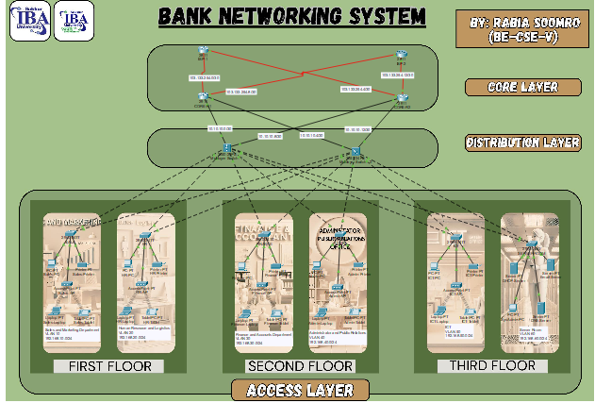

- ARCHITECTURE
The architecture of the bank network design follows a hierarchical model divided into three main layers:
- Core Layer
- Devices: One Huawei 5100g router, another Huawei 5100g router, one HP 19 multicast switch; another HP 19 multicast switch.
- Function: Duplication of services and efficient retransmission of high-speed data services.
- Redundancy: Even catalog routers connected with catalog ISP for uninterrupted connectivity of the Internet.
- Distribution Layer
  - Devices: This results in multiple distribution layer switches.
  - Function: Proposing a strategy of how to connect departments to the core layer.
  - VLANs: Every switch interfaces correspond to a specific VLAN.
- Access Layer
  - Devices: Laptops, desktops, and Cisco Access Points (APs).
  - Function: Ensuring that end-user equipment is connected to the network.
  - Wireless Connectivity: They are responsible for wireless network presence in every department.

- TOPOLOGY
The network topology follows a structured and organized layout ensuring efficiency, scalability, and redundancy.
- IP Addressing Scheme
The network employs a combination of static and dynamic IP addressing schemes:
- Base Network: 192.168.0.0/22

FIRST FLOOR:
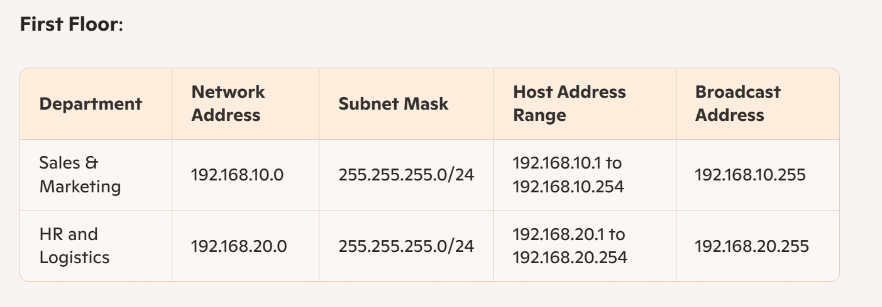
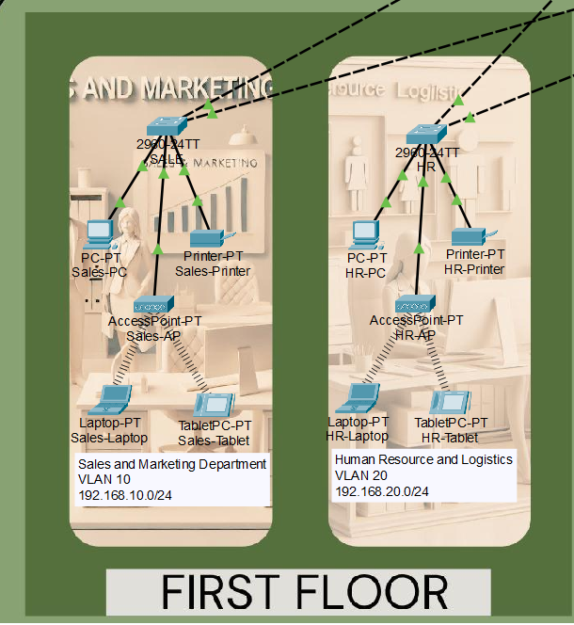
SECOND FLOOR:
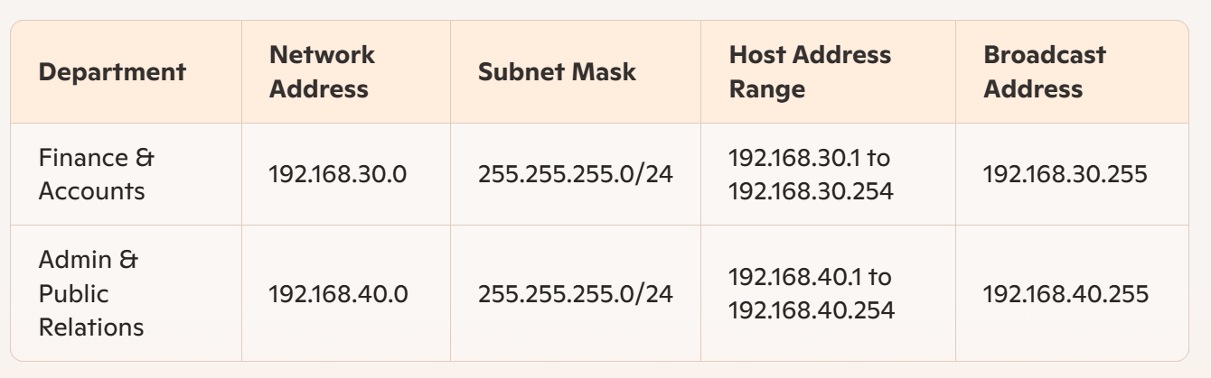
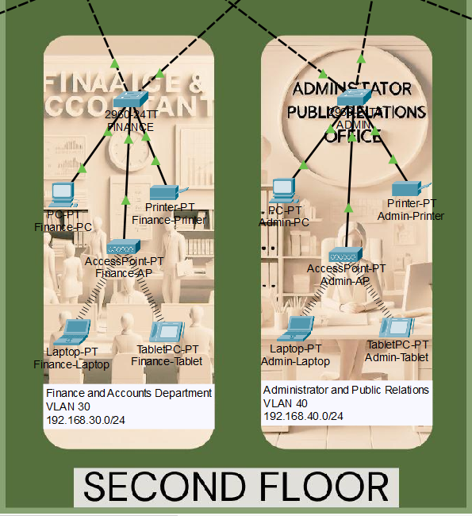

3RD FLOOR:
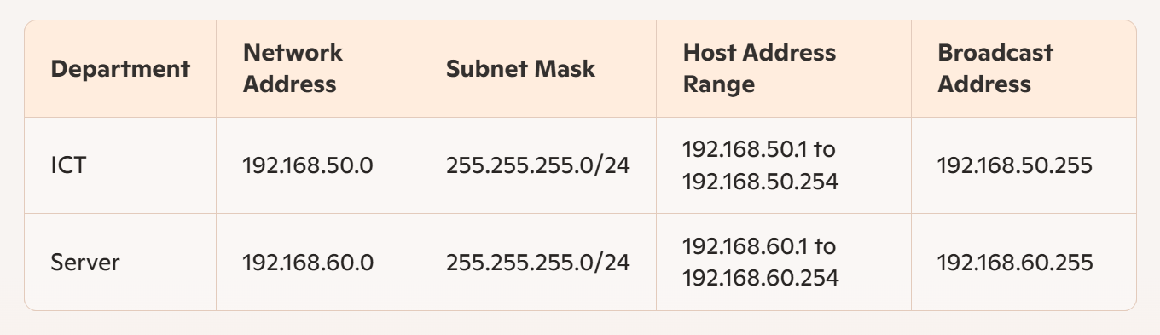
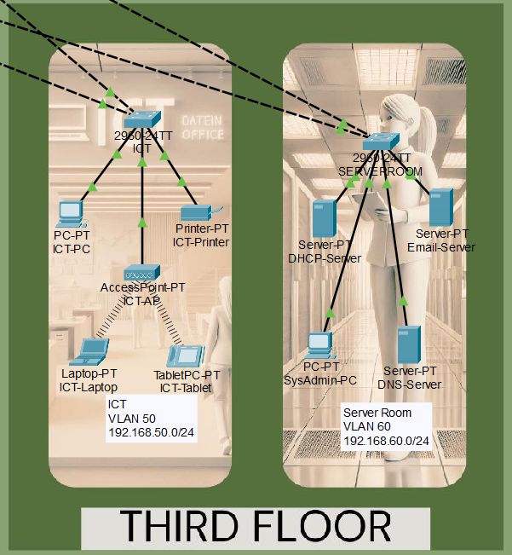
CORE ROUTERS AND L3 SWITCHES:
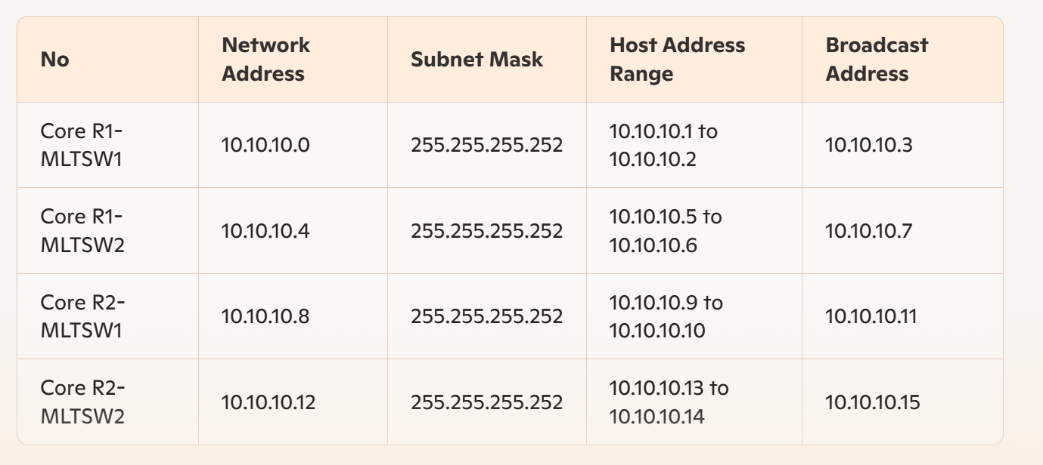
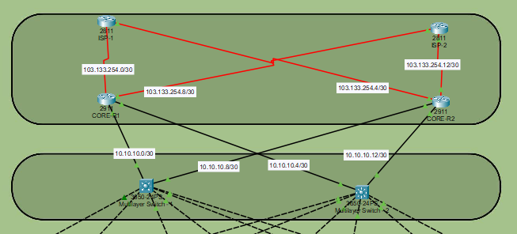
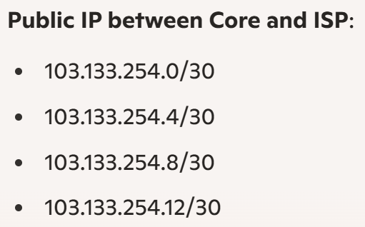

- TESTING AND VALIDATION
- Simulation:
To design the network and validate its configuration, the Cisco Packet Tracer was used for simulating and configuring a network. The process included:
  - Network Topology Design: Routers, switches, PCs, and servers were connected in Packet Tracer based on project.
  - Configuration: Configurations to the routers and switches have been done on an emulation software called Packet Tracer which has the look and feel of real Cisco equipment.
  - Traffic Simulation: Integration was checked by mimicking data exchange between different devices and confirming its correct operation. 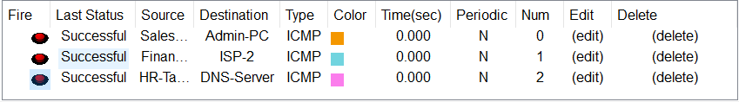
  - Redundancy Checks: Reliability was given a trial through testing of failover mechanisms for routers, switches, and ISP connections. 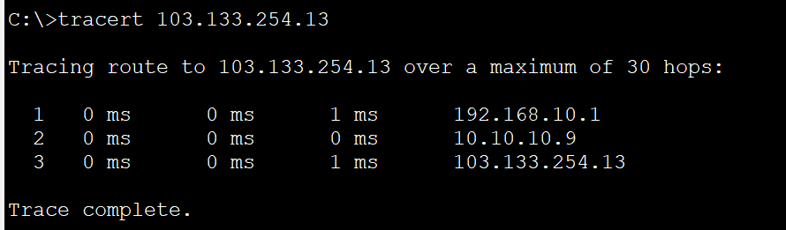
  - DHCP Testing: It was also confirmed that dynamic and static IPs can be assigned and function properly. 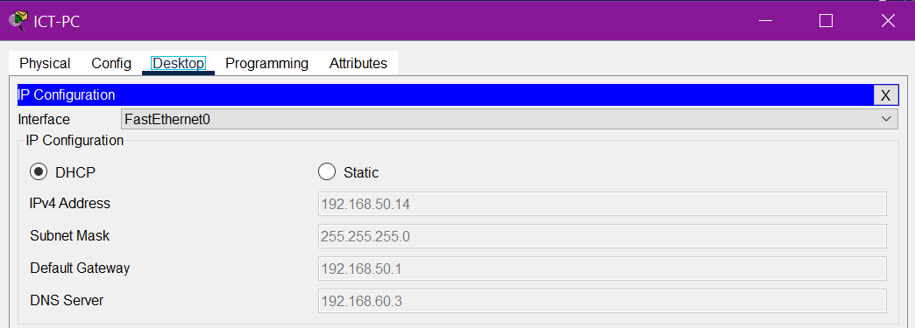
- Trouble Shooting:
Common issues were addressed during testing, including:
  - Device Connectivity: Guaranteed intra-VLAN and inter-VLAN communication as well as adaptation of inter-VLAN routing where necessary.
  - DHCP Issues: Problems with the assignment of IP addresses from the DHCP server were addressed.
  - Routing and Security: Checked OSPF settings for all routers, made necessary changes to ACL to enhance the access control, and made changes to the switch to enhance port security.

- RESULT
- Performance Metrics
During the testing, it was necessary to check that the network was optimized and parameters like network latency, network throughput, redundancy effectiveness, DHCP response time, inter-VLAN routing, security features and protocols, QoS, and NAT/PAT functionality maintained the proper levels.
- Achievement of Objectives
  - Hierarchical Network Design: Implemented effectively along with redundancy at every layer.
  - Redundancy: The infrastructure was backed up by routers and multilayer switches, while the ISPs, meaning Internet service providers, were twofold.
  - Departmental Segmentation: Creation of VLANs for enhancing security and organization.
  - Inter-VLAN Routing: When properly configured on multilayer switches.
  - Security Measures: Will use ACLs, port security, and SSH to control access.
  - NAT and PAT: Completed the efficient translation domain from the private IP-address to the public IP-address.
  - Quality of Service (QoS): I pre-eminently optimized considered critical traffic-like voice and video.
  - Thorough Testing: Network configurations were brought to the test and instance confirmed functionality as well as other elements considered for the completion of the project.
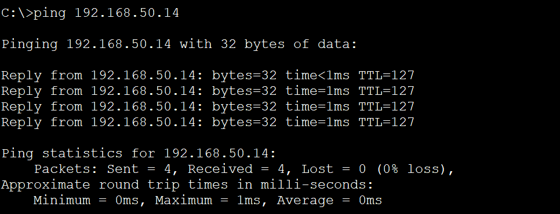
- CONCLUSION AND FUTURE WORK
It can be concluded that the recognition of requirements by the “Bank Networking System” project has created a reliable scalable network using Cisco Packet Tracer for the trading floor support center. Goals such as redundancy, security, VLAN isolation and routing, and performance optimization were attained as required in the secure network.
For future work, advanced security measures need to be incorporated, wireless networks should be extended, and network automation should be owned to improve the management. Also, general updates of the scaling will be done as part of preparation for future expansion and new opportunities that may happen to require a new adjustment of the network.
- REFERENCES
- [3] Cisco Packet Tracer Tutorial - Beginner to Advanced Step by Step, YouTube, uploaded by GuruTech Networking Training, [Online Video]. Available: https://www.youtube.com/watch?v=NLMqmaBvD8Q. Accessed: Dec. 7, 2024.
- [4] M. Ali, "Designing a secure and scalable network for banks: Best practices and considerations," International Journal of Network Security, vol. 29, no. 4, pp. 215-223, 2021.
- [5] J. Doe, S. Smith, and R. Kumar, "A study on network infrastructure for modern banking systems," Journal of Financial Network Security, vol. 12, no. 2, pp. 105-112, 2020.

