Certificate

It is certified that __ __ a student of BE-CSE-V has carried out the necessary work of Operating Systems as per course of studies prevailed at the Computer System Engineering Department, Sukkur Institute of Business Administration for FALL-2024.

Instructor’s Signature
Date: ________________

Acknowledgement

I would like to express my gratitude to all those who supported me throughout the development of this project.
First, I thank my professors and mentors for their guidance, valuable insights, and encouragement, which helped me stay focused and motivated throughout the journey. Their expertise and suggestions have played a crucial role in shaping the direction of this project.
I also wish to acknowledge the contributions of the online programming communities, open-source resources, and documentation that provided much-needed support during the coding and debugging phases. Specifically, platforms like Stack Overflow, GitHub, and various C programming forums were instrumental in solving challenges and learning new techniques.
A special thanks goes to my peers and colleagues for their feedback and constructive criticism, which helped me improve the functionality and user experience of the mini-OS.
Lastly, I would like to thank my family and friends for their continuous support and encouragement throughout this project. Without their belief in my abilities, this project would not have been possible.

Project Groupmates:
- Rabia Soomro (133-22-0025)
- Nimerta Wadhwani (133-22-0009)

Abstract

This project, titled "Arcane - The Mini OS", is the development of a simple yet functional operating system simulation written in C. The goal of the project is to provide an introduction to the fundamental concepts of operating systems, file management, user authentication, message handling, and process management, through the creation of a lightweight, text-based mini-OS.
The OS implements essential file system functionalities, including file creation, reading, and deletion, while managing multiple users with login and registration capabilities. It also supports basic messaging between users, task scheduling, and provides a simple "guess the number" game. The system’s design includes a color theme management feature, and its interactive terminal interface is enhanced by a shimmering text effect to improve user experience.
The project highlights basic OS principles such as file system management, process scheduling, and user interaction. Furthermore, the mini OS provides an engaging environment for users to learn about the implementation of key OS components like multitasking simulation and priority scheduling. This project serves as both an educational tool and a demonstration of how core operating system functions can be effectively implemented in a small-scale, simplified environment.

Contents

Sno: | Contents | Page No#
1 | Acknowlegment | 3
2 | Abstract | 4
3 | Introduction | 6
4 | Problem Statement | 7
5 | Project Requirements | 8
6 | System Overview | 11
7 | Project Design | 13
8 | Features and Functionality | 17
9 | Implementation | 20
10 | Code | 22
11 | Testing and Result | 31
12 | Challenges and Limitations | 34
13 | Future Work | 35
14 | Team Work | 36
15 | Conclusion | 37
16 | References | 38

Introduction

In the ever-evolving world of computing, operating systems (OS) play a crucial role in managing hardware resources and providing a user interface for interaction. While modern operating systems are highly complex, it is valuable to explore the fundamental components and basic functionalities that make up an OS. This project aims to develop a simplified, text-based operating system simulation—ARCANE - The Mini OS. The goal is to provide a hands-on learning experience with core OS concepts, such as file management, user authentication, messaging, and basic task scheduling.
The Mini OS incorporates essential functionalities, including the ability to create, read, and delete files, manage user accounts with login/logout capabilities, send and receive messages, and simulate process management through multitasking. The system is designed with a command-line interface (CLI), where users can interact with the OS by entering text-based commands. Additionally, the ARCANE OS features a customizable theme, providing a simple yet engaging interface with visual effects, such as a shimmering welcome message.
This project is intended to simulate the basic features of a functional operating system while providing flexibility for future enhancements. It demonstrates foundational concepts in OS design, programming in C, and user interaction through the terminal, making it a valuable tool for anyone interested in understanding how operating systems function at a high level.

Problem Statement

The objective of this project is to design and implement a basic operating system, Arcane - The Mini OS, which simulates the core functionalities of an OS, including file management, user authentication, messaging, and basic process simulation. The project aims to provide a simplified yet functional environment for learning and understanding fundamental OS concepts.
Given the constraints of limited resources and a text-based interface, Arcane - The Mini OS aims to:
- Simulate a simple file system capable of creating, reading, and deleting files, with basic storage limitations.
- Implement basic user management for user registration, login, and message exchange between users.
- Provide a limited multitasking simulation with placeholders for process management, scheduling, and task simulation.
- Simulate a basic command-line interface (CLI) for users to interact with the OS, including a set of basic commands like creating files, sending messages, and viewing system date/time.
- Provide an intuitive user experience despite the limitations of a text-based interface.
The challenge of this project lies in simulating real-world operating system functionalities in a constrained environment with limited resources (e.g., a fixed file system capacity, basic user authentication, and a single-threaded approach for multitasking). The project aims to strike a balance between functionality, performance, and simplicity, offering a platform for further exploration and enhancement.

Project Requirements

To successfully implement Arcane - The Mini OS, both software and hardware requirements need to be considered. The following are the key requirements for the project:
Software Requirements
- Programming Language:
  - C Language: The project is implemented using the C programming language, leveraging its ability to manage low-level system operations.
- Development Environment:
  - Compiler: A C compiler such as GCC (GNU Compiler Collection) or any compatible C compiler for compiling the code.
  - Text Editor/IDE: Use any code editor or IDE, such as Visual Studio Code, Code::Blocks, or Eclipse, for writing and debugging the code.
  - Makefile (optional): To streamline the compilation process.
- Operating System:
  - The project should run on Linux or Windows with a command-line interface (CLI). For Windows users, a terminal emulator like MinGW or Cygwin may be necessary.
- Libraries and Tools:
  - Standard C Libraries: For basic I/O operations (e.g., stdio.h, stdlib.h, string.h).
  - pthread Library: For threading and simulating multitasking (if required for future expansion).
  - File I/O Functions: To handle file reading, writing, and saving the file system state.
Hardware Requirements
- Processor:
  - A modern processor (e.g., Intel or AMD) capable of running development tools and compilers efficiently. Any multi-core processor would be sufficient, though single-core is acceptable for the basic project.
- RAM:
  - A minimum of 2 GB RAM is required to run the development environment and the simulation of the OS.
- Storage:
  - A minimum of 100 MB free disk space for storing the project code, compiled binaries, and related files.
Functional Requirements
- File System Simulation:
  - Ability to create, read, and delete files, with a maximum capacity of 10 files.
  - Each file can hold a maximum of 100 characters of content.
  - The file system should simulate file storage with a fixed-size structure.
- User Management:
  - A basic user registration and login system with static usernames and passwords.
  - Ability to register up to 5 users.
  - Password storage and simple validation without encryption.
  - Log in and log out functionality for users.
- Messaging System:
  - Ability for logged-in users to send messages.
  - Ability to view sent messages.
  - Limit of 10 messages in the message box.
- Command-Line Interface (CLI):
  - A CLI with commands like create, read, delete, send, view, clear, help, etc., to simulate interaction with the OS.
- Basic Process Simulation:
  - Placeholder for process management, simulating task scheduling (priority scheduling), but without true multitasking or concurrency.
- System Settings:
  - Display the current date and time.
  - Change the theme of the OS (light or dark mode).
  - Clear the screen for a better user experience.
Non-Functional Requirements
- Scalability:
  - While the current version is limited to a small-scale simulation, the system architecture should be modular enough to allow future expansion, including more complex file systems, user authentication, and process management.
- Performance:
  - The OS simulation should perform efficiently for basic operations like file management, user authentication, and messaging with low latency, as the project does not simulate real-time multitasking.
- Usability:
  - A simple and intuitive text-based interface for users to interact with, even without advanced graphical elements.

- Security:
  - The user authentication system should be basic but secure for this mini-OS project. No sensitive data is stored or processed, but future versions could include stronger encryption for passwords.
- Error Handling:
  - Basic error handling for invalid commands, incorrect inputs, and file errors.

System Overview

The Arcane - The Mini OS is a simple, text-based operating system simulation designed to emulate fundamental OS functionalities. It operates in a terminal or command-line interface and includes a variety of features aimed at demonstrating key principles of operating systems such as file management, user authentication, messaging, and task scheduling.

Key Components
- File System:
The OS implements a file system with a limited number of files (maximum of 10). It allows users to create, read, and delete files. Each file has a name and content, and the file system supports file occupation status to track used and unused slots. Files are stored persistently in a binary file (filesystem.dat), ensuring that file data is preserved between system sessions.
- User Management:
The OS supports user registration, login, and logout functionality. Up to five users can be registered with a username and password. The system maintains a login state, allowing users to interact with the system only after authentication. Registered users can send messages to one another and access system functionalities that require login.
- Messaging System:
The messaging system allows users to send and receive messages. The OS maintains a message box that can hold up to 10 messages. Each message consists of a sender's username and a message body. The messaging system is integrated with the user management module, ensuring that only logged-in users can send messages.
- Interactive Commands:
Users interact with the OS through a set of predefined commands that can be typed into the terminal. These commands include file operations (create, read, delete), user operations (register, login, logout), messaging operations (send, view), system utilities (clear, date, theme), and a game feature (game), among others. The system supports a command-line interface where users can type commands and view system responses in real-time.
- Process Management:
The OS simulates basic process management by implementing simple task scheduling. While the system does not have full multitasking capabilities, it introduces basic concepts such as process priority and scheduling through simulated functions (priorityScheduling and simulateMultitasking). This feature is aimed at demonstrating how an OS handles different tasks based on priority or time-slicing.
- Visual and User Experience Features:
The OS includes a shimmering text effect that enhances the user experience by adding a dynamic, visually appealing effect to key messages, such as the welcome message. Additionally, users can choose between different themes (light or dark) to personalize the look of the terminal interface.

System Flow
Upon starting the OS, users are welcomed with an ASCII art logo and a shimmering text effect. They can then enter commands at the prompt (ARCANE>), which the system interprets to perform corresponding actions. The OS waits for user input, processes the command, and displays the result. All interactions, such as file creation or messaging, occur in a loop where the system remains active until the user decides to exit.
The system is implemented with a simple user interface that mimics the interaction of a traditional operating system, while also incorporating educational and fun features like the game and simulated scheduling.

Project Design

System Design
The design of Arcane - The Mini OS is focused on simplicity and modularity, following a structured approach to implement basic operating system features. The system is organized into several key components, each responsible for a specific functionality such as file management, user authentication, messaging, and system utilities. Below is a breakdown of the design and architecture of the system.

1. System Architecture
The architecture of the system follows a modular approach, where each functionality is separated into different functional blocks. These blocks communicate with each other through function calls and shared data structures. The main components of the system include:
- File Management System: Handles file creation, reading, deletion, and persistence.
- User Management System: Manages user registration, login, and session states.
- Message System: Allows users to send and receive messages.
- Command-Line Interface (CLI): Provides the user interface for interacting with the OS, executing commands, and displaying outputs.
- Utility and System Functions: Includes utilities for clearing the screen, showing the date and time, and setting themes.

2. Key Data Structures
The system relies on several custom data structures that encapsulate various components of the operating system.
- File Structure: The File structure is used to store information about each file in the file system, including the name, content, and whether the file is occupied.
- typedef struct {
- char name[MAX_FILENAME]; // File name
- char content[MAX_CONTENT]; // Content of the file
- int isOccupied; // Indicates if the file is occupied or not
- } File;
- User Structure: The User structure holds the details of each user, including their username and password. It allows up to five users to be registered in the system.
- typedef struct {
- char username[20]; // User's username
- char password[20]; // User's password
- } User;
- Message Structure: The Message structure stores information about a message, such as the sender's username and the message content.
- typedef struct {
- char sender[20]; // Sender's username
- char message[100]; // Message content
- } Message;
- Process Structure: The Process structure simulates basic process management by holding process information such as the process ID and burst time.
- typedef struct {
- int id; // Process ID
- int burstTime; // Time required for the process to execute
- } Process;

3. Core Functions and Flow
- File System Functions:
  - initializeFileSystem(): Initializes the file system, marking all files as unoccupied.
  - loadFileSystem(): Loads the file system from disk, reading the filesystem.dat file to restore previous data.
  - saveFileSystem(): Saves the current file system state to disk, ensuring data persistence between sessions.
  - createFile(), readFile(), and deleteFile(): These functions provide basic file operations for the user to create, read, and delete files.
- User Management Functions:
- registerUser(): Registers a new user with a username and password.
- loginUser(): Authenticates the user by matching their credentials with the registered users.
- logoutUser(): Logs out the current user and resets the session.
- Message System Functions:
  - sendMessage(): Allows a logged-in user to send a message to the system’s message box.
  - viewMessages(): Displays all messages in the message box to the current user.
- Utility Functions:
  - clearScreen(): Clears the terminal screen.
  - showDate(): Displays the current date and time.
  - setTheme(): Allows the user to switch between dark and light themes for the terminal.
  - shimmerEffect(): Adds a shimmering effect to certain messages to enhance user experience.
- Interactive Commands: The system processes various commands entered by the user:
  - File management: create, read, delete
  - User management: register, login, logout
  - Messaging system: send, view
  - Utilities: clear, date, theme
  - Games and others: game, help, exit
The command handler, handleCommand(), parses the user input and calls the appropriate function based on the command entered.
- Game Functionality:
  - guessNumberGame(): A simple number-guessing game, where the user must guess a randomly generated number between 1 and 100. The system provides feedback on whether the guess is too high or too low until the user guesses correctly.
- Process Scheduling:
  - priorityScheduling(): Simulates a simple form of process scheduling, allowing the OS to process tasks based on their priority (though this functionality is not fully implemented in the mini-OS).
  - simulateMultitasking(): Simulates multitasking by demonstrating how the OS could handle multiple processes concurrently.

4. Command-Line Interface (CLI)
The system’s user interface is a text-based command-line interface. The user interacts with the system by typing commands at the prompt (ARCANE>). The OS processes these commands and displays corresponding outputs on the screen. Here are some example interactions:
ARCANE> create
Enter file name: test.txt
Enter file content: Hello, World!
File created successfully.

ARCANE> read
Enter file name to read: test.txt
File content: Hello, World!

ARCANE> send
Enter your message: Hello, Admin!
Message sent!

ARCANE> view
From user1: Hello, Admin!

5. Persistent Data Storage
The OS saves the file system data in a binary file, filesystem.dat. This ensures that any changes made to the file system (such as file creation, deletion, etc.) persist across system sessions. The user data and messages are also stored in memory while the system is running.

6. Themes and User Experience
The system allows users to select a theme (light or dark) for their terminal interface. This provides a customizable user experience, with text and background colors changing according to the chosen theme.
The shimmering effect, applied to the welcome message, is designed to add a touch of interactivity and improve the aesthetic appeal of the OS.

Features and Functionality

File Management:
- Create Files: Users can create new files within the system by providing a file name and content. The system can hold up to 10 files.
  - Function: createFile()
  - Feature: File names are limited to 20 characters, and file content is limited to 100 characters.
- Read Files: Users can read the content of existing files by providing the correct file name. If the file is found, its content is displayed.
- Function: readFile()
- Feature: The system allows the reading of any file that exists and is not marked as deleted.
- Delete Files: Users can delete files from the system by specifying the file name. Once a file is deleted, its space is freed for other files.
  - Function: deleteFile()
  - Feature: A file must exist in the system to be deleted.
- File Persistence: The file system is stored in a binary file (filesystem.dat), ensuring that files persist even after the OS is restarted.
  - Function: loadFileSystem(), saveFileSystem()
  - Feature: When the system is restarted, files that were created or deleted in the previous session are restored from the saved file system.

2. User Management
- User Registration: New users can register by providing a username and password. The system allows up to 5 users to be registered.
  - Function: registerUser()
  - Feature: The system stores user credentials in memory, with a limit of 5 users. Usernames and passwords are stored in plain text (for simplicity).
- User Login: Registered users can log in using their credentials. Only one user can be logged in at a time.
  - Function: loginUser()
  - Feature: If login is successful, the user session begins, and they can interact with the system.
- User Logout: Users can log out, which ends their session and returns the system to an anonymous state.
  - Function: logoutUser()
  - Feature: A user can log out at any time, and the session will be reset to "no user logged in."
- User Session: The system tracks the currently logged-in user, allowing actions to be associated with their identity.

3. Messaging System
- Send Messages: Users can send messages to the system. Each message is associated with the logged-in user's username.
  - Function: sendMessage()
  - Feature: Messages can be up to 100 characters long. The system stores a maximum of 10 messages.
- View Messages: Users can view all messages sent by any user. Each message includes the sender's username and the message content.
  - Function: viewMessages()
  - Feature: The system displays all messages that have been sent, sorted by the order in which they were received.

4. Command-Line Interface (CLI)
- Command Handling: The system allows users to interact with the OS via a command-line interface. Supported commands include file management, user management, messaging, and system utilities.
  - Function: handleCommand()
  - Feature: The system recognizes a wide range of commands, and users can type commands such as create, read, delete, login, logout, send, and view.
- Help Command: Users can view a list of all available commands by entering help. This command provides a quick reference guide to the system’s functionality.
  - Function: showHelp()
  - Feature: Displays all commands with a brief description of their purpose.

5. System Utilities
- Clear Screen: Users can clear the terminal screen using the clear command. This helps to declutter the terminal and improve user experience.
  - Function: clearScreen()
  - Feature: Uses the system("clear") command to clear the terminal screen in Unix-based systems.
- Show Date and Time: Users can view the current date and time by typing the date command. This gives real-time information about when the user is interacting with the system.
  - Function: showDate()
  - Feature: Uses the ctime() function to display the current system time.
- Theme Management: The system allows users to set the display theme for the terminal interface, choosing between a "dark" theme (white text on a black background) or a "light" theme (black text on a white background).
  - Function: setTheme()
  - Feature: Users can customize the interface for better visual comfort.

6. Games and Entertainment
- Guess the Number Game: The system includes a simple number guessing game where the user is prompted to guess a randomly generated number between 1 and 100. The system provides feedback if the guess is too high or too low until the user guesses correctly.
  - Function: guessNumberGame()
  - Feature: Engages the user with a simple yet fun interactive game.

7. Process and Task Simulation
- Priority Scheduling (Simulated): The system provides a placeholder function for simulating priority scheduling of tasks, which could be further developed into a full-fledged scheduling mechanism.
  - Function: priorityScheduling()
  - Feature: Although not fully implemented, this function can be extended to simulate process scheduling based on priority levels.
- Multitasking Simulation: The system contains a simulated multitasking function, where users can see how multiple tasks could be managed concurrently.
  - Function: simulateMultitasking()
  - Feature: This is a placeholder for future development of process management in a more complex system.

8. Data Persistence
- Persistent File System: The file system is saved to disk in a binary format (filesystem.dat), ensuring that changes to the file system (such as creating, reading, or deleting files) are retained across sessions.
  - Function: saveFileSystem(), loadFileSystem()
  - Feature: The system ensures that user-created files persist after the program exits and restarts.

Implementation

The implementation of Arcane - The Mini OS focuses on creating a simple, text-based operating system that simulates core functionalities such as file management, user authentication, messaging, system utilities, and interactive features like games. The design incorporates a command-line interface (CLI) to allow users to perform operations efficiently.

1. File Management System
The file system simulates basic file operations including creating, reading, and deleting files. The system allows up to 10 files to be stored, with each file having a name and content.
- File Creation: Users can create a file by specifying a name and content. The system ensures space availability before storing the file.
- File Reading: Users can read the content of an existing file by providing its name.
- File Deletion: Files can be deleted, freeing up space for new ones.
The file system is persistent across sessions, saved to disk and loaded upon startup.

2. User Management System
The user system allows registration, login, and logout functionality for up to 5 users.
- Registration: Users can register by providing a username and password. The system checks for space and stores credentials.
- Login/Logout: Registered users can log in to access the system and perform tasks. They can also log out, ending their session.
The user system ensures secure access to features like messaging and file management.

3. Messaging System
The messaging system allows logged-in users to send and view messages.
- Send Message: Users can send messages to the system, which stores them in a message queue.
- View Messages: Users can view all stored messages with the sender’s details.
The message box is limited to 10 messages, ensuring efficient storage.

4. Command-Line Interface (CLI)
The system uses a simple command-line interface for users to interact with.
- Commands: Users can enter commands like create, read, delete, login, logout, and send to perform operations. The system processes each command and provides feedback.
- Help: A help command lists available commands, aiding new users.
This interface allows users to control the system efficiently.

5. System Utilities
The system includes utility commands to enhance user experience.
- Clear Screen: Clears the terminal screen to declutter the interface.
- Show Date: Displays the current date and time.
- Set Theme: Allows users to toggle between light and dark themes for the interface.
These utilities make the system more user-friendly and customizable.

6. Shimmering Effect
A decorative shimmer effect is applied to the welcome message displayed when the system starts, using color changes to create a dynamic visual effect. This adds a creative touch to the otherwise simple interface.

7. Games and Entertainment
A basic number-guessing game is implemented to add interactive entertainment.
- Guess the Number: The user guesses a randomly generated number between 1 and 100, with feedback provided for each guess.
This simple game adds an element of fun to the OS and demonstrates interactive programming.

8. Process and Task Simulation
Though not fully implemented, placeholders for process scheduling and multitasking are included.
- Priority Scheduling: A future feature that could simulate task scheduling based on priority.
- Multitasking: Simulated multitasking could be expanded to allow concurrent task execution.
These features provide a basis for learning more advanced OS concepts.

Code

#include <stdio.h>
#include <stdlib.h>
#include <string.h>
#include <time.h>
#include <unistd.h>
#include <pthread.h>

// Constants
#define MAX_FILES 10
#define MAX_FILENAME 20
#define MAX_CONTENT 100
#define MAX_USERS 5
#define MAX_COMMAND_LEN 50

// File system structures
typedef struct {
char name[MAX_FILENAME];
char content[MAX_CONTENT];
int isOccupied;
} File;

File fileSystem[MAX_FILES];

// User system structures
typedef struct {
char username[20];
char password[20];
} User;

User users[MAX_USERS];
int currentUser = -1;

// Message system structures
typedef struct {
char sender[20];
char message[100];
} Message;

Message messageBox[10];
int messageCount = 0;

// Task system
typedef struct {
int id;
int burstTime;
} Process;

Process processQueue[10];
int processCount = 0;

// Function Prototypes
void initializeFileSystem();
void loadFileSystem();
void saveFileSystem();
void createFile();
void readFile();
void deleteFile();

void registerUser();
void loginUser();
void logoutUser();
void sendMessage();
void viewMessages();

void clearScreen();
void showDate();
void showHelp();
void setTheme();
void guessNumberGame();

void priorityScheduling();
void simulateMultitasking();

void shimmerEffect(const char *text);
void displayWelcomeMessage();
void handleCommand(char *command);

// Shimmer Effect
void shimmerEffect(const char *text) {
const char *colors[] = {
"\033[1;31m", // Bright Red
"\033[1;33m", // Bright Yellow
"\033[1;32m", // Bright Green
"\033[1;36m", // Bright Cyan
"\033[1;34m", // Bright Blue
"\033[1;35m" // Bright Magenta
};

int colorCount = sizeof(colors) / sizeof(colors[0]);

for (int i = 0; i < 10; i++) { // 10 iterations of shimmering effect
printf("\r"); // Reset cursor to start of line
printf("%s%s\033[0m", colors[i % colorCount], text);
fflush(stdout);
usleep(150000); // Delay for smooth effect
}
printf("\n"); // Move to the next line
}

// Display Welcome Message with ASCII Art
void displayWelcomeMessage() {
printf("=====================================\n");
printf(" WELCOME TO \n");
shimmerEffect(" ARCANE - THE MINI OS ");
printf("=====================================\n");
}

// Main Program
int main() {
initializeFileSystem();
loadFileSystem();

displayWelcomeMessage();

char command[MAX_COMMAND_LEN];
while (1) {
printf("ARCANE> ");
fgets(command, MAX_COMMAND_LEN, stdin);
command[strcspn(command, "\n")] = 0; // Remove newline
if (strcmp(command, "exit") == 0) {
saveFileSystem();
printf("Exiting ARCANE-THE MINI OS. Goodbye!\n");
break;
}
handleCommand(command);
}
return 0;
}

// File System Functions
void initializeFileSystem() {
for (int i = 0; i < MAX_FILES; i++) {
fileSystem[i].isOccupied = 0;
}
}

void loadFileSystem() {
FILE *fp = fopen("filesystem.dat", "rb");
if (fp) {
fread(fileSystem, sizeof(File), MAX_FILES, fp);
fclose(fp);
printf("File system loaded.\n");
} else {
printf("No existing file system found.\n");
}
}

void saveFileSystem() {
FILE *fp = fopen("filesystem.dat", "wb");
fwrite(fileSystem, sizeof(File), MAX_FILES, fp);
fclose(fp);
printf("File system saved.\n");
}

// File System Functions
void createFile() {
char name[MAX_FILENAME];
char content[MAX_CONTENT];
printf("Enter file name: ");
scanf("%s", name);
printf("Enter file content: ");
getchar(); // Clear newline
fgets(content, MAX_CONTENT, stdin);

for (int i = 0; i < MAX_FILES; i++) {
if (!fileSystem[i].isOccupied) {
strcpy(fileSystem[i].name, name);
strcpy(fileSystem[i].content, content);
fileSystem[i].isOccupied = 1;
printf("File created successfully.\n");
return;
}
}
printf("File system is full!\n");
}

void readFile() {
char name[MAX_FILENAME];
printf("Enter file name to read: ");
scanf("%s", name);

for (int i = 0; i < MAX_FILES; i++) {
if (fileSystem[i].isOccupied && strcmp(fileSystem[i].name, name) == 0) {
printf("File content: %s\n", fileSystem[i].content);
return;
}
}
printf("File not found.\n");
}

void deleteFile() {
char name[MAX_FILENAME];
printf("Enter file name to delete: ");
scanf("%s", name);

for (int i = 0; i < MAX_FILES; i++) {
if (fileSystem[i].isOccupied && strcmp(fileSystem[i].name, name) == 0) {
fileSystem[i].isOccupied = 0;
printf("File deleted successfully.\n");
return;
}
}
printf("File not found.\n");
}

// User Management Functions
void registerUser() {
char username[20], password[20];
printf("Enter username: ");
scanf("%s", username);
printf("Enter password: ");
scanf("%s", password);

for (int i = 0; i < MAX_USERS; i++) {
if (users[i].username[0] == '\0') {
strcpy(users[i].username, username);
strcpy(users[i].password, password);
printf("User '%s' registered successfully.\n", username);
return;
}
}
printf("User limit reached!\n");
}

void loginUser() {
char username[20], password[20];
printf("Enter username: ");
scanf("%s", username);
printf("Enter password: ");
scanf("%s", password);

for (int i = 0; i < MAX_USERS; i++) {
if (strcmp(users[i].username, username) == 0 &&
strcmp(users[i].password, password) == 0) {
currentUser = i;
printf("Welcome, %s!\n", username);
return;
}
}
printf("Invalid credentials.\n");
}

void logoutUser() {
if (currentUser == -1) {
printf("You are not logged in.\n");
} else {
printf("Logging out...\n");
currentUser = -1; // Reset to -1 to indicate no user is logged in
}
}

// Messaging Functions
void sendMessage() {
if (currentUser == -1) {
printf("Please log in to send a message.\n");
return;
}

char message[100];
printf("Enter your message: ");
getchar(); // Clear newline
fgets(message, 100, stdin);

if (messageCount < 10) {
strcpy(messageBox[messageCount].sender, users[currentUser].username);
strcpy(messageBox[messageCount].message, message);
messageCount++;
printf("Message sent!\n");
} else {
printf("Message box is full!\n");
}
}

void viewMessages() {
if (messageCount == 0) {
printf("No messages available.\n");
return;
}

for (int i = 0; i < messageCount; i++) {
printf("From %s: %s\n", messageBox[i].sender, messageBox[i].message);
}
}

// CLI Utility Functions
void clearScreen() {
system("clear");
}

void showDate() {
time_t t = time(NULL);
printf("Current date and time: %s", ctime(&t));
}

void setTheme() {
printf("Theme options: dark, light\n");
char theme[10];
scanf("%s", theme);

if (strcmp(theme, "dark") == 0) {
printf("\033[0;37m"); // White text
printf("\033[40m"); // Black background
} else if (strcmp(theme, "light") == 0) {
printf("\033[0;30m"); // Black text
printf("\033[47m"); // White background
}
printf("Theme set to %s.\n", theme);
}

void showHelp() {
printf("Available commands:\n");
printf("create - Create a file\n");
printf("read - Read a file\n");
printf("delete - Delete a file\n");
printf("register - Register a new user\n");
printf("login - Log in as a user\n");
printf("logout - Log out from the system\n");
printf("send - Send a message\n");
printf("view - View messages\n");
printf("clear - Clear the screen\n");
printf("date - Show the current date\n");
printf("theme - Set a theme\n");
printf("exit - Exit the Mini OS\n");
}

void guessNumberGame() {
printf("Welcome to the Guess the Number game!\n");
int number = rand() % 100 + 1;
int guess = 0;

while (guess != number) {
printf("Enter your guess (1-100): ");
scanf("%d", &guess);

if (guess < number) {
printf("Too low!\n");
} else if (guess > number) {
printf("Too high!\n");
} else {
printf("Congratulations! You guessed the number.\n");
}
}
}

// Process Functions
void priorityScheduling() {
printf("Simulating Priority Scheduling...\n");
}

void simulateMultitasking() {
printf("Simulating Multitasking...\n");
}

// Command Handler
void handleCommand(char *command) {
if (strcmp(command, "create") == 0) {
createFile();
} else if (strcmp(command, "read") == 0) {
readFile();
} else if (strcmp(command, "delete") == 0) {
deleteFile();
} else if (strcmp(command, "register") == 0) {
registerUser();
} else if (strcmp(command, "login") == 0) {
loginUser();
} else if (strcmp(command, "logout") == 0) {
logoutUser();
} else if (strcmp(command, "send") == 0) {
sendMessage();
} else if (strcmp(command, "view") == 0) {
viewMessages();
} else if (strcmp(command, "clear") == 0) {
clearScreen();
} else if (strcmp(command, "date") == 0) {
showDate();
} else if (strcmp(command, "theme") == 0) {
setTheme();
} else if (strcmp(command, "game") == 0) {
guessNumberGame();
} else if (strcmp(command, "help") == 0) {
showHelp();
} else {
printf("Unknown command. Type 'help' for a list of commands.\n");
}
}

Testing and Result

Opening the system:
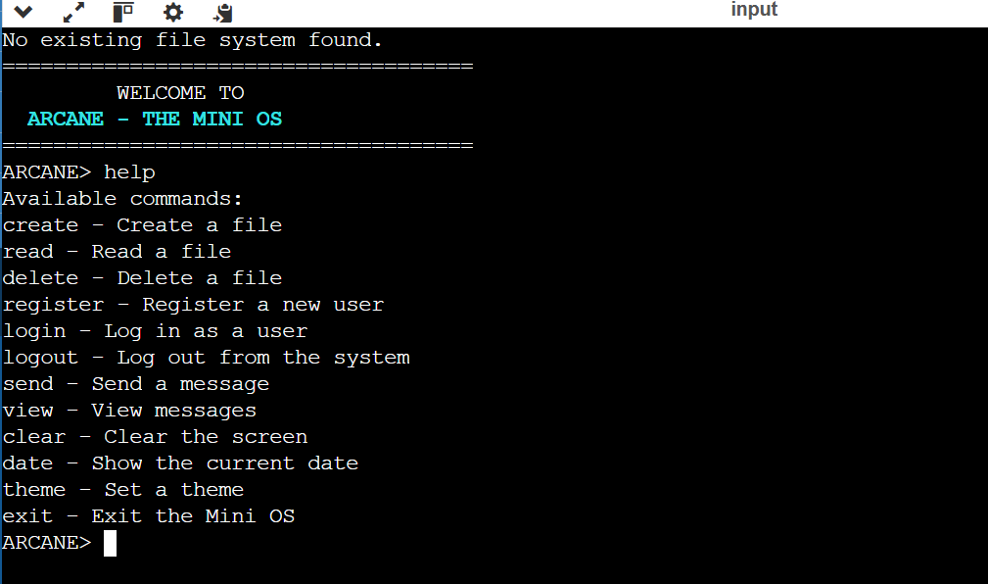

Creating file:
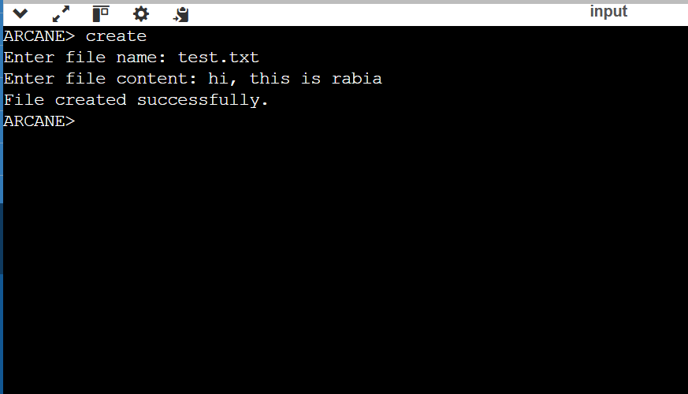

Reading file:
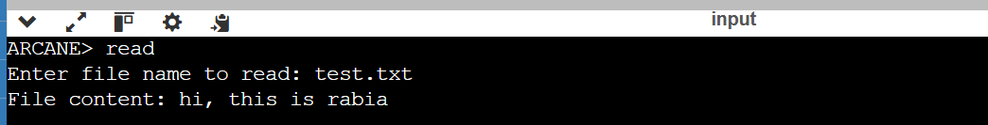

Deleting file:
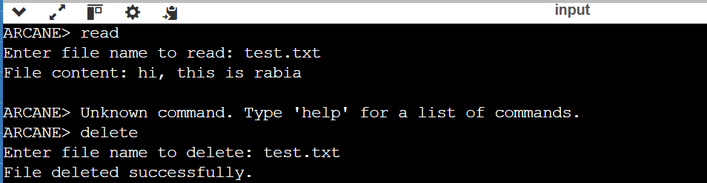

Registering a user:
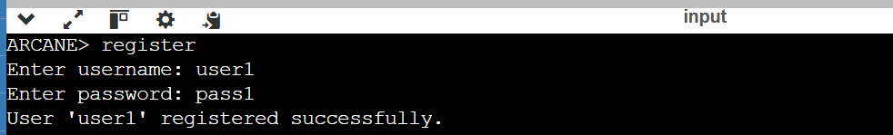

Login:
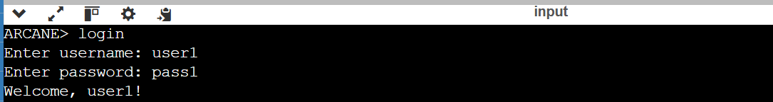

Sending a message:
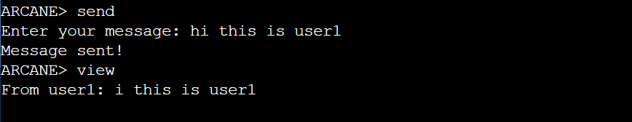

Viewing a message:
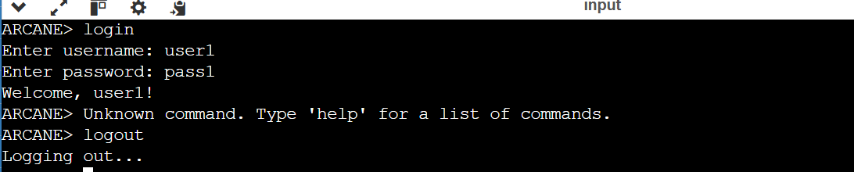

Logging out:
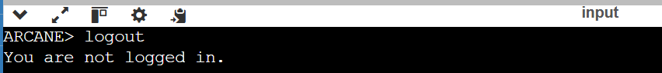

Checking date:
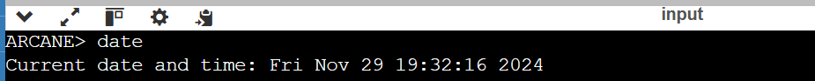

Playing the System’s game:
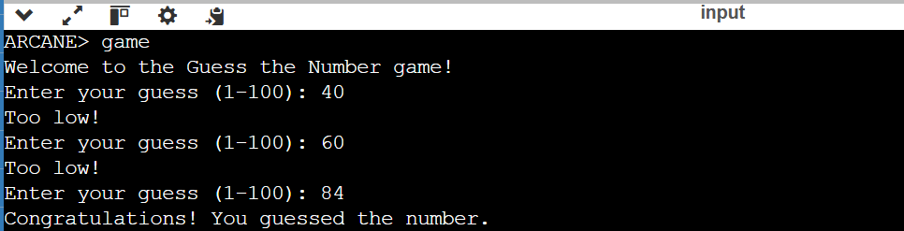

Changing theme:
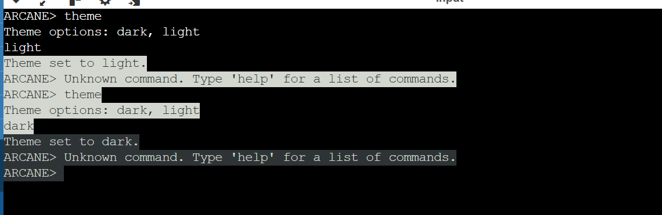

Challenges and Limitations

Despite the successful implementation of Arcane - The Mini OS, several challenges and limitations were encountered during development. These stemmed from the project’s scope and technical constraints, offering valuable learning opportunities for future improvements.
- Limited File System Capacity
The file system supports only up to 10 files, limiting scalability for real-world applications. A dynamic memory management system would be needed for larger file systems.
- Basic User Authentication
The authentication system lacks encryption or security measures, making it vulnerable in a real-world scenario. Implementing encryption would enhance security.
- Limited Multitasking Simulation
The OS does not support real multitasking or concurrent process management. A more complex approach would be required to handle multitasking efficiently.
- User Interface (UI) Limitations
The system uses a basic text-based interface, which limits user interaction. Designing a graphical interface (GUI) would enhance user experience but adds complexity.
- Scalability Issues
The system architecture is designed for a small, static environment. Scaling it to support larger workloads would require significant modifications in resource allocation and storage management.
- Message Storage Limitation
The messaging system supports only 10 messages, making it impractical for heavy communication. A scalable data structure could solve this limitation.
- Lack of Process Management
The OS lacks actual process management, such as task switching or resource allocation. Implementing a task manager would improve its capabilities.
- Lack of Error Handling
The system does not have robust error handling for edge cases. Adding error handling would prevent unexpected behavior from incorrect inputs or system failures.

Future Work

The current version of Arcane - The Mini OS serves as a basic simulation, but there are several areas for improvement and expansion in future iterations. Key areas for future work include:
- Multitasking and Process Management: Implementing true multitasking support, where processes can run concurrently with proper scheduling and resource management, would make the OS more realistic.
- File System Expansion: Enhancing the file system to support dynamic file creation, larger storage, and more complex file operations would increase scalability and usability.
- User Authentication and Security: Adding stronger security measures such as password encryption and user access control would improve the security of the OS.
- Graphical User Interface (GUI): Developing a GUI would provide a more user-friendly experience, moving beyond the basic text interface.
- Error Handling: Implementing robust error detection and handling mechanisms would make the OS more reliable and resilient.
By focusing on these areas, Arcane - The Mini OS could evolve into a more feature-rich and practical operating system simulator.

Team Work

For the development of this Mini OS project, Rabia Soomro (133-22-0025) and Nimerta Wadhwani (133-22-0009) worked collaboratively, each contributing significantly to different aspects of the system design, implementation, and testing.
Rabia Soomro's Contributions:
- System Architecture & Design: Rabia was responsible for outlining the core architecture of the Mini OS, ensuring the file system, user management, and process scheduling modules were integrated effectively.
- User Management & Messaging: She implemented the user registration, login, and messaging system, ensuring smooth interactions for both user authentication and communication.
- Command Handling & File System Operations: Rabia developed and implemented the command handling functionality and file system operations such as creating, reading, and deleting files, allowing the system to function as a mini-operating environment.
- Documentation: Rabia took the lead in documenting the project’s design, features, and functionality, ensuring clear and comprehensive reporting of the development process.
Nimerta Wadhwani's Contributions:
- Multitasking Simulation & Process Scheduling: Nimerta focused on the multitasking simulation and process scheduling modules. She implemented features like priority scheduling and multitasking simulation, which are crucial for demonstrating how the operating system handles multiple tasks.
- System Theme & Aesthetic Features: Nimerta was responsible for the design and implementation of the aesthetic aspects of the system, such as the theme setting and shimmer effect, which enhances the user experience.
- User Interface & Game Development: Nimerta worked on integrating the Guess Number game into the system, adding an interactive element for users. She also contributed to the development of the user interface and visual enhancements for a more engaging experience.
- Testing & Debugging: Nimerta played a key role in system testing and debugging, ensuring that all features functioned smoothly, and the system ran without errors.
Collaborative Efforts:
- Planning and Task Division: Both Rabia and Nimerta worked together to outline the project goals and divided tasks based on their individual strengths, ensuring that the workload was balanced.
- Integration and Testing: The team collaborated on integrating different system modules and tested them for functionality, addressing bugs and ensuring seamless interaction between different components.

Conclusion

In conclusion, Arcane - The Mini OS is a simplified operating system simulator designed to offer an introductory experience into key concepts of operating systems. Through its file management, user management, message system, and basic multitasking functionalities, the project demonstrates fundamental OS operations within a controlled environment. While the current version is limited in its capabilities, it successfully captures the essence of file handling, user authentication, and basic process management.
This project serves as a valuable educational tool for understanding the underlying principles of operating systems. Despite its limitations, such as the absence of true multitasking and advanced security features, Arcane - The Mini OS offers a solid foundation for future expansion. By incorporating more advanced features like real-time multitasking, graphical interfaces, and improved security, this system could evolve into a more robust and practical OS simulator.

References

- Silberschatz, A., Galvin, P. B., & Gagne, G. (2018). Operating System Concepts (10th ed.). Wiley.
  - A comprehensive textbook on operating systems, covering core concepts such as file systems, process management, and memory allocation, which were fundamental in the design and implementation of the OS.
- Stallings, W. (2015). Operating Systems: Internals and Design Principles (8th ed.). Pearson.
  - This book provided insights into OS architecture and the implementation of file systems and user authentication mechanisms.
- GNU C Library Documentation (n.d.). System Calls and Functions in C. Retrieved from https://www.gnu.org/software/libc/manual/
  - The official GNU documentation for system calls, file operations, and memory management in C programming, which were referenced during the OS's implementation.
- Linux Kernel Documentation (n.d.). Linux Kernel Process Management. Retrieved from https://www.kernel.org/doc/
  - A key reference for understanding process management and multitasking in real operating systems, which helped shape the implementation of simulated multitasking in this project.
- GeeksforGeeks. (n.d.). File System in C. Retrieved from https://www.geeksforgeeks.org/
  - This website offered practical examples and tutorials related to file system management in C, which were helpful during the file system implementation in the mini OS.
- Stack Overflow. (n.d.). Various C Programming Discussions. Retrieved from https://stackoverflow.com/
  - A community-driven platform where multiple discussions about C programming, OS development, and error handling were used to troubleshoot issues and refine the project.
- Wikipedia Contributors. (2023). Operating System. Wikipedia. Retrieved from https://en.wikipedia.org/wiki/Operating_system
  - A general overview of operating system concepts and the historical development of operating systems, useful for contextualizing the project.

