Brandon Walker

CS4370

Parallel Programming Many-Core GPUs

Meilin Liu

30-Nov-2024

Histogram

My histogram program has all required functionality, with both parts of the assignment in a single program, with the different parts clearly labeled in parenthesis. It lets you type in array size, and then creates an input array using the assigned random generation method, and then creates a histogram on the CPU, GPU using global memory, and then GPU using shared memory. It displays computation and memory transfer times, thread block size, number of thread blocks, and first ten elements of all inputs and outputs.

For the 131072 array size  
 CPU = 0.33ms  
 GPU(Global Mem)= 0.15ms

GPU(Shared Mem)=0.04s

Mem= 0.05ms

GPU(Global incl. Transfer)=0.21ms

GPU(Shared incl. Transfer)=0.09ms

For the 1048576 size array  
 CPU=2.19ms  
 GPU(Global)=0.61ms

GPU(Shared)=0.20ms  
 Mem=0.19ms

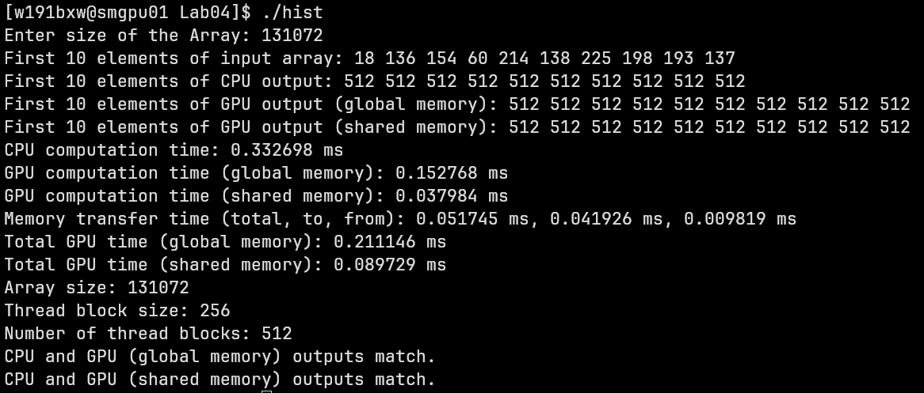GPU(Global Total)=0.81ms

GPU(Shared Total)=0.39ms

