CS4370

Parallel Programming Many-Core GPUs

Brandon Walker

Meilin Liu

23-Sep-2024

Project 1

My matrix addition program has all required functionality, as well as showing timing of cpu vs gpu. It is compiled with the following command. The extra part of the std= etc is necessary because of my timing functionality.

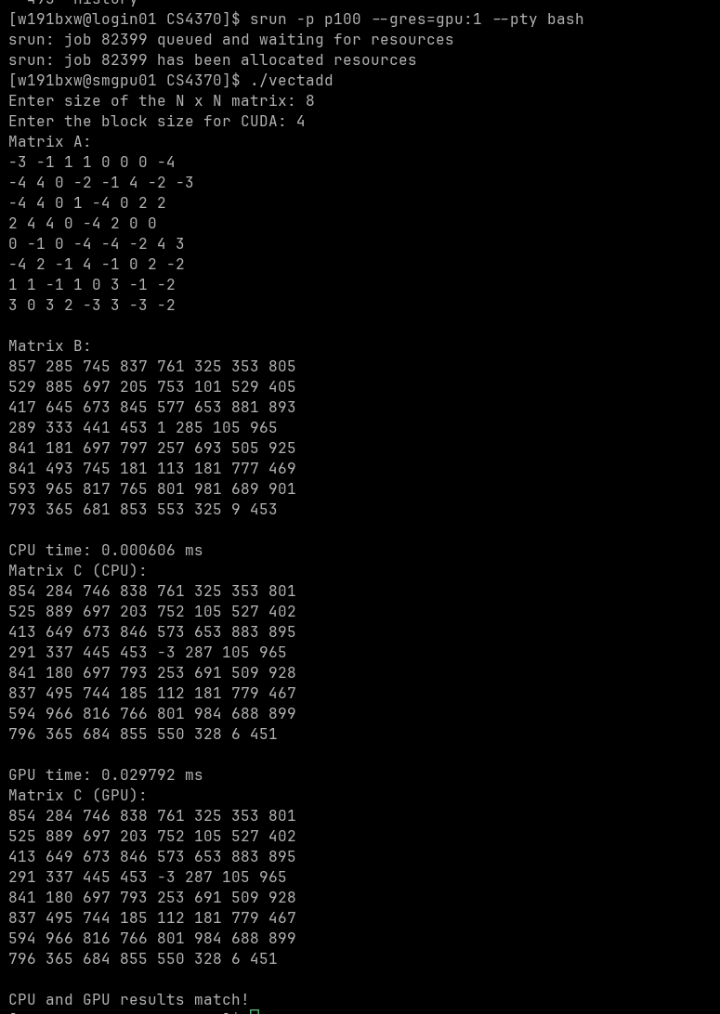nvcc Walker_vectadd.cu -o vectadd -std=c++11

My matrix multiplication program has all required functionality, with the added timing, and is compiled with the following command and same logic as the addition command.

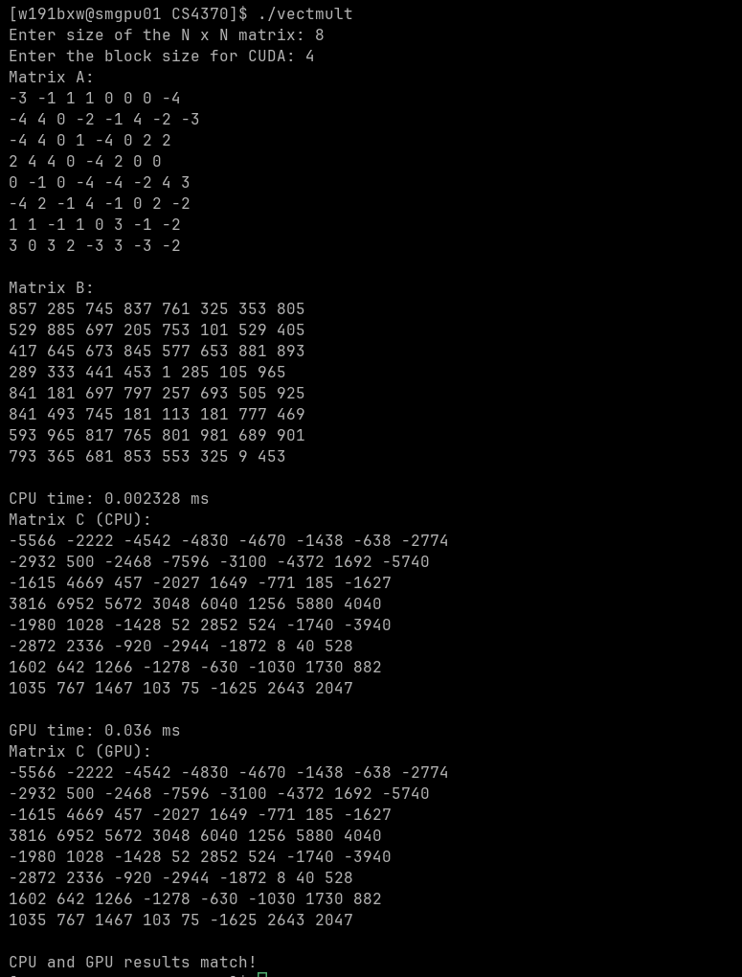nvcc Walker_vectmult.cu -o vectmult -std=c++11

