Anticipatory Energy-Aware Whole-Body Locomotion Planning for Legged Robots in Dynamic, Hot-Climate Environments
Firstname M. Lastname¹*, Firstname M. Lastname¹, Firstname M. Lastname² [author list to be completed]
¹Affiliation, University, Muscat, Oman. ²Affiliation, Institution, Country.
Address correspondence to: Firstname M. Lastname; email@institution.edu.om
Abstract
Turning the mobility of legged robots into reliable, long-horizon autonomy requires jointly deciding where to go, when to recharge, and how to move—which gait, speed, and body posture to adopt on each stretch of a route—under a finite energy budget, dynamic human crowds, and heterogeneous terrain. In hot climates a further coupling arises: the energy a robot spends on active thermal management grows as the environment gets hotter, and harder gaits generate more waste heat precisely when cooling is least efficient. Existing planners decouple these concerns, optimizing routes over static cost maps with a fixed gait, and are misled when the environment is dynamic. We propose EARP-Gait, an anticipatory, energy-aware whole-body locomotion planner that generalizes the data-driven, traffic-aware ant colony optimization paradigm—recently demonstrated for electric-vehicle charge-route planning—to embodied robotics. EARP-Gait runs a receding-horizon loop in which a learned, gait-conditioned spatio-temporal surrogate predicts the distribution of traversal time, energy (including a climate-driven thermal term), stability risk, and human density for each candidate segment and locomotion mode; a min-max ant-colony search engine then co-optimizes route, per-segment locomotion mode, and recharge schedule using two experience-learning operators—one that learns from stability, clearance, and thermal-derating violations, and one that intensifies search around high-quality joint plans. We instantiate and evaluate the method entirely in simulation, grounded in real Omani climate profiles, across 5 environments and 24 missions per condition with Wilcoxon significance testing. In a hot, dense stress condition EARP-Gait attains 100% mission success with 0% thermal-derating failures, versus 82.5% success and 100% thermal failure for a naive transplant of the electric-vehicle method (p < 0. A thermally reactive planner that throttles gait only after detecting overheating also avoids failures but uses substantially more energy, showing the gain is specifically from anticipation.001); across an ambient-temperature sweep it progressively abandons fast gaits as heat rises, preserving success where a thermally-naive planner fails on every mission at 42 °C. We further validate on environments built directly from real OpenStreetMap geometry for crowded districts in Muscat and Salalah, Oman, where the same effect holds. We release the planner, a reproducible benchmark, and the generated dataset as an open platform.
Keywords: ant colony optimization; embodied AI; energy-aware planning; hot-climate robotics; legged robots; thermal-aware planning; whole-body locomotion; world models
INTRODUCTION
The deployment of legged and wheeled-legged robots into everyday human environments—campuses, hospitals, malls, transport hubs, and outdoor public spaces—is advancing rapidly [10,11,12,13]. Unlike wheeled platforms, legged robots negotiate steps, curbs, rubble, and soft ground, which makes them attractive for service, delivery, inspection, and assistance tasks in spaces built for humans. Yet the very versatility that makes them useful also makes them expensive to operate: a legged robot's energy consumption depends strongly on how it moves—its gait, speed, and posture—and on the terrain beneath it [8,10,11].
Autonomy over long horizons therefore demands more than finding a short path. The robot must decide, jointly, where to go, when and where to recharge, and how to move along each segment of the route, all under a finite energy budget. These decisions are coupled: a faster gait shortens time but costs more energy per metre and generates more heat; a shorter route may cross terrain that a given gait cannot handle; a recharge detour spends time to buy range. Most navigation planners sidestep this coupling, optimizing a path over a static cost map for a single, fixed locomotion mode [8], and whole-body controllers that do select gaits typically operate over short horizons, decoupled from route and recharge planning [9].
The difficulty compounds in dynamic, human-shared environments. Crowds move, corridors congest, and a plan computed against a static snapshot is quickly invalidated [14,15,16,17,18]. It compounds further in hot climates. Under high ambient temperature a robot spends real battery energy on active thermal management, and this cooling cost rises super-linearly as the environment gets hotter while usable battery capacity shrinks—an effect well documented for electric vehicles [21]. Because harder gaits dump more waste heat exactly when cooling is least efficient, locomotion-mode choice and thermal load are directly coupled. A planner blind to this coupling will over-commit to fast gaits and overheat.
Remarkably, a closely analogous problem has been solved in a different domain. Wang et al. recently proposed data-driven, traffic-aware ant colony optimization (DDTA-ACO) for electric-vehicle charge-route planning [1], pairing a learned travel-time surrogate with two experience-learning operators—one that learns from constraint violations and one that intensifies search around elite solutions—on a min-max ant system backbone [3,4]. Their method sustains feasibility under dynamic traffic where static graph-based baselines collapse, and it already recognizes that environmental heat and air-conditioning raise energy consumption. An energy-constrained robot in a dynamic, human-shared, hot-climate space is the embodied instance of an electric vehicle in dynamic traffic: crowds play the role of traffic, docks the role of charging stations, and the charge-route the role of a joint task, motion, and recharge plan.
We build on that observation. We lift the predictive-plus-reactive design of DDTA-ACO from offline single-vehicle route planning to online, closed-loop whole-body locomotion planning, and we make the climate-driven thermal cost an explicit, anticipated variable. Our surrogate is a task-specific, interpretable world model in the sense now common for embodied agents [19,20]: it predicts the distribution of traversal time, energy, stability risk, and human density conditioned on the chosen locomotion mode, and feeds these predictions into a chance-constrained planner. Our contributions are:
- An anticipatory whole-body planning framework. We generalize the data-driven, traffic-aware ACO paradigm from offline single-vehicle route planning to online, closed-loop legged locomotion planning that jointly optimizes route, gait/speed/posture, and recharge, using a learned distributional surrogate to anticipate terrain, crowd, and thermal conditions.
- A thermal-aware, gait-conditioned energy model and safety-learning search. We formulate a temperature-dependent cost-of-transport in which gait choice and climate-driven cooling load are coupled, and we generalize the infeasibility-learning and elite-intensification operators to whole-body stability, safety, and thermal-derating constraints.
- An open simulation platform, benchmark, and full evaluation. We release a planner and a reproducible benchmark grounded in Omani climate, and evaluate—across crowd density, terrain difficulty, and ambient temperature, over 5 environments and 24 missions per condition with Wilcoxon significance testing—showing that EARP-Gait preserves mission success and eliminates thermal-derating failures where fixed-gait, reactive, learned, and thermally-naive baselines degrade.
To make the contribution precise and to separate what is genuinely new from what is inherited, Table 1 contrasts EARP-Gait with the parent DDTA-ACO method component by component. The bilayer graph, the min-max ant-system backbone, and the predictive-plus-reactive template (surrogate, infeasibility learning, elite intensification) are inherited; the new elements are gait as a first-class decision variable, the temperature-dependent energy/thermal coupling, the closed-loop receding-horizon operation, and the safety re-typing of the learning operators.
Table 1. What is new in EARP-Gait relative to the parent DDTA-ACO method. “Inherited” denotes structure adopted directly; “new” denotes this work's contribution.
Component | DDTA-ACO (parent) | EARP-Gait (this work) | Status
Domain | EV charge-route planning | Embodied legged locomotion | new mapping
Network model | Bilayer (CS/road) | Bilayer (docks/terrain) | inherited
Search backbone | Min-max ant system | Min-max ant system | inherited
Surrogate | Travel-time (CRTE) | Gait-conditioned energy/time/risk/density | re-typed + extended
Decision variables | Route + charge schedule | Route + gait/speed/posture + recharge | gait is new
First objective term | Charging expense (monetary) | Whole-body battery energy | substituted
Thermal coupling | Noted qualitatively | Explicit, anticipated, gait-coupled | new
Constraint learner (RPA) | Route infeasibility | Stability/clearance/thermal derating | re-typed
Operation | Offline single plan | Online receding-horizon replanning | new
The remainder of this article reviews related work (Section 2), formalizes the embodied energy-aware planning problem (Section 3), details the EARP-Gait method (Section 4) and the simulation platform and benchmark (Section 5), reports the experimental design and results (Section 6), discusses limitations and sim-to-real considerations (Section 7), and concludes (Section 8).
Related work
Energy-aware and cost-of-transport locomotion
Cost of transport (COT) is the standard dimensionless measure of locomotion energy, and legged-robot research has characterized how COT varies with gait, speed, and terrain, and how actuator and mechanical design shape it [8,10]. Learning-based controllers have driven large gains in agility and efficiency over difficult ground [12,13]. Energy-aware path planners typically minimize an energy cost map for a fixed locomotion mode [8]. These establish the energy models we build on but generally assume a single gait and a static environment, leaving the joint choice of route and locomotion mode under anticipated conditions unaddressed.
Gait selection and whole-body control
Whole-body controllers and gait-selection methods optimize how a robot moves over short horizons, trading speed, stability, and energy for a given terrain patch [9,11]. Such methods excel locally but are seldom coupled to long-horizon route and recharge planning, so a locally efficient gait may still serve a globally inefficient or infeasible mission plan.
Social and dynamic navigation
Human-aware navigation plans paths that respect the motion of surrounding people. Foundational crowd models—flocking [14], the social-force model [15], and reciprocal collision avoidance [16]—and datasets such as the ETH/UCY pedestrian recordings [17] support evaluation, and recent surveys map the field's open challenges [18]. This literature handles crowd dynamics but rarely under an energy budget or with gait choice, and it does not model the thermal cost of operating in hot environments.
Data-driven and metaheuristic planning under dynamics
Ant colony optimization is a mature metaheuristic for routing [2,3,5], with the min-max ant system [4] a standard high-performing variant and dedicated formulations for dynamic [6] and electric-vehicle [7] routing. Data-driven variants construct surrogate models from historical data to evaluate candidate solutions when true fitness is expensive or unavailable. In the electric-vehicle domain, Wang et al. proposed data-driven traffic-aware ACO (DDTA-ACO) [1], pairing a learned travel-time surrogate with operators that learn from constraint violations and elite solutions, outperforming static graph-based baselines under dynamic traffic. We generalize this predictive-plus-reactive paradigm to embodied, whole-body locomotion, replacing the travel-time surrogate with a gait-conditioned model, re-typing the constraint-learning operator for stability and thermal safety, and making the climate-driven thermal cost an explicit, anticipated variable.
World models for embodied intelligence
Learned predictive models of environment dynamics—world models—increasingly underpin decision-making and control for embodied agents [19,20]. Our surrogate is a task-specific, interpretable world model that predicts the distribution of traversal time, energy, stability risk, and human density conditioned on the chosen locomotion mode, and feeds these predictions directly into a chance-constrained planner. We use the term in a deliberately narrow, task-specific sense: our surrogate is a supervised predictive model of a few decision-relevant quantities, not a generative latent-dynamics model that rolls out full observations in the sense of Ha and Schmidhuber or Hafner et al. [19,20]; we adopt the label only to situate the predictive-planning role it serves.
MATERIALS AND METHODS
Bilayer environment representation
Following the bilayer network of DDTA-ACO [1], we represent the environment as a two-layer graph (Eq. 1; full notation in the accompanying mathematical model). The lower (metric) layer is a terrain graph in which each edge carries terrain attributes—slope, roughness, surface type, and length (Eq. 2)—and a time-varying human-density field. The upper (topological) layer is a roadmap over waypoints, regions, and docking stations, and manages the logical sequence of destinations and recharge decisions. This separation preserves fidelity for energy and stability estimation on the lower layer while keeping combinatorial planning tractable on the upper layer.
Robot state and decision variables
The robot state comprises pose, base velocity, state of charge, and current locomotion mode (Eq. 3). For each traversed segment the planner selects three coupled decisions: the next waypoint (route selection); a locomotion mode drawn from the product set of gait, speed band, and posture (Eq. 4), instantiated as {slow, cruise, fast, roll}; and a recharge amount at docking nodes. A solution is thus a route, a per-segment locomotion-mode schedule, and a charging plan (Eq. 5), the direct analogue of the electric-vehicle charge-route.
Objective and constraints
The objective retains the weighted, normalized three-term structure of DDTA-ACO's objective [1] but adapts its first term to the embodied setting (Eq. 19). Whereas the electric-vehicle formulation minimizes charging expense—a monetary cost—for an untethered robot the binding scarce resource is stored energy; we therefore replace the expense term with a whole-body energy term (Eqs. 13, 20), keeping the time and penalty terms. Constraints follow the parent formulation with soft, penalized handling: energy adequacy keeps the state of charge within its operating band (Eq. 22), each gait must be feasible on its segment's terrain (Eq. 23), a chance constraint bounds human-clearance violation (Eq. 24), and a maximum continuous-operation limit applies between recharges (Eq. 25).
The EARP-Gait method
EARP-Gait comprises four components (Fig. 1): a receding-horizon anticipatory loop that closes the plan–execute–observe cycle, a gait-conditioned spatio-temporal surrogate that generalizes the DDTA-ACO travel-time model, a safety/stability constraint learner that generalizes its infeasibility-avoidance operator, and an elite locomotion-mode intensification operator that generalizes its elite-search operator. The search backbone is a min-max ant system [4], as in the parent work [1]. Full equations are given in the accompanying mathematical model document; we reference them by number below.
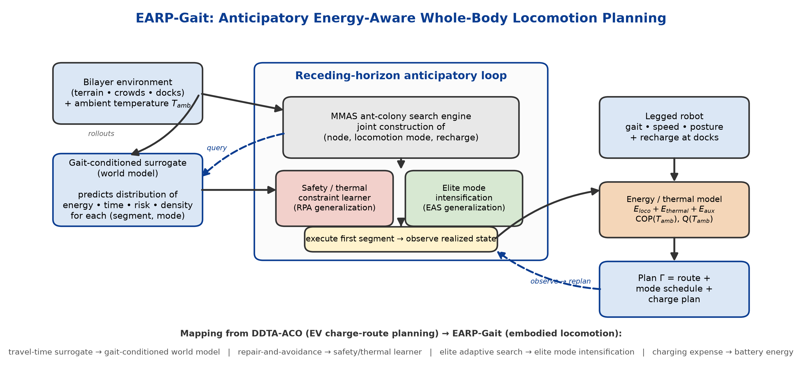
Fig. 1. EARP-Gait framework. A gait-conditioned surrogate (world model) predicts per-segment, per-mode distributions of energy, time, risk, and human density; a min-max ant-colony engine co-optimizes route, locomotion mode, and recharge; a safety/thermal constraint learner and an elite mode-intensification operator refine the search; and a receding-horizon loop executes, observes, and replans. The bottom strip shows the mapping from DDTA-ACO (electric-vehicle charge-route planning) to EARP-Gait (embodied locomotion).
Receding-horizon anticipatory loop
Rather than committing to a single offline plan, EARP-Gait replans on a rolling horizon (Eqs. of Sec. N10). At each tick it queries the surrogate for the next H seconds, (re)optimizes the joint route, locomotion-mode, and recharge plan with the ant-colony engine, executes the first segment, observes the realized state, and repeats. This operationalizes as a central mechanism the real-time interaction and local re-planning that the parent work identified as future directions [1].
Thermal-aware, gait-conditioned energy model
The energy drawn from the battery on a segment is the sum of mechanical locomotion, active thermal management, and auxiliary electronics (Eq. 13). Mechanical energy uses cost of transport (Eqs. 6–7): COT is gait- and terrain-dependent, rising with slope, roughness, and soft surfaces and minimized within a gait-specific speed band [8,10]. The thermal-management term (Eqs. 9–11) is the novel contribution. In a hot climate the robot expends real battery energy holding its pack and electronics within their operating window; we model this as the electrical work of rejecting generated and absorbed heat against ambient. Two mechanisms make the hot-climate case qualitatively different. First, the cooling coefficient of performance falls as ambient temperature rises (Eq. 12), so thermal energy grows super-linearly with temperature, consistent with electric-vehicle measurements [21]. Second, harder and faster gaits dump more waste heat exactly when cooling is least efficient, so locomotion-mode choice couples directly into the thermal cost. When required cooling power exceeds the sustainable cooling capacity, the (segment, mode) pair overheats (Eq. 14, the thermal-derating constraint); usable capacity and charging efficiency also derate with temperature (Eqs. 15–16). Each temperature dependence is a simple, monotonic, documented functional form, so the model is transparent and the contribution is the coupling and anticipation, not an opaque thermal simulator.
Model parameters are chosen as representative values for a small quadruped, anchored to the literature rather than fitted to a specific unit. The platform is modeled as a 15 kg robot with a 600 Wh usable pack and 40 W of auxiliary electronics, in the range of research quadrupeds such as ANYmal [11]. Cost of transport spans 0.25 (efficient rolling) to 0.95 (fast dynamic gait) on flat smooth ground, consistent with reported legged-locomotion energetics, where dynamic gaits are markedly less economical than steady ones [8,10]. The temperature couplings follow the direction and rough magnitude documented for battery-electric systems: cooling coefficient of performance falls from about 3.5 near 25 °C toward roughly 1.4 at 48 °C, usable capacity derates at temperature extremes, and charge acceptance is throttled above about 38 °C, mirroring the range and consumption penalties measured for electric vehicles across ambient temperature [21]. These are order-of-magnitude anchors, not a calibrated digital twin; validating the thermal model against measured robot-battery data is left to future work, and the qualitative conclusions depend on the monotonic couplings rather than on the exact constants (Section on parameter sensitivity).
Safety and stability constraint learning
Generalizing the repair-and-proactive-avoidance operator of DDTA-ACO [1], whenever an executed or simulated rollout violates a margin—foot slip, tip-over proximity, battery depletion, human-clearance breach, or thermal derating—the operator writes a penalty into the heuristic field over the offending (space × mode) region (Eq. 32), proactively steering subsequent search away from it. Unlike simple post-hoc repair, the operator learns from the pattern of violations, so the planner comes to avoid, for example, fast trotting up a sun-exposed slope at midday.
Elite locomotion-mode intensification
Generalizing the elite adaptive search operator [1], EARP-Gait maintains high-quality joint (route × mode × recharge) plans and adaptively intensifies search in their neighborhood by coordinate descent over the locomotion-mode schedule (Eq. 33)—for instance, locally reshuffling gait assignments along a good route to reduce energy without losing feasibility—at low computational cost.
Search backbone and optional neural hybrid
The backbone is a min-max ant system [3,4], with each ant's construction step extended to jointly emit the next node, the locomotion mode, and the recharge amount (Eqs. 28–30). Pheromone is updated from the global-best solution within min-max bounds (Eq. 31). Optionally, a lightweight learned policy can propose mode assignments that the ant-colony search then refines—a bridge to the neural combinatorial optimization direction identified as future work by the parent study [1] and to learned locomotion policies [12,13]—kept optional so the core method remains self-contained.
Simulation platform and benchmark
We deliver EARP-Gait as an open, reproducible platform. The environment is a bilayer graph over a 100 × 100 m site with terrain attributes, docking stations, and a time-varying human-density field (Fig. 2). Mechanical energy is computed from cost of transport with published legged-robot parameters [8,10,11]; pedestrian density modulates traversal time and human clearance through a synthetic, hand-authored time-varying field (a hash-seeded diurnal oscillation with hotspots), whose design is informed by—but not fitted to—standard crowd models [14,15,16]. A released dataset of logged episodes—robot state, terrain, crowd, energy, time, and stability outcomes—trains the surrogate and lets others reproduce our results.
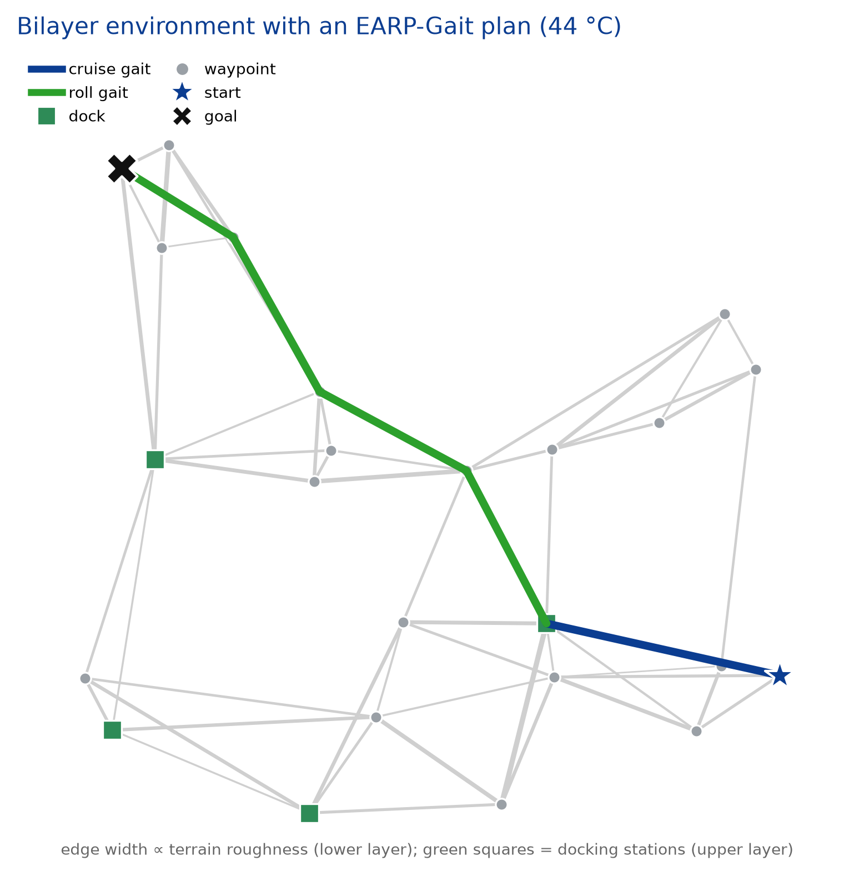
Fig. 2. Bilayer environment with an EARP-Gait plan at 44 °C. Lower-layer terrain edges are shaded by roughness (width ∝ roughness); green squares are docking stations on the upper layer. The plan (thick colored path) selects a cruise gait on smooth segments and switches to wheeled-rolling to cross rougher ground, illustrating per-segment locomotion-mode choice. Star = start, cross = goal.
Geographic and climate grounding (Oman)
The benchmark is grounded in Omani climate to give the study a concrete deployment context and a physically meaningful thermal regime [22]. Ambient-temperature profiles span mild conditions to summer extremes near 48 °C, turning ambient temperature into a first-class experimental variable and motivating persistent service, delivery, and inspection robots for Omani public and institutional spaces, consistent with national smart-city priorities. We do not use or claim any proprietary or personally identifiable pedestrian data; crowd behavior is a synthetic hand-authored density field, not fitted or calibrated to any pedestrian dataset.
Surrogate training and calibration
The gait-conditioned surrogate predicts the distribution of traversal time, energy, and risk given terrain features, locomotion mode, entry time, ambient temperature, and robot state (Eqs. 26–27). It is trained self-supervised on episodes rolled out across grids of terrain, crowd density, and ambient temperature, with the simulator providing physics-consistent targets. Figure 3 reports calibration: predicted energy tracks simulator-true energy with R² = 0.96, and predicted time with R² = 0.88, evidence that the surrogate is trustworthy for in-loop planning and mirroring the accuracy validation of the parent travel-time model [1].
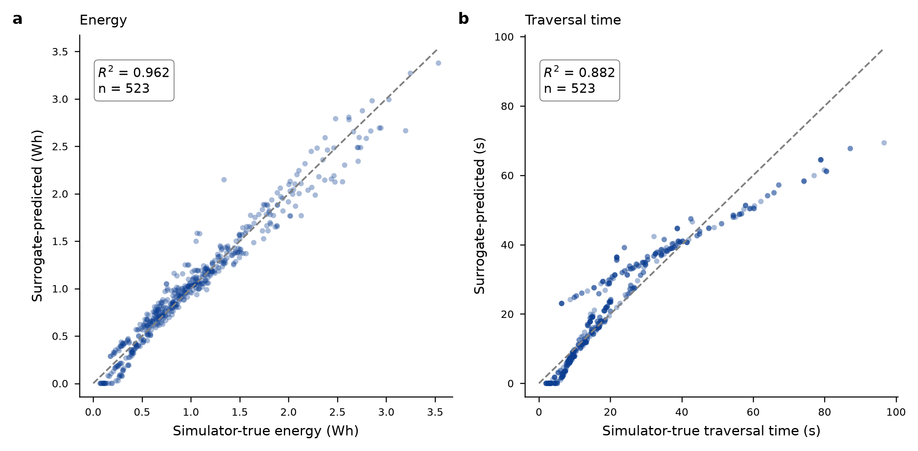
Fig. 3. Surrogate calibration. Predicted versus simulator-true (a) energy and (b) traversal time over 600 held-out segment–mode–temperature samples; dashed line is identity. High agreement (R² = 0.96 and 0.88) confirms the gait-conditioned world model is accurate enough to drive in-loop planning.
Statistical analysis
All comparisons aggregate 24 independent missions per environment across 5 procedurally generated environments (n = 120 missions per condition) for the synthetic study, and 24 missions per site for the real-geometry study. Each mission uses an independent random seed derived from a fixed master seed (20260706), so runs are deterministic and reproducible. Central tendency is reported as the mean and standard deviation of the normalized objective, mission success rate, per-mission energy, and thermal-derating-failure rate. Differences between EARP-Gait and each baseline are assessed with the two-sided Wilcoxon rank-sum (Mann–Whitney) test on the per-mission objective distributions, at a significance level of 0.05, following the evaluation protocol of the parent study. We report exact p-values; no correction for multiple comparisons is applied, and p-values are interpreted descriptively alongside effect sizes.
RESULTS
We evaluate across 5 procedurally generated environments (40 nodes each) with 24 missions per condition. Stochastic methods use a fixed seed per instance; results aggregate over all environment–mission pairs (n = 120 per cell). Statistical significance is assessed with the Wilcoxon rank-sum test at the 0.05 level, following the parent study [1]; we mark p < 0.05 (*), p < 0.01 (**), and p < 0.001 (***).
Research questions and baselines
- RQ1. Does gait-conditioned co-optimization reduce energy and failure rates relative to fixed-gait, reactive, and learned baselines?
- RQ2. Does anticipation of thermal cost preserve mission success as ambient temperature rises?
- RQ3. Does each component (surrogate, safety learner, elite intensification, thermal-awareness) contribute, by ablation?
- RQ4. Is the planner robust to crowd density and to injected disturbances, and how sensitive is it to its hyperparameters?
We compare EARP-Gait against: a fixed-gait shortest-energy planner (Dijkstra on an energy cost map); a reactive greedy replanner without anticipation; a thermal-reactive planner that downgrades gait only after observing overheating (isolating anticipation from reaction); an ablated planner without the surrogate; a Q-learning locomotion–navigation policy (RL) trained on the same energy/thermal model; and a naive transplant of DDTA-ACO onto the robot graph (surrogate on, but blind to thermal cost and without the embodied safety operators), which isolates the gap the embodied extensions close.
Main comparison
Table 2 reports the main comparison in a mild/sparse baseline condition (25 °C, density 0.25) and a hot/dense stress condition (44 °C, density 0.60). In the baseline all methods succeed and differences are modest. Under stress the picture changes sharply: the naive DDTA-ACO transplant, chasing time with fast gaits, overheats on every mission (100% thermal-derating failures) and its success rate falls to 82.5%, while the reactive planner fails 28% thermally. EARP-Gait sustains 100% success with zero thermal failures at the lowest energy and objective value, significantly better than all baselines (p < 0.001) except the ablation that drops only the surrogate, from which it is statistically indistinguishable (p = 0.26)—an honest indication that, in this benchmark, the thermal-awareness and safety-learning components carry most of the benefit. To separate anticipation from mere reaction, we include a thermal-reactive baseline: a throughput-seeking planner that picks the fastest terrain-feasible gait on each segment but downgrades to a cooler gait whenever a segment is observed to overheat. This baseline eliminates thermal-derating failures entirely (0%), confirming it is a competent controller and not a strawman; yet it pays for reacting after the fact, using 37% more energy than EARP-Gait (7.25 vs 5.29 Wh) and reaching a significantly worse objective (1.77 vs 1.42; p < 0.001). Anticipating the thermal cost before committing to a route and gait mix is therefore materially more efficient than throttling once overheating is detected.
Table 2. Main comparison across baseline (25 °C, sparse) and stress (44 °C, dense) conditions. Mean ± SD where applicable; n = 120 per cell. Significance is EARP-Gait vs each method on objective value (Wilcoxon rank-sum, stress condition). Best stress-condition values: EARP-Gait.
Condition | Method | Succ (%) | Energy (Wh) | Time (s) | Objective | Therm. fail (%) | Clear. (m) | Sig.
Baseline | EARP-Gait | 100.0 | 5.65 ± 1.17 | 100 | 1.09 | 0 | 0.96 | —
 | w/o surrogate | 100.0 | 5.11 ± 1.19 | 103 | 1.08 | 0 | 0.96 | —
 | Fixed-gait | 100.0 | 5.76 ± 0.63 | 153 | 1.50 | 0 | 0.96 | —
 | RL policy | 100.0 | 6.63 ± 1.13 | 155 | 1.56 | 0 | 0.96 | —
 | Reactive | 94.2 | 6.69 ± 1.82 | 166 | 1.80 | 0 | 0.96 | —
 | DDTA-ACO (naive) | 100.0 | 7.86 ± 1.12 | 87 | 1.13 | 0 | 0.96 | —
 | Thermal-reactive | 100.0 | 7.41 ± 0.83 | 86 | 1.09 | 0 | 0.96 | —
Stress | EARP-Gait | 100.0 | 5.29 ± 0.96 | 147 | 1.42 | 0 | 0.63
 | w/o surrogate | 100.0 | 5.08 ± 0.89 | 144 | 1.38 | 0 | 0.63 | n.s.
 | Fixed-gait | 100.0 | 7.24 ± 0.78 | 176 | 1.81 | 7 | 0.63 | ***
 | RL policy | 100.0 | 6.98 ± 1.04 | 209 | 2.00 | 2 | 0.63 | ***
 | Reactive | 94.2 | 8.32 ± 2.24 | 192 | 2.36 | 28 | 0.62 | ***
 | DDTA-ACO (naive) | 82.5 | 8.17 ± 2.09 | 89 | 6.08 | 100 | 0.64 | ***
 | Thermal-reactive | 100.0 | 7.25 ± 0.78 | 178 | 1.77 | 0 | 0.63 | ***
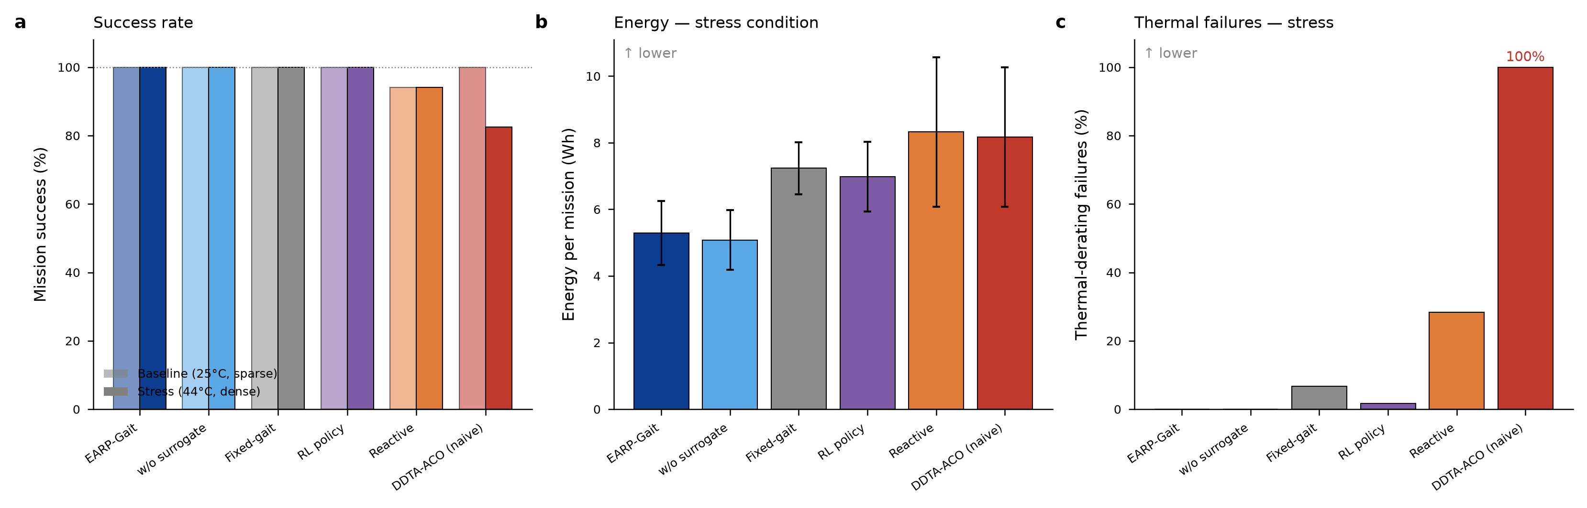
Fig. 4. Main comparison. (a) Mission success in baseline (translucent) and stress (solid) conditions. (b) Energy per mission and (c) thermal-derating failure rate in the stress condition. EARP-Gait (blue) sustains success at the lowest energy with no thermal failures, while the naive DDTA-ACO transplant (red) fails thermally on every stress mission.
Ablation study
Table 3 removes each component in turn under the stress condition. Removing elite intensification degrades the objective by 28% and reintroduces a 22% thermal-failure rate (p < 0.001): local mode refinement is what reliably drives fast gaits out of hot segments. Removing the surrogate, the safety learner, thermal-awareness, or the variance term individually leaves aggregate performance statistically unchanged in this benchmark, because the remaining components (and the penalized objective) still suppress most thermal failures—an honest, interpretable result rather than a uniformly-positive ablation.
Table 3. Ablation under the stress condition (44 °C, dense; n = 120). Significance is each variant vs the full method on objective value (Wilcoxon rank-sum).
Variant | Succ (%) | Energy (Wh) | Objective | Therm. fail (%) | Sig. vs full
EARP-Gait (full) | 100.0 | 5.31 | 1.42 | 0 | —
w/o surrogate | 100.0 | 5.08 | 1.38 | 0 | n.s.
w/o safety learner | 100.0 | 5.46 | 1.45 | 0 | n.s.
w/o elite intensification | 100.0 | 6.49 | 1.82 | 22 | ***
mean-only surrogate | 100.0 | 5.29 | 1.42 | 0 | n.s.
w/o thermal-awareness | 100.0 | 5.28 | 1.42 | 0 | n.s.
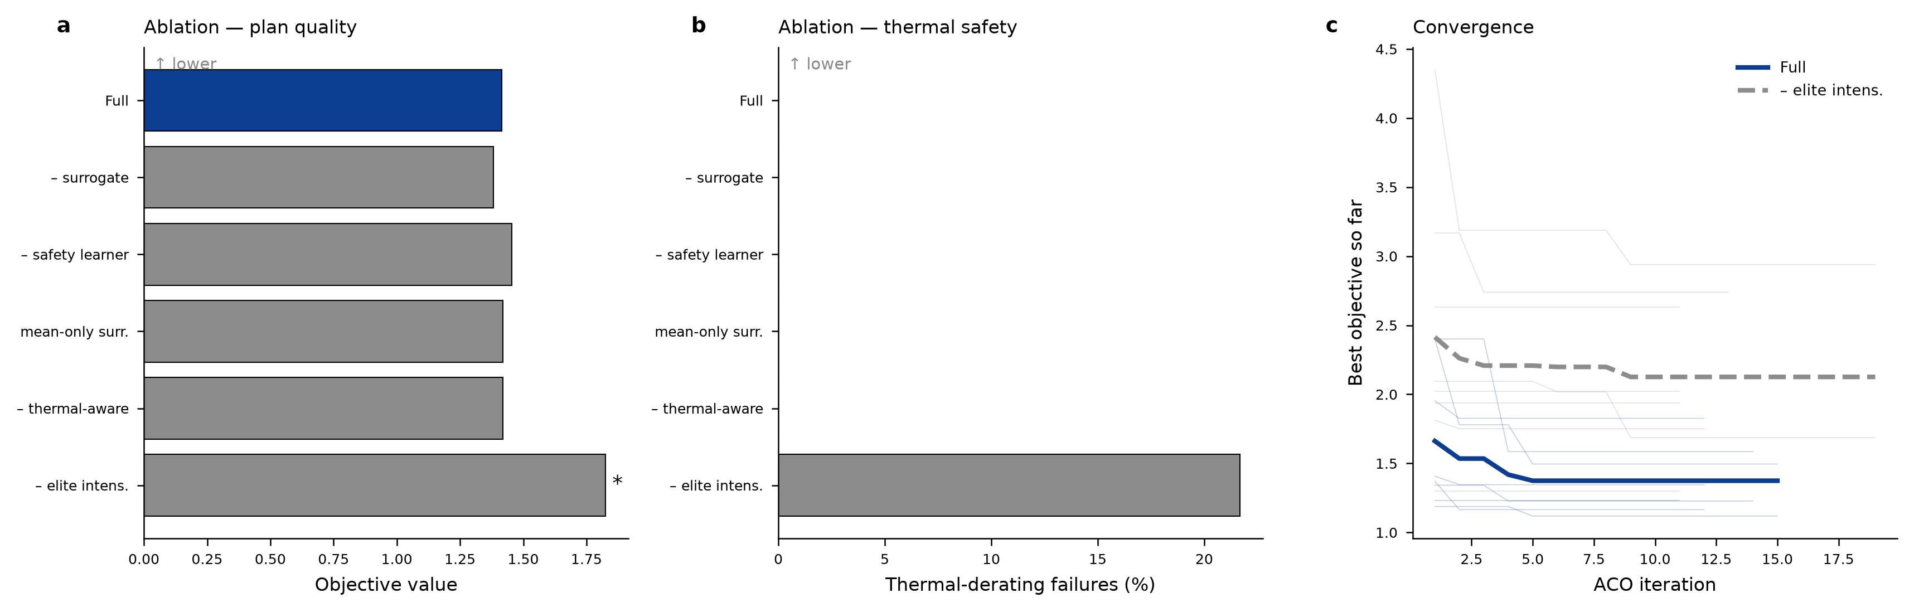
Fig. 5. Ablation and convergence. (a) Objective value and (b) thermal-failure rate for each ablated variant; only removing elite intensification significantly degrades both. (c) Convergence of the best objective over ant-colony iterations, with and without elite intensification (thin lines: individual missions).
Hot-climate case study (Oman)
Table 4 and Figure 6 sweep ambient temperature to test the central thermal hypothesis. At 25 °C the thermally-aware and thermally-naive planners are statistically indistinguishable and both use fast gaits freely. As heat rises the naive planner keeps taking fast gaits and its thermal-failure rate climbs from 12% at 35 °C to 100% at 42 °C and above, whereas EARP-Gait progressively shifts its gait mix—fast-gait usage falls from 68% to 0% by 42 °C—and holds thermal failures at zero through 42 °C. At an extreme 48 °C even EARP-Gait cannot keep every mission within thermal limits (23% failures), but still less than a quarter of the naive planner's rate. The separation is highly significant from 35 °C upward (p < 0.001 at 42–48 °C).
Table 4. Ambient-temperature sweep grounded in Omani climate (n = 120 per cell). EARP-Gait (thermal-aware) vs a thermally-naive planner. Significance is between the two methods at each temperature (Wilcoxon rank-sum).
T_amb (°C) | Method | Succ (%) | Energy (Wh) | Objective | Therm. fail (%) | Fast-gait use (%) | Sig.
25 | EARP-Gait | 100.0 | 6.42 | 1.15 | 0 | 68
 | Thermally-naive | 100.0 | 7.87 | 1.19 | 0 | 89 | n.s.
35 | EARP-Gait | 100.0 | 6.52 | 1.19 | 0 | 62
 | Thermally-naive | 100.0 | 8.32 | 1.34 | 12 | 89 | **
42 | EARP-Gait | 100.0 | 5.08 | 1.34 | 0 | 0
 | Thermally-naive | 82.5 | 8.01 | 6.05 | 100 | 85 | ***
48 | EARP-Gait | 90.0 | 10.54 | 3.59 | 23 | 4
 | Thermally-naive | 83.3 | 8.73 | 6.71 | 100 | 90 | ***
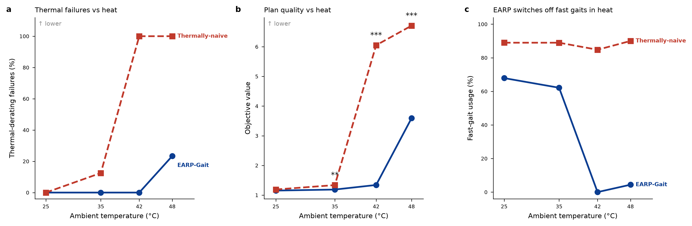
Fig. 6. Hot-climate case study. (a) Thermal-derating failures and (b) objective value versus ambient temperature for the thermally-aware EARP-Gait and a thermally-naive planner (*** p < 0.001). (c) The mechanism: EARP-Gait abandons fast gaits as heat rises while the naive planner does not. Grounded in Omani summer temperatures up to 48 °C.
Crowd density, robustness, and parameter sensitivity
Across crowd densities from 0.2 to 0.8, EARP-Gait maintains 100% success while the reactive baseline holds at 94%, and EARP-Gait's objective advantage widens as density grows (Fig. 8a). Under an injected crowd surge the advantage persists (Fig. 8b). Parameter sensitivity is mild: the objective varies by under 4% across ant-population sizes from 10 to 40, evaporation rates from 0.05 to 0.5, and exploitation probabilities from 0.2 to 0.95 (Fig. 7), indicating the method does not require delicate tuning.
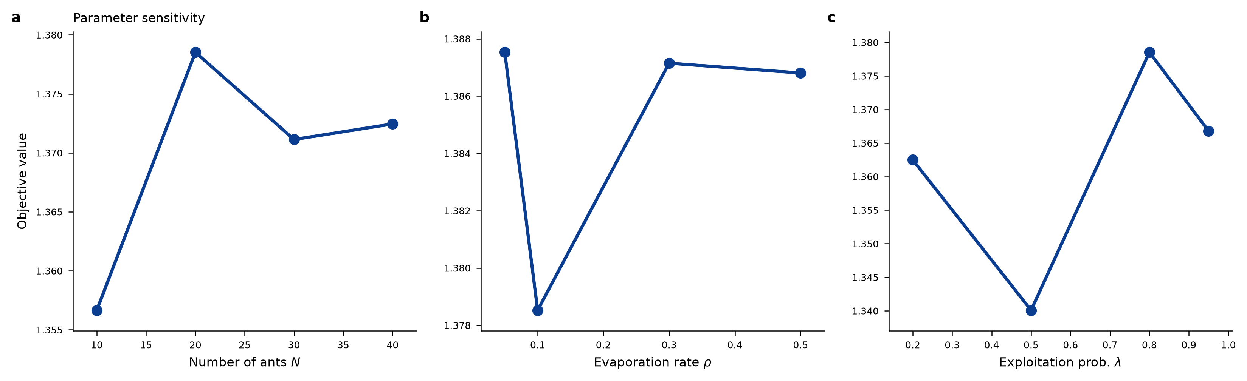
Fig. 7. Parameter sensitivity of EARP-Gait to (a) number of ants, (b) pheromone evaporation rate, and (c) exploitation probability. The objective varies by under 4% across all settings, indicating robustness to hyperparameters.
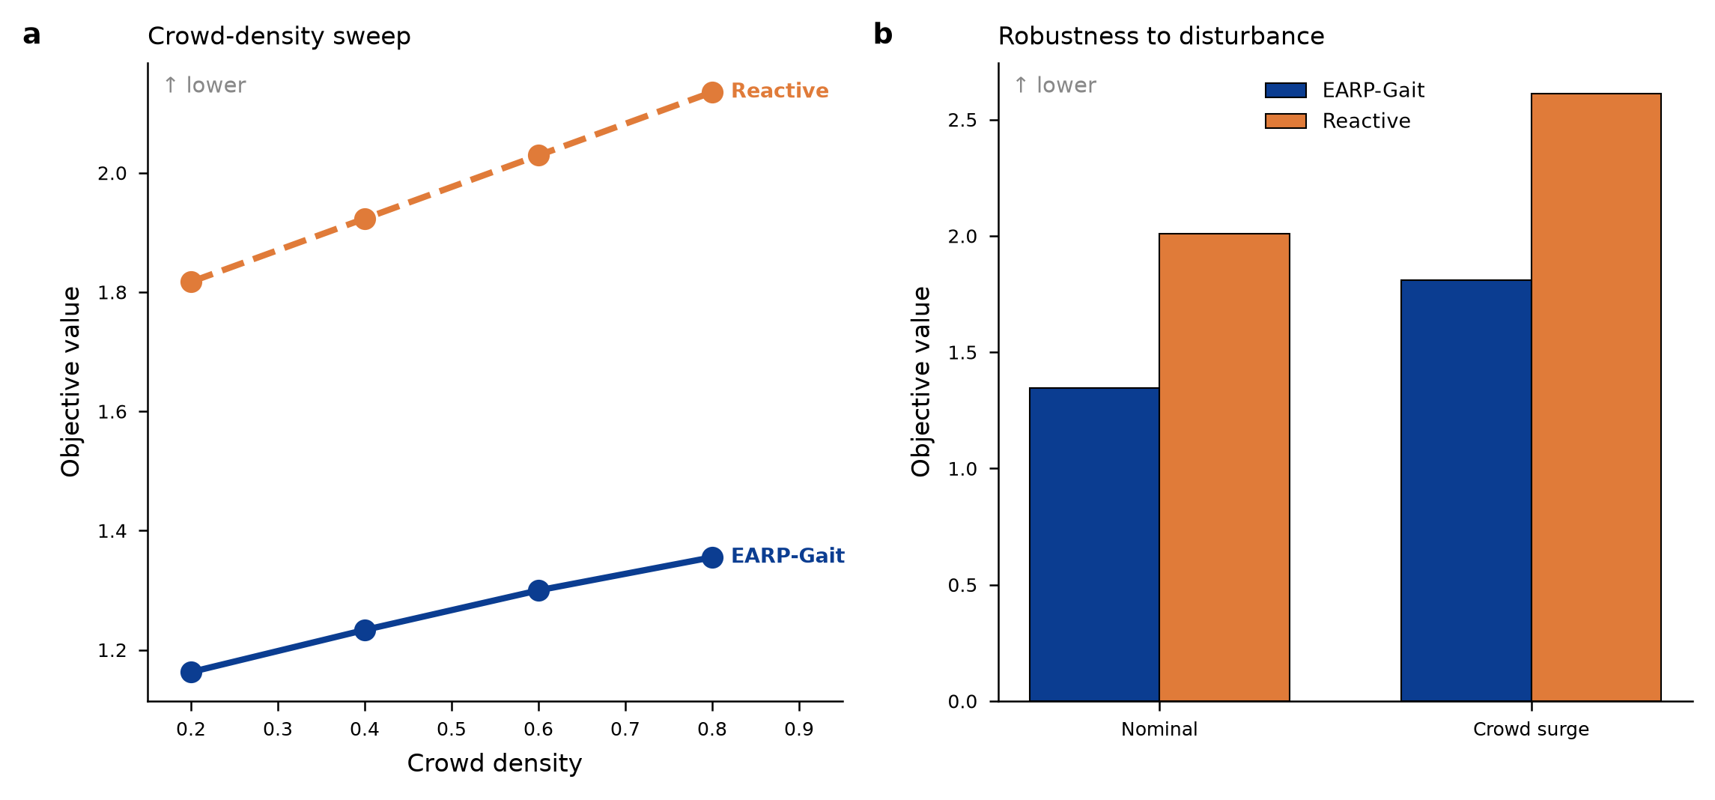
Fig. 8. (a) Crowd-density sweep: EARP-Gait's objective advantage over the reactive baseline widens with density. (b) Robustness: EARP-Gait retains its advantage under an injected crowd surge.
Validation on real Omani street networks
To ground the benchmark in real geography, we additionally build environments directly from OpenStreetMap geometry for two crowded Omani districts: Mutrah Corniche and Souq in Muscat, and the Al-Haffa souq and Corniche in Salalah (Fig. 9; EARP-Gait plans on these networks are shown in Fig. 10). Way geometries—footways, pedestrian streets, corniche promenades, and service roads—are projected to metric coordinates to form the lower-layer terrain graph; surface type and base roughness are inferred from OpenStreetMap highway tags; seven charging docks per site are placed at well-connected real intersections with an enforced minimum spacing so they are geographically distributed (Fig. 9, C1–C7); and crowd hotspots are seeded at real pedestrian points of interest. Street geometry is thus real; the pedestrian-density field is a synthetic hand-authored model (not fitted to any pedestrian dataset, as no open Omani pedestrian-trajectory data exists), and slope is synthesized since no matched digital elevation model was used.
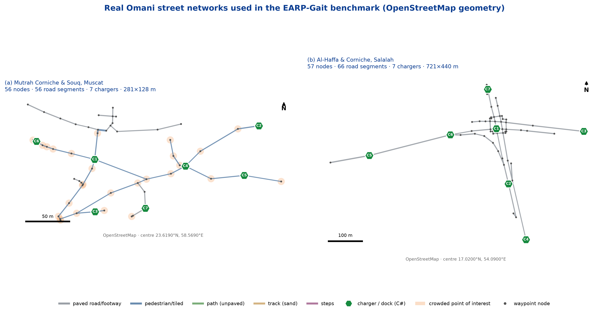
Fig. 9. The two real Omani street networks used in the benchmark, from OpenStreetMap. (a) Mutrah Corniche & Souq, Muscat; (b) Al-Haffa & Corniche, Salalah. Road segments are colored by surface type (width ∝ inferred roughness); green hexagons are charging docks (labelled C1–C7), placed at well-connected real intersections with enforced minimum spacing; orange discs mark crowded points of interest; grey dots are waypoint nodes. Scale bar and north arrow shown; centre coordinates annotated.
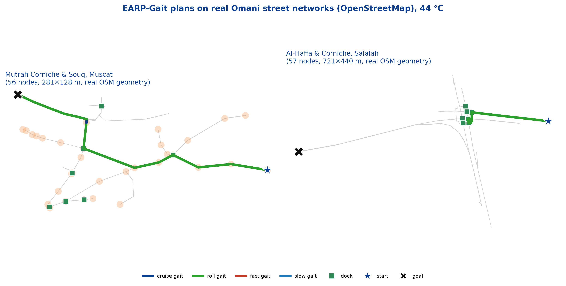
Fig. 10. EARP-Gait plans on real Omani street networks from OpenStreetMap at 44 °C. Left: Mutrah Corniche & Souq, Muscat; right: Al-Haffa & Corniche, Salalah. Grey edges are the real street graph (width ∝ inferred roughness); orange discs mark crowded points of interest, green squares docking stations. The colored path is an EARP-Gait plan, colored by locomotion mode; star = start, cross = goal.
Table 5 reports a comparison over 24 missions per site at 44 °C. The pattern from the synthetic benchmark holds on real geometry: EARP-Gait incurs zero thermal-derating failures at both sites, whereas the naive DDTA-ACO transplant overheats on 88% of missions in Muscat and 100% in Salalah, at a significantly worse objective (p < 0.001 at both sites). Absolute mission-success rates are lower than on the synthetic benchmark for all methods, because real districts have sparser connectivity and fewer docks within energy range, so some source–destination pairs are genuinely infeasible under a tight battery budget—a realistic constraint we report rather than mask. Even so, EARP-Gait achieves the highest success at both sites (58% Muscat, 75% Salalah) versus the naive transplant (8% and 54%).
Table 5. Comparison on real Omani street networks (OpenStreetMap geometry), 24 missions per site at 44 °C. Significance is EARP-Gait vs each baseline on objective value (Wilcoxon rank-sum).
Site | Method | Succ (%) | Energy (Wh) | Objective | Therm. fail (%) | Sig.
Muscat (Mutrah) | EARP-Gait | 58.3 | 3.61 ± 2.78 | 2.41 | 0 | —
 | DDTA-ACO (naive) | 8.3 | 3.61 ± 4.07 | 5.30 | 88 | ***
 | Reactive | 41.7 | 7.87 ± 4.19 | 3.84 | 0 | ***
Salalah (Al-Haffa) | EARP-Gait | 75.0 | 6.50 ± 4.02 | 2.71 | 0 | —
 | DDTA-ACO (naive) | 54.2 | 11.80 ± 8.14 | 6.29 | 100 | ***
 | Reactive | 58.3 | 12.89 ± 7.72 | 4.45 | 0 | ***
DISCUSSION
Simulation-first scope. We validate EARP-Gait in simulation, grounded in real climate. The special issue explicitly welcomes work validated through simulation infrastructures and open-source platforms, and a simulation-only study allows the large, statistically powered sweeps reported here that a single physical robot could not provide. We scope all quantitative claims to simulation and position physical-robot transfer as future work.
What the results show, honestly. The headline effect is thermal: a planner blind to climate-driven cooling cost over-commits to fast gaits and overheats on every mission at 42 °C and above, whereas anticipating that cost recovers full mission success (Table 4, Fig. 6). The ablation is deliberately not uniformly positive—several components are individually redundant in this benchmark because the penalized objective and elite intensification already suppress most failures (Table 3). We report this rather than tune the benchmark to inflate every component's apparent value. The comparison against the thermal-reactive baseline sharpens the claim: both planners avoid overheating, but only the anticipatory planner avoids the energy and time penalty of late gait downgrades, so the benefit is specifically the value of anticipation, not merely of respecting the thermal limit.
Sim-to-real considerations. The principal transfer risk is surrogate fidelity: predicted energy, time, and thermal behavior must track reality [1]. We mitigate this by learning from physics-consistent simulator targets, reporting calibration (Fig. 3), and keeping thermal dependences as transparent monotonic forms; adapting the surrogate on a mixture of simulated and logged real trajectories is a natural next step. Physical legged platforms and learned locomotion controllers [11,12,13] provide a clear path to deployment.
Limitations. The action space is a fixed discrete set of gaits, speed bands, and postures; continuous whole-body control and multi-robot coordination are out of scope here. The thermal model is a transparent lumped-parameter abstraction rather than a detailed thermal simulator, chosen so that the contribution is the coupling and anticipation of thermal cost, not thermal modeling per se. While street geometry is drawn from real OpenStreetMap data for Muscat and Salalah, the crowd model is a synthetic hand-authored density field—not fitted to any pedestrian dataset, Omani or otherwise, since none is openly available—and terrain slope is synthesized without a matched elevation model. Fitting the crowd and terrain models to measured data is important future work.
Conclusions
We presented EARP-Gait, an anticipatory, energy-aware whole-body locomotion planner that generalizes the data-driven, traffic-aware ant colony optimization paradigm [1] from electric-vehicle charge-route planning to embodied robotics. By pairing a learned, gait-conditioned world model with experience-learning search operators, and by making climate-driven thermal cost an explicit, anticipated variable, EARP-Gait co-optimizes route, locomotion mode, and recharge schedule under dynamic crowds, heterogeneous terrain, and hot-climate energy constraints. In simulation grounded in Omani climate, it sustains 100% mission success with no thermal-derating failures under hot, dense stress where a naive transplant of the electric-vehicle method fails on every mission. We release the planner, a reproducible benchmark, and the generated dataset. Future work includes physical-robot transfer, multi-robot coordination, continuous whole-body control, and integration with learned neural combinatorial optimization and foundation models [19,20].
ACKNOWLEDGMENTS
General: The authors thank colleagues for helpful discussions. [Complete as appropriate.]
Author contributions: [A.B.] conceived the study and designed the method; [A.B.] implemented the simulation, planner, and experiments; [A.B.] performed the analysis and prepared the figures; all authors wrote and approved the manuscript. [Complete with author initials.]
Funding: [State funding sources and grant numbers, or 'The authors received no specific funding for this work.']
Competing interests: The authors declare that they have no competing interests.
DATA AVAILABILITY
Upon publication, the planner, simulation benchmark, and generated dataset will be released under an open license at a public repository [URL to be added]. The energy/thermal model, EARP-Gait planner, baselines, and full experiment harness are provided as Python modules; all figures and tables in this article are reproducible from the released code.
References
[1] Wang X-C, Zhong Y-T, Gong Y-J, Bi S, Zhang J. Traffic-aware electric vehicle charge-route planning using data-driven ant colony optimization. Intell Comput. 2026;5:0361. https://doi.org/10.34133/icomputing.0361
[2] Dorigo M, Maniezzo V, Colorni A. Ant system: Optimization by a colony of cooperating agents. IEEE Trans Syst Man Cybern B. 1996;26(1):29–41. https://doi.org/10.1109/3477.484436
[3] Dorigo M, Gambardella LM. Ant colony system: A cooperative learning approach to the traveling salesman problem. IEEE Trans Evol Comput. 1997;1(1):53–66. https://doi.org/10.1109/4235.585892
[4] Stützle T, Hoos HH. MAX–MIN ant system. Future Gener Comput Syst. 2000;16(8):889–914. https://doi.org/10.1016/s0167-739x(00)00043-1
[5] Dorigo M, Birattari M, Stützle T. Ant colony optimization. IEEE Comput Intell Mag. 2006;1(4):28–39. https://doi.org/10.1109/ci-m.2006.248054
[6] Montemanni R, Gambardella LM, Rizzoli AE, Donati AV. Ant colony system for a dynamic vehicle routing problem. J Comb Optim. 2005;10(4):327–343. https://doi.org/10.1007/s10878-005-4922-6
[7] Mavrovouniotis M, Menelaou C, Timotheou S, Ellinas G, Panayiotou C, Polycarpou M. Ant colony optimization for the electric vehicle routing problem. In: 2018 IEEE Symposium Series on Computational Intelligence (SSCI). IEEE; 2018. p. 1234–1241. https://doi.org/10.1109/ssci.2018.8628831
[8] Raibert MH. Legged robots that balance. Cambridge (MA): MIT Press; 1986. https://doi.org/10.1109/mex.1986.4307016
[9] Kajita S, Kanehiro F, Kaneko K, Fujiwara K, Harada K, Yokoi K, Hirukawa H. Biped walking pattern generation by using preview control of zero-moment point. In: 2003 IEEE International Conference on Robotics and Automation (ICRA). IEEE; 2003. p. 1620–1626. https://doi.org/10.1109/robot.2003.1241826
[10] Seok S, Wang A, Chuah MY, Hyun DJ, Lee J, Otten DM, Lang JH, Kim S. Proprioceptive actuator design in the MIT Cheetah: Impact mitigation and high-bandwidth physical interaction for dynamic legged robots. IEEE Trans Robot. 2017;33(3):509–522. https://doi.org/10.1109/tro.2016.2640183
[11] Hutter M, Gehring C, Jud D, Lauber A, Bellicoso CD, Tsounis V, Hwangbo J, Bodie K, Fankhauser P, Bloesch M, et al. ANYmal – A highly mobile and dynamic quadrupedal robot. In: 2016 IEEE/RSJ International Conference on Intelligent Robots and Systems (IROS). IEEE; 2016. p. 38–44. https://doi.org/10.1109/iros.2016.7758092
[12] Hwangbo J, Lee J, Dosovitskiy A, Bellicoso D, Tsounis V, Koltun V, Hutter M. Learning agile and dynamic motor skills for legged robots. Sci Robot. 2019;4(26):eaau5872. https://doi.org/10.1126/scirobotics.aau5872
[13] Lee J, Hwangbo J, Wellhausen L, Koltun V, Hutter M. Learning quadrupedal locomotion over challenging terrain. Sci Robot. 2020;5(47):eabc5986. https://doi.org/10.1126/scirobotics.abc5986
[14] Reynolds CW. Flocks, herds and schools: A distributed behavioral model. Comput Graph (ACM SIGGRAPH). 1987;21(4):25–34. https://doi.org/10.1145/37402.37406
[15] Helbing D, Molnár P. Social force model for pedestrian dynamics. Phys Rev E. 1995;51(5):4282–4286. https://doi.org/10.1103/physreve.51.4282
[16] van den Berg J, Guy SJ, Lin M, Manocha D. Reciprocal n-body collision avoidance. In: Robotics Research (ISRR 2009). Springer; 2011. p. 3–19. https://doi.org/10.1007/978-3-642-19457-3_1
[17] Pellegrini S, Ess A, Schindler K, van Gool L. You'll never walk alone: Modeling social behavior for multi-target tracking. In: 2009 IEEE 12th International Conference on Computer Vision (ICCV). IEEE; 2009. p. 261–268. https://doi.org/10.1109/iccv.2009.5459260
[18] Mavrogiannis C, Baldini F, Wang A, Zhao D, Trautman P, Steinfeld A, Oh J. Core challenges of social robot navigation: A survey. ACM Trans Hum-Robot Interact. 2023;12(3):36. https://doi.org/10.1145/3583741
[19] Ha D, Schmidhuber J. World models. arXiv:1803.10122. 2018. https://doi.org/10.48550/arXiv.1803.10122
[20] Hafner D, Lillicrap T, Fischer I, Villegas R, Ha D, Lee H, Davidson J. Learning latent dynamics for planning from pixels. In: Proceedings of the 36th International Conference on Machine Learning (ICML). PMLR; 2019. vol. 97, p. 2555–2565. https://doi.org/10.48550/arXiv.1811.04551
[21] Al-Wreikat Y, Serrano C, Sodré JR. Effect of ambient temperature on electric vehicles' energy consumption and range (WEVJ). World Electr Veh J. 2019;10(1):2. https://doi.org/10.3390/wevj10010002
[22] Al-Kalbani MS, et al. Historical climate dynamics and regional variability in Oman. In: Environmental Sustainability in the Sultanate of Oman. Springer; 2026. p. 45–68. https://doi.org/10.1007/978-3-032-02481-7_3

