**Project Web 1 – 2021**

Online games website

For this project, you need to create a games site, playable online in the browser.

The site will be created entirely in front-end (client side), therefore HTML, CSS and JavaScript.

Here is the mock-up of the Home Page.

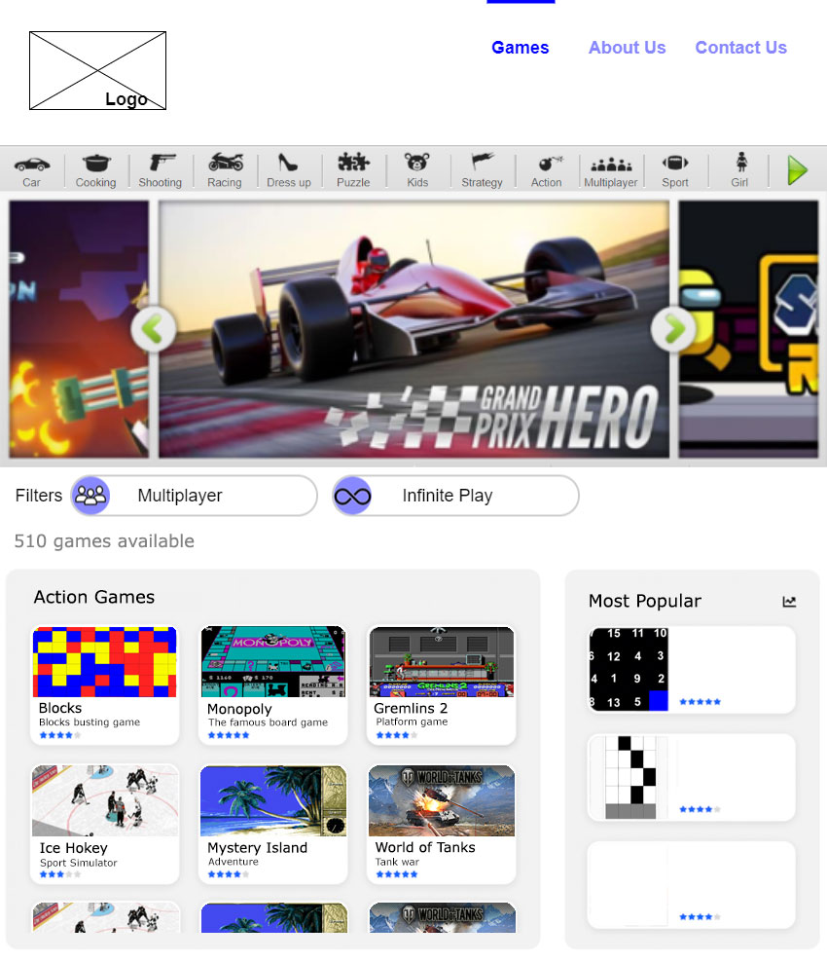

1- You have to create a logo yourself. You can use Photoshop, Paint, or any other tool. Be careful not to copy an already existing logo. The goal is that you know the current trend of logos for websites. Doing a logo is not usually the role of the developer, but you need to know the trends.

2- In the home page, at the bottom, you must add a "plug-in" which displays the weather forecast. You need to do some research on this.

3- At the top right, the "Games", "About Us", "Contact Us" links. These links must exist in all pages of the site.

The "Games" link returns to this page.

The "About Us" link opens a page that contains a large text

The “Contact Us” link opens a page with contact information, and a form with “Full Name, E-mail, Message”.

When one of these pages is open, a bar should appear above the corresponding link, as shown in the mockup.

4- In the home page, the categories at the top "Car, Cooking, Shooting etc." are fixed. They must each appear with an icon, and if their number is large, there must be a scrolling, as indicated by the green arrow to the right. When scrolling more than 50 pixels, the arrow should disappear.

5- When you click on a category, the area below (named "Action Games" in the model) must display the games related to this category, without refreshing the page. Upon presenting the project, you must fill-in at least 8 fictive games in each category. For each game, there must be an image, a title (for example "Monopoly") and a subtitle (for example "The famous board game"), as well as the number of stars (between 0 and 5) which indicates the popularity of this game.

6- Below the categories, images must appear. Visit https://bgames.com to see exactly how this part should play out. You will have to explain how you performed this scrolling upon presenting your project.

7- Filters boxes must be placed on the page, but without functionality.

8- Below the filters, indicate the total number of games.

9- Below the total number of games, display the games in the selected category. (see 5-). When opening the home page, this part is not visible by default. The dimensions of this area must be fixed (as in the layout) and the content must scroll vertically. Each game must be clickable, and open a new page (see 11-)

10- On the right, a zone will display three games, chosen at random from the existing games. Each time the visitor clicks on a category, it is necessary to display three games chosen at random.

11- When you click on a game, a new page must open and allow you to play it in the browser. For this purpose, you are asked to make the games listed at the end of this document (which must be included in the list of games presented on the home page).

12- You must create the layout of the pages that allow the visitor to open a game and play there. Not just the game itself, but the entire page as well. Its appearance should match that of the home page.

**The Games**

Each game has a coefficient. You must make one or more games from the list below, so that the total of the coefficients of the chosen games reaches at least 10.

You will be noted on applying the mockup, the logo chosen (with the name of the site you must come up with), and especially on games.

You must be able to access the games from the home page (only the games you have chosen to make). Each game should be well presented. You don't have a mockup for the games page, so you have to make it yourself.

Each game should be fully functional, without errors and without problems.

You are only asked to make the site so that it displays correctly on a Desktop type screen.

The site should open normally on Chrome, Edge (Chromium), Safari, Firefox and Opera.

**List of Games**

Blocks (coefficient 5)

Chess (coefficient 4)

Go (coefficient 6)

Minesweeper (coefficient 6)

Nine (coefficient 3)

Pipe (coefficient 5)

Puzzle (coefficient 2)

Snake (coefficient 5)

Solitaire (coefficient 6)

Tetris (coefficient 5)

See the video of each game for details.