**An**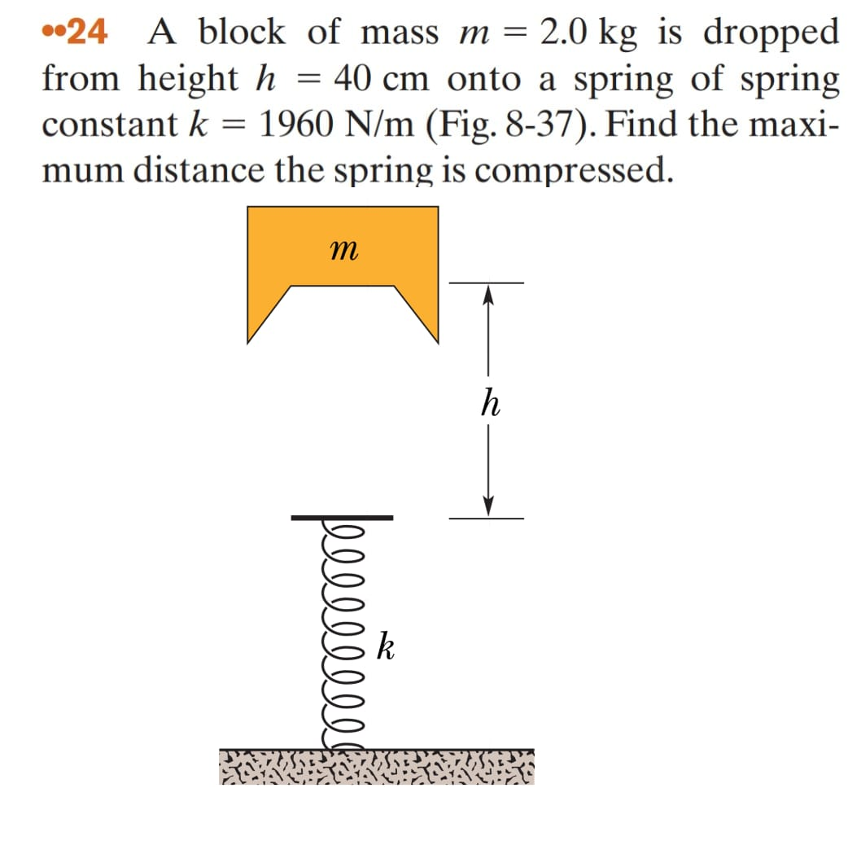

**User**: Look and declassify this physics exercise

**META**: A block of mass m = 2.0 kg is dropped from height h = 40 cm onto a spring with constant k = 1960 N/m. Find the maximum distance that the spring will be compressed.

**Instructor Annotation:** Meta accurately sets up the problem, but briefly noting the role of energy conservation (gravitational to elastic potential) in calculating compression would enhance clarity.

**User**: Identify all the key variables and parameters mentioned in the problem statement for each and specify if it’s a given value, unknown, or a constant value.

**META**: Here are the key variables and parameters mentioned in the problem statement: 1. m (mass) - given value, constant 2. h (height) - given value, constant 3. k (spring constant) - given value, constant 4. x (maximum distance of spring compression) - unknown Note that g (acceleration due to gravity) is not explicitly stated but it's a known physical constant approximately equal to 9.8m/s² on Earth's surface.

**Instructor Annotation:** Meta correctly identifies key variables, but adding each variable’s role (e.g., ggg for gravitational potential energy) would improve conceptual clarity, especially for beginners.

**User**: Look at this diagram and tell me what are the main keywords

**META**: The main keywords are: * Block of mass (m) * Height (h) * Spring constant (k) * Compression distance (maximum compression, h or k)

**Instructor Annotation:** Meta lists the main keywords accurately. However, clarifying each keyword’s relevance to energy conversion (e.g., height for potential energy, compression for elastic energy) would enhance understanding.

**User**: Can you explain your reasoning at each stage including any relevant formula in short

**META**: Here's a step-by-step explanation: 1. The block of mass (m) is dropped from height (h). This means the initial potential energy will be converted into kinetic energy and then elastic potential energy as it compresses the spring. Relevant formula: PE = mgh, where g=9.8m/s² on Earth's surface. 2. As the block falls onto the spring with constant k, its velocity increases until it reaches maximum compression in the spring. At this point, all the energy has been transferred to elastic potential energy stored within the compressed spring. Relevant Formula: KE = 0.5mv²; Ue = 0.5kx², where x represents distance or displacement. 3. To find h (maximum compression), we can equate both energies since they are equal at that moment when v=0 for an instant before bouncing back up again due to conservation laws such as law of total mechanical energy being conserved throughout any process involving only conservative forces like gravity here acting upon our object under consideration i.e., the falling block. Equating them gives us: mgh = 0.5kh² Solving further by dividing each side by kh/2, we get: h = √(2mg/k)

**Instructor Annotation:** Meta provides a solid step-by-step explanation. However, clarifying why energy conservation applies here and simplifying the final steps (e.g., directly solving mgh=0.5kx2mgh = 0.5kx^2mgh=0.5kx2) would improve clarity and help students better follow the energy transition from gravitational to elastic potential energy

**User**: Can you explain how this problem or concept relates to other areas of physics we have not directly addressed in solving it

**META**: This problem relates to other areas of physics such as Simple Harmonic Motion (SHM), work and energy, and oscillations, as the block's motion on the spring is a classic example of SHM.

**Instructor Annotation:** Meta makes relevant connections to SHM and energy, but adding a brief example of how energy oscillates between kinetic and potential forms in SHM would provide a clearer understanding of these links.

**User**: Can you provide a real world application or example that illustrate the physics concept used in this problem

**META**: A real-world application of this physics concept is a car's shock absorber system, where a spring compresses to absorb the energy of a bump, converting kinetic energy into elastic potential energy.

**Instructor Annotation:** Meta’s example of shock absorbers is appropriate, but briefly explaining how the spring dissipates energy to stabilize the vehicle would make the application clearer and more relatable for students.

**User**: Can you generate a brief quiz with two multiple choice questions to test understanding of the key concept in this problem

**META**: Here's a brief quiz: Question 1: What happens to the kinetic energy of the block as it compresses the spring? A) It increases B) It decreases C) It remains the same D) It becomes zero Answer: B) It decreases Question 2: What type of energy is stored in the compressed spring? A) Kinetic energy B) Potential energy C) Thermal energy D) Elastic potential energy Answer: D) Elastic potential energy

**Instructor Annotation:** Meta’s questions effectively assess key concepts, but adding a question on energy transformation, such as how gravitational potential energy converts to elastic potential energy, would deepen conceptual understanding.

**User**: My answer is for both questions are d

**META**: That's correct, the kinetic energy of the block becomes elastic potential energy as it compresses the spring, so your answers, D) It becomes zero and D) Elastic potential energy, are both correct.

**Instructor Annotation:** Meta provides correct feedback, but briefly clarifying why kinetic energy becomes zero at maximum compression (as all energy is converted to elastic potential) would reinforce understanding of the energy conversion process.

**User**: What follow-up question might my student have about this problem or solution please anticipate and answer the potential questions

**META**: A potential follow-up question is 'What happens to the elastic potential energy stored in the spring when the block is released?'

**Instructor Annotation:** Meta anticipates a relevant question, but it could expand by addressing other likely follow-ups, such as how variations in mass or spring constant affect compression. This would encourage critical thinking and deepen students’ understanding of energy dynamics in spring systems.