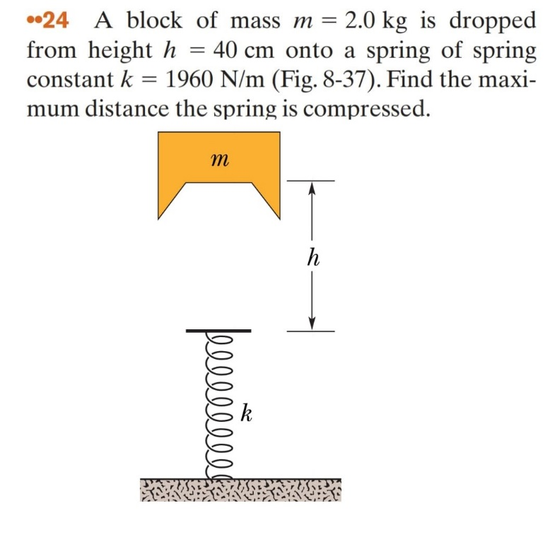

**User:** Look and classify this physics exercise

**Meta:** A block of mass m = 2.0 kg is dropped from height h = 40 cm onto a spring with constant k = 1960 N/m. Find the maximum distance that the spring will be compressed.

**Instructor Annotation:** Meta sets up the problem correctly, identifying the key details (mass, height, and spring constant). However, mentioning energy conservation as the primary principle—showing how gravitational potential energy converts to elastic potential—would enhance clarity

**User:** Identify all the key variables and parameters mentioned in the problem statement for each and specify if it's a given value, unknown, or a constant value.

**Meta:** Here are the key variables and parameters mentioned in the problem statement:

1. mmm (mass) - given value, constant
2. hhh (height) - given value, constant
3. kkk (spring constant) - given value, constant
4. xxx (maximum distance of spring compression) - unknown

Note that ggg (acceleration due to gravity) is not explicitly stated but it's a known physical constant approximately equal to 9.8 m/s² on Earth's surface.

**Instructor Annotation:** eta lists variables accurately; adding each variable’s role (e.g., ggg for potential energy) would enhance clarity.

**User:** Look at this diagram and tell me what the main keywords are.

**Meta:** The main keywords are:

* Block of mass (m)
* Height (h)
* Spring constant (k)
* Compression distance (maximum compression, h or k)

**Instructor Annotation:** Meta identifies keywords correctly, but linking each to energy concepts (e.g., height for potential energy, compression for elastic energy) would improve understanding.

**User:** Can you explain your reasoning at each stage including any relevant formula in short.

**Meta:** Here’s a step-by-step explanation:

1. The block of mass mmm is dropped from height hhh. This means the initial potential energy will be converted into kinetic energy and then elastic potential energy as it compresses the spring.
   * Relevant formula: PE=mghPE = mghPE=mgh, where g=9.8 m/s2g = 9.8 \, m/s^2g=9.8m/s2 on Earth's surface.
2. As the block falls onto the spring with constant kkk, its velocity increases until it reaches maximum compression in the spring. At this point, all the energy has been transferred to elastic potential energy stored within the compressed spring.
   * Relevant Formula: KE=0.5mv2; Ue=0.5kx2KE = 0.5mv^2; \, U_e = 0.5kx^2KE=0.5mv2;Ue​=0.5kx2, where xxx represents distance or displacement.
3. To find hhh (maximum compression), we can equate both energies since they are equal at that moment when v=0v = 0v=0 for an instant before bouncing back up again due to conservation laws such as the law of total mechanical energy being conserved throughout any process involving only conservative forces like gravity here acting upon our object under consideration, i.e., the falling block.

Equating them gives us: mgh=0.5kh2mgh = 0.5kh^2mgh=0.5kh2. Solving further by dividing each side by kh/2kh/2kh/2, we get: h=(2mg/k)h = \sqrt{(2mg/k)}h=(2mg/k)​.

**Instructor Annotation:** Meta provides a thorough explanation, but simplifying the final steps (directly solving mgh=0.5kx2mgh = 0.5kx^2mgh=0.5kx2) and briefly clarifying why energy conservation applies would enhance clarity and focus.

**User:** Can you explain how this problem or concept relates to other areas of physics we have not directly addressed in solving it.

**Meta:** This problem relates to other areas of physics such as Simple Harmonic Motion (SHM), work and energy, and oscillations, as the block’s motion on the spring is a classic example of SHM.

**User:** Can you provide a real-world application or example that illustrates the physics concept used in this problem.

**Meta:** A real-world application of this physics concept is a car’s shock absorber system, where a spring compresses to absorb the energy of a bump, converting kinetic energy into elastic potential energy.

**Instructor Annotation:** Meta makes relevant connections to SHM and work-energy principles. Including a quick example of energy oscillation in SHM would clarify these links. The shock absorber example is appropriate, but briefly noting how energy dissipates to stabilize the car would improve understanding.

**User:** Can you generate a brief quiz with two multiple-choice questions to test understanding of the key concept in this problem.

**Meta:** Here’s a brief quiz:

**Question 1:** What happens to the kinetic energy of the block as it compresses the spring?

* A) It increases
* B) It decreases
* C) It remains the same
* D) It becomes zero

**Question 2:** What type of energy is stored in the compressed spring?

* A) Kinetic energy
* B) Potential energy
* C) Thermal energy
* D) Elastic potential energy

**Instructor Annotation:** Meta’s quiz questions effectively cover key concepts. Adding a question on energy transformation, such as how gravitational potential converts to elastic potential energy, would deepen understanding.

**User:** My answer is for both questions are D

**Meta:** That’s correct, the kinetic energy of the block becomes elastic potential energy as it compresses the spring, so your answers, D) It becomes zero and D) Elastic potential energy, are both correct.

**User:** What follow-up question might my student have about this problem or solution? Please anticipate and answer the potential questions.

**Meta:** A potential follow-up question is, "What happens to the elastic potential energy stored in the spring when the block is released?"

**Instructor Annotation:** Meta’s feedback is correct; adding why kinetic energy becomes zero at max compression would help. The follow-up is relevant; more on mass or spring constant variations would deepen understanding