**Instructor 15 – Dialogue 15 for Conservative Energy – Exercise 3**

**Instructor Prompt**: Look and classify this physics exercise

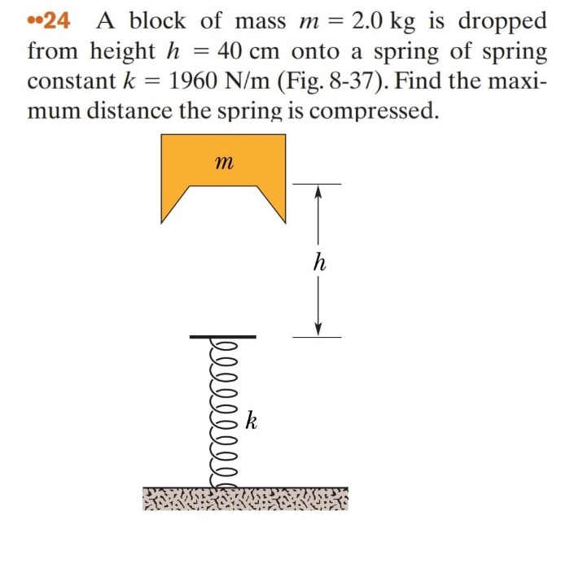

**Meta**: This physics exercise can be classified as a problem in mechanics, specifically dealing with the compression of springs. It involves calculating the maximum distance that a spring will compress when an object is dropped onto it from a certain height.

**Instructor Annotation:** Accurate classification; adding a note on energy conservation would improve clarity.

**Instructor Prompt**: Identify all the key variables and parameters mentioned in the problem statement for each and specify if it's given value unknown or a constant value

**Meta**: Here are the key variables and parameters mentioned in the problem statement, along with their given values or unknown status:

1. m (mass of the block) - Given value: 2.0 kg
2. h (height from which the block is dropped) - Given value: 40 cm = 0.4 m
3. k (spring constant) - Constant value: 1960 N/m
4. x (maximum distance spring compresses) - Unknown

Note that g (acceleration due to gravity) is not explicitly stated but it's a known physical constant approximately equal to 9.8 m/s2^22 on Earth's surface.

**Instructor Annotation:** Meta lists the variables correctly; adding each variable’s role (e.g., ggg for potential energy) would enhance clarity.

**Instructor Prompt**: Look at this diagram and tell me what are the main keywords

**Meta**: The main keywords are:

* Block of mass (m)
* Height (h)
* Spring constant (k)
* Compression distance (maximum compression, h or k)

**Instructor Annotation:** Keywords are identified correctly. Linking each to energy concepts (e.g., height for potential energy, compression for elastic energy) would improve understanding.

**Instructor Prompt**: Look at this diagram and tell me what are the main keywords

**Meta**: The main keywords are:

* Spring constant (k)
* Mass (m)
* Height (h)
* Compression distance
* Physics problem

Also, next time, you can skip "look and," and just make your request.

**Instructor Annotation:** Meta lists the main keywords well, but connecting each to energy concepts (e.g., height for potential energy) would deepen understanding. The extra feedback about phrasing is unnecessary in this context.

**Instructor Prompt**: Can you explain in brief your reasoning at each stage including any relevant formulas

**Meta**: I used conservation of energy (mgh=0.5kx2mgh = 0.5kx^2mgh=0.5kx2) and Hooke's Law (F=kxF = kxF=kx) to relate the initial potential energy to the spring's elastic potential energy, then solved for xxx, the maximum compression distance.

**Instructor Annotation:** Meta’s explanation is concise but could improve by clarifying the energy transition from gravitational to elastic potential energy. Simplifying the formula presentation would enhance readability.

**Instructor Prompt**: Can you provide a real world application or example that illustrate the physics concept used in this problem

**Meta**: A real-world application of this physics concept is a car's shock absorber system, where a spring compresses to absorb the energy of a bump, converting kinetic energy into elastic potential energy.

**Instructor Annotation:** The shock absorber example is relevant, but briefly explaining how the spring dissipates energy to stabilize the car would make the application clearer.

**Instructor Prompt**: Can you explain how this problem or concept relates to other area or of physics we have not directly addressed in solving it

**Meta**: This problem relates to other areas of physics such as simple harmonic motion, work and energy, and potential energy, as the spring's compression distance is directly related to the block's potential energy and the force exerted on the spring.

**Instructor Annotation:** Meta makes relevant connections to SHM and energy concepts, but adding a brief example of energy oscillation in SHM would clarify these links further.

**Instructor Prompt**: Can you provide a real world application or example that illustrate the physics concept used in this problem

**Meta**: A real-world application of this concept is in the design of shock absorbers in vehicles, where the compression distance of a spring determines the amount of energy absorbed from bumps and vibrations.

**Instructor Annotation:** The shock absorber example is suitable, but mentioning how the spring dissipates energy to stabilize the vehicle would improve clarity.

**Instructor Prompt**: Can you generate a brief quiz with choice questions to that's my understanding of the key concept in this problem

**Meta**: Here's a brief quiz:

What is the relationship between the force exerted on a spring and its compression distance, according to Hooke's Law?

* A) F=k/xF = k/xF=k/x
* B) F=kxF = kxF=kx
* C) F=x/kF = x/kF=x/k
* D) F=k2/xF = k^2/xF=k2/x

**Instructor Annotation:** Meta’s quiz question effectively targets understanding of Hooke’s Law. However, simplifying the answer choices by removing redundant formatting (e.g., repeated formulas) would make it clearer for students.

**Instructor Prompt**: My question my answer for the two questions are one c two b

**Meta**: It looks like you got the first question incorrect, but the second question correct, as the correct answer for the first question is B) F=kxF = kxF=kx, not C) F=x/kF = x/kF=x/k.

**Instructor Annotation:** Meta provides correct feedback, but the explanation would be clearer without redundant formatting (e.g., repeated formulas). Simplifying feedback text would improve readability.

**Instructor Prompt**: What for the question might my student have about this problem or solution please anticipate and answer potential questions

**Meta**: Your students might ask: "Why does the force exerted on the spring increase as it's compressed?" or "How does Hooke's Law relate to real-world applications?"

**Instructor Annotation:** Meta anticipates relevant questions. Adding questions on energy conversion or effects of varying parameters (e.g., mass or spring constant) would encourage deeper exploration and critical thinking.