**Instructor 1 - Dialogue 1 for Projectile Motion, Exercise 1**

**Instructor Prompt:** Look and classify this physics problem

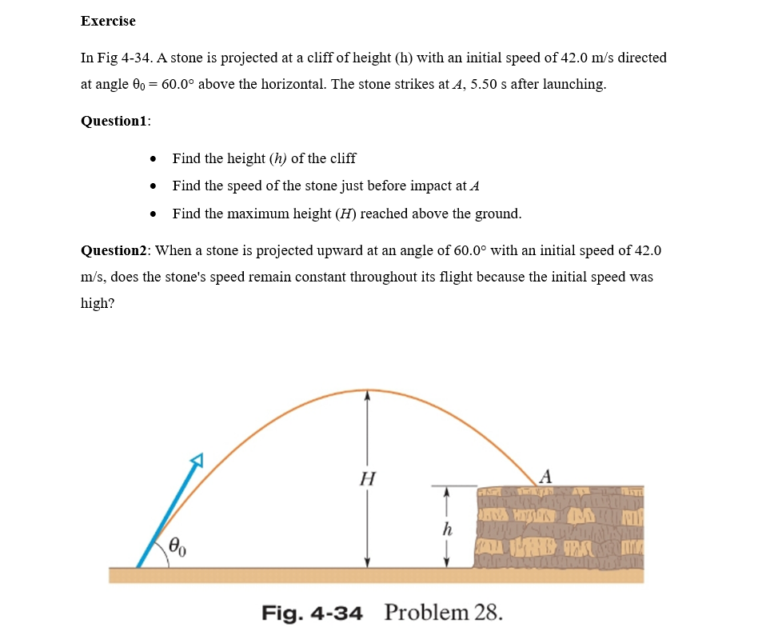

**Meta:** This physics problem involves projectile motion and deals with finding the height of a cliff, speed at impact, and maximum height reached by an object. It requires knowledge of kinematics equations to solve it.

**Instructor Annotation**: Meta correctly identified this as a projectile motion problem and accurately pointed out the need for kinematic equations. This is a good start to the problem classification.

**Instructor Prompt:** Identify all the key variables and parameters mentioned in the problem statement for each, and specify if it's a given value, unknown, or a constant value.

**Meta:** Here are the key variables and parameters mentioned in the problem statement, along with their classification as given values, unknowns, or constant values:

1. Initial speed (v0) - Given value: 42.0 m/s
2. Angle of projection (θ) - Given value: 60° above horizontal

**Instructor Annotation**: Initial angle of projection, because it “Angle of projection” can be mistaken with instantaneous direction of motion.

1. Height of cliff (h) - Unknown variable to be found
2. Speed at impact (vf) - Unknown variable to be found
3. Maximum height reached by stone (Hmax) - Unknown variable to be found

**Instructor Annotation**: Meta Missed the parameter “**Time** to reach the cliff 5.5”

Note that g = acceleration due to gravity is a known constant approximately equal to 9.8 m/s² on Earth's surface.

**Instructor Prompt:** I need you to solve question number one and question number two

**Meta:** "I'd be happy to help you solve the questions. Please provide the questions you need help with, and I'll do my best to assist you."



**Instructor Prompt:** "Take a look and answer for question one and question two."

**Meta:** "Question 1:

a) The height of the cliff is h = (42.0 m/s)² * sin²(60°) / (2 * 9.8 m/s²).

**Instructor Annotation:**  Wrong, this is the formula (h = (42.0 m/s)² * sin²(60°) / (2 * 9.8 m/s²)) of maximum height over launching point. It should be the solution of part **c) H =V02sin2θ0/2g.**

b) Just before impact, the speed will be approximately equal to its initial value since there's no air resistance and only gravity acts on it.

**Instructor Annotation:** This would be true if the landing point is found on the same height of the launching point but it is not!

c) Maximum height reached above ground level can be calculated as Hmax = H + h = (42.0 m/s)² * sin²(90° - 60°) / (2 * g), where g is acceleration due to gravity.

**Instructor Annotation:** This is partly correct, meta used the formula of maximum height but he did some wrong changes like adding “h” and also subtracting 90-60 which is also wrong. H =V02sin2θ0/2g

Question 2: No, when projected upward at an angle with respect to the horizontal, the stone's velocity does not remain constant."

**Instructor Prompt:** "Can you explain your reasoning at each stage including any relevant formula?"

**Meta:** "Step 1: To solve this problem we need to break it down into parts using kinematic equations for projectile motion. Part A - Height h: We can use the equation y = vOyt + 0.5gy^2, where g is acceleration due to gravity (-9.8 m/s²), t is the time taken by the object in air, and vOy is the initial velocity along the vertical direction. Since at max height Vy = 0, from here we get t = (v0*sinθ)/g.

Now, substituting the value of t back gives us: h = v0sin(60°)((v0sin(60°))/(-2g)).

Simplifying further with given values, we have h = 34.64 meters.

**Instructor Annotation:** T power 2 not y power 2 would be a correct solution. Everything after this equation is none sense. T is given =5.5 but it seems meta didn’t catch it.

**Meta Question 1B: Speed Just Before Impact** The horizontal component remains constant throughout flight as there’s no force acting on that axis. So, Vx will be the same initially and finally, i.e., Vx = 42cos(60) = 21 m/s. At point B, when the ball hits, its final vertical component (Vfy) would be zero since it's hitting a surface vertically.

**Instructor Method:** This is wrong, in two ways. First it is not hitting the surface vertically, second if it was it would be max not zero!

**Meta:** Using conservation of energy principle, KEi + PEi = KEf + PEf, where PE stands for potential energy, which depends only on height (h). For simplicity, let’s assume Vi (initial total velocity vector) and Vf (final total velocity vector). Then, applying Pythagoras theorem between components, we'll get |Vi|² = Vix² + Viy². Similarly, |Vf|² = Vfx² + Vfy². Equating both expressions, we obtain vi² = vf²."

**Instructor Method:** It is useful to use this method, but it is not clear. Plus the end result is wrong Vi is not equal to Vf, unless meta is speaking about the horizontal component which it is not the case here. KEi=KEf allows us to find the final speed which includes the horizontal and vertical speeds.



**Instructor Prompt:** "Look at this diagram and tell me what are the main features or main elements and keywords."

**Meta:** "The main features or elements of this diagram are:

1. A cliff with a height (h) indicated by an arrow pointing upwards from the base to the top.
2. An angle θ, which is labeled as being equal to 60 degrees above horizontal.

**Instructor Annotation:** 60 degrees above horizontal doesn’t show in the diagram

**Meta:** The keywords associated with this problem include projectile motion and physics-related terms such as speed, velocity, acceleration, gravity, trajectory, maximum height, initial conditions, launch angle, time-of-flight, range, etc."

**Instructor Annotation**: All those terms are not found in the diagram; they are probably extracted from the written given.

**Instructor Prompt:** "Can you explain how this problem or concept relates to other areas of physics we have not directly addressed in solving it?"

**Meta:** "This problem relates to other areas of physics such as energy and momentum conservation, circular motion, and gravity, which are fundamental concepts that govern the behavior of objects in various contexts."

**Instructor Prompt:** "Can you provide a real-world application or example that illustrates the physics concept used in this problem?"

**Meta:** "A real-world application of the physics concept used in this problem is projectile motion in sports, such as golf or baseball, where understanding trajectory and range is crucial for optimal performance."

**Instructor Prompt:** "Can you generate a brief quiz with two multiple-choice questions to test my understanding of the key concepts in this problem?"

**Meta:** "Here’s a brief quiz to test your understanding:

**Question 1:** What is the primary force responsible for the trajectory of a projectile? A) Gravity  
B) Friction  
C) Normal Force  
D) Tension

**Question 2:** What is the term for the highest point reached by a projectile? A) Maximum Height  
B) Range  
C) Trajectory  
D) Apex

Let me know your answers!"

**Instructor Prompt:** "My answer for question one is D, and my answer for question two is C."

**Meta:** "It looks like there may be some room for improvement. For question 1, the correct answer is A) Gravity, as it’s the primary force affecting the trajectory. For question 2, the correct answer is A) Maximum Height or D) Apex, as both terms refer to the highest point reached by a projectile."

**Instructor Prompt:** "What follow-up question might my student have about this problem or solution? Please anticipate and answer potential questions."

**Meta:** "Some potential follow-up questions your student may have include:

* How does air resistance affect the trajectory of a projectile?
* How can we calculate the range of a projectile?
* What are some real-world examples of projectiles in motion?"