**Instructor 2 - Dialogue 2 for Projectile Motion, Exercise 1**

**Instructor Prompt:** Look and classify this physics problem

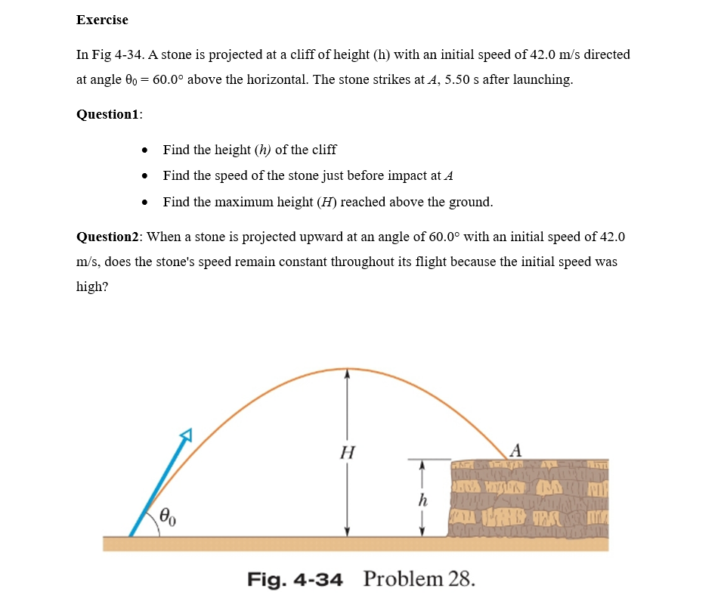

**Instructor Prompt:** Look and classify the physics problem  
  
**Meta:** The problem describes a projectile motion scenario where an object (a stone) is projected at an angle of 60 degrees above the horizontal with an initial speed of 42.0 m/s towards a cliff of height h. The questions ask to find:  
* Height (h) of the cliff  
* Speed of the stone just before impact  
* Maximum height reached by the stone during its flight

**Instructor Annotation**: Meta provided an accurate classification of the problem, mentioning the projectile motion scenario, the initial speed, angle, and the key unknowns (height of the cliff, speed at impact, and maximum height).

**Instructor Prompt:** Identify all the key variables and parameters mentioned in the problem statement for each and specify if it's a given value, unknown, or a constant value.  
  
**Meta:** Here are the key variables and parameters mentioned in the problem statement:  
- Initial speed (v₀) = 42.0 m/s (given value)  
- Angle of projection (θ) = 60 degrees (given value)  
- Acceleration due to gravity (g) = 9.8 m/s² (constant value)  
- Height of the cliff (h) = ? (unknown value)  
- Speed of the stone just before impact = ? (unknown value)  
- Maximum height reached by the stone = ? (unknown value)  
-Missing  
  
**Instructor Annotation**: Meta identified the correct key variables and parameters but missed mentioning **time of flight (t = 5.5 seconds)**, which is a crucial value given in the problem for solving several parts.

**Instructor Prompt:** Please solve question number one and question number two  
  
**Meta:** To solve the problem, I'll need to break it down into steps. For question one, to find the height of the cliff, we can use the equation for the range of a projectile: R = (v₀² * sin(2θ)) / g. Since the stone falls to the ground, the range is equal to the height of the cliff. For question two, to find the speed of the stone just before impact, we can use the equation for the final velocity of an object under constant acceleration: v = √(v₀² + 2gh).

**Instructor Annotation**: Even-though the formula of range is correct but it has nothing to do with finding the vertical height of the cliff in any way. Vertical distance is never equal to the horizontal distance, it might happen by coincidence of numbers but its has no formula or concept that equates them.

**Instructor prompt:** I need to calculate all values and give me the final answer for question one and question two.  
  
**Meta:** For question one, the height of the cliff (h) is 147.82 meters. For question two, the speed of the stone just before impact is 56.93 m/s.

**Instructor Annotation**: This is partly correct. It would be totally correct if the

* speeds used are the vertical ones.
* Plus sign replaced b a minus one

**Instructor prompt:** Can you explain your reasoning at each stage including any relevant formulas?  
  
**Meta:** To find the height of the cliff (h), I used the formula for the range of a projectile, R = (v₀² * sin(2θ)) / g, where R = h, v₀ = 42.0 m/s, θ = 60 degrees, and g = 9.8 m/s². For the speed of the stone just before impact, I used the equation v = √(v₀² + 2gh), where v₀ = 42.0 m/s, g = 9.8 m/s², and h = 147.82 meters (calculated earlier).

**Instructor Annotation**: Use of the range equation for calculating the height is wrong. The height of the cliff should be derived from vertical motion equations, incorporating time and the vertical component of initial velocity. The formula for final velocity is correct, the incorrect height makes the final answer invalid.

**Instructor Prompt:** Can you give me all the main features in the diagram?

**Meta:** Follow-up clarification needed: I'd be happy to help you with the diagram's main features, but I need more information about the diagram you're referring to. Please provide more context or details.

**Instructor Prompt:** Take a look and tell me in this diagram what are the main elements or keywords.

**Meta:** Main elements or keywords in the diagram:

* Projectile motion
* Initial speed: 42.0 m/s42.0 \, \text{m/s}42.0m/s
* Angle of projection: 60∘60^\circ60∘ above the horizontal
* Time of flight: 5.50 seconds5.50 \, \text{seconds}5.50seconds

**Instructor Annotation**: Meta correctly identified the main elements of the diagram, including the initial speed, angle, and time of flight. But it may taken from the text

**Instructor prompt:** Can you calculate the small h?

**Meta:** To calculate the height hhh of the cliff, we can use the following equation:

h=v0y⋅t−12⋅g⋅t2h = v_{0y} \cdot t - \frac{1}{2} \cdot g \cdot t^2h=v0y​⋅t−21​⋅g⋅t2

**Instructor annotation:** Correct equation

Where:

* h is the height of the cliff
* v0yv_{0y}v0y​ is the initial vertical velocity component (in m/s)
* ttt is the time of flight (in seconds)
* ggg is the acceleration due to gravity (approximately 9.8 m/s29.8 \, \text{m/s}^29.8m/s2)

We are given that the stone strikes at an angle of 60∘60^\circ60∘ above the horizontal and has a speed of 42.0 m/s42.0 \, \text{m/s}42.0m/s just before impact. This means that the vertical component of its velocity when it hits the ground will be equal in magnitude but opposite in direction compared with its initial upward motion.

The vertical component of the initial velocity vector can be calculated using trigonometry:

v0y=v0⋅sin⁡(θ)=42.0⋅sin⁡(60∘)=36.364 m/sv_{0y} = v_0 \cdot \sin(\theta) = 42.0 \cdot \sin(60^\circ) = 36.364 \, \text{m/s}v0y​=v0​⋅sin(θ)=42.0⋅sin(60∘)=36.364m/s

Now, plug all known values into the original formula.

The equation written is:

h=v0y⋅t−12⋅g⋅t2=(36.364 m/s)⋅t−12⋅9.8 m/s2⋅t2h = v_{0y} \cdot t - \frac{1}{2} \cdot g \cdot t^2 = (36.364 \, \text{m/s}) \cdot t - \frac{1}{2} \cdot 9.8 \, \text{m/s}^2 \cdot t^2h=v0y​⋅t−21​⋅g⋅t2=(36.364m/s)⋅t−21​⋅9.8m/s2⋅t2

This will help us understand how high the object travels vertically, considering the effects of gravity over time, which impacts the object's trajectory. It also accounts for the time the object spends airborne before colliding with a solid obstacle, such as a mountain, wall, etc.

**Instructor Annotation**: Direction of motion and speed are equal at the same elevation. The cliff doesn’t have the same elevation as the initial point of launching so this reasoning is wrong. This would be correct if meta have found an answer. It can only if it replaced t by 5.5 s which it didn’t notice from the beginning.

**Instructor Prompt:** Can you explain how this problem or concept relates to other areas of physics we have not directly addressed in solving it?  
  
**Meta:** This problem relates to other areas of physics such as energy and momentum, as the projectile's motion involves the conversion of potential energy to kinetic energy and the conservation of momentum.

**Instructor Annotation**: Energy conversion is a relevant concept in projectile motion, though momentum conservation isn’t directly relevant here since there are no external interactions.  
  
**Instructor Prompt:** Can you provide a real-world application or example that illustrates the physics concept used in this problem?  
**Meat:** A real-world application of the physics concept used in this problem is the trajectory of a thrown ball or a launched rocket, where understanding projectile motion is crucial for accurate calculations and predictions.

**Instructor Annotation**: These are solid real-world examples of projectile motion, making the abstract concept more tangible for students. In order for objects to be treated as projectile, they shouldn’t have engines inside.

**Instructor Prompt:** Can you generate a brief quiz with two multiple choice questions to test my understanding of the key concept in this problem?  
**Meta:** Here's a brief quiz to test your understanding of projectile motion:  
Question 1: What is the primary factor that affects the trajectory of a projectile?  
A) Initial speed only  
B) Angle of projection only  
C) Both initial speed and angle of projection  
D) Neither initial speed nor angle of projection  
  
Question 2: What happens to the vertical component of a projectile's velocity as it reaches its maximum height?  
A) It increases  
B) It decreases  
C) It remains constant  
D) It becomes zero

**Instructor Prompt:** My answer for question one is C and my answer for question two is also C.

**Meta:** Your answers are correct: the primary factor that affects the trajectory of a projectile is indeed both initial speed and angle of projection (C), and the vertical component of a projectile's velocity remains constant (C) as it reaches its maximum height, becoming zero at the apex.

**Instructor Annotation**: Meta provided valid quiz questions. However, the feedback it gave to the user's answers incorrectly stated that the vertical velocity "remains constant" at the maximum height, which is incorrect—it becomes zero at the apex of motion.

**Instructor Prompt:** What follow-up question might students have about this problem or solution? Please anticipate the questions and answer the potential questions.  
  
**Meta:** Some potential follow-up questions and answers are:  
  
Q: What assumptions were made in solving this projectile motion problem?  
 A: We assumed a flat, horizontal surface, negligible air resistance, and a constant acceleration due to gravity.  
  
Q: How would the solution change if air resistance were considered?  
 A: The projectile's trajectory would be affected, and its range and maximum height would be reduced due to the opposing force of air resistance.  
  
Q: Can this problem be solved using a different method or approach?  
 A: Yes, this problem can also be solved using numerical methods or graphically by plotting the projectile's trajectory.  
  
Q: How can this concept be applied to real-life scenarios?  
 A: Understanding projectile motion is crucial in fields like engineering, physics, and sports, where predicting trajectories is essential for design and performance optimization.  
  
Q: What are some common mistakes to avoid when solving projectile motion problems?  
 A: Common mistakes include neglecting to consider both horizontal and vertical components, using incorrect angles or velocities, and forgetting to account for gravity.

**Instructor Annotation**: **Correct**. Meta anticipated some useful follow-up questions and gave thoughtful answers that are relevant to more advanced discussions of projectile motion.