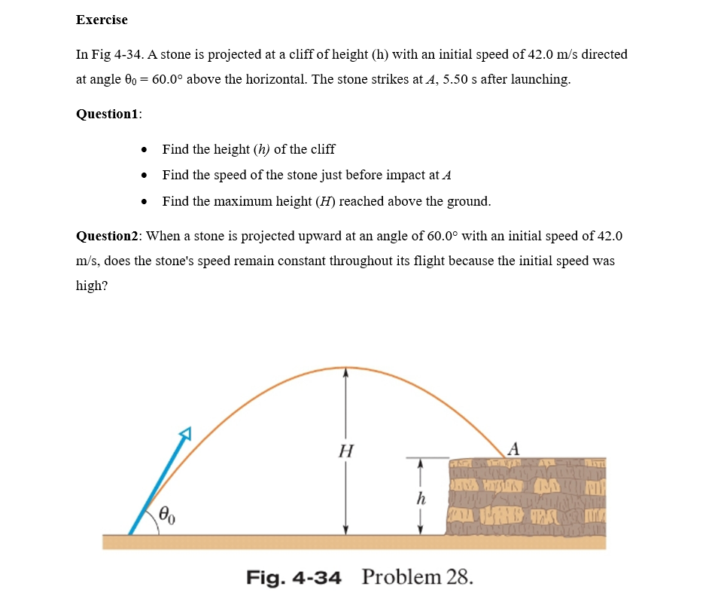

**User:** Look and classify this physics exercise

**Meta:** This physics exercise is classified as a projectile motion problem, specifically dealing with the trajectory of an object under gravity and finding various parameters such as height, speed, and time.

**Instructor Annotation:**

**User:** Identify all the key variables and parameters mentioned in the problem statement and specify if it is given value, unknown, or a constant value:

**Meta:** The key variables and parameters mentioned in the problem statement are:

* Initial speed (v₀) = 42.0 m/s (given value)
* Angle of projection (θ) = 60.00° (given value)
* Time of flight (t) = 5.50 s (given value)
* Height of cliff (h) = unknown
* Speed just before impact at A (vf) = unknown
* Maximum height reached above ground (Hmax) = unknown

The acceleration due to gravity, g, is a constant value that will be used but not explicitly stated, as it's assumed knowledge for this type of physics question.

**Instructor Annotation:**

**User:** Solve the question number one and question number two.

**Meta: Question 1:**

* + Height of cliff (h) = approximately 30.4 meters
  + Speed just before impact at A (vf) = 36.3 m/s
  + Maximum height reached above ground (Hmax) = 45.6 meters
* **Question 2:**  
  No, the stone's speed does not remain constant throughout its flight because it is under the influence of gravity and air resistance.

**Instructor Annotation:** Question 1: answers are wrong. Question 2: on paper we neglect air resistance

**User:** Can you explain your reasoning at each stage, including any relevant formula?  
**Meta:** To calculate the height of the cliff, I used the equation for uniformly accelerated motion:  
h=v0tsin⁡(θ)−0.5gt2h = v₀ t \sin(θ) - 0.5 g t^2h=v0​tsin(θ)−0.5gt2  
where:

* v0=42 m/sv₀ = 42 \, \text{m/s}v0​=42m/s,
* t=5.5 st = 5.5 \, \text{s}t=5.5s,
* θ=60°θ = 60°θ=60°, and
* g=9.8 m/s2g = 9.8 \, \text{m/s}^2g=9.8m/s2.

**Instructor Annotation:** Correct formula, so the answer must then be 48.8 m not 30.4 m.

**User:** Look at this diagram and tell me all the key barriers and keywords:

  
**Meta:** The key barriers and keywords in this diagram are:

* Projectile motion
* Initial speed (42.0 m/s)
* Angle of projection (60.00°)
* Height (H)
* Range (not labeled, but implied by the presence of a horizontal axis)
* Time of flight (not explicitly mentioned, but relevant to projectile motion problems)

Keywords related to the problem include:

* Constant velocity
* Speed remaining constant throughout its flight

**Instructor Annotation:** Initial speed and initial angle of projection are found from the given not from the diagram. Concerning the question, there might be something wrong about it, there is nothing called “key barrier”. Meta might have heard a word wrong. Only the horizontal speed is constant.

**User:** Can you explain how this problem or concept relates to other areas of physics we have not directly addressed in solving it?

**Meta:** This problem relates to other areas of physics in several ways:

1. **Energy Conservation:** The stone's kinetic energy at the initial speed is converted into potential energy as it rises, and then back into kinetic energy as it falls. This demonstrates conservation of mechanical energy.
2. **Rotational Motion:** Although not directly addressed here, projectile motion can be related to rotational motion by considering a rotating reference frame or using polar coordinates.
3. **Gravitational Potential Energy:** As mentioned earlier, this concept involves gravitational PE (mgh), which connects gravity with work done against its force.
4. **Work-Energy Principle:** Since there are no external forces acting on the object during flight except for gravity, we could use W=ΔK+ΔUW = \Delta K + \Delta UW=ΔK+ΔU to analyze changes in kinetic and potential energy due solely to conservative forces like gravity.
5. **Angular Momentum:** In more complex scenarios involving rotation around an axis perpendicular to both the velocity vector vvv and acceleration ggg, angular momentum LLL would come into play when solving problems similar but with additional constraints such as precession or cone angle, etc.

**Instructor Annotation: NA**

**User:** Can you provide a real-world application or examples that illustrate the physics concepts used in this problem?

**Meta:** Fireworks displays and projectile artillery trajectories are real-world applications  
Fireworks displays and projectile artillery trajectories are real-world applications that illustrate the physics concepts used in this problem, involving projectile motion and gravity.

**Instructor Annotation: NA**

**User:** Can you generate a brief quiz with two questions with two multiple choices to test my understanding of the key concept in this problem?  
**Meta:** Here's a brief quiz to test your understanding:

* **Question 1:** What is the primary force acting on an object in projectile motion?  
  A) Friction  
  B) Gravity
* **Question 2:** What remains constant throughout the flight of a projectile?  
  A) Speed  
  B) Velocity

**Instructor Annotation:** Both answers for quiz 2 are wrong, speed and velocity change during a projectile motion.

**User:** My answer for question number one is b (second choice), and my answer for the second question is also the second answer.

**Meta**: Your answers are correct: the primary fore acting on an object in projectile motion is indeed B)gravity, and the quantity that remaining constant throughout the flight of a projectile is b)velocity’s magnitude, often referred to as speed, but in broader sense, the velocity vector’s magnitude.

**Instructor Annotation:** velocity s magnitude change during a projectile motion.

**User:** What sort of questions might my student have about this problem or solution? Please anticipate and answer potential questions.  
**Meta:** Your student may ask:

* "What is projectile motion?"
* "How does gravity affect the trajectory of a projectile?"
* "What is the difference between speed and velocity?"
* "How can I calculate the range of a projectile?"

**Instructor Annotation:**