**Instructor 6 - Dialogue 6 for A Traffic Light at Rest, Exercise 2**

**Instructor Prompt:** Look and declassify this physics exercise

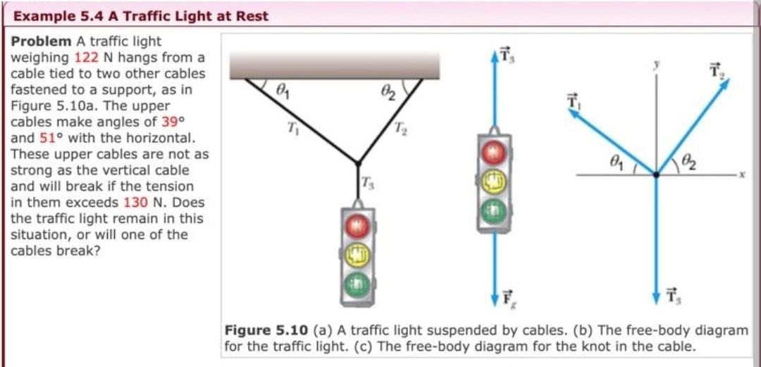

**Meta:** This physics exercise is about a traffic light suspended by cables. It asks whether he traffic light will remain in its current position or if one of the supporting cables will break, given that each cable can withstand up to 130 N (newtons) of tension and there are two upper cables at an angle with respect to the horizontal plane.

**Instructor Annotation:** It understood it as a real-life experience. It didn’t link it to the physics laws used which is Newton’s first law.

**Instructor Prompt:** Identify all the key variables and parameters mentioned in the problem statement for each and specify if it's a given value unknown or constant value  
**Meta:** Here are the key variables and parameters mentioned in the problem statement: 1.  
Tension (T) - unknown value, needs to be calculated or determined 2. Angle of upper  
cables with respect to horizontal plane (6 = 39°) - given constant value 3. Mass of traffic  
light (m) - not explicitly stated but can be considered a known/unknown variable  
depending on context 4. Acceleration due to eee gravity (g) - assumed as standard  
acceleration due to gravity (~9.8 m/s*2), so it's animplied constant value 5. Maximum  
tension each cable can withstand before breaking (130 N) - given constant value  
Note that some values might need additional assumptions or information from  
outside this specific exercise for full clarity.

**Instructor Annotation:** weight of the traffic light is given, the second angle with the horizontal is given. It didn’t catch them

**Instructor Prompt:** Can you solve the questions in the given exercises  
**Meta:** The exercise is asking whether the traffic light will remain in its current position or if one of the supporting cables will break. To solve this, we need to calculate the tension (T) in each cable and compare it with the maximum tension that each cable can  
withstand before breaking (130 N). Let's assume the mass of the traffic light is m kg.  
We have two upper cables at an angle 6 =39° with respect to the horizontal plane. The  
free-body diagram for the traffic light shows three forces: * Weight force W = mg  
downwards * Tension force T1 upwards along the left cable * Tension force T2  
upwards along the right cable Since the system is at rest, the net force on the traffic  
light must be zero. Therefore, we can write the following equations based on Newton's  
second law: * Vertical component: -mg + T1 sin(6) + T2 sin(@) = 0 * Horizontal  
component: T1 cos(8) - T2 cos(8) = O From these equations, we get: * T1 = T2 (since  
they are equal and opposite) * T1 sin(6) = T2 sin(8) = mg/2 Now, let's find the value of T1 (or T2): *T1 = mg/ (2 \* sin(6)) Substituting given values: * T1= mg / (2 \* sin(39°)) If mg > 260 N (~= 2 x 130), then T1 would exceed 130 N, indicating a possible failure scenario where either cable could potentially snap under excessive load conditions; otherwise both stay intact as long as no external factors disturb their equilibrium state

**Instructor Annotation:** Newton s first law. Angles not clear. T1 is not equal to T2. Wrong. the weight is given.

**Instructor Prompt:** Can you explain how this problem or concept relate to other area of physics who have not directly addressed in solving it

**Meta:** This problem relates to other areas of physics like rotational motion and torque, as  
the tension in the cables can be seen as a force causing rotational motion, and energy °**  
conservation, as the potential energy of the traffic light is balanced by the tension in the  
cables.

**Instructor Annotation:** NA (it indicates no comment on the Meta answer.)

**Instructor Prompt**: Can you provide a real word application or examples that illustrate the physics Concept used in this problem

**Meta:** A real-world application of this physics concept is the design of suspension bridges, where cables are used to support the weight of the bridge and vehicles, and the tension in the cables must be carefully calculated to ensure stability and safety.

**Instructor Annotation:** NA (it indicates no comment on the Meta answer.)

**Instructor Prompt:** Can you generate a brief quiz with two questions and multiple choice question to test my understanding of the key concept of this problem

**Meta:** Here's a brief quiz with two multiple-choice questions to test your understanding of the key concept:

Question 1: What is the primary force that the cables need to counteract to keep the  
traffic light in its current position?  
A) Frictional force  
B) Normal force  
C) Weight force  
D) Tension force

Question 2: If the mass of the traffic light increases, what happens to the tension in the cables?  
A) It decreases  
B) It remains the same  
C) It increases  
D) It becomes zero  
  
Let me know when you're ready to submit your answers!

**Instructor Prompt:** My answers for both questions is C

**Meta:** It seems like you meant to submit your answers as "C) Weight force" for Question 1 and "C) It increases" for Question 2, is that correct?

**Instructor Prompt:** Yes those are my answers

**Meta**: That's correct, well done! Your answers, "C)Weight force" and "C) It increases", demonstrate a good understanding of the key concept.

**Instructor Annotation:** what does make a force to be primary?

**Instructor Prompt:** What follow up question might my student have about this problem or solution please anticipate and answer potential questions

**Meta:** Your student might ask, "What happens to the tension in the cables if the angle  
between the cables and the horizontal increases?"

**Instructor Annotation:** NA (it indicates no comment on the Meta answer.)