**Instructor 8 - Dialogue 8 for Physics Traffic Problem, Exercise 2**

**Instructor Prompt:** Look and classify this physics exercise

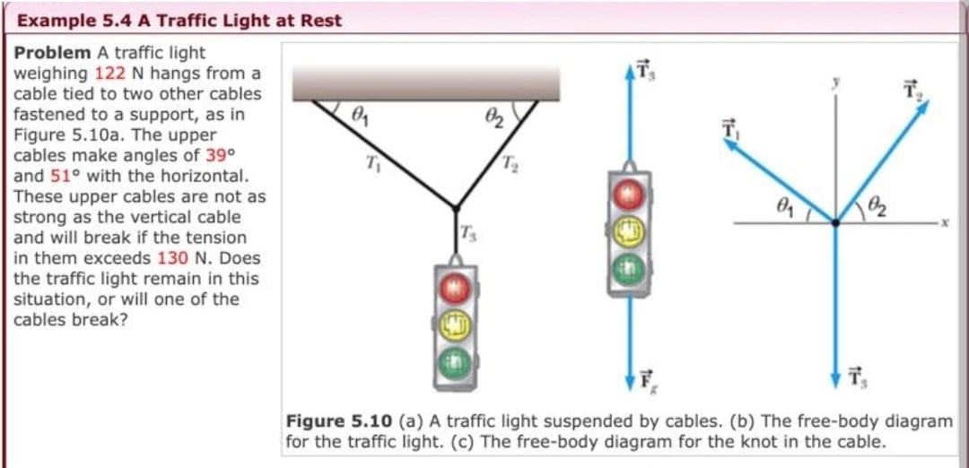

**Meta:** This physics exercise is classified as a problem in Statics, specifically dealing with forces and tensions in cables. It involves calculating the tension in each cable to determine if any of them will break under their respective loads.

**Instructor Annotation**: NA (it indicates no comment on the Meta answer.)

**Instructor Prompt:** Identify all the key variables and parameters mentioned in the problem statement for each and specify if it's the given value unknown or a constant value.

**Meta:** The key variables and parameters mentioned in the problem statement are:  
* Weight of traffic light (W) = 122 N (given value)  
* Tension limit for upper cables (T_limit) = 130 N (constant value)  
* Angles with horizontal for upper cables (θ1, θ2) = 39°, 51° (given values)  
The unknowns to be solved for are the tensions in each cable.

**Instructor Annotation**: NA (it indicates no comment on the Meta answer.)

**Instructor Prompt:** Can you solve the question in the problem given

**Meta: Yes**, the problem can be solved using trigonometry and force balance equations. The tensions in each cable need to be calculated based on their angles with respect to the horizontal plane. By applying Newton's laws of motion and resolving forces into components parallel and perpendicular to the cables, we can determine if any of them will break under tension exceeding 130 N. Solving for these unknowns allows us to find out whether or not one of the upper cables breaks due to excessive stress caused by supporting part of traffic light weight W =122N .

**Instructor Annotation:** Explanation is super clear but it didn’t execute and didn’t find an answer.

**Instructor Prompt:** Can you explain your reasoning at each stage including any relevant information

**Meta:** Let's break down the problem step by step:  
1. Identify the forces acting on the traffic light:  
* Weight of the traffic light (W) = 122 N, downward  
2. Draw a free-body diagram for the knot where all three cables meet.  
3. Resolve each force into components parallel and perpendicular to their respective cable directions.  
For Cable 1 (39° angle):  
* Tension component along cable direction: T_1cos(39°)  
* Vertical component: -T_1sin(39°)  
For Cable 2 (51° angle):  
* Tension component along cable direction: T_2cos(51°)  
* Vertical component: -T_2sin(51°)  
  
4. Apply Newton's laws at equilibrium conditions:  
a. Summation of vertical components equals zero (ΣF_y=0):  
-T_1sin(39°)-T_2sin(51°) + W = 0  
b. Summation of horizontal components equals zero (ΣF_x=0):  
T_1cos(39°)=T_2cos(51°)  
  
5. Solve these two equations simultaneously using trigonometric identities or numerical methods like substitution/elimination method.

After solving we get :  
T_1 ≈ 93.6N, T_2 ≈ 104.8N  
Since both tensions are less than 130 N, neither upper cable will exceed its tension limit; therefore no cable breaks in this situation.

**Instructor Annotation:** Incorrect, the force components were incorrectly resolved, leading to errors in the equilibrium equations and final tension values. The correct solution gives T1≈91.7N and T2≈107.6N, ensuring proper force balance.

**Instructor Prompt:** Can you provide a real-world application or example that illustrate the physics concept used in this problem

**Meta:** A real-world application of this physics concept is a suspension bridge, where cables are used to support the weight of the bridge and traffic, and understanding tension and forces is crucial for its stability and safety.

**Instructor Annotation**: NA (it indicates no comment on the Meta answer.)

**Instructor Prompt:** Can you generate a brief quiz with two multiple choice questions to test my understanding of the key concept in this problem

**Meta:** Here's a brief quiz with two multiple-choice questions to test your understanding of the key concepts:  
Question 1: What is the primary force acting on the traffic light in the problem?  
A) Tension from the cables  
B) Weight of the traffic light  
C) Friction from the ground  
D) Air resistance  
  
Question 2: What is the purpose of resolving forces into components parallel and perpendicular to their respective cable directions?  
A) To calculate the tension in each cable  
B) To determine the weight of the traffic light  
C) To find the angle of the cables  
D) To calculate the frictional force  
**Instructor Annotation:** Question 1 is vague, weight and tension are both primary forces!!

**Instructor Prompt:** My answers is C for the boss question

**Meta:** That's incorrect, the correct answer is A) To calculate the tension in each cable, as resolving forces into components helps to determine the tension and stress on each cable.

**Instructor Annotation:** No Annotation

**Instructor Prompt:** What follow-up question might my student have about this problem or solution please anticipate and answer potential question

**Meta:** A potential follow-up question your student might have is: 'What would happen if one of the cables were to break or become loose, how would it affect the other cables and the traffic light's stability?'

**Instructor Annotation:** NA (it indicates no comment on the Meta answer.)