**Instructor 9 - Dialogue 9 for Physics Traffic Problem, Exercise 2**

**Instructor Prompt**: Look and classify this physics exercise  
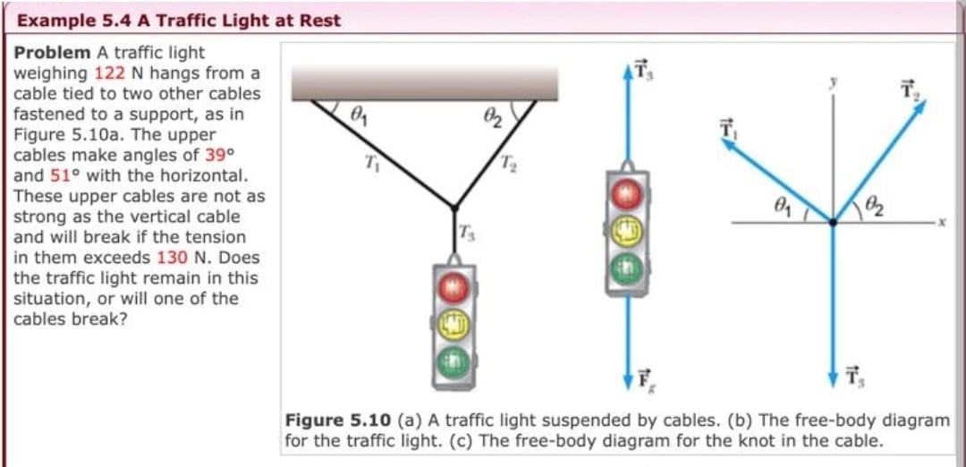

**Meta:** This physics exercise is classified as a problem involving forces, tension and equilibrium. It requires the application of Newton's laws to determine if an object will remain at rest or not.

**Instructor Annotation:** NA (it indicates no comment on the Meta answer.)

**Instructor Prompt:** Identify all the key variables and parameters mentioned in this problem statement and specify if it's the given value unknown or constant value.

**Meta:** Here are the key variables and parameters mentioned in this problem statement:  
1. Weight of traffic light (W) - Given value: 122 N  
2. Tension in upper cables (T1, T2) - Unknown values  
3. Angles with horizontal (θ1, θ2) - Given values: 39°, 51°  
4. Maximum tension allowed in upper cables (T_max) - Constant value: 130 N  
Note that other constants like gravity acceleration g = 9.8 m/s² is not explicitly stated but it's a known constant used to calculate weight from mass or vice versa.

**Instructor Annotation:** NA (it indicates no comment on the Meta answer.)

**Instructor Prompt:** Can you solve the question in the exercise given

**Meta:** Yes, I can help solve the problem. Let's break it down step by step:  
1. First, we need to find the total tension in both cables (T1 and T2). We know that the weight of the traffic light is 122 N.  
2. Since the system is at rest, the sum of all forces acting on the object must be zero. So, we have:  
ΣF = W - T1sin(θ1) - T2sin(θ2)  
3. Substituting given values:  
0 = 122 - T1sin(39°) - T2sin(51°)  
4. Now, let's use trigonometry identities to simplify this equation.  
0 = 122 - T1 * 0.63 - T2 * 0.78  
5. Simplifying further, 0 ≈ 122 - 0.63T1 - 0.78T2  
6. To make things easier, let's assume T1 = x and T2 = y  
7. Then our simplified equation becomes: 0 = 122 - 0.63x - 0.78y  
8. This gives us one linear equation with two unknowns. However, there are infinitely many solutions for such a case unless another constraint or condition exists.  
9. The question states an additional restriction: neither cable should exceed its maximum allowed force of 130N.  
So now we also have these constraints: x ≤ 130, y ≤ 130

**Instructor Annotation:** Even-though the explanation was great but it didn’t notice the summation of forces along the x axis

**Instructor Prompt:** Can you explain shortly your reasoning at each stage including any relevant formula

**Meta:** To solve the problem, I used the following reasoning and formulas at each stage:  
1. Identified the forces acting on the object: weight (W) and tensions in the cables (T1 and T2).  
2. Applied the equilibrium condition: ΣF = 0, where ΣF is the sum of all forces.  
3. Used trigonometry to resolve the tensions into their vertical components: T1sin(θ1) and T2sin(θ2).  
4. Simplified the equation using numerical values for the angles and weight.  
5. Introduced variables x and y for T1 and T2 to simplify the equation further.  
6. Recognized the need for an additional constraint to solve for x and y.  
7. Applied the constraint: x ≤ 130 and y ≤ 130, based on the maximum allowed force in the cables.

**Instructor Annotation:** it explained without using numbers and solving. It missed out the use of sum of forces along the horizontal axis.

**Instructor Prompt:** Can you provide a real-world application or example that illustrates the physics concept used in this problem

**Meta:** A real-world application of this physics concept is the design of suspension bridges, where cables are used to support the weight of the bridge and traffic, and must be carefully tensioned to ensure stability and safety.

**Instructor Annotation:** NA (it indicates no comment on the Meta answer.)

**Instructor Prompt:** Can you generate a brief quiz with two multiple choice questions to test my understanding of the key concept in this problem

**Meta:** Here's a brief quiz to test your understanding:  
Question 1: What is the primary principle used to solve this problem?  
A) Conservation of Energy  
B) Newton's Second Law of Motion  
C) Equilibrium of Forces  
D) Momentum Conservation  
  
Question 2: What is the purpose of introducing variables x and y in the problem?  
A) To represent the angles between the cables and the horizontal  
B) To represent the tensions in the upper cables  
C) To represent the weight of the traffic light  
D) To represent the maximum allowed force in the cables

**Instructor Annotation:** NA (it indicates no comment on the Meta answer.)

**Instructor Prompt:** My answer for question one is A and my answer for question two is C

**Meta:** Here are the correct answers and explanations:  
Question 1: The correct answer is C) Equilibrium of Forces. The problem uses the principle of equilibrium to balance the forces acting on the traffic light.  
Question 2: The correct answer is B) To represent the tensions in the upper cables. Variables x and y are introduced to represent the tensions in the cables, T1 and T2, to simplify the equation.

**Instructor Annotation:** NA (it indicates no comment on the Meta answer.)

**Instructor Prompt:** What Follow-up question might my student have about this problem or solution. Please anticipate and answer potential question

**Meta:** A potential follow-up question a student might have is: 'What would happen if the traffic light's weight was increased, and how would that affect the tensions in the cables?'

**Instructor Annotation:** NA (it indicates no comment on the Meta answer.)