***GLPI Guide***

Prerequisites

GLPI is a web application that requires the following:

* Web Server: You need a web server software such as Apache, Nginx, or IIS to host the GLPI application.
* PHP: GLPI is developed using PHP, so you need to have PHP installed on your server. Ensure that you have a compatible version of PHP for GLPI.
* Database: GLPI requires a database management system to store its data. It is compatible with various database systems such as MySQL, MariaDB, PostgreSQL, and SQLite. Choose a database system that best suits your needs and install it on your server.

To install glpi on ubuntu you can follow these steps.

Version :

Ubuntu:22.04

Php7.4

Glpi 10.0.7

1. Install mysql Database

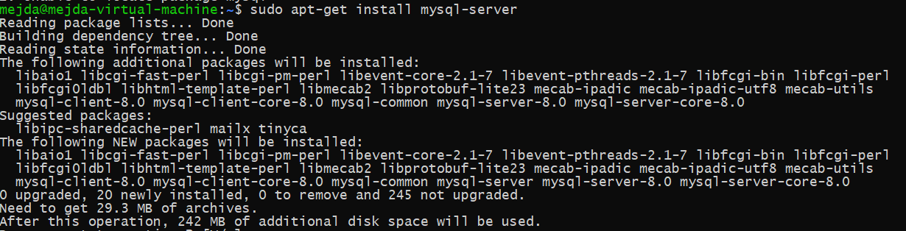

1. Configure mysql server

* mysql -u root : opens the MySQL command-line client with the root user.
* Within the MySQL shell:
* CREATE DATABASE glpi : creates a database named "glpi" to be used by GLPI.
* CREATE USER 'glpi'@'localhost' IDENTIFIED BY 'glpi' : creates a user named "glpi" with the password "mejdaglpi" that can access the database from the localhost.
* GRANT ALL PRIVILEGES ON glpi.* TO 'glpi'@'localhost' : grants all privileges to the "glpi" user on the "glpi" database.
* FLUSH PRIVILEGES : refreshes the privileges to apply the changes.

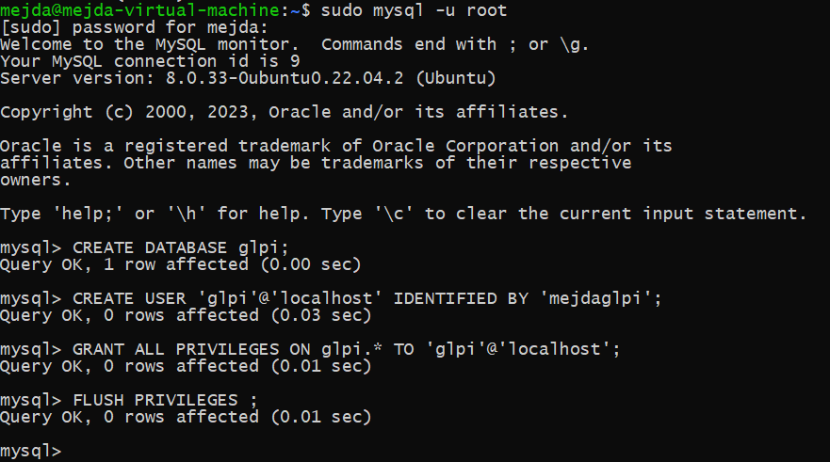

1. Install apache web server

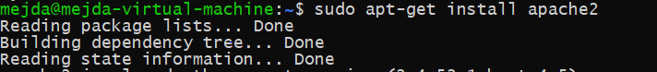

1. Install php7.4

GLPI 10.x work with php7.4 and above

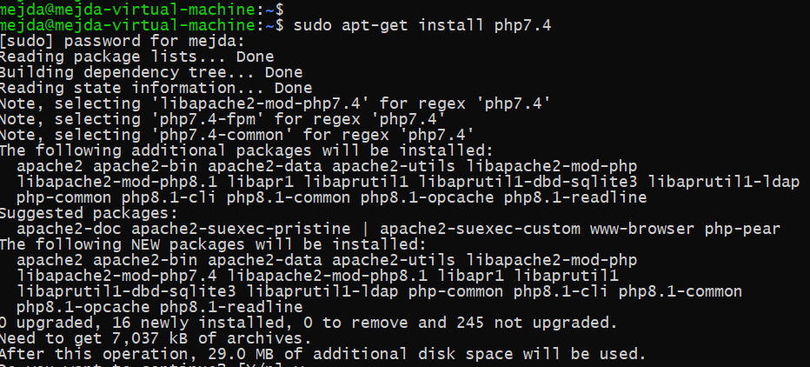

1. Install additional PHP7.4 modules needed by GLPI



1. Restart apache service



1. Download glpi 10.0.7

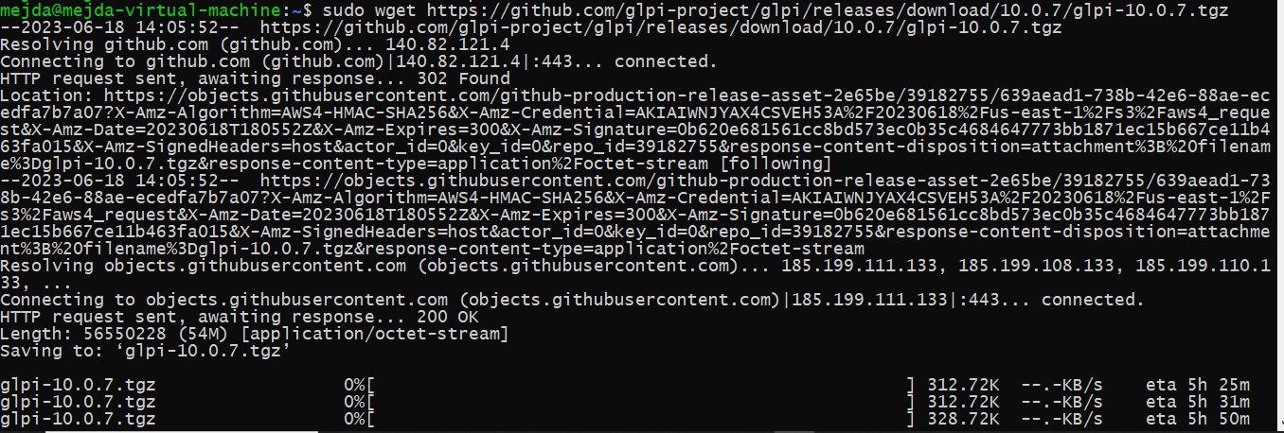

1. Configure apache

open the Apache configuration file in a text editor you can use this command

**sudo nano /etc/apache2/apache2.conf**

In the configuration file, find the <Directory /var/www/> section.

Set AllowOverride directive to "All" within that section. This allows the use of .htaccess files for directory-specific configuration then save the changes and exit the editor.

Use sudo service apache2 restart restarts Apache to apply the configuration

1. Extract and move GLPI files:

These commands handle the extraction and movement of the GLPI files.

tar xvf glpi-9 .5.7.tgz :extracts the contents of the GLPI archive.

sudo cp -r glpi /var/www : copies the extracted GLPI directory to the /var/www directory.

sudo mv glpi /var/www/html : moves the GLPI directory to the /var/www/html directory.

sudo chown -R www-data:www-data /var/www/html : changes the ownership of the GLPI files to the user and group "www-data," which is the default user/group for the Apache web server.

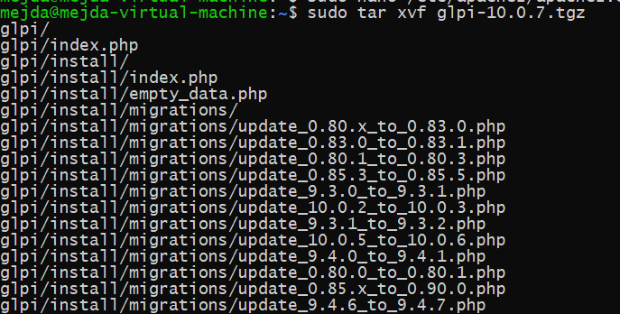

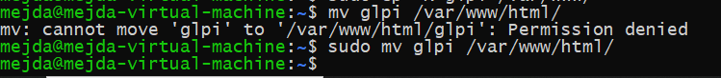



1. Open the browser and configure GLPI:

After completing the above steps, you can open a web browser and access the GLPI installation page by clicking the following URL: http://localhost/glpi/install/install.php. This will launch the GLPI installation wizard, where you can provide the necessary configuration details for GLPI.

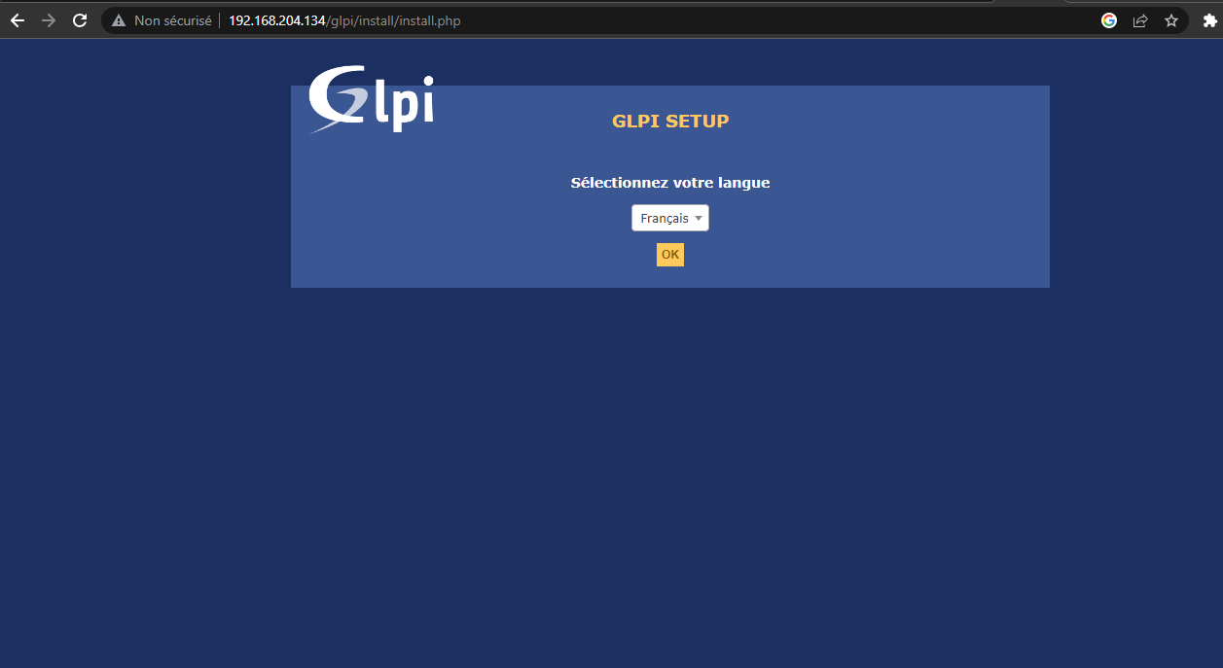

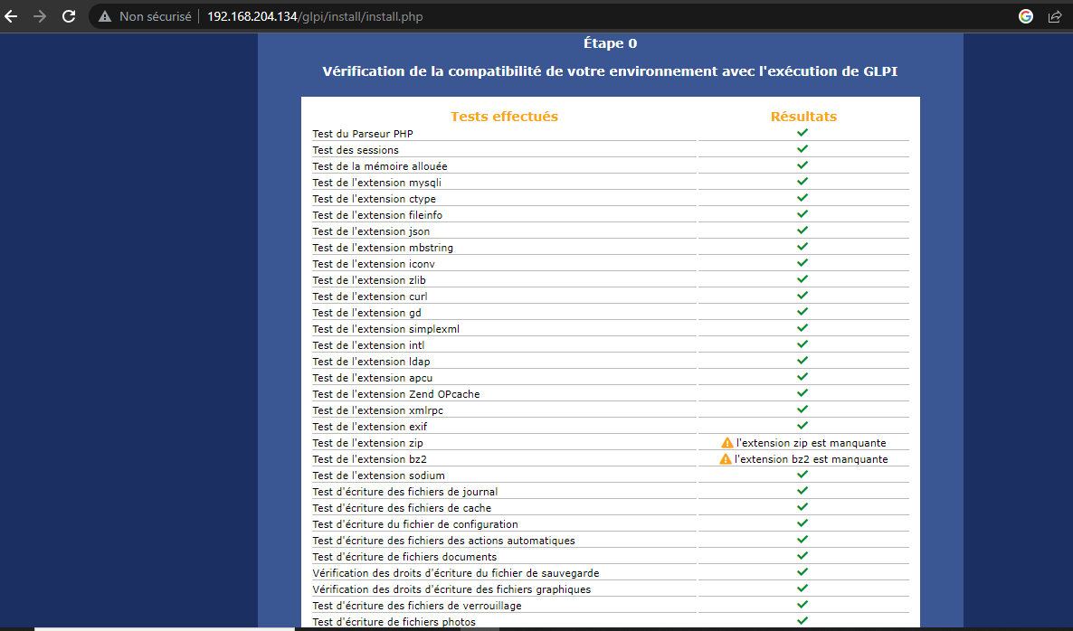

Once GLPI is installed and configured, it is important to take the following steps to enhance security:

* Change the passwords for the specified user(s) (glpi, post-only, tech, normal) to strong and unique passwords. It is crucial to follow good password practices to ensure the security of your GLPI installation.
* Remove the "install/install.php" file from the GLPI installation directory. This action is necessary to prevent potential security vulnerabilities. After completing the installation and initial configuration, it is highly recommended to delete this file.

By performing these actions, you will bolster the security of your GLPI setup