I designed this circuit because the connection of the HTPA32x32d to achieve the best performance.

→ A pull-up resistor of 4.7 k for the I2C pins (SDA and SCL) is recommended.
→ Adding 100 pF and 47 μF are improving the stability of the supply voltage.
→ To ensure a stable voltage supply the Application Sets are having a voltage conversion from 5 V, powered via USB, down to 3.35 V.
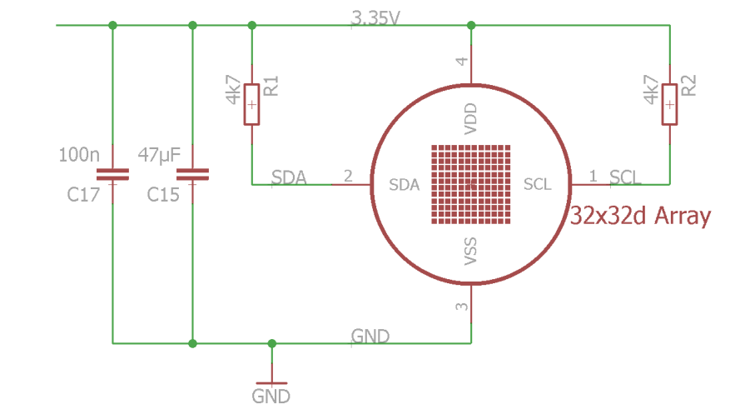
→ This is done by using the TPS62260DDCT from TI or alternatively the MCP1603TADJI/OSCT-ND.

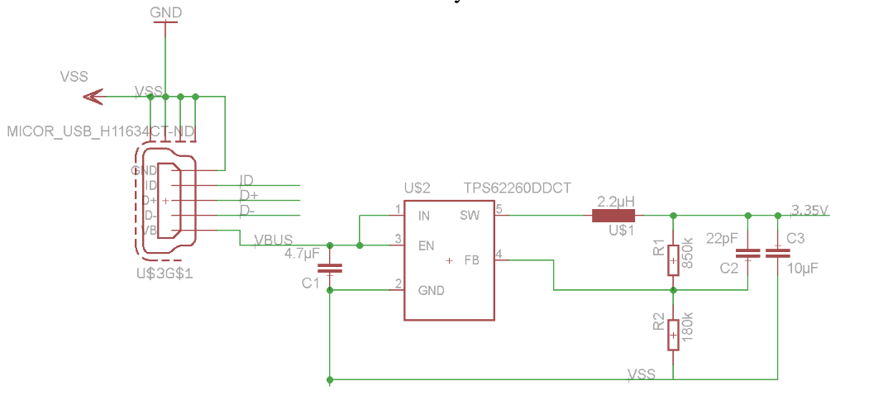
İMPORTANT!
→ The Sensor can be powered directly via 3.35 V if the supply voltage is stable enough, this has to be measured before and tested with the sensor. It is important to not insert any inductor or otherwise the noise will increase.

