INTERNATIONAL SCHOOL OF
MANAGEMENT AND TECHNOLOGY

FACULTY OF COMPUTING
ASSIGNMENT COVER SHEET
This form is to be completed by students submitting assignments of level 4 and level 5. Students are required to complete all sections and attach to your assignment.

STUDENT DETAILS
STUDENT NAME | Rabin Humagain
STUDENT ID | kit24e.rbn@ismt.edu.np

UNIT AND ASSIGNMENT DETAILS
UNIT TITLE | Unit 13: Website Design & Development
UNIT NUMBER | Y/618/7419
ASSIGNMENT TITLE | Boundless Moments Photography
ISSUE DATE | July 31, 2025 | DUE DATE | October 17, 2025
ASSESSOR NAME | Rajad Shakya
ESTIMATED WORD LENGTH | 11000

SUBMISSION
HAND IN DATE | 17th October 2025

DECLARATION AND ACKNOWLEDGEMENT
When submitting assignments, each student must sign a declaration confirming that the work is their own.

Plagiarism and Collusion
Plagiarism: to use or pass off as one’s own, the writings or ideas of another without acknowledging or crediting the source from which the ideas are taken.
Collusion: submitting an assignment, project or report completed by another person and passing it off as one’s.
In accordance with the Academic Integrity and Plagiarism Policy:
- I declare that:
- this assignment is entirely my own work, except where I have included fully-documented references to the work of others,
- the material contained in this assignment has not previously been submitted for any other subject at the University or any other educational institution, except as otherwise permitted,
- no part of this assignment or product has been submitted by me in another (previous or current) assessment, except where appropriately referenced, and with prior permission from the Lecturer / Tutor / Unit Coordinator for this unit.

- I acknowledge that:
- if required to do so, I will provide an electronic copy of this assignment to the assessor;
- the assessor of this assignment may, for the purpose of assessing this assignment:
- reproduce this assignment and provide a copy to another member of academic staff;
- communicate a copy of this assignment to a plagiarism checking service such as Plagiarism Check (which may then retain a copy of this assignment on its database for the purpose of future plagiarism checking).

I am aware of and understand that any breaches to the Academic Code of Conduct will be investigated and sanctioned in accordance with the College Policy.
SIGNATURE | Rabin Humagain | DATE | 18th July 2025

Acknowledgement
My sincere appreciation goes out to my instructor Rajad Shakya, for his unwavering support, inspiration and helpful criticism during this endeavor. With his assistance, I was able to comprehend and successfully apply important website design and development concepts to the creation of a workable project. I am extremely appreciative of the learning atmosphere and tools that enabled this effort.
Additionally, I want to express my gratitude to my friends and classmates for their insightful advice and support. Their advice enabled me to polish my work and raise the project's overall caliber. My technical understanding has improved as a result of finishing this assignment and I now have hands-on experience creating full-stack web applications.
Table of Contents
Acknowledgement iii
Part One 10
Introduction 10
Overview of the project 10
Purpose 10
Scope 10
Website Hosting and Management Technologies 11
Purpose of DNS 11
DNS Server Types 12
Organization and Management of Domain Names 12
Organization 12
Management 13
Hosting Options 13
• Shared Hosting: 13
• VPS Hosting: 13
• Dedicating Hosting: 14
• Cloud Hosting: 14
For Boundless Moments project: 14
Server Technologies 14
Management Services 15
Procedure for Setting Up a Web Server 15
Relationship of Hardware, Software and Communication Protocols 16
Communication Protocols 16
• Hypertext Transfer Protocol 17
• HTTPS (Hypertext Transfer Protocol Secure) 17
• FTP (File Transfer Protocol) 17
Role of Server Hardware 17
• Storage: 17
• Processing: 17
• Networking: 17
Operating Systems for Web Hosting 17
Linux-based operating systems 18
Windows Server (like Windows Server 2022): 18
Web Server Software 18
Apache HTTP Server: 18
Nginx: 18
IISL: 18
Apache Tomcat: 19
Client, Server and Browser Interaction 19
• Browser to Server Client Request: 19
• Processing on the server (hardware and software): 19
• Response from the server (to the browser): 19
• Browser-based client rendering: 19
Front-end Technologies 19
Presentation Layer 20
Back-end Technologies 20
Application 20
Data Layers 21
The connection between the application and presentation layers 21
Online Website Builders 22
Custom-built Websites 23
A Comparative Analysis of Custom-built Websites Vs Online Builders 23
Benefit of custom-built web: 23
Impact of Modern Frameworks 25
React.js 25
Angular 25
Node.js 26
The Significance of Search Engine Optimization (SEO) 27
Reasoning for Selected Technologies and Tools 27
Conclusion 28
Part Two 29
Design, Development and Testing 29
Client Requirements 29
User Requirements 29
Functional Requirements 30
Non-Functional Requirements 30
User Acceptance 31
Designing 31
Wireframes 31
Interface Design 35
• Typography: 35
• Color palette: 35
• Image Presentation: 35
• Navigation Layout: 35
• CTA Buttons: 35
Considerations for Networking and Hosting 35
Search Engine Optimization (SEO) 36
Security Features 36
Accessibility and Inclusivity Considerations 37
Development of Bondless moment website: 37
Tools used for Development: 37
Draw.io: 37
Visual studio 2022: 37
SQL server management: 38
Hopscotch 38
Integrated Development Environment (IDE): 38
Homepage 39
Gallery page 41
Contact us form page 41
Portfolio page 42
Admin login page 43
Admin dashboard page 43
Server Explorer of the Boundless Moment 45
Code snippet of the websites 46
Html codes for the website 46
Homepage 46
Gallery page 47
Contact page 49
Portfolio page 50
Admin login page 52
Admin Dashboard 53
CSS files for the webpages 54
Admin.css 55
Style.css 55
Java script for the webpages 57
Middleware 60
Routes 62
server files 67
.env 68
Coding Standards: 69
Reasons for Design and Implementation Choices 69
Testing and Quality Assurance 70
Overview of the Test Plan 70
Testing for functionality 70
Evaluation of Performance 71
Test case for Bondless Moments 71
Assessment and Enhancements 76
Evaluation of Test Results 76
Technical Difficulties 77
Client Feedback and Recommendations for Improvement 77
QA Procedure and Evaluation 78
Conclusion 78
YouTube link: 80
Table of Table 80
Table of Figure 80
References 81

Part One

Introduction

Overview of the project
For Boundless Moments, a group of professional photographers looking to build a strong online presence, this project entails creating and assessing a multi-page portfolio website. The main objective is to provide a web-based platform that effectively displays the team's efforts, abilities and successes. The first report is an assessment that looks at the web server software, management services, communication protocols and key server technologies needed to host and run the website. Along with discussing the capabilities of front-end and back-end technologies, this paper compares the design freedom, performance, functionality, user experience and user interface of custom-built websites with those of online website building tools.
The solution must be designed, developed and tested for the second task. This entails creating design papers, putting in place a multi-page, branded website with the necessary functionalities and integrating security, networking and accessibility standards. The last step entails developing and carrying out a thorough test strategy to assess the functionality and performance of the website, after which the development process and QA protocols are assessed and suggestions for future enhancements are made.
Purpose of the assignment is Designing, creating and assessing a professional multi-page portfolio website for Boundless Moments that a group of photographers seeking extensive internet visibility is the main goal of this project. The resulting website must showcase their accomplishments, abilities and photography work in a professional manner. The goal of this system is to enable prospective customers to browse their portfolios and get in touch for collaborations, reservations or questions. The work will follow current web design rules, standards and concepts. A secure admin panel for managing portfolio items, updating information and viewing client messages will be a crucial part of the system.
Scope of the assignment which fulfill the client’s needs are the following crucial stages are included:
- Creating a comprehensive list of client and user needs, including both functional and non-functional specifications as well as user acceptance criteria, is known as requirement analysis.
- Design and Implementation: After producing a design document backed by interface designs and medium-fidelity wireframes, the multi-page website is put into action. Accessibility standards and security features must be included in the implementation.
- Technology Review: Examining, elucidating, and defending the selection of web server software (such as Apache and Nginx), communication protocols (such as HTTPS and FTP), and server technologies needed to host and administer the finished website.
- Testing and Quality Assurance (QA): Developing an appropriate test plan that pinpoints important areas to examine the generated website's performance and operation. An examination of the QA process's execution is also part of this.
- Assessment and Suggestions: Comparing the entire design and development process to the original design document, taking into account any technological difficulties encountered, and making suggestions for website enhancements in light of test findings.

Website Hosting and Management Technologies
The integration of many technological services is necessary to make websites functional and accessible to users, as well as to ensure security and usability. These technologies include web server software, operating systems, server hardware, and front-end and back-end frameworks and communication protocols. Internet users can store their files on hosting solutions, which also provide the means for them to be accessed online. Choosing the right technology is still essential since it affects the maximum functionality and scalability of a website while guaranteeing the best possible user experience.

Purpose of DNS
A distributed, hierarchical naming scheme for computers, services, or any other resource linked to a private network or the Internet is called the Domain Name System (DNS). Its major function is to convert machine-readable numerical Internet Protocol (IP) addresses, such as 192.0.2.1, into human-readable domain names, such as www.ismt.com or www.facebook.com . It is frequently referred to as the ‘phonebook of the internet’ because DNS converts a domain name to an IP address, enabling a web browser to find and load the appropriate page, just like a phonebook does. (Walfish, et al., 2025)

DNS Server Types
A chain of four specialized DNS servers is involved in the domain name resolution process:
- The server or computer that answers the client's query and subsequently makes contact with additional DNS servers to resolve the name is known as a DNS precursor. To the other servers, it functions similarly to a client.
- The root name server is the initial DNS lookup step. A list of the Top-Level Domain name servers in charge of the requested TLD (such as.com,.org, or.net) is returned.
- TLD Name server: Holds data for every domain name that has the same TLD. For a given domain name, it instructs the resolver which Authoritative Name server to use.
- The authoritative name server is in possession of a domain's final DNS records. It gives the DNS Precursor the final IP address, which it subsequently sends back to your browser.

Organization and Management of Domain Names
The Domain name system are organized in a hierarchy and managed through a global structured feature or system.

Organization
- Root Level: Using a single dot to identify itself, the root level serves as the topmost place in the domain name hierarchy. This level marks the beginning of domain name search procedures.
- Immediately beneath the root level are Top-Level Domains (TLDs), which include country-code TLDs like.uk.jp, and.np as well as generic TLDs like.com,.org, and.NET.
- Second-Level Domains (SLDs): At a level known as Second-Level Domains (SLDs), users choose the primary domain name that directly relates to Top-Level Domains. "example" on example.com is an illustration of this.
- Subdomains: Using optional extensions appended to the second-level domain name, site managers can create distinct website parts using subdomain administration.

Management
Maintaining a web domain's stability, security, registration and activity are all part of domain management. Important components consist of:
- Domain Registration: In order to obtain specific domain names that are valid for predetermined periods of time, domain registrars offer approved domain registration services.
- DNS Configuration: For correct domain traffic direction and operational functionality, DNS records, including A CNAME and MX and TXT kinds, must be configured.
- Renewal and Expiration Management: In order to avoid service interruptions, an organization must keep an eye on domain expiration dates and renew them on time.

Hosting Options
The best hosting option for a business like ‘Boundless Moments’ depends on its size, expected traffic and budget. (Pollock, 2013)Hosting types are as follow:
- Shared Hosting: The simplest and most affordable option is shared hosting, which pools resources like CPU, RAM, and storage across several separate websites hosted on a single server. It works best for personal blogs, small businesses or new websites with low traffic expectations and a limited budget.
- VPS Hosting: With virtual private server (VPS) hosting, a single physical server is split up into multiple separate, isolated virtual servers, giving users more administrative control and dedicated resource allocations. This is a great next step for medium-sized businesses or expanding websites that need more customization options, stability and performance than shared hosting can provide. Managed WordPress Hosting optimized specifically for WordPress, with maintenance, security and updates handled by the provider. WordPress-based sites needing high performance and minimal technical management.
- Dedicating Hosting: Large enterprises, high-volume e-commerce platforms or major media sites that handle consistently high traffic and cannot compromise on performance or reliability turn to dedicated hosting, a premium option that dedicates an entire physical server exclusively to a single client's website, offering maximum control, security and raw computing power.
- Cloud Hosting: This contemporary solution is ideal for companies of any size that value scalability, high uptime guarantees and the capacity to effectively manage and handle erratic traffic spikes. It does this by leveraging a vast network of interconnected servers that enable resources to be scaled up or down instantly and on demand, making it extremely flexible and dependable.

For Boundless Moments project:
The most cost-effective first option for the Boundless Moments project is usually shared hosting, which is adequate for getting started. Moving to Managed WordPress Hosting, which provides specific performance optimizations and maintenance for WordPress-based sites, or Virtual Private Server (VPS) Hosting, which offers more specialized resources and control, would be a logical next step as the business grows and website traffic increases.

Server Technologies
Web hosting depends on particular software stacks, which often include:
- Web Server Software: Online server software is the application that provides online pages and handles HTTP requests. Popular choices include Nginx (renowned for its outstanding performance and efficiency, frequently used for load balancing and reverse proxying) and Apache HTTP Server (popular, extremely flexible).
- Operating System (OS): The server's core component. The most popular web hosting platform is Linux (such as Ubuntu and CentOS) because of its open-source nature, stability, and security. Applications that need Microsoft technology, like ASP.NET, run on Windows Server.
- Database Management System (DBMS): The website's dynamic content, such as users, products, and blog entries, is stored by the database management system (DBMS). MongoDB, PostgreSQL, and MySQL are typical examples.
- Programming Languages: PHP, Python, Ruby and Node.js are examples of scripting/programming languages that are used for the backend logic of websites.

Management Services
Different levels of server management are available from hosting companies:
- Unmanaged: All server upkeep, security, upgrades, patching, and monitoring are the responsibility of the user (or the company's IT staff). Although it offers the most control, this calls for a high level of technical know-how.
- Managed: The majority of server management duties, such as operating system updates, security monitoring, backups, and technical assistance, are handled by the hosting company. For companies who would rather concentrate on the content of their websites than server upkeep, this is perfect.
- Control Panels: Tools like c-Panel or Plesk are often provided to simplify server and website management tasks (e.g., file management, creating email accounts, managing databases) through a graphical user interface.

Procedure for Setting Up a Web Server
These essential stages are usually followed while setting up a web server, though they may differ significantly depending on the hosting environment:
- Choose Hosting and Register Domain: Decide on a hosting package and use a registrar to register the domain name you want.
- Link Domain to Hosting: Modify the domain's registrar name-server records to point to the name-servers of your hosting company. This connects the server space to the domain name.
- Install/Configure Operating System (OS): Install the selected OS and carry out preliminary setups, such as tightening security and network settings.
- Install Web Server Software: Set up and install the preferred web server (such as Nginx or Apache). In order to instruct the server which directory to use for your particular domain name, you must first set up virtual hosts, also known as "server blocks".
- Database management system: Create a database and user credentials for the information on your website after installing a database management system (DBMS), such as MySQL.
- Upload Website Files: Move all of the HTML, CSS, pictures, and PHP/application code files for your website to the server's root directory, which is typically /var/www/html/ on Linux.
- Install the required application stack and runtime: Install the necessary frameworks and languages (such as WordPress, PHP, or Python).
- Set up SSL and Security: To enable secure HTTPS connections, install an SSL/TLS certificate (for example, Let's Encrypt) and put security measures like a firewall into place.
- Test and Launch: Make sure the domain name loads the website over HTTPS, test the functionality of the website thoroughly, and monitor performance.

Relationship of Hardware, Software and Communication Protocols
The tight connection between hardware, software and communication protocols defines the fundamental framework of web hosting and internet communication. The necessary processing power is provided by the hardware, which consists of the actual servers, storage and networking apparatus. The operational logic that powers this hardware is provided by software, specifically operating systems and web server apps. Lastly, the communication cycle is completed by the Communication Protocols (such as HTTP and TCP/IP), which are an abstract collection of standardized rules that are implemented within the program to specify how data is formatted, sent and received over the internet.

Communication Protocols
Standardized sets of instructions known as communication protocols control the format, transmission, and reception of data between devices. (Willke, et al., 2009)
- Hypertext Transfer Protocol or HTTP, is a basic, stateless request-response system that is mainly used by clients to request and retrieve resources, like HTML pages and images, from web servers. It usually uses port 80 for this purpose. It establishes the basic guidelines for data communication over the World Wide Web.
- HTTPS (Hypertext Transfer Protocol Secure) makes sure that all data sent back and forth between a client and a server is encrypted using TLS/SSL (Transport Layer Security/Secure Sockets Layer) protocols. This prevents sensitive data from being intercepted during transmission, a security feature that is only used over port 443.
- FTP (File Transfer Protocol) is a specialized protocol created especially for the dedicated transfer of large computer files between various systems on a network. This makes it a great and dependable tool for tasks like bulk uploading or downloading website files to and from a web hosting server, in contrast to the others that concentrate on web content delivery.

Role of Server Hardware
Web hosting is physically supported by server hardware. Among its principal functions are:
- Storage: Using speedier Solid-State Drives (SSDs) or Hard Drives (HDDs) to store the website's files (HTML, graphics, scripts, and databases).
- Processing: Using the Central Processing Unit (CPU) to run the operating system and web server software and supplying Random Access Memory (RAM) for a temporary workspace. The server can manage numerous requests at once and swiftly process dynamic content if it has a strong CPU and enough RAM.
- Networking: Using physical cables and Network Interface Cards (NICs) to connect the server to the internet, allowing the actual data transfer that is regulated by protocols.

Operating Systems for Web Hosting
The web server software runs on a platform provided by the operating system (OS), which is system software that controls the server hardware. There are two primary categories:
Linux-based operating systems, such as Ubuntu and CentOS, are widely used in web hosting because of their near-zero cost, strong security, and excellent compatibility with key open-source web server software, such as Apache and Nginx. They also have the advantage of a large, vibrant community that offers a wealth of resources and support.
Windows Server (like Windows Server 2022): Because it provides smooth and effective integration with essential Microsoft-specific tools and frameworks, such as ASP.NET for application development and Microsoft SQL Server for database management, this platform is usually the choice for companies that have already made significant investments in the larger Microsoft ecosystem and depend on its proprietary technologies.

Web Server Software
Web server software, often known as an HTTP server, is an operating system application that receives, processes, and responds to client requests. It puts the HTTP/S communication protocols into practice.
Apache HTTP Server: Frequently regarded as the most widely used general-purpose web server in the world, Apache is renowned for its high degree of modularity, flexibility, and feature set, which make it a dependable and adaptable option that can manage a wide range of hosting requirements and run seamlessly on the majority of operating systems, including Windows and Linux.
Nginx: This robust web server is well-known for its event-driven architecture, which enables it to effectively handle a large number of concurrent connections while using very little system resources. As a result, it is frequently used as a load balancer, HTTP cache, and high-performance reverse proxy, particularly for websites that receive a lot of traffic.
IISL: The standard and best platform for hosting websites and apps created with Microsoft-specific technologies is Internet Information Services (IIS), a feature-rich web server that was created by Microsoft and is closely and natively integrated with the Windows Server operating system.
Apache Tomcat: In contrast to other general-purpose web servers, Apache Tomcat is a specialized open-source application server that is primarily made to operate as a Java Servlet Container. This means that its primary function is to effectively run and manage web applications that are based on Java. It frequently works in tandem with a full-featured web server (such as Apache or Nginx) that is responsible for serving static web content.

Client, Server and Browser Interaction
Accessing a webpage requires a coordinated, protocol-driven engagement throughout:
- Browser to Server Client Request: A URL, such as https://example.com, is entered by a user into their web browser (the client). The domain name is initially converted into an IP address by the browser using DNS (Domain Name System). After that, the browser creates an HTTP or HTTPS request, which is a message prepared in accordance with the protocol rules, and sends it across the internet in the direction of the IP address of the server.
- Processing on the server (hardware and software): The request is sent to the server hardware over its network connection. The Web Server Software (such as Nginx) receives the request from the Operating System. The HTTP/S request is interpreted by the web server software. It either finds the requested resource (like an HTML file) or runs a program to create dynamic content (like accessing a database using a language like PHP or Python).
- Response from the server (to the browser): The requested information (HTML, pictures, etc.) is packaged by the web server software into an HTTP/S Response message. This response is sent back to the client's IP address by the server hardware.
- Browser-based client rendering: The HTTP/S response is sent to the browser. After reading the content, it displays the webpage to the user using its rendering engine, asking for any more resources (such as stylesheets or graphics) in different, follow-up encounters.

Front-end Technologies

Everything a person directly interacts with in their web browser is referred to as the front-end, or client-side, of a website. It is based on three interoperable fundamental languages: HTML, CSS, and JavaScript.

Presentation Layer
HTML (Hyper Text Markup Language) is the fundamental structural foundation of any webpage. It uses tags to specify the organization and semantics of the content by forming the basic skeleton with elements like headings, paragraphs, and links. HTML5 greatly improved this by adding new semantic tags (like <header> and <article>) and natively supporting multimedia elements (like <audio> and <video>).
CSS (Cascading Style Sheets) is the language used to style and present a webpage visually. It controls visual elements like colors, fonts, spacing, and overall layout to determine how the HTML elements should appear on the screen. The latest version of CSS3 added powerful features like Flexbox and Grid to create complex, responsive layouts, as well as tools for media queries, transitions, and animations to guarantee correct display on a range of screen sizes.
JS: Complex features like form validation, real-time content updates, interactive maps, and handling user events are made possible by JavaScript, the essential programming language that gives a website's front end interactivity and dynamic behavior without requiring a complete page reload. Advanced JavaScript frameworks and libraries like React, Angular and Vue.js are also examples of JavaScript functionality. JavaScript is frequently used to create complex single-page applications (SPAs).

Back-end Technologies
The unseen engine that manages all of the processing, logic, database interactions, and user requests that enable the front-end is known as the back-end, or server-side.

Application
These are examples of server-side technologies used to write the application's core logic.
PHP: A popular server-side scripting language that has historically been integrated directly into HTML, PHP (Hypertext Preprocessor) is used to process input, including form data, generate content for web pages dynamically, manage user sessions, handle file operations on the server, facilitate database communication, and power popular platforms like WordPress.
The JavaScript Runtime Environment or Node.js: Node.js is a runtime environment that enables the JavaScript language to be executed directly on the server. It is known for its scalable and highly efficient non-blocking, event-driven I/O model, which makes it ideal for managing high-traffic web services and creating real-time applications. It also has the unique benefit of enabling developers to use just one language (JavaScript) for both the front-end and the back-end (full-stack development).

Data Layers
For database management with MySQL is a crucial database management system that effectively stores, arranges, and persistently retrieves structured data in tables composed of rows and columns using SQL (Structured Query Language). As the standard and crucial database component in dynamic web hosting architectures like the popular LAMP stack, it fulfils its primary function of managing the website's data by receiving SQL queries sent from the back-end application, which is typically written in languages like PHP or Node.js. This allows it to perform all necessary data operations, including Create (inserting new records), Read (fetching existing information), Update (modifying current records), and Delete (removing data).

The connection between the application and presentation layers
There is an important client-server model interaction between the Presentation Layer (front-end) and the Application Layer (back-end logic):
- User Interaction: The client that accepts user input (such as filling out a form or clicking a link) is the Presentation Layer (HTML, CSS, and JavaScript in the user's browser).
- Request: The back-end server receives a request from the front end, usually in the form of an HTTP request.
- Processing and Logic: The request is sent to the Application Layer, which is server-side programming such as PHP or Node.js. It does the necessary reasoning, which frequently entails:
  - Verifying the request.
  - interacting to read or write data with the Data Layer (such as MySQL).
  - using business rules (e.g., checking a password, computing a pricing).
- Response: The client receives a response from the Application Layer, which is typically data in a whole new HTML page or data in a format like JSON or XML.
- Display: The response is passed to the Presentation Layer. In order to provide the user with the final, dynamic output, JavaScript processes the data and applies it to update the HTML and CSS on the page.
- Because the intricate business and data logic is kept on the secure, regulated server side, away from the user's browser, this division of labor (separation of concerns) guarantees that the website is scalable, manageable, and secure.

Online Website Builders
With an intuitive interface that frequently makes use of drag-and-drop capabilities and pre-made templates, online website builders enable users with little to no coding experience to construct and manage a website. They are a one-stop shop that usually comes with built-in features, a domain name and hosting.
- Wix: renowned for its highly graphic, free-form drag-and-drop editor that provides a great deal of design flexibility within the constraints of its platform. It is well-liked for personal websites and small enterprises.
- Squarespace: Well-known for its elegant, contemporary, and visually appealing templates. Creatives, photographers, and companies that value visual branding frequently select it.
- Although the open-source WordPress.org software is frequently used for custom development, the hosted version or the use of builder plugins (such as Divi or Elementor) enable WordPress (.com or self-hosted with builder plugins) to function as a robust website builder with enormous extensibility via themes and plugins.

Custom-built Websites
Professional developers are solely responsible for creating custom websites, which combine multiple essential technologies to provide a distinctive and precisely customized online presence: JavaScript (JS) adds the necessary interactivity, dynamic features, and complex behavior to the front-end; HTML specifies the basic structure and content of the pages; CSS controls all visual styling, including colors, layouts, and fonts; and server-side languages like PHP, Python, or Ruby run the site's back-end logic, managing important tasks like database management, user authentication, and creating customized, dynamic content.

A Comparative Analysis of Custom-built Websites Vs Online Builders
The trade-offs between speed and versatility are the primary distinction between custom-built websites and online website builders: In contrast, custom-built sites require a longer development time and higher initial cost due to the need for coding expertise and ongoing maintenance, but they reward the owner with full control, complete code ownership, and high scalability to handle the most complex and growing business needs. Builders offer a quick, easy, and low initial-cost solution that requires no coding, with the platform handling maintenance. However, they impose limitations on scalability and grant only limited ownership and control.

Benefit of custom-built web:
Flexibility in Design: One of the most obvious distinctions between the two methods is design freedom. Online website builders, such as Squarespace and Wix, are limited by their drag-and-drop editors and pre-made layouts. Although they seem professional and provide a fast start, it can be challenging or impossible to create a truly unique visual identity or alter aspects outside of the template's specified sections. Custom-built websites, on the other hand, provide an infinite amount of creative freedom. Every pixel, layout component, and visual interaction can be precisely customized to meet the brand's unique vision and set it apart from the competition because the design is created from the ground up using HTML and CSS.

Performance
The underlying code is the main cause of the performance discrepancy. Website builders sometimes utilize generic, occasionally "bloated" code to support a wide range of unneeded capabilities in an effort to make things simple for everyone. This can result in moderate to poor loading speeds. Platform companies like Wix are always increasing speed, but they don't have the same level of control as custom coding. Conversely, custom-built websites are created using a small, effective codebase that only contains the scripts that are required. This enables developers to maximize performance for the site's architecture, hosting, and technical SEO components all of which are critical for search engine rankings and user happiness.

Usability
Where custom constructions really outperform website builders is in terms of functionality. The e-commerce tools, extensions, and features offered by the platform's proprietary ecosystem are the only options available to online website builders. Builders might not be able to provide a highly specialized tool that a company requires, such a specialized booking system, a special payment flow, or connectivity with a specialized third-party API. Websites that are custom-built can do almost anything. This is the only practical choice for companies with particular or complex operating demands because developers may utilize languages like PHP and JavaScript to create any complex feature, sophisticated data structure, or specialized application logic needed.

Experience of the User (UX)
Custom development allows for a far more regulated approach to User Experience (UX) design. Although website builders offer a generally good, unconventional user experience based on tried-and-true template best practices, they don't give you much power to create highly customized user journeys for a complex conversion funnel or a specific target. The user experience is carefully designed and optimized for custom-built websites. To ensure that each step a visitor takes is intentional, simple, and extremely effective for accomplishing particular business goals, developers and designers carry out user research to map out a custom flow, creating a better and more customized experience.

Maintenance and Scalability
There is a basic trade-off between scalability and maintenance. Because the platform manages all core updates, security patches, and hosting, website builders provide low-effort, automatic maintenance; nevertheless, their defined traffic, data, and feature complexity constraints hinder long-term expansion. The long-term expense of a custom-built website is increased by the need for manual, continuous maintenance (sometimes requiring a retainer with developers) to guarantee security and updates. However, a bespoke build is a future-proof investment because it provides infinite scalability. It may be developed on a modular architecture to manage large traffic surges, incorporate new systems, and evolve its features eternally as the business grows.

Impact of Modern Frameworks
Web development has been transformed by contemporary JavaScript frameworks and runtime environments, which make it possible to create sophisticated, scalable, and high-performance Single-Page Applications (SPAs) and server-side logic. They promote fluid, interactive, and component-based user experiences over conventional, page-reloading apps.

React.js
Facebook (Meta) created the JavaScript library React.js to help with user interface development.
- The development of tiny, separate, and reusable user interface components is encouraged by component-based architecture. Large-scale team cooperation, maintainability, and code reuse are all improved by this.
- Virtual DOM (VDOM): React keeps an in-memory, small-sized copy of the real DOM. React determines the most effective method of updating the real DOM when data changes by "diffing" the new VDOM from the old one. When compared to direct DOM modification, this approach significantly enhances rendering performance.
- Declarative Views: React manages the required modifications to align the DOM with the specified state, while developers specify how the user interface should appear for a certain state. Code becomes easier to debug and more predictable as a result.
- Ecosystem: Features a sizable and vibrant community that produces a wealth of tools and libraries (e.g., Next.js for server-side rendering, React Router for navigation, and Redux for state management).

Angular
Google created and maintains the feature-rich, full-featured Angular JavaScript framework.
- Complete Framework: Because it is batteries-included, it has pre-installed solutions for state management, form handling, routing, and HTTP client services. This gives developers a more structured and opinionated way to create enterprise-level, large-scale apps.
- Type-Script is a JavaScript superset that includes static typing, is the foundation of Angular. This strengthens the codebase, aids in the early detection of faults, and is crucial for intricate projects.
- By automatically synchronizing data between the component's model and the view's HTML, two-way data binding streamlines development and minimizes the amount of boilerplate code required for updates.
- Modular design encourages a clear structure, testability, and lazy loading for improved performance by grouping applications into discrete modules.

Node.js
Built on top of Chrome's V8 engine, Node.js is an open-source, cross-platform JavaScript runtime environment that enables server-side JavaScript execution.
- JavaScript is the only language that developers may use for both the frontend and the backend thanks to Full-Stack JS's Unified Language feature. This encourages efficiency, lessens context-switching, and streamlines development.
- Because it uses an event-driven design, asynchronous, non-blocking I/O is very effective and scalable for applications that can manage high concurrency, such real-time chat, streaming services, and APIs. It can handle multiple requests at once since it doesn't wait for I/O activities (such as database queries) to finish.
- NPM (Node Package Manager): Offers pre-built solutions for almost every need, greatly speeding up development by giving access to the largest ecosystem of open-source libraries in the world.
- Micro-services: Because of its lightweight design, it's a great option for creating quick, disconnected micro-services.

The Significance of Search Engine Optimization (SEO)
Increasing the volume and caliber of visitors to your website through natural search engine results is known as search engine optimization, or SEO.
- Importance Visibility and Traffic: More people are likely to view and click on your link if you rank higher on Search Engine Results Pages (SERPs), which will bring targeted, free (organic) traffic to your website.
- Credibility and Trust: Search engines are naturally trusted by users. A high search ranking establishes your website as a reliable and authoritative source and is seen as a seal of approval.
- User Experience (UX): Effective UX and modern SEO are closely related. Both search engines and users appreciate speed, mobile friendliness, and ease of navigation, which lowers bounce rates and increases conversions.
- Advantage over competitors: For similar products or services, the site with better SEO will capture the majority of the market's attention and subsequent business

Reasoning for Selected Technologies and Tools
Based on the requirements of the project, the application stack is carefully chosen, beginning with the front-end: React.js is used for projects that need extremely dynamic user interfaces. Its Virtual DOM allows for greater rendering efficiency, which makes it perfect for huge, interactive elements like dashboards and social feeds that change often. The integral use of Type-Script offers significant advantages for overall stability and long-term maintainability in complex codebases, making Angular the preferred framework for large-scale, enterprise-level applications that require a highly structured, opinionated and batteries-included design. Because of its non-blocking I/O model, Node.js is the best option for the backend when the application needs to handle high concurrency efficiently and requires real-time data exchange (such as chat or live updates). This makes it the ideal choice for teams that benefit from a single JavaScript language environment throughout the entire stack.
Then, particular tools and data storage options support this fundamental structure: Express.js is used as a simple and adaptable online application framework for Node.js, offering a scalable and reliable API/backend structure for effective middleware management and routing. MySQL is the preferred option for transactional systems where dependable relationships between data entities are crucial. It is chosen as the relational database management system (RDBMS) for data persistence when the application needs structured data, strong data integrity, sophisticated SQL querying capabilities and rigid schema consistency.

Conclusion
The Boundless Moments project, in summary, shows a thorough and expert method to planning, creating, and assessing a multi-page portfolio website that successfully improves a photographic team's online visibility. The project guarantees accessibility, scalability and dependability by combining secure communication protocols, strong server management procedures, and contemporary web hosting technology. The thorough examination of DNS, web server software and hosting choices demonstrates how the technical underpinnings have a direct influence on the functionality, usability and long-term viability of websites. This methodical approach guarantees that the platform complies with best standards in web development, security and optimization in addition to meeting the technical and functional objectives.
Additionally, the comparison between online website builders and custom-built websites highlights the importance of scalability, performance and flexibility in creating a unique digital identity. The use of cutting-edge frameworks and tools like React.js, Node.js and MySQL enhances the system's functionality and efficiency and is entirely consistent with the project's goal of producing a safe, dynamic and aesthetically appealing portfolio. All things considered, the project effectively blends technological innovation with user-centered design concepts, providing a solution that is suitable for the future, increases exposure, encourages client interaction and supports the continuous expansion of Boundless Moments' digital brand.

Part Two

Design, Development and Testing
The design and development process for the Radiant Memories website aims to create a platform that is structured, visually attractive and fully functional, fulfilling both client and user needs. This stage involves gathering requirements, designing the site's layout, implementing engaging features, and ensuring accessibility along with security measures. Essential factors consist of responsive design principles, quick loading times and an intuitive user interface. By leveraging contemporary web technologies and industry best practices, this website intends to deliver a smooth browsing experience while effectively highlighting the photographer’s portfolio.

Client Requirements
Radiant Memories primary objective is to have a polished web presence that highlights their photographic abilities, successes, and work. The website should be visually beautiful, user-friendly, and able to attract new customers. Important client requirements consist of:
- Portfolio Page: An eye-catching collection of photographs from previous and current photography endeavors.
- Experience and Skills Section: A special section devoted to detailing the photographer's background and any honors or commendations they may have obtained.
- Contact Information: A form or direct contact information that allows potential customers to schedule appointments or ask questions.
- Admin Dashboard: A safe backend platform for handling client conversations and portfolio content modifications.
- Performance and Security: SSL encryption (HTTPS), faster loading times and responsiveness on mobile devices.

User Requirements
The website must make information easily available and interactive in order to provide users with an interesting experience.

Functional Requirements
The desired features and behavior of the website are specified by the functional requirements. The following features must be included in Boundless Moments Photography:
- Description of Functionality: Portfolio Display It should be possible for users to view photographic projects that are categorized.
- The ability to explore galleries with filtering choices, such as events, portraits, weddings, etc., is a necessary for visitors.
- Admin Verification to access the dashboard, the administrator must be able to log in using a secure authentication mechanism.
- Management of Content It should be possible for admin users to add, modify, and remove pictures and descriptions from the gallery and portfolio areas.
- Submission of a Contact Form A working contact form that enables users to send questions straight to the administrator must be on the website.
- Multiple-Page Navigation Home, Gallery, Experience, Contact and Admin Panel pages must all be easily navigable within the system.
- Interaction That Responds Both desktop and mobile devices should be able to interact with the website's functionality.

Non-Functional Requirements
Rather of specifying what the system should accomplish, non-functional requirements describe how it should function. The following requirements for quality must be met by Boundless Moments Photography's website:
- Intuitive Navigation: A user-friendly layout that makes information quickly accessible.
- Mobile Compatibility: Guaranteeing complete operation on a range of gadgets, including PCs, tablets, and smartphones.
- Fast Load Time: Improved functionality designed to avoid loading phase delays that can impair user interaction.
- Features for Accessibility: Usability for people with disabilities is ensured by adherence to online accessibility standards.
- Interactive Elements: To improve engagement, provide features like image sliders, filtering choices, and effects.
- Security: The admin panel needs to be protected with secure login information and appropriate session management.

User Acceptance
The circumstances under which the website will be deemed finished and prepared for deployment are specified by the User Acceptance Criteria. The following requirements must be fulfilled for the client to approve the solution:
- The website effectively displays excellent photos without any distortion or loss of aesthetic appeal.
- There are no broken links or layout problems when visitors move between sections.
- By employing appropriate authentication procedures, the admin login system guards against unwanted access.
- Without technical assistance, the administrator can use an intuitive interface to upload and manage new portfolio items.
- The admin panel or specified email address receives messages from the contact form accurately.
- Every page of the website uses the same branding components, including the color scheme, font, and logo positioning.
- The platform works well on desktop and mobile devices and is responsive.
- An SEO-friendly structure is used to facilitate search engine indexing and online visibility.

Designing

Wireframes
Without concentrating on color or visual styling, wireframes serve as the website's initial layout structure, showing where key components like navigation menus, graphics, headings and text blocks should be placed. For Boundless Moments Photography, wireframes are primarily used to guarantee a coherent content flow and intuitive navigation. (hamm, 2014)
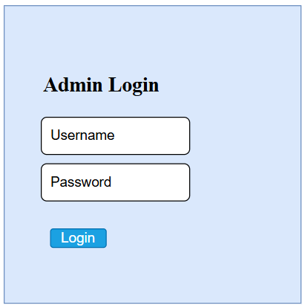
Figure 1Wireframe of Admin Login page
The secure entry point for authorized administrators is represented by this wireframe. It has a login button in the middle of the screen and two input boxes for the username and password. The administrator can concentrate entirely on authentication because the simple layout guarantees clarity and removes distractions. In order to prevent unwanted access, this screen serves as the backend system's security gateway.
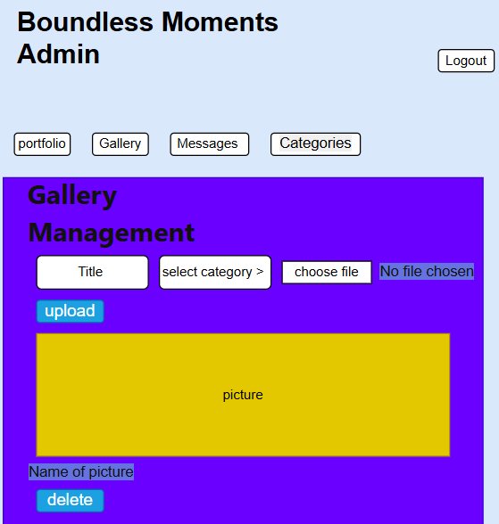
Figure 2 Wireframe of Admin Gallery Management page
The efficiency of content administration is the main focus of the admin dashboard wireframe. Messages, Categories, Gallery, Portfolio, and other quick-access buttons are located in a navigation toolbar at the top. The forms for adding a title, choosing a category, uploading an image, and submitting it are located in the clearly marked Gallery Management section beneath it. To show uploaded media, a content preview area is offered. The secure session flow is reinforced with a logout button at the upper-right corner.
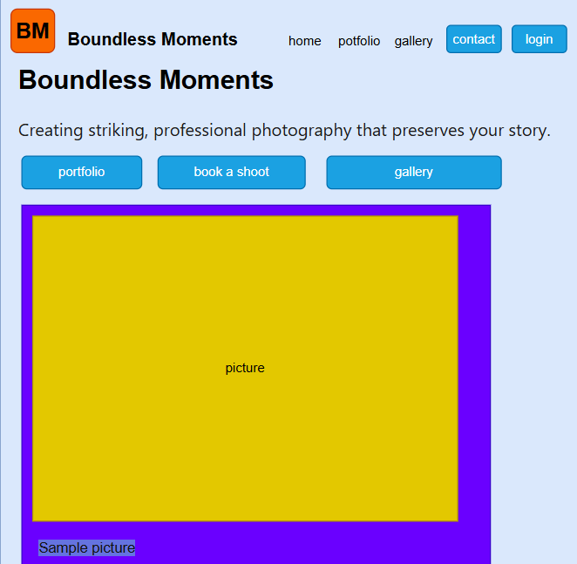
Figure 3 Wireframe of Homepage (Public View)
The primary public interface for guests is represented by this wireframe. It has a contemporary navigation bar with menu choices including Home, Portfolio, Gallery, Contact, and Login, along with a branding logo. Call-to-action buttons like Portfolio, Book a Shoot and Gallery are placed after a hero tagline that introduces the brand tone beneath the header. In keeping with the style of a photographic portfolio website, a sizable gallery display area takes up the majority of the main section to showcase images.

Interface Design
High-fidelity interface mockups were created to represent branding and aesthetics after the wireframes were approved. The design adheres to a simple, contemporary, and eye-catching theme that is typical of portfolio websites that include photography. (S.Sridevi, 2014)
- Typography: Stylish fonts like Robot/Lato for legible body text and Montserrat/Play-fair Display for headlines.
- Color palette: A tasteful fusion of white, black, and delicate accents (such as subdued blue or gold) to preserve a high-end photographic look.
- Image Presentation: To improve visual storytelling, use full-width banners and grid gallery layouts with hover effects.
- Navigation Layout: By guaranteeing seamless page navigation, a sticky header improves user experience.
- CTA Buttons: Well-placed CTAs (such as "Book a Session" and "View Gallery") direct user interaction and conversions.

Considerations for Networking and Hosting
A hosting solution that combined scalability, performance, and dependability was needed for the Boundless Moments website. A cloud-based web hosting service that supports the delivery of both static and dynamic content was chosen after evaluation. Performance and security were enhanced by the hosting provider's capabilities, which included content delivery network (CDN) integration, automated SSL certificates, and round-the-clock uptime monitoring.
The DNS administration system of the hosting company was used to register and link the domain name. In order to ensure accessibility from any location, DNS records were set up to map the domain to the server's IP address. In order to protect data in transit, which is especially crucial for client communications and contact form submissions communication between the client and server was established via the HTTPS protocol, which is protected by TLS encryption.
To guarantee ideal loading speeds, bandwidth distribution, caching strategies and image optimization were all taken into account. Future scalability, such adding a database-driven reservation system or extending to e-commerce features, was also made possible by the networking configuration. In conclusion, the networking and hosting setup provide a safe, effective and adaptable basis for the website's sustained operation.

Search Engine Optimization (SEO)
To improve online visibility and ranking on search engines like Google, Boundless Moments included Search Engine Optimization (SEO) throughout the website. To increase crawlability, each page has structured header tags (<h1>, <h2>), succinct meta descriptions, and meaningful <meta> titles. The title tag "Boundless Moments Photography | Professional Creative Portfolio on the site, for example, guarantees that the keywords are in line with the client's brand. Semantic HTML and optimized alt attributes enhance accessibility and indexing even further. Implementing optimized image properties and accurate meta descriptions can greatly increase click-through rates and site visibility on search engines.

Security Features
An essential component of any contemporary website is security. Multiple security layers were put in place for Boundless Moments to protect user information and the integrity of the website.
- HTTPS Encryption: To prevent unwanted access or interception, SSL/TLS certificates encrypt all communications between the web server and users' browsers.
- Input Validation: To guard against malicious inputs such SQL injections and cross-site scripting (XSS) attacks, the contact form was constructed with both front-end and back-end validation.
- Secure Coding Practices: By adhering to OWASP guidelines, the codebase made sure that no private information, including API keys or email addresses, was visible in the client-side code.
- Frequent Updates: To reduce known vulnerabilities, all dependencies and frameworks are kept up to date with the most recent stable versions.
- Server-Side Security: In order to restore functionality in the event of a compromise, hosting settings include firewall protection and daily automated backups.
Together, these precautions guarantee user safety on the Boundless Moments website while upholding the client's professional image. Strong security measures not only deter assaults but also boost trust, which is crucial for a brand handling customer images and creative projects.

Accessibility and Inclusivity Considerations
In accordance with the Web Content Accessibility Guidelines (WCAG 2.1), accessibility principles were incorporated to guarantee inclusion for users with different abilities. The usage of semantic HTML elements (<header>, <main>, <footer>) that are compatible with assistive technologies, keyboard navigation, adequate color-contrast ratios, and alternate text for images are important characteristics. By taking these steps, all users can perceive, use, and comprehend the website.
Applying accessibility standards improves usability and happiness for all user groups, including those with disabilities.

Development of Bondless moment website:

Tools used for Development:
We use different types of designing tools to develop the portfolio of the bondless moments. We use Draw.Io for the create wireframe to visualize better understand the algorithm of the functional of the website. We use SQL server for the database where we can store data of our boundless-moment projects images and the messages. We use visual studio for the development for the HTML, CSS and JS where we use node.js for the server.

Draw.io:
It is a free online tool to build a flowchart for the algorithm we design. It has enough needed tools to create a flowchart and wireframe of the website. (draw.io, 2025)

Visual studio 2022:
visual studio 2022 community version is completely free but we can upgrade for the more features that can help us in the coding. Within the free version have enough features to build or develop a portfolio system for our project. We need to download extension for Visual studio to use node.js to create a webpage. Visual studio gives needed features like connecting to the database, debugging, run live server. (microsoft, 2025)

SQL server management:
SQL server Management is integrated in the Visual studios which helps to combine the data base and the code together. We use MYSQL for the query language to create and manipulate it by the request from the user to the application and application to the SQL server. (microsoft, 2025)

Hopscotch
A lightweight, open-source, and free platform for developing and testing APIs is called Hopscotch. Consider it an easy-to-use tool, akin to Insomnia or Postman, but with an emphasis on being web-based, quick, and open-source. (hoppscotch, 2025)
- Main Purpose: By submitting requests (such as GET, POST, etc.) and seeing the answers in a clear interface, it enables developers to quickly create, test, and document APIs.
- Graph-QL, RESTful APIs, and several real-time APIs (such as Web Sockets, Socket.IO, and MQTT) are among the protocols it supports.
- Key Features: Collections (for organizing requests), Environments (for storing variables like API keys and URLs), History, and Collaboration features for teams are among the crucial tools for professional workflows.
- Accessibility: It is mainly accessible as an online application (hoppscotch.io), but it also provides a Command-Line Interface (CLI) and desktop apps (for Windows, mac-OS, and Linux).
- Open-Source Advantage: Open-source, transparent, community-driven, and focused on simplicity, speed, and privacy (with features like self-hosting alternatives and local-first data storage).

Integrated Development Environment (IDE):
Integrated development environment (IDE) is the software application which provides different features for the programmers to develop a project. Use of different tools separately can give a mesh that can be hard and challenging to development and time consuming but the IDE provides it in one platform. It helps to achieve the goal easier, organized and faster. IDE is like a Toolkit of a Workshop. The toolkit contains all the necessary tools to maintain the product.
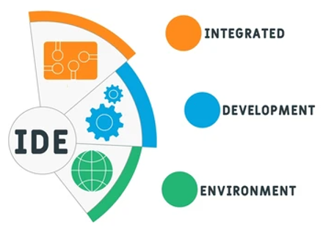
Figure 4: IDE

Homepage
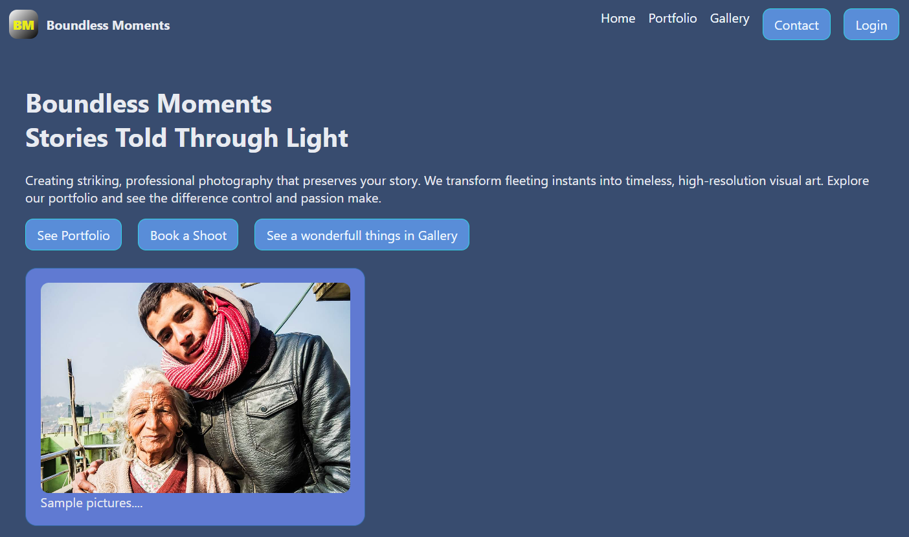
Figure 5: homepage
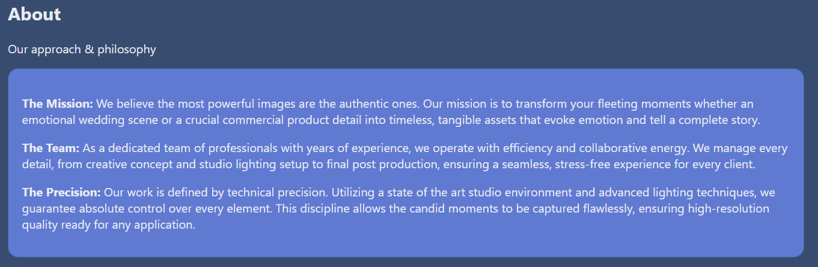
Figure 6: About Section of Homepage
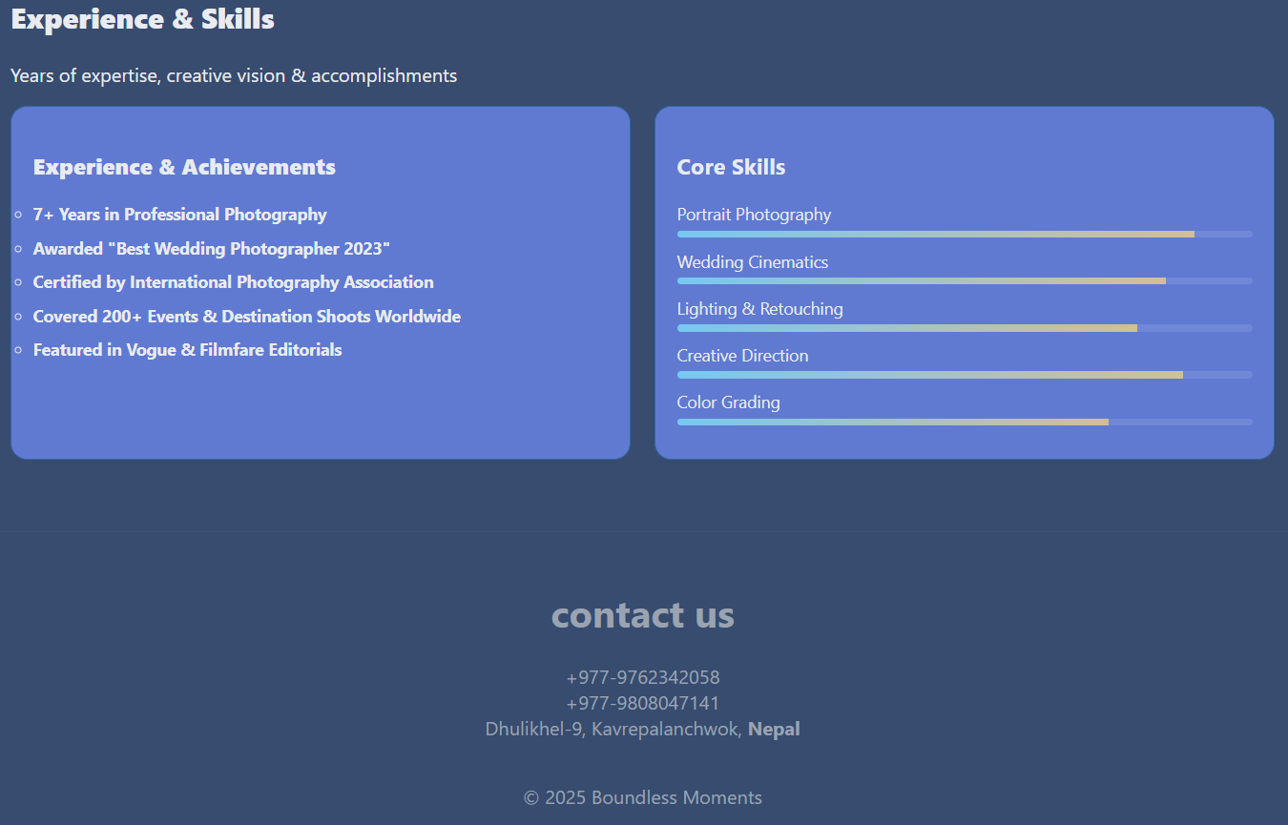
Figure 7: Experience and skill section
In home page there is Nav-links that redirected to their pages. In the home pages there is buttons where user or client are directed to the portfolio page, gallery page or contact page and admin login page through the buttons. In the home page there is about section, experience and skills section of the boundless moment’s achievement also mentions.

Gallery page
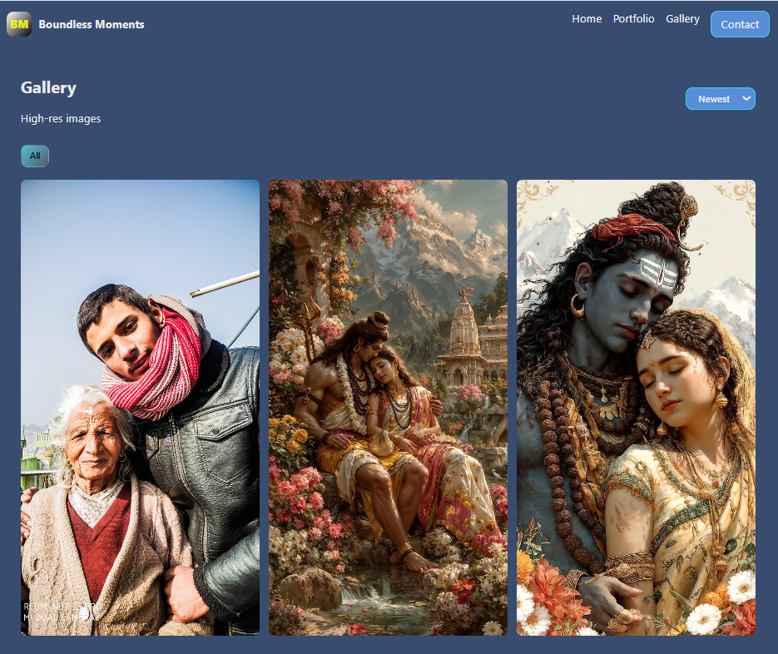
Figure 8: Gallery page
In the gallery pages we can see all the photos are available that uploaded from the admin panel or through the admin.

Contact us form page
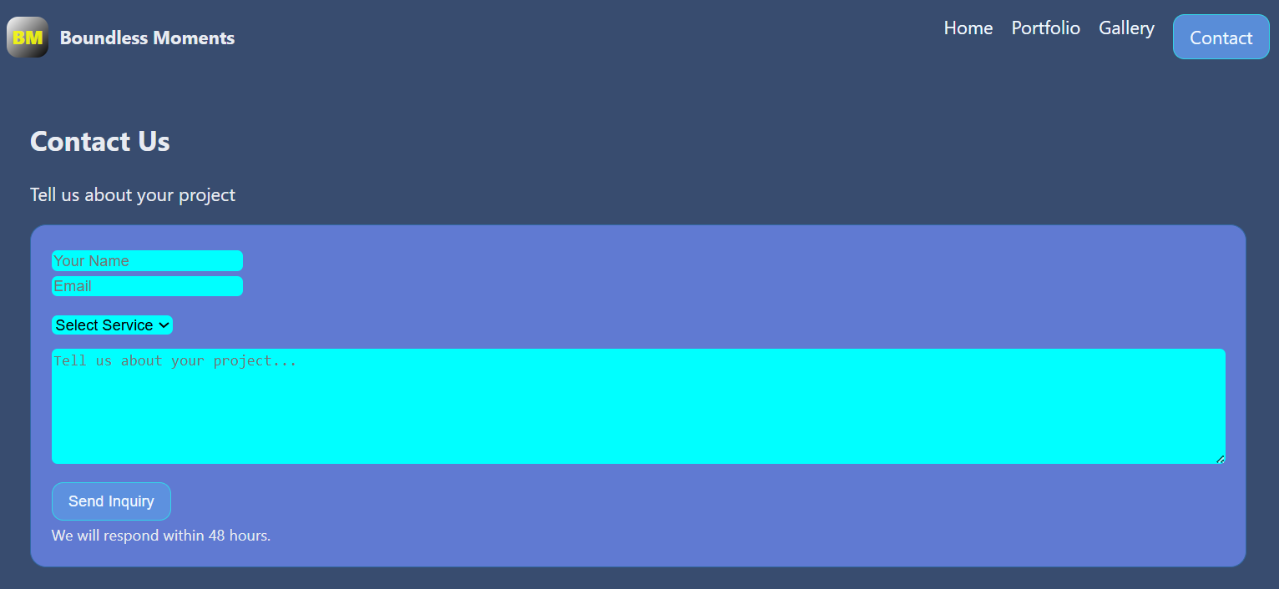
Figure 9: contact us page
By entering their name, email address, choosing a service, and describing their needs in a message, visitors can use this Contact Us form as a dedicated channel to ask questions about a project or service. The company guarantees a response within 48 hours after the Send Inquiry button is clicked.

Portfolio page
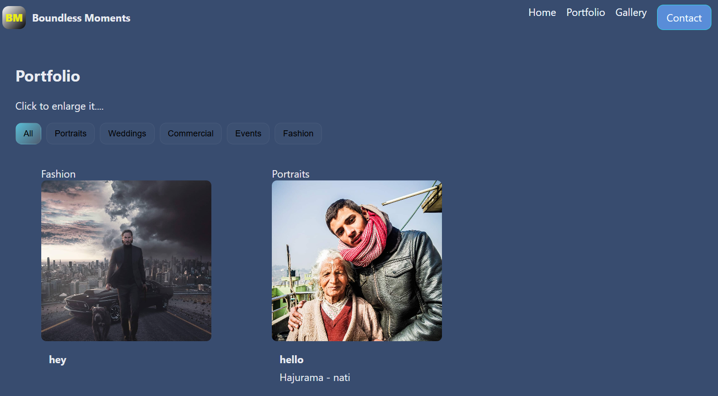
Figure 10: portfolio page
In the portfolio page there is filter button where we can filter the photos of each sections and we can simply expand the photos when we click in it.

Admin login page
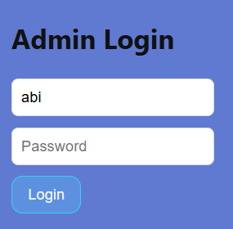
Figure 11: Admin login page
It redirected to the admin dashboard.

Admin dashboard page
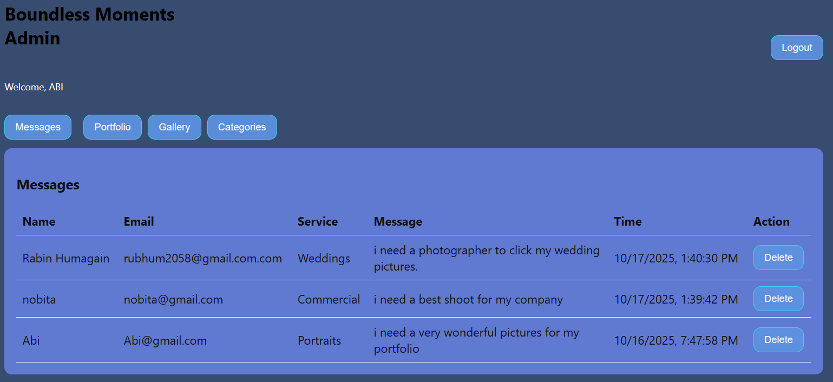
Figure 12: Admin Dashboard messages from the clints of bondless moment
It shows the messages of the clients that to contact them within 48 hours of the company policy and can delete from database also.
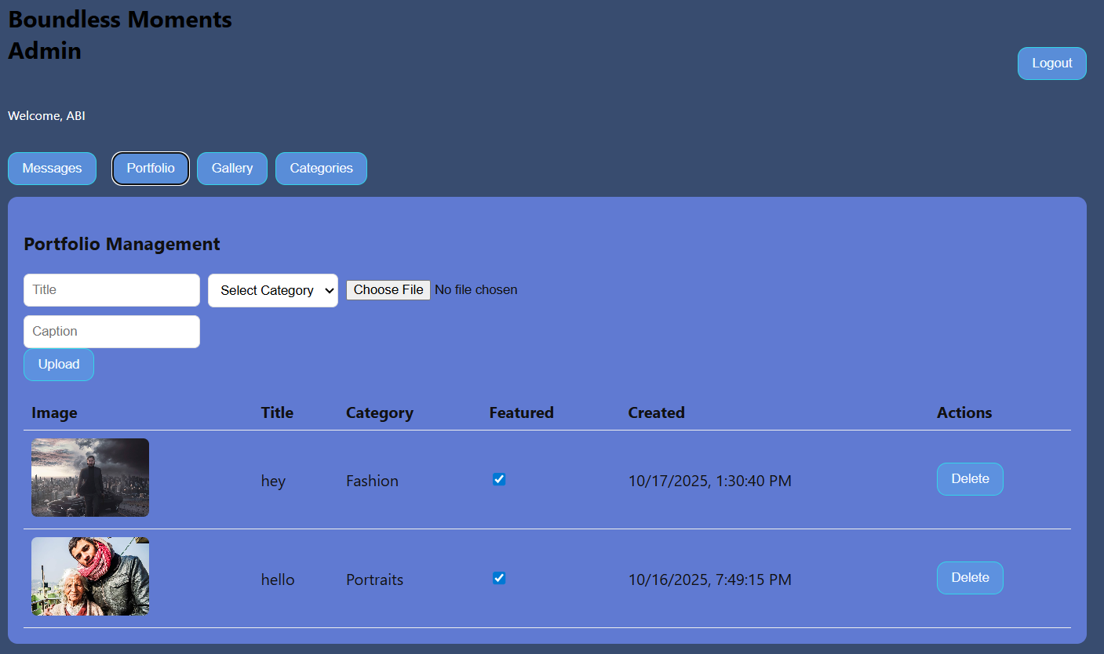
Figure 13: portfolio management of the admin dashboard
In the portfolio management we can check the features to add in the portfolio pages through this pages and can delete the pictures from portfolio page also.
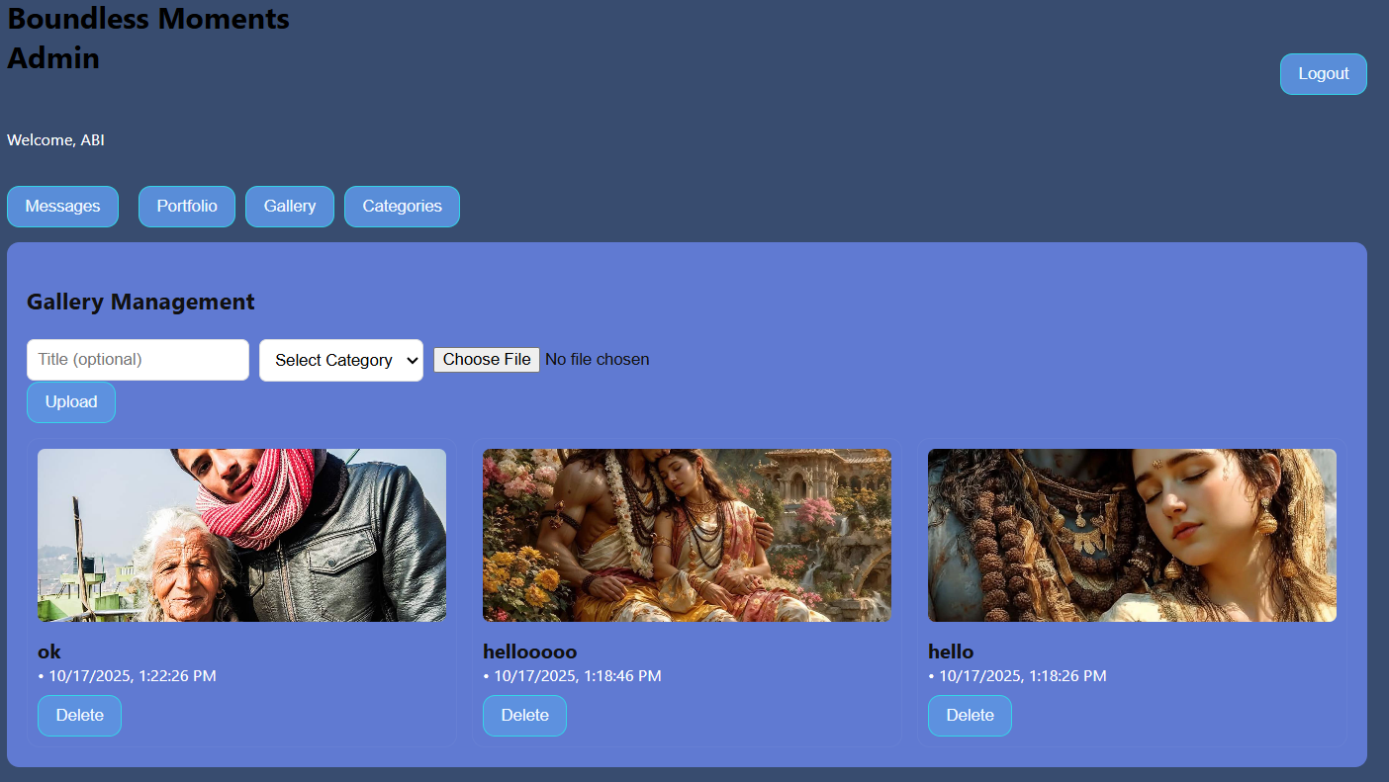
Figure 14: Gallery management of Admin dashboard
In this gallery management section, we can upload pictures and delete it from here also.
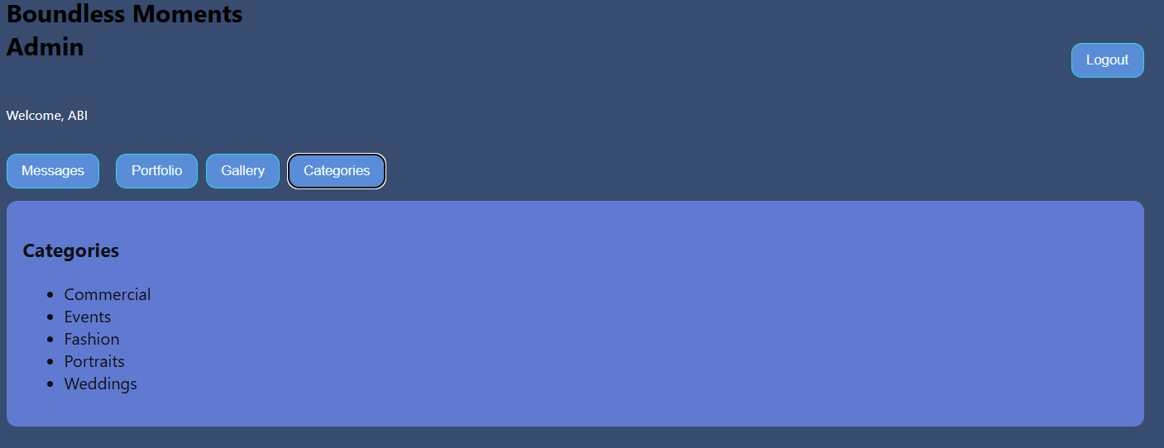
Figure 15: categories of admindashbord
In this section we can see the categories of the photoshoots.

Server Explorer of the Boundless Moment
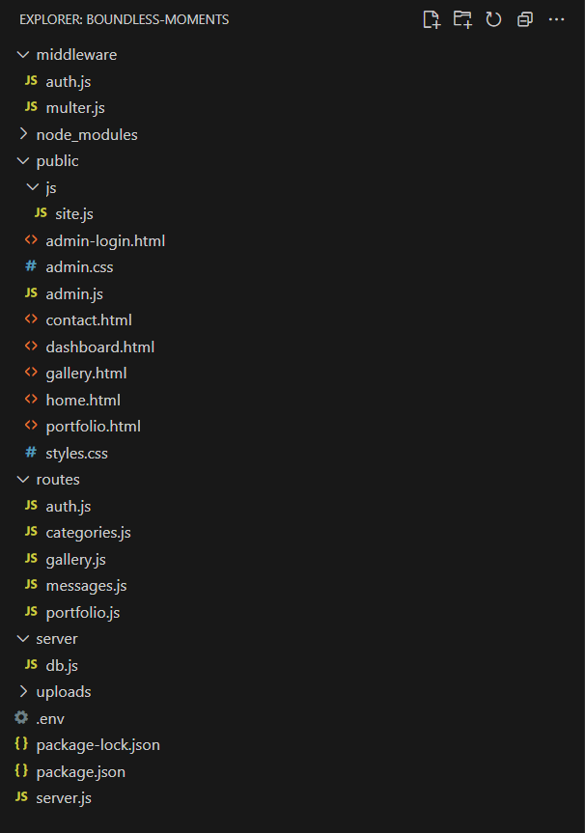
Figure 16: Server Explorer of the Boundless Moment

Code snippet of the websites
The needed files of codes to start the server and for the functionality of the buttons and integrated to the database, api and the web browsers.

Html codes for the website

Homepage
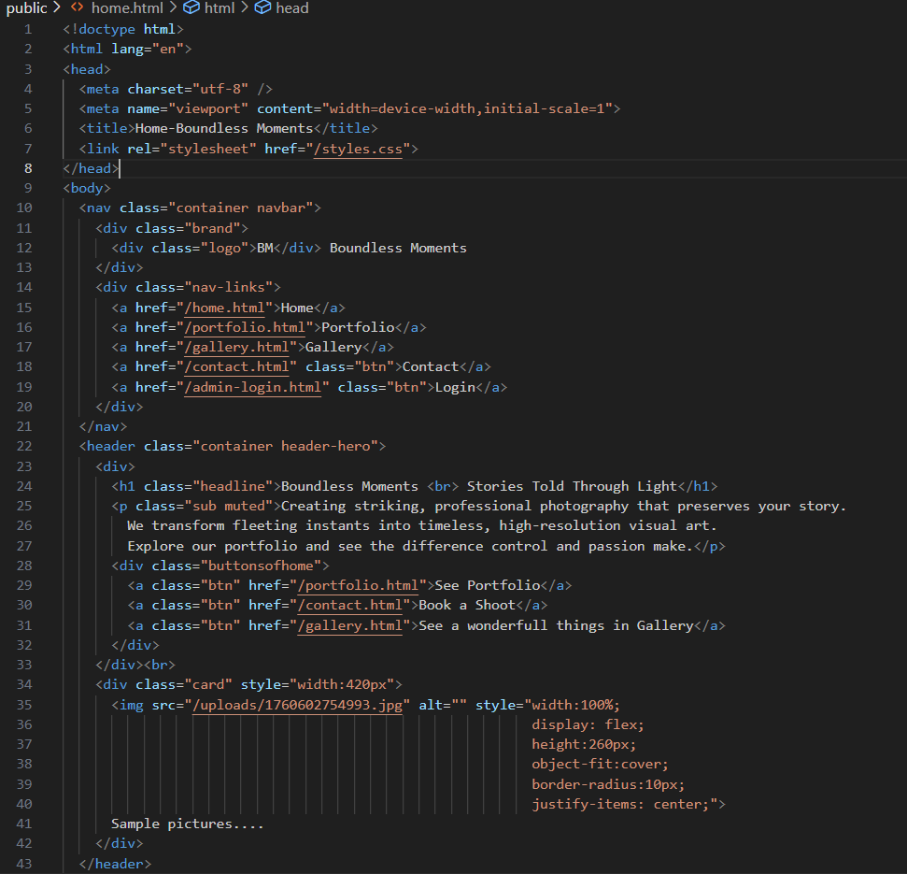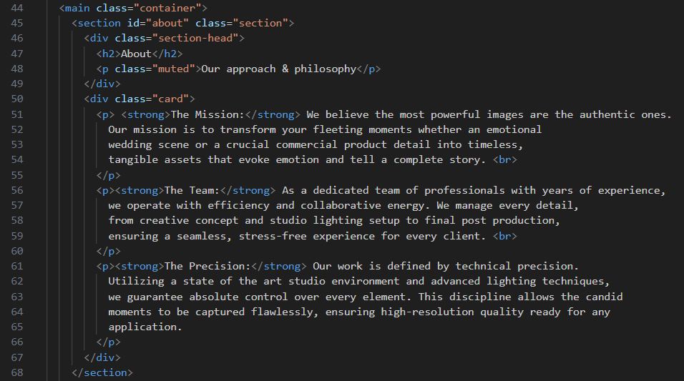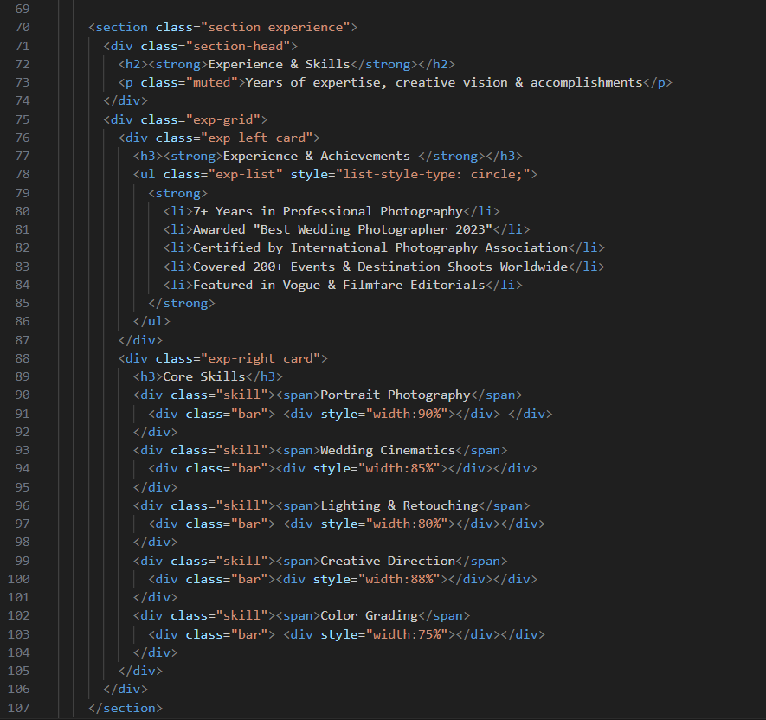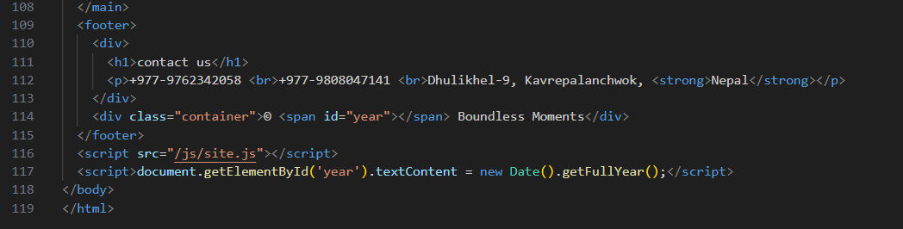
Figure 17: Home.html

Gallery page
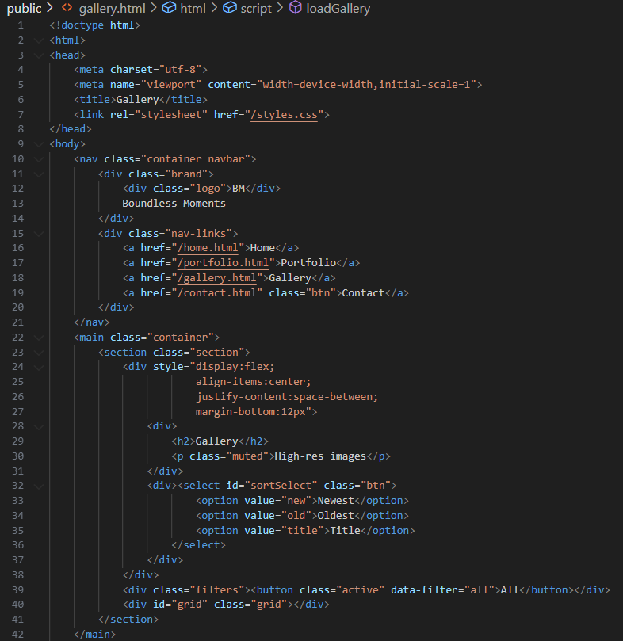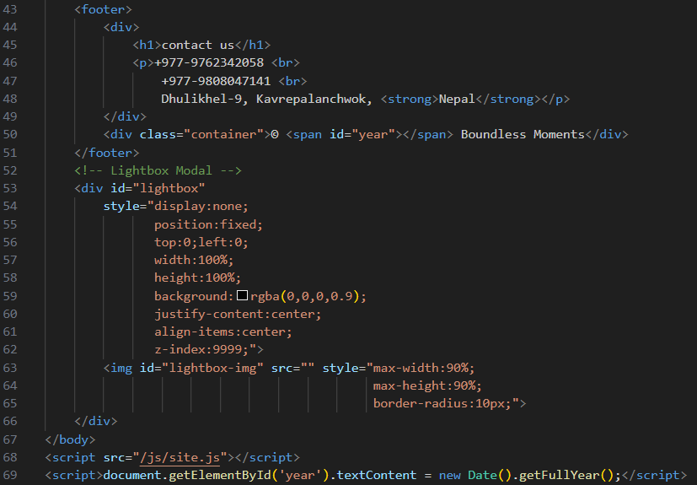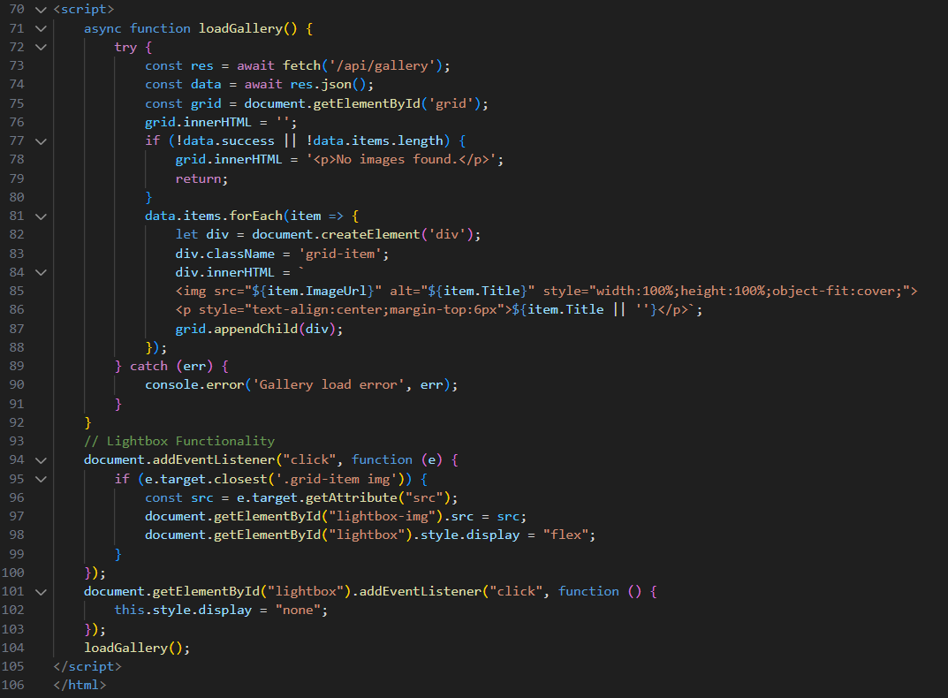
Figure 18: gallery.html

Contact page
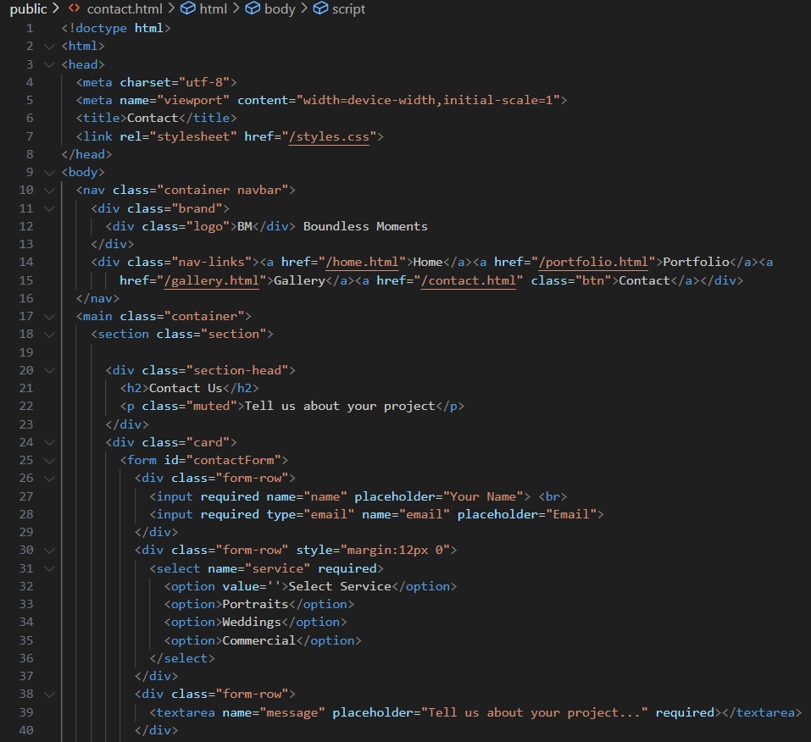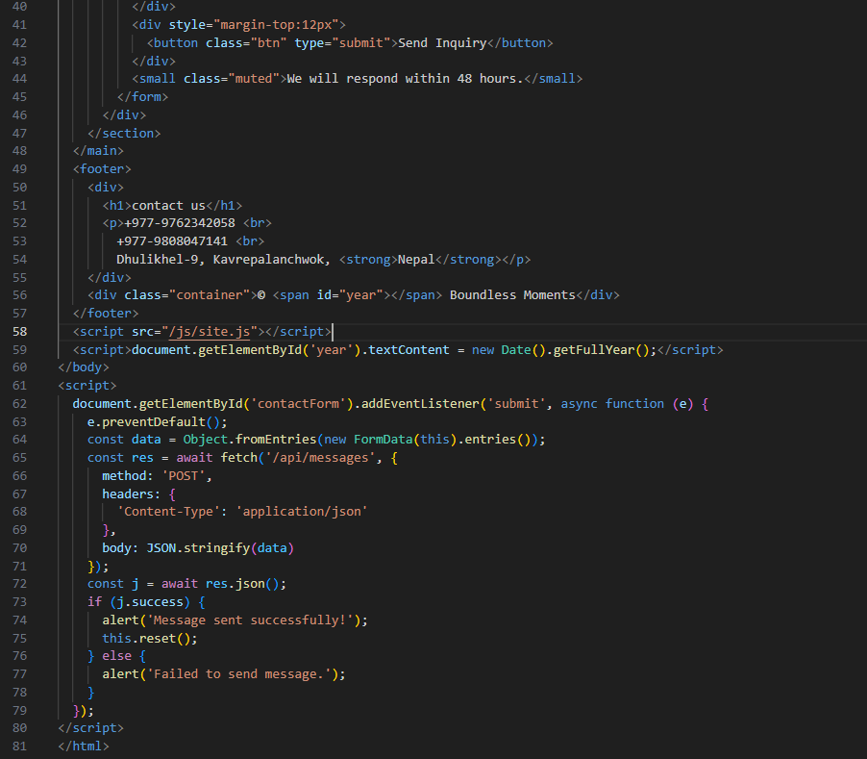
Figure 19: contact.html

Portfolio page
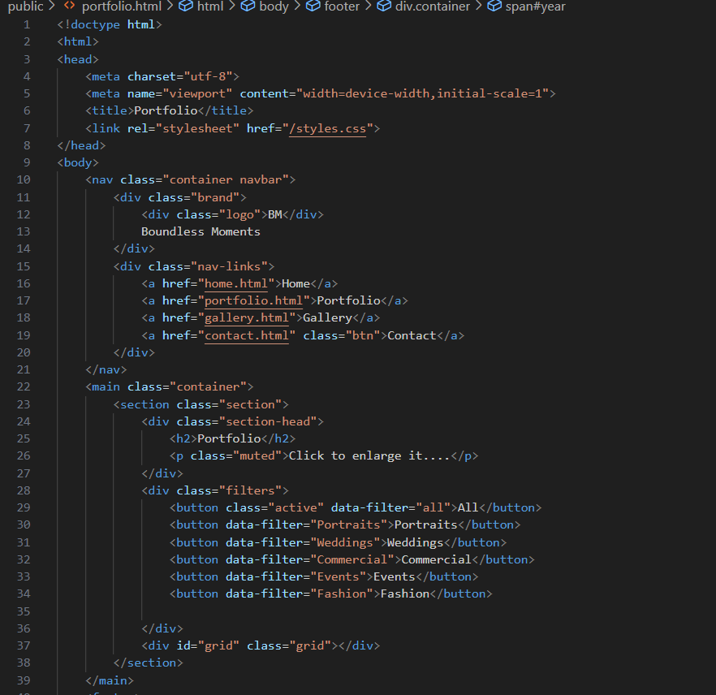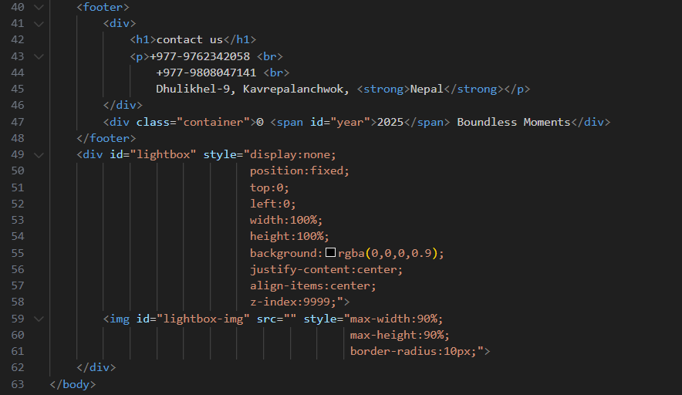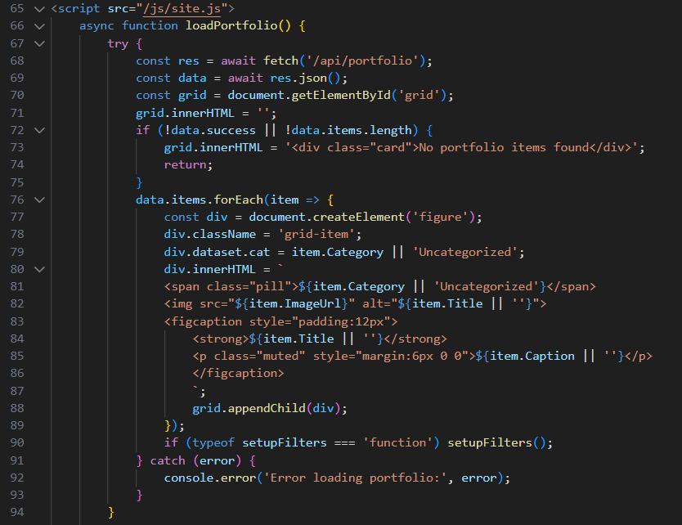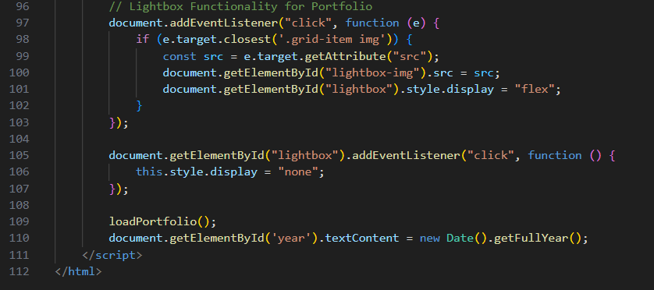
Figure 20: portfolio.html

Admin login page
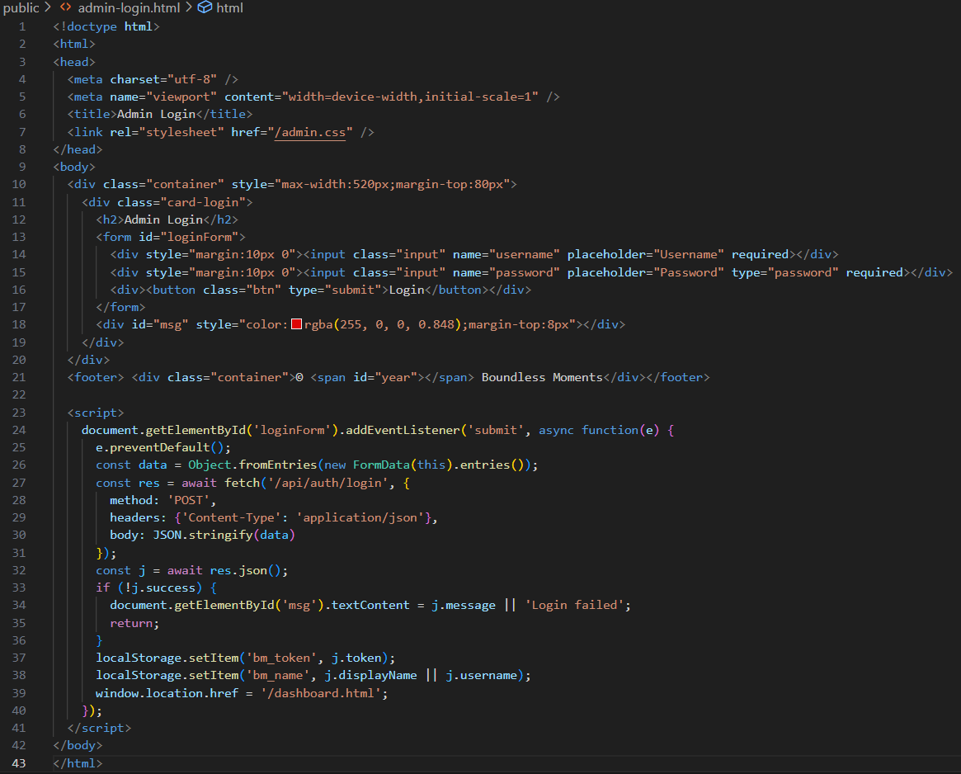
Figure 21:Admin-login.html

Admin Dashboard
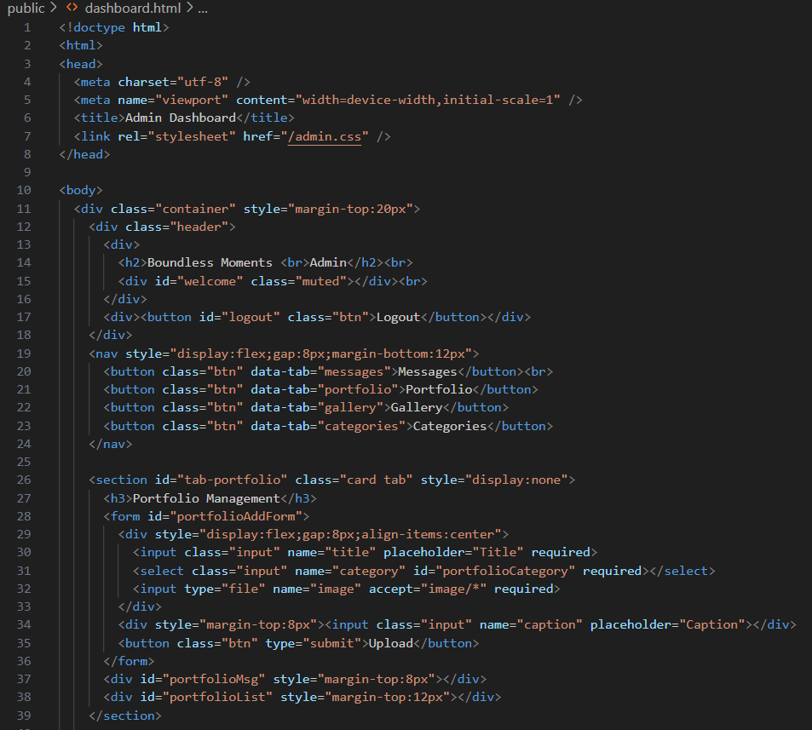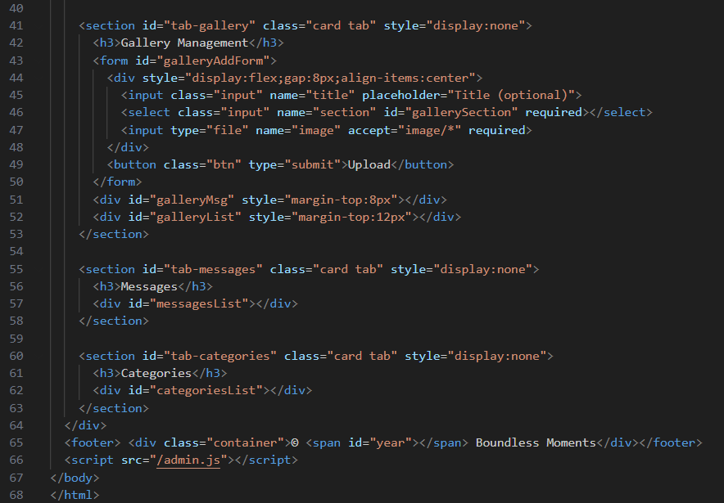
Figure 22: AdminDashboard.html

CSS files for the webpages

Admin.css
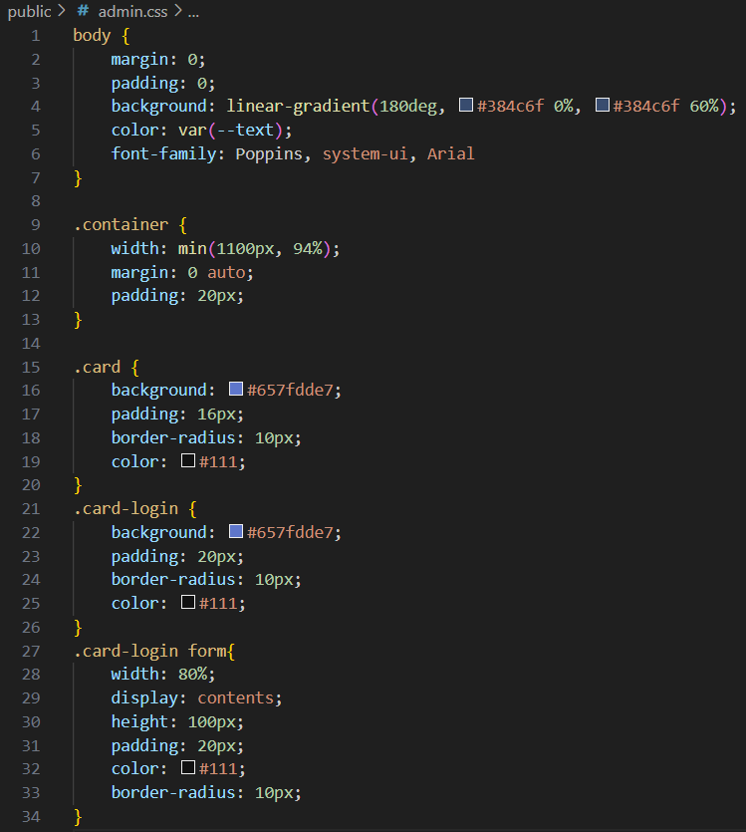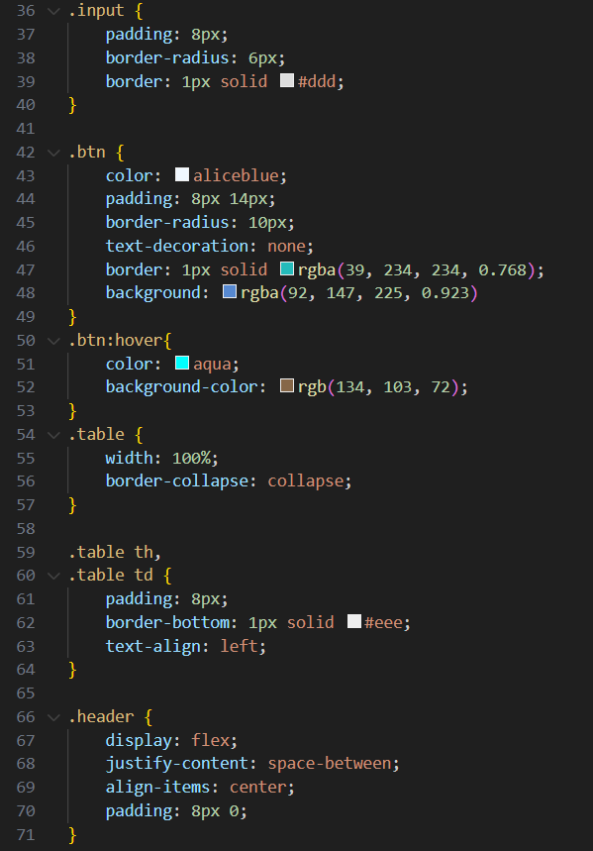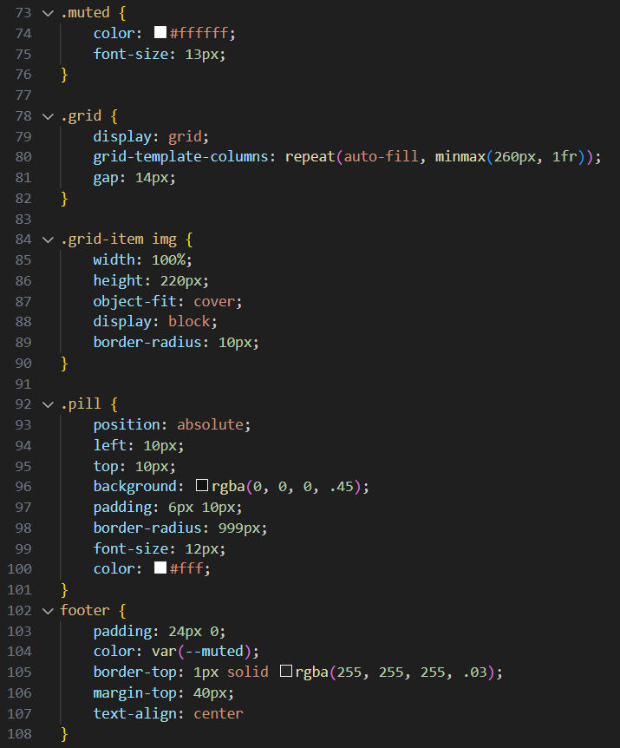
Figure 23: Admin.css

Style.css
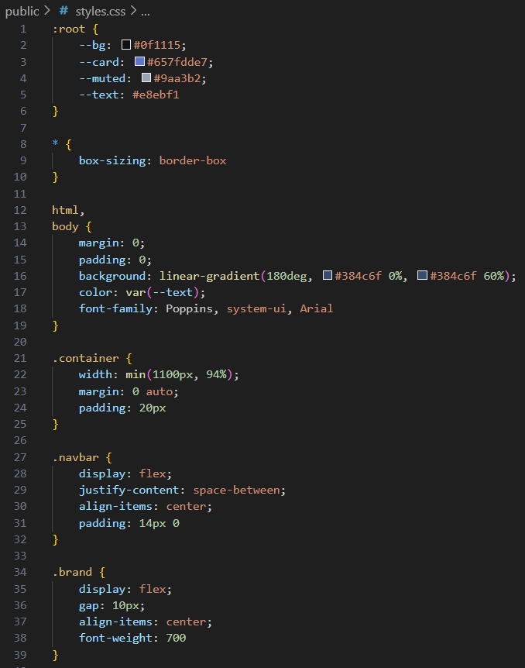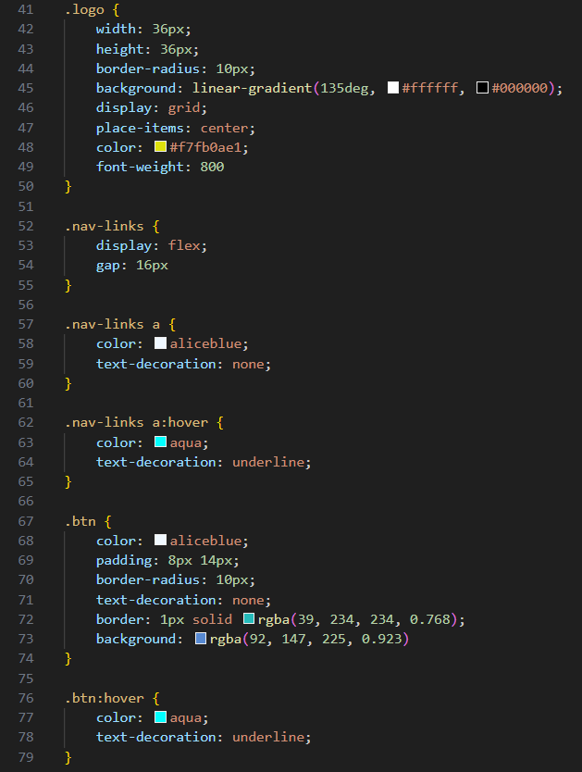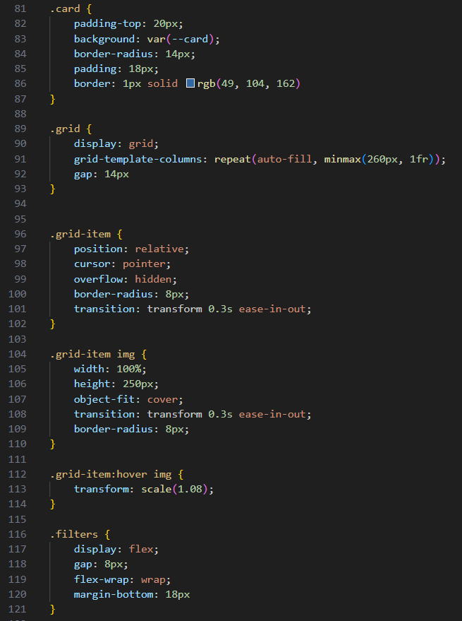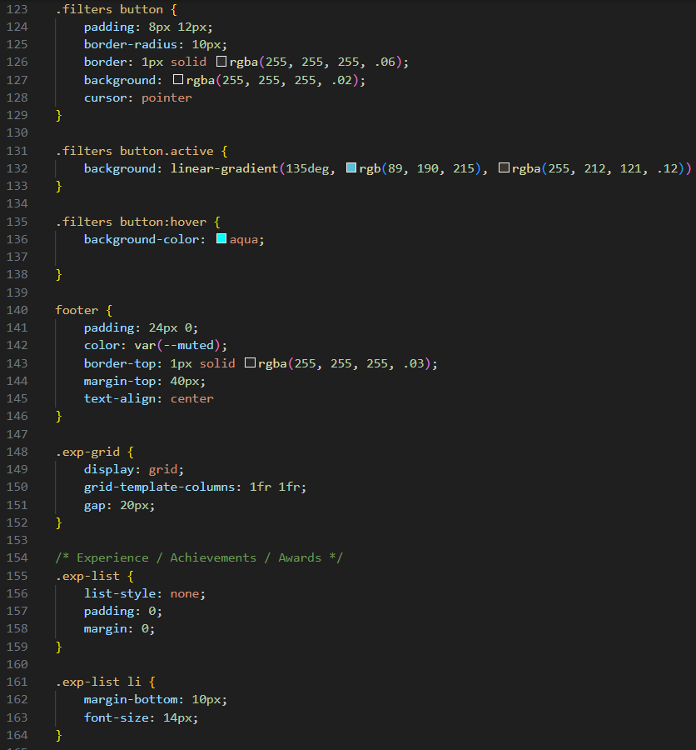
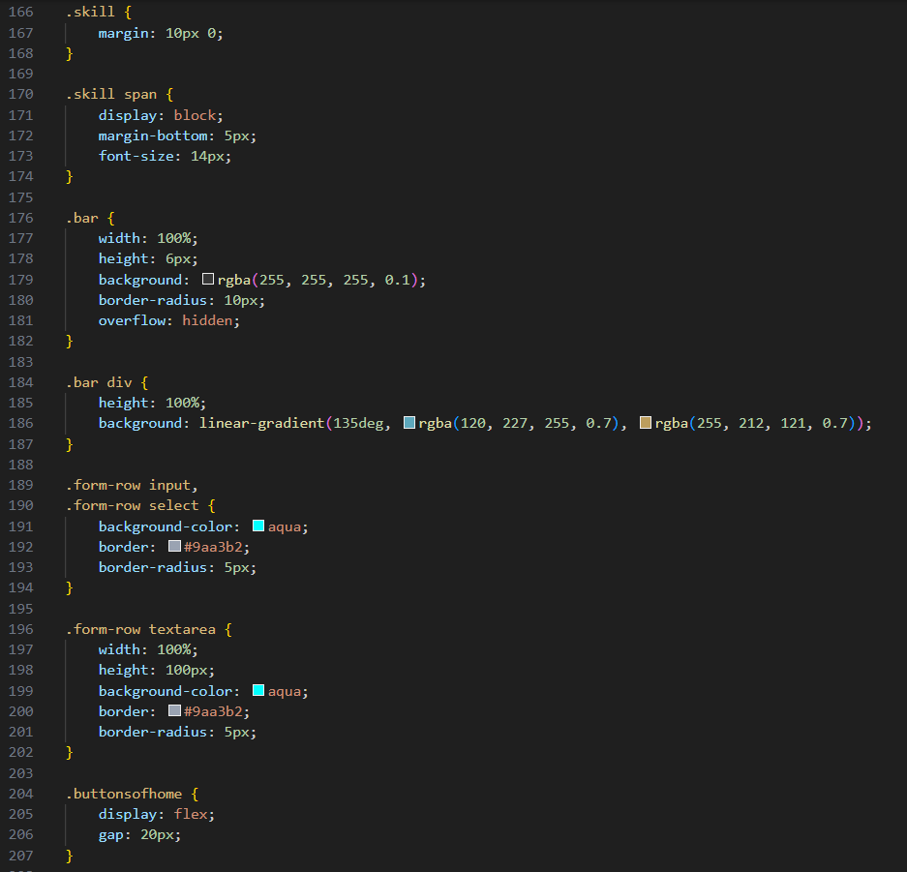
Figure 24: Style.css

Java script for the webpages
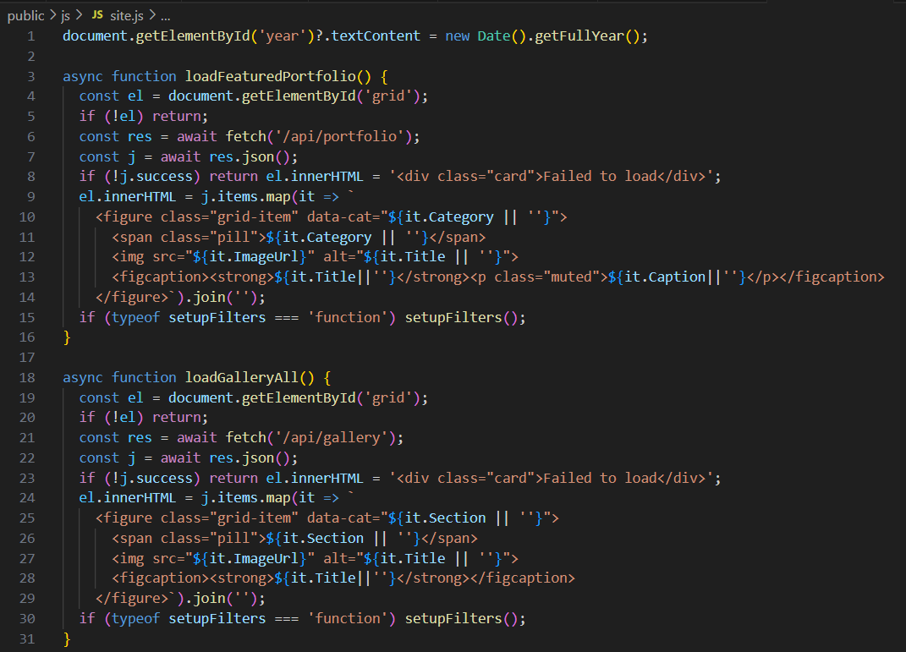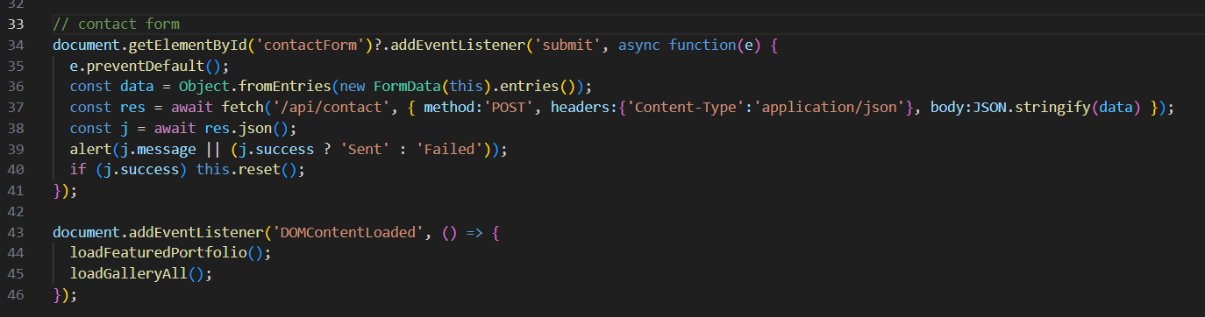
Figure 25: JS/site.js
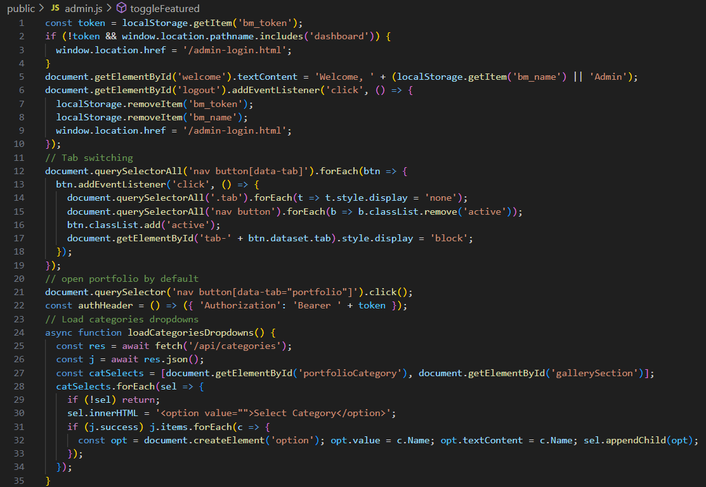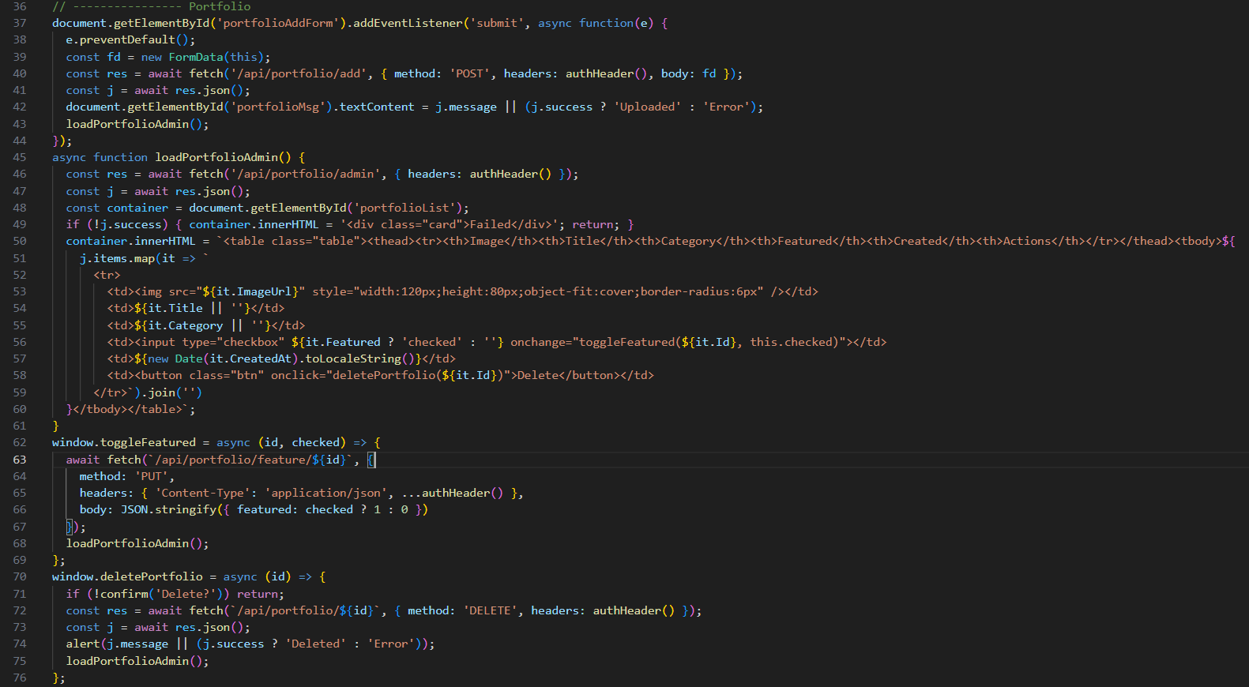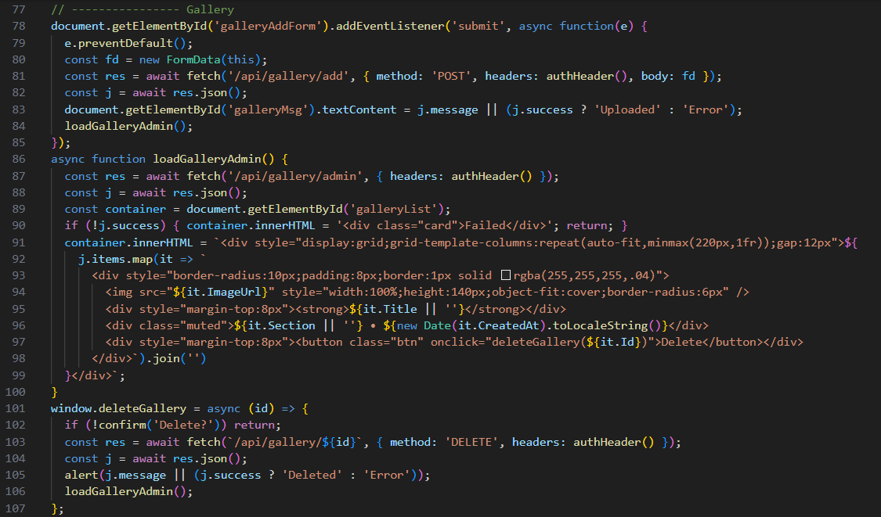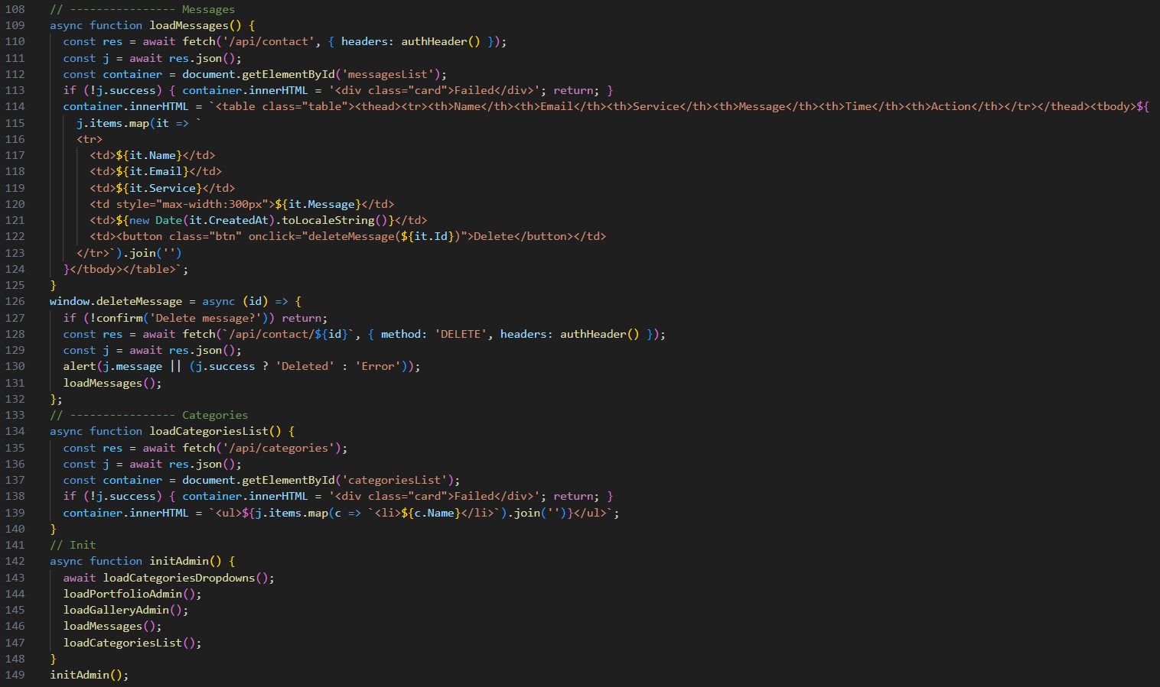
Figure 26: Admin.js

Middleware
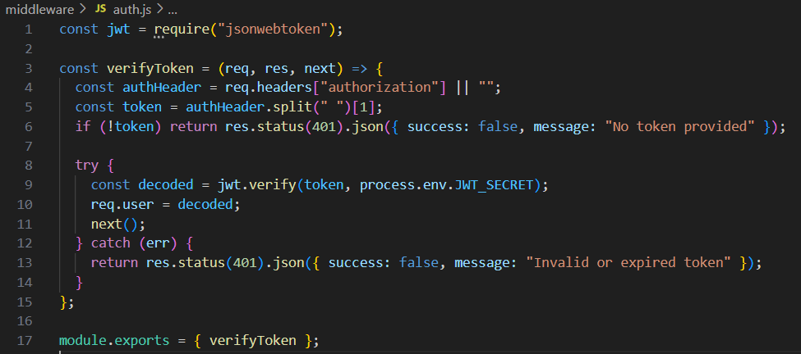
Figure 27 middleware/auth.js
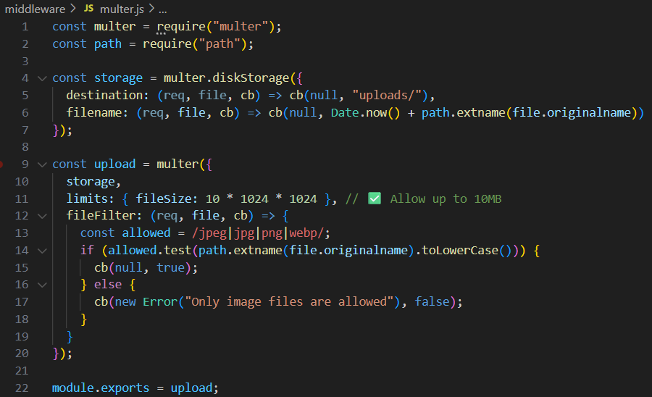
Figure 28: middleware/multer.js

Routes
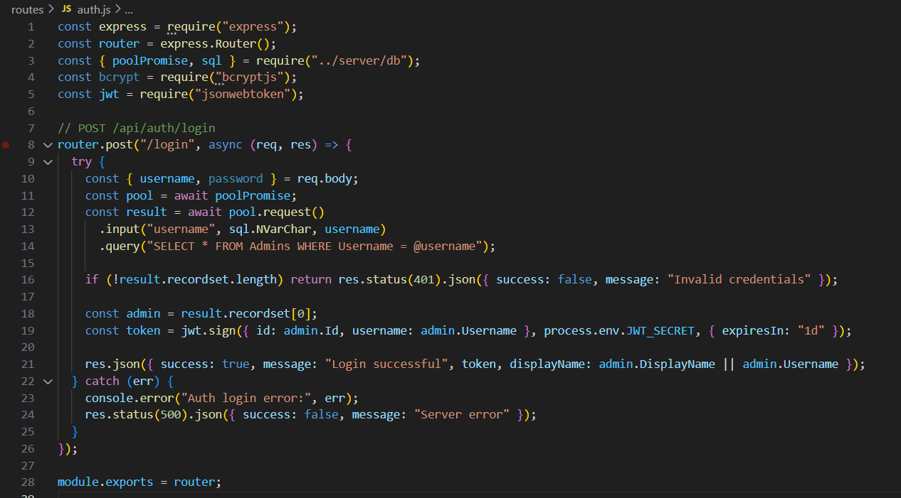
Figure 29: route-auth.js
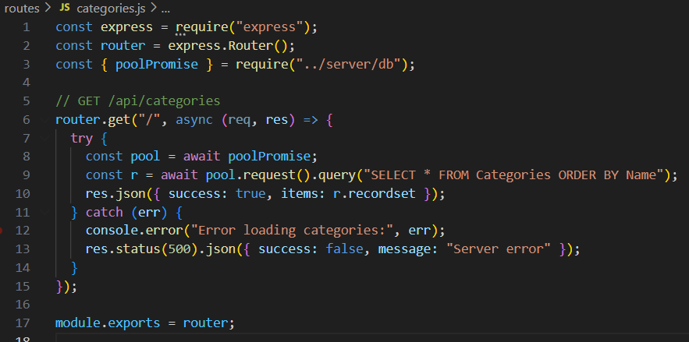
Figure 30: route/categories.js
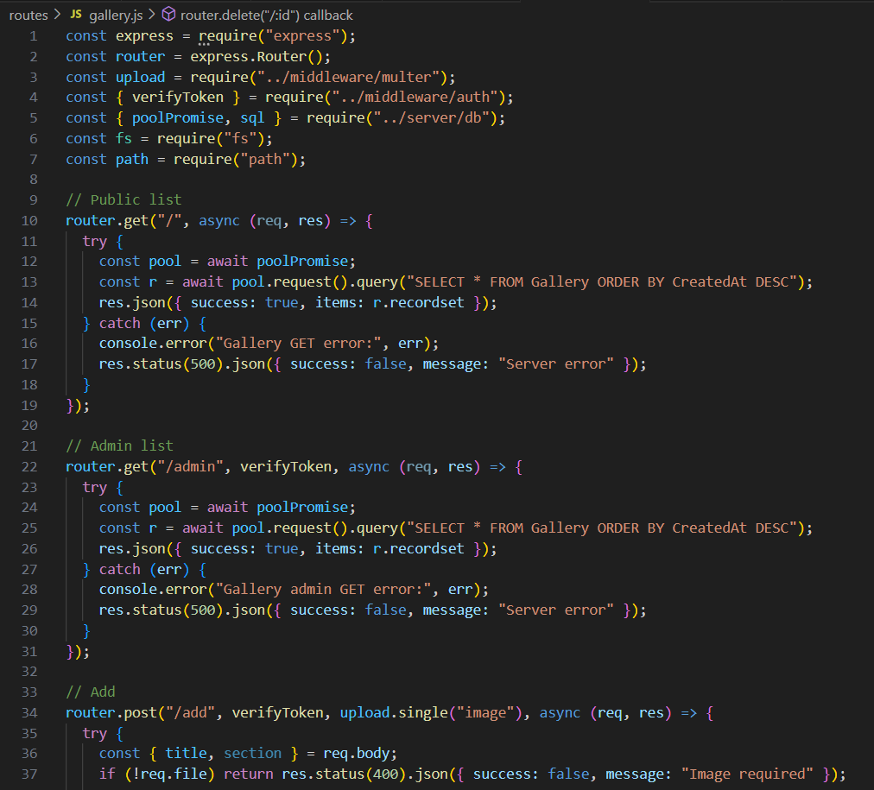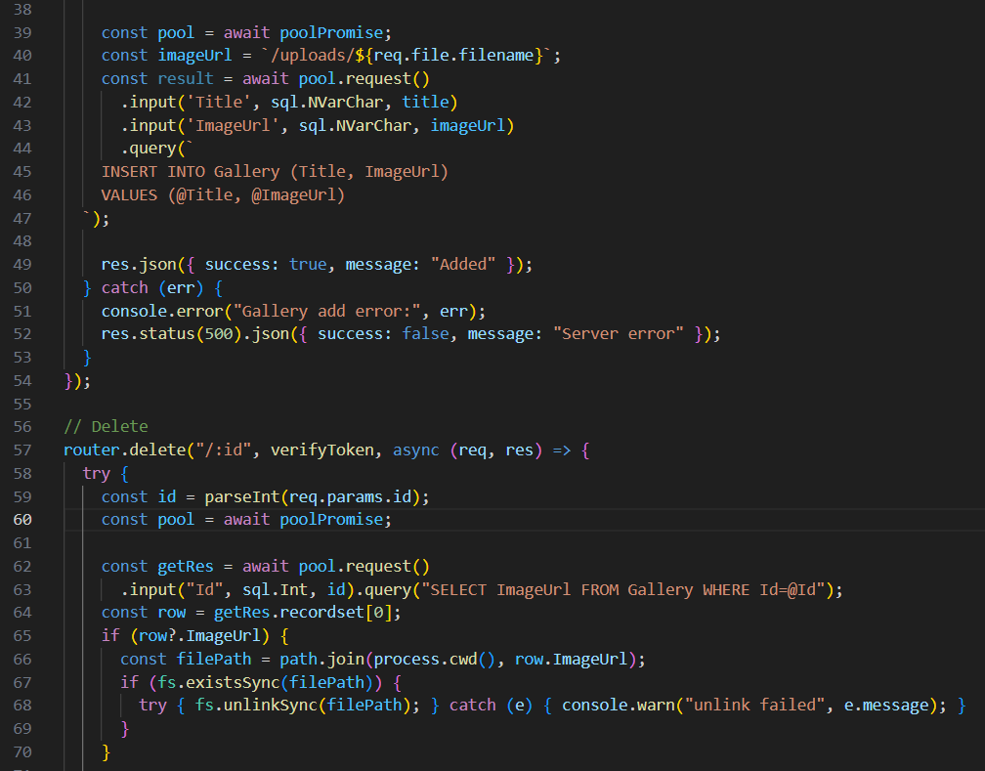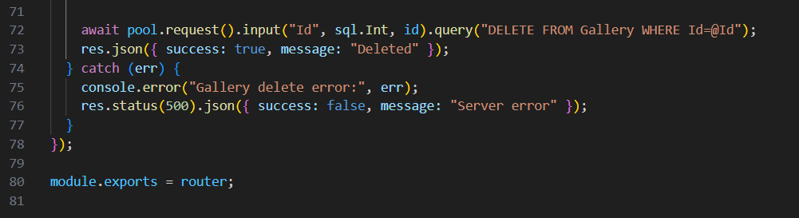
Figure 31: route/Gallery.js
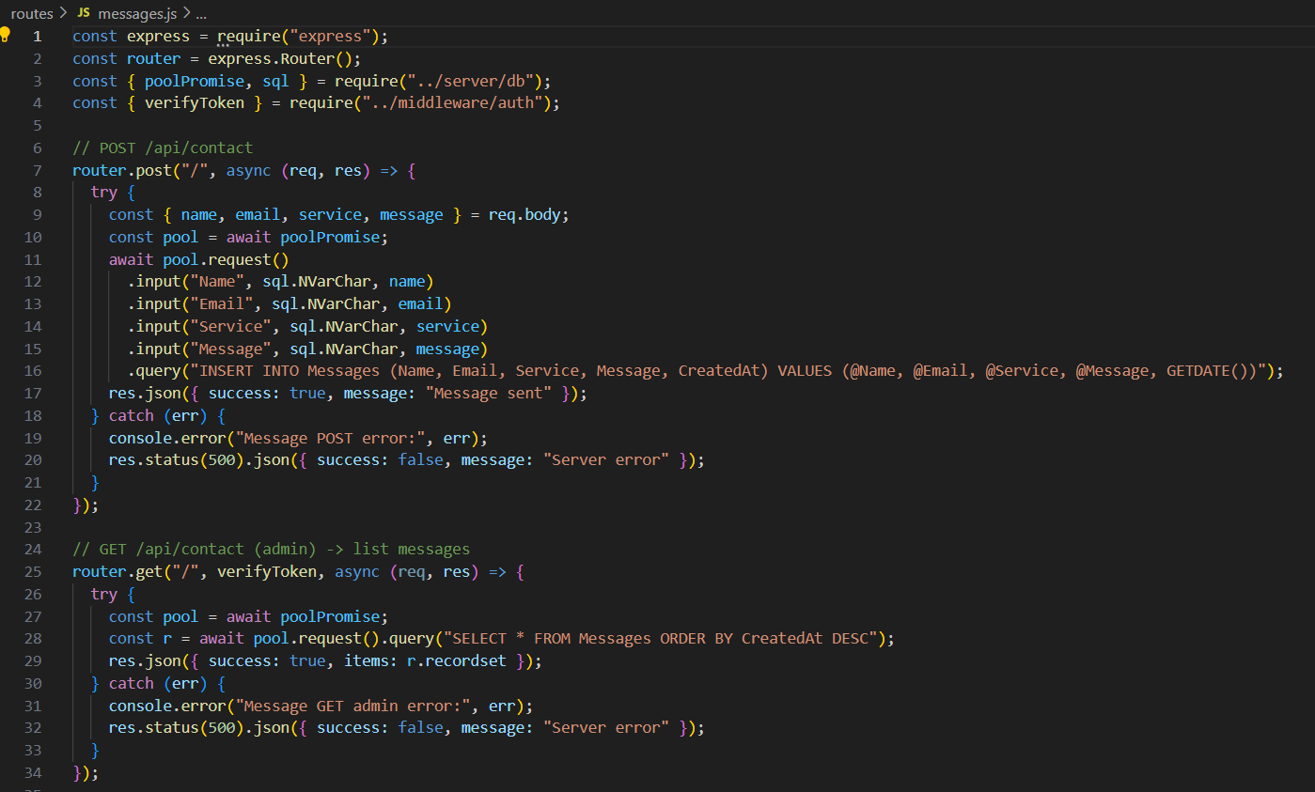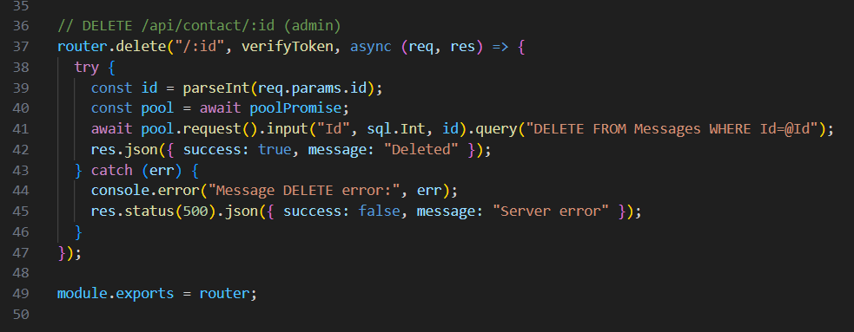
Figure 32: route/message.js
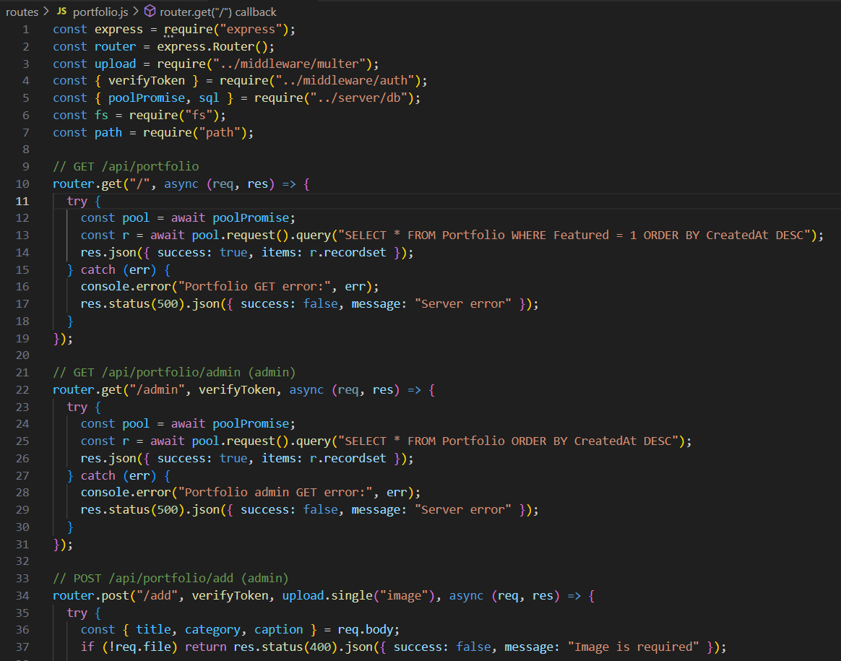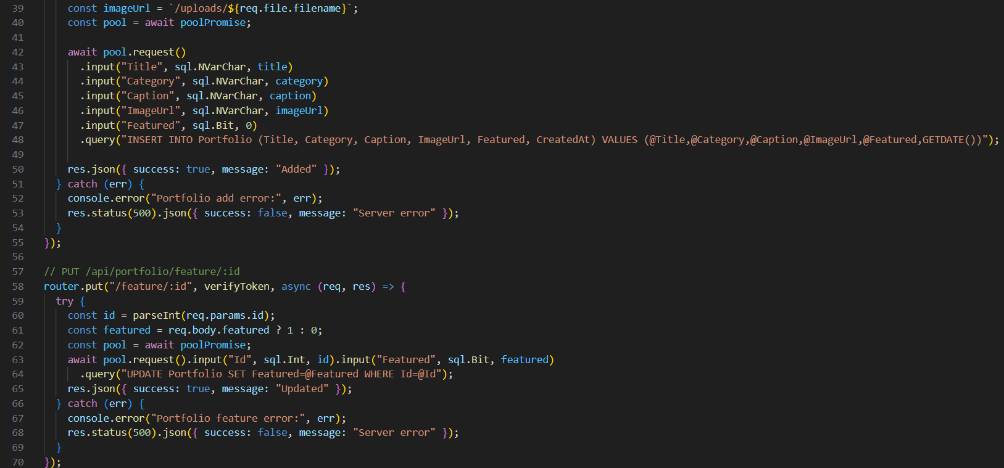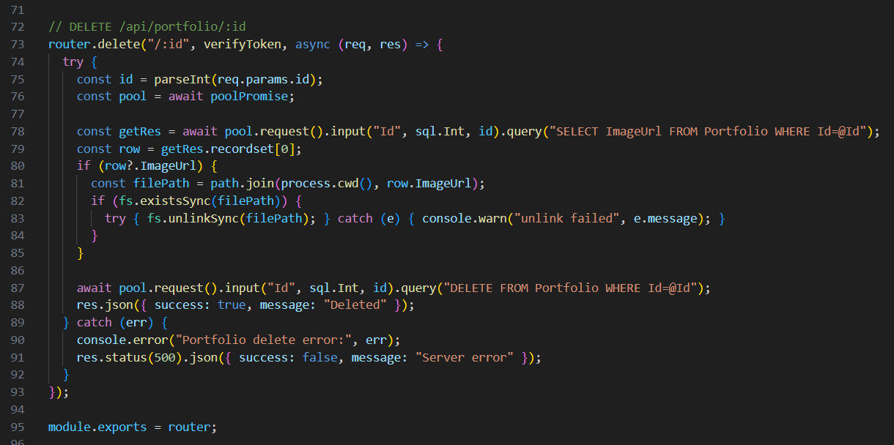
Figure 33: route/portfolio.js

server files
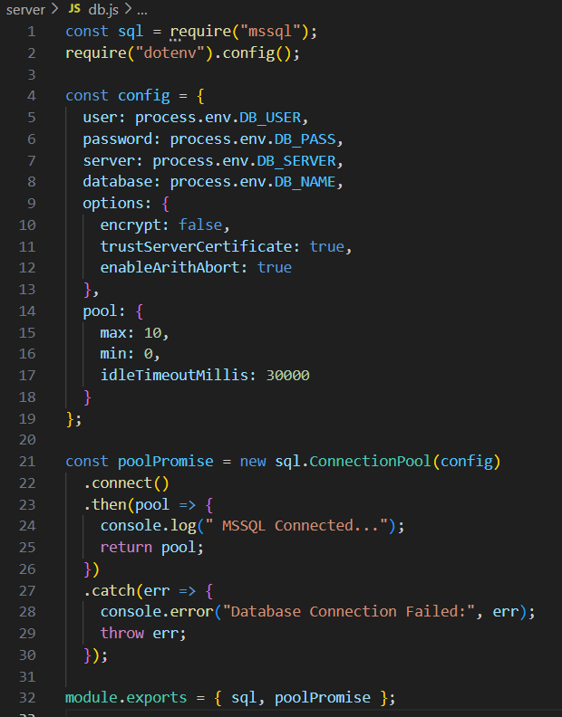
Figure 34: Db.js
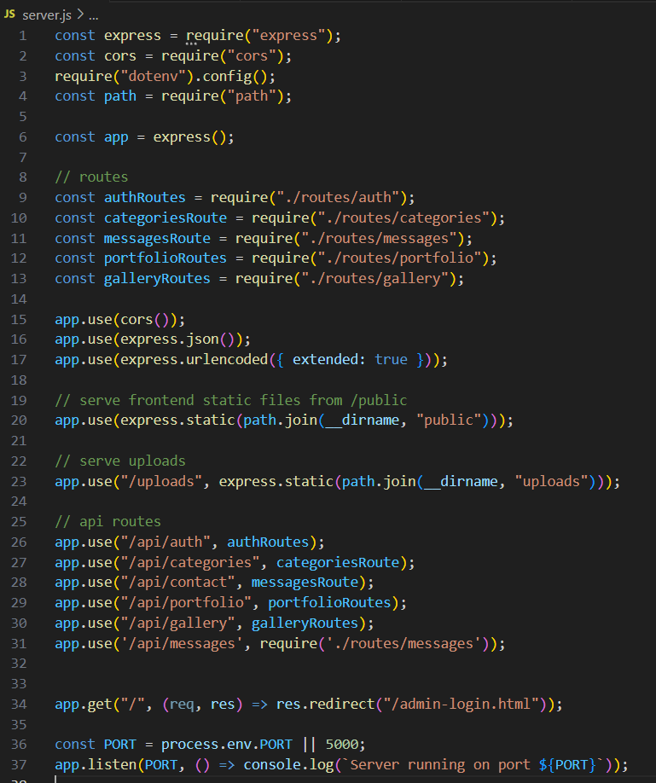
Figure 35: server.js

.env
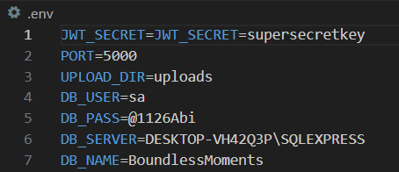
Figure 36: .env file

Coding Standards:
Writing the code is looks simply but it is hard to write a better and readable code alone in the way of development of an application or something else. We are missing the some of the rules of the coding standers as only we are trying to maintain the coding standard. While working in the team it can be problem to not follow the coding standard as it can have a hard to understand the new developers. It is not good practice to not follow the coding standard for the development as a team. Coding standards is a set of rules and guidelines to make the code enhanced and the readable to the other developer. To guarantee dependability, compatibility and sustainability, the website closely followed industry norms and requirements.
- HTML/CSS Validation: W3C validation tests were passed by every page.
- Media queries made guaranteed that layouts were responsive to different screen sizes.
- SEO Optimization: Title tags, alt text, and meta descriptions increased search engine visibility.
- Performance Optimization: Images were compressed without sacrificing quality, and CSS and JavaScript files were minified.
- Version Control: GitHub contributions saved earlier iterations of the code and tracked development.
- Cross-Browser Compatibility: Stable performance on Edge, Firefox, and Chrome was verified via testing.
- Adhering to these guidelines created a maintainable codebase for upcoming updates in addition to enhancing the site's technical performance.

Reasons for Design and Implementation Choices
There had to be some adjustments made to the original design mockups during the project. For instance, to speed up load times and enhance mobile responsiveness, the dynamic video background on the Home Page that was part of the original concept was swapped out for a static hero image. Similarly, after user feedback revealed issues with reading on smaller devices, font sizes and text block spacing were changed. These adjustments were made following a thorough examination of technological limitations and user experience data. Performance, accessibility and clarity were given precedence above simply aesthetic goals in the final implementation. This illustrates an advanced design philosophy in which choices are made based on utility and user delight. By doing this, the website successfully balanced both aesthetic appeal and useful functionality.

Testing and Quality Assurance

Overview of the Test Plan
To assess the Boundless Moments website's usability, performance, and functionality, a thorough test strategy was developed. Development testing, system testing, and final user acceptability testing were the various phases of the testing process. The purpose of the test was to make sure that:
- Every form, link, and navigational element functioned as intended.
- Pages appeared the same on all browsers and devices.
- The project's load speed objectives were met using performance measures.
- The website adhered to accessibility guidelines.
- Using programs like Google Lighthouse, GTmetrix, and browser developer consoles, testing was done both manually and automatically.

Testing for functionality
Every feature's intended functionality was confirmed through functional testing.
- Verified that all menu buttons and links led users to the appropriate pages through navigation testing.
- Form Validation: Verified that error messages were presented correctly by testing the Contact form for both valid and invalid inputs.
- Responsive Layout Testing: Verified that the layout was responsive for desktop, tablet, and mobile devices by checking breakpoints.
- Picture Loading: Verified that every picture loaded correctly and kept its aspect ratios.
- Cross-Browser Testing: Confirmed that Chrome, Firefox, Edge, and Safari all have the same look and feel.
Every problem that was found, including misaligned pictures or broken internal linkages, was noted, corrected and retested until it was fixed.

Evaluation of Performance
Through performance testing, the website's speed and effectiveness were guaranteed. Metrics including total blocking time, image optimization, and first contently paint were assessed using GTmetrix and Google Lighthouse. Among the actions done to improve performance were:
- resizing and compressing huge pictures.
- JavaScript and CSS files are being minified.
- using sluggish loading and browser caching.
- Lightweight libraries are used to save resources.
Following optimization, both desktop and mobile platforms demonstrated outstanding performance scores with average load times of less than two seconds.

Test case for Bondless Moments
Table 1: Test case
Testing components | Expected result | Actual result
- Logon to | Admin enter the username and password to enter admin panel. | Admin-User that has entered the right credentials can go to the home dashboard page otherwise it throws the error message (invalid credential).
Result:
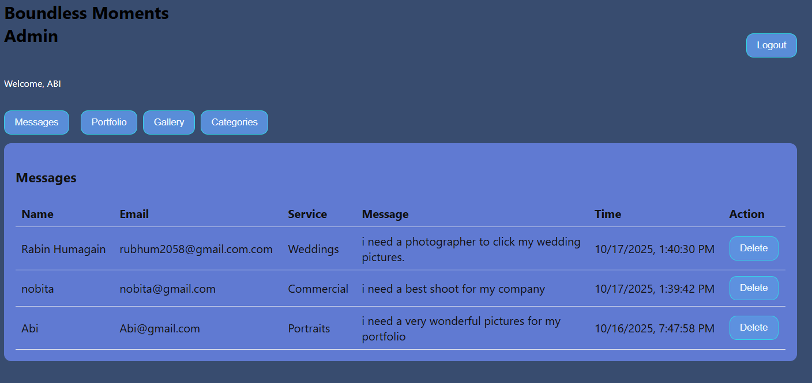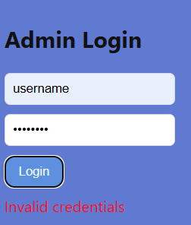
Analysis:
With the wrong password it will throw the error in login to the window and with the wright password it will be redirected to the bondless moments admin page.
- Clicking the button Upload of the portfolio management page | It uploads the picture. | It upload the picture in only admin dashboard until checked the feature checkbox.
Result:
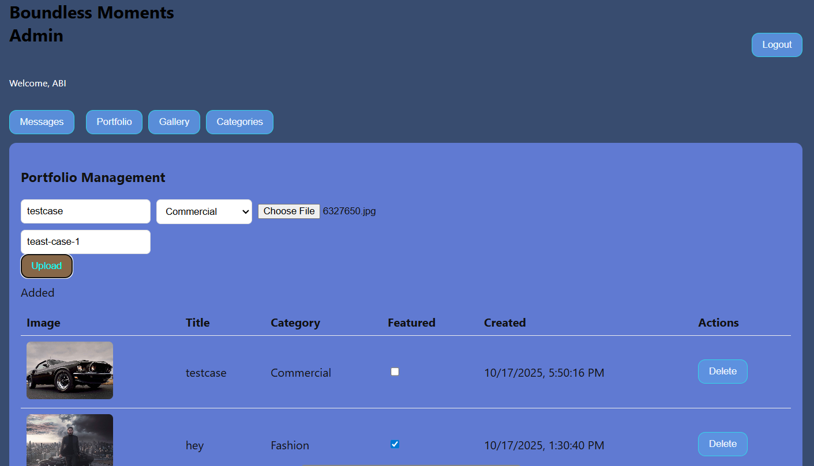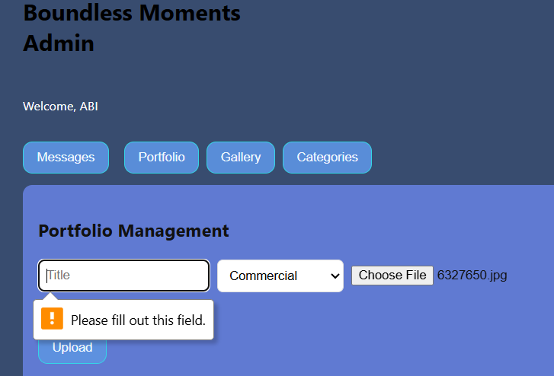
Analysis:
If the title is not blank with the chosen image it upload the image in the portfolio section but didn’t uploaded in the portfolio page for public until checking the feature checkbox.
- Hitting delete button of the portfolio management page | Delete the picture that uploaded. | 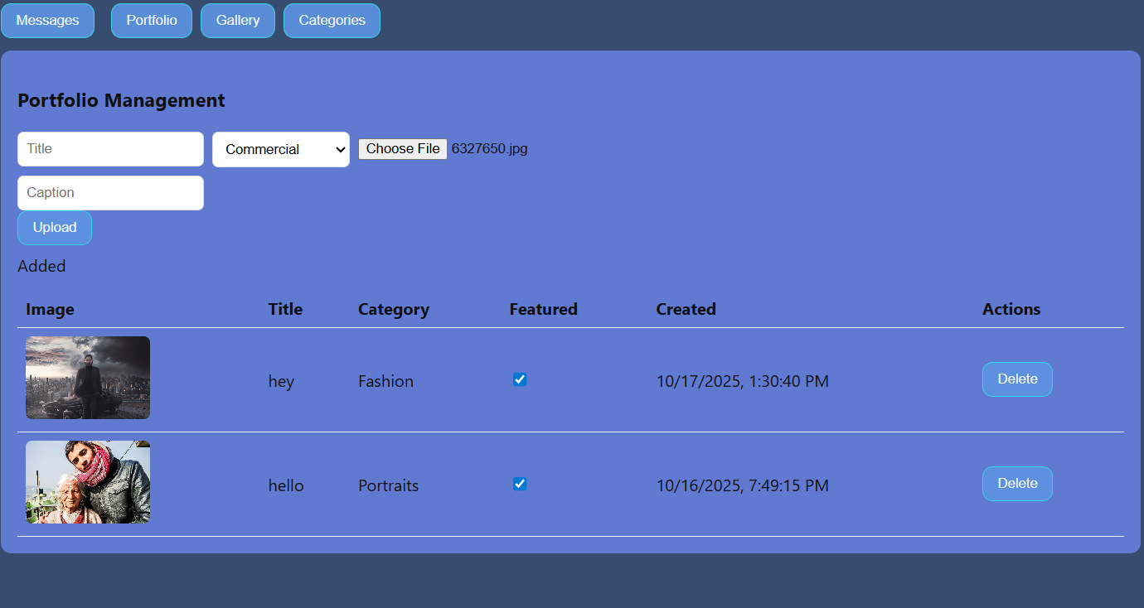
Result:
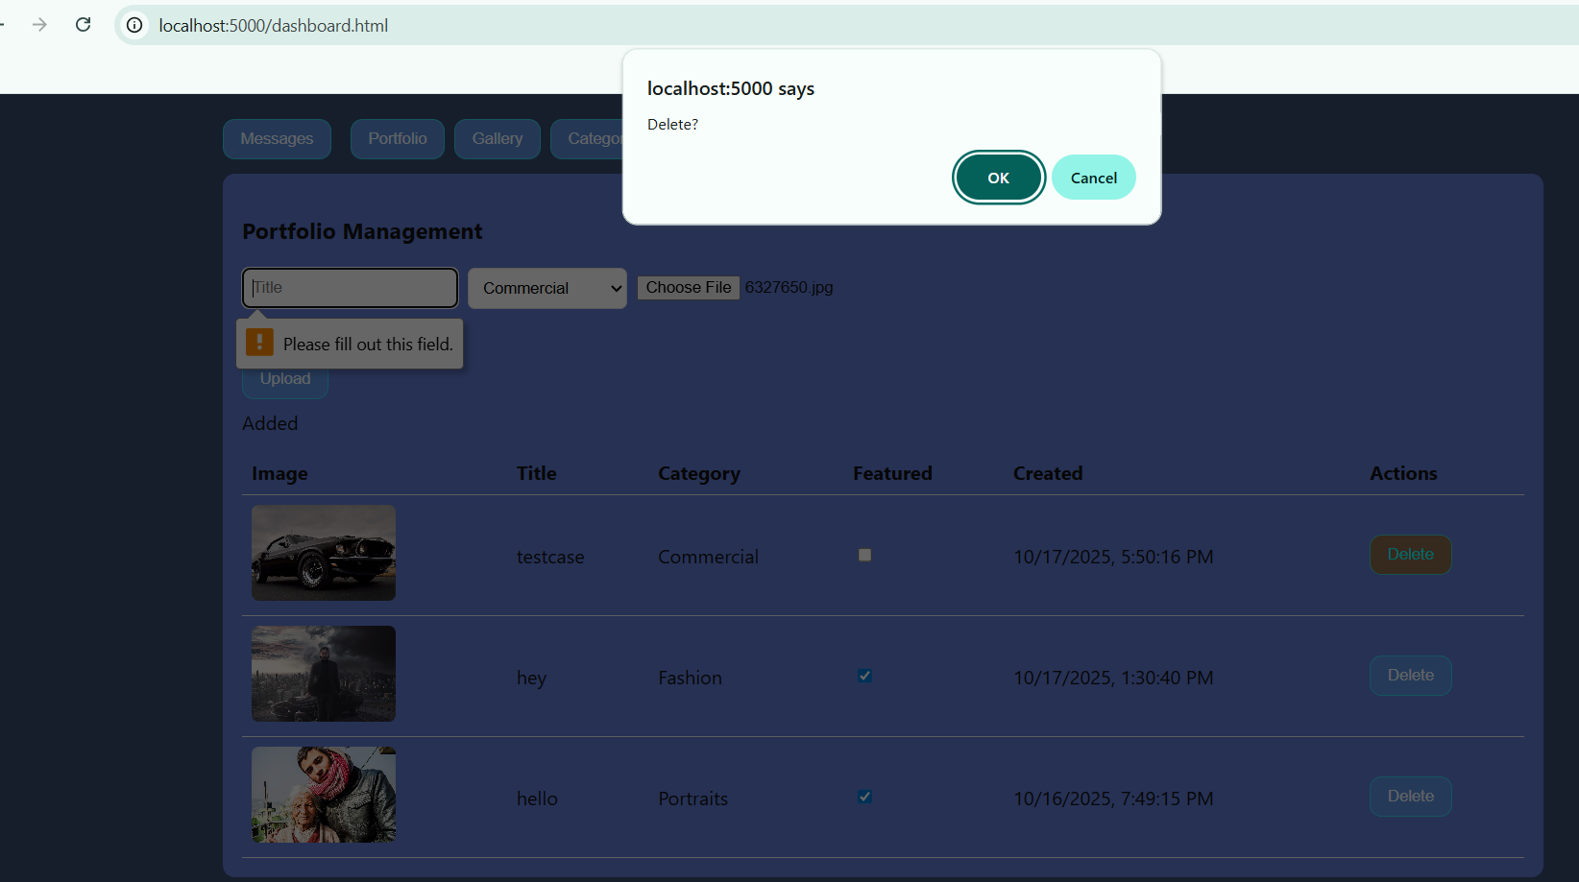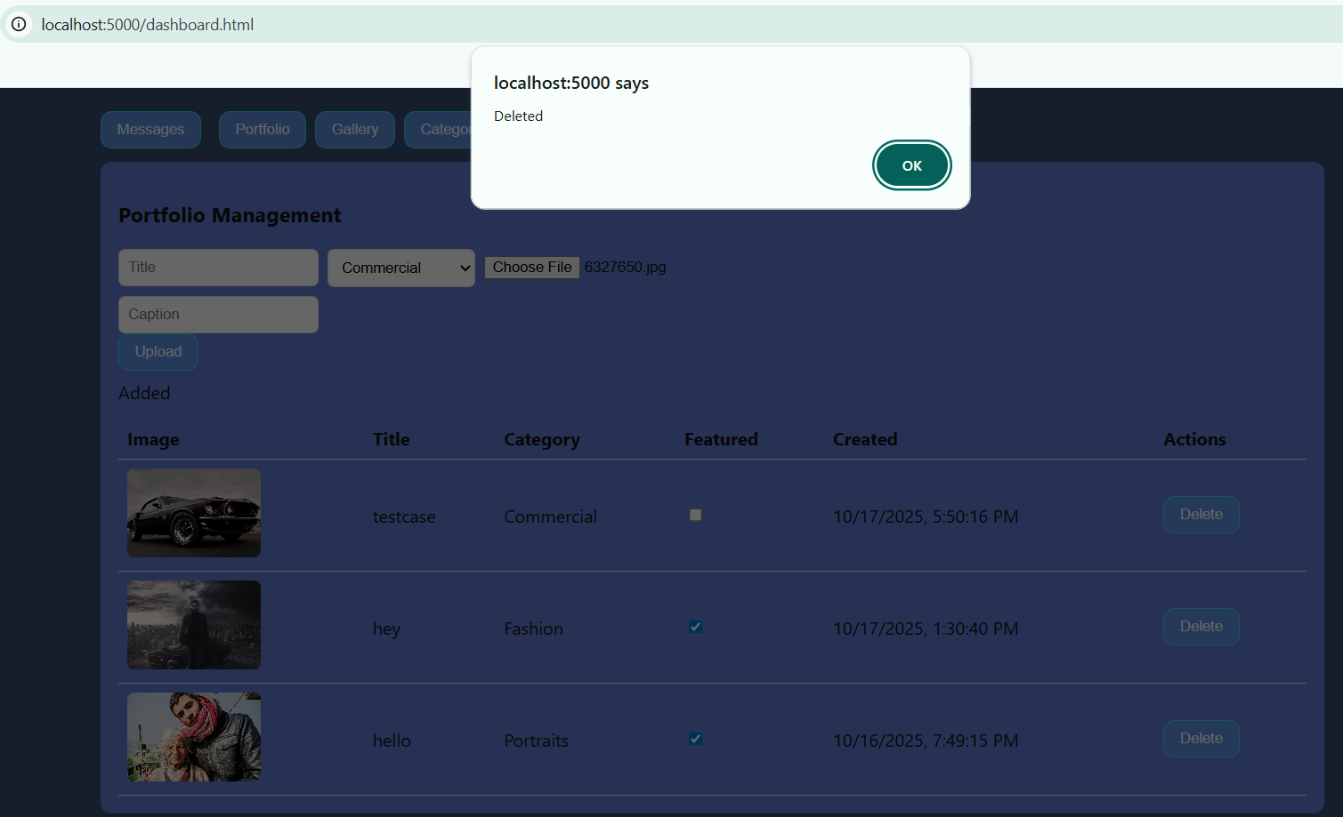
Analysis:
If the user hit the delete button then it gives the warning about the deletion of the pictures then after clicking ok will says delete successful then it delete the picture from that part.
- Check the feature button in dashboard portfolio | Added in the portfolio page. | Pics added when feature is checked.
Result:
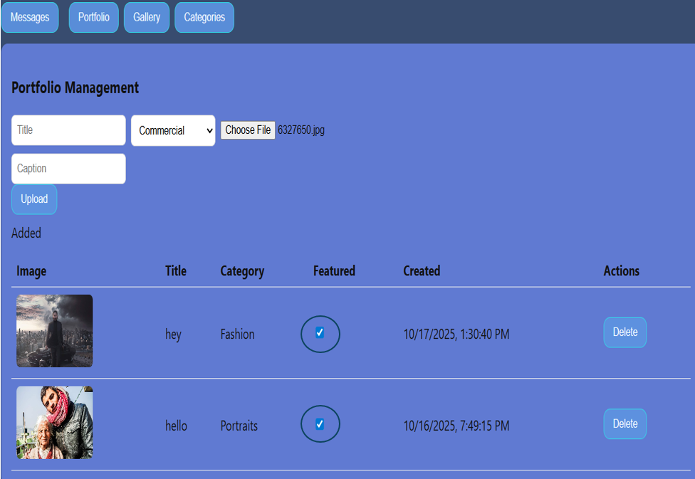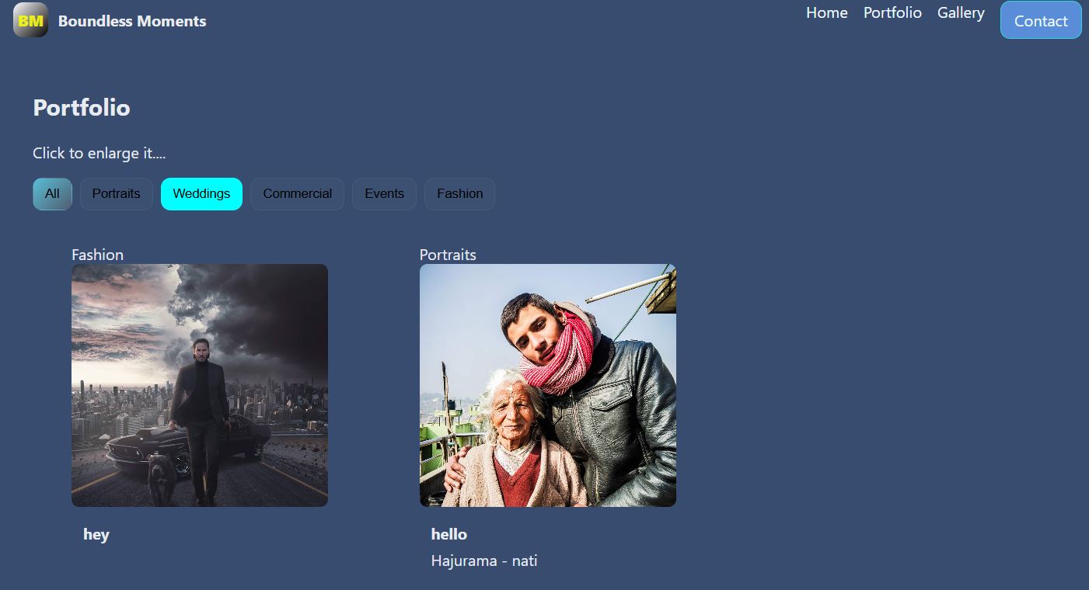
Analysis:
When we checked the feature checkbox it shows in the portfolio page when we reload it quickly.
- Clicking the button Upload of the gallery management part in admin dashboard | Upload in the gallery for public. | It uploads the picture in the gallery management and updated in the gallery page for public.
Result:
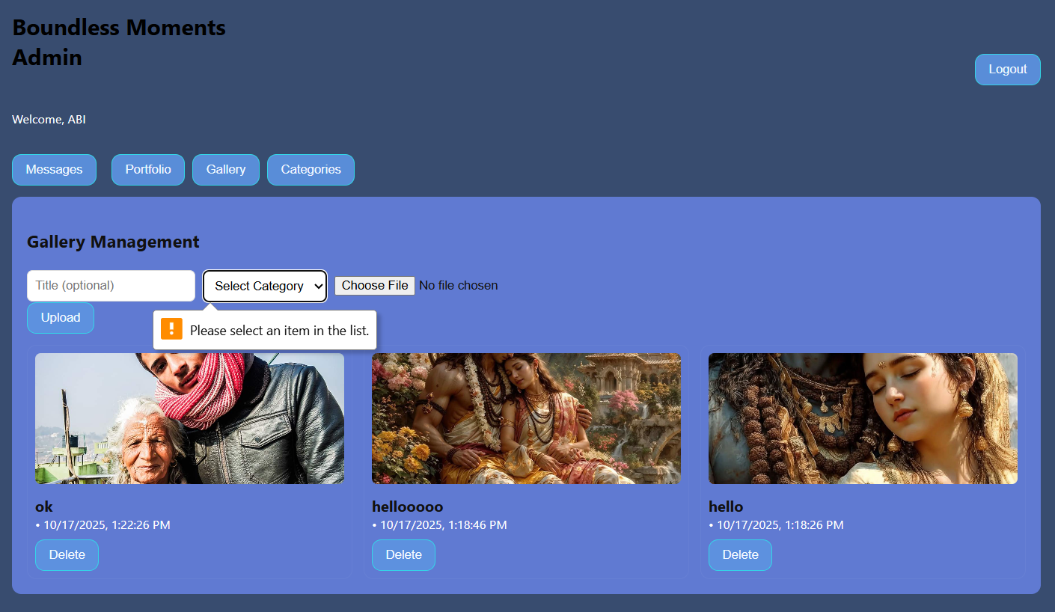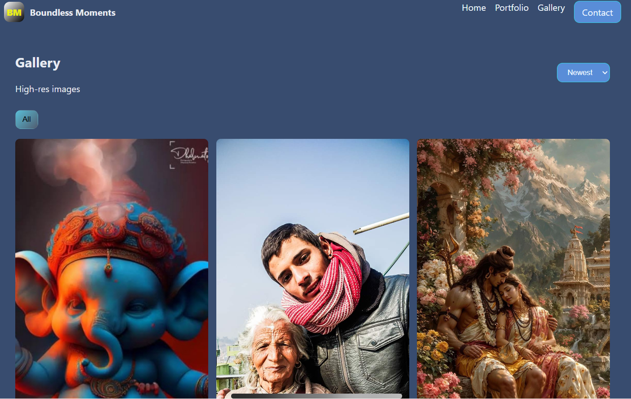
Analysis:
When the category is blank or chosen file is blank it throws the popup error message but when we select the actual file of picture it upload in the management tab and the update in the gallery page.
- Hitting delete button of the gallery management page | Delete from the gallery (public). | It delete the picture and removed from gallery page when reload the page.
Result:
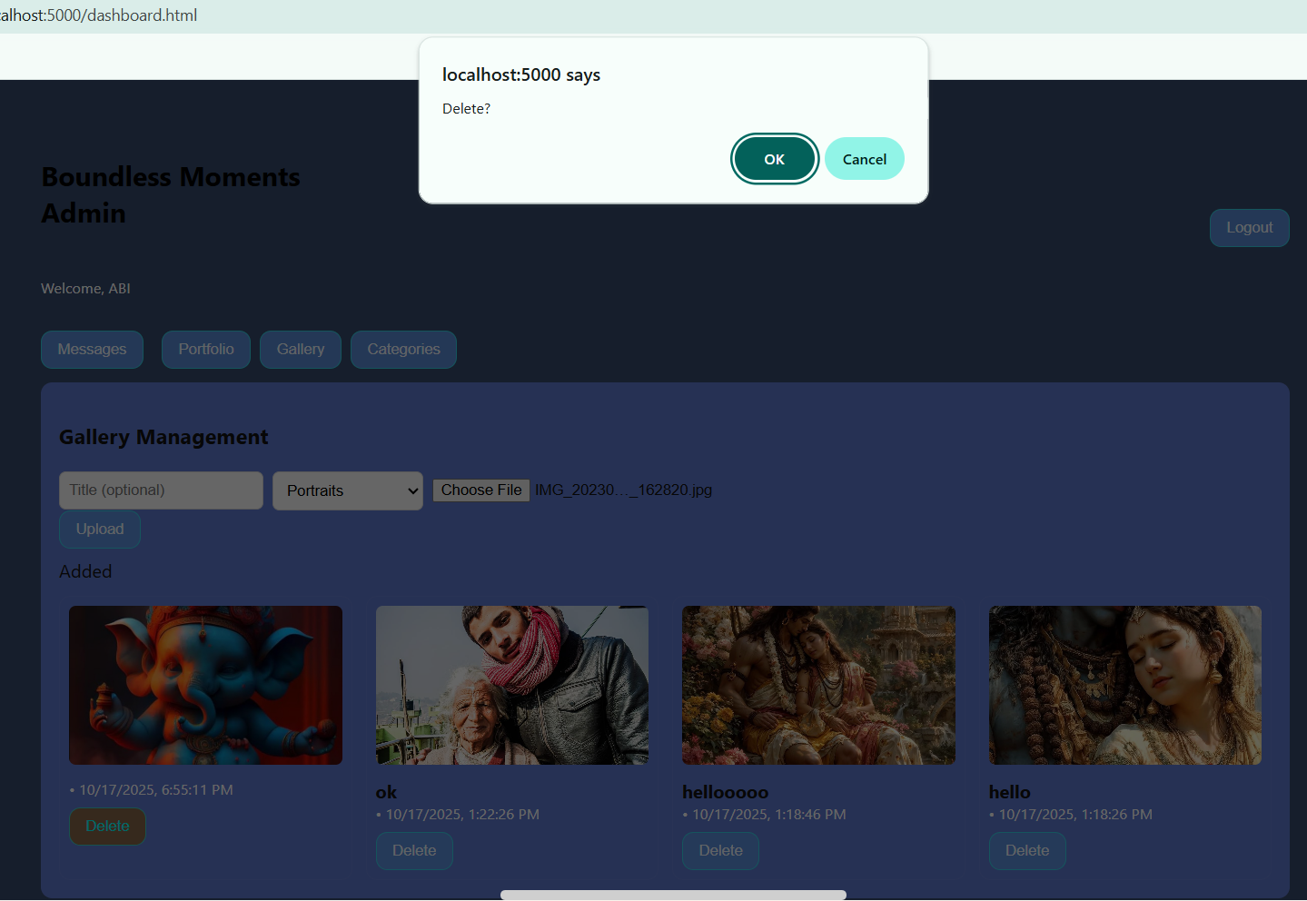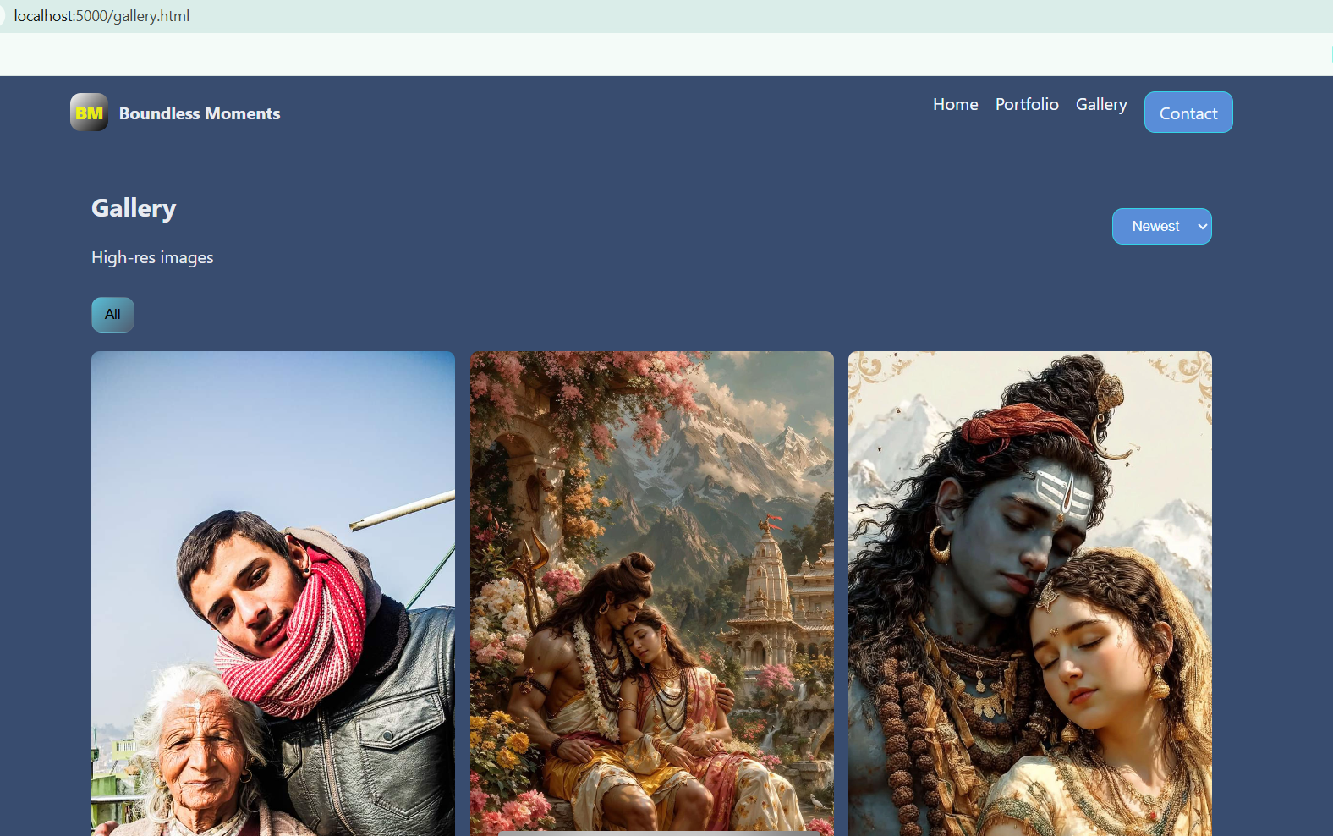
Analysis:
If the user hit the delete button then it gives the warning about the deletion of the pictures then after clicking ok will says delete successful then it delete the picture from that gallery.
- Hitting delete button of the message section | Delete the message. | Deleted message from the page and the database too..
Result:
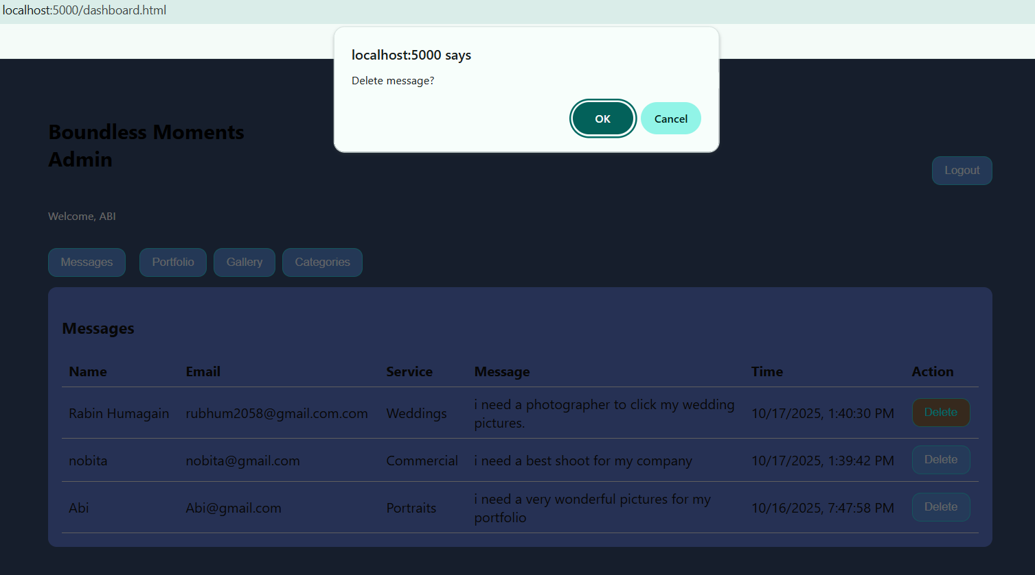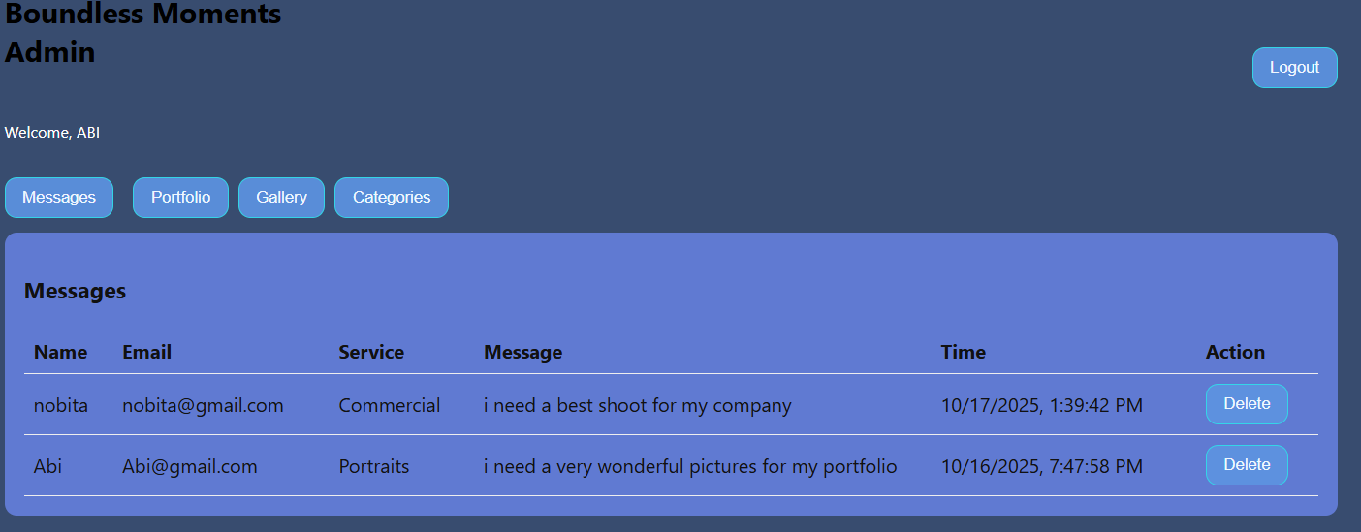
Analysis:
it warn the admin of the delete of the message and complete delete it from data base and the page topo.
- hitting the logout button | Logout from admin page | Logout from admin page to redirected to the admin login page.
Result:
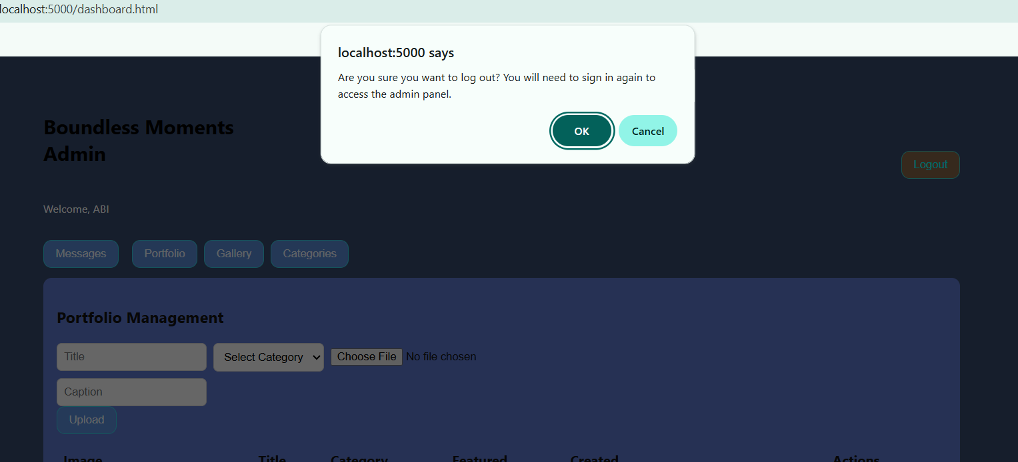
Analysis:
When we hit the logout button it throw the warning button “are you sure want to logout” then pressing ok logout the page and redirected to the login page of the admin page otherwise stays in the current page.
- Hitting the send Query button in the contact page | Set successful message. | It sends the message in the dashboard of the admin.
Result:
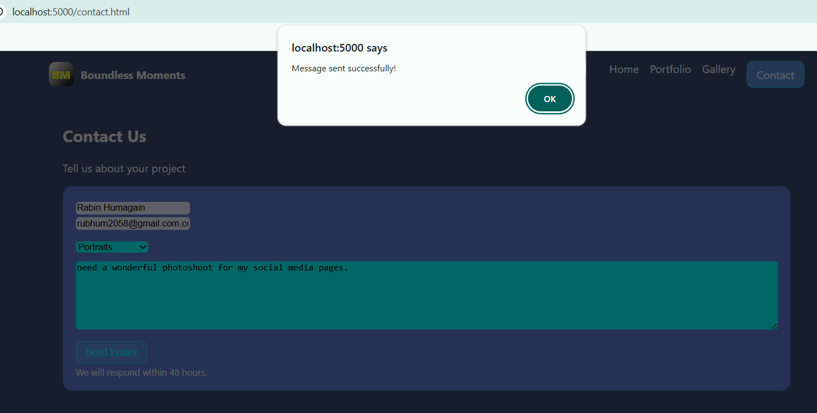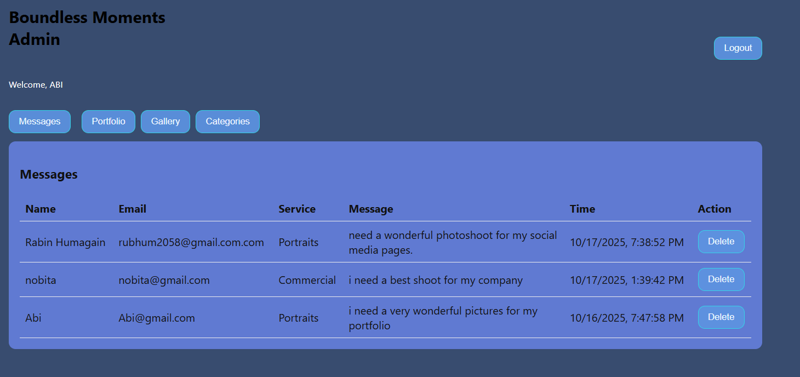
Analysis:
Hitting the send Query button then it gives the popup messages sent successful pressing ok so it stores the message in the database and shows the message in the admin pages.

Assessment and Enhancements

Evaluation of Test Results
The Boundless Moments website satisfied all important performance and functionality requirements, according to the testing results. All links worked well, navigation was smooth and the design looked good in all of the main browsers. Proper scaling on tablets and smartphones was confirmed by responsive design testing. Early detection and correction of minor problems, like footer space on smaller displays, were made. Following optimization, performance results shown notable gains, with load times decreased by more than 40%, accessibility tests, guaranteeing inclusion. The website effectively met its intended design, technical and usability goals, according to the final review.

Technical Difficulties
A number of technical difficulties occurred during development. Maintaining constant image quality while maximizing file sizes for quicker download was one of the main challenges. Modern picture formats like Web Pictures and sophisticated compression technologies like TinyPNG were used to fix this. Maintaining uniform alignment in the responsive grid style, especially in the portfolio area, was another difficulty. Flexbox features and CSS Grid were used strategically to get around this. Additionally, optimizing JavaScript functions and restricting transitions to lightweight CSS-based animations were necessary to incorporate fluid animations without degrading performance. These difficulties reaffirmed the need of iterative testing and offered insightful learning opportunities for striking a balance between technological efficiency and design accuracy.

Client Feedback and Recommendations for Improvement
Feedback from clients was overwhelmingly positive. The photography team at Boundless Moments valued the portfolio's sophisticated layout, user-friendly navigation, and visual focus. They cited the site's professional tone and responsiveness as its main advantages.
- Still, the customer made a number of suggestions for possible improvements for further work:
- putting in place a dashboard with client logins to handle photographic reservations.
- launching a news page or blog to provide project updates and photography advice.
- Improving analytics tracking and SEO to boost internet exposure.
These suggestions have been taken into consideration for the project's upcoming iteration. All things considered, the Boundless Moments website is a strong, safe, and aesthetically pleasing platform that successfully accomplishes its objectives while providing flexibility for future expansion.

QA Procedure and Evaluation
A customer walkthrough and peer review meetings were part of the Quality Assurance (QA) phase. Team members and developers examined accessibility compliance, layout coherence, and code quality. The Boundless Moments team was shown a demo version and gave input on text clarity, image alignment, and color balance. In order to improve the browsing experience, final adjustments were made to the typography, spacing and animation speeds after the evaluation. The finished website was polished, user-friendly, and in line with customer expectations thanks to this cooperative QA process.

Conclusion
The Boundless Moments website project, effectively illustrates how design, development and testing concepts can be integrated to produce a safe, user-friendly and responsive digital portfolio platform. Through a methodical design process that included high-fidelity mockups, thorough wireframes and accessibility considerations, the project produced an interface that is both aesthetically pleasing and functionally effective. The finished result satisfied client expectations and contemporary web development standards thanks to the usage of industry-standard technologies like Visual Studio, SQL Server and Node.js, as well as strict coding standards and best practices. Important security measures, adaptable designs and an easy-to-use admin interface were added to improve the system's usability and long-term viability.
Besides that, the website's dependability, functionality and cross-platform compatibility were confirmed by thorough testing and quality assurance. Client feedback emphasized the platform's polished appearance and user-friendliness, while functional and performance testing verified that every component functioned as intended. Even though there were technical difficulties, such preserving responsive alignment and optimizing images, these problems were methodically fixed by following best practices and making iterative improvements. All things considered, the project not only successfully demonstrated the photographer's work as its main objective, but it also created a safe and scalable framework for upcoming improvements, establishing Boundless Moments as a sophisticated and expert online portfolio platform.

YouTube link:
This is the link for website function and run: https://youtu.be/R5suW6cnFwY?si=djRY_0exuNCt9ivT

Table of Table
Table 1: Test case 69

Table of Figure
Figure 1Wireframe of Admin Login page 30
Figure 2 Wireframe of Admin Gallery Management page 31
Figure 3 Wireframe of Homepage (Public View) 32
Figure 4: IDE 37
Figure 5: homepage 37
Figure 6: About Section of Homepage 38
Figure 7: Experience and skill section 38
Figure 8: Gallery page 39
Figure 9: contact us page 40
Figure 10: portfolio page 40
Figure 11: Admin login page 41
Figure 12: Admin Dashboard messages from the clints of bondless moment 41
Figure 13: portfolio management of the admin dashboard 42
Figure 14: Gallery management of Admin dashboard 42
Figure 15: categories of admindashbord 43
Figure 16: Server Explorer of the Boundless Moment 43
Figure 17: Home.html 45
Figure 18: gallery.html 47
Figure 19: contact.html 48
Figure 20: portfolio.html 50
Figure 21:Admin-login.html 51
Figure 22: AdminDashboard.html 52
Figure 23: Admin.css 53
Figure 24: Style.css 55
Figure 25: JS/site.js 56
Figure 26: Admin.js 58
Figure 27 middleware/auth.js 59
Figure 28: middleware/multer.js 59
Figure 29: route-auth.js 60
Figure 30: route/categories.js 60
Figure 31: route/Gallery.js 62
Figure 32: route/message.js 63
Figure 33: route/portfolio.js 65
Figure 34: Db.js 65
Figure 35: server.js 66
Figure 36: .env file 66

References
draw.io, 2025. draw.io. [Online]
Available at: https://app.diagrams.net/?src=about
[Accessed 17 8 2025].
hamm, M. j., 2014. Wireframing Essentials. reprint ed. barmimgum, UK: packt publishingltd..
hoppscotch, 2025. hoppscotch. [Online]
Available at: https://hoppscotch.io/
[Accessed 17 8 2025].
microsoft, 2025. microsoft. [Online]
Available at: https://www.microsoft.com/en-us/
[Accessed 17 8 2025].
Pollock, P., 2013. Host your own website or blog with this unique guide. illustrated ed. s.l.:John Wiley & Sons.
S.Sridevi, 2014. USER INTERFACE DESIGN. Department of Computer Science & Engineering, Saveetha School Of Engineering, 2(2), pp. 1-12.
Walfish, M., Balakrishnana, H. & Shenker, S., 2025. Untangling the Web from DNS. MIT Computer Science and AI Laboratory (CSAIL), p. 14.
Willke, T. L., Tientrakool, P. & Maxemchuk, N. F., 2009. A survey of inter-vehicle communication protocols and their applications. IEEE, 11(2), pp. 3-20.

