Cover page

Table of Contents
List of Figures 2
List Of Tables 3
Introduction 1
Overview of the problem 1
Aim of the Project 1
Objectives of the Program 1
Problem Analysis and Planning 2
Understanding the Requirements 2
Program Features 2
Algorithm Design 2
Pseudocode 3
Flowchart Design 4
Program Development 6
Programming Language Selection 6
Development Environment 6
Variables and Data Structures 6
Use of Functions 6
Implementation of Loops and Conditional Statements 7
Error Handling and Input Validation 7
Grade Calculation Logic 7
Program Implementation 7
Student Data Input 7
Average Mark Calculation 7
Grade Assignment 7
Summary Report Generation 8
Multiple Student Processing 8
Testing and Debugging 8
Testing Strategy 8
Tast cases 8
Errors Encountered 10
Debugging process 10
Improvement after Testing 10
Evaluation of the solution 10
How the Program Meets Requirements 10
Strengths of the System 10
Limitations of the Program 11
Possible Future Improvements 11
Conclusion 11
References 12
Appendix 1
Appendix A – Sample Program Output 1
Appendix B – Screenshots of the Program 1
Appendix D – Source Code 5

List of Figures
Figure 1: Pseudocode 4
Figure 2: Flowchart 6
Figure 3: Program Start Screen with Student Data Entry 1
Figure 4: Input Validation 2
Figure 5: student added successfully 3
Figure 6: Grade Calculation Output 4
Figure 7: Summary Report 5
Figure 8: code Stipites 8

List Of Tables
Table 1: Taste Case 9

Introduction

Overview of the problem
Grading procedures conducted manually within an academic environment consume a lot of time and involve the possibility of human errors, especially when numerous students have to be graded in various subject areas. Calculating the average marks, applying the appropriate grade limits and generating comments for students are time-consuming tasks in case they are carried out manually. As a solution to this problem, the Student Grade Calculator has been developed using the Python programming language.
The Student Grade Calculator automates the whole process of grading, starting from the moment when the information about the student is entered until the final grade summary report is generated. Through the inclusion of input validation, automatic average mark calculation, and personalized comments, this software resolves the problems related to manual grade calculation. This project was useful in terms of implementing programming principles covered in the course.

Aim of the Project
One of the main Aim of this project was to creation of a practical and easy-to-use program that would help users perform grade calculation operations with easy process. The program had to be able to receive user inputs on student subject marks, compute the averages, allocate grades through a set grade boundary and offer feedback on the student's level of achievement.

Objectives of the Program
The objectives that were formulated in the initial stages of the program creation were the following:
- To enable users to input information on the student’s name and the courses.
- To input and store grades for a specified number of subjects per student.
- To calculate the average of every student.
- To assign grades according to a predetermined grade boundary system.
- To check all user inputs for errors.
- To output a detailed summary report after data inputting is completed.
- To produce personalized feedback depending on the grade received.
- To conduct statistical analysis of class-level data including minimum and maximum averages.

Problem Analysis and Planning

Understanding the Requirements
Requirements of the project had been considered before writing any code. The software had to support multiple students in one execution, deal with various numbers of subjects, give correct output and make it readable for users. The software should be reliable, resistant to errors made by users. Those requirements defined both structure of the project and data structures.
An important thing to think about during the planning stage was how to organize data properly. Data about each student should include student's name, his or her course, a dictionary that will contain names of subjects and grades, average grade of all subjects and grade. The use of list of dictionaries turned out to be efficient.

Program Features
The developed system includes the following features:
- Student inputs their name
- After adding names then adds their course name
- How many subjects are in your module or course
- Mark entry name of subject and marks one by one
- It calculates the average marks
- According to the average marks it marks the grade and gives the output
- And could add multiple students
- It includes error handling and input validation
- Gives the output or summary report

Algorithm Design
Step 1:
Student & Course: Input the user is prompted to enter the name of the student and the name of the course.
Step 2:
Number of Subjects: Input the user is asked to input the number of subjects.
Step 3:
Validation of Input: Verify that the number of subjects is a valid input by ensuring it is a positive integer.
Step 4:
Marks of Subjects: Input Loop through the number of subjects and take input for marks of each subject.
Step 5:
Calculation of Average: Calculate the total marks and then find the average marks.
Step 6:
Assignment of Grades: Compare the average marks with the standard grading scheme to allocate a grade to the student.
Step 7:
Storing Data Store: The data including the name of the student, the course, the marks, and the grades obtained by the student.

Pseudocode
According to this book, pseudocode is defined as a form of cross-platform modeling technique that developers adopt to sketch out the process flow of the program to be developed. (Gaddis, 2016)
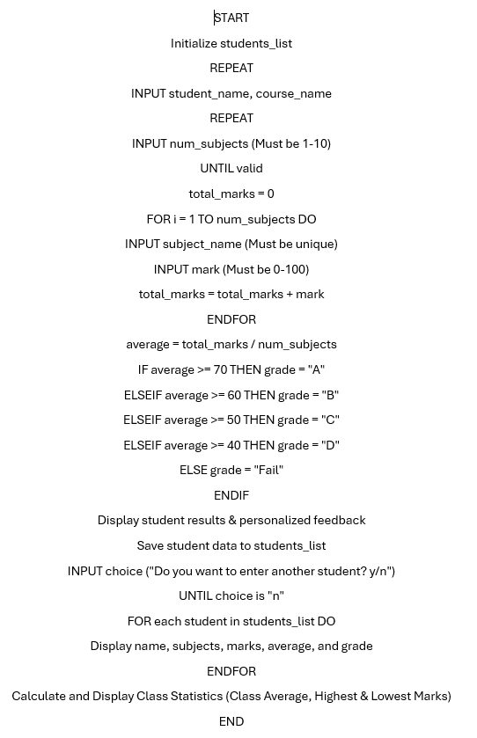
Figure 1: Pseudocode

Flowchart Design
Flowchart can be defined as a visual representation of the steps and decisions involved in designing a particular program prior to coding. (Gaddis, 2016)
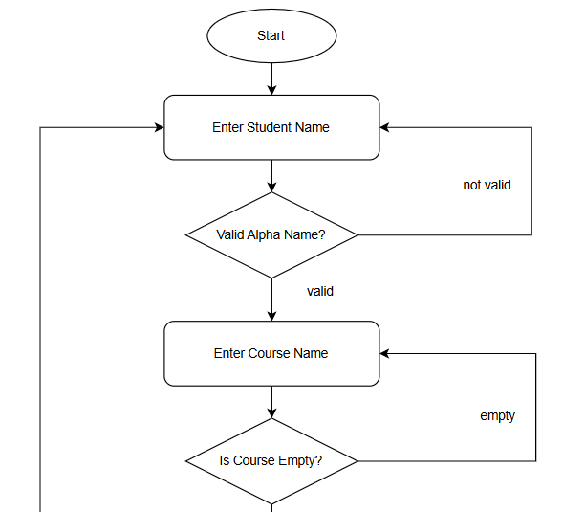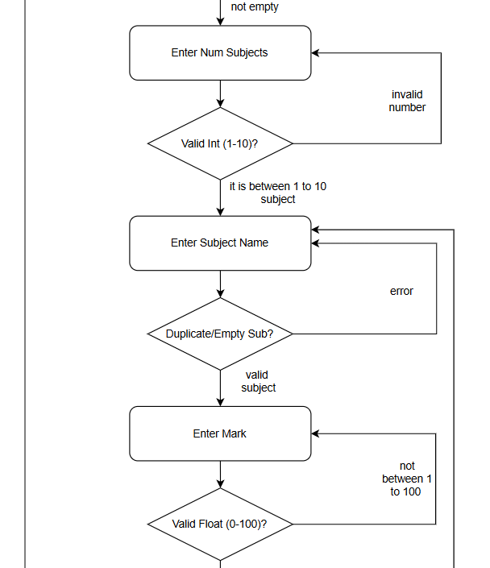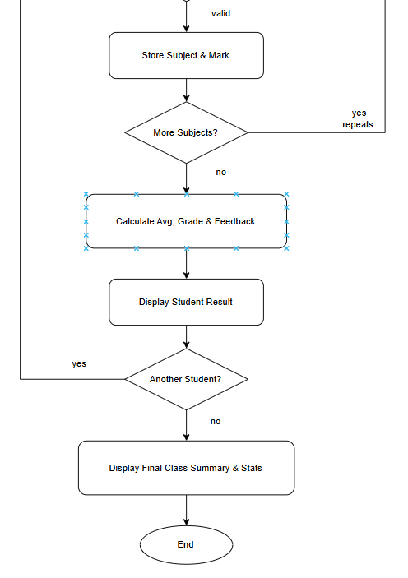
Figure 2: Flowchart

Program Development

Programming Language Selection
Python was chosen due to its simplicity in understanding and implementation. The simplicity in the programming language made it easier to create the grade calculator.

Development Environment
The program was coded using Python programming language in Visual Studio Code. This software or ide offered useful debuggers that helped in developing the program. Also, helps to increase in speed of coding and it also suggest some of the codes that helps to improvise the function if logic is broken.

Variables and Data Structures
These variables were used to hold the names of the students, the names of the courses, the marks, the averages and the grades.

Use of Functions
Functions were used to make the code easier to organize and read. Different functions were created for reading input, calculating average, grading and printing reports.

Implementation of Loops and Conditional Statements
Loops were applied to handle multiple subjects and students. Conditions were applied to assign grades and validate inputs.

Error Handling and Input Validation
Input validation was applied to avoid inputting invalid grades, empty names, and wrong number of subjects. Error handling was applied to ensure that the program did not crash when an invalid input is provided by a user.

Grade Calculation Logic
The grading approach was based on the following limits:
- 70 & above = A
- 60-69 = B
- 50-59 = C
- 40-49 = D
- Less than 40 = Fail

Program Implementation

Student Data Input
Users provide the name of the student and the course before adding the details of each subject.

Average Mark Calculation
Average mark is calculated through summing up all the subject scores and dividing the result by the number of subjects.

Grade Assignment
The result of the average score computation is compared with grade ranges to assign grades accordingly.

Summary Report Generation
Summary reports display the student’s name, course, average score, and assigned grades.

Multiple Student Processing
Loops can be used to handle multiple students at one go.

Testing and Debugging

Testing Strategy
The test on the application included use of valid as well as invalid inputs. Different numbers of subjects, marks, and student details were used to make sure that the program runs successfully.

Tast cases

Table 1: Taste Case
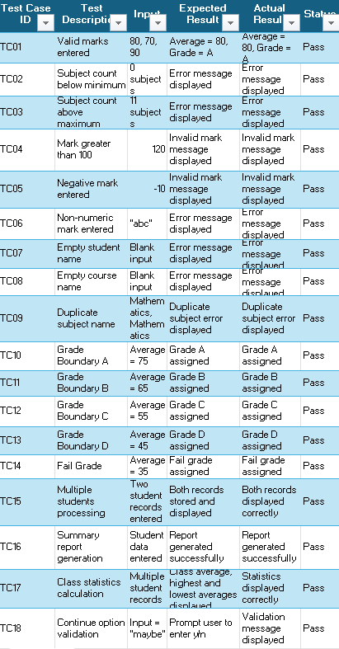

Errors Encountered
One major problem was noted while programming, concerning the initial version of the program. The loop in the original code forced the program to request for module names and marks many times. Another problem occurred when invalid number of subjects was keyed into the program during calculation of averages.

Debugging process
In order to deal with the problem of multiple entry of modules, the program code was modified. In the new code, the program does not ask for module names repeatedly but asks first for the student’s name, then course name. Finally, the number of subjects is entered where validation ensures that only numbers from 1 to 10 subjects are allowed. The process is to ensured that data entry follows a certain pattern hence avoiding repetition. In addition, other tests were done to ensure that only valid marks between 0 to 100 are allowed.

Improvement after Testing
Various improvements were made through debugging as follows:
- Effective input validation.
- Improved loops.
- Accurate grade calculation.
- Structured user prompts.
- No repetition of data input.
- Efficient reporting.

Evaluation of the solution

How the Program Meets Requirements
The program fulfills all the assignment requirements in that it provides for student processing, averaging calculations, grading of students, input validations, and report generation.

Strengths of the System
- Highly accurate calculation.
- Efficient error checking.
- Well-structured code.
- Good for beginners.

Limitations of the Program
- Lacks persistent data storage.
- Has no graphical user interface.
- Only limited report generation ability.
- Not for large-scale application.

Possible Future Improvements
In the future, this system could be enhanced to develop a school management system. Some possible improvements might include:
- Graphical User Interface (GUI).
- Better UI/UX.
- Integration with student database.
- Management of teachers/administrators.
- Attendance management.
- Generation of report cards.
- Data export feature.

Conclusion
The Student Grade Calculator project was successfully implemented with the help of Python. It is possible to calculate students' scores and create their academic reports automatically within the system. Users can input all required data regarding a student, his/her subjects, and marks. Additionally, the system is capable of computing average scores, grading, and giving personalized advice. In the process of writing the program, numerous programming techniques such as working with variables, utilizing data structures, designing functions, using loops and conditionals, as well as implementing exception handling have been considered.
The main challenge that occurred in the process was linked to the program logic, which continuously asked about module names and marks. By creating a modified version, during which the system asked first about students' data and number of subjects, I managed to address this problem. It significantly contributed to developing problem-solving, algorithm creation, debugging, and refining skills. Testing is the crucial step in evaluating the reliability of a computer program. Using both valid and invalid inputs to test the application helps determine its weaknesses and make necessary corrections to improve its performance. In particular, several improvements have been made in terms of input validation, loop usage, and user-friendliness of the program.
On balance, this project improved my knowledge in programming and analysis of problem and solution to software. The Student Grade Calculator has met all the criteria set by the assignment and is a good platform for future improvement. Future plans include developing the software into a full School Management System with a graphical interface, database support, attendance record keeping, production of report cards, and so on.

References
Gaddis, T. (2016). Starting out with programming logic and design. Boston: Pearson.

Appendix

Appendix A – Sample Program Output
The following sample output demonstrates the successful execution of the Student Grade Calculator program.

Appendix B – Screenshots of the Program
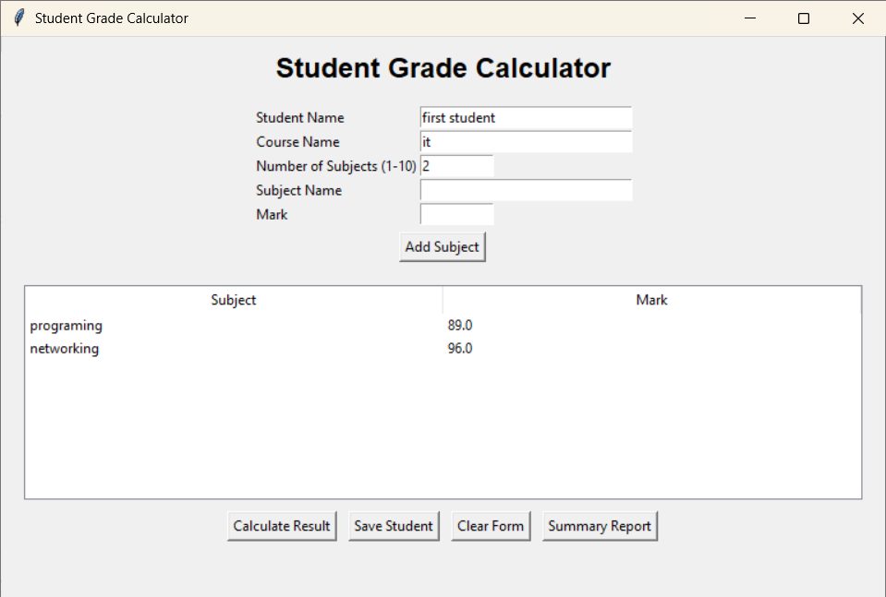
Figure 3: Program Start Screen with Student Data Entry
Screenshot of the welcome screen and initial data entry of student name, course name and subject entry.
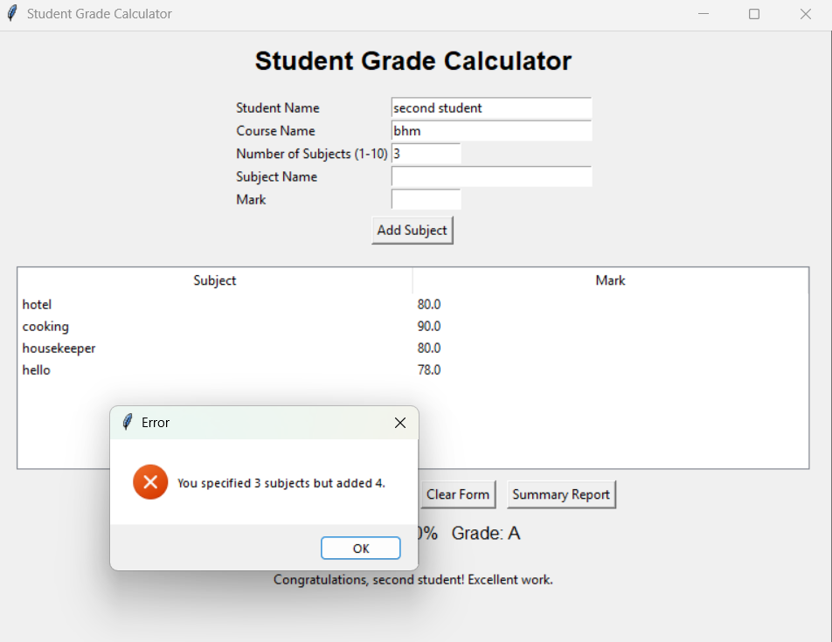
Figure 4: Input Validation
Screenshot demonstrating invalid input handling.
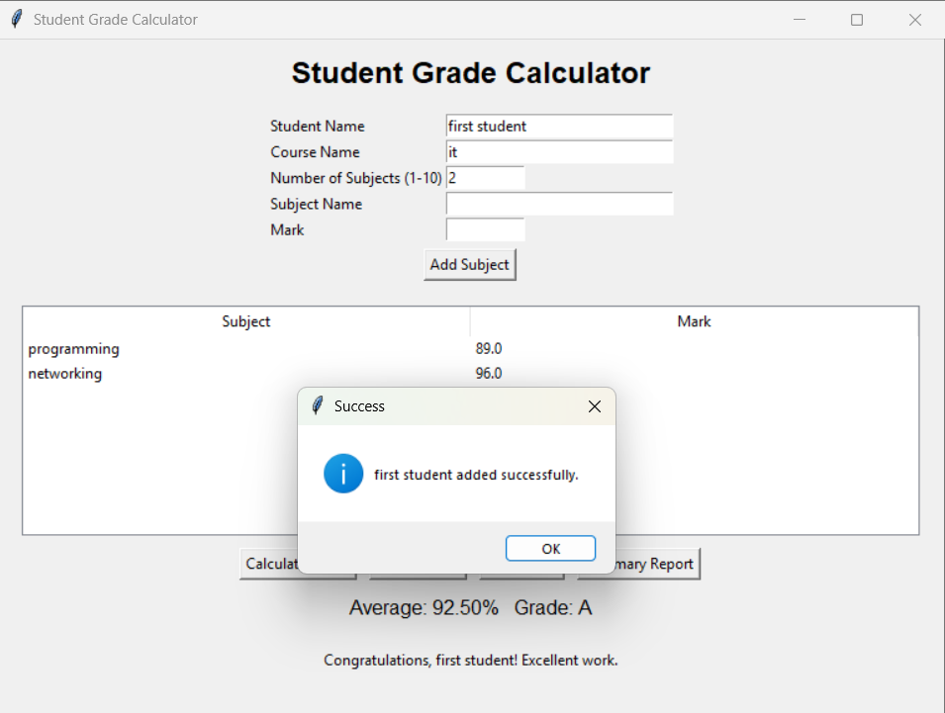
Figure 5: student added successfully
The successfully added to the class that the last static of the student summary have best student and lower grade student.
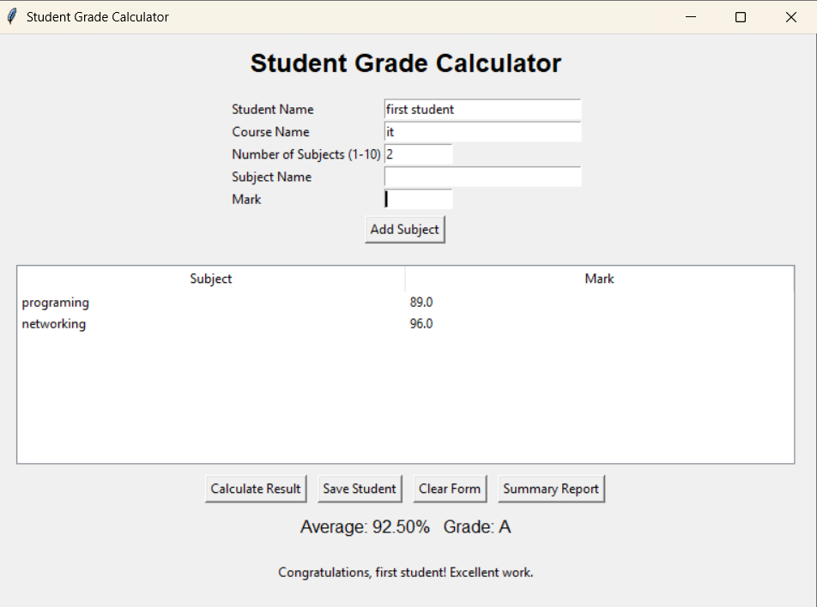
Figure 6: Grade Calculation Output
Screenshot showing calculated average, assigned grade and feedback.
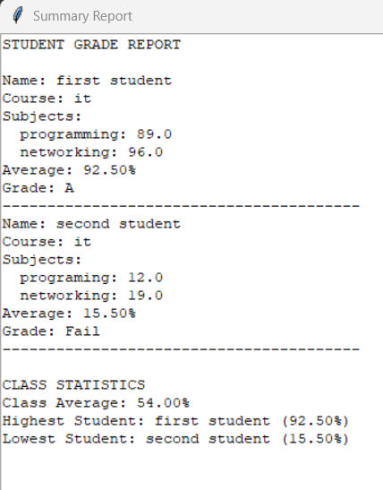
Figure 7: Summary Report
Screenshot displaying the final student grade report and class statistics.

Appendix D – Source Code
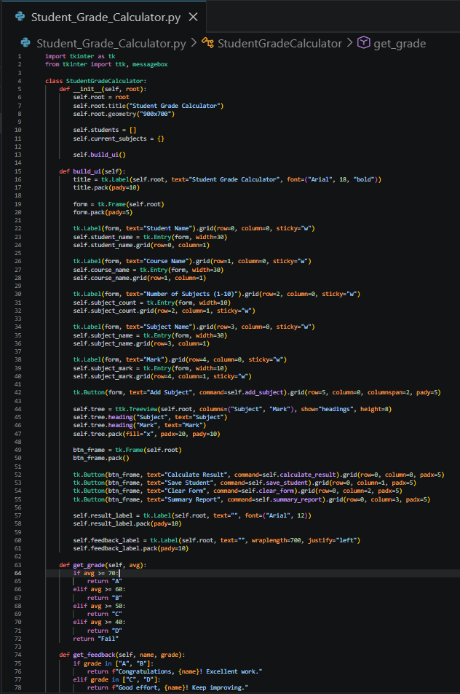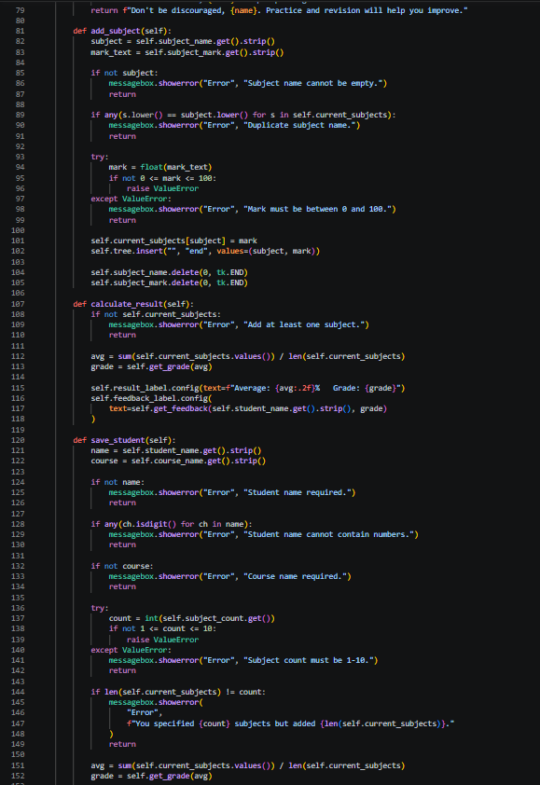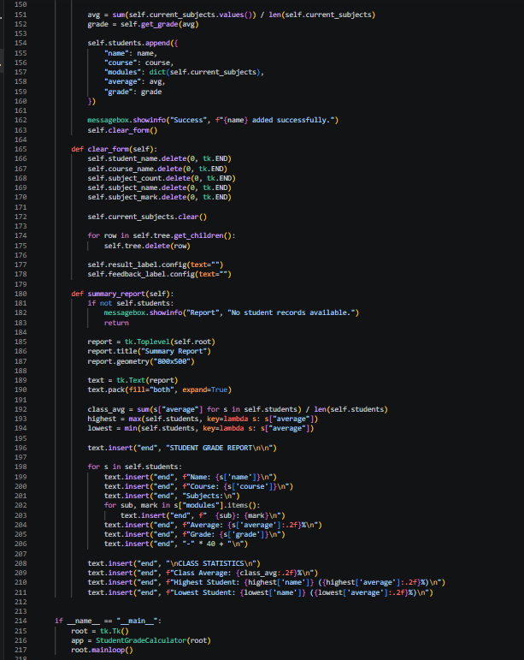
Figure 8: code Stipites

