# Chapter 2- Analysis

Analysis is the practise to study the data and records in detail to understand the new system to solve any problems or enhance or replace the existing system. In other words, analysis is the detailed description of all the features of the inbuilt system. In SDLC (System Development Life Cycle) analysis is the first step to collect the requirements for a particular situation or scenario. Analysis is done in almost every projects.

## 2.1 Analysis Methodology

First step of SDLC is analysis of this project for understanding the situation. The method of performing or executing analysis defined as Analysis Methodology. Analysis Methodology includes Hard Approach, Soft Approach, Combined Methodology, Object Oriented Methodology etc.

For this project Soft System Methodology (SSM) is performed. SSM mainly focus on user requirements. It is a more people focused analysis and recognizes that user interaction as important as technical requirements. Human Activity modelled in this methodology. Stages can be followed when undertaken SSM:

**Rich Picture**

Usually Rich Pictures are drawn by hand and include structures, processes, issues or development. It represents the interaction of the people with the system and how the whole system works.

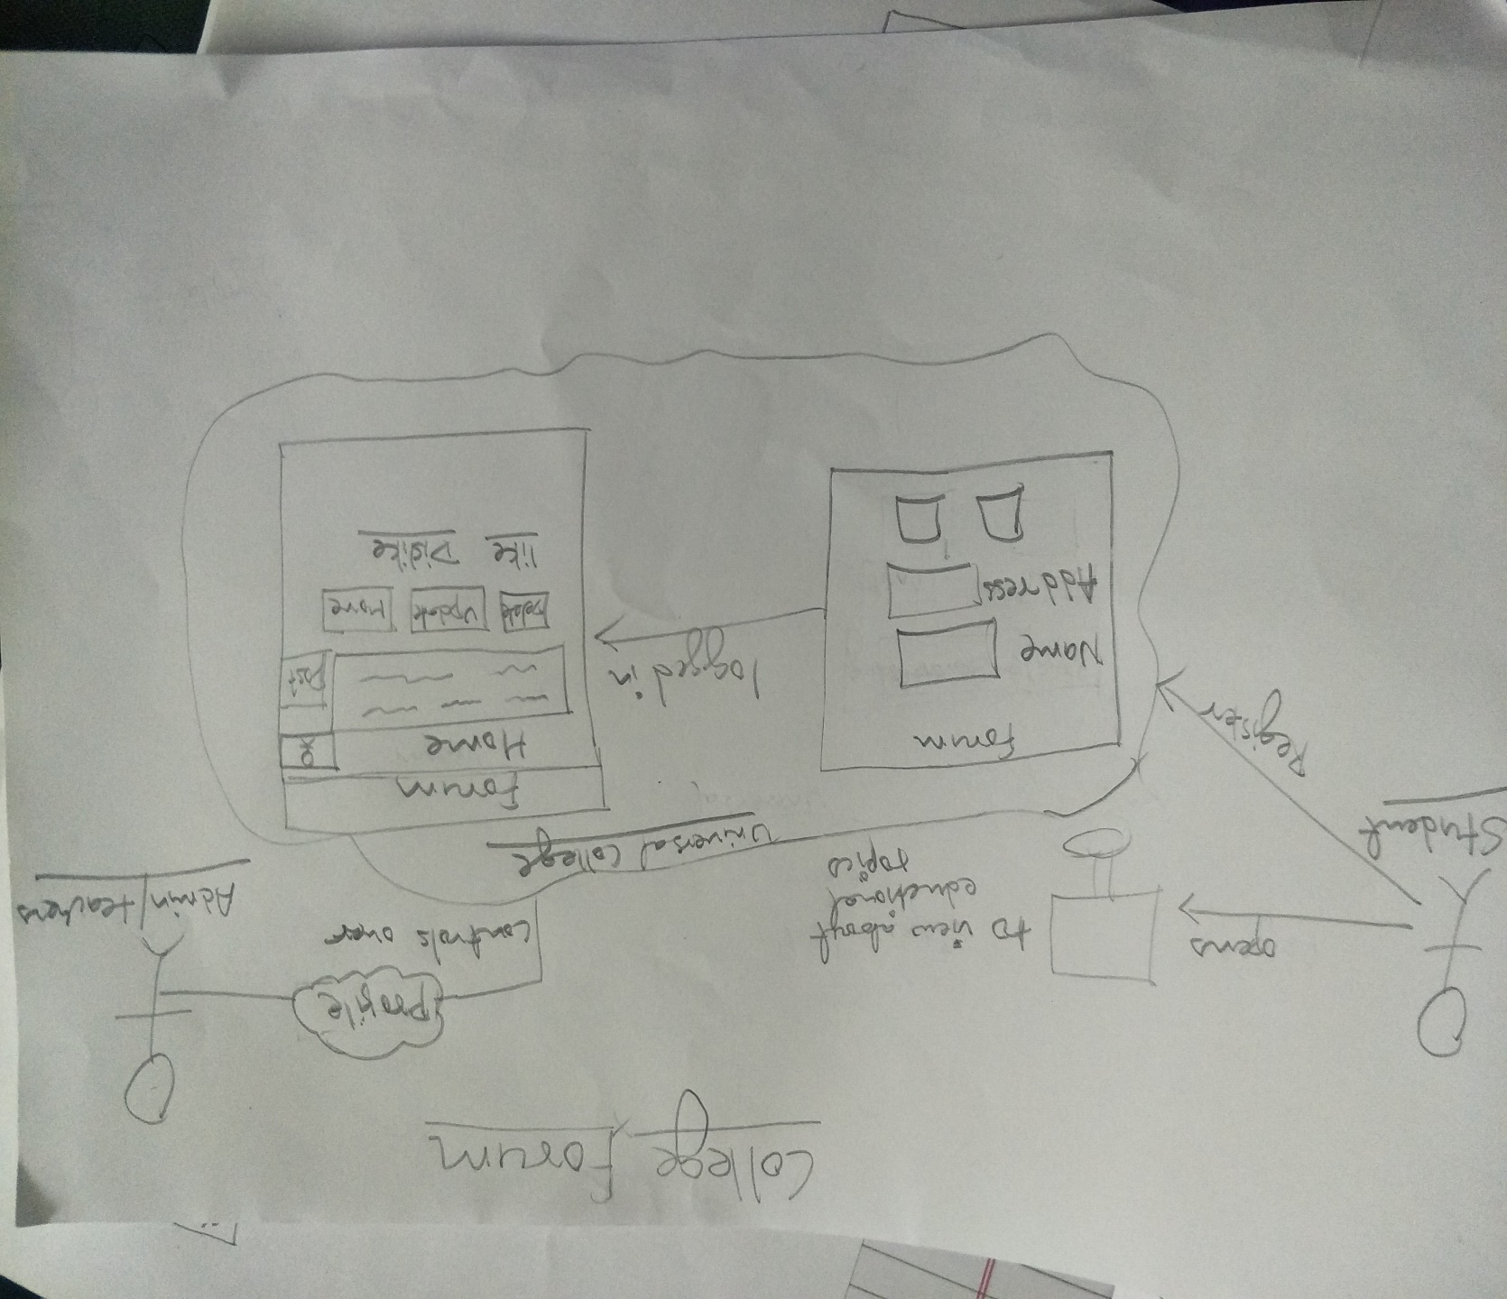

Figure 1: Rich Picture

**Root Definitions**

It is second step of SSM done after the Rich Picture. It clarify the system processes and to find out if there’s any problem. Root Definitions are short word-based statement that define the aims and functions of the system to be developed.

When defining root definitions, the analyst needs to ask the following questions:

**What does the system do? (Aim of the system)**

Aim of our system is to provide an online discussion site where students, teachers and alumni of particular college can hold conversations in the form of posted messages.

**How does the system do it? (Means of achieving the aim)**

Creating platform to discuss on unlimited topics, providing access to students and teachers and Alumni will provide responsibility to maintain the environment.

**Why is it being done? (Longer term aim)**

For the flow of information or any details or notices in student circles.

**Conceptual models**

After rich picture and root definitions, conceptual models compares to identifies the must have of the system and the desirable aspects of the system. It can be used to define how the system should function and what activities are essential for the processed to take place.

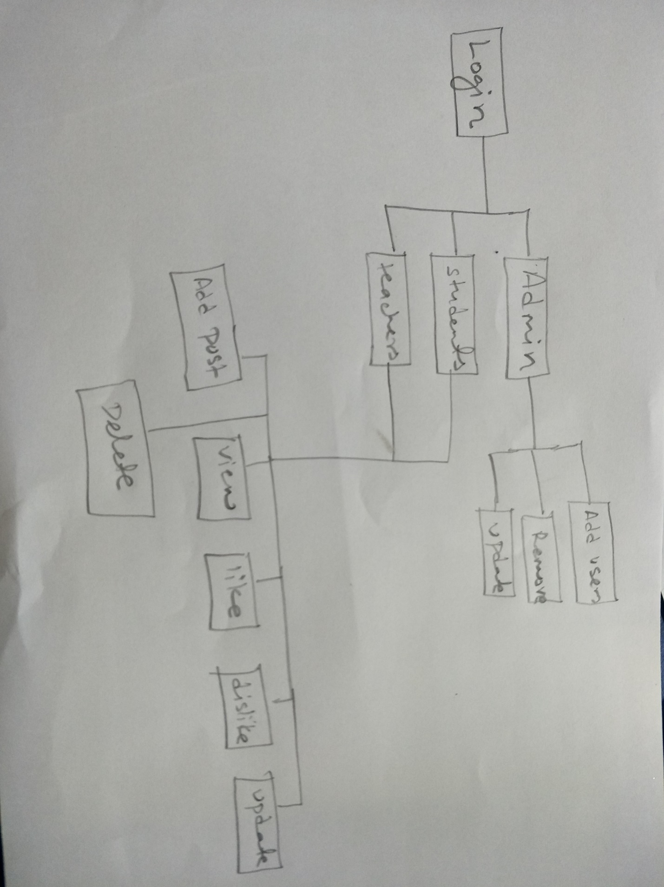

Figure 2: Conceptual Model

## 2.2 Information Gathering Methodology

Information Gathering Methodology is the most essential part of the SDLC for project superiors and in-house stakeholders of a project. Gathering the requirements form the client might be unclear and not proper, they are not sure exactly what they want. So, appropriate needs and requirement are hard to identify and gather.

This information gathering process includes requirements of functional, system, technical from the stakeholders like customers, users, vendors and IT staffs. There are some well-known information gathering practices that are chosen for this project.

**1. Brainstorming**

Brainstorming mainly used to generating ideas from a number of collections of people. Collecting around 10 people who were willingly having interest in this online meeting medium and this will to generate and find out the various ideas. And those listed ideas were prioritized to work on.

**2. Survey**

To examine and record the area and features of so as to build a plan or explanation of something. Its major means of data collection are almost used in each and every project. It can execute via online or with tradition systems alike giving form separately. For this project an online survey was led and send to various people so that we can collect their general views and opinions. The sample for the **College Forum** survey is showed below:-

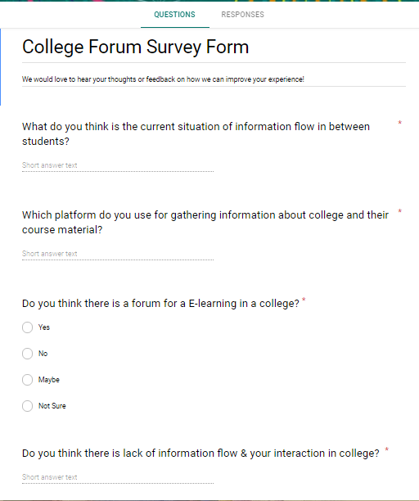

Figure 3: College Forum Survey Google Form

**3. Questionnaire**

In general, Questionnaire is a set of printed or handwritten question with multiple choices of answer for the purpose of gathering information. It is easy and quick practice of data collection. Below represented sample is how questionnaire were directed for this project.

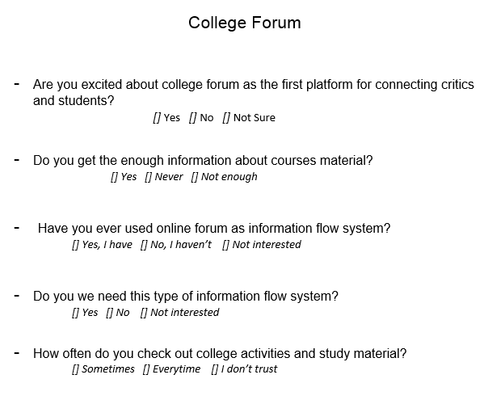

Figure 4: Questionnaire

**4. Observation**

Observation analysis is a field research of both the strength and weakness of market. In another way it can be defined as the study of user’s future potential in their natural state. It means studying people without disturbing their natural behaviors, how they react or they are comfort with a new system? All these things are monitored and collect data.

## 2.3 Feasibility Study

Feasibility Study studies all the related factors of the project to find out the possibility and probability of accomplishing project effectively. It is an analysis to determine if it is financial feasible, is feasible within the estimated cost, socially feasible and other factors. Generally, it concludes the existence of the project or not. Some of the feasibility studies that I’ve done due to its importance are following:

* **Financial Feasibility**

To determine if this project will be viable for an organization, financial feasibility is used. It shows the capability of this project which makes sure the project doesn’t surpass budget limit. For instance, it is an educational project and it assured that this project won’t surpass financial/budget limits as there’s no budget limits are executed in it.

* **Technical Feasibility**

Studying the technical feasibility of this project its hardware and software are compatible, programming language are open source and for database and domain it cost an affordable price. So, studying of project in terms of it hardware and software, it is effective and adequate to support the system.

* **Legal feasibility**

It is the study to know if the undertaken project is viable and doesn’t violate any legal terms and condition of the state during and after implementing the project. The project ensures the legal doable and it is conducted in a way that doesn’t harm any ethnic group and it esteems the laws and regulation of the country. And the study of project it concludes that it is viable and doesn’t oppose to the laws of country.

* **Social Feasibility**

The lunched product is acceptable to the people, in society or how it effects on users considered as social feasibility. After studying does the new product impact positively or negatively in any culture, ethnic group etc. concludes there’s not anything that would impact negatively into peoples or any group.

* **Time Feasibility**

It studies an appropriate scheduling and time allocation of the project so that it completion on time. As there’s previously determined milestone/scheduling during the proposal, there was an acceptable time for the completion of this project and allocated time and schedule wouldn’t act any obstacle.

Lastly, it is concluded that there’s no major barrier during implementing the project.

## 2.4 Software Requirement Specification (SRS)

A software requirements specification (SRS) is a full description of a system to be developed. It detailed of system’s functional and non-functional requirements. Usually it shows how a software system run and function and the features and behavior of a software or system.

I will be preforming the below listed tasks:

### 2.4.1 Functional Requirement

Functional requirements defines what the system is supposed to achieve and accomplish that it may involves technical details, calculations, data manipulation and other specific functionality of the project. All the functional requirements are listed below:

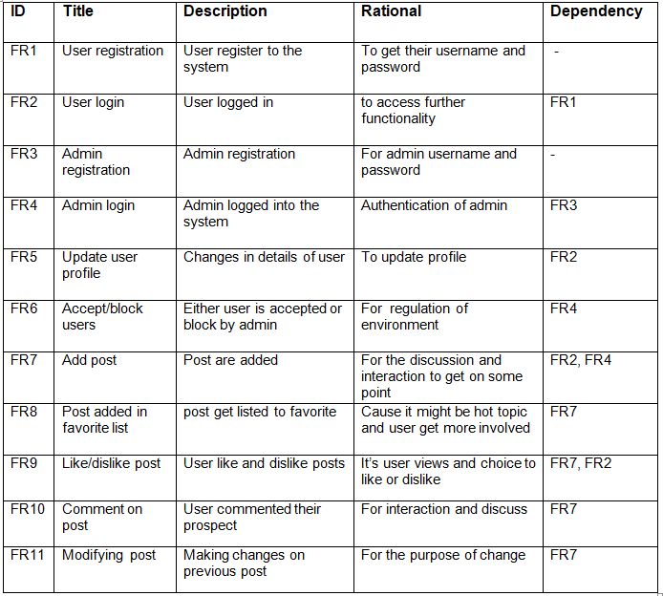

### 2.4.2 Non-functional Requirement

A non-functional requirement relates with how the system works and performs rather then what the system will do. It groups into usability, reliability, performance and supportability. All the non-functionally requirements are listed below:

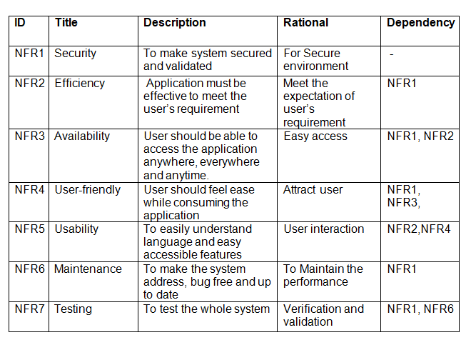

### 2.4.3 MoSCow

The arrangement of the task according to their value and importance defines prioritization. MoSCow prioritization is used to determine the task according to their importance. It is divided task or the features into **Must Have, Should Have, Could Have** and **Won’t Have**. Here is the MoSCow prioritization task:

|  |  |  |
| --- | --- | --- |
| **ID** | **Functional** | **MoSCoW** |
| FR1 | User registration | Must have |
| FR2 | User login | Must have |
| FR3 | Admin registration | Must have |
| FR4 | Admin login | Must have |
| FR5 | Update user profile | Should have |
| FR6 | Accept/block users | Should have |
| FR7 | Add post | Must have |
| FR8 | Post added in favorite list | Could have |
| FR9 | Like/dislike post | Should have |
| FR10 | Comment on post | Must have |
| FR11 | Modifying post | Should have |
| **Non Functional** | | |
| NFR1 | Security | Must have |
| NFR2 | Efficiency | Must have |
| NFR3 | Availability | Must have |
| NFR4 | User-friendly | Should have |
| NFR5 | Usability | Could have |
| NFR6 | Maintenance | Should have |
| NFR7 | Testing | Should have |

### 2.4.4 Hardware and software Requirement

To run efficiently, all the application required certain hardware components and software resources should available on a single computer. The minimum requirements of hardware and software are listed:

|  |  |
| --- | --- |
| **Hardware Specification** | **Software Specification** |
| RAM: Minimum 1 GB | OS: Windows/MAC OS/IOS/Linux/Android |
| Storage: Minimum 1 GB | Browser: Chrome, Safari, Mozilla, Opera, MS Edge |
| Processor: 1.5 GHz x86 based CPU(Intel i3 or equivalent) |

## 2.5 Use Case Diagram

Use Case diagram allows representing the broad interactions between parts of a system. Use Case diagram consists of the following elements:

* System
* Actor
* Use Case

The use case for the system is shown below:-

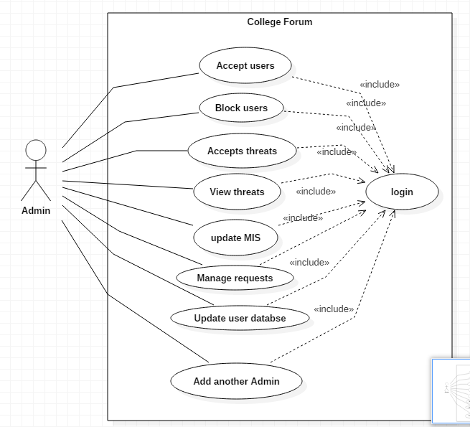

Figure 5: Use Case diagram of admin

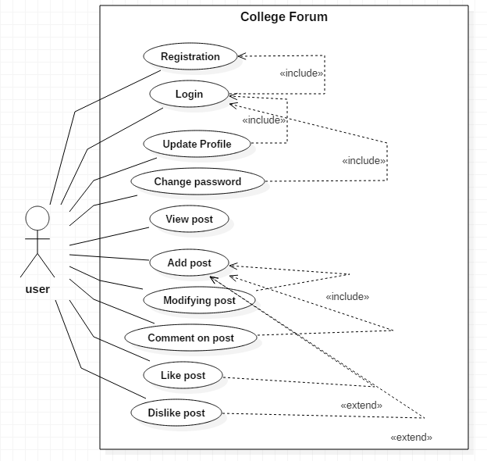

Figure 6: Use Case diagram of user

### 2.5.1 Natural Language Analysis

Natural Language Analysis (NLA) used to identify the possible classes. It is the process of listing out the actual classes and methods. NLA include steps for filtration of nouns as possible classes and verbs as methods.

**Scenario:**

Universal College is private educational institution located in shantinagar, Kathmandu and founded in 1999. Their ambition is to provide the best education in the field of Management, Humanities and Information Technology.

But what the problem is their increasing students affect the lack of information flow and causes mix-up and confusion on them. So the College is looking for online forums discussion group. And that should provide a common area for students, teachers, alumni to come together and discuss unlimited topics, including social activities and educational ideas

It should allow participants to create new threads under different categories and post them on timeline. Registered users and admin are allowed to comment on post, like or dislike that post. And admin have authority to accept or block the users. The most likes post can be added in favorite list. Registered users have their own profile and can view their personal details, have the access to change their password and update their profile.

To create friendly environment, bad comment on post are blocked by admin and not on view on timeline. The System used for managing all thread/post, replies and like from users with proper well-structured flow.

Followings are the Candidate class for the project which is extract from the scenario:

|  |  |  |
| --- | --- | --- |
| **Nouns as(Candidate Class)** | **Adjectives as (Attributes of class)** | **Verbs as (Methods/operation)** |
| Users, teachers, admin, topics, article, member, comment | Name, address, email, phone number, Gender, batch, faculty | Update, Add, Delete, Comment |

### 2.5.2 Initial Class Diagram

In the UML, a class diagram is an illustration of the source code and relationships dependencies among the classes. Candidate classes and attributes serve as the first step towards an accurate representation of a system. The class diagram gives a static view of the system.

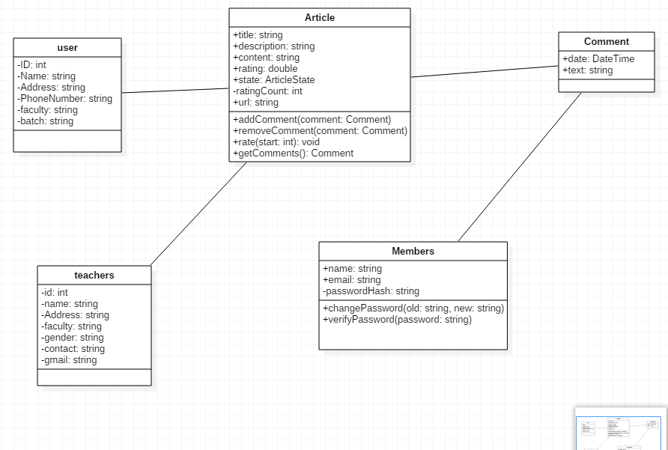

Figure 7: Initial Class Diagram

## 2.6 System Architecture

**System architecture** is the conceptual model that defines the structure, behavior, and more views of a **system**. There are 3 types of system architecture i.e. **One Tier Architecture, Two Tier Architecture** and **Three Tier Architecture.** Basically, for this project we will be using Three Tier Architecture, it is AKA web based application divided into three parts i.e.

* Presentation Layer: The User Interface parts for the user are designed here. The project contents are directing to the browser.
* Application Layer: It uses an application server and processes the business logic for the application. The project processes the dynamic content and interaction between the presentation and database layer.
* Database Layer: The project understands the requirement of system, choose the database tier, design database and building it.

Client computer holds Presentation layer, Application server holds Application layer and Database Server holds Database layer. So, this is how the system works. And the following figure helps to visualize the architecture of system:

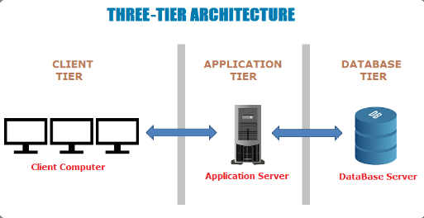

Figure 7: System Architecture