# Chapter 1- INTRODUCTION

### Introduction to the system

‘College Forum with Alumni’ is a web based application for colleague’s discussion in particular topics and E-learning. College Forum is online discussion group. It provide a common area for students, teachers, alumni to come together and discuss unlimited topics, including social activities and educational ideas. This system i.e. College Forum helps in managing all the post, comments, replies and like from users in proper well-structured flow.

### Justification for the project

#### Background of project

The project ‘College Forum with Alumni’ is a new concept in organization field. So, it is highly profitable and has great future scope. I will include various features unique to my own and also implement many features of other websites to make it a step ahead. The great advantages of e-learning is the flexibility it affords to all participants.

And another benefits of this projects is we don’t need to go through the person for interaction which this helps to communicate and reduces the time. It begin to grow in their understandings of course material and individual contributions to the knowledge construction process.

#### Problem Statement

In many colleague’s, what most of the students faces was lack of interaction in college. Students are not aware of their course material and understandings of it. And they might face problem to raise questions due to because of nervousness or reserve people. Mainly, there’s no person communication between students and teachers to flow the information or any details and notices. So, this are the reason behind this project.

For an interactive environment between them, this will feasible and effective to flow the information. My project will take advantage of this to make profit.

### Overview of the propose system

Lastly, I have introduced what is ‘College Forum with Alumni’ project and what we’ll be doing for more effective and beneficial. Stating its background and problem this project will include various features to demand to the users. It will be as user friendly as possible and will provide feature such as search and subscription.

# Chapter 2- SCOPE

### Aims of the Project

* Online College Forum aims to provide interactive web based platform to discuss unlimited topics including social activities and educational ideas.
* An online discussion site where students, teachers and alumni of particular college can hold conversations in the form of posted messages.

### 2.2 Objectives

To succeed our goal and to achieve the quality product, we will be involving following tasks in our project:

* Analysis the requirements then design the functional application as the requirements.
* To engage users UI of application will be user friendly and proper design reduces the chance of distraction and unwillingness.
* Access web application for students, teachers and alumni.
* To maintain co-operative environment an Alumni will provide responsibility.
* Provide detail documentation of system working and user booklet.

### 2.3 Features to be included

This project will have the following features in it:

* It allows participants to create new posts under different categories and post them on Timeline.
* Register users and Admin can comment, like/dislike the post.
* User can view their profile and will have access to their password.
* Voting and Reddit system.
* Admin have authority to accept and block users, filtering abusive words – block and not viewable.

### Limitation

Every project has its limitation, some of the other problems are:

1. Without internet service use won’t be able to access the website and therefore it limiting the users.
2. It requires high internet speed for better results and many customers might lack it.
3. Due to connection failure causes the upload and download of large files and needs to be started from start. This takes a lot of time.
4. Due to personality Differences, reviews for this concept might not be accurate and can create misunderstanding.

### 2.5 Overview of the scope

The project called ‘College Forum with Alumni’ is to create interactive environment between the colleague’s students and teachers for the discussion on particular topics. It is also feasible for E-learning, can support learning that is not always tutor/teacher-centered, your role will be important. We have work on features for better UI and our aim is to improve on the limitation periodically and maximize the benefits.

# Chapter 3- Development Methodology

### 3.1 Methodology to be used

For this project, Waterfall Model has been practiced. It has its various steps and is an arrangement type. Each step should be completed before using the next one. Each step has its own importance and are essential for the development of the software.

First steps consist of collection of all the requirements. In 2nd step those analysis are used to design a system. The third step includes implementing which means creating the system and its following step involves testing of product. After that product is deployed. Future upgrade and maintenance are includes as final step of waterfall model. The steps are shows in the below figure:

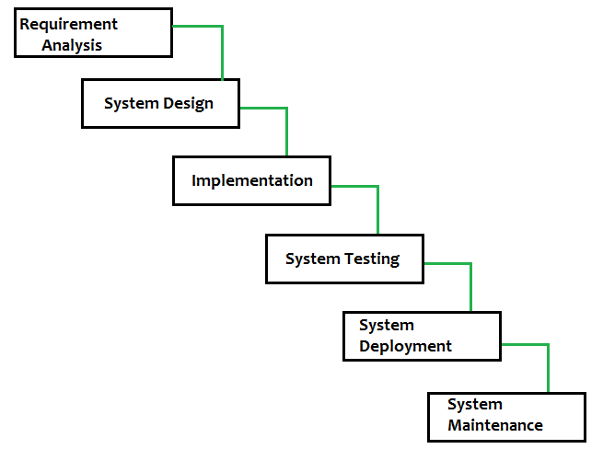

Figure 1: Waterfall model

### 3.2 Design Pattern

**Model View Controller (MVC)** design pattern will be applied in this project. It is very effective design pattern that it uses widely in software development process nowadays. It can used for both web and desktop-based languages uses MVC design pattern.

**Model:** It is in control for data and datatype which are operated on the controller.

**Controller:** The data are operated using CRUD function and delivered output.

**View:** Users acknowledged with the operated data.

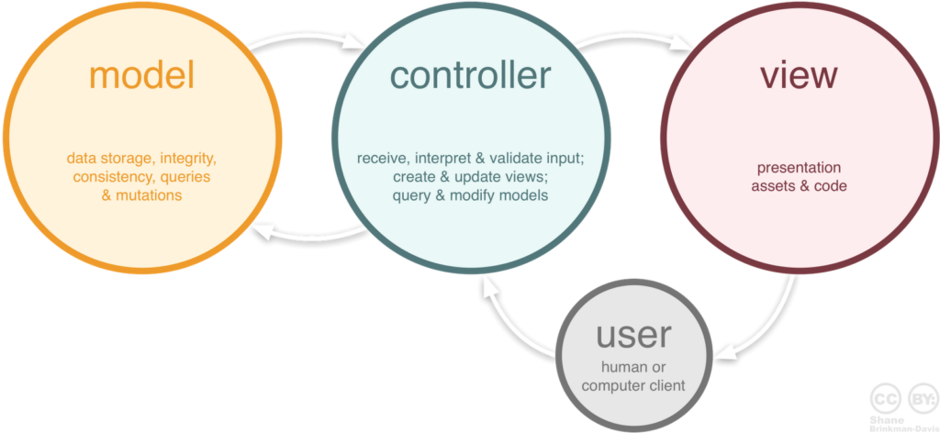

Figure 2: Design Pattern

### 3.3 System Architecture

A **system architecture** is the conceptual model that defines the structure, behavior, and more views of a **system**. There are 3 types of system architecture i.e. **One Tier Architecture, Two Tier Architecture** and **Three Tier Architecture.** Basically, for this project we will be using Three Tier Architecture, it is AKA web based application divided into three parts i.e.

* Presentation Layer
* Application Layer
* Database Layer

Client system holds Presentation layer, Application server holds Application layer and Server system holds Database layer. So, this is how the system works. And the following figure helps to visualize the architecture of system:

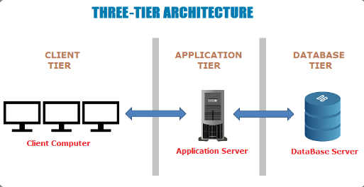

Figure 3: System Architecture

# Chapter 4- SCEHDULING

### 4.1 Work Breakdown Structure (WBS)

A work breakdown structure is a key project deliverable that organizes the team's work into manageable sections. Here is the process how the work break down into manageable sections.

Proposal

Deployment

Testing

Design

Coding

Final Document

Analysis

Unit testing

Interface Design

Aims, features and limitation analysis

Install

Final Description

System Creation

Requirement analysis

Configure

Whitebox testing

Structure Design

Interface Analysis

Development Methodology

Database Formation

Black box testing

Work Breakdown Structure

Testing

Database Design

Class Diagram

Validation Testing

Make changes

Response Design

Risk Management

Activity Diagram

Submission

Figure 4: Work Break Structure

### 4.2 Milestone

|  |  |  |
| --- | --- | --- |
| **Milestones** | **No. of Days** | **Date** |
| **Proposal**  Aims, features and limitation Analysis  Development Methodology  Work Break Down Structure  Risk Management  Submission | **16** 4  3 4 4  1 | **June 16th - July 1th, 2019**  June 16th – June 19th, 2019  June 20th – June 22st, 2019 June 23nd – June 26th, 2019 June 27th – June 30th, 2019  July 1st, 2019 |
| **Analysis**  Requirement Analysis Interface Analysis Class Diagram Activity Diagram | **28** 7  7  7  7 | **July 2nd – July 29th, 2019** July 2nd – July 8th, 2019 July 9th – July 15th, 2019 July 16th – July 22th, 2019 July 23st – July 29th, 2019 |
| **Design**  Interface Design Structure Design  Database Design Response Design | **31**  87  8  8 | **July 30th – August 29th , 2019** July 30th – August 6th, 2019 August 7th – August 13th, 2019 August 14th – August 21th, 2019 August 22th – August 29th, 2019 |
| **Coding**  System Creation  Database Formation | **22**  12  10 | **August 30th – September 20th,2019**  August 30th- September 10th,2019  September 11th- September 20th,2019 |
| **Testing** Unit Testing White Box Testing Black Box Testing Validation Testing | **10** 2 3 4 1 | **September 21st – September 30th, 2019** September 21st - September 22nd, 2019 September 23th – September 25tth, 2019 September 26th – September 29th, 2019 September 30th, 2019 |
| **Deployment** Install Configure  Testing  Make Changes | **9**  1  1  2  5 | **October 1st - October 9th, 2019** October 1st, 2019 October 2nd, 2019  October 3rd – October 4th,2019  October 5th- October 9th,2019 |
| **Final Documentation** Final description | **3** 3 | **October 10th – October 12th, 2019** October 10th – October 12th, 2019 |
| **Total Days** | **119** |  |

**Allocation Description of WBS**

**Proposal:**

For the plan and preparation of the project, it has been allocated 16 days. And those 16 days are divided into 5 sub parts. For Aims, features and limitation analysis, 4 days has been allocated. 3 days for Deployment Methodology and each 4 days for Work Break down Structure (WBS) and Risk Management. And last 1 day for Submission of Proposal.

**Analysis:**

To Analysis the proper requirement, it has been allocated 28 days. Those 28 days are divided into 4 sub parts and each 7 days are allocated for Requirement Analysis, Interface Analysis, Class Diagram and Activity Diagram.

**Design:**

To design the whole project, it has been allocated 31 days. And those for Interface Design, Structure Design, Database Design and Response Design. Each 8 days for Interface Design, Database Design and Response Design and 7 days for Structure Design.

**Coding:**

For coding, 22 days has allocated. System Creation and Database Formation plays role in this part and 12 days for system creation and 10 days for Database Formation. Both the database and system are important, if one is not done correctly it might affect the other in formation of the platform.

**Testing:**

To verify and validate the production, 10 days has allocated. Here we will be doing Unit Testing, White Box Testing, Black Box Testing and Validation Testing.

**Deployment:**

It plays another vital role in the success of product, so 9 days has been allocated for Deployment of product. And we’ll doing Installation, Configuration, Testing and then Changes in the product if it is needed.

**Final Documentation:**

It is the final phase of the whole project. Documentation of each and every activities like analysis, design, coding, testing and deployment of the project. And 3 days has been allocated for the description of all this and for better user interaction for future use of it.

### 4.3 Gann chart

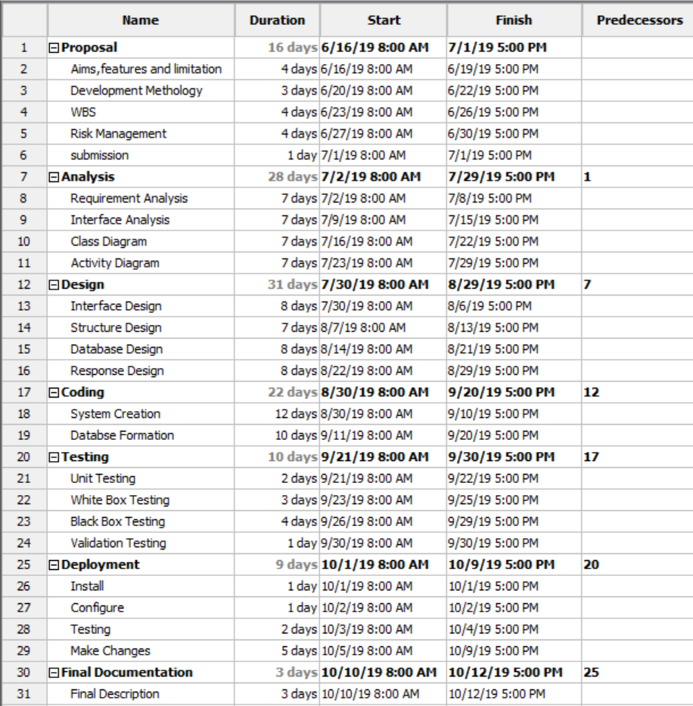

Figure 5: Time Estimation

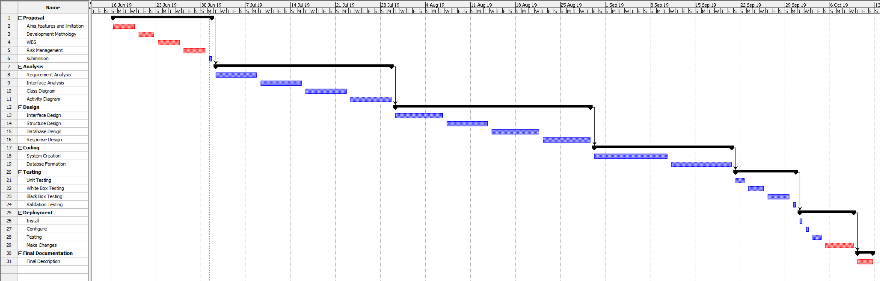

Figure 6: Gann Chart

# Chapter 5- Risk Management

Risk Management is identify of risk, analyze and evolution of the risk and finally prioritize and monitor the risk to control and avoid their possibility impact. It helps to specify the task. For prioritization and identify the risk below table helps in risk likelihood and consequence:

Below is a table for Risk likelihood

|  |  |
| --- | --- |
| **Likelihood** | **Value** |
| Low | 1 |
| Medium | 2 |
| High | 3 |

Below is a table for Risk Consequence

|  |  |
| --- | --- |
| **Consequence** | **Value** |
| Low | 1 |
| Very Low | 2 |
| Medium | 3 |
| High | 4 |
| Very High | 5 |

This table determine the Impact by mentioning to how much likelihood an event might occur and its consequence. Below using a table Impact is determined.  
**Impact = Likelihood * Consequence**

|  |  |  |  |  |  |
| --- | --- | --- | --- | --- | --- |
| **No.** | **Event** | **Likelihood** | **Consequence** | **Impact** | **Solution** |
| 1 | System Crash | 2 | 4 | 8 | Keep periodic backup of complete system and delicate data and resources.  Provide uniformly power supply to server, hardware and end devices. |
| 2 | User Criteria not fulfilled | 1 | 5 | 5 | Proper requirement analysis should be done |
| 3 | Bad allocation of time and effort | 1 | 3 | 3 | Time should be allocated with respect to tasks |
| 4 | Lack of user friendliness | 2 | 3 | 6 | Design should be done with user in mind |
| 5 | Malware/ Virus | 2 | 5 | 10 | Antivirus and other related software should installed and daily backup of the system and upgraded the software weekly. |
| 6 | Phishing | 3 | 5 | 15 | Developer should be trained to handle all situations  Well managed of all the **patches** to fix, update and removing programs. |

# Chapter 6- Configuration Management

Configuration Management is an authority and scheme manufacturing process for ensuring the regularity physical and logical sensitive resources in a working location or environment. It helps in categorization of detailing functional abilities, specific configuration objects and dependences.

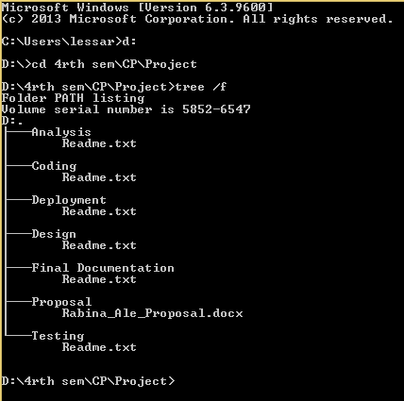

Figure 8: Physical Project Structure

# Chapter 7- Conclusion

This project focus on creating an environment between the students and teachers to discuss on particular topics including educational ideas and social activities through a website. This also focus on friendly environment with the navigation system so, that it makes them easy to use and navigate. Other features like search bar, Reddit, feedback system for user interaction also included.We will be working on better UI and features for successfully development of this project.

# Chapter 8- Reference and bibliography

* Bagyatech.com. (2019). *Waterfall Model -*. [online] Available at: http://www.bagyatech.com/waterfall-model/ [Accessed 30 Jun. 2019].
* Software Testing Material. (2019). *Software Architecture: One-Tier, Two-Tier, Three Tier, N Tier*. [online] Available at: https://www.softwaretestingmaterial.com/software-architecture/ [Accessed 30 Jun. 2019].
* MundoInterativo. (2019). *A break in Laravel to understanding MVC architecture - MundoInterativo*. [online] Available at: http://www.mundointerativo.com/2017/09/08/how-learn-mvc-architecture-design-patterns/ [Accessed 30 Jun. 2019].
* En.wikipedia.org. (2019). *Risk management*. [online] Available at: https://en.wikipedia.org/wiki/Risk_management [Accessed 1 Jul. 2019].

### 