Predicting Residential Electricity Consumption Using CNN-BiLSTM-SA Neural Networks
Increasing population required more electricity consumption and electricity organization has to produce sufficient electricity which must satisfy all customers’ requirements. To produce ample energy organization must have accurate tool which can forecast required energy. So author of this paper employing combination of multiple algorithms which is forecasting electricity consumption with an R2score (accuracy) of over 97%. In propose paper for accurate forecasting author selecting features which are not highly co-related by employing features selection algorithm called ‘Maximal Information Coefficient’ (MIC). This algorithm will calculate Spearman Rank for each features and then select only those features whose score is not high. High score means features are highly co-related to each other which must be avoided.
In propose paper author combining Convolution Neural Network (CNN), Bidirectional Long Short Term Memory (BILSTM) and Self Attention (SA). CNN will be used to integrate temporal feature extraction from input training features, BILSTM will capture correlated features and then intrinsic feature analysis using SA mechanisms which will enhancing predictive accuracy.
Details of CNN, BILSTM and SA concept you can read from base paper. In propose paper author has trained models for 1 minute, 1 hour and 1 day but it’s difficult to implement all this models so we have created propose algorithm to forecast electricity consumption for 1 day.
Propose CNN-BILSTM-SA algorithm performance is evaluated in terms of R2score, RMSE (root mean square error), and MAE (mean absolute error). RMSE and MAE refers to difference between original and predicted values so the lower the difference the better is the algorithm. R2score refers to accuracy for forecasting algorithm whose values between 0 and 1. R2score closer to 1 will be consider as best model. Propose algorithm is compare with many existing algorithms such as Linear Regression, SVM, LSTM and many more.
To implement this project author has used Electricity Consumption dataset from UCI repository which can be download from below URL
https://archive.ics.uci.edu/dataset/235/individual+household+electric+power+consumption
in below screen showing dataset details
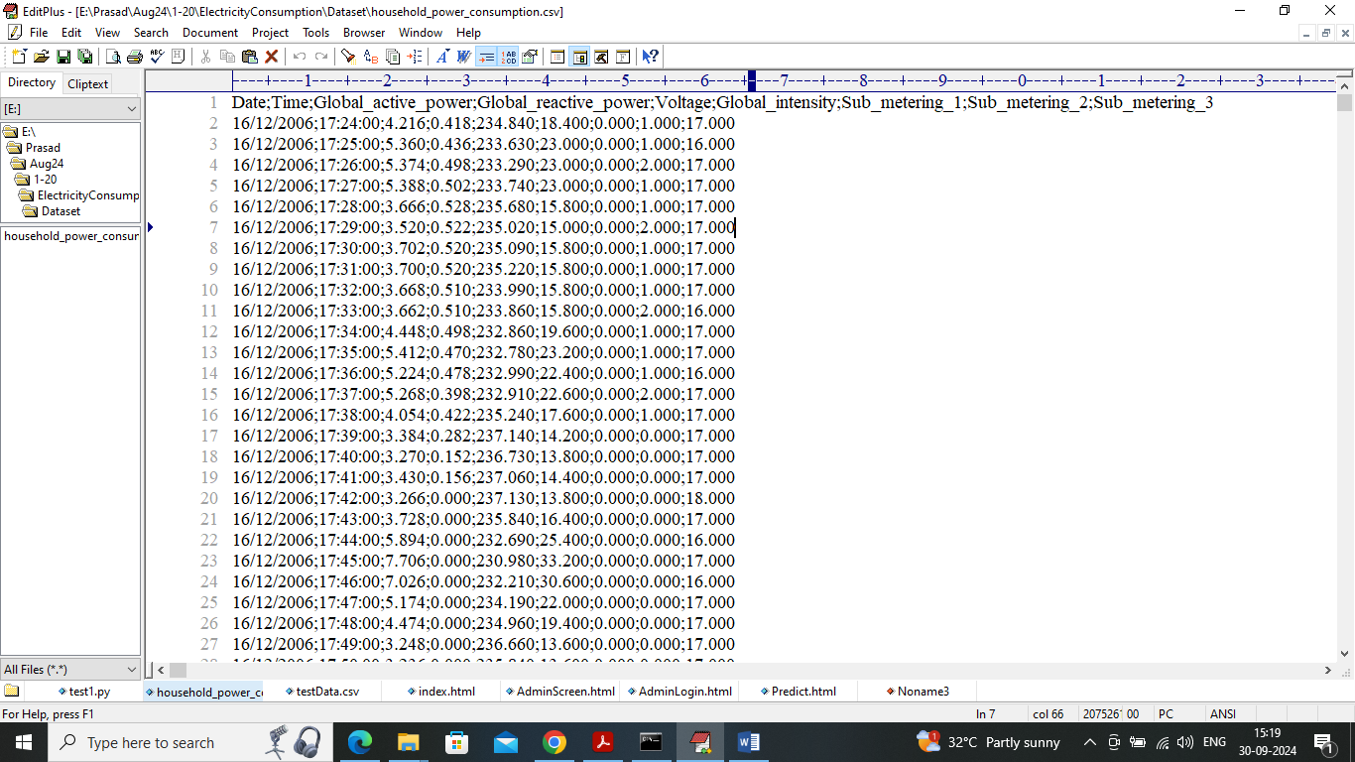
In above dataset screen first row contains dataset column names and remaining rows contains dataset values and each row has 3 electricity consumption values such as ‘Sub-meter1, submeter2 and sub-meter3’ where meter1 refers to consumption of ‘Water heater, dish washer’ and meter 2 consumption refers to ‘washing machine and other equipment’s’. You can red paper to know about different equipment’s using different meter consumption. In above dataset we are summing all 3 sub-meters values as target electricity consumption. So by using above dataset we are evaluating performance of propose and existing algorithms
Extension Concept
In propose paper author has used BILSTM which is mainly used to process sequence of data and this algorithm having extra processing layers which will reduce processing speed and affect accuracy. To overcome from this issue we have used BIGRU which also works on sequence of data with minimum layers so accuracy and processing speed can be enhanced. A Gated Recurrent Unit (GRU) is a type of recurrent neural network (RNN) that enhances the speed performance of LSTM networks by simplifying the structure with only two gates: the update gate and the reset gate. It is used when speed and prediction accuracy is crucial in processing large amounts of data.
SCREEN SHOTS
We have coded this project using JUPYTER notebook and below are the code and output screens with blue colour comments
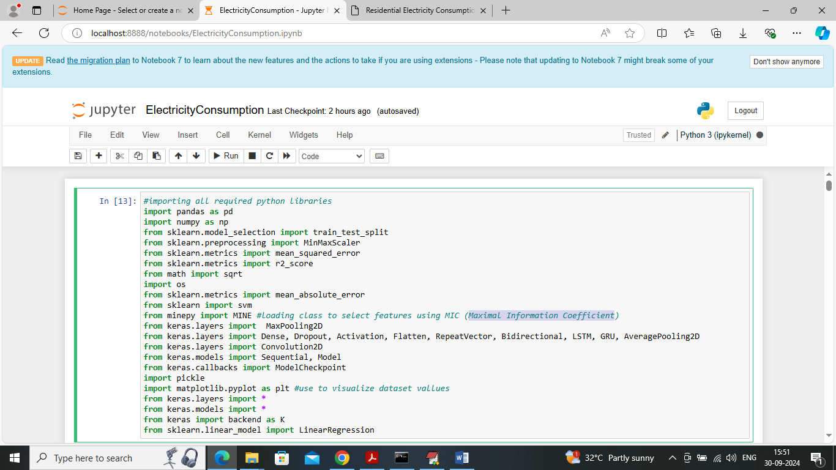
In above screen importing required python classes and packages
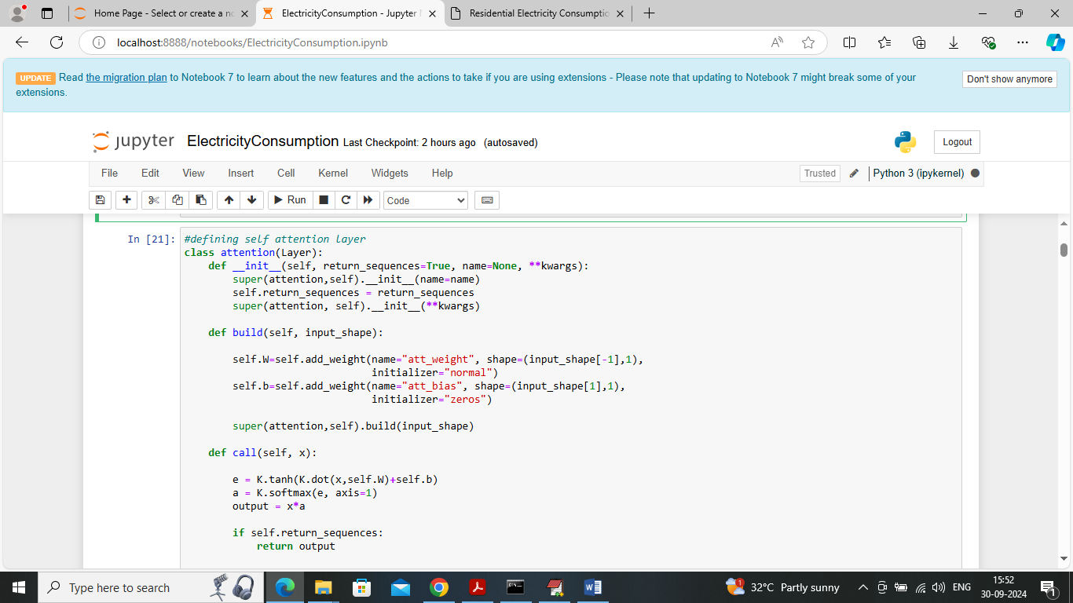
In above screen defining Attention class layer which will analyse features and then assigned weight to each features based on importance
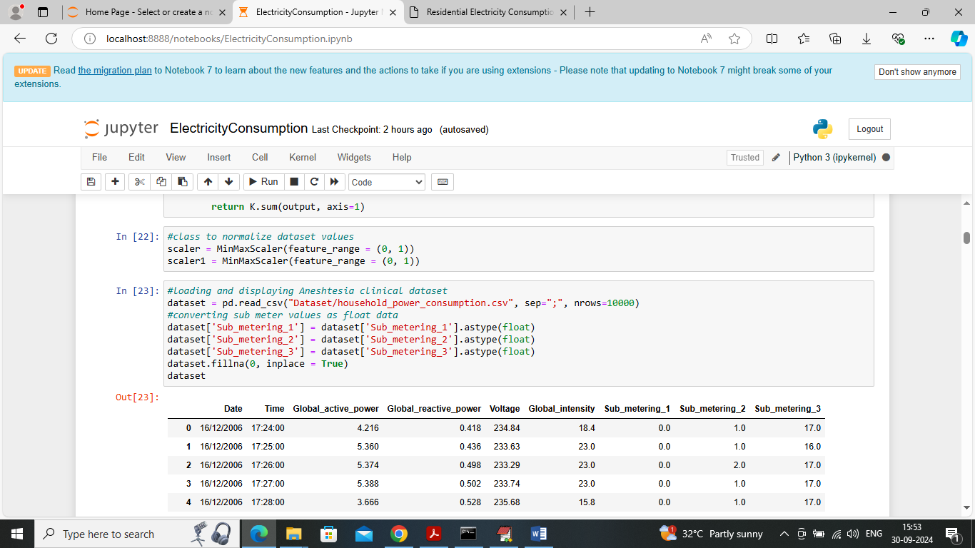
In above screen loading and displaying dataset values
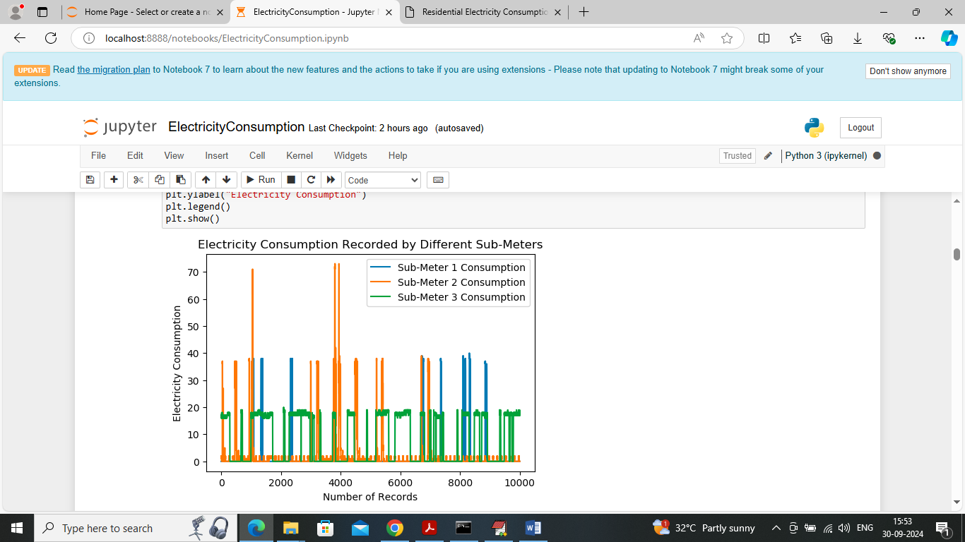
In above graph visualizing electricity consumption for different sub-meters where x-axis represents number of records and y-axis represents electricity consumption and each line represents electricity consumption for different meters
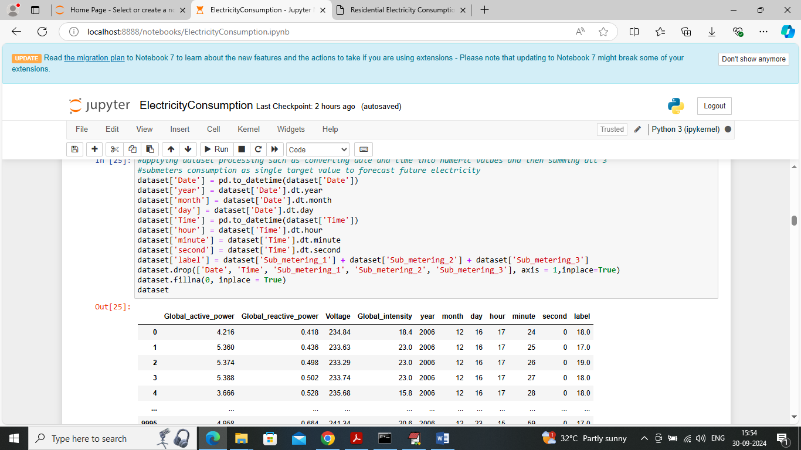
In above screen applying processing techniques to convert date and time to numeric values and then displaying converted and clean dataset
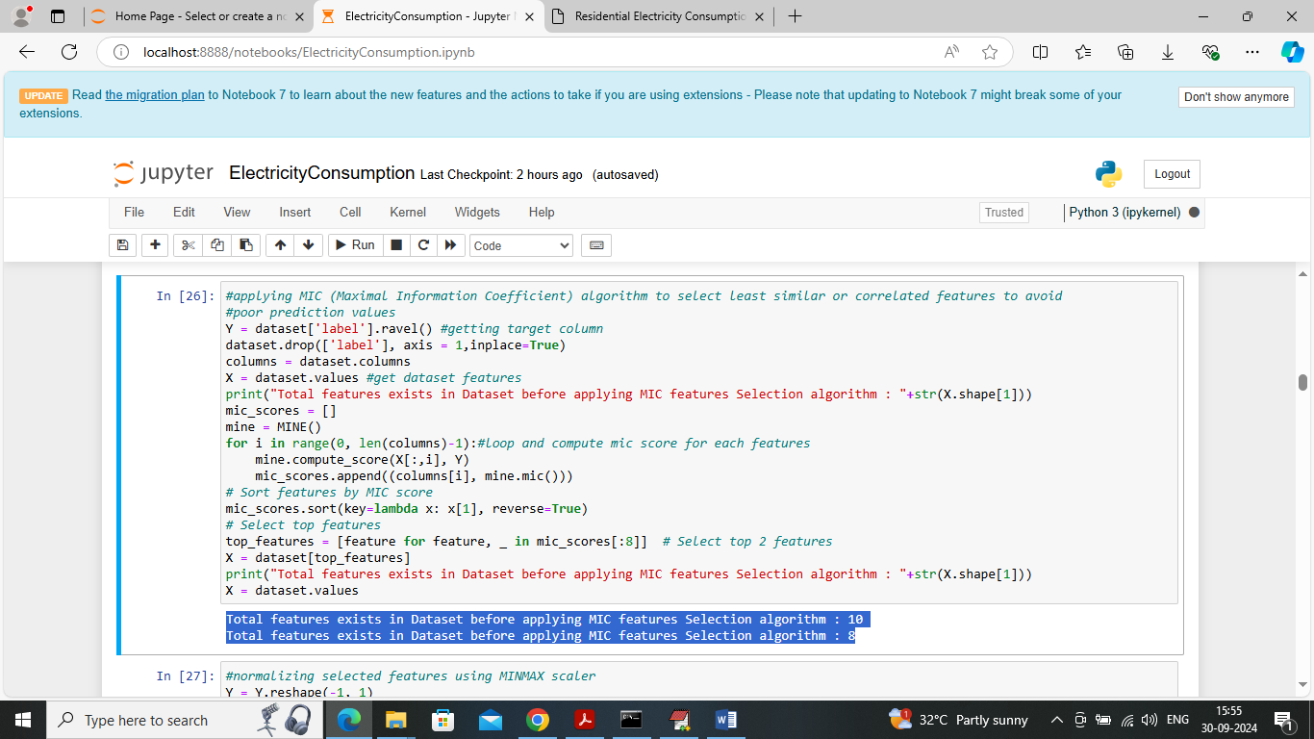
In above screen applying MIC (Maximal Information Coefficient) algorithm to select features and before applying MIC dataset having 10 features and after applying MIC then algorithm select top 8 features
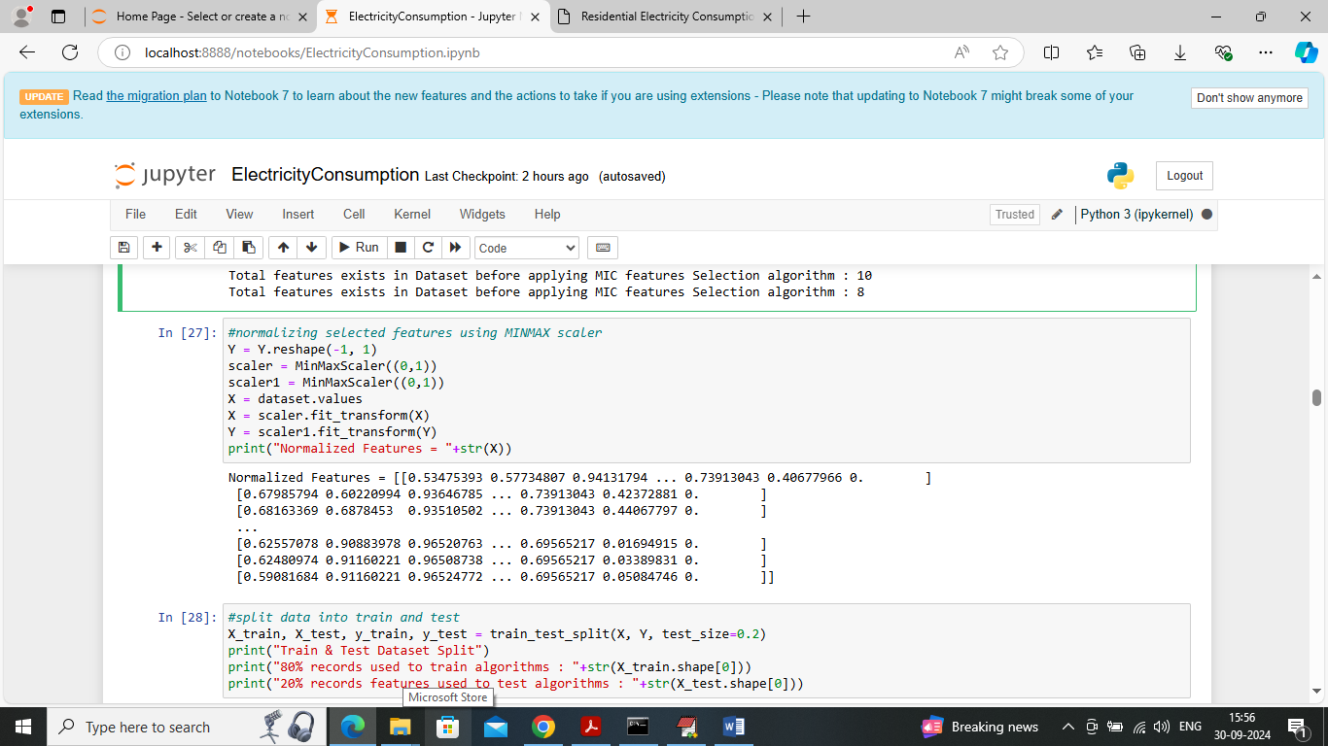
In above screen normalizing selected features using MINMAX scaling
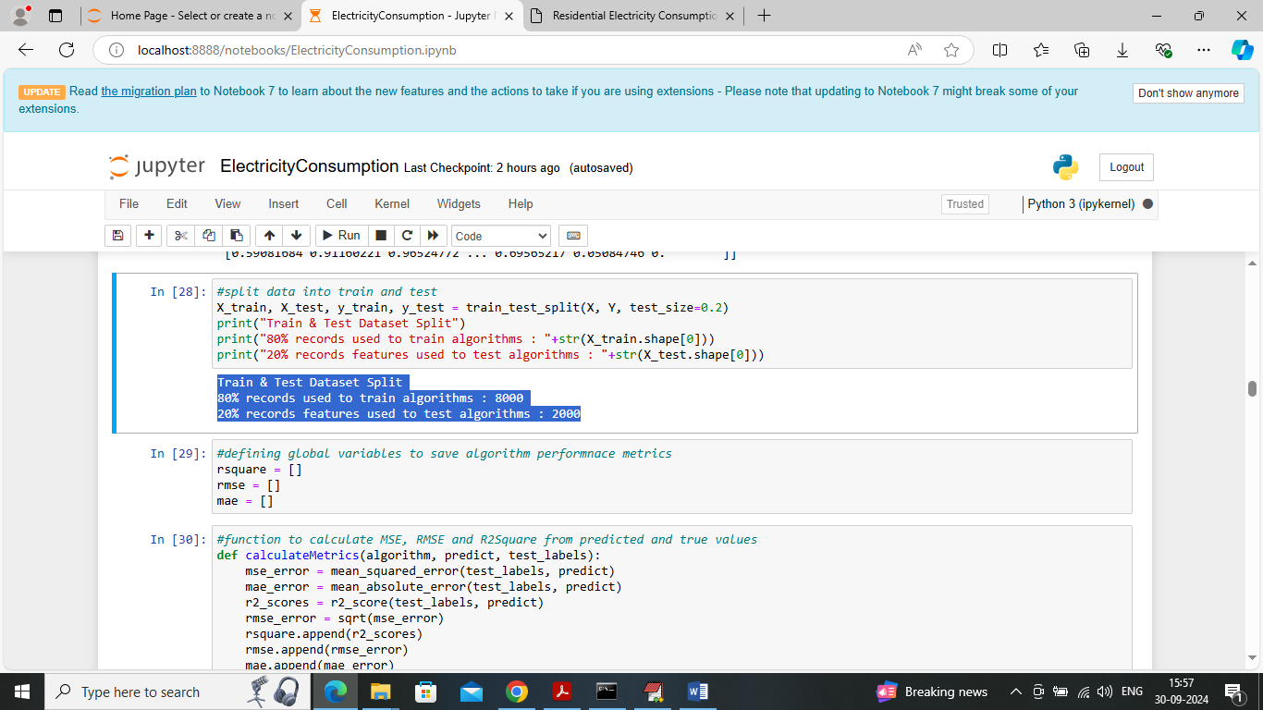
In above screen splitting dataset into train and test where application using 80% dataset records for training and 20% for testing and then defining function to calculate RMSE, MAE and R2score
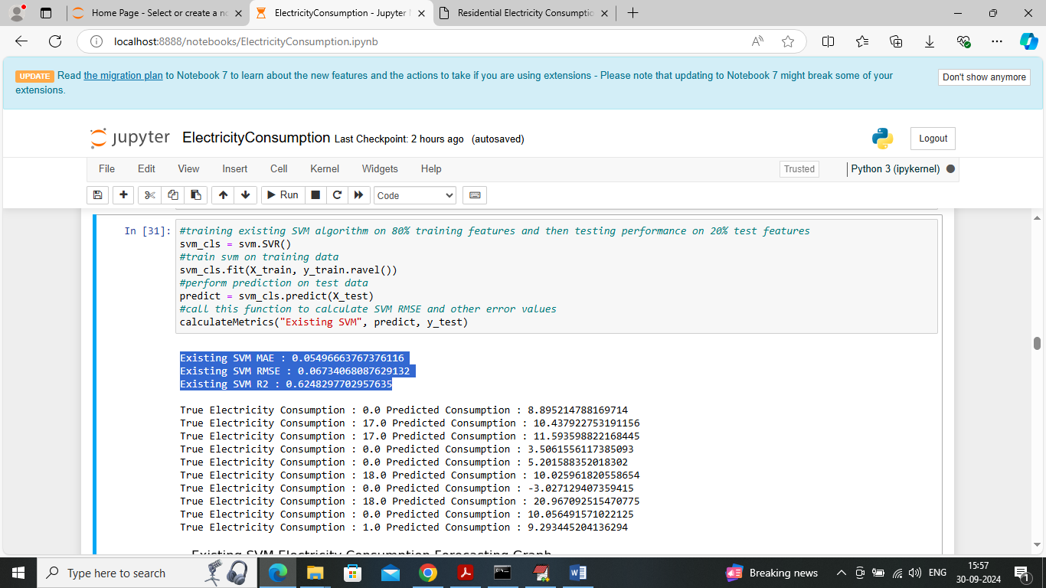
In above screen training existing SVM algorithm which got 62% R2score can see RMSE and MAE error rates and then in next lines can see original text data electricity and predicted electricity consumption and below is the forecasting graph
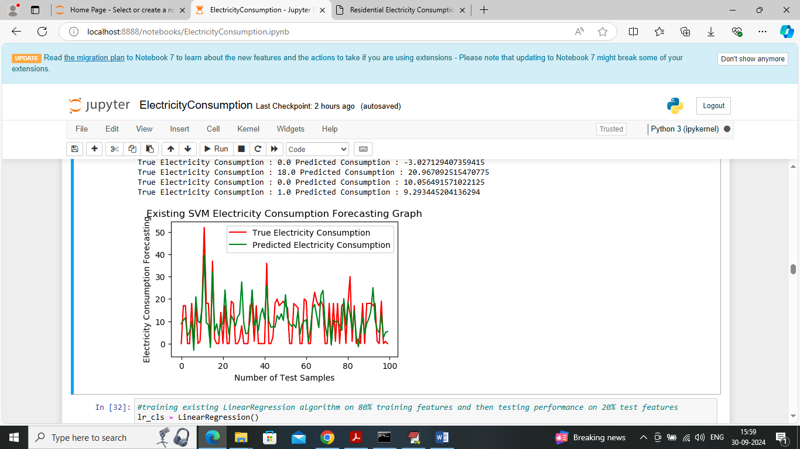
In above graph x-axis represents ‘test record numbers’ and y-axis represents ‘electricity consumption’ and then red line represents original consumption and green line represents predicted consumption and in above graph can see both lines are having much gap so SVM prediction is not accurate
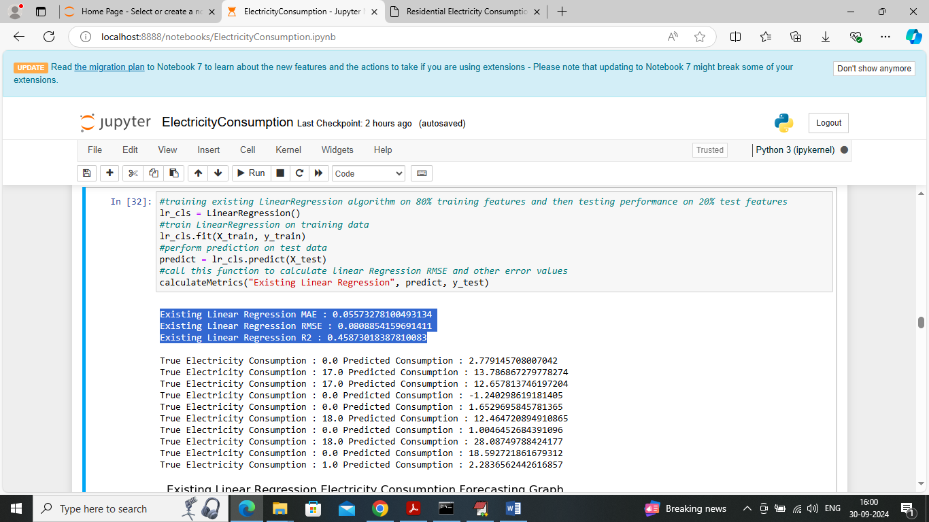
In above screen Linear Regression got 45% R2score and can see other metrics also
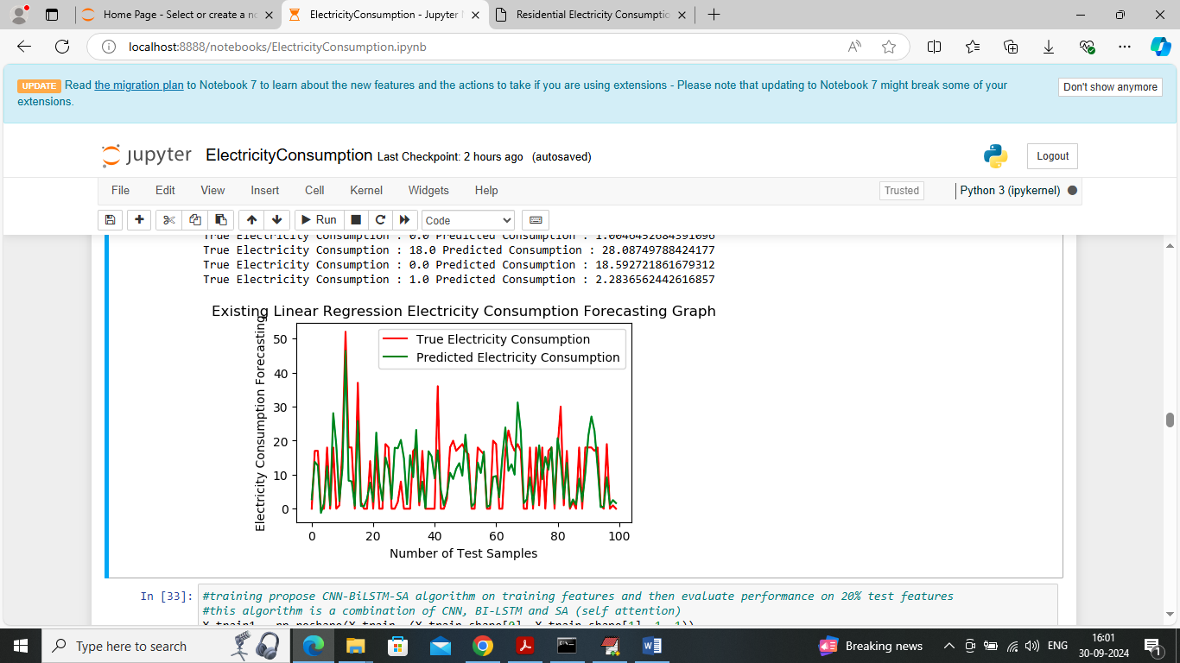
In above linear regression forecasting graph both lines are not fully overlapping so this algorithm is also not accurate.
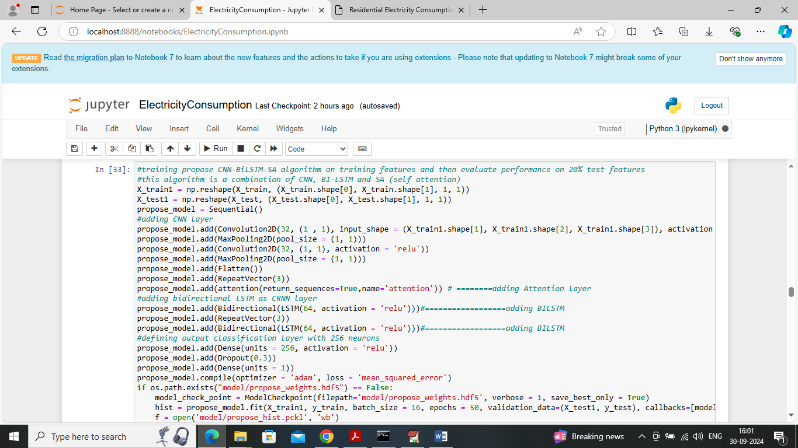
In above screen training propose CNN-BILSTM-SA algorithm and after executing above block will get below output
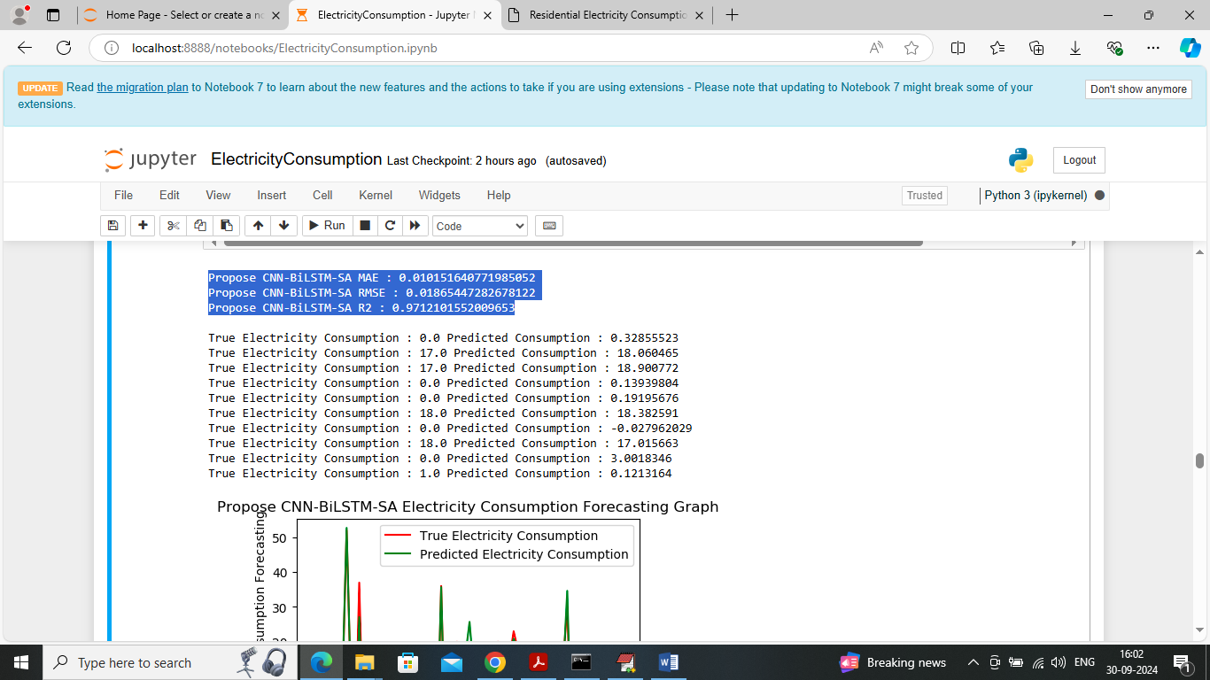
In above screen propose algorithm got 97% R2score and can see other metrics also and in below screen can see forecasting graph
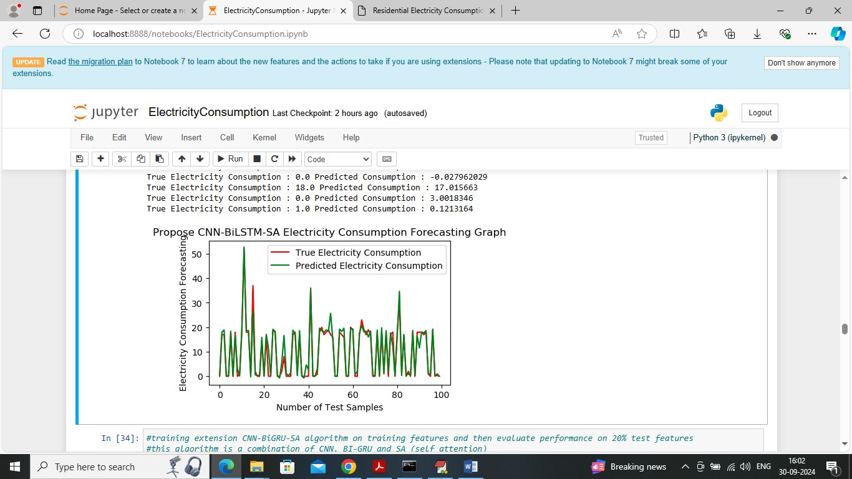
In above screen propose algorithm has predicted electricity consumption closer to original values and both lines are fully overlapping so we can say propose algorithm I accurate in prediction
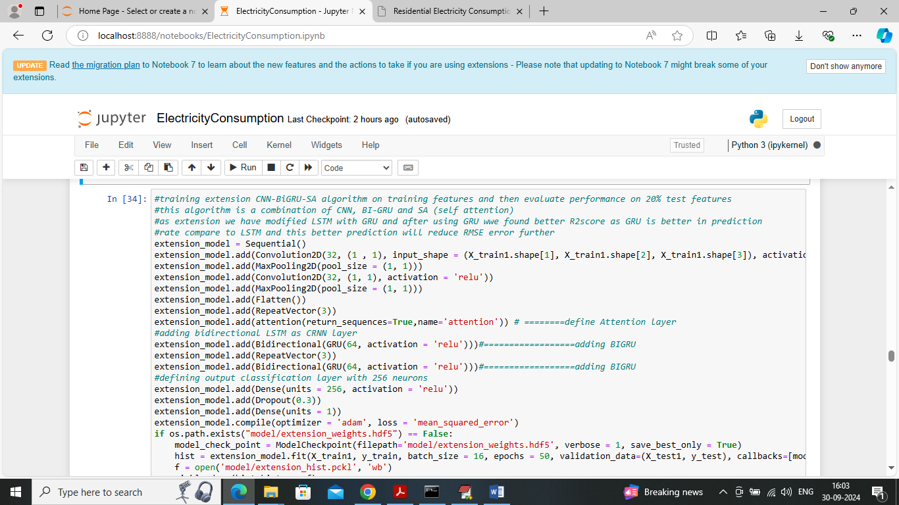
In above screen training extension CNN-BIGRU-SA algorithm and below is the output
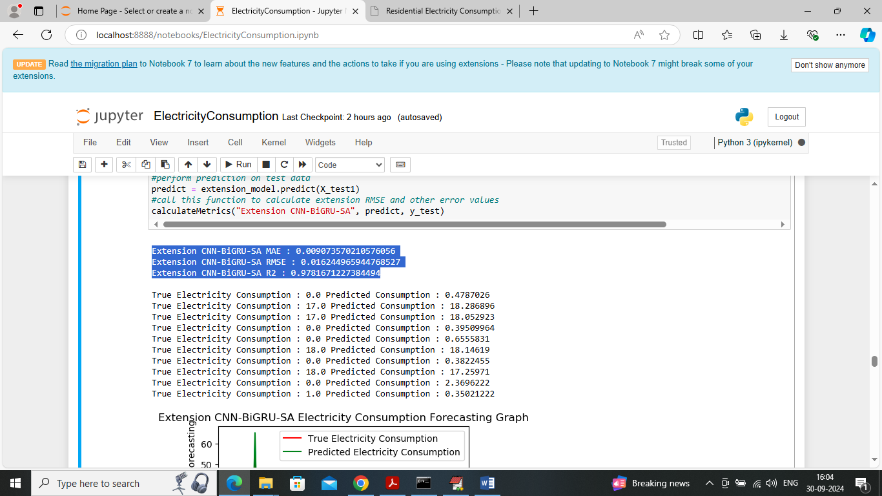
In above screen extension algorithm got 0.9781% r2score which is higher than propose algorithm
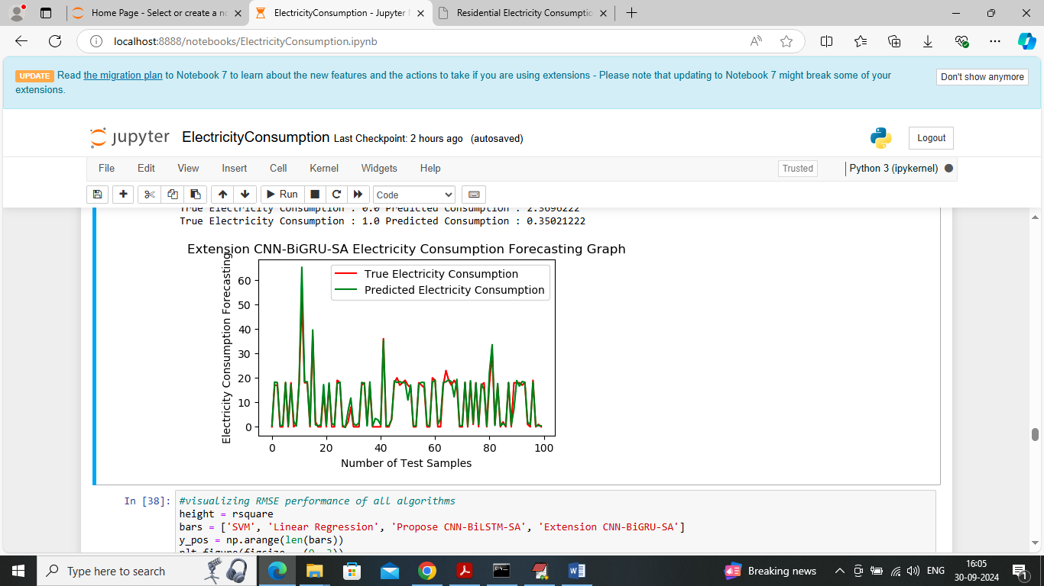
In above extension forecasting graph can see both lines are fully overlapping with minute gap so original and predicted values are very close
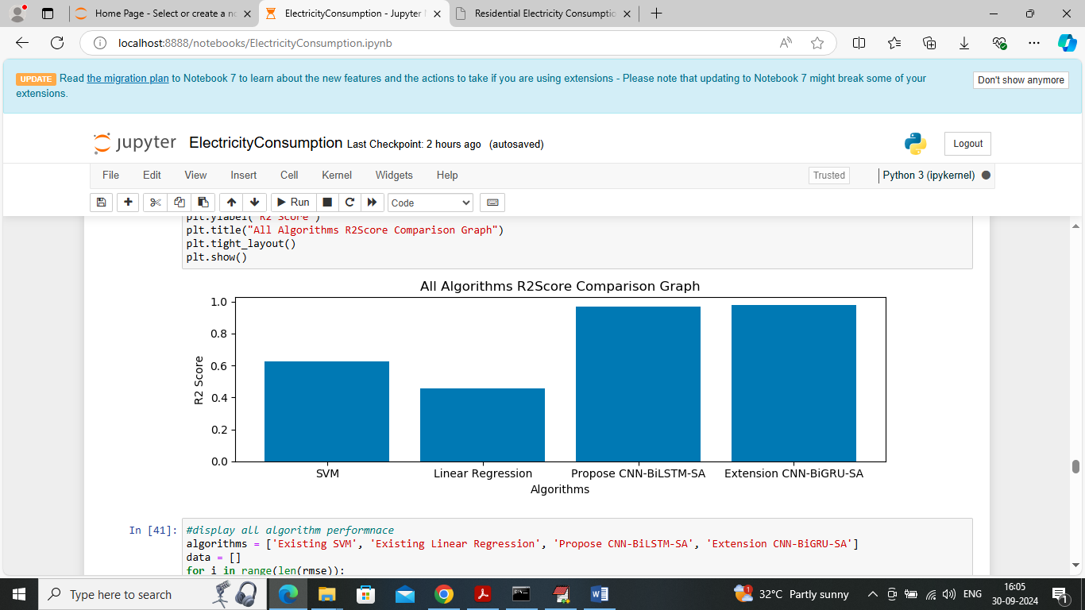
In above screen visualizing R2score graph where x-axis represents algorithm names and y-axis represents R2score and in all algorithms extension got high R2score
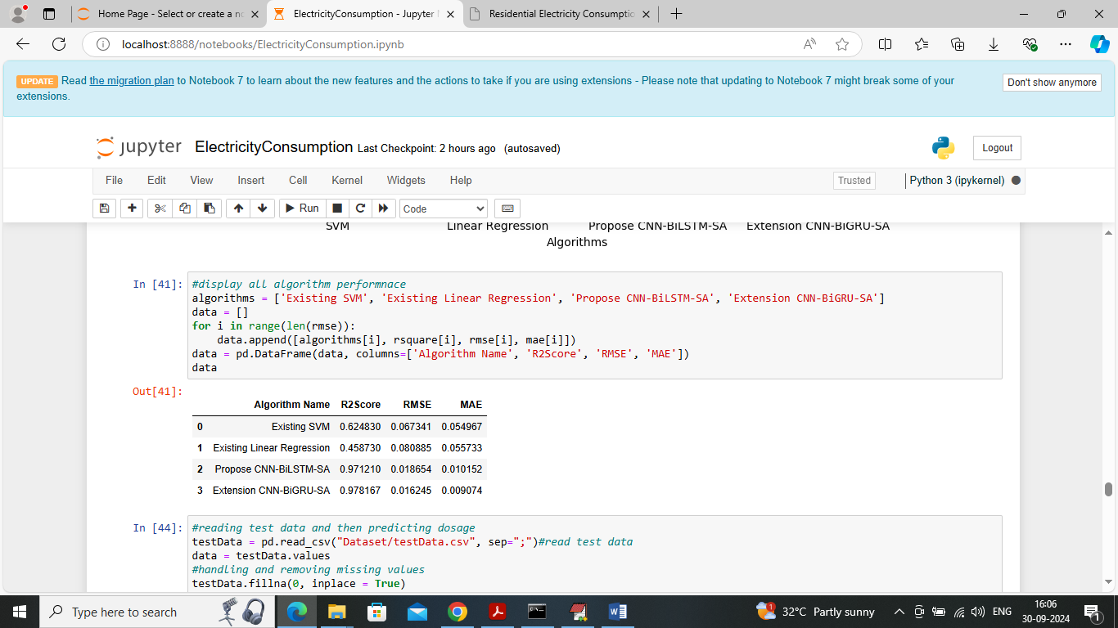
In above screen showing RMSE, MAE and R2score for all algorithm in tabular format and in all algorithms extension got high R2score and low RMSE and MAE
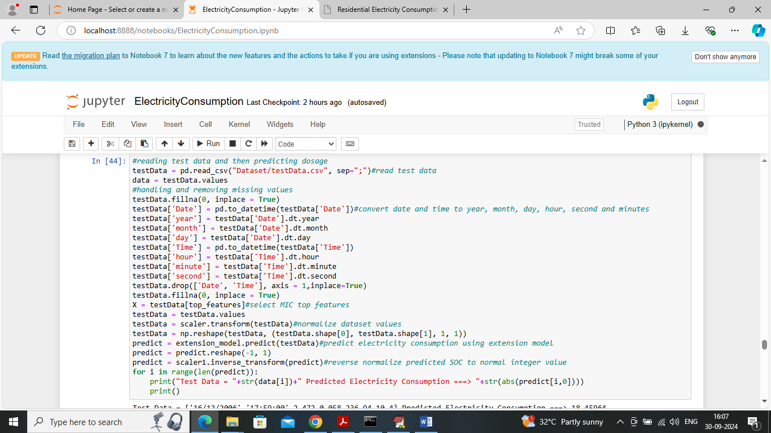
In above screen reading test data and then selecting features using MIC and then applying normalization and then applying extension algorithm to predict electricity consumption
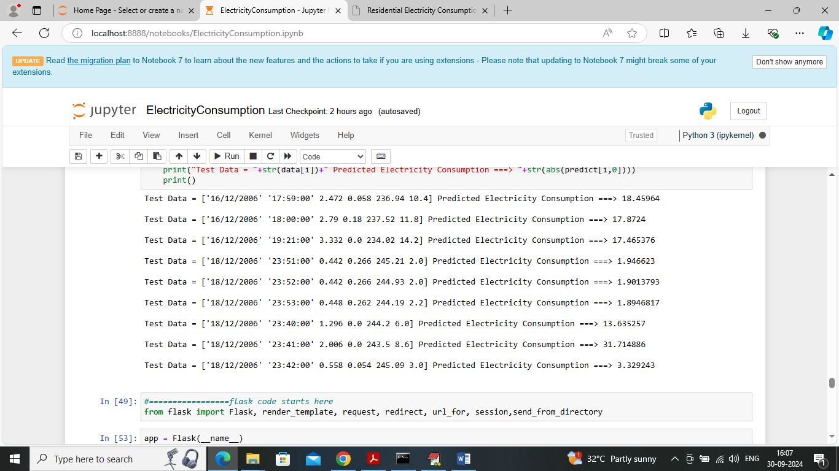
In above screen in square bracket can see test data values and after = symbol can see predicted electricity consumption values
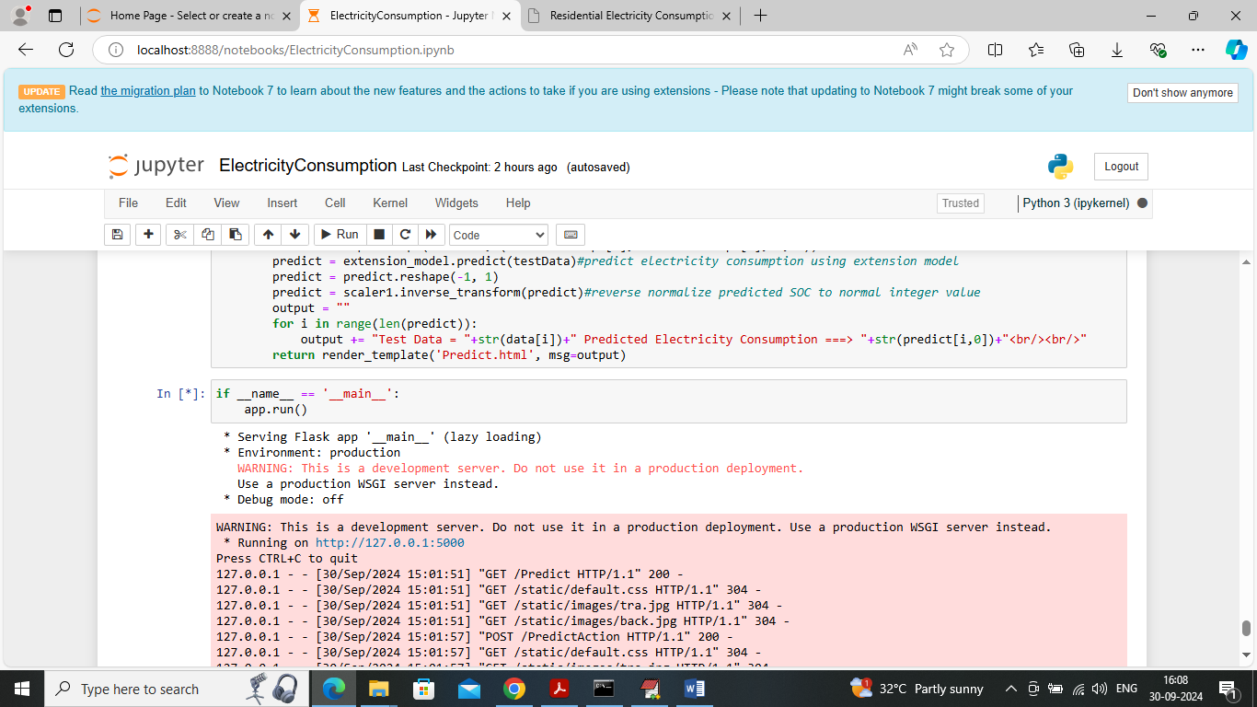
In above screen run all flask block to start server and then open browser and enter URL as http://127.0.0.1:5000/index and press enter key to get below page
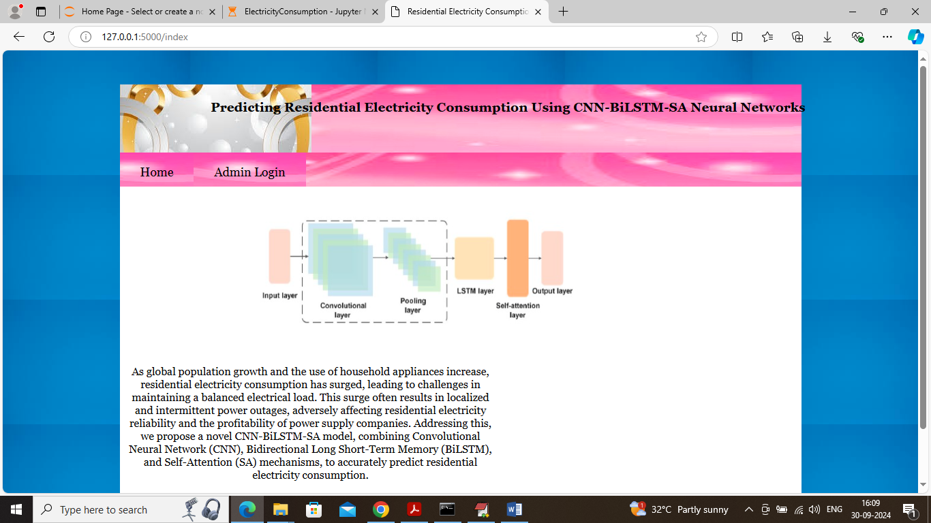
In above screen click on ‘Admin Login’ link to get below page
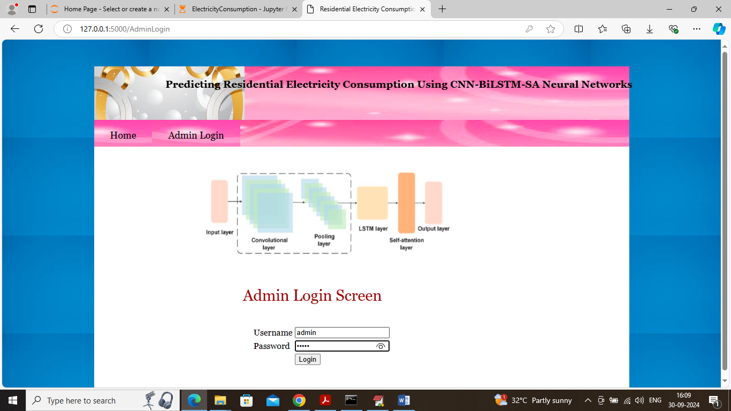
In above screen admin is login and after login will get below page
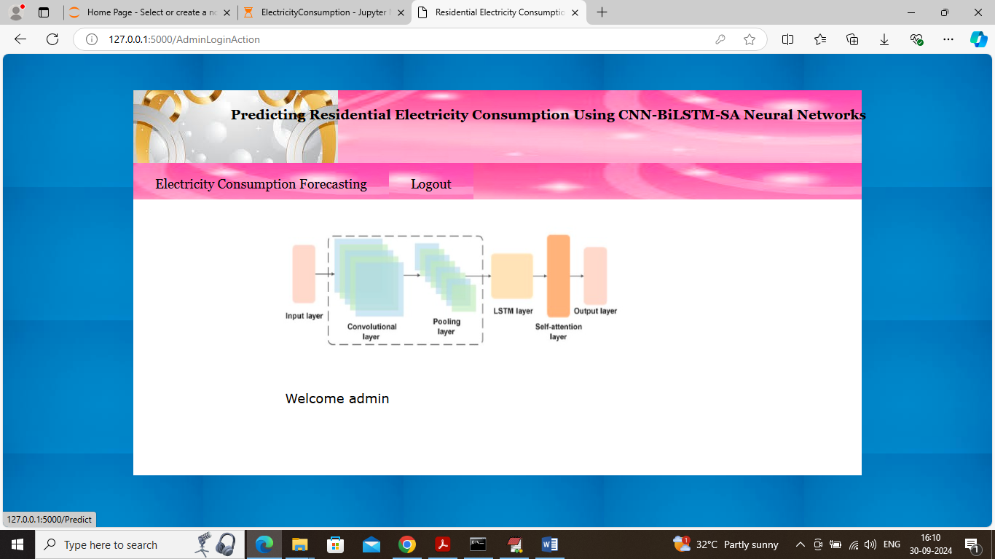
In above screen click on ‘Electricity Consumption Prediction’ link to get below page
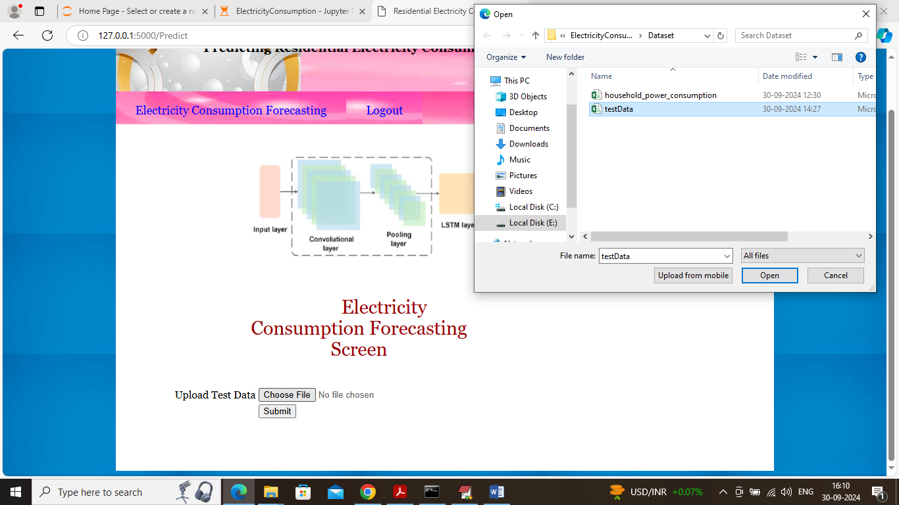
In above screen selecting and uploading test data file and then click on ‘Open and Submit’ button to get below page
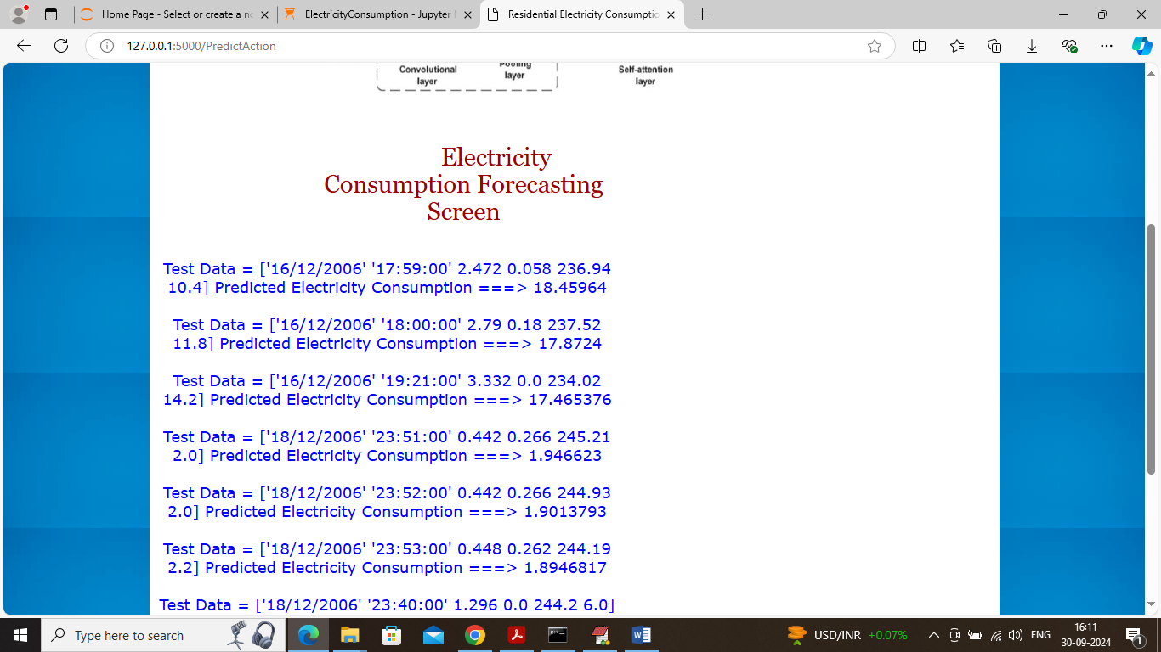
In above screen in square bracket can see test data values and after = symbol can see predicted energy consumption.

