«بسمی تعالی»
مستندات api ماژول کاربری
الف) فرایند احراز هویت
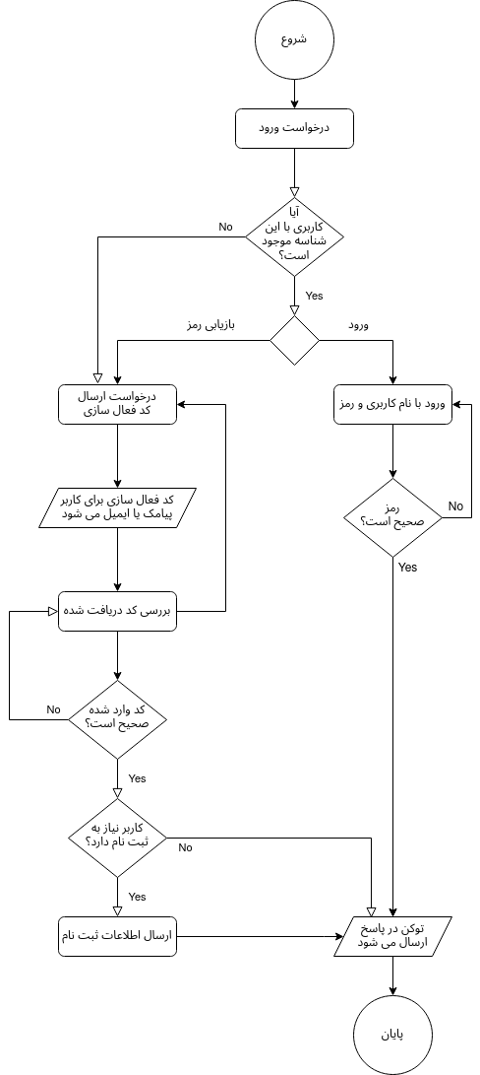

- نمونه درخواست کد فعال سازی:
Url:
{base_url}/user/api/check-activation

Request Raw body:
{"identity":"09154526352","token":"4564"}

Response:
{
"head":{
"error":0,"message":"","_csrf":"leuJJNzdZEnCTqltmMCp","request_time":1627451457.1166265625,"response_time":1627451457.16375
},
"body"{
"activated":true,"need_register":true,"identity":"09154526352","token":"54769z8cb5e6a19e664109b1e692c2f3379c94","register_token":"eqggfqmey7kskok0838498802cd"
}
}

- نمونه درخواست کد فعال سازی:
Url:
{base_url}/user/api/register

Request Raw body:
{
"password":"qweqwe","confirm":"qweqwe","name":"حسن","family":"رضایی",
"father_name":"قلی","melli_code":"0954152632","brithdate":"1352-05-10",
"base_edu":"شسیشسی", "note":"", "token":"54769z8cb5e6a19e664109b1e692c2f3379c94",
"regToken":"eqggfqmey7kskok0838498802cd",
"identity":"09154526352"
}

Response:
{
"head":{
"error":0,"message":"","_csrf":"leuJJNzdZEnCTqltmMCp","request_time":1627451457.1166265625,"response_time":1627451457.16375
},
"body":{
"registered":true,"login_access_token":"54769z8cb5e6a19e664109b1e692c2f3379c94"
}
}

ب) ارسال درخواست بر اساس کاربر احراز شده

