‏25/5/2021

eitan danon

LINUX FINAL PROJECT

SEE SECURITY



*LINUX*

What is Linux: is a Unix-like, open source and community-developed operating system for computers, servers, mainframes, mobile devices and embedded devices. It is supported on almost every major computer platform including x86, ARM and SPARC, making it one of the most widely supported operating systems.

When it all started:  is a family of [open-source](https://en.wikipedia.org/wiki/Free_and_open-source_software) [Unix-like](https://en.wikipedia.org/wiki/Unix-like) [operating systems](https://en.wikipedia.org/wiki/Operating_system) based on the [Linux kernel](https://en.wikipedia.org/wiki/Linux_kernel),[[10]](https://en.wikipedia.org/wiki/Linux#cite_note-12) an [operating system kernel](https://en.wikipedia.org/wiki/Kernel_(computing)) first released on September 17, 1991, by [Linus Torvalds](https://en.wikipedia.org/wiki/Linus_Torvalds). Linux is typically [packaged](https://en.wikipedia.org/wiki/Package_manager) in a [Linux distribution](https://en.wikipedia.org/wiki/Linux_distribution).

Why we use Linux:

High security: Installing and using Linux on your system is the easiest way to avoid viruses and malware

High stability: The Linux system is very stable and is not prone to crashes. The Linux OS runs exactly as fast as it did when first installed, even after several years

Runs on any hardware: All of us know that with every new release of Windows OS, a huge number of hardware systems become obsolete as their technical specifications are no longer adequate to run the latest Windows OS.

Open source: The most important aspect of Linux is that its source code is available as it falls under the FOSS category (Free and Open-Source Software)

Customization: Users have tremendous flexibility in customizing the system as per their requirements

Linux is fun and its good 😊

**Table of contents**

Linux topology ________________________________________________________3

Root folders creation___________________________________________________4

Users’ creation and management setup___________________________________5-6

Default home directory edit______________________________________________7

Users GUI login check __________________________________________________8

Group creation and File permission_____________________________________9-11

Copy and data transfer______________________________________________12-16

Content filtering___________________________________________________17-18

Symbolic and hard link ________________________________________________19

find (rm-cp) command______________________________________________20-21

program install______________________________________________________22

networking_______________________________________________________23-24

system properties _________________________________________________25-26

In this project I’m going to show and example commands that we learned so we will be able to use Linux operation system by our needs, I’m going to use ubuntu to show the examples

Important --- in Linux is very important the type of letters you write, if the folder is with big letter, we will use big letter and if it is with small letter, we will use small letter

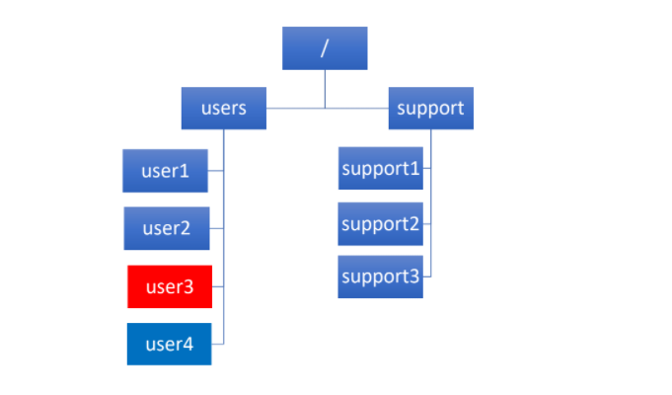

This is the project topology we are going to use at this project to explain our knowledge and to administrate the system basic operation.

First of all, ill crate 2 folders under root (the main folder of Linux operation system),

Users – in users we are going to create 4 users that every one of them have different premotions and purpose so we will example different commands and how they work.

Support – we are going to create 3 support folders

Cd – allow us to go to the file or folder we want to go

Ls- allow us to see what exist in the folder we are in

mkdir – allow to create new folder

sudo is the super administrator with all the permissions

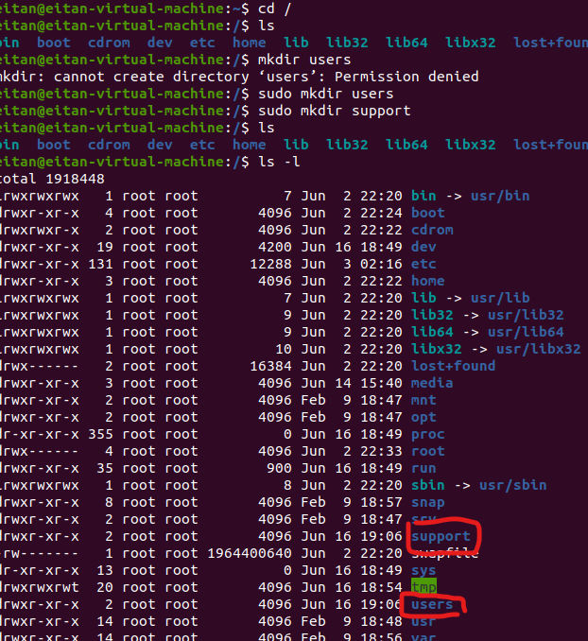

So, I went to root folder (cd /) command and typed ls command to see if we have the existing folders we want to create, now I used mkdir command to create users and support folders but I didn’t have the permission because the root folder is the main folder and I need to use sudo command to enter as administrator to create the folders.

2.a create to all user’s home folder at /users

2.b to user1 and user 2 will have /bin/bash shell configuration

2.c configure user2 to expire in 31.12.2021

2.d configurate user1 one to have password expire after 30 days

2.e user3 will be system account without home folder or shell and add note system account

2.f every user will have Aa1234 password configure

User1: sudo useradd user1 -mb /users -s /bin/bash -K PASS_MAX_DAYS=30



-----------------------------------------------------------------------------------------------------------------

User2: sudo useradd user2 -mb /users -s /bin/bash -e 31-12-2021



-----------------------------------------------------------------------------------------------------------------

User3: sudo useradd -r user3 -s /sbin/nologin -c “system account”



-----------------------------------------------------------------------------------------------------------------

Here we can see that we had created in /users, user1 and user2 home folders.



Now we need to config every user password Aa1234 and here we can see that user1 and user2 don’t have password.

To see the password, we are going to use sudo cat /etc/shadow

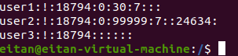

By using passwd {username} we can setup new password for every user we want



Here we can see that after we setup the new password for the usernames we see the password encrypted, and that means we created a new password



3. change home directory setting in the system to the /users’ folder so every time you create users the home folder is under /users.

For Forder configurations we want every time that we create users, his home folder will be at /users, and to do that we will need to enter to default folder and change adduser.txt config from HOME=HOME to HOME=/users

We will to it in that way

sudo nano /etc/default/adduser



Then change the HOME= but we need to delete the # and the same line

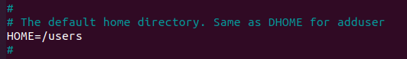

Then we will save the file and check if it worked by using adduser -D

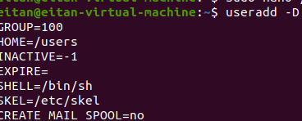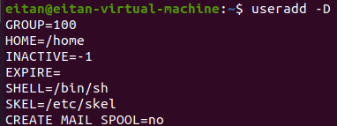before after

4. login to the users and check if they are working with GUI, check if the home folder path is correct as we wanted and check if there are 8 folders at home.

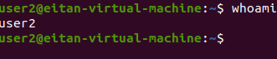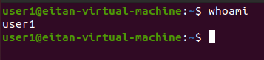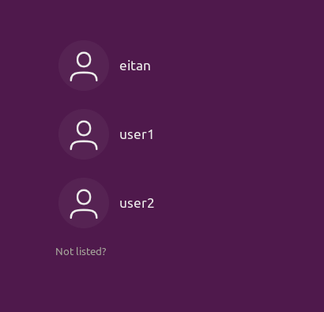user1 and user2 has GUI as we wanted by exit from the user and select user1 or 2 and put the password we assigned

to check if the home folder path is correct as we needed it to be we will do that

ls -l /users | grep -e user1 -e user2

and we can see we have the user’s folder in /users

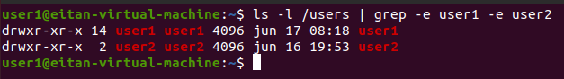

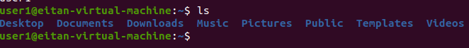And now we will check if we have all the folders and the home directory. By type cd ls

*File permissions*

3. change the default settings in every case of creating a file in the way that every new file will have those permissions:

a. User owner will have RWX- read, write, execute

b. Group will have RW – read, write

c. other will have X – execute

first of all, to change default file permission we will use umask command and decide which permission everyone will get.

First, I decided to give 002 permission:

User: RWX

Group: RWX

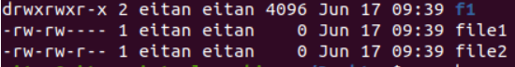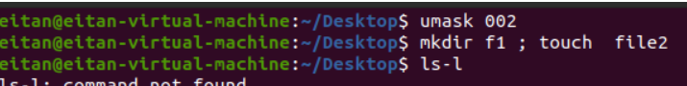Other RX

-----------------------------------------------------------------------------------------------------------------

And then I decided to edit that faction to what’s needed in that way:

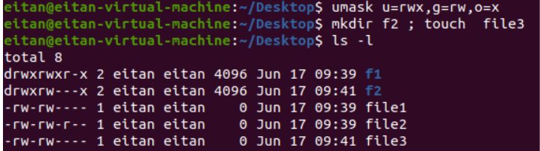u=rwx, g=rw, o=x

and we can see below that the new file and folder got the permission that we wanted.

6. create the next groups:

a. group it with user1 in it

b. group Users with user1 and user2 in it

first, we will create both of the groups and then we will add the users each group we need.

We will use groupadd {groupname} command to create a group,



Now we will use usermod -a -G {groupname} {username} command to add users to the group we need



And now we will check if we accomplished to add the users, we wanted to the groups we needed

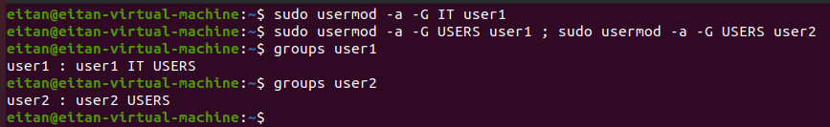By using groups {username} command:

7. Enter to user1 and create in home folder file(user1.txt) and give the next permission to the file: user=rw, group=r, other=x

b. gives a permission to group USERS to this file.

First, we will enter to user1 with su user1 command

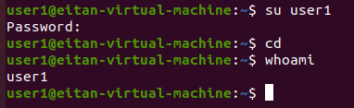

Now we will create the file user1.txt at the home folder. With touch {filename} command:



To give the permission to user1.txt file we will use chmod 641{filename} command, 641 mean users=rw, group=r, other=x

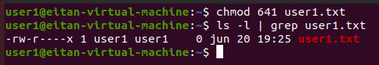

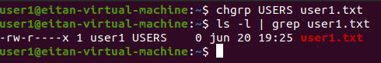Now we need to set the group of the file so we will have the permission for specific group with chgrp {groupname} {filename} command

8.create user by name user4

a. adds this user to groups: IT, GROUPS

b. show that user4 is in those groups

c. shows all the members in file /etc/passwd

d. copies those files to Document folder by using script

/etc/passwd - /etc/group - /etc/network/if

First, we will create user4 by useradd command



Now we will add this user to IT and USERS groups by usermod -a -G {groupname}{username} command



We will use groups{username} command to see if the user is in those groups and with nano /etc/passwd we can see all the users and groups in the file

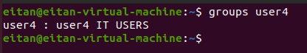

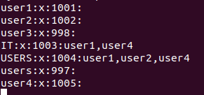

We need to create a script that will copy all the files in 8.d with those steps

First, we will create TXT file with nano command like script.txt and we will type on the title #! /bin/bash 🡪 that means that the TXT file is script file

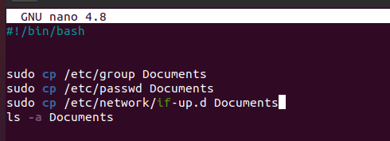

After we saved the file, we need to add execute permission to this file if we want to run it

We will use chmod +x script.txt so we can add the permission



Now we will run the file by typing ./script.txt

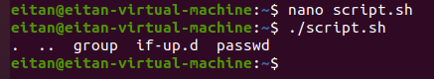

We can see that the file was copied and the script worked

9. print all the users in /etc/paswwd file to file users.csv in separate format

We will cut the text from /etc/passwd file to our new file by using cut -d “:” -f1 command

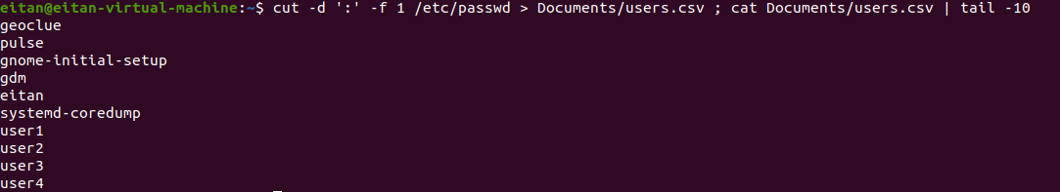

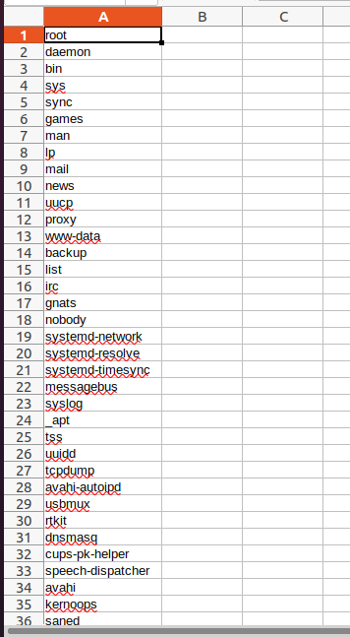

10. sign in user1 and do the next actions

a. creates, 10 files by the name user1.txt-user10.txt

b. prints the text “never say never” on all the files are created

c. shows all files that were created and sort them by size

d. extract all file names into “file.txt” file

e. show user1 home folder size and size of all folders in it

first we will create 10 files with touch user{1..10}.txt command

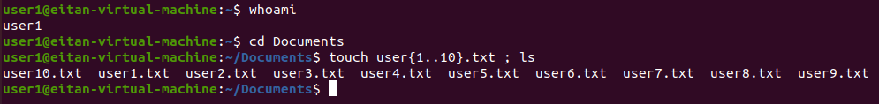

To print “never say never” we will use echo “never say never” | tee user{1..10.txt

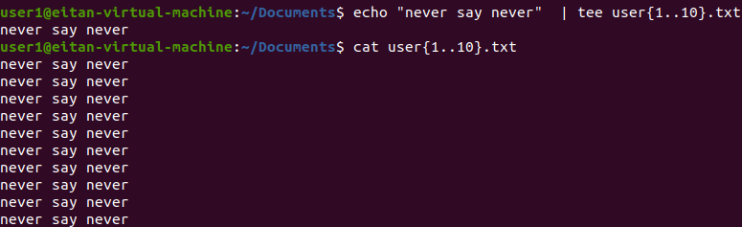

To show all the files that were created by size we will use ls -lS.

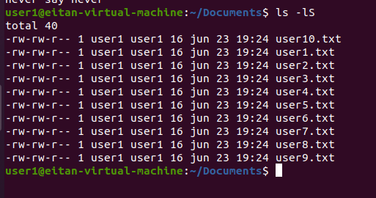

To extract all the files to file.txt we will use ls > file.txt

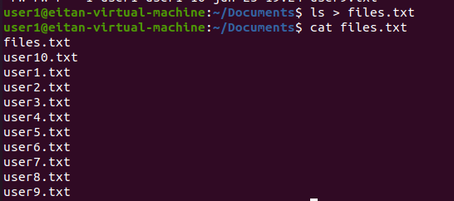

To see what is the size of the home folder and the folders in the home folder we will use ls -lSh

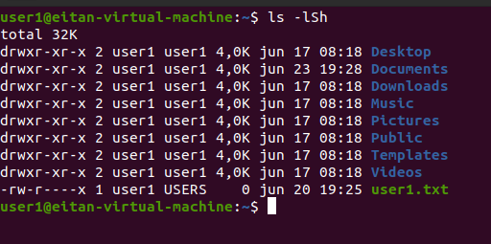

11. show all the files in /etc only on top of the folder without sub-folders

a. filter from the folder only ascii.files

b. list file by name

c. prints the txt to file etcfiles.txt with line numbers

To show the files that are not directory we will use ls -p |grep -v/

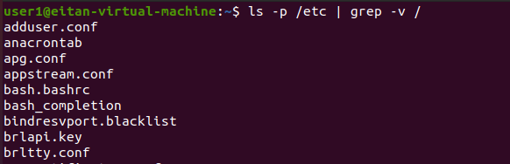

To filter only the ascii files we will use file /etc/* | grep ASCII

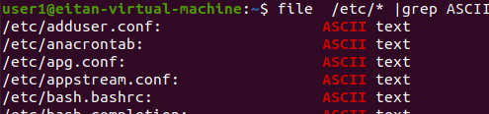

List file by name or other option we will use file /etc/* | grep ASCII | sort

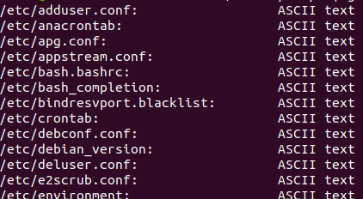

To print the text to file ercfiles.txt and add numbers we will use file /etc/* | grep ASCII | sort | nl >etcfiles.txt ; cat etcfiles.txt

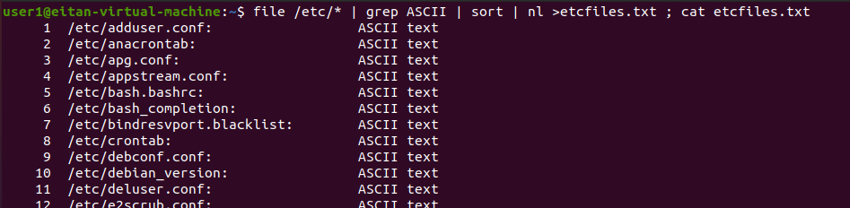

12. show /etc/passwd file

a. cut only the first line to users.txt file

b. cut the user line and shell partition to users2.file

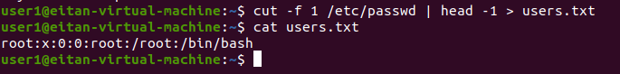to cut only the first line we will use the head -1 option

to cut the user line and shell partition we will use the same command as before but this time we will use grep to the username

cut -f 1 /etc/passwd | grep “eitan” > users.txt

13. sing in user2 and do the next actions

a. create symbolic link to /etc/passwd by name password.txt

b. create file user2.txt and print “welcome user2”

c. create hard link to file user2.txt user3.txt

to create symbolic link, we will use ln -s {originname}{destenasion}

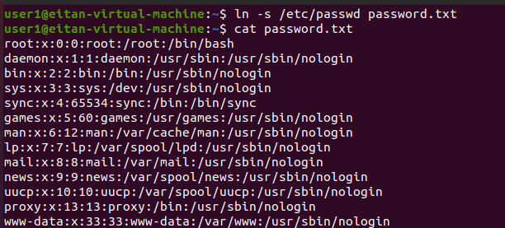

To create file, we will use touch user2.txt ; echo “welcome user2”|tee user2.txt command

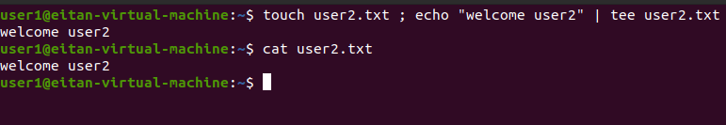

To make hard link we will use ln {originname}{newname}

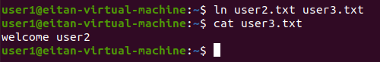

14. create under support folder 3 folders by the name support1-3

a. deletes support1-3 folders

To create folder, we will use mkdir command

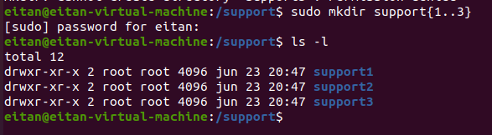

To delete those folders, we will use rw -r command

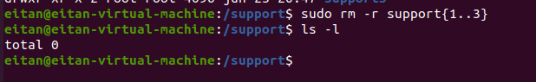

15. find all the files in /tmp that are older then 3 days and delete them

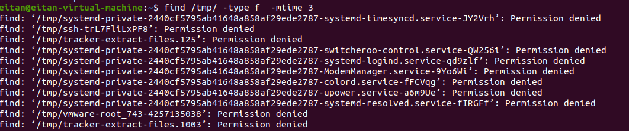to find all the files older than 3 days I used find /temp/ -type f -mtime 3

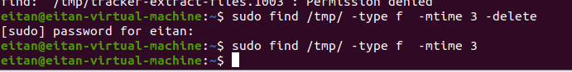to delete those files I use the same command but add -delete at the end find /temp/ -type f -mtime 3-delete

16. find all the txt files in all users folder and copy them to /temp

To find the files we will use find -iname “*.txt”

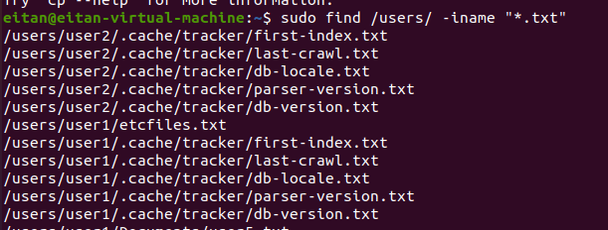

To copy those files we will add -exec cp{} /tmp \;



Lets check if we succeed to copy the files

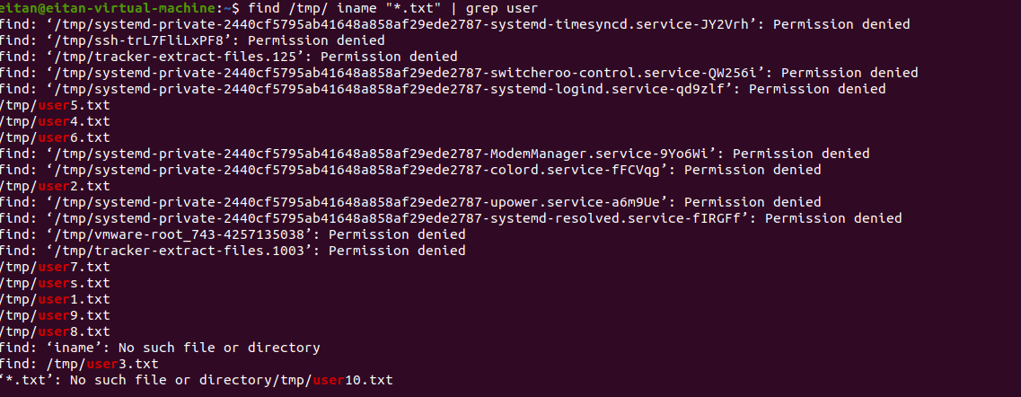

Yes. We can see the files we created in user 2.

17. install the next programs

a. open-vm-tools

b. tree

c. openssh-server

to install program, we will use apt install command

a. open-vm-tools

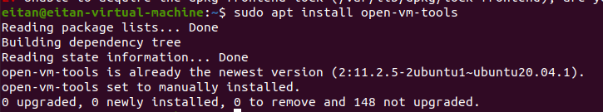

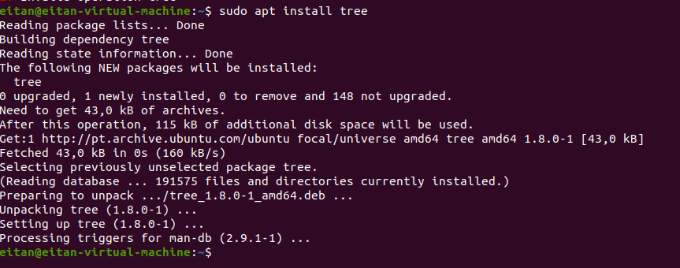b. tree

c. openssh-server

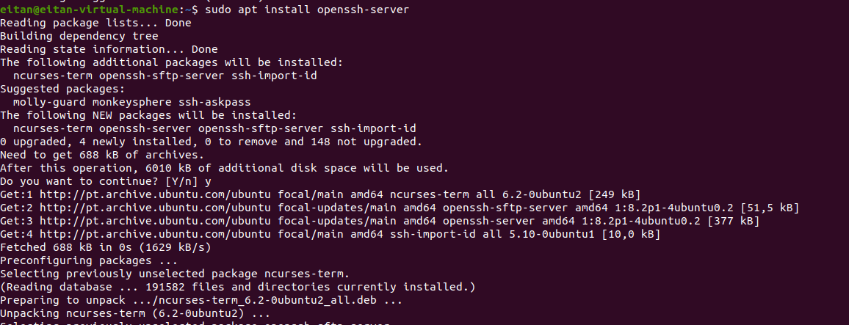

18.setup static IP address

a. setup 2 DNS IP address

b. connect with putty to the system and show the connection work

to setup new IP address, we need first to check what is our interface by using ifconfig command, after we use this command, we will change the IP address by using

sudo ifconfig{interface} {IP address} netmask{netmask}

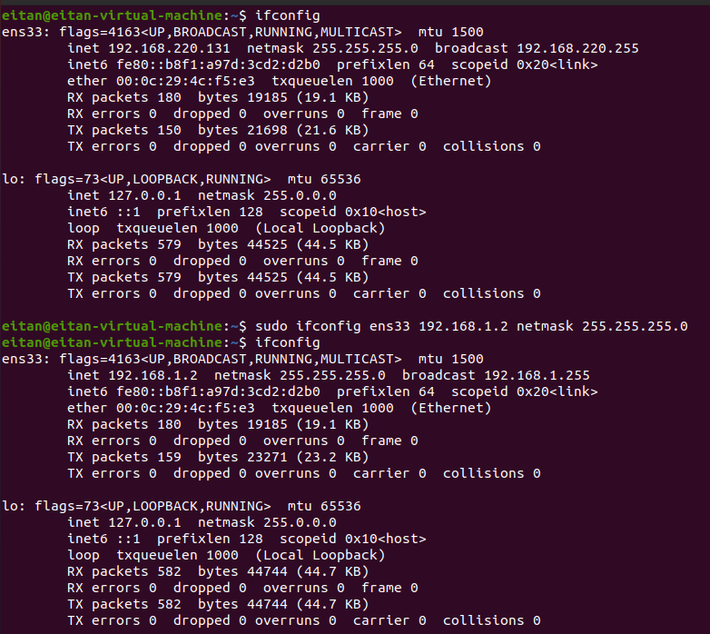then we will type ones more ifconfig to see if it setup as we config

in our case the interface is ens33 and the IP: 192.168.1.2/24

to change DNS address we will need to nano a file by the name /etc/resolv.conf

first we will go to the file:



then we will edit the file and type:

nameserver: 8.8.8.8

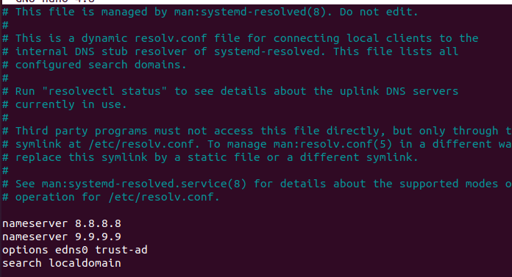nameserver: 9.9.9.9

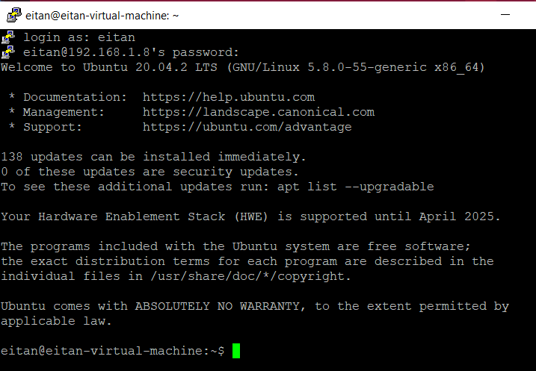connect with putty:

19. show system version

a. show global environment

c. show 2 help commands for ls

to see the system version, we will use uname -a

to see the system global environment, we will use sudo lshw -short

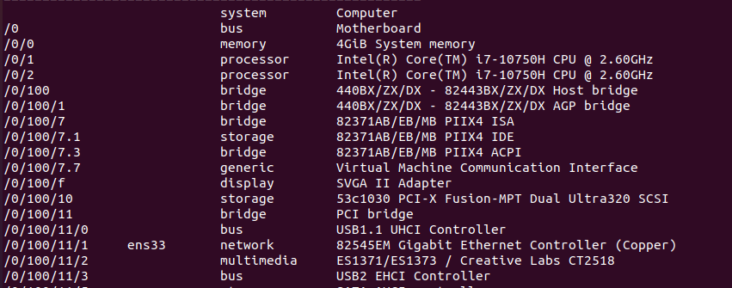

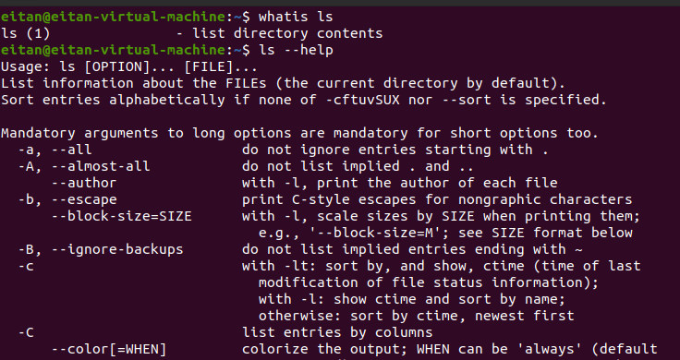2 help commands for ls command we can use - - help and whatis

20. show the structure of the system hard disk /dev/sda1 that contains the size of the hard drive (free space, busy space):

To do that we will use df -ha command



We can see that there are 511M in the drive and 4K are used and 511M are empty

And only 1% of the drive is used