**Abstract**

This project is aimed at developing a prison management system that is a collection of data for the effective management of prisons. This system contains data for prisoners, employees, doctors, and duty officers. Administrators will be able to store, search and delete data of the Prison which includes the basics of a prisoner, doctors, employees; duty officer and duty officer will be able to view the prisoner and employees data. This project includes information about prisoners, their crime and lodging pattern. It also records, tracks and monitors the movement of prisoners. There is no provision to keep feedback regarding the performance of the prisoners. The prototype was developed using MySQL, PHP, CSS, JavaScript, Bootstrap and HTML. Prison Management system is an application to automate the process for maintaining and tracking the day to day activities of any prison. This software is an Internet (Intranet) based online portal, which allows users to access the application from all over the world. The Portal’s major responsibility is to take care of the proper maintenance of any prison. This application maintains the centralized database so that any changes done by any one at any location reflects on fly. This is an online application that allows multi-user access of system and to track or manage the data simultaneously. The aim of this application is to reduce the manual effort  
needed to manage transactions and historical data used by jail admin team. Also this application provides an interface to police officials and other important government officials to view the details of prisoners, case details and to generate required reports. This helps to prevent unnecessary delays and human errors. The visitors and jailors can log in and the jailer can generate various status reports as well as demographical analysis reports. This project is aimed at developing a prison management system that is a collection of registers and reports for the effective management of prisons. This system should contain the modules like nominal roll, case register, parole register, Interview requests, In-out register, visitor’s details and an automated release diary generator.

**Keywords:** Prison Management, Web-Based Application, Efficient Administration, Prison, Compensation, Activities, Multi-User Access.

**Table of Contents**

**List of Figures : ------------------------------------------------------------------------------------- 4**

**Chapter -------------------------------------------------------------------------------------- Page No**

**1. Introduction 5 - 9**

* 1. Introduction **: ---------------------------------------- 6**
     1. Aims of the Project  **: ---------------------------------------- 6**
     2. Features of Prison Management System **: --------------------------------------- 6**
  2. Objective **: ------------------------------------------------------------**   **7**
  3. Project Background  **: ------------------------------------------------------------ 7**
  4. Problem Statement  **: ------------------------------------------------------------ 8**
     1. Existing System  **: ----------------------------------------------------------- 8**
     2. Proposed System  **: ------------------------------------------------------------ 8**
     3. Features of Proposed System **: ---------------------------------------- 9**

**2. Methodology 10 - 16**

2.1. Definition of Methodology **: ---------------------------------------------------------- 11**

2.1.1. Methodology of the system  **: ------------------------------------- 11-13**

2.2. Tools Requirement  **: --------------------------------------------------------- 14**

2.3. Feasibility Study  **: --------------------------------------------------------- 14**

2.3.1. Economic Feasibility **: --------------------------------------------------------- 14-15**

2.3.2. Technical Feasibility  **: -------------------------------------------------------- 15**

2.3.3. Operational Feasibility  **: ------------------------------------------------------- 15-16**

2.4. Software Engineering Paradigms Applied  **: ------------------------------------ 16**

**3. Requirement Engineering 17 - 20**

3.1. Requirement Specification  **: -------------------------------------------------------- 18**

3.1.1. Analysis of Actual Data  **: -------------------------------------------------------- 18**

3.1.2. Identification of Essential Requirement **: ------------------------------------ 18**

3.1.3. Selection of Requirement Strategies **: ------------------------------------ 19**

3.2. Overview of Prison Management System **: ----------------------------------- 19**

3.2.1. Overall Description  **: ------------------------------------------------------- 19**

3.2.2. Specific Requirements **: ------------------------------------------------------- 19**

3.3. Configuration  **: ------------------------------------------------------ 20**

3.3.1. Hardware Configuration **: ------------------------------------------------------- 20**

3.3.2. Software Configuration **: ------------------------------------------------------ 20**

**4. System Design & Implementation 21 - 35**

4.1. System Design **: ------------------------------------------------------- 22**

4.2. Design Methodology **: ------------------------------------------------------- 22**

4.2.1. Logical Design **: ------------------------------------------------------- 22**

4.2.2. Physical Design **: ------------------------------------------------------- 23**

4.2.3. Modular Design **: -------------------------------------------------------- 23**

4.3. Database Design **: --------------------------------------------------------** **23**

4.3.1. E-R Diagram **: -------------------------------------------------------- 24**

4.3.2. Schema Diagram **: ------------------------------------------------------- 25**

4.3.3. Data Flow Diagram **: ------------------------------------------------------- 26**

4.3.4. Sequence Diagram **: --------------------------------------------------------- 27**

4.4. System Implementation **: ----------------------------------------------------- 28-35**

**5. Testing 36 - 38**

5.1. Basic Testing **: ------------------------------------------------------------- 37**

5.1.1. Static Testing **: ------------------------------------------------------------- 37**

5.1.2. Dynamic Testing **: ------------------------------------------------------------- 37**

5.1.3. White Box Testing **: ------------------------------------------------------------- 37**

5.1.4. Black Box Testing **: ------------------------------------------------------------- 38**

5.2. Maintenance **: ------------------------------------------------------------- 38**

**6. Conclusion 39 - 41**

6.1. Conclusion **: ------------------------------------------------------------- 40**

6.1.1. Limitations **: ------------------------------------------------------------ 41**

6.1.2. Future Work **: ------------------------------------------------------------ 41**

**7. Appendix 42 - 43**

7.1. References **: ------------------------------------------------------------- 43**

**List of Figures**

Figure 1: Waterfall model approach **: ---------------------------------------------------- 13**

Figure 2: E-R Diagram **: ---------------------------------------------------- 24**

Figure 3: Schema Diagram **: --------------------------------------------------- 25**

Figure 4: Data Flow Diagram for the proposed system **: ---------------------------------- 26**

Figure 5: System Execution Sequence **: --------------------------------------------------- 27**

Figure 6: Login System **: ---------------------------------------------------- 29**

Figure 7: Admin Homepage **: --------------------------------------------------- 29**

Figure 8: Prisoner Registration **: --------------------------------------------------- 30**

Figure 9: Search Prisoner  **: ---------------------------------------------------- 30**

Figure 10: Duty Officer Registration **: ---------------------------------------------------- 31**

Figure 11: Delete Duty Officer from List  **: ------------------------------------- 31**

Figure 12: Examinee Registration **: ------------------------------------------------------ 32**

Figure 13: Delete Examinee from List  **: ------------------------------------ 32**

Figure 14: Employee Registration **: ----------------------------------------------------- 33**

Figure 15: Delete Employee from List  **: ------------------------------------- 33**

Figure 16: Doctor Registration **: ------------------------------------------------------ 34**

Figure 17: Delete Doctor from List **: -------------------------------------- 34**

Figure 18: Visitor Registration **: ------------------------------------------------------- 35**

Figure 19: Delete Visitor from List **: ------------------------------------------------------- 35**

**Overview**

* **Introduction**
* **Aims of the Project**
* **Features of Prison Management System**
* **Objective**
* **Project Background**
* **Problem Statement**
* **Existing System**
* **Proposed System**
* **Features of Proposed System**

***Overview*:** In this I will try to give a short introduction about my project. I also focus on existing system and proposed system. In the last section, I will discuss about my whole project.

* 1. **Introduction**

This system is named as Prison management system. This system is made to keep the records about the prisoners and about the guards. Jailor can log in as a user and can add the details of prisoners like name, age, address, crime and punishment. Jailor can also add the details about the different guards that are on duty. Jailor can change attributes like time shift duty hours of guards. Jailor can also write the First Information Report and can save it. This system has one more user which is an admin. Admin can add the user (jailor) and delete the user. All other attributes can only be changed by Jailor. This system tells about when any prisoner gets its punishment period over so that he she can be released. Prison management system can be implemented in every prison without any problem. This system has the capability to maintain an infinite number of records. There is no option to delete a prisoner’s record because it may be required later by the government to know any details about the person and can help in the tracking of the prisoner.

**1.1.1. Aims of the project**

This project is aimed at developing a prison management system that is a collection of data for the effective management of prisons. The proposed system which is very fast and efficient can be used conveniently as an alternative to the existing manual system. We have the database of prisoners, employee, duty officers, guards and administrator. Administrator can schedule jobs for prisoners and guards. Through feedback management guards can records the performance of prisoners. Administrator can have and update all the details of prisoners and guards. The ultimate aim of the study is to automate the routine function of prison management system and overcome the problems associated with the present system.

**1.1.2. Features of Prison Management System**

* Login system
* Prisoner Registration
* Admin Homepage
* Prisoner List
* Add Duty Officer
* Search Prisoner by ID
* Examinee Registration
* Duty Officer List
* Delete Duty Officer
* Add Employee
* Employee List
* Delete Employee
* Add Doctor
* Doctor List
* Delete Doctor
* Visitor Registration
* Visitor List
  1. **Objectives**

The overall objective of PRISMS was to scale up prison governance by ensuring a transparent, user friendly, problem solving, and friendly and trustworthy prison management system across Bangladesh The objective of this chapter is to give an overview of the design & implementation process of Prison Management System which includes the following:

* We have the database of prisoners ,employee , duty officers, guards and administrator
* Administrator can schedule jobs for prisoners and guards
* Through feedback management guards can records the performance of prisoners
* To do work effectively and timely manner
* Administrator can have and update all the details of prisoners and guards
* It is helpful for the security purpose.
* To bring in maximum accuracy in the prison management in all key functional and operational areas.
  1. **Project Background**

Prison management is a daunting task and especially when the numbers are too high to handle, resources are minimal to manage and there is lack of trained manpower to manage pressures and crisis situations. In case of Goa, two major set of challenges were identified in relation to prison affairs management. One challenge was from the prison administration perspective. The manual prison was plagued by ills of a traditional administrative and management structure. These included  time consumption process, human errors in administering records and registers of prison inmates, and management hurdles in compilation and analysis of data due to lack of data and information accuracy. For example, the manual visitor’s management could not track photographs of visitors, fingerprints taken were not recorded, difficulty to track the previous convictions of the inmates with regard to other trials pending and so on. Remission, release and bail calculations were extremely time consuming and prone to data and information errors. Human errors in information and data management amounted to 40 % to 50 % of total defaults. Overall, the impact from these was no less disturbing. Sharing of accurate data and information within the department and other stakeholders was a problem. Right decisions at right time could not be taken when needed. The challenge was “rule of law” could not be successfully implemented. The bigger challenge was in record management of no less than 23 activity functions related to prison and prisoners. These included areas like prisoners information, court related information, remission management, prisoner admission and release, detention of under-trials, prisoners work allotment and monitoring, prisoners medical management, victim compensation, parole and furlough management, prison reforms, and so on. The manual system had failed to keep timely, updated records of all these activities. There was negligence, worn out and casual attitude in managing records in all these critical areas. The other set of challenge was from the prisoners’ perspective. This has to do with uneasiness and insecurity in the minds of the prisoners related to appropriate justice by the system in various aspects including parole, remission, release, emoluments etc.

* 1. **Problem Statement**

This project is focus on designing the web based system that will be used for efficiency prison inmate information management system within the prison in order to control. The manual method has over the year proven faculty. This is due to several reasons:

* Inability to locate record: due to the fact that the records are so many, some of them are not located easily this happens especially when the order of arrangement.
* Bulky records: this is because the records are so many that they eventually take up a lot of unnecessary.
* Missing records: this is because the records are so many that they eventually take up a lot of unnecessary.
* Difficulties are encountered in granting requests to people who come for investigation or research and prison staff.
  + 1. **Existing System**

Existing system for prison management is a manual system. In this system, the personal details, case details, parole details of prisoner, visitor’s details are kept in a register in the handwritten format. The details of the prisoner are accessed from this register at the time of

* + 1. **Proposed System**

The proposed system which is very fast and efficient can be used conveniently as an alternative to the existing manual system. The aim are to handle the following:

* To improve the existing manuals system by introducing a computerized system.
* To reduce human dependability and lapses.
* To design a system for easy information storage update and retrieval.
* Court report can be prepared easily.
* To bring into focus the important of computer in prison management.
* To improve the operational speed for faster calculation of sentences.
* To provide facility for good access to date store in the data base
  + 1. **Features of the Proposed System**

The features included in this Prison Management System are:

* To create a distributed system that will be used by all the prisons across the country to share a common database.
* To ensure that data capturing is done using computers for easy access.
* To add a fingerprint capturing facility to help the prisons service get biometric details of prisoners so that they are identified once they are brought to the station.
* To view and edit records of prisoners in real-time so that accurate figures can be given as and when needed.
* To keep all information about the prisoners such as their family details and background information so that some knowledge is gained at least about the reasons why people commit crimes and also the sections of people who usually fall into the criminal category as a result of friendship or hereditary.
* Reduce the work load of the prisons officers in collating prisoner information.
* Manage large number of prisoner details collected in the database.
* Create statistical reports to facilitate the finance department’s work.

**Overview**

* **Definition of Methodology**
* Methodology of the System
* **Tools Requirement**
* **Feasibility Study**
* Economic Feasibility
* Technical Feasibility
* Operational Feasibility

* **Software Engineering Paradigms Applied**

***Overview:*** In this chapter, I will try to discuss about the methodology of my project. I will discuss about tools requirement and feasibility studies of my project here.

**2.1. Definition of Methodology**

**Methodology** is a system of broad principles or rules from which specific methods or rules procedures may be derived to interpret or solve different problems within the scope of a particular discipline. Unlike an algorithm, a methodology is not a formula but a set of practices. Methodology is the analysis of the principles or procedures of inquiry in a particular field. It is the procedure where the system of methods and principles used in a particular discipline. Software process is the way in which we produce the software. Apart from hiring smart, knowledgeable engineers and buying the latest development tools, effective software development process is also needed, so that engineers can systematically use the best technical and managerial practices to successfully complete their projects. A software life cycle is the series of identifiable stages that a software product undergoes during its lifetime .A software lifecycle model is a descriptive and diagrammatic representation of the software life cycle .A life cycle model represents all the activities required to make a software product transit through its lifecycle phases .It also captures the order in which these activities are to be taken.

**2.1.1. Methodology of the System**

There are various life cycle models to improve the software processes:

* WATERFALL MODEL
* PROTOTYPE MODEL
* ITERATIVE ENHANCEMENT MODEL
* EVOLUTIONARY MODEL
* SPIRAL MODEL

In order to develop the Prison Management System we considered to use a development methodology and it is the waterfall model. Methodology is used during the development of an IT project; it describes the different stages involved in the project from the drawing board, through the completion of the project. A series of steps followed by the developer are**:**

* **Requirement gathering and analysis**: First we need to study HTML, PHP, MySQL, CSS and Bootstrap to make this project well developed and dynamic. Then need to collect information available in online or manual for developing project. After requirement gathering these requirements are analyzed for their validity and the possibility of incorporating the requirements in the system to be development is also studied.
* **Design:** In this phase the system and software design is prepared from the requirement specifications which were studied in the first phase. System Design helps in specifying hardware and system requirements and also helps in defining overall system architecture. The system design specifications serve as input for the next phase of the model.
* **Implementation / Coding:** On receiving system design documents, the work is divided in modules/units and actual coding is started. Since, in this phase the code is produced so it is the main focus for the developer. This is the longest phase of the software development life cycle.
* [***Testing***](http://istqbexamcertification.com/what-is-a-software-testing/)**:**  After the code is developed it is tested against the requirements to make sure that the product is actually solving the needs addressed and gathered during the requirements phase. During this phase unit testing, integration testing, system testing, acceptance testing are done.
* **Deployment:** After successful testing the product is delivered / deployed to the students/candidates for their use.
* **Maintenance:** Once when the students/candidates start using the developed system then the actual problems comes up and needs to be solved from time to time. This process where the care is taken for the developed product is known as maintenance.

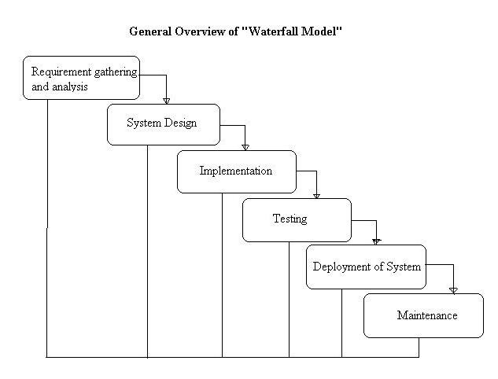

**Figure 1:**

**Why we are using this model:**

* My requirements are clear, well known and fixed.
* Technology is understood.
* Project is short.
* Product definition is stable.
* There are no ambiguous requirements.

**2.2. Tools Requirement**

### In this project we have developed a web based application. It is a dynamic system. It can be maintained and changed easily because it is based on database. Prison management system is developed to computerize process of daily activities with in and our time, daily wages, criminal records, case status etc. These details are available on website which can be visible by higher authorities from any location. This will help higher officials to view records of each prisoner details and take respective actions.. These include Web scripting code, such as PHP. It is fully secured from unauthorized access. In a word it can say that our mobile application is a completely dynamic project. Here we have used waterfall model to create the web based project. We have collected all kinds of information related to this application from the website. It is the one kind of Customized application products. The project background model specially designed on the basis of using certain web programming language **-**

### PHP

### MYSQL

### HTML

### CSS

### JavaScript

* Bootstrap

### XAMPP

**2.3. Feasibility Study**

Feasibility study includes consideration of all the possible ways to provide a solution to the given problem. The proposed solution should satisfy all the user requirements and should be flexible enough so that future changes can be easily done based on the future upcoming requirements.

**2.3.1. Economic Feasibility**

Economic analysis is most frequently used for evaluation of the effectiveness of the system. More commonly it is known as cost/benefit analysis the procedure is to determine the benefit and saving that are expected from a system and compared them with costs, decisions is made to design and implement the system. This part of feasibility study gives the top management the economic justification for the new system. This is an important input to the management the

Management, because very often the top management does not like to get confounded by the various technicalities that bound to be associated with a project of this kind. A simple economic analysis that gives the actual comparison of costs and benefits is much more meaningful in such cases. It is economically feasible, it will only require a single operator to operate the system, who is responsible for entering the data into the database via a user interface provided to him, who can also able to show all the data in html tabular form so to provide information regarding the students who are either taken admission or to take admission, since it requires only a single person to operate the whole system thus reduces the cost to operate the system.

In the system, the organization is most satisfied by economic feasibility. Because, if the organization implements this system, it need not require any additional hardware resources as well as it will be saving lot of time.

**2.3.2. Technical Feasibility**

Technical feasibility centers on the existing manual system of the test management process and to what extent it can support the system. According to feasibility analysis procedure the technical feasibility of the system is analyzed and the technical requirements such as software facilities, procedure, inputs are identified. It is also one of the important phases of the system development activities. It is technically feasible, since the whole system is designed into the latest technologies like PHP and SQL Server which are the most recent technologies to develop web based systems and design databases. The system offers greater levels of user friendliness combined with greater processing speed. Therefore, the cost of maintenance can be reduced. Since, processing speed is very high and the work is reduced in the maintenance point of view management convince that the project is operationally feasible. The system have been developed using PHP, the project is technically feasible for development.

**2.3.3. Operational Feasibility**

It is Operational feasible, since the system is providing an attractive user interface to the operator/end user, so he feel very easy to work onto it. Response to operator/end user is very fast and very good. Since, as we mentioned above that it requires much less amount of cost, it uses computer work so it is very fast to operate and it is very easy for user to work on it. The operational feasibility is the one that will be used effectively after it has been developed. And the integrated prison controlling and monitoring is useful project to be implement and practice the system with the organization. And it is easy to operate after implemented and we say this project is operationally feasible.

**2.4. Software Engineering Paradigms Applied**

The two main programming approaches are top-down approach and bottom-up approaches. Here while doing the software for online placement system; we use the bottom up approach. In bottom up method, the sub modules are designed and developed and these are assembled together to get the main system. The individual modules are coded and debugged with example data given checks ready for the major project design. The individual module transaction processing can be checked thoroughly so that minute mistakes and correction can be passed from one module to other when required and these requisition are also considered at the development stage of code module. These checked and corrected modules will be integrated to make the entire system. This project also followed the bottom up design. The sub modules are prepared very keenly and minute notations are made.

In the prison management system, the sub modules are designed first, these sub modules are integrated into main modules. Other modules also designed in the same fashion. Each module is tested at the beginning when they are integrated with the sub-modules. These checked and corrected modules are integrated to make the main system, i.e. Prison Management System.

**Overview**

* **Requirement Specification**
* Analysis of Actual Data
* Identification of Essential Requirement
* Selection of Requirement Strategies
* **Overview of Prison Management System**
* Overall Description
* Specific Requirements
* **Configuration**
* Hardware Configuration
* Software Configuration

***Overview:*** In this chapter, I will discuss about requirement specification of my project. It also include some information about different equipment’s which is related to the project.

**3.1. Requirement Specification**

The final output is the requirements specification document. For smaller problems or problems that can easily be comprehended; the specification activity might come after the entire analysis is complete. However, it is more likely that problem analysis and specification are done concurrently. The transition from analysis to specification should also not be expected to be straightforward, even if some formal modeling is used during analysis. Essentially, what passes from requirements analysis activity to the specification activity is the knowledge acquired about the system. The modeling is essentially a tool to help obtain a thorough and complete knowledge about the proposed system.

**3.1.1. Analysis of Actual Data**

Analysis of data is a process of inspecting, cleaning, transforming, and modeling data with the goal of highlighting useful information, suggesting conclusions, and supporting decision making. Data analysis has multiple facets and approaches, encompassing diverse techniques under a variety of names, in different business, science, and social science domains.

Data mining is a particular data analysis technique that focuses on modeling and knowledge discovery for predictive rather than purely descriptive purposes.

**3.1.2. Identification of Essential Requirements**

Identification of essential requirement is an important task in developing the project. In this system the essential requirements are identified through surveying. By surveying, the important needs of the user in our website are known. In the surveying, the different possibilities of tour information that have to be included in the website is given by questionnaire. Questions included like:

* Need to change the current prison formalities.
* Is it advantageous

**3.1.3. Selection of Requirement Strategies**

From the survey analysis graph it is clear that which are all the requirements that the user requires the most. It is decided to include the required information and omit the less priority ones.

**3.2. Overview of Prison Management System**

Prison management system will include two sections:

* **Overall Description** will describe major components of the system, interconnection and external interfaces.
* **Specific Requirements** will describe the functions of actors, their role in the system and constraints.

**3.2.1. Overall Description**

The prison management system document will give further details on the overall product description, including the hardware, software, and communications interfaces, product functions, user characteristics, and any assumptions that will be made.

**3.2.2. Specific Requirements**

The prison management system document will also include the specific requirements needed. These will include the functions, performance, design, and software attributes. This document is organized in a logical manner and is easy to follow. Readers should refer to the table of contents, appendices, or index if looking for something in specific. Otherwise, reading this document from start to finish will start with a vague description and get more specific and detailed as changing sections and reading further.

**3.3. Configuration**

In this project we have developed a web based application. It is a dynamic system. It can be maintained and changed easily because it is based on database. Prison management system is developed to computerize process of daily activities with in and our time, daily wages, criminal records, case status etc. These details are available on website which can be visible by higher authorities from any location. This will help higher officials to view records of each prisoner details and take respective actions.. These include Web scripting code, such as PHP. It is fully secured from unauthorized access. In a word it can say that our mobile application is a completely dynamic project. Here we have used waterfall model to create the web based project. We have collected all kinds of information related to this application from the website. It is the one kind of Customized application products.

**3.3.1. Hardware Configuration**

* System : Multimedia PC
* Processor : Dual Core or above
* Memory : 1GB RAM
* Hard Disk : 500GB or above
* Keyboard : 104 standards
* Monitor : SVGA
* Modem : Dial up/Broadband

**3.3.2. Software Configuration**

* Front end : HTML, CSS, JavaScript, Bootstrap
* Back end : MYSQL, PHP,

**Overview**

* **System Design**
* **Design Methodology**
* **Logical Design**
* **Physical Design**
* **Modular Design**
* **Database Design**
* **E-R Diagram**
* **Schema Diagram**
* **Data Flow Diagram**
* **Sequence Diagram**
* **System Implementation**

***Overview:*** In this chapter, I will discuss about ER diagram, Schema diagram, Data Flow Diagram & Sequence Diagram of my project. And I’ll discuss about implementation of Program Code which is the basic part of my project. I also include some information about different equipment’s which is related to the diagram.

**4.1. System Design**

The system design develops the architectural detail required to build a system or product. As in the case of any systematic approach, this software too has undergone the best possible design phase fine tuning all efficiency, performance and accuracy levels. The first step in system designing is to determine how the output is to be produced and in what format. Samples of the output and input are also presented. In the second step, input data and master files are to be designed to meet requirement of the proposed output. The processing phases are handled through program construction and testing, including a list of the programs needed to meet the system’s objectives and complete documentation.

**4.2. Design Methodology**

System design is the solution to the creation of a new system. This phase is composed of several systems. This phase focuses on the detailed implementation of the feasible system. It emphasis on translating design specifications to performance specification. System design has two phases of development logical and physical design. During logical design phase the analyst describes inputs (sources), outputs (destinations), databases (data sores) and procedures (data flows) all in a format that meats the uses requirements. The analyst also specifies the user needs and at a level that virtually determines the information flow into and out of the system and the data resources. Here the logical design is done through data flow diagrams and database design. The physical design is followed by physical design or coding. Physical design produces the working system by defining the design specifications, which tell the programmers exactly what the candidate system must do. The programmers write the necessary programs that accept input from the user, perform necessary processing on accepted data through call and produce the required report on a hard copy or display it on the screen.

**4.2.1. Logical Design**

Logical design of an information system shows the major features and also how they are related to one another. The first step of the system design is to design logical design elements. This is the most creative and challenging phase and important too. Design of proposed system produces the details of the state how the system will meet the requirements identified during the system analysis that is, in the design phase we have to find how to solve the difficulties faced by the existing system. The logical design includes input design, output design, and database design and physical design.

**4.2.2. Physical Design**

The process of developing the program software is referred to as physical design. We have to design the process by identifying reports and the other outputs the system will produce. Coding the program for each module with its logic is performed in this step. Proper software specification is also done in this step.

**4.2.3. Modular Design**

A software system is always divided into several sub systems that makes it easier for the development. A software system that is structured into several subsystems makes it easy for the development and testing. The different subsystems are known as the modules and the process of dividing an entire system into subsystems is known as modularization or decomposition.

A system cannot be decomposed into several subsystems in any way. There must some logical barrier, which facilitates the separation of each module. The separation must be simple but yet must be effective so that the development is not affected.

The system under consideration has been divided into several modules taking inconsideration the above-mentioned criteria. The different modules are

* user module
* administrator module

**4.3. Database Design**

This part shows the Entity Relationship Diagram of the system, Schema Diagram, Data Flow Diagram & Sequence Diagram of the proposed system.

**4.3.1. E-R Diagram**

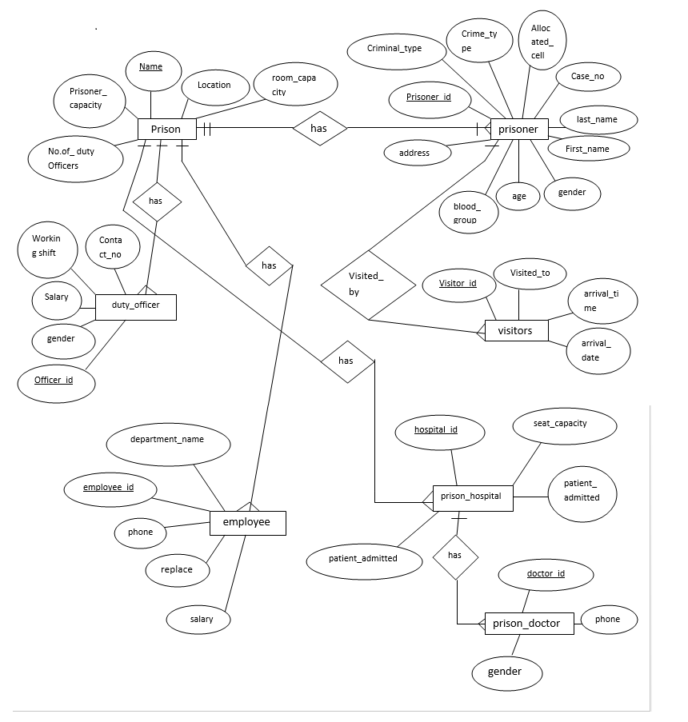

**Figure 2: E-R Diagram**

**4.3.2. Schema Diagram**

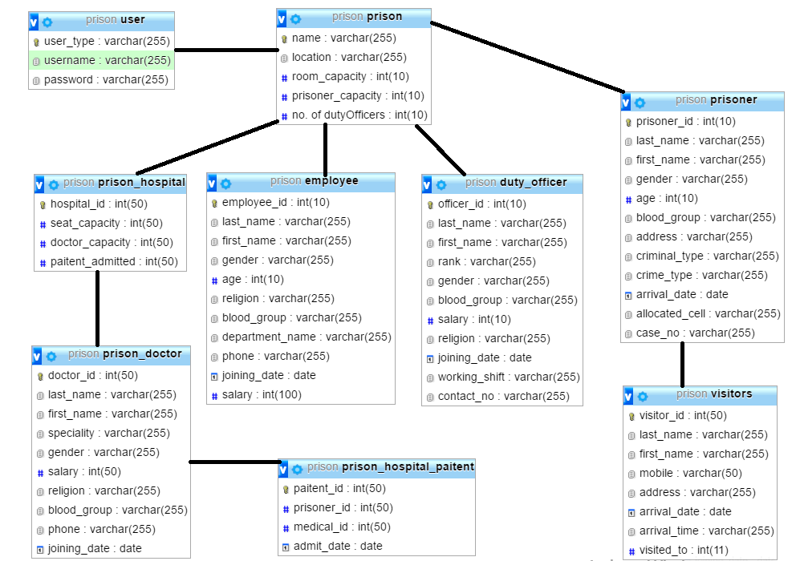

**Figure 3: Schema Diagram**

**4.3.3. Data Flow Diagram**

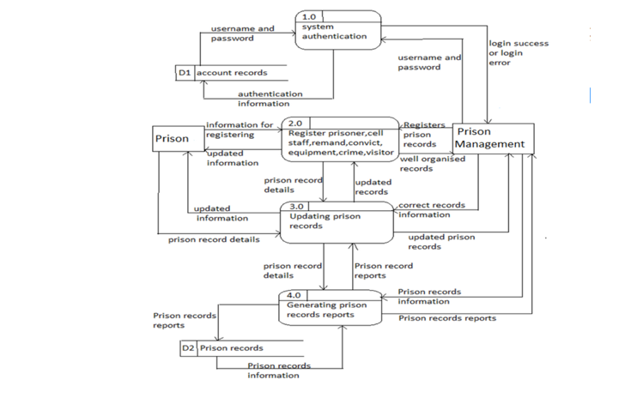

Figure 4:

**4.3.4. Sequence Diagram**

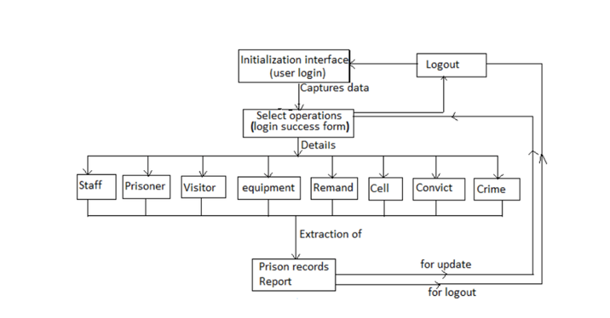

**Figure 5:**

**4.4. Implementation of program code**

Implementation is an activity that is contained throughout the development phase. It is a process of bringing a developed system into operational use and turning it over to the user. The new system and its components are to be tested in a structured and planned manner. A successful system should be delivered and users should have confidence that the system would work efficiently and effectively. The more complex the system being implemented the more involved will be the system analysis and design effort required for implementation.

In the implementation part, different user interfaces will be developed. The objective of implementation includes the development of the following user interface:

* Login system
* Prisoner Registration
* Admin Homepage
* Prisoner List
* Add Duty Officer
* Search Prisoner by ID
* Examinee Registration
* Duty Officer List
* Delete Duty Officer
* Add Employee
* Employee List
* Delete Employee
* Add Doctor
* Doctor List
* Delete Doctor
* Visitor Registration
* Visitor List

The coding part will help to create the above user interfaces. This part will be accomplished using PHP, HTML, CSS, Java Script & Bootstrap framework will be used. For storing data MySQL database will be used.

**Login System**

In the login administrator will be able to log in if he has the username and password. This process will lead them forward to the admin homepage. Selection of different button will open different section while the user is logged in.

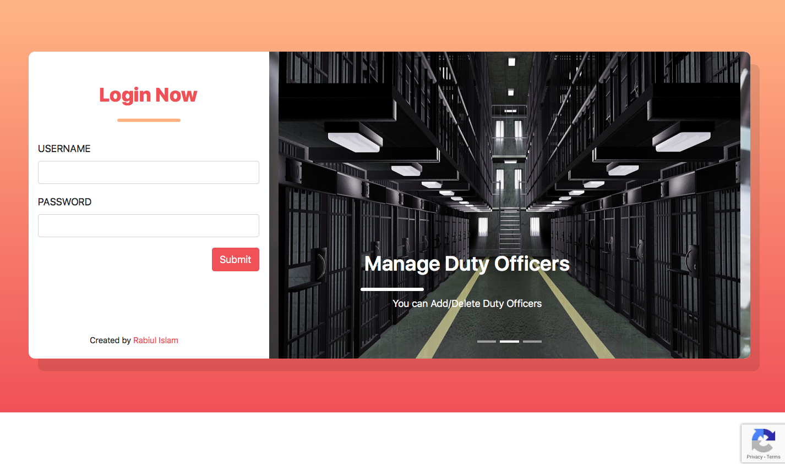

**Figure 6: Login System**

**Admin Homepage**

Admin members have all the access. They can update this database, they can check, they can add or delete. In this section admin will see some feature. These features are given below:

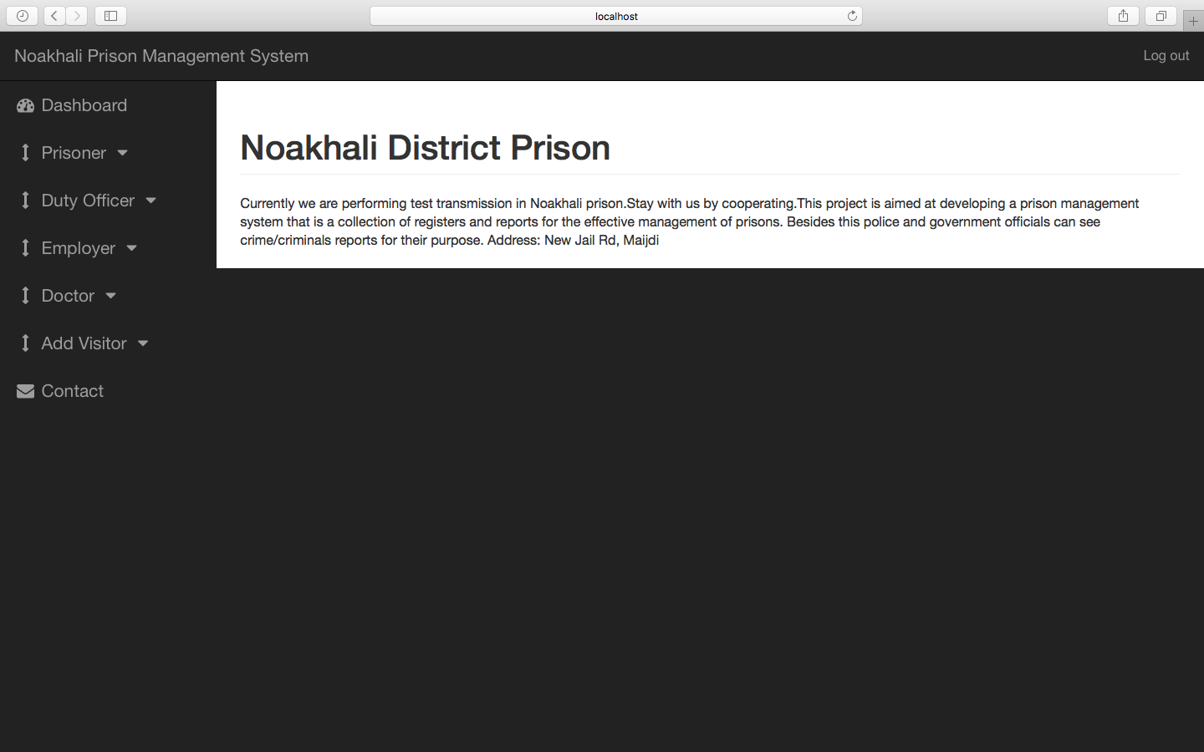

**Figure 7: Admin Homepage**

**Prisoner Registration**

All the basic information of every prisoners will be stored there. Their prisoner id, first name, last name, gender, age, blood group. Admin can add up a new prisoner in this database or delete anyone out from this database or can simply search a prisoner by their unique id.

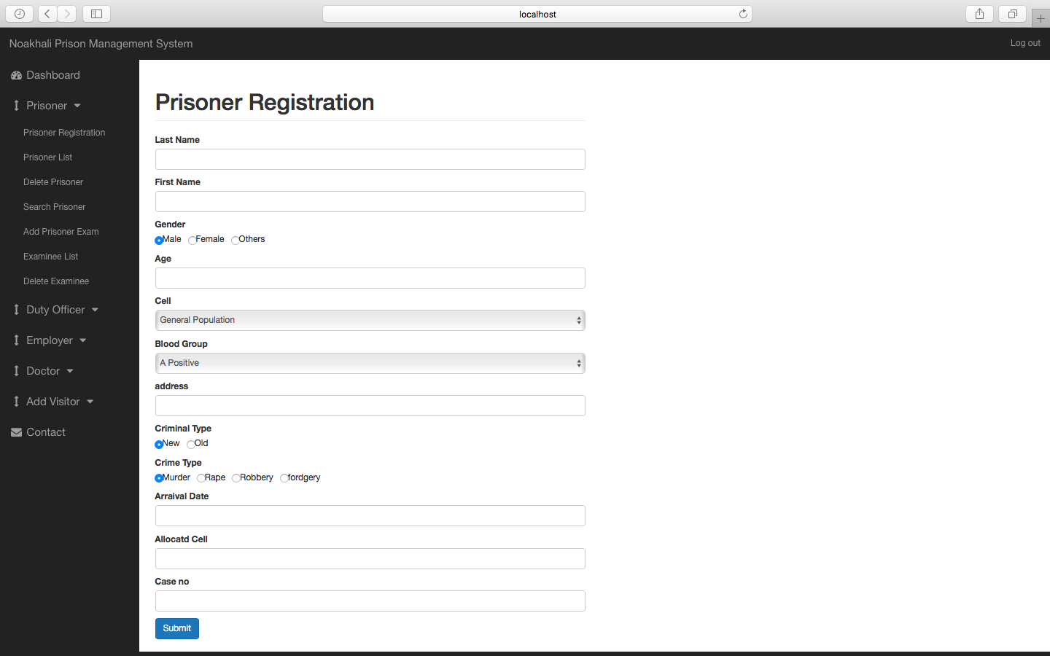

**Figure 8: Prisoner Registration**

**Search Prisoner**

If any prisoners specific information needed then this search option can be used for retrieving all

Data of a specific prisoner.

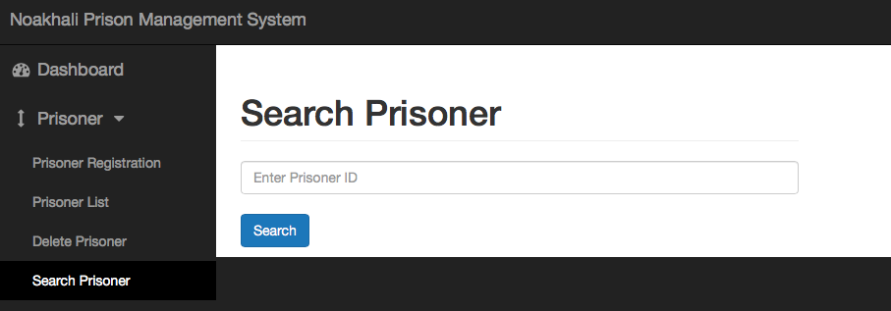

**Figure 9: Search Prisoner**

**Add Duty Officer**

Prisoner has its duty officers. Admin can add basic data of a duty officer such as Name, id, blood group, salary, religion, joining date, work shift, contact no etc.

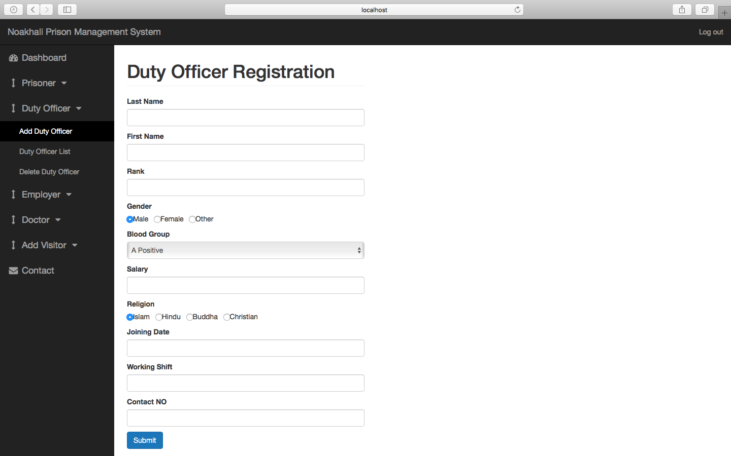

**Figure 10: Duty Officer Registration**

**Detele Duty Officer**

A prisoner can be deleted from this section if anyone dies or removed or transferred.

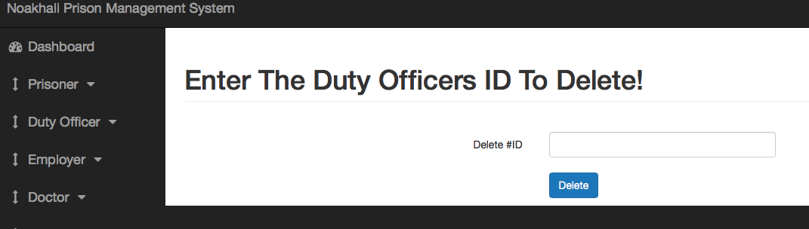

**Figure 11: Delete Duty Officer from List**

**Examinee Registration**

All the basic information of every prisoner’s examinee will be stored there. Their prisoner id, name, date and exams will be included. Admin can add up a new prisoner examinee in this database or delete anyone out from this database or can simply search a prisoner by their unique id.

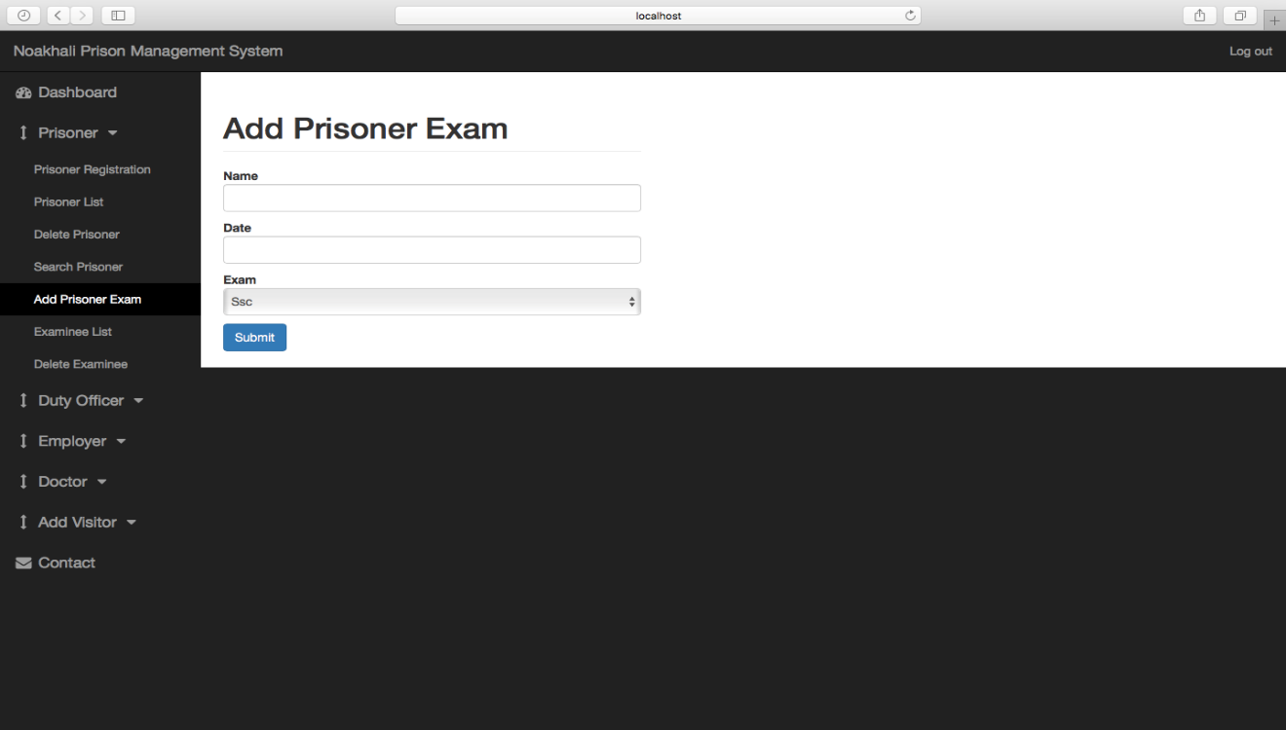

**Figure 12: Examinee Registration**

**Delete Examinee**

A prisoner can be deleted from this section if anyone dies or removed or transferred**.**

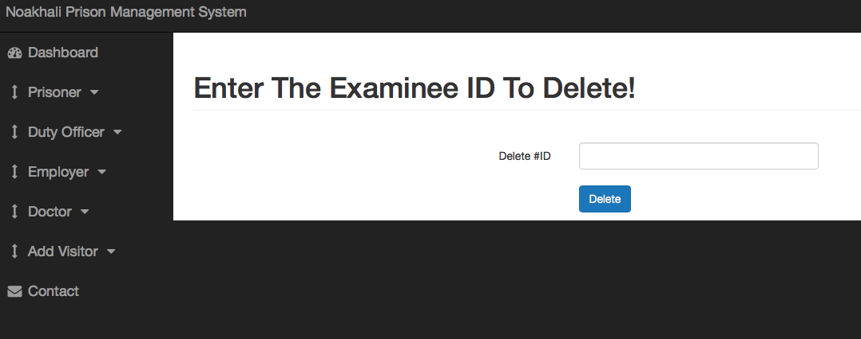

**Figure 13: Delete Examinee from List**

**Employee Registration**

Prisoner has its employees. Admin can add basic data of an employee such as Name, id, blood group, salary, religion, joining date, work shift, contact no etc.

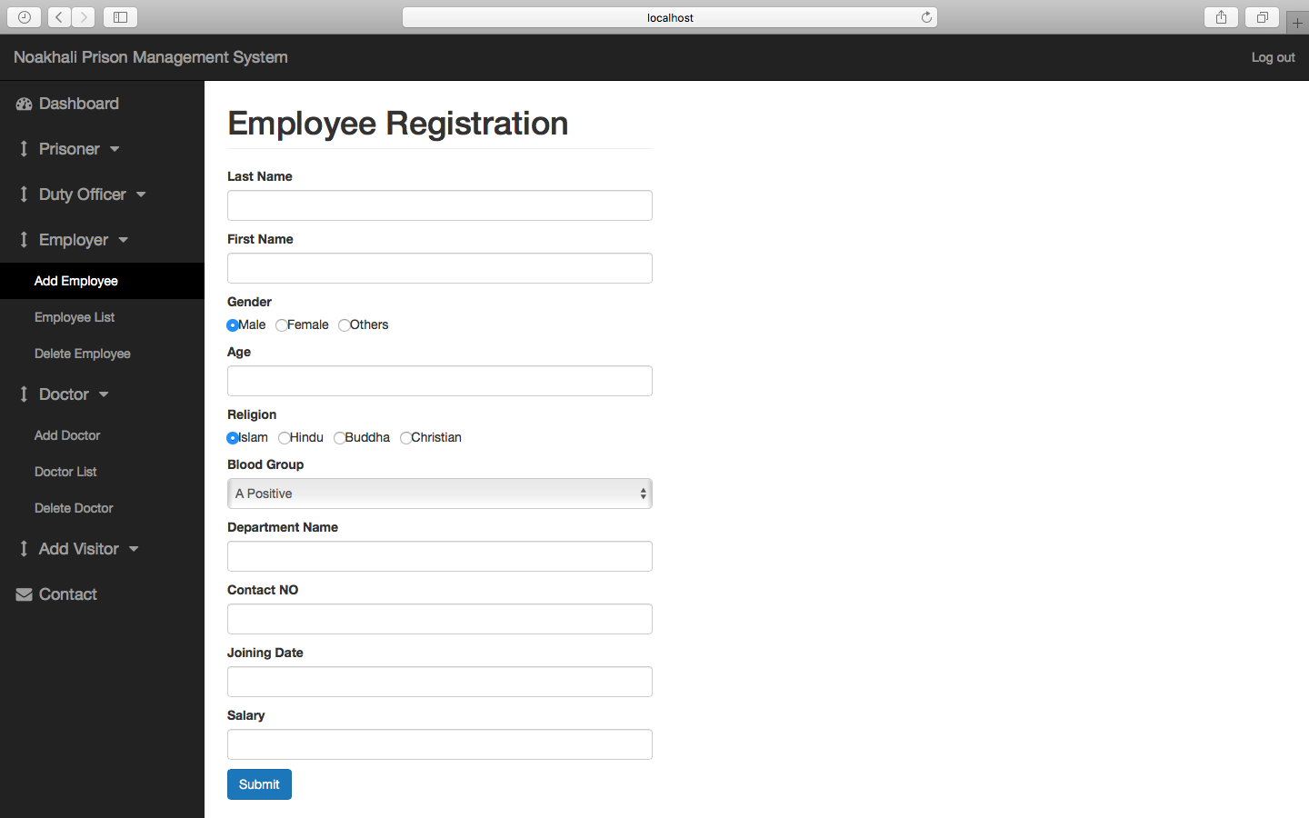

**Figure 14: Employee Registration**

**Delete Employee**

Employee can be deleted from here by the unique id if needed.

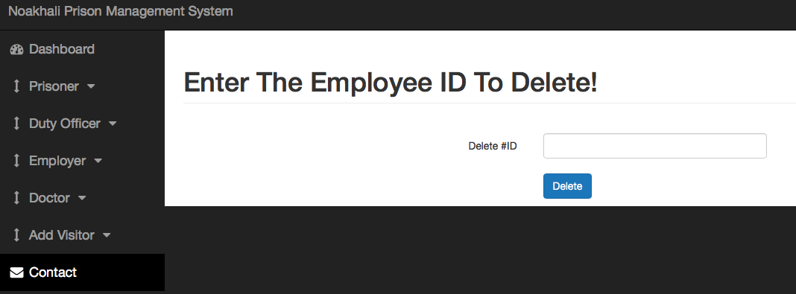

**Figure 15: Delete Employee from List**

**Doctor Registration**

Prisoner doctor’s information will be added here.

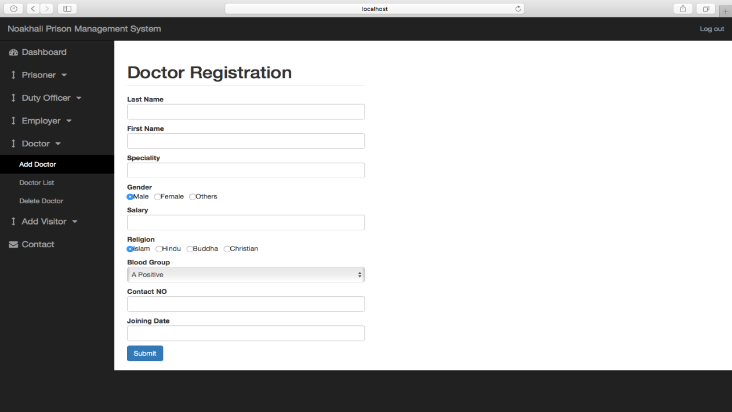

**Figure 16: Doctor Registration**

**Delete Doctor**

Doctor list can be deleted from here by the unique id if needed.



**Figure 17: Delete Doctor from List**

**Visitor Registration**

If anyone comes to visit to a prisoner then his information will be added here.

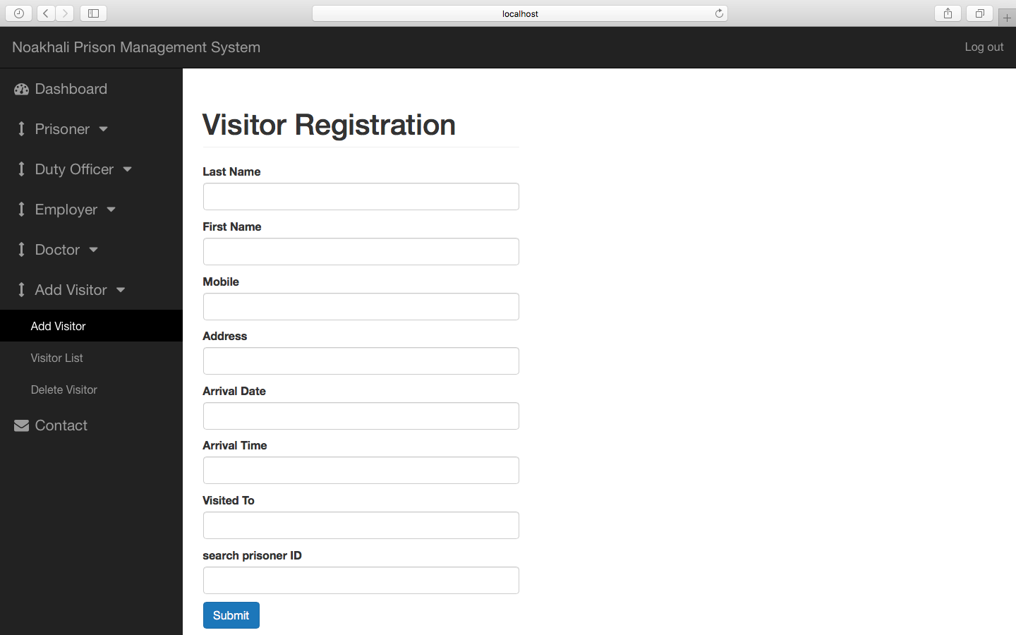

**Figure 18: Visitor Registration**

**Delete Visitor**

Employee can be deleted from here by the unique id if needed.

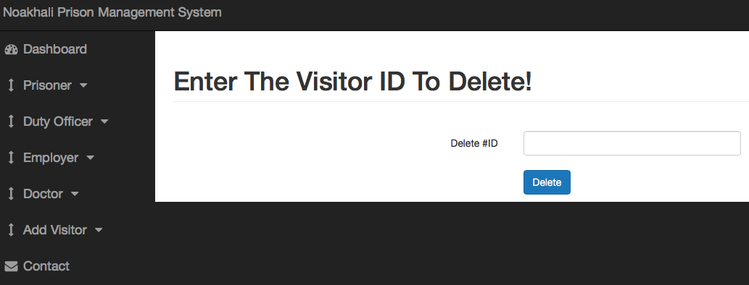

**Figure: Delete Visitor from List**

**Overview**

* **Basic Testing**
* Static Testing
* Dynamic Testing
* White box Testing
* Black box Testing
* **Maintenance**

***Overview:*** In this chapter, I will discuss about Testing. A Test Plan can be defined as a document describing the scope, approach, resources, and schedule of intended Testing activities. A project may fail without a complete Test Plan. In software testing, a test plan gives detailed testinginformation regarding an upcoming testing effort, including Test Strategy.

**5.1. Basic Testing**

Software testing is a critical element of the software development cycle. The testing is essential for ensuring the Quality of the software developed and represents the ultimate view of specification, design and code generation. Software testing is defined as the process by which one detects the defects in the software. Testing is a set of activities that work towards the integration of entire computer based system. A good test case is one that has a high probability of finding an as-yet a discovered error. A successful test is one such uncovers or finds such errors. If testing is conducted successfully, it will uncover errors in the software. It also demonstrates that software functions are being performed according to specifications and also behavioral and performance requirements are satisfied. For this, test plans have to be prepared. The implementation of a computer system requires that test data has to be prepared and that all the elements in the system are tested in a planned and efficient manner. Nothing is complete without testing, as it is vital success of the system.

To make the system reliable several testing will be carried out

**5.1.1. Static Testing (Program is not run)**

* Can use Inspection
* Can use Formal Verification

**5.1.2. Dynamic Testing (Program is executed)**

Program is tested with test data Test data is selected dependent on the style of test There are two basic types of testing:

**5.1.3. White box Testing**

* Where the structure of the code is known.
* Typically undertaken by the developer of the code.
* Test code on module by module basis moving toward the complete system.
* Consider the internals of the modules that make up the program.
* Test the logical paths through the software with test cases that apply to conditional statements and loops.
* However we cannot for many modules carry out exhaustive testing.

**5.1.4. Black box Testing**

* Tests all of the code according to the functional specification.
* Typically undertaken by a separate authority.
* Black box testing focuses on the functionality of the software rather than is structure, as in white box testing.
* The set of tests are derived by considering the Requirement Specification for the software.
* In general, White box testing is performed early in the testing stage where Black box testing toward the end.

**5.2. Maintenance**

Maintenance involves the software industry captive, typing up the system resources. It means restoring something to its original condition. Maintenance involves a wide range of activities including correcting, coding, and design errors, updating documentation and test data and upgrading user support. Maintenance is continued till the product is re-engineered or deployed to another platform. Maintenance is also done based on fixing the problems reported, changing the interface with other software or hardware enhancing the software.

For the betterment of the project the following maintenance will be carried out:

* Corrective maintenance
* Adaptive maintenance
* Perfective maintenance

This 3 types of software maintenance helpful to repair defects in the software, maintenance to adapt the software in new operating environment & maintenance to add or modify the functionality of the system.

**Overview**

* **Conclusion**
* **Limitations**
* **Future Work**

**Overview:** In this chapter, I will try to draw a conclusion of my project. For this I will focus on Limitations and future work of this project.

**6.1. Conclusion**

This system, being the first we have created in PHP, has proven more difficult than originally imagined. While it may sound simple to fill out a few forms and process the information, much more is involved in the selection of applicants than this. Every time progress was made and features were added, ideas for additional features or methods to improve the usability of the system made themselves apparent. Furthermore, adding one feature meant that another required feature was now possible, and balancing completing these required features with the ideas for improvement as well as remembering everything that had to be done was a project in itself.

Debugging can sometimes be a relatively straight forward process, or rather finding out what you must debug can be. Since so many parts of the admissions system are integrated into one another, if an error occurs on one page, it may be a display error, for example; it may be the information is not correctly read from the database; or even that the information is not correctly stored in the database initially, and all three must be checked on each occasion. This slows down the process and can be frustrating if the apparent cause of a problem is not obvious at first. Language used must be simple and easy to understand and compatibility is paramount. If this system were not designed as an entirely web based application, it would not have been possible to recreate its current state of portability.

Overall, the system performs well, and while it does not include all of the features that may have been desired, it lives up to initial expectations. The majority of features that are included work flawlessly and the errors that do exist are minor or graphical. As the Technology is growing day by day, hour by hour very fast we have to use those growing technologies to the best. My system provides different services like easy access to users, efficient management, clear productivity & feedback summary. So the outcome of all the-the hard work did for prison management system is here. It is a software which helps the user to work with the prisons easily. This software reduces the amount of manual data entry and gives greater efficiency.

The User Interface of it is very friendly and can be easily used by anyone. It also decreases the amount of time taken to write FIR details and other modules.

At the end, we can say that this software is performing all the tasks accurately and is doing the work for which it is made.

**6.1.1. Limitations**

This research is based on prison management, but the system to design will be limited to the prisoners record keeping i.e. how the prison record can be stored, edited, updated and the security of the records. This system is only used for local district prison/jail. It is not applicable for the central prison. This is not a fully dynamic system. The features of the new system are as follows.

* + It has segment that handles prisoner’s family information.
  + It stored prisoner’s profile.
  + It entails inmate court information.
  + It stores prisoner’s information.
  + It stores prisoner’s criminal records

**6.1.2. Future Work**

The system scope of the prison is to attend to the welfare of prisoners and updating of information and enhance-the criminal investigation research e.tc the general information system will help to ensure that up to-dated individual information of every prisoner is being maintained such as the cell number and other personal information relating to his date of release, how to locate such inmate and make him/ her available.

The future scope of this project is very broad. Few of them are:

* This can be implemented in less time for prison management process.
* This can be accessed anytime anywhere by the administrator, since it is a web application provided only an internet connection for authentication.
* Can be upgraded with new features like sms alerts for the guards and supervisors regarding their job shift time
* The administrator can give feedback of corresponding work sections, after analyzing overall productivity details.
* PMS can be extended with regional language support for ease of access to users.

**Overview**

* **References**

**Overview:** In this Section, I will include some of References from where I was gathered all of this datas and informations of this project work.

**7.1. References**

[1] Goa launches country's first jail monitoring system, Times of India, Issue Feb 20, 2009,<http://articles.timesofindia.indiatimes.com/2009-02-20/goa/28028101_1_sada-sub-jail-manohar-parrikar-video-conferencing-facility>

[2] Prison Management System, <http://www.powershow.com/view/15e0bc-MTExN/Prison_Management_System_PRISMS_flash_ppt_presentation>

[3] Goa Electronics Website, [http://www.goaelectronics.co.in/Prisms.html](http://www.goaelectronics.co.in/prisms.aspx)

[4] Internet Society, Award Document, [www.csi-sigegov.org/ppts2/PRISMS.ppt](http://www.csi-sigegov.org/ppts2/PRISMS.ppt)

[5] 'No modern structure for prison in state', <http://articles.timesofindia.indiatimes.com/2009-10-17/goa/28088647_1_prison-department-goa-electronics-limited-e-governance>

[6] Government department analysis of e-governance application, <http://www.mit.gov.in/sites/upload_files/dit/files/State%20-%20Goa.pdf>

[7] PRISMS, Mantuan Award documentation, [www.defindia.net](http://www.defindia.net/)

[8]. STATE OF MICHIGAN, RECORDS MANAGEMENT MANUAL FOR LOCALGOVERNMENTS, Records Management Services, July 27, 2010.

[9] J. Douglas Walker Consultant, Knowledge and Information Services, National Center for State Courts

[10] http://www.egovonline.net/articles-list/47-features/8109-prison-management-and-visitor-management-system.html

[12] Search engine optimization. (2018, July 15). Retrieved from <https://en.wikipedia.org/wiki/Search_engine_optimization>.

[13] W3Schools. (2018, July 15). Retrieved from <https://en.wikipedia.org/wiki/W3Schools>.

[14] D. Jahan, 2018. [Online]. Available: http://www.trainingwithliveproject.org. [Accessed: 17- Nov- 2018].

[15] Silberschatz, A., Korth, H. F., & Sudarshan, S. (2011). *Database system concepts*. New York: McGraw Hill.

[16] Welling, L., Thomson, L., & Base, O. (2017). *Istrovství PHP a MySQL*. Brno: Computer.

[17] Meloni, J. C. (2006). *Sams teach yourself PHP, MySQL and Apache all in one*. Indianapolis, IN: Sams.

[18] PHP. (n.d.). Retrieved July 15, 2018, from <http://www.php.net.com/>