Laxmi Charitable Trust’s
Sheth L.U.J College of Arts & Sir M.V. College of Science and Commerce
Department of Information Technology (B.Sc.I.T Semester V)
AI and Application Development and Jira

AI MINI PROJECT
MovieMind AI
AI Movie Recommendation System

Particular | Details
Student Name
Roll No.
Class / Batch | TYIT
Subject | AI and Application Development and Jira
Academic Year | 2026 - 2027

Submitted to: Prof. Chetana Tanavade

Introduction:
The MovieMind AI Movie Recommendation System is a Flask-based web application that uses Artificial Intelligence and Machine Learning techniques to recommend movies similar to a movie selected by the user.
The system uses movie genre and description as content features. These text features are converted into numerical representations using TF-IDF (Term Frequency-Inverse Document Frequency), and cosine similarity is then used to measure how similar one movie is to the others. The application displays the most similar movies together with their genres, descriptions, and an AI Match percentage.
The project provides a simple demonstration of how Natural Language Processing, Machine Learning, Python and Flask can be integrated to create a practical movie discovery website.

Problem Statement:
To develop an AI-based web application that analyzes movie information such as genre and description and recommends movies similar to a user-selected movie using TF-IDF and cosine similarity, thereby helping users discover relevant movies quickly.

Objectives:
- To create a sample movie dataset containing movie titles, genres and descriptions.
- To use movie genre and description as content features.
- To apply TF-IDF vectorization to convert movie text into numerical features.
- To calculate movie similarity using cosine similarity.
- To generate a ranked list of similar movies.
- To provide movie recommendations through a Flask web application.
- To display the similarity-based AI Match percentage for each recommendation.
- To create a simple and user-friendly website interface.

Technologies Used:
Technology / Component | Purpose
Programming Language | Python
Framework | Flask
Machine Learning Library | Scikit-learn
NLP Technique | TF-IDF Vectorization
Similarity Technique | Cosine Similarity
Front-End | HTML & CSS
Development Tool | Visual Studio Code
Web Browser | Chrome / Edge / Firefox

Dataset:
Source: The movie dataset is created directly within the project code in recommender.py. It is not an externally downloaded dataset.
Dataset Property | Details
Dataset Name | Sample Movie Dataset
Number of Records | 24 movies
Storage | Built into recommender.py
Input / Content Features | Genre and Description
Identifier | Movie Title
Recommendation Type | Content-Based Recommendation

The dataset contains movies from several categories such as:
- Science Fiction
- Action and Adventure
- Drama
- Romance
- Comedy
- Animation
- Biography
- Sport
- Crime
- Family

Dataset Attributes:
Attribute | Description
Title | Name of the movie.
Genre | Genre or category information associated with the movie.
Description | Short text describing the movie story or theme.

Dataset Distribution:
Movie Category / Theme | Examples in Dataset
Science Fiction | Inception, Interstellar, The Matrix, Avatar, The Martian, Gravity
Action / Adventure | Avengers: Endgame, Iron Man, Guardians of the Galaxy
Drama | The Shawshank Redemption, The Pursuit of Happyness, Forrest Gump
Romance | Titanic, The Notebook, La La Land
Indian Cinema | 3 Idiots, Dangal, PK, Drishyam, Taare Zameen Par
Animation | Spider-Man: Into the Spider-Verse

Methodology / Working:
- A sample movie dataset is created inside recommender.py.
- The genre and description of every movie are combined into one text feature.
- The combined movie text is processed using TfidfVectorizer from Scikit-learn.
- The TF-IDF vectorizer converts the movie text into numerical feature vectors.
- Cosine similarity is calculated between the feature vectors of all movies.
- The Flask application displays the available movie titles on the website.
- The user selects one movie from the movie selection interface.
- The selected movie is located in the dataset.
- The similarity scores for the selected movie are sorted from highest to lowest.
- The selected movie itself is skipped and the top six similar movies are returned.
- The website displays the recommendations with genre, description and AI Match percentage.

Working Flow:
User Selects Movie → Flask Application → Movie Genre + Description → TF-IDF → Cosine Similarity → Similarity Ranking → Top Recommendations → Website Output

Algorithm Used:
The project uses a content-based recommendation approach based on TF-IDF vectorization and cosine similarity.

1. TF-IDF Vectorization
TF-IDF stands for Term Frequency-Inverse Document Frequency. It is a Natural Language Processing technique used to represent text documents as numerical vectors. In this project, each movie's genre and description are treated as a document. TF-IDF gives greater importance to words that are useful for distinguishing one movie from another.

2. Cosine Similarity
Cosine similarity measures the similarity between two numerical vectors by calculating the cosine of the angle between them. A higher similarity value means the movie descriptions contain more similar content. The project uses these scores to rank recommended movies.

Why is it used?
- It works well with text-based movie information.
- It is simple and suitable for a small academic recommendation system.
- It does not require user ratings to generate initial recommendations.
- It provides a direct similarity score that can be displayed as an AI Match percentage.

Implementation:

Step 1: Movie Dataset
MOVIES = [
{"title": "Inception", "genre": "Sci-Fi Thriller",
"description": "A skilled thief enters dreams..."},
...
]
The project stores the movie records as Python dictionaries in recommender.py.

Step 2: Combine Movie Features
FEATURE_TEXT = [
movie["genre"] + " " + movie["description"]
for movie in MOVIES
]
Genre and description are combined so that both types of information contribute to the similarity calculation.

Step 3: Create TF-IDF Matrix
VECTORIZER = TfidfVectorizer(stop_words="english")
FEATURE_MATRIX = VECTORIZER.fit_transform(FEATURE_TEXT)

Step 4: Calculate Similarity Matrix
SIMILARITY_MATRIX = cosine_similarity(FEATURE_MATRIX)

Step 5: Generate Recommendations
scores = sorted(
enumerate(SIMILARITY_MATRIX[idx]),
key=lambda x: x[1],
reverse=True
)
The similarity values are sorted in descending order. The selected movie is excluded, and the six highest-scoring movies are returned.

Step 6: Flask Web Application
from flask import Flask, render_template, request
app = Flask(__name__)
@app.route("/")
def home():
return render_template("index.html", movies=get_movie_titles())
The Flask application connects the recommendation engine with the website interface. The user submits a movie selection and the application renders the recommendation results.

Input Form:
The website provides a movie selection interface. The user selects one movie from the available movie list and submits the selection. No numerical values or complex configuration is required.
Input | Description | Example
Movie | Movie selected by the user. | Inception
Input Type | Selection from available movie list. | Dropdown / Selection

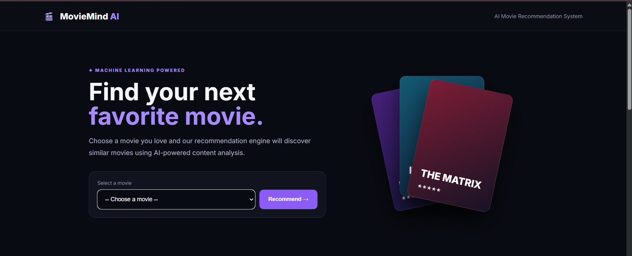

Recommendation Output:
After the user selects a movie, the application displays a list of similar movies. Each recommendation contains the movie title, genre, short description and an AI Match percentage.
Output Field | Description
Recommended Movie | Movie selected as a similar recommendation.
Genre | Genre of the recommended movie.
Description | Short description of the recommended movie.
AI Match | Similarity score converted to a percentage for display.

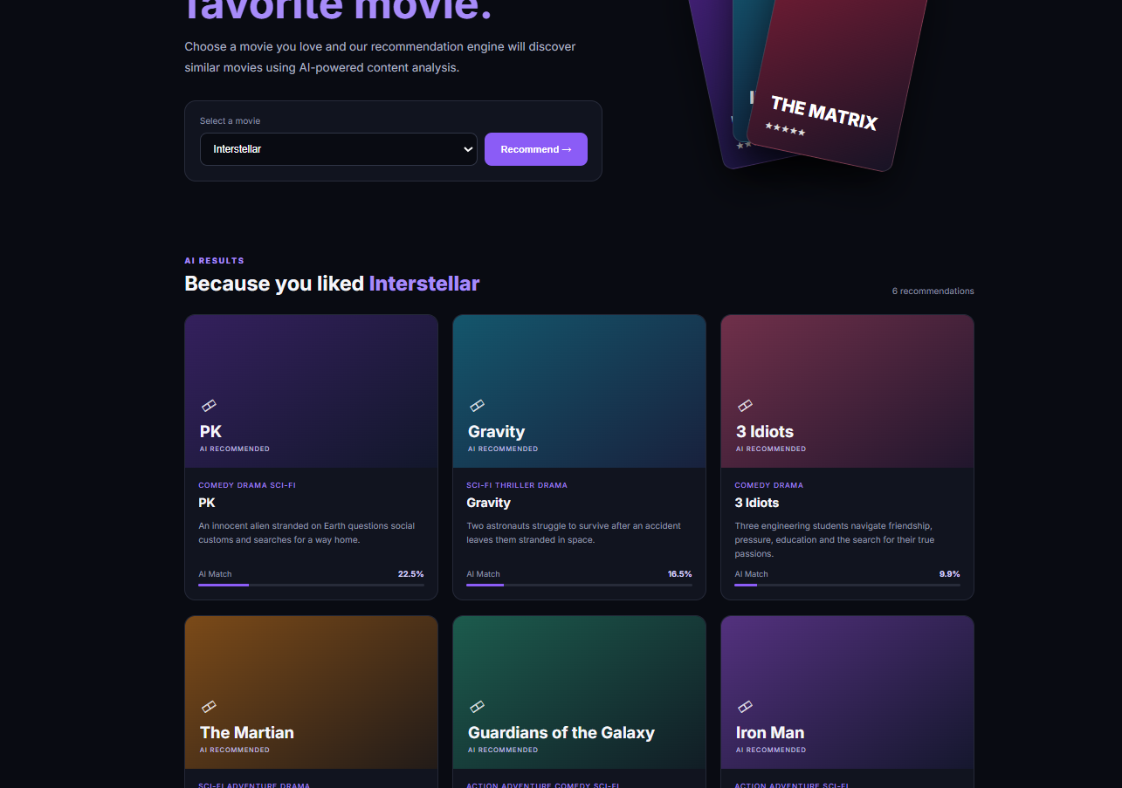

Results:
The developed Flask application successfully accepts a movie selection and generates content-based movie recommendations. The system compares the selected movie with all other movies in the built-in dataset and ranks them according to cosine similarity.
Input
- The user selects a movie from the available movie list.
Output
- The system displays the top six similar movies.
- Each recommendation contains title, genre and description.
- Each recommendation displays an AI Match percentage based on cosine similarity.

Example:
For example, when the user selects “Inception”, the system analyzes its genre and description. Movies containing similar science-fiction, thriller, technology or related story concepts receive higher similarity scores and are placed higher in the recommendation list.
Selected Movie | Recommendation Type | Displayed Result
Inception | Content similarity | Top similar movies ranked by cosine similarity
Titanic | Content similarity | Top similar romance / drama movies
3 Idiots | Content similarity | Top similar comedy / drama movies

AI Match Percentage:
The AI Match percentage is calculated from the cosine similarity value between the selected movie and the recommended movie. For example, a similarity value of 0.75 may be displayed as 75.0%.
Important: The AI Match percentage is a similarity score and should not be interpreted as the accuracy of the recommendation system.

Performance:
The current project does not calculate recommendation-system evaluation metrics such as Precision@K, Recall@K, F1-score, Mean Average Precision, NDCG or user satisfaction. Therefore, an overall accuracy percentage should not be added to the documentation unless a separate evaluation dataset and evaluation procedure are implemented.
Performance Aspect | Current Project
Recommendation Method | Content-based similarity
Formal Accuracy | Not calculated
Precision / Recall | Not calculated
Evaluation Dataset | Not separately implemented
Similarity Score | Calculated using cosine similarity

Advantages:
- Provides quick movie recommendations.
- Uses Artificial Intelligence / Machine Learning concepts.
- Uses Natural Language Processing through TF-IDF.
- Uses cosine similarity for content comparison.
- Simple and user-friendly web interface.
- Does not require user ratings for the basic recommendation process.
- Easy to understand and demonstrate as an academic AI project.
- Can be extended with a larger real-world movie dataset.

Limitations:
- The dataset contains only 24 movies.
- The dataset is a sample dataset created within the project.
- Recommendations depend on the quality of movie descriptions.
- The system does not use user ratings or personal watch history.
- The system does not currently provide personalized recommendations for individual users.
- Movie information is not retrieved from a live external movie API.
- The current project does not perform formal recommendation-quality evaluation.

Applications:
The system can be used as a prototype for:
- Movie discovery websites
- Entertainment recommendation systems
- Streaming-platform recommendation prototypes
- Content discovery applications
- Academic AI / ML projects
- Natural Language Processing demonstrations
- Future personalized entertainment systems

Screenshots to Include:
- 1. Project Folder / VS Code – Show app.py, recommender.py, templates and static folders.
- 2. MovieMind AI Home Page – Show the main website interface.
- 3. Movie Selection – Show the selected movie before recommendation.
- 4. Recommendation Results – Show recommended movies and AI Match percentages.
- 5. Terminal / Flask Server – Show the Flask application running at http://127.0.0.1:5000.

Conclusion:
The MovieMind AI Movie Recommendation System was successfully developed as a Flask-based Artificial Intelligence and Machine Learning web application.
The system uses movie genre and description as content information and applies TF-IDF vectorization followed by cosine similarity to identify movies that are similar to the movie selected by the user.
The project demonstrates the integration of Artificial Intelligence, Natural Language Processing, Machine Learning, Python, Scikit-learn, HTML, CSS and Flask to create a practical movie recommendation website.

Future Scope:
The project can be improved by:
- Using a larger real-world movie dataset.
- Integrating a movie API for live movie details, posters, ratings and release information.
- Adding user registration and login.
- Storing user ratings, likes, dislikes and watch history.
- Developing a hybrid recommendation system using collaborative filtering and content-based filtering.
- Adding actor, director, language, year and genre filters.
- Adding movie search and autocomplete.
- Adding formal recommendation evaluation metrics such as Precision@K and Recall@K.
- Adding a database such as SQLite, MySQL or PostgreSQL.
- Adding graphical analytics and recommendation history.
- Deploying the application online.
- Developing a mobile application version.

References:
- Python documentation – Python programming language.
- Flask documentation – Python web application framework.
- Scikit-learn documentation – TfidfVectorizer.
- Scikit-learn documentation – cosine_similarity.
- Project source code – MovieMind AI Movie Recommendation System.

Github Link:

