**1.3.1 Introduction to Agents**

An agent acts in an environment.

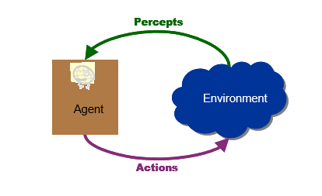

An agent perceives its environment through sensors. The complete set of inputs at a given time is called a percept. The current percept, or a sequence of percepts can influence the actions of an agent. The agent can change the environment through actuators or effectors. An operation involving an effector is called an action. Actions can be grouped into action sequences. The agent can have goals which it tries to achieve.

Thus, an agent can be looked upon as a system that implements a mapping from percept sequences to actions.

A performance measure has to be used in order to evaluate an agent.

An autonomous agent decides autonomously which action to take in the current situation to maximize progress towards its goals.

**1.3.1.1 Agent Performance**

An agent function implements a mapping from perception history to action. The behaviour and performance of intelligent agents have to be evaluated in terms of the agent function.

The ideal mapping specifies which actions an agent ought to take at any point in time.

The performance measure is a subjective measure to characterize how successful an agent is. The success can be measured in various ways. It can be measured in terms of speed or efficiency of the agent. It can be measured by the accuracy or the quality of the solutions achieved by the agent. It can also be measured by power usage, money, etc.

**1.3.1.2 Examples of Agents**

1. Humans can be looked upon as agents. They have eyes, ears, skin, taste buds, etc. for sensors; and hands, fingers, legs, mouth for effectors.

2. Robots are agents. Robots may have camera, sonar, infrared, bumper, etc. for sensors. They can have grippers, wheels, lights, speakers, etc. for actuators.

Some examples of robots are Xavier from CMU, COG from MIT, etc.

Xavier Robot (CMU)

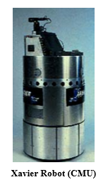

Then we have the AIBO entertainment robot from SONY.

Aibo from SONY

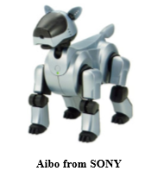

3. We also have software agents or softbots that have some functions as sensors and some functions as actuators. Askjeeves.com is an example of a softbot. 4. Expert systems like the Cardiologist is an agent. 5. Autonomous spacecrafts. 6. Intelligent buildings.

**1.3.1.3 Agent Faculties**

The fundamental faculties of intelligence are • Acting • Sensing • Understanding, reasoning, learning

Blind action is not a characterization of intelligence. In order to act intelligently, one must sense. Understanding is essential to interpret the sensory percepts and decide on an action. Many robotic agents stress sensing and acting, and do not have understanding.

**1.3.1.4 Intelligent Agents**

An Intelligent Agent must sense, must act, must be autonomous (to some extent),. It also must be rational.

AI is about building rational agents. An agent is something that perceives and acts. A rational agent always does the right thing.

1. What are the functionalities (goals)?

2. What are the components?

3. How do we build them?