We will import the files into one drive and place the files in source folder.

Read the field and process and move to target folder after process.

Convert the leads in given format and review and push to career.desss.com / chiliadstaffing.com

Then place in site for new jobs posting.

Match if any candidates are available.

Contact each other and start placement

Indeed.com leads as well. We worked on indeed.com earlier to process the leads. We need to bring into our system and edit and upload and match resumes and contact employer and talents.

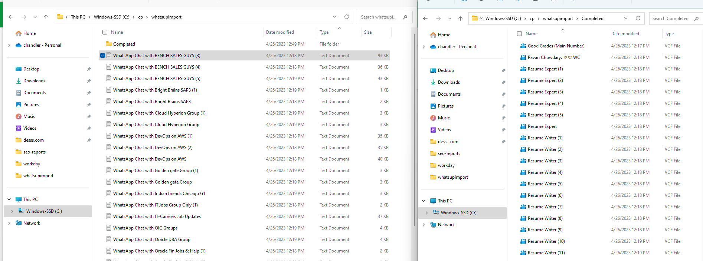

Check the above. I have 2 folder.

1. Source imported from whatsup group
2. After upload move to completed folder
3. Graphical user interface, text, application, email

   Description automatically generated

WhatsApp Chat with BENCH SALES GUYS (3)

Moved to completed folder.

