AI JOB REPLACEMENT & WORKFORCE SKILL SHIFT
A DATA VISUALIZATION STUDY USING TABLEAU & EXCEL
Exploring the impact of Artificial Intelligence on workforce transformation across industries and job roles.

My Name: Rableen Kaur Kapoor
Course name: Data Visualization
Professor Name: Sharath Kumar
University: Saint Peter’s University
Date: 03/25/2026
Dataset Source: Kaggle – AI Job Replacement & Workforce Skill Shift Dataset

ANALYSIS FLOW –
- Understanding the dataset structure and variables
- Exploring automation risk patterns
- Comparing industries and job roles
- Analyzing relationships between key variables
- Deriving workforce insights and implications

ABSTRACT –
This dataset provides a comprehensive and structured analysis of global workforce transformation driven by Artificial Intelligence (AI) between 2020 and 2026. It captures how automation risk, AI adoption, and technological disruption influence job roles, industries, salary structures, and evolving skill demands across multiple countries.
The dataset enables in-depth analytical exploration of workforce automation exposure, reskilling pressure, and economic shifts caused by AI integration. By combining multiple workforce indicators, it offers valuable insights into how technological advancements are reshaping employment patterns, decision-making, and future workforce strategies.

OVERVIEW AND NATURE OF THE DATASET -
The AI Job Replacement & Workforce Skill Shift dataset focuses on analyzing AI-driven job displacement risk and workforce skill transition across industries and countries over a six-year period (2020–2026).
The dataset consists of approximately 15,000 observations (rows) and 20+ variables (features/columns), making it a robust and comprehensive dataset suitable for detailed analytical exploration, visualization, and predictive modeling.
It is a structured, mixed-type dataset, containing both categorical and numerical variables:
- Categorical variables include job role, industry, country, year, and automation risk category (Low / Medium / High), enabling segmentation and comparative analysis across sectors and regions.
- Numerical variables include automation risk percentage, salary before and after AI impact, skill demand growth rate, AI adoption level, wage volatility index, reskilling urgency score, and AI disruption intensity. These variables support statistical analysis, trend identification, and modeling of workforce transformation dynamics.
Overall, the dataset is highly suitable for both descriptive analytics and predictive modeling.

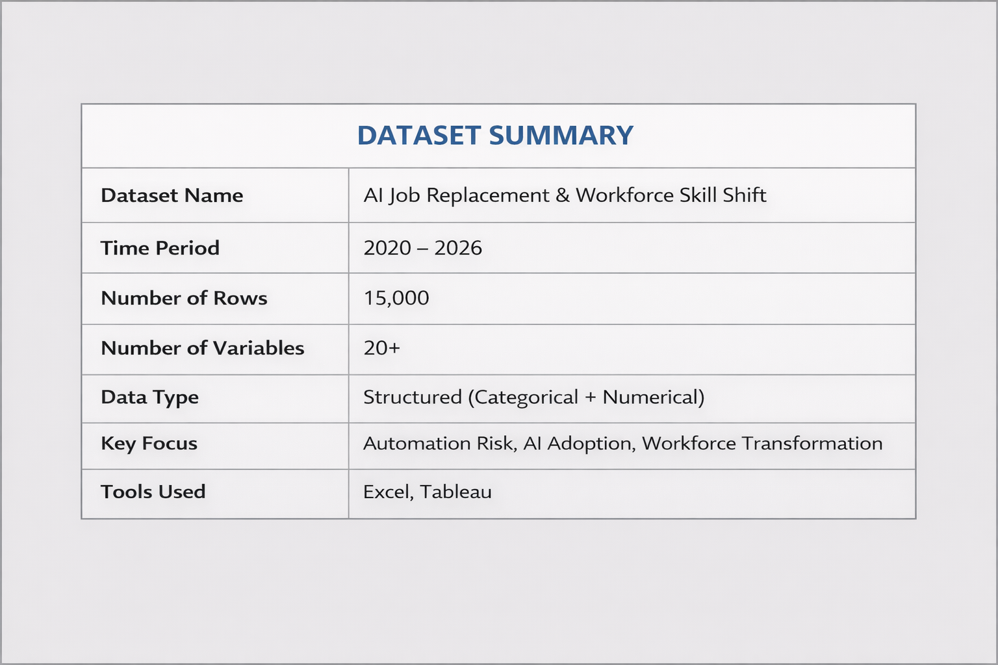

WHAT THE DATASET EXPLORES -
The dataset provides a multi-dimensional view of AI-driven workforce transformation by examining:
- Industry-level exposure to automation risk
- Variation in AI adoption across countries and sectors
- Changes in salary structures before and after AI integration
- Growth in skill demand and workforce reskilling urgency
- Relationships between automation risk, wage volatility, and AI disruption
It effectively models how technological advancements influence employment stability, skill evolution, and economic shifts.

REPORTS AND ANALYSIS THAT CAN BE GENERATED -
Using this dataset, a wide range of analytical reports and dashboards can be developed, including:
- Automation risk comparison across industries and countries
- Salary impact analysis before and after AI adoption
- AI adoption trends over time (2020–2026)
- Skill demand growth and workforce transition analysis
- Automation risk category segmentation dashboards
- Workforce pressure and reskilling urgency analysis
These visualizations help uncover patterns, trends, and hidden insights within the data.

POSSIBLE INSIGHTS AND INFERENCES -
Analysis of this dataset can reveal key insights such as:
- Industries with higher AI adoption tend to exhibit increased automation risk
- Certain sectors show rising demand for advanced skills despite automation exposure
- Countries with higher AI maturity experience wage volatility and workforce restructuring
- Job roles with higher automation risk require urgent reskilling and workforce adaptation
- Strong relationships exist between automation risk, AI disruption intensity, and skill transition pressure
These insights highlight both the risks and opportunities created by AI in the workforce.

APPLICATIONS OF THE DATASET -
This dataset supports multiple analytical and real-world applications, including:
- Exploratory Data Analysis (EDA)
- Interactive dashboard development (Excel, Tableau, Power BI)
- Regression modeling to predict automation risk or salary changes
- Classification modeling for automation risk categorization
- Feature importance analysis and workforce risk scoring
- Strategic business and policy recommendations
Overall, the dataset provides a powerful foundation for understanding AI-driven workforce transformation and enables meaningful data storytelling, academic research, and data-driven decision-making.

KEY TAKEAWAY -
Artificial Intelligence is not only transforming job roles but also redefining workforce skill requirements. Organizations and individuals must adapt through continuous learning, reskilling, and data-driven decision-making to remain competitive in an AI-driven economy.

The above analysis is supported by visualizations including scatter plots, box plots, histograms, heatmaps, and pie charts created using Tableau and Excel.

