Appendix A

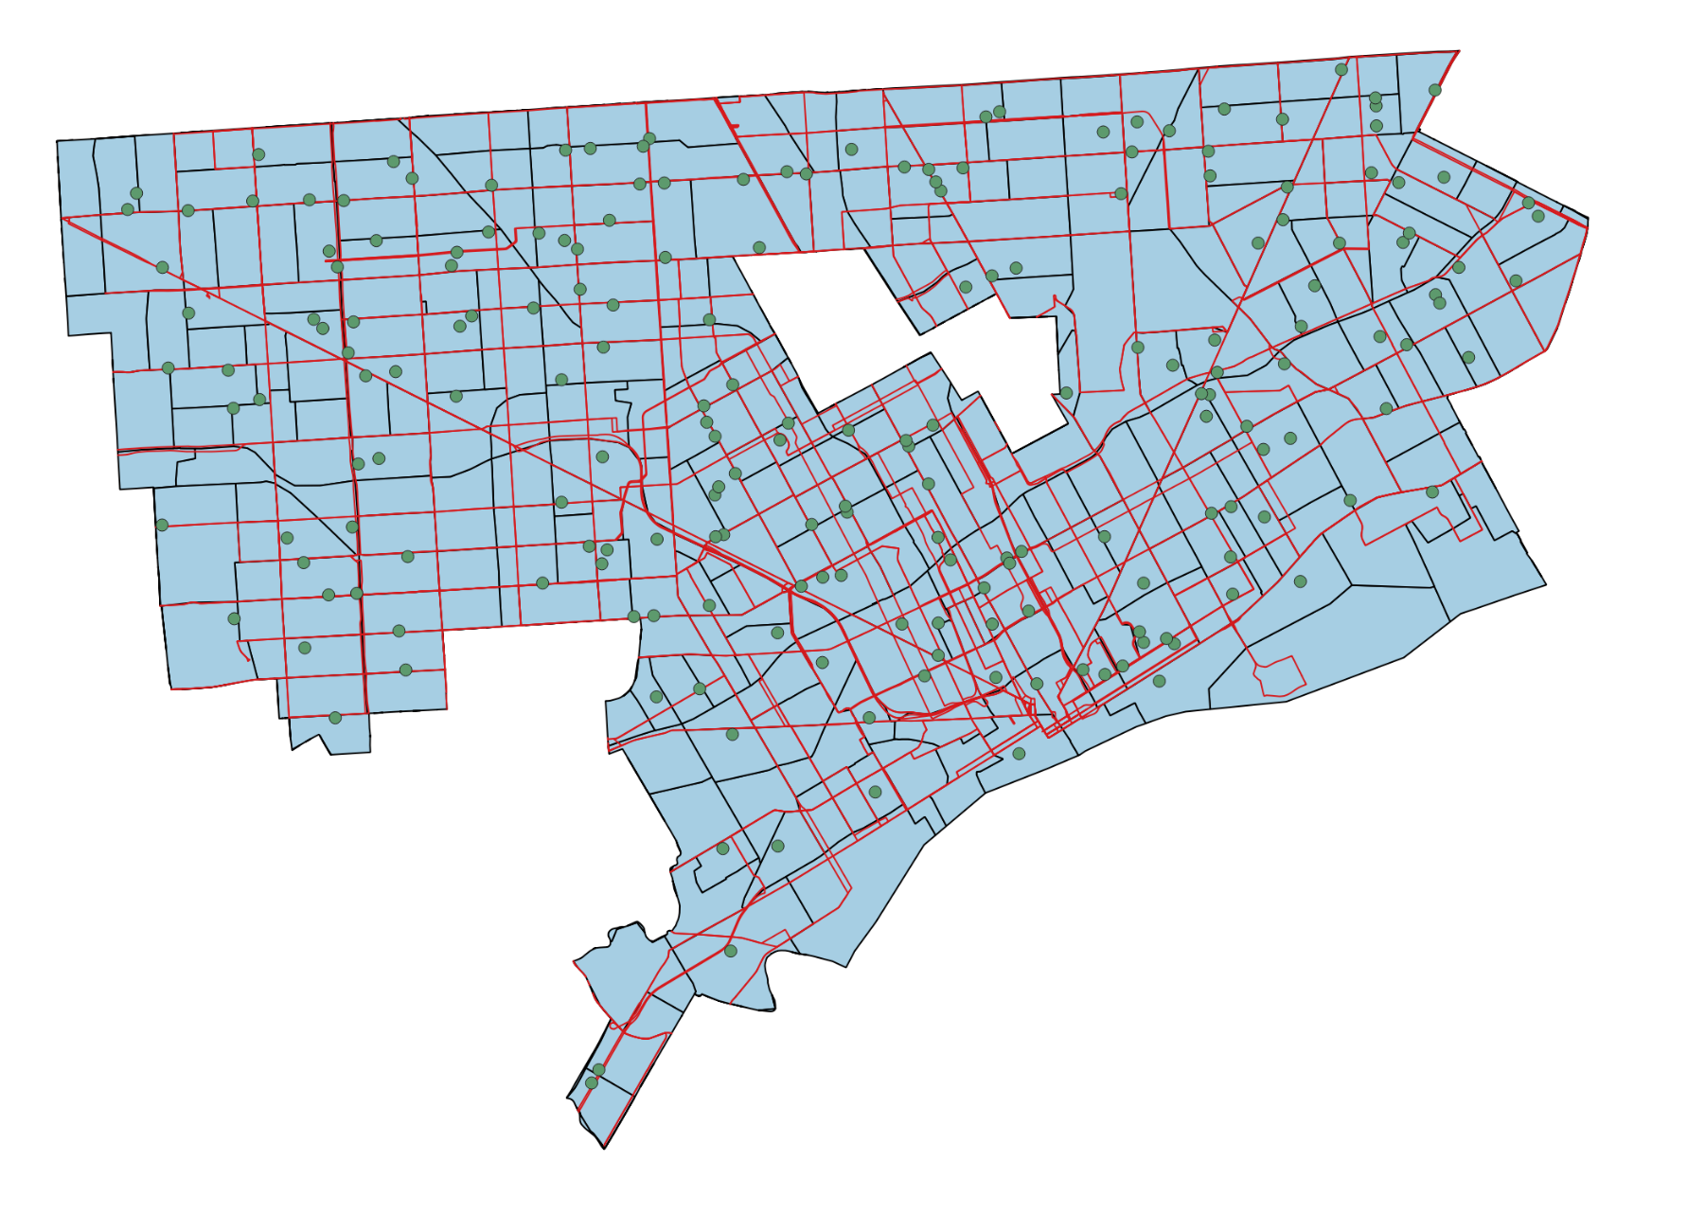

Detroit map, divided by Census tract borders, overlaid by bus routes and polling locations.

Appendix B

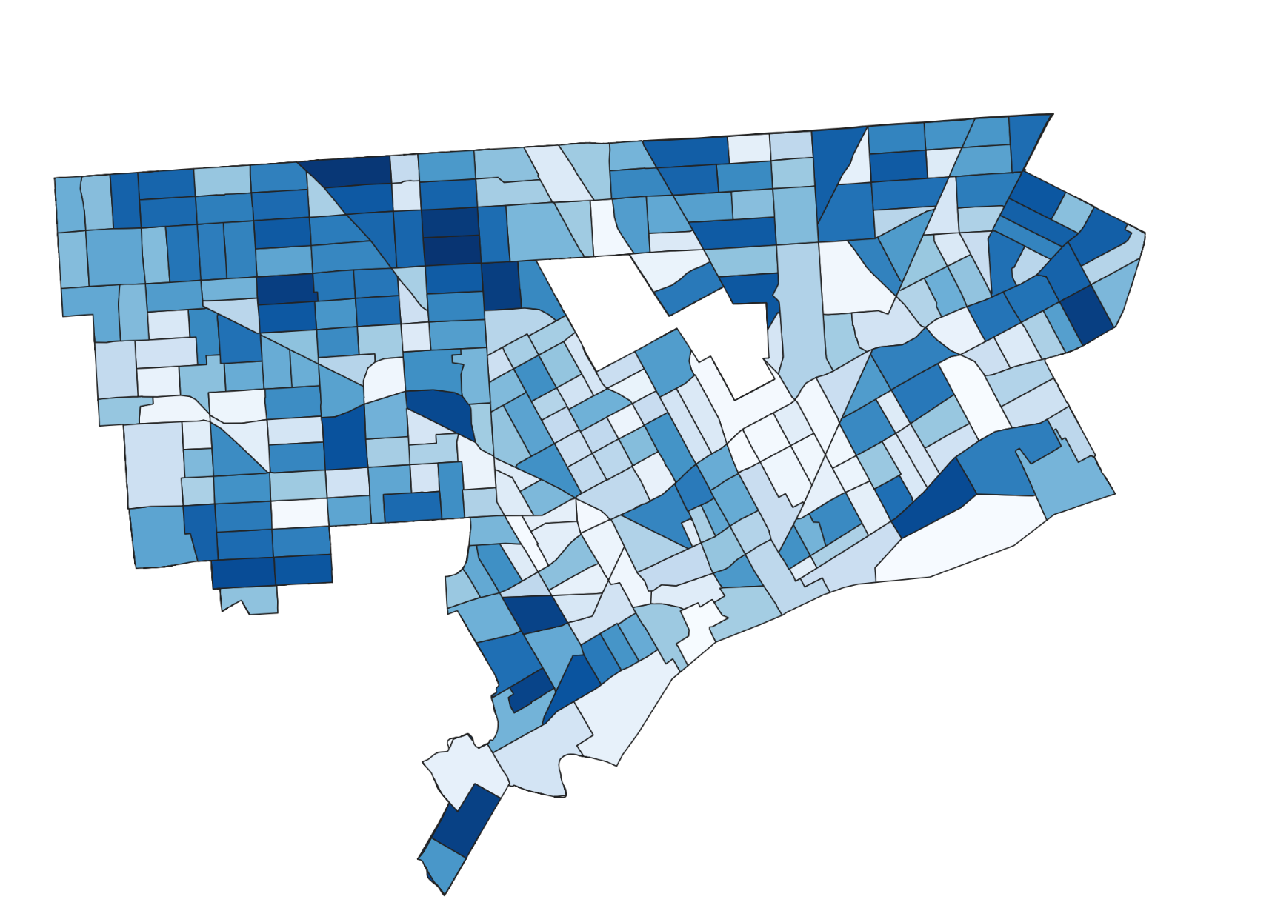

Gradient applied to Census tracts, based on voting age (18+) population. Darker colors indicate greater population.

Appendix C

|  |  |
| --- | --- |
| **Route** | **Frequency (min)** |
| 40 | 65 |
| 39 | 60 |
| 41 | 60 |
| 54 | 60 |
| 12 | 50 |
| 43 | 50 |
| 46 | 50 |
| 47 | 50 |
| 11 | 45 |
| 38 | 45 |
| 13 | 40 |
| 23 | 40 |
| 52 | 40 |
| 89 | 40 |
| 29 | 35 |
| 32 | 35 |
| 67 | 35 |
| 92 | 35 |
| 95 | 35 |
| 96 | 35 |

20 routes with wait times greater than 30-minute limit set by our team.

Appendix D

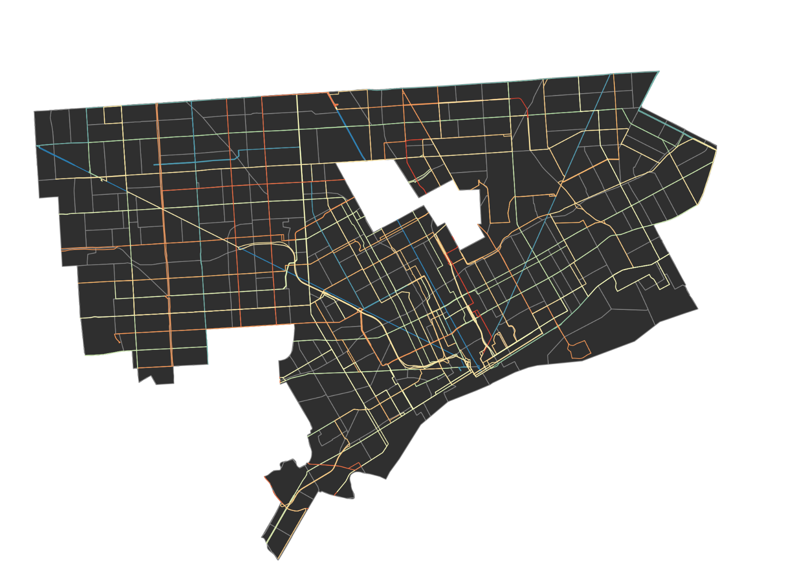

Map with bus frequency overlaid. Warm colors are associated with greater wait time.

Appendix E

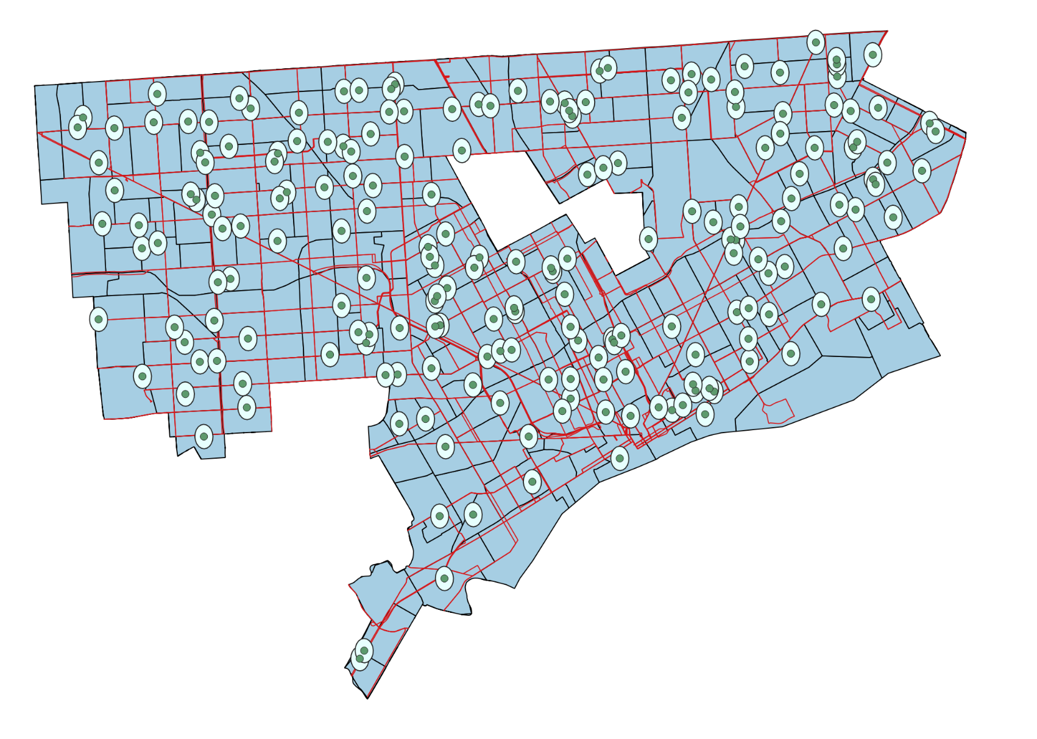

Polling locations with quarter-mile buffer.

Appendix F

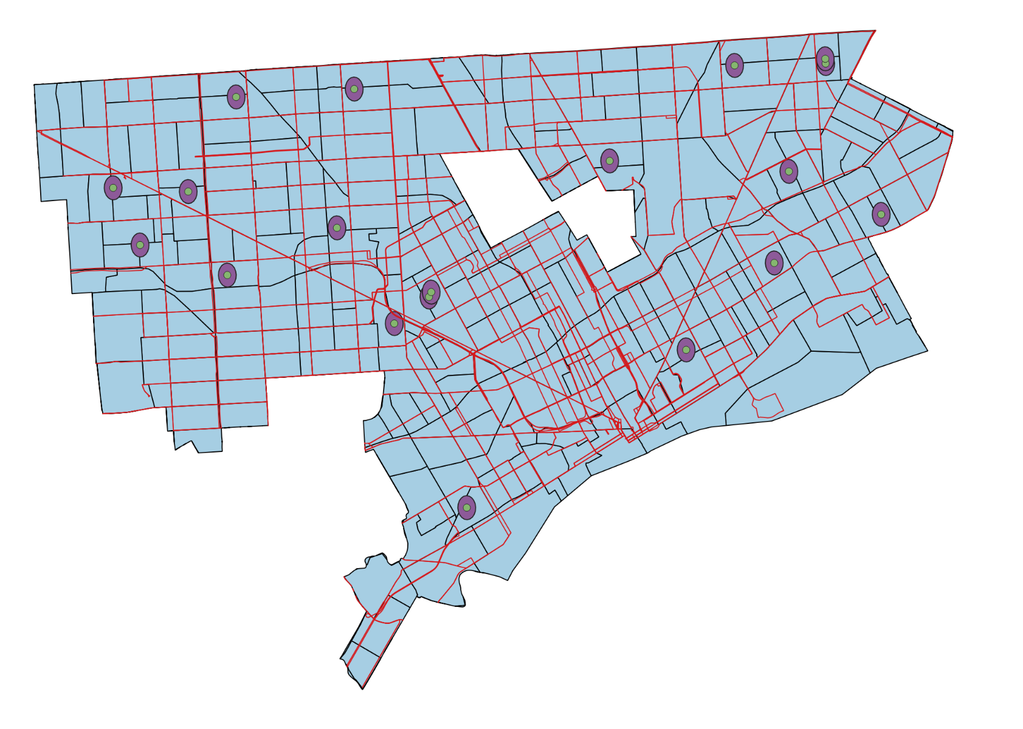

19 polling locations without a bus stop in the quarter-mile buffer.

Appendix G

  
Polling locations outside of quarter-mile buffer, greatest population prioritized first.

Appendix H  
  


Polling locations outside of quarter-mile buffer, greatest distance prioritized first.

Appendix I



Polling locations outside of quarter-mile buffer, shortest prioritized first.

Appendix J  
  
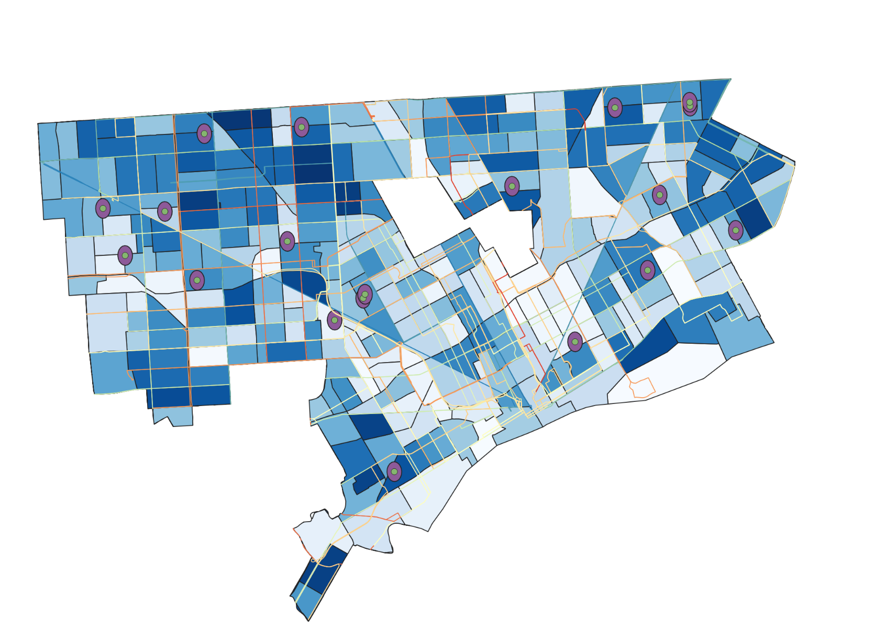

Visualization of Census tract population, bus route wait time, and polling locations outside of walking distance of bus stop.