Compiled using Ubuntu
Ubuntu was used for the WSL since buildozer needs to have a linux terminal
  - https://www.youtube.com/watch?v=qytwzrPqs10
    - I found this video to be extremely useful in setting up for the first time and understanding the process.
  - Frequently used commands in Ubuntu
    - Navigate to where your files would be. For me it was this (working in a virtual environment)
      - cd /mnt/c/Users/mattc/ECE480G16-main/kivy_venv
    - This command is used to set up where the app is saved once the compilation is done. (I believe only needs to be done once when initially setting up everything)
      - export PATH="$PATH:~/.local/bin:$PATH"
    - Command used to create buildozer spec file for the first time (done only once)
      - buildozer init
    - Command used to compile the app
      - buildozer android debug
  - Important Notes
    - Compiling for the first time will take a LONG time, as well as if you install any additional libraries beyond the first. However, once you have done it once, as long as you are still working in the same folder, future compiling will be a lot quicker (~5ish minutes)
    - Initial setup had caused me the most headache but once it is working I was able to work on the app without any issues from the Ubuntu or the compiling process.
    - When compiling, making sure that you have a “main.py”, buildozer spec file, and then any other py or kv files located all in the same folder. It should look something like this
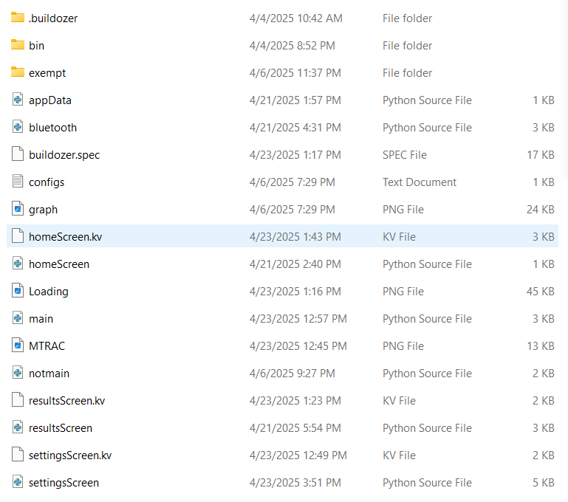

Known Bugs and Quick Fixes
- If the connect button is pressed while already connected to the Bluetooth module then the phone will disconnect and the top of the phone will still say connected.
  - While there is no immediate fix for this (besides not pressing the button when already connected), a change could be added so that there is a check performed every so often to see whether the Bluetooth is connected and update the status. This is different to what is currently being used, which will only change it when the Bluetooth is connected successfully.
- Often times if there is a frozen screen or another issue, closing the app and waiting a few seconds and then restarting will often fix the issue
- The save settings and load settings buttons were intended to save and load parameters. As of right now, we do not have the time to implement that function so the buttons are currently a placeholder.
- Pressing the run test button on the parameters screen when not connected to the Bluetooth will cause the app to crash
- The saved results may not immediately show up in the phone. The app may need to be closed in order for them to show up in the documents folder of the phone.
- The password for the HC06 is 1234, you can pair to it prior to working. If you do the connect button will connect to it. If you don’t, the connect button will give you a notification to pair with the device and input the password.
- When Installing the App, make sure to go into the app settings and allow nearby devices.

