Quantum Random Bit Generator Simulation Using MATLAB

Jibril Abdullahi | Quantum Computing Enthusiast

# Abstract

This project simulates a basic quantum random bit generator using MATLAB to explore the probabilistic nature of quantum measurements. By initializing a single qubit in an equal superposition state and simulating repeated measurements, we generate truly random bits. The simulation confirms a balanced distribution of outcomes, illustrating the core principles of quantum randomness and its application to secure communication systems.

**Keywords:** *Quantum Computing, Random Number Generation, Qubit, MATLAB Simulation, Quantum Cryptography.*

# 1. Introduction

Quantum random number generation (QRNG) is a cornerstone of quantum information science, offering a robust solution to the limitations of classical pseudo-random generators. Unlike deterministic algorithms used in classical computing, QRNG leverages the intrinsic unpredictability of quantum measurements to produce truly random bits. This project presents a simulation of a QRNG using MATLAB, modeling the behavior of a single qubit in superposition. The goal is to explore the principles of quantum randomness and its relevance to applications such as cryptography and secure communications.

# 2. Objective

The primary objective was to implement a basic quantum random bit generator using MATLAB and demonstrate how the probabilistic nature of quantum measurements can yield unbiased, non-deterministic outcomes. This project also aimed to provide an intuitive grasp of quantum measurement mechanics by simulating bit generation from a single qubit.

# 3. Methodology

The qubit is initialized in an equal superposition state:  
  
|ψ⟩ = (1/√2)(|0⟩ + |1⟩)  
  
Upon measurement, this state collapses randomly to either |0⟩ or |1⟩ with a 50% probability. The MATLAB script uses the randsample() function to simulate this behavior based on the amplitude probabilities of the qubit state. A loop is used to generate a sequence of 10 random bits. The distribution of the resulting bits is visualized with a histogram to confirm uniformity.

Code Snapshot:

qubit = [1; 1] / sqrt(2);  
n_bits = 10;  
quantum_random_bits = zeros(1, n_bits);  
for i = 1:n_bits  
 probability = abs(qubit).^2;  
 quantum_random_bits(i) = randsample([0, 1], 1, true, probability);  
end

# 4. Results

The simulation successfully generated the following random bit sequence:  
0 0 1 0 0 1 0 1 0 1  
  
The histogram below shows the distribution of 0s and 1s, confirming near-uniformity:

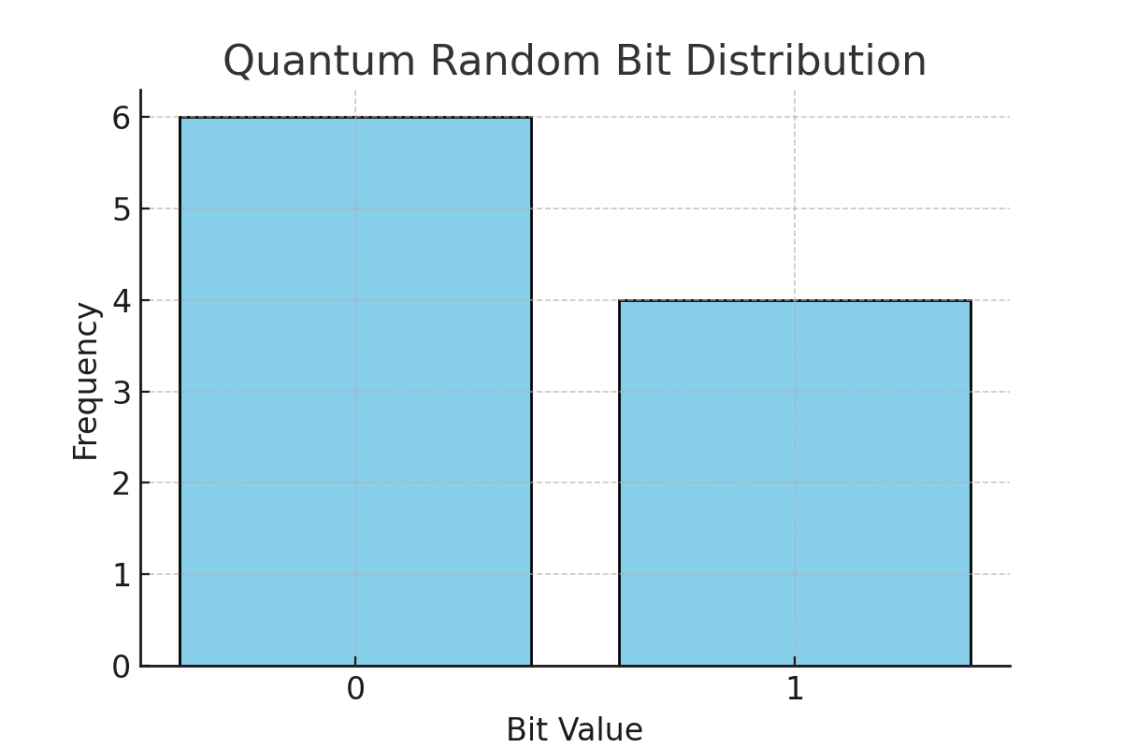

# 5. Conclusion

This simulation illustrates the simplicity and effectiveness of quantum random number generation through the measurement of a single qubit in superposition. The project not only demonstrated unbiased randomness but also deepened my understanding of quantum measurement principles. These insights are particularly valuable for future exploration in quantum cryptography and secure quantum communication systems. Projects like this strengthen my commitment to advancing in quantum technologies through initiatives that encourage practical exploration, collaboration, and continuous learning in this rapidly evolving field.