**Purpose**: Assignment for Oracle E- Business Suite General Ledger

**Date:**18th Nov-2024

**Student**: Areba Hashmi

____________________________________________________________________________

1. **Create Your Own user ID from System Administrator Responsibility. Assign the following responsibilities to your Oracle User ID** 
   1. **Vision Operation General Ledger.**
   2. **Vision Operation Inventory.**
   3. **Vision Operation Procurement**
2. **For your user ID password expiration day should be 60 days**

Step 1: Oracle EBS > System Administrator > Security > User > Define

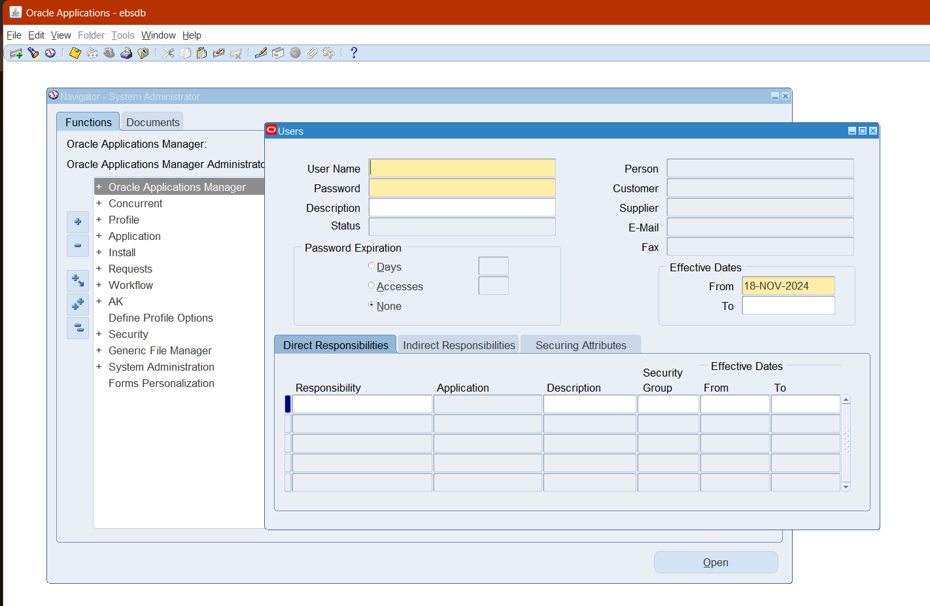

Step 2: Create the User ID (XX_AH_USER) & Assign Responsibilities

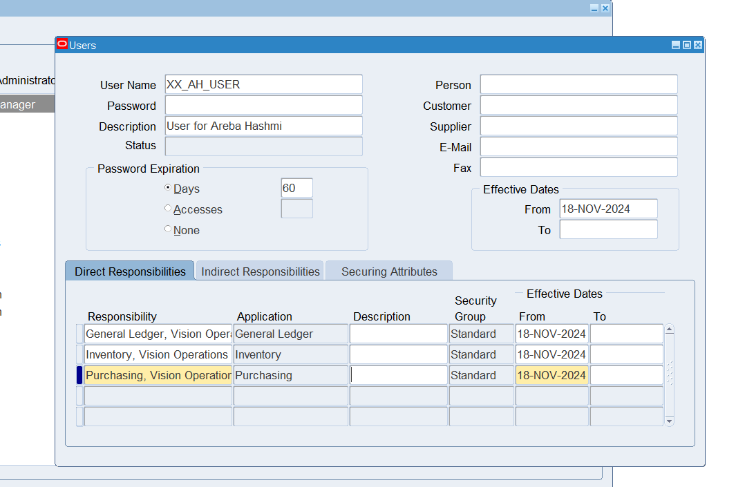

1. **In Vision Operation General Ledger responsibility.**
   1. **Form Accounting Setup Manager> Find the Vision Operation [Primary Ledger]**
   2. **In this Ledger finds the 4C Component, mentions the 4C name & take the screen shot as Evidence.**
   3. **Find the Respective Calendar Vision Operation [Primary Ledger].**

Switch Responsibilities > General Ledger

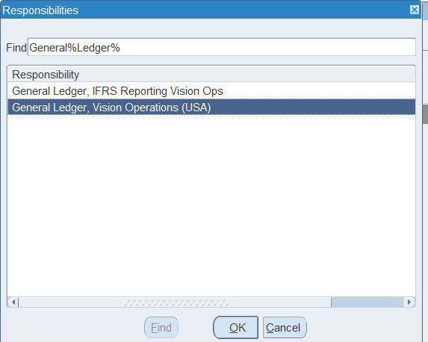

General Ledger > Setup > Financials > Accounting Setup Manager > Accounting Setups

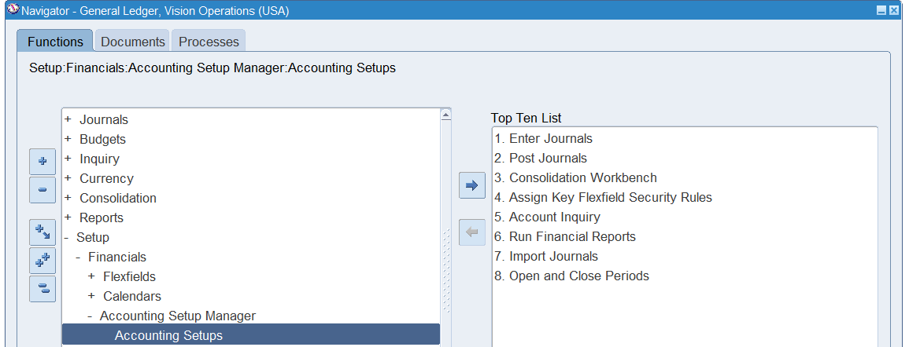

Search: Vision Operation [Primary Ledger]

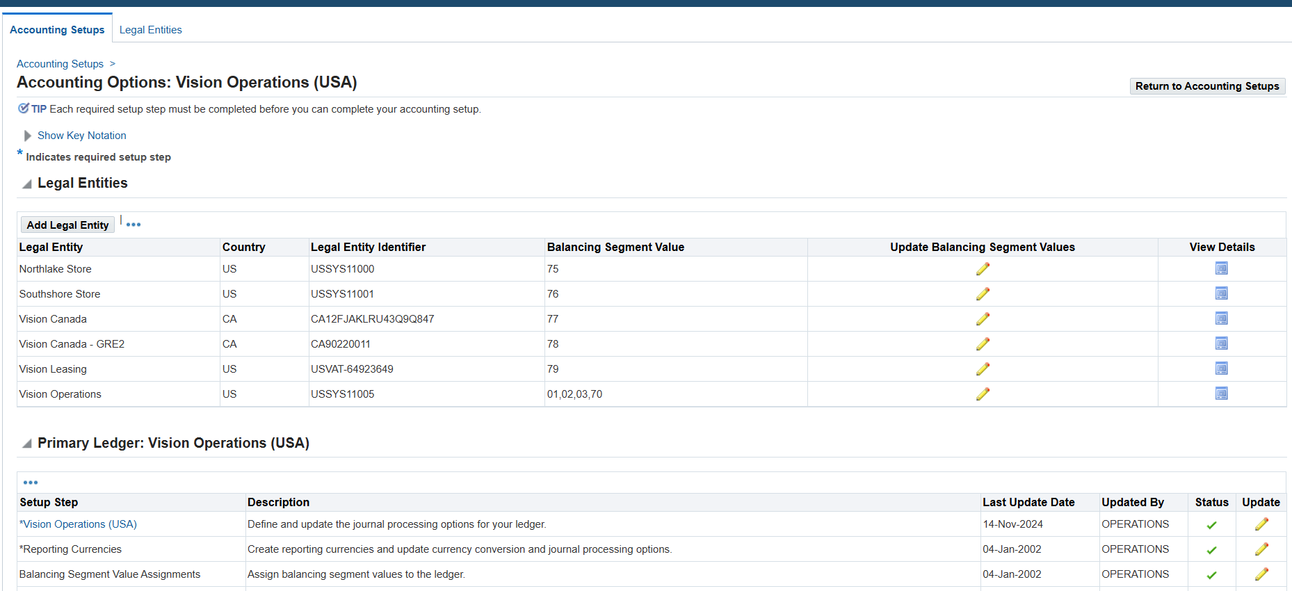

**Find 4C Components in this Ledger**

1. Currency - USD
2. Calendar - Accounting
3. Char of Accounts – Operations Accounting Flex
4. Accounting Conventions – Standard Accrual

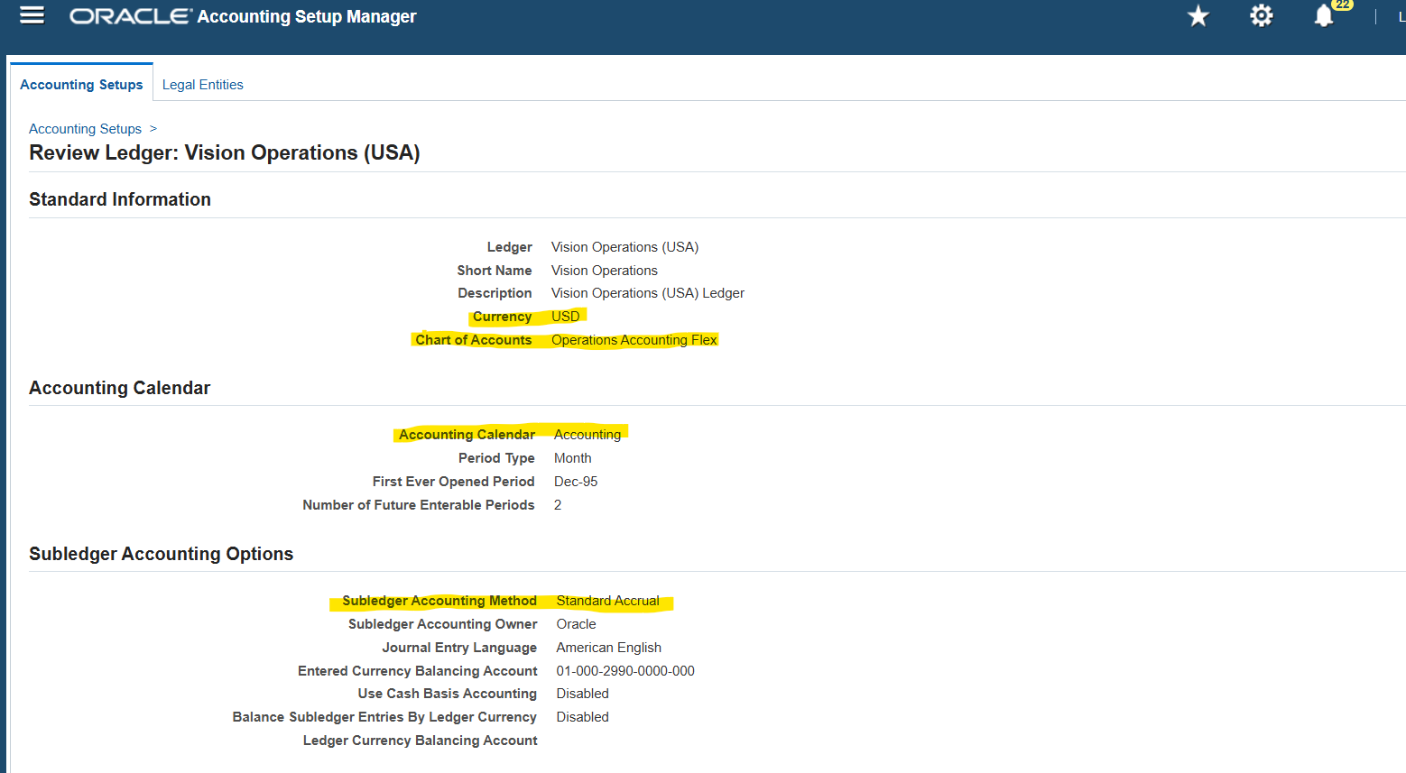

**Find the respective calendar [Vision Operations]**

General Ledger > Setup > Financials > Calendars> Accounting

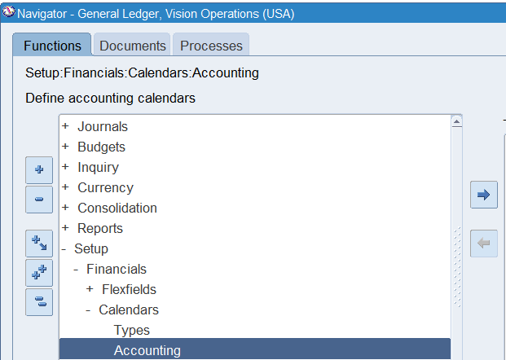

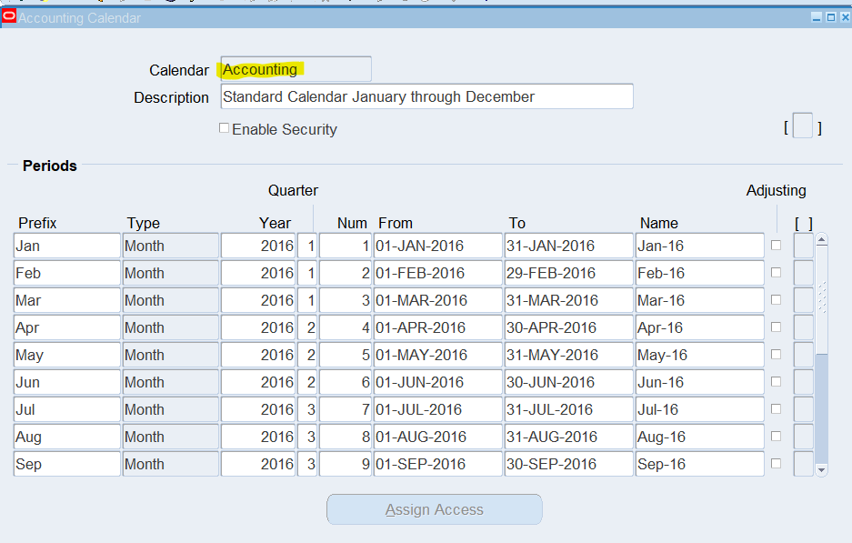

1. **Find all the Account Code Combinations.**

General Ledger > Setup > Accounts > Combinations

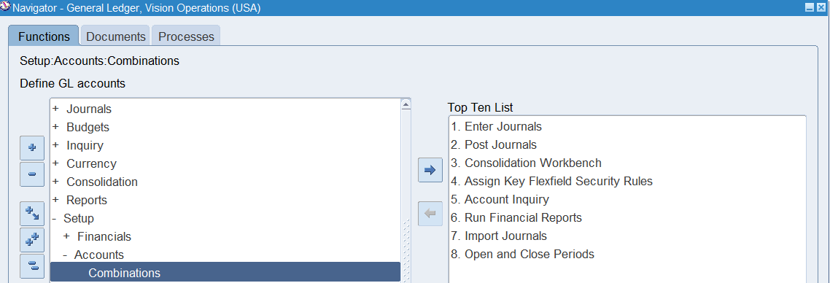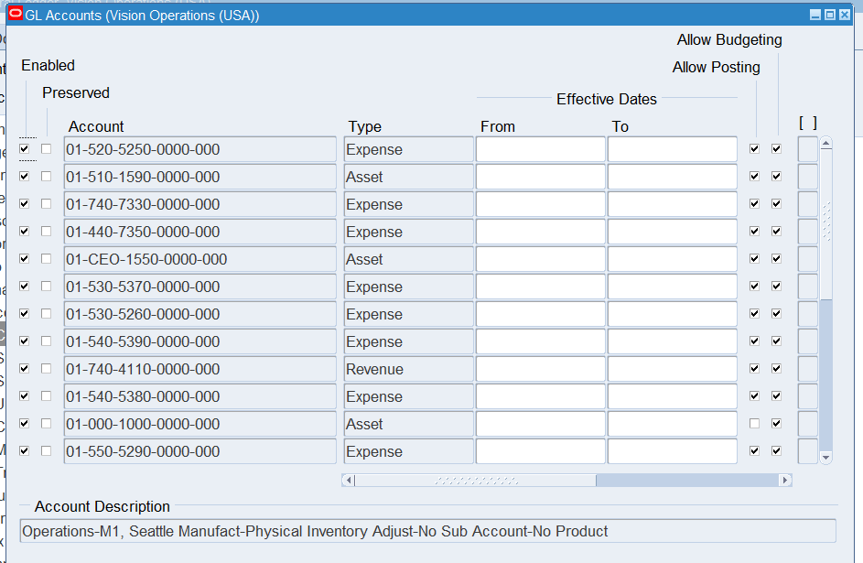

1. **Find all the Journals [SOURCE: Payables].**

General Ledger > Journals > Enter

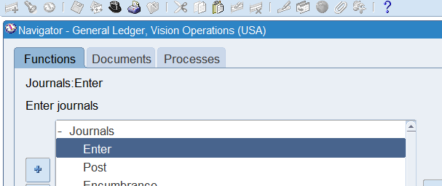

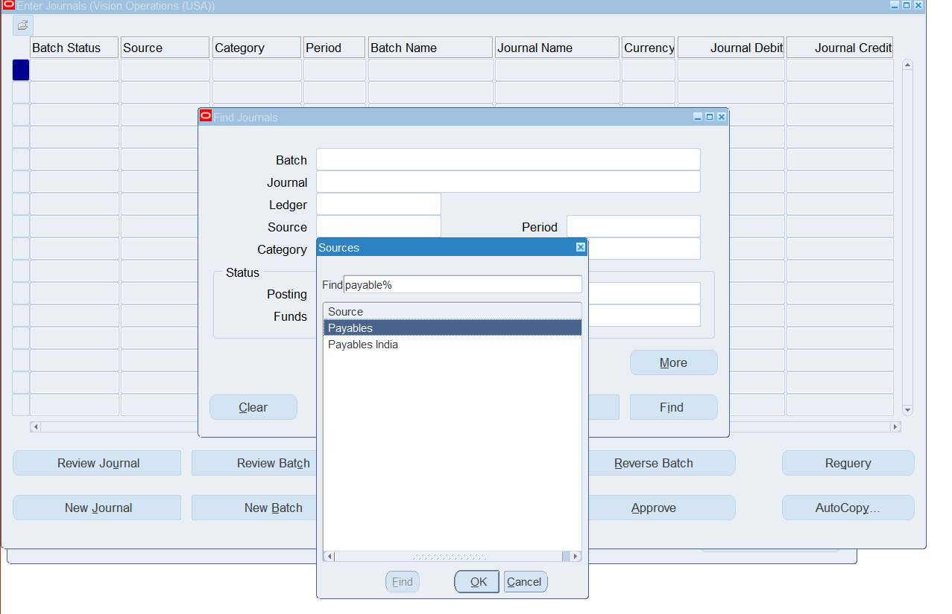

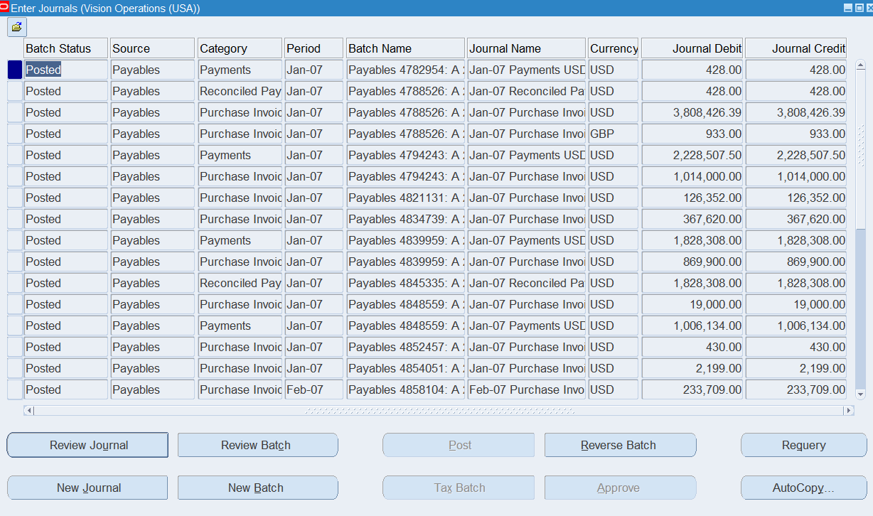

1. **In Journal Header form record History find the respective Data base Table name.**

Tool Bar > Help > Record History

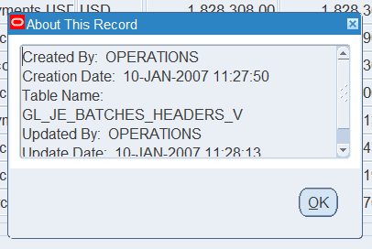

1. **Find the one Manual [Source] & one Payable [Source].**

One Payable

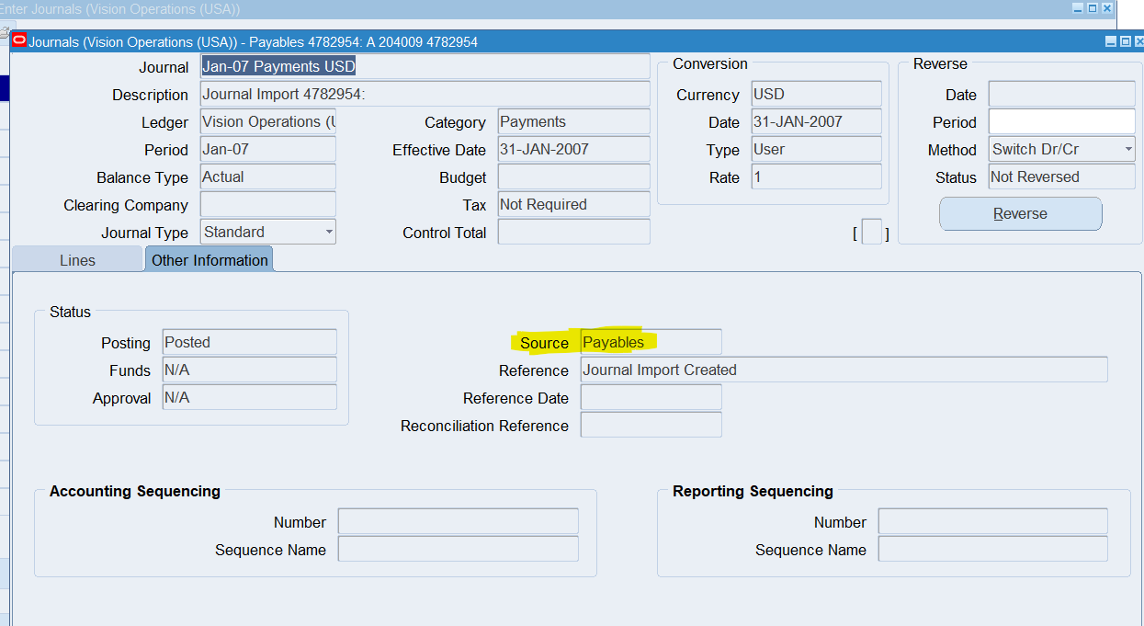

One Manual

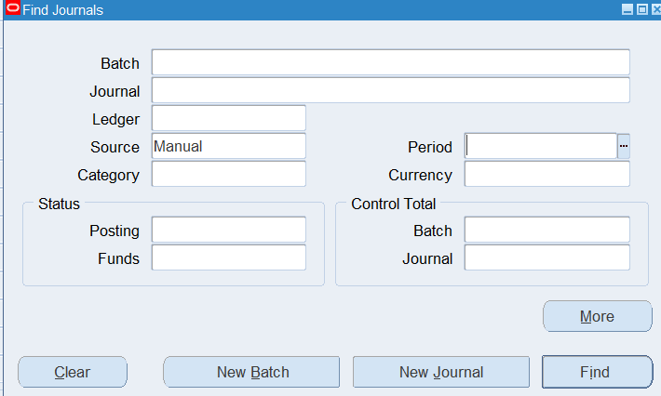

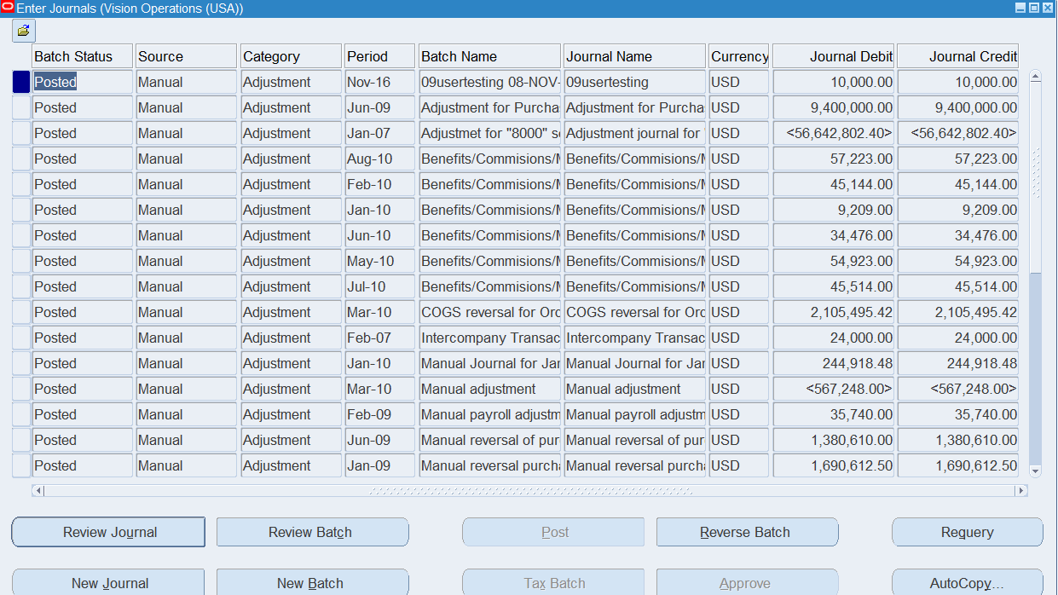

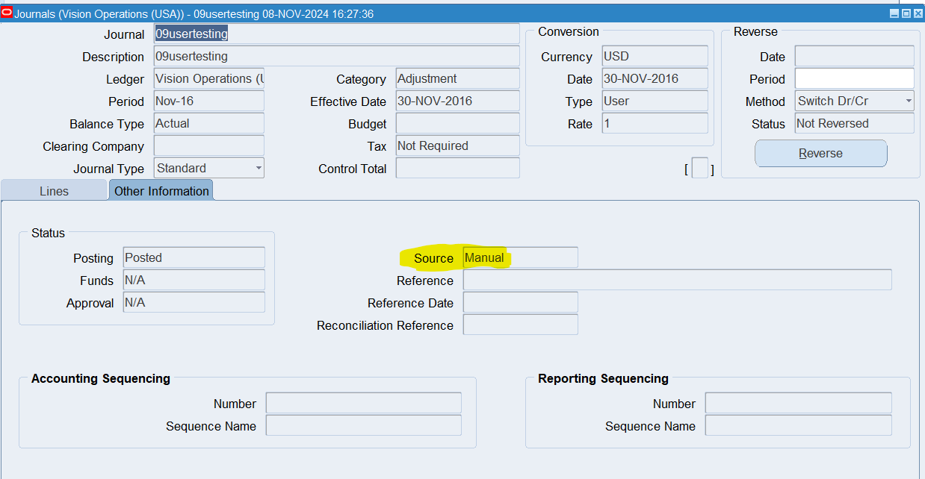

1. **How can you review posted journal entries in Oracle GL? Steps & screen shots**
2. General Ledger > Journal > Enter



1. Enter Specifications > Find

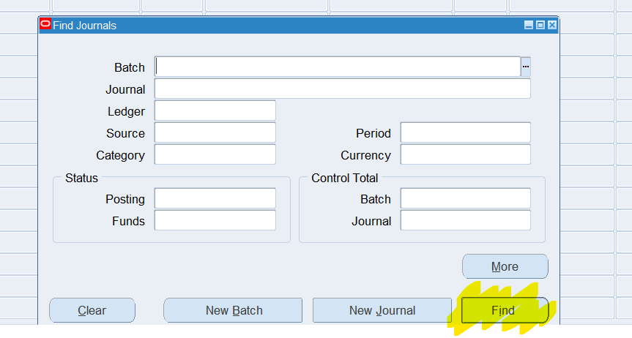

1. Click on Journal of Choice > Review Journal

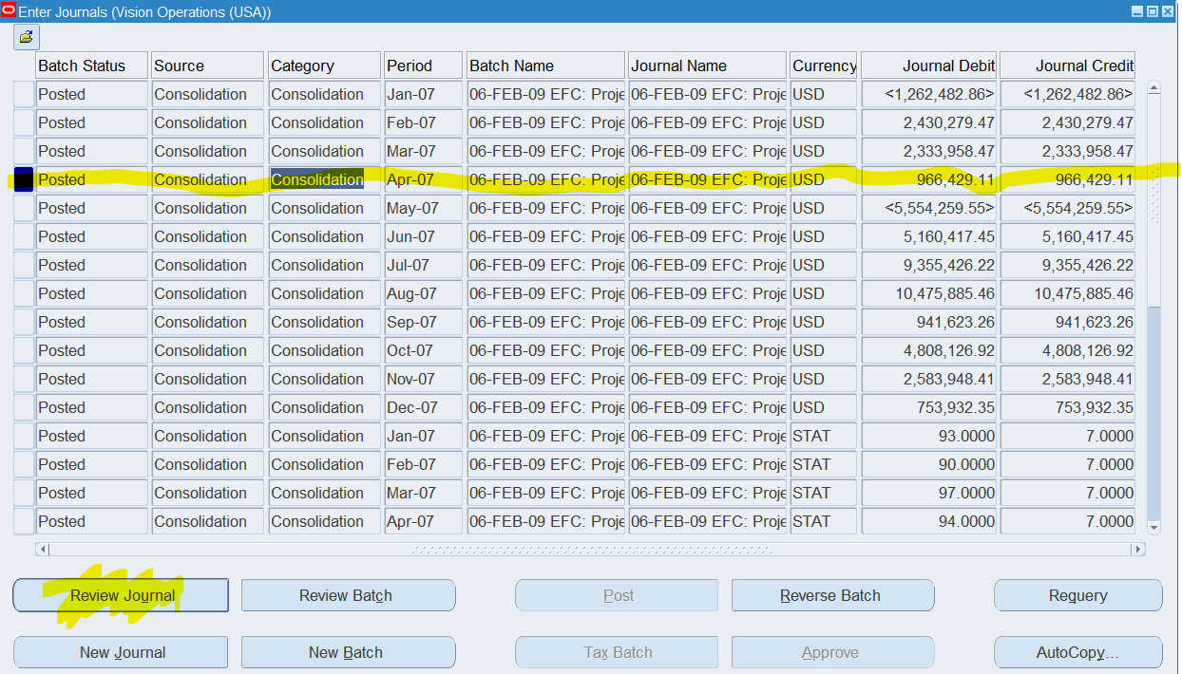

1. Under ‘Lines’ header, you can review transactions.

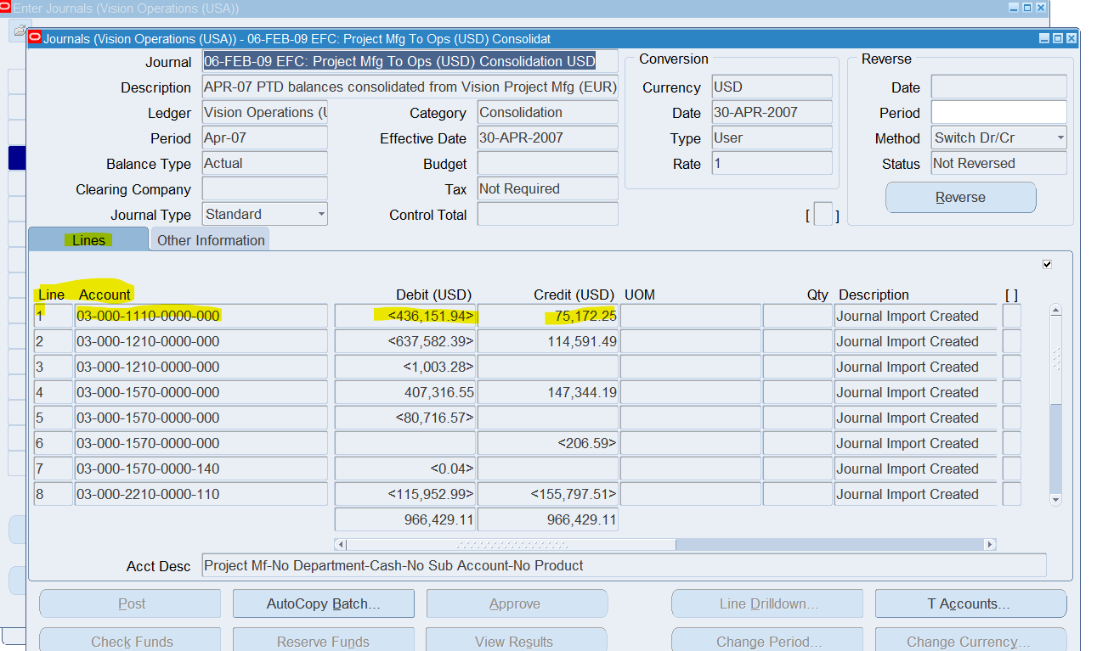

1. **Find the Chart of Accounts [COA] Structure in General Ledger.**

General Ledger > Setup > Financials > Flexfields > Key > Segments

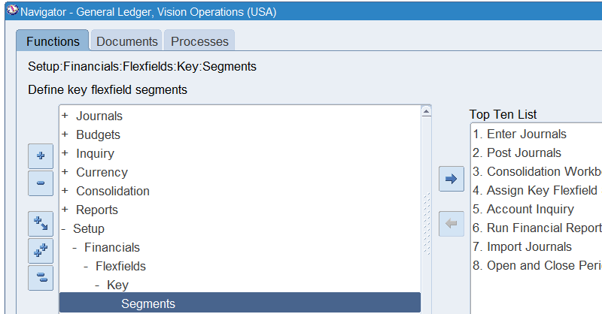

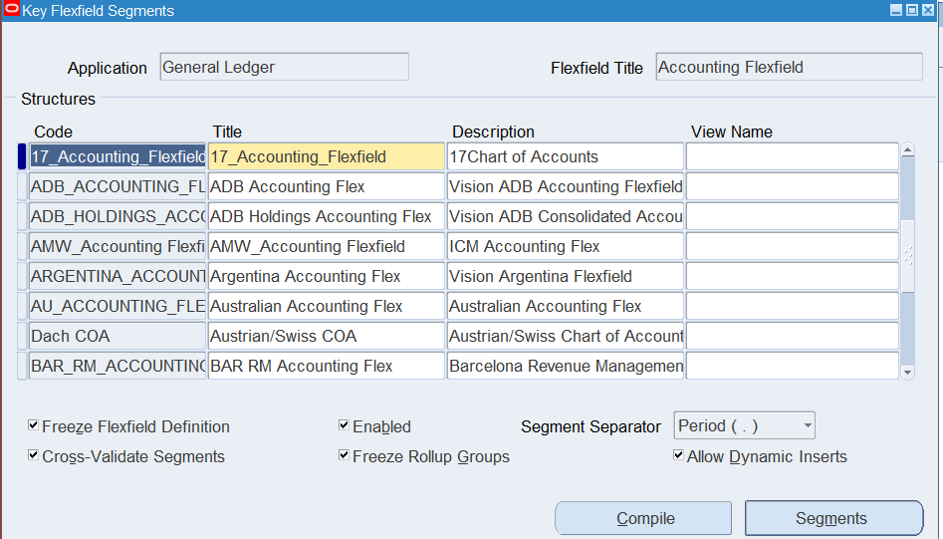

Search Query CoA Name: Operations Accounting Flex (We know this from question #3)

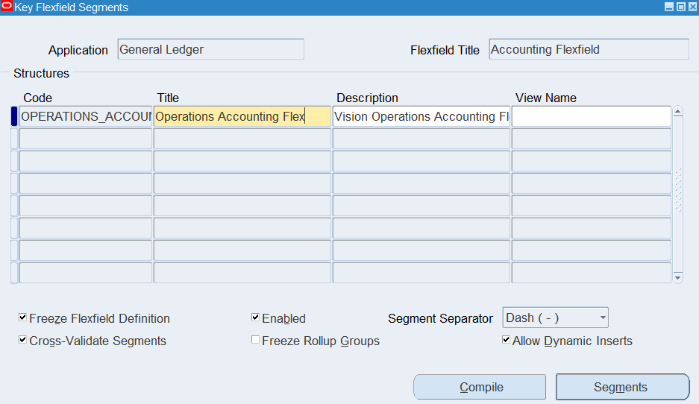

Select segments to view more detail

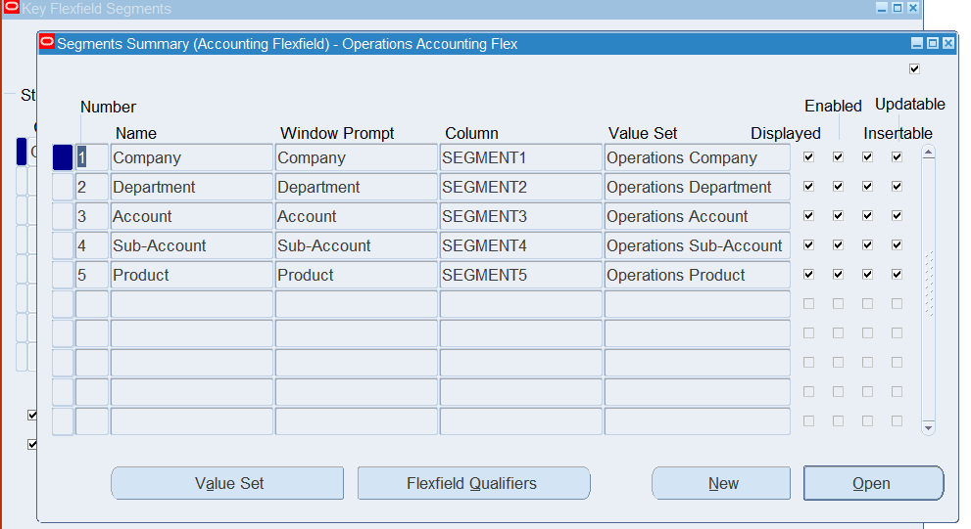

Click ‘Value Set’ to view the Segment Structure

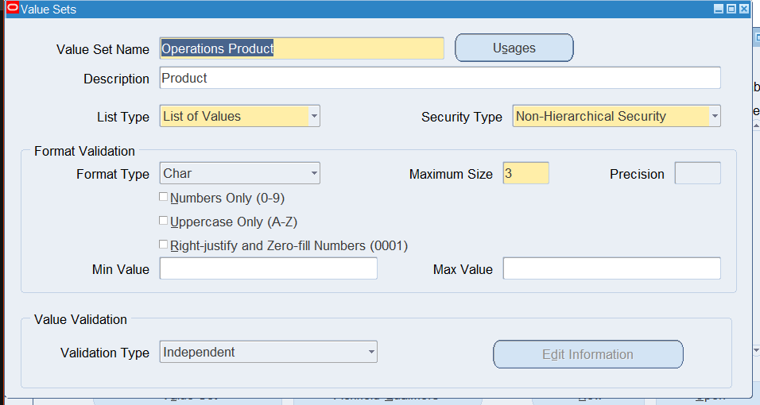

1. **How are you going to run one Concurrent Request from General Ledger (Navigation).**

General Ledger > Reports > Request > Standard > Single Request

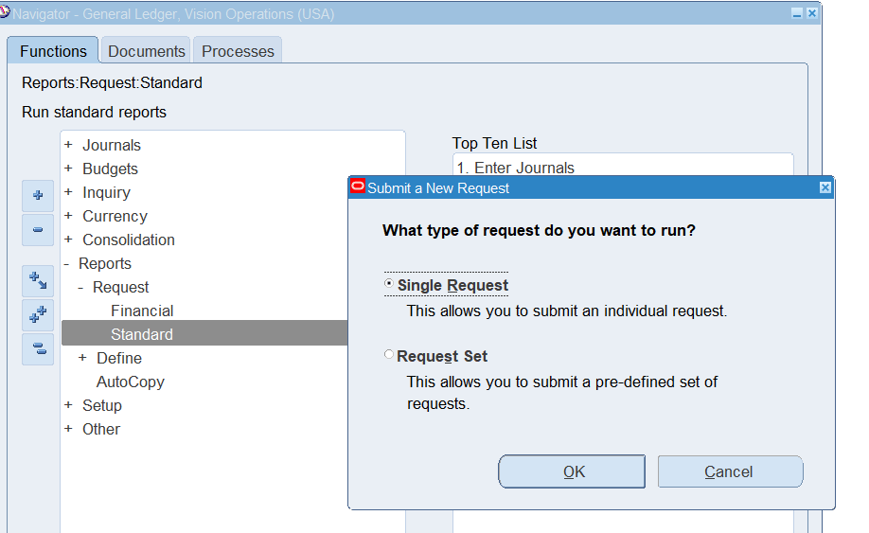

Insert information + Parameters and Submit the Request

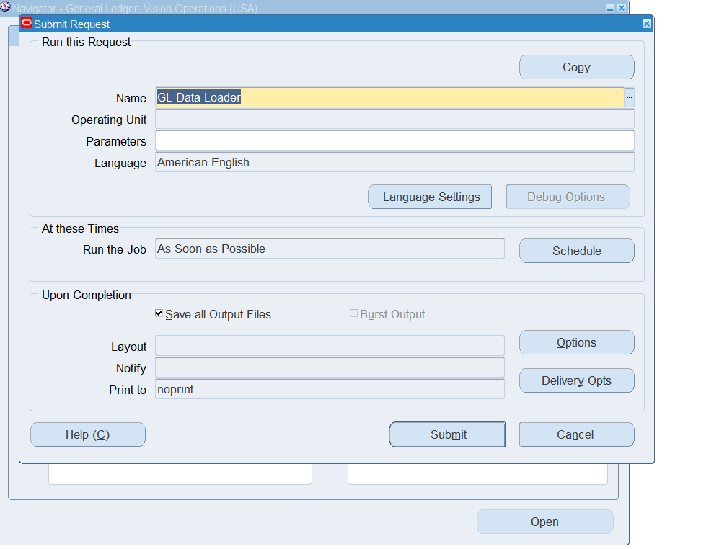

1. **In One Ledger Set what are all components common in all the Ledger?**
2. Chart of Accounts
3. Accounting Calendar
4. Currency
5. Accounting Method/Convention
6. **Find how many types of accounts in Oracle GL [Account Code Combination]?**

Asset, Liability, Expense, Revenue

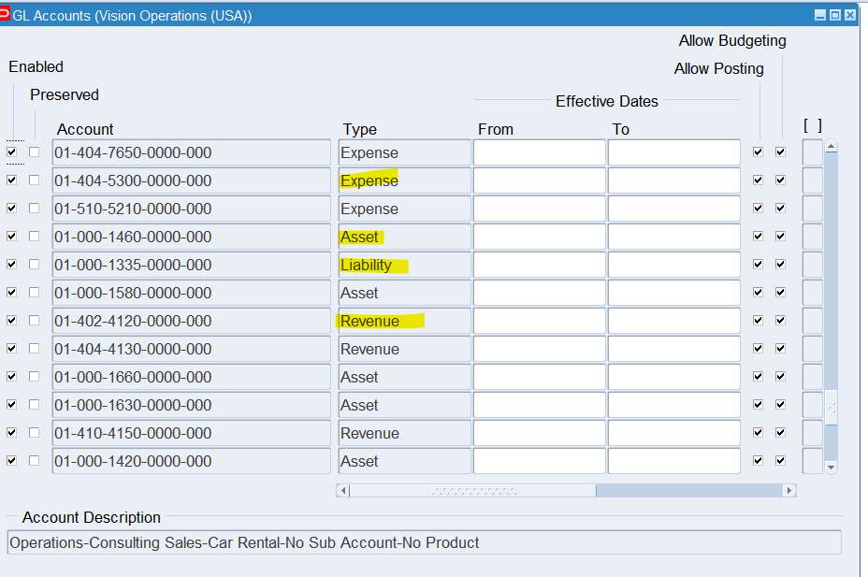

1. **Check & show the Structure of Chart of Account segment structure.**

General Ledger > Setup > Financials > Flexfields > Key > Segments





Search Query CoA Name: Operations Accounting Flex (We know this from question #3)



Select segments to view more detail



Click ‘Value Set’ to view the Segment Structure

