**Purpose**: Assignment for Oracle E- Business Suite Inventory

**Date:**18th Nov-2024

**Student**: Areba Hashmi

____________________________________________________________________________

1. **What is the Oracle Inventory module?**

Responsibility > Inventory, Vision Operations (USA)

This module is used for organizations to manage, organize, and streamline their inventory + supply chain processes. Organizations have the ability to order items, organize them, track their inventory, receive shipment approvals, receipts, and more. This module is very effective in Financial Technology because it also allows for the organization to manage the cost of goods and include expenses in their ledgers.

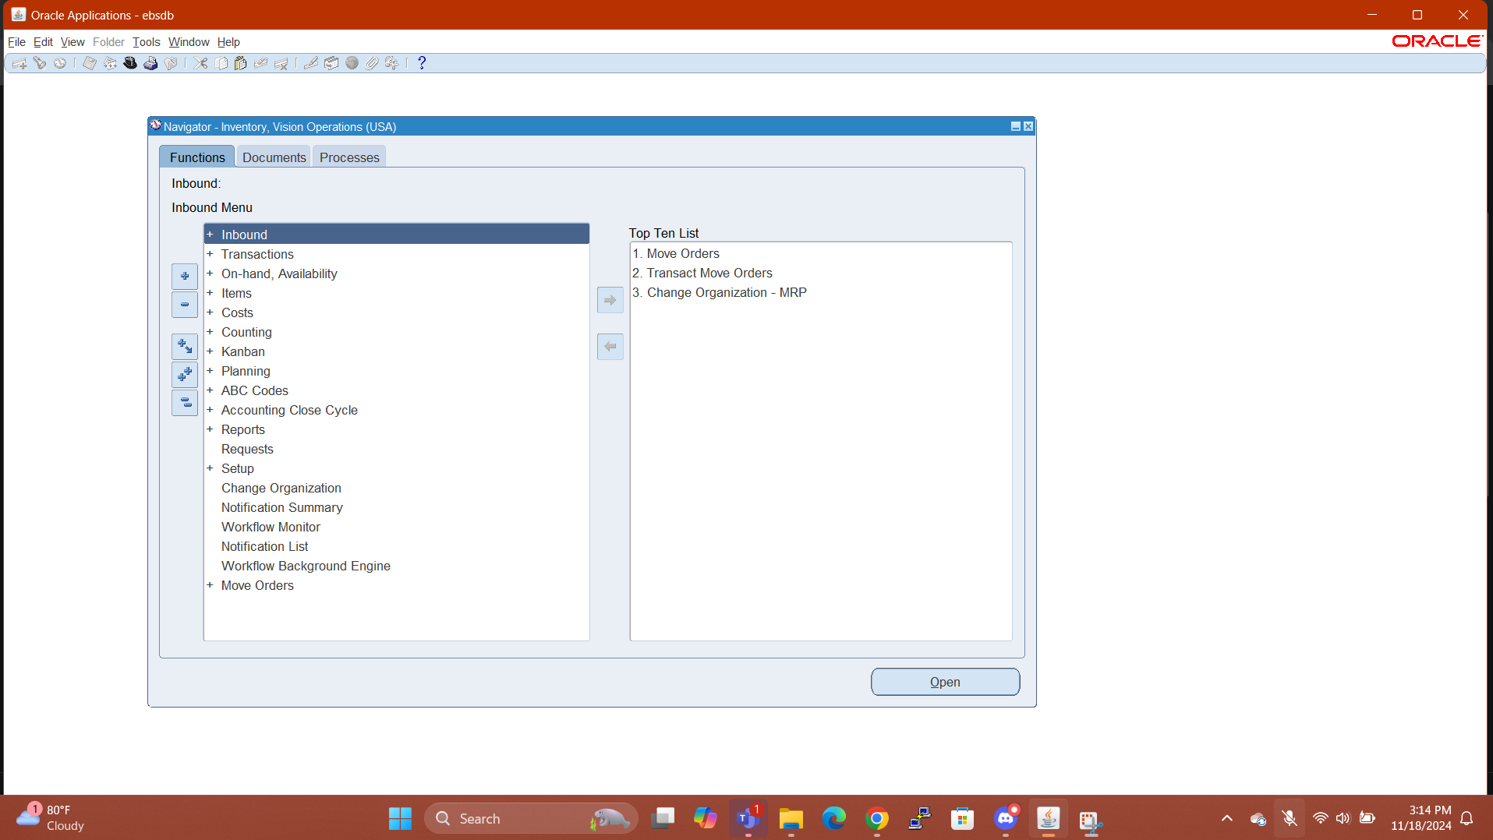

1. **With your User id switch to: Vision Operation Inventory. Responsibility.**

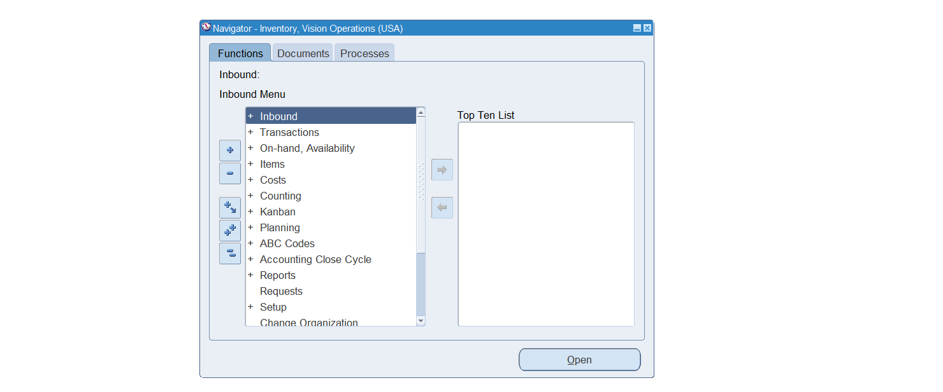

1. **Choose VI Inventory Org & Find the master Items.**

Inventory > Change Organization > Select ‘VI’

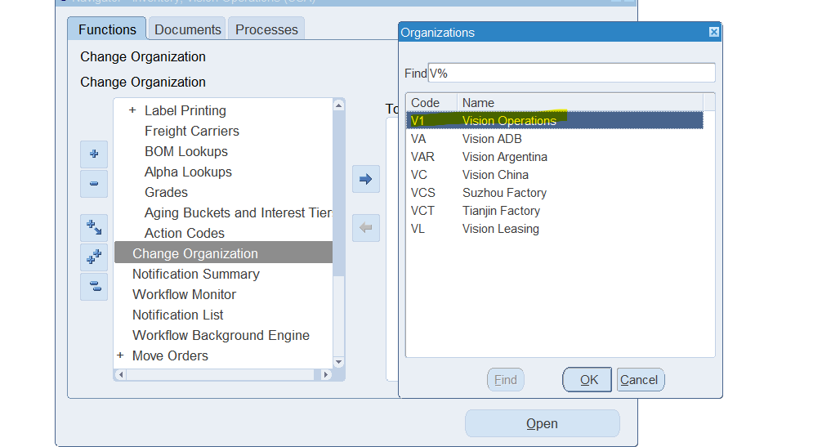

Inventory > Items > Master Items

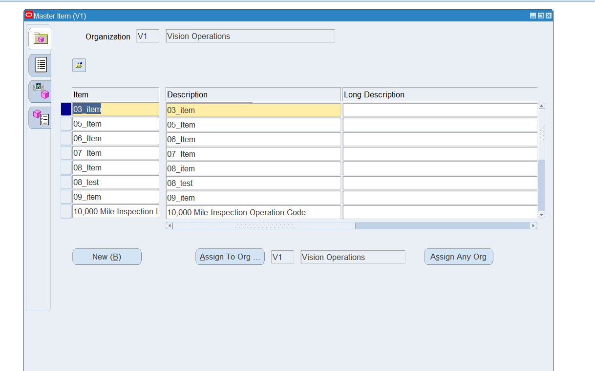

1. **Take any Item & assign the same Item for all the Inventory Org.**

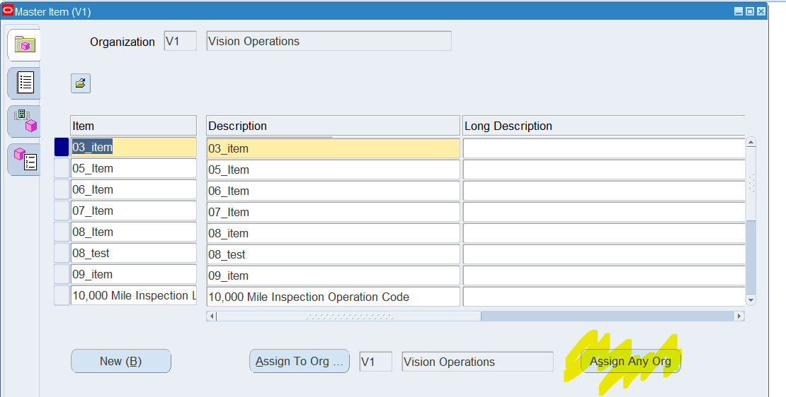

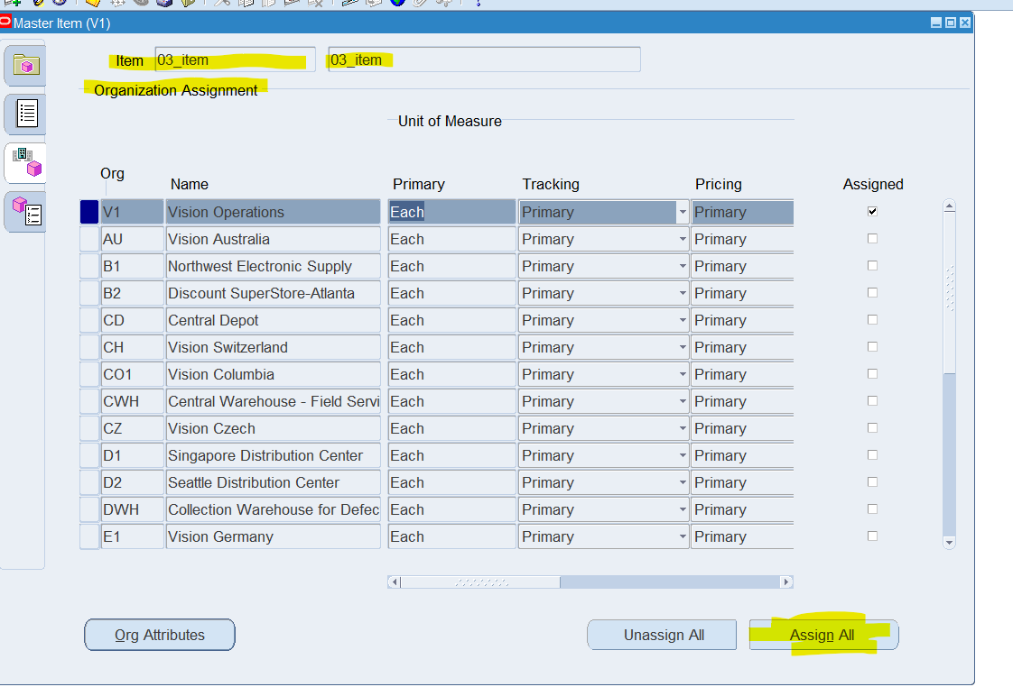

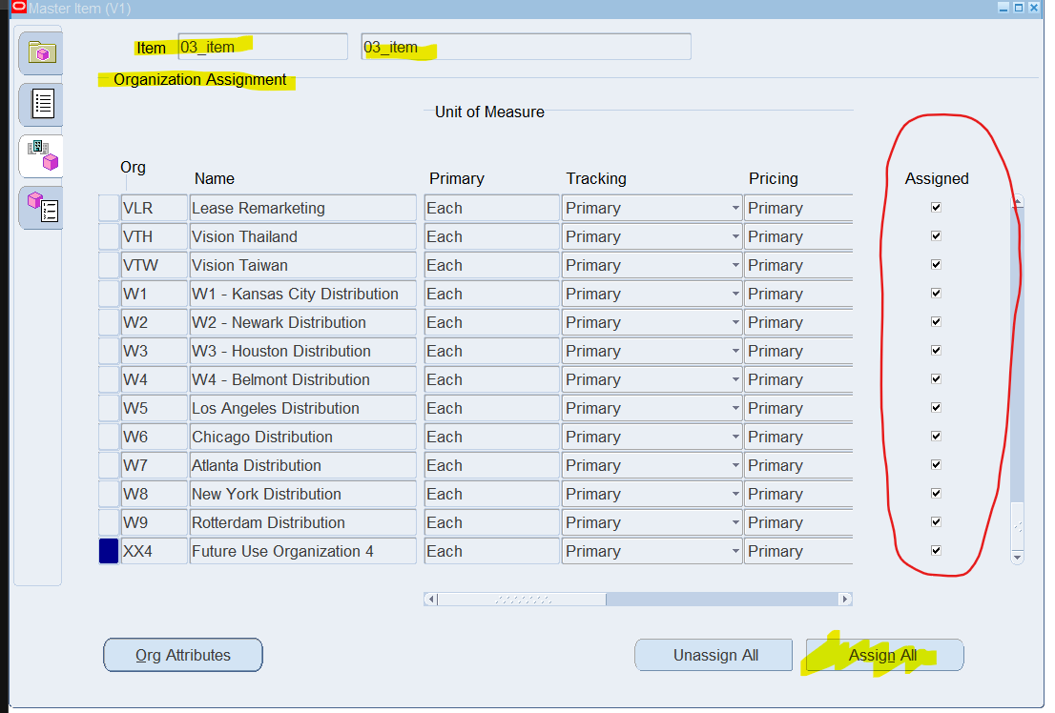

1. **And Un assign the same Item for all the Inventory Org.**

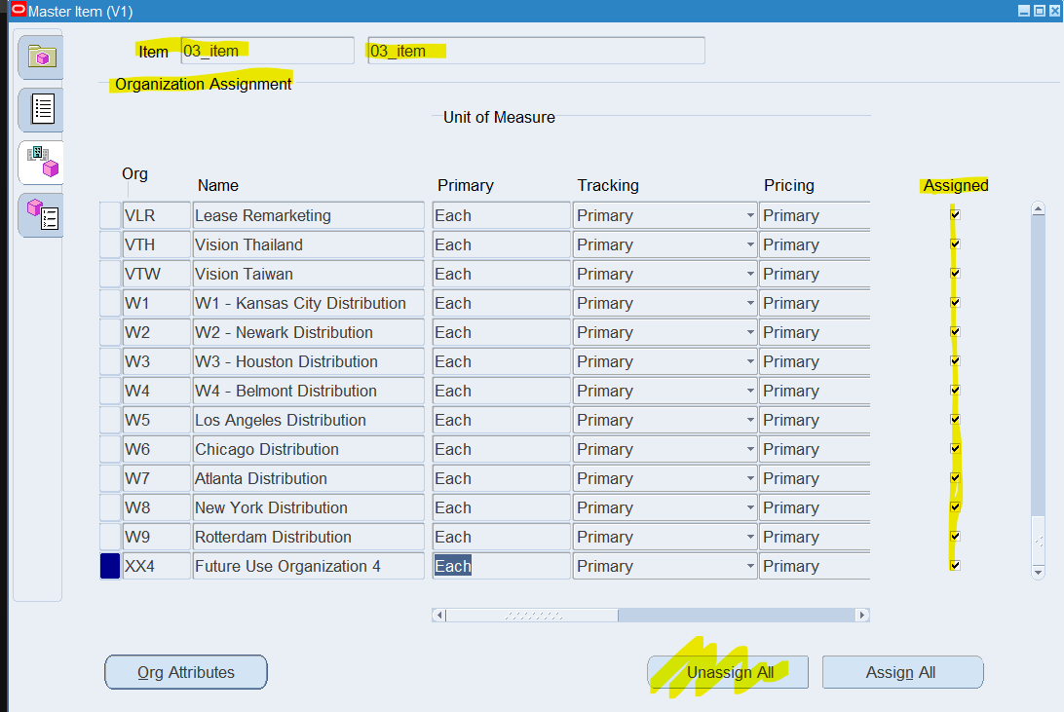

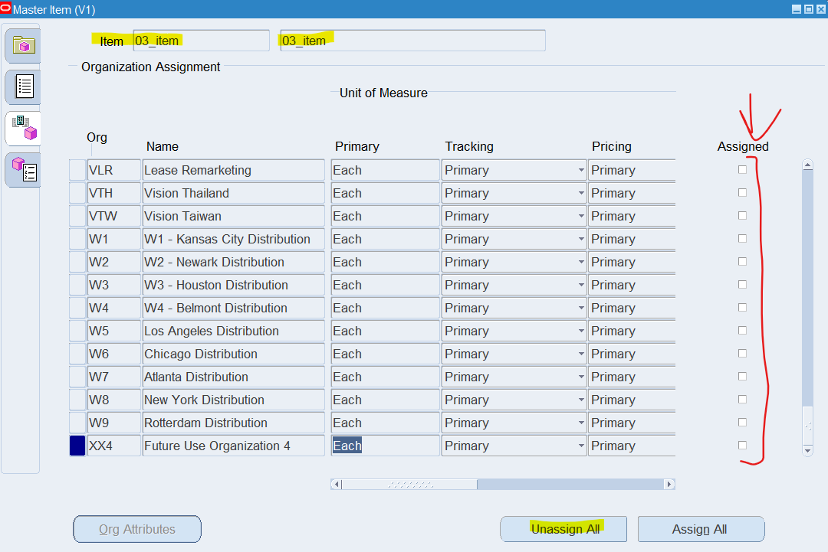

1. **Any of the existing Item [VI Inventory org] Check the on-hand quantity.**

Inventory > On-Hand, Availability > On-hand Quantity

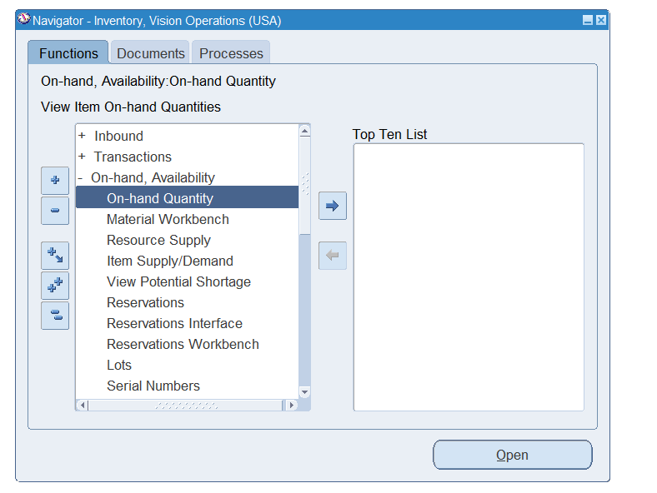

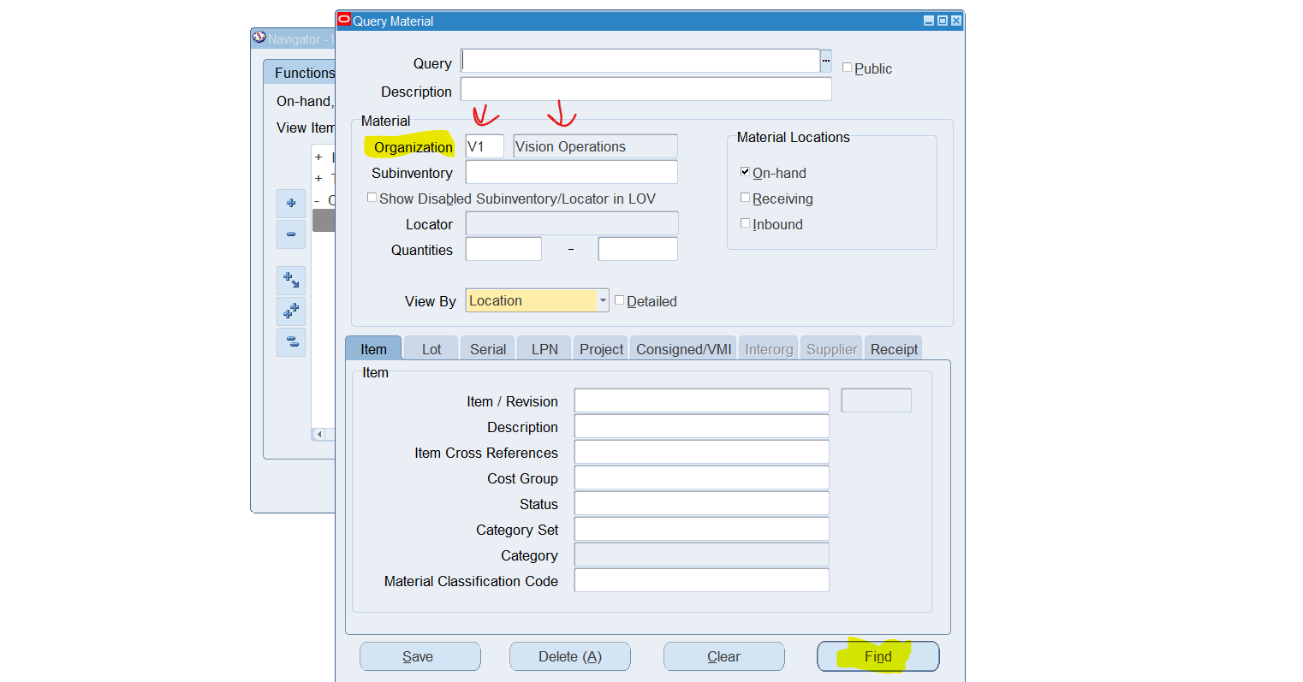

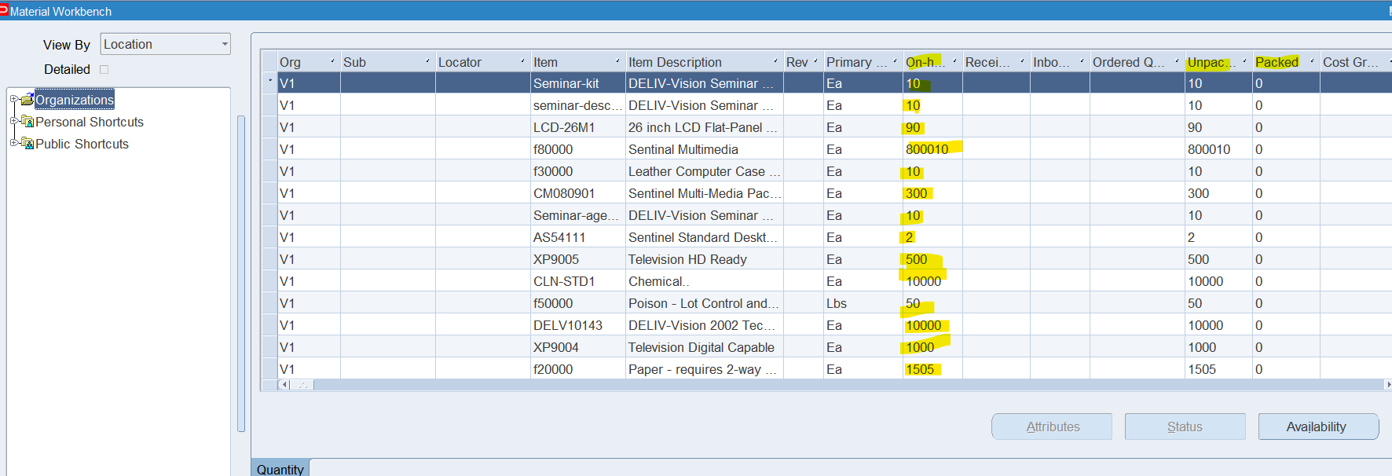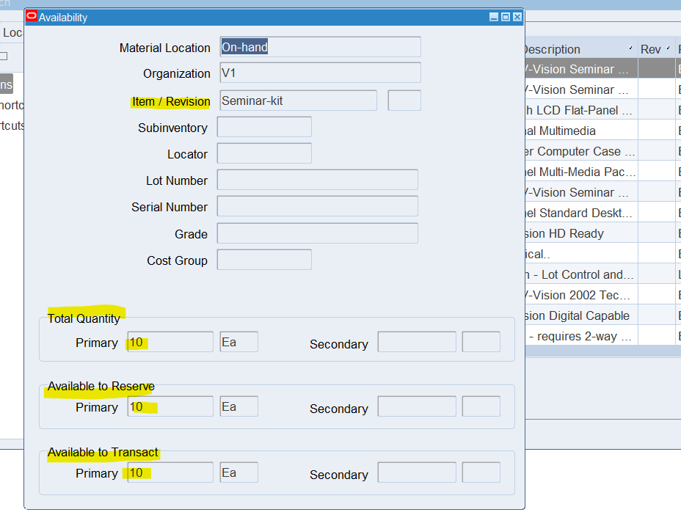

1. **Unit of Measure (UOM)... with Navigation show where UOM has been defined.**

Inventory > Setup > Units of Measure > Units of Measure

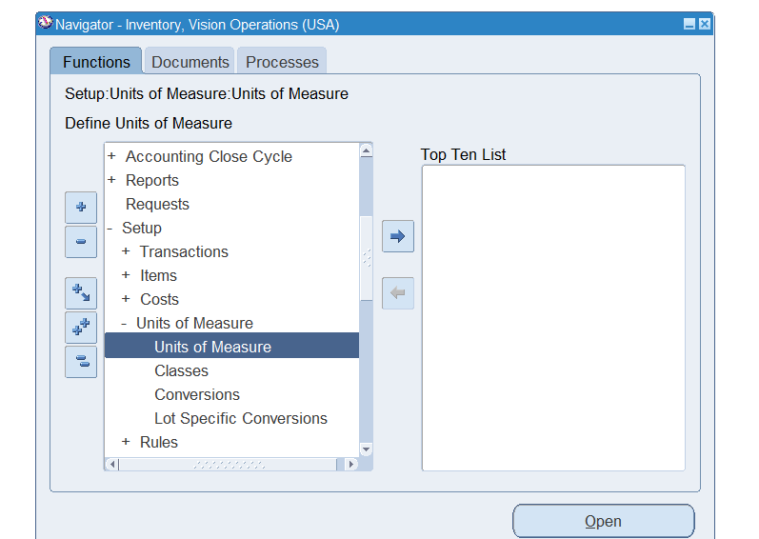

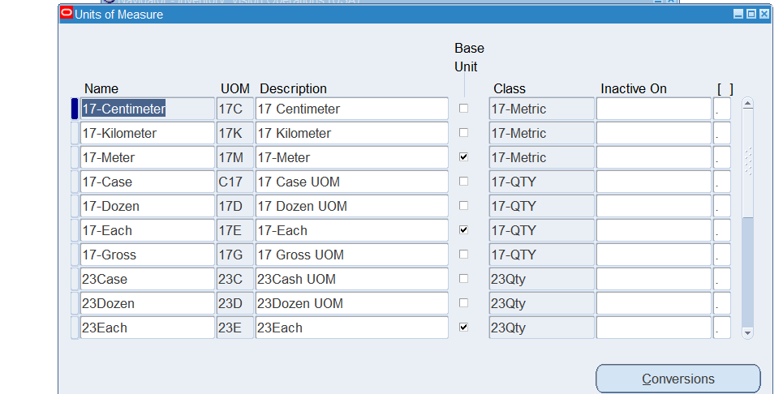

1. **How do you create a new inventory item?**

Inventory > Items > Master Items > New Item

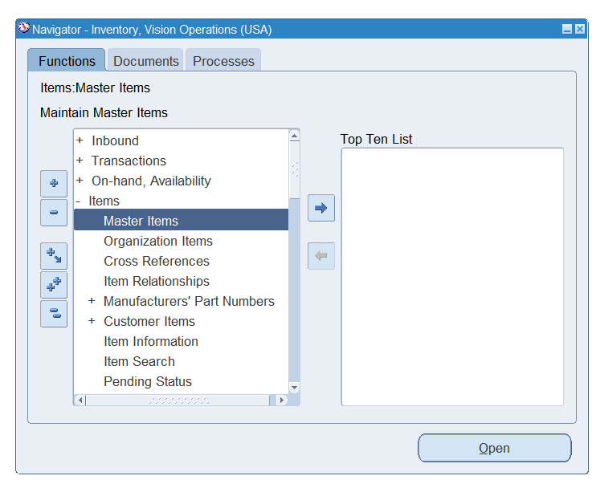

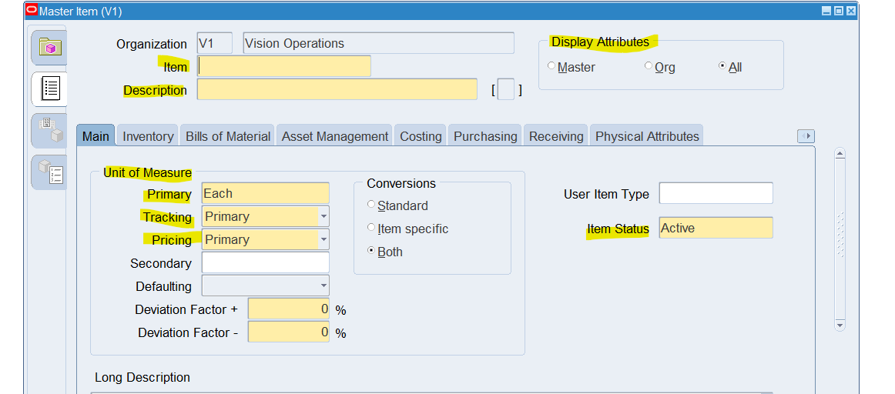

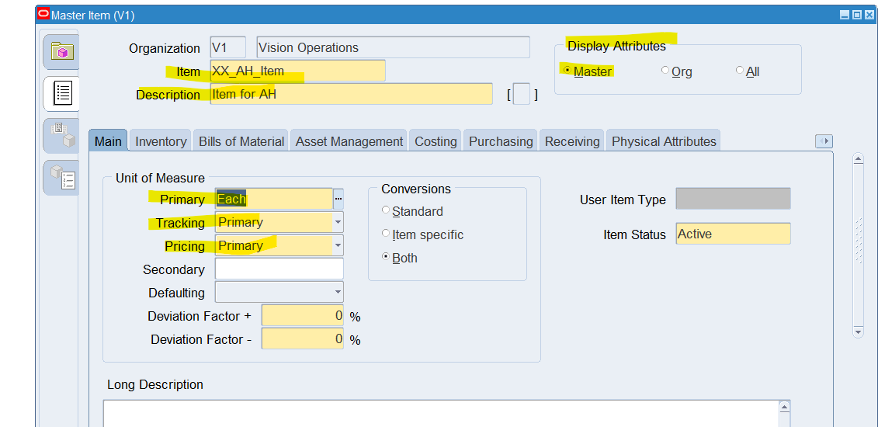

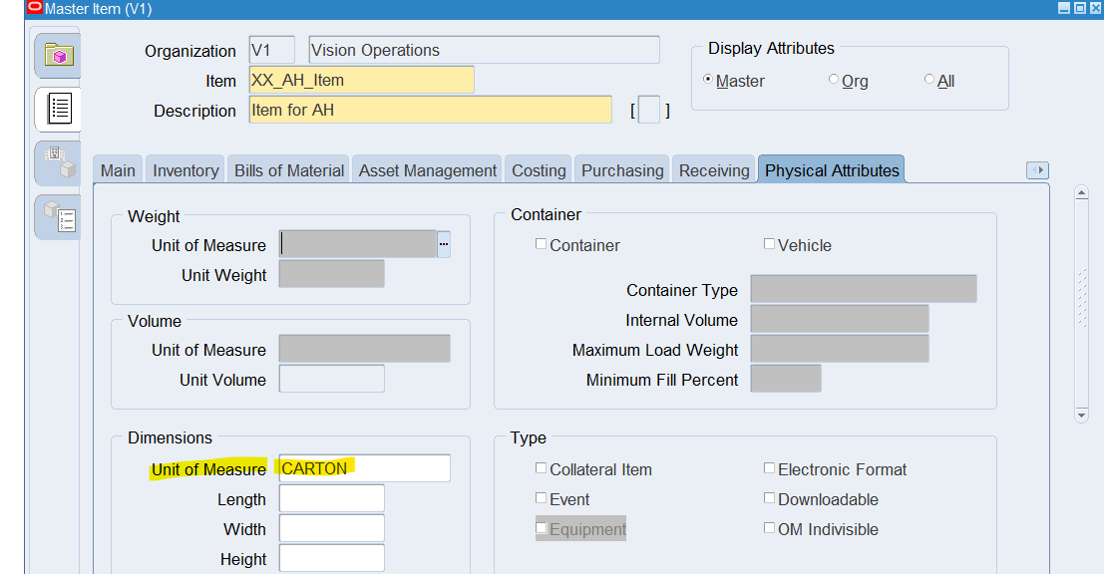

1. **How to run Inventory Valuation Report**

Inventory > Requests > New Request

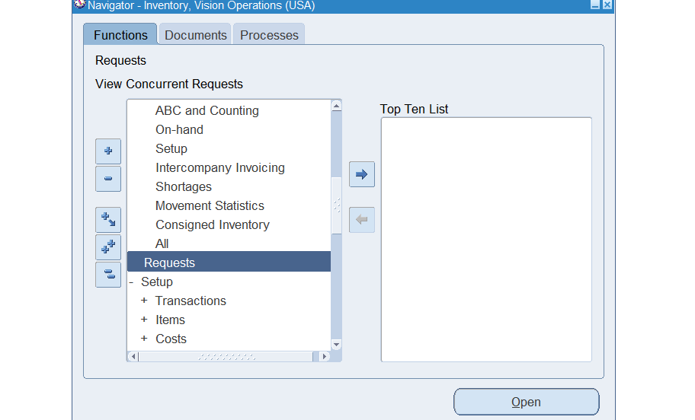

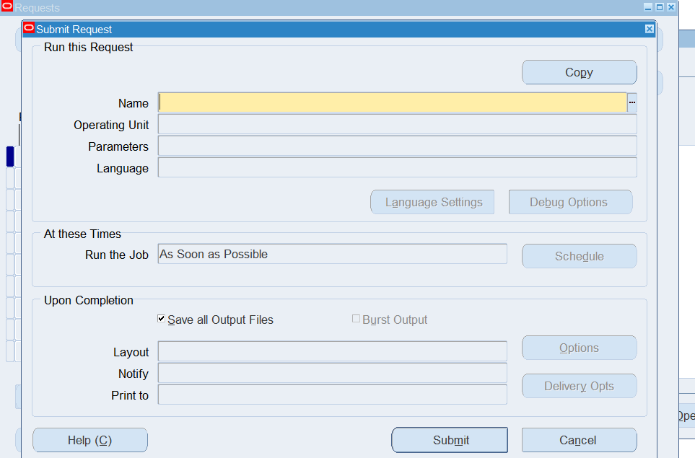

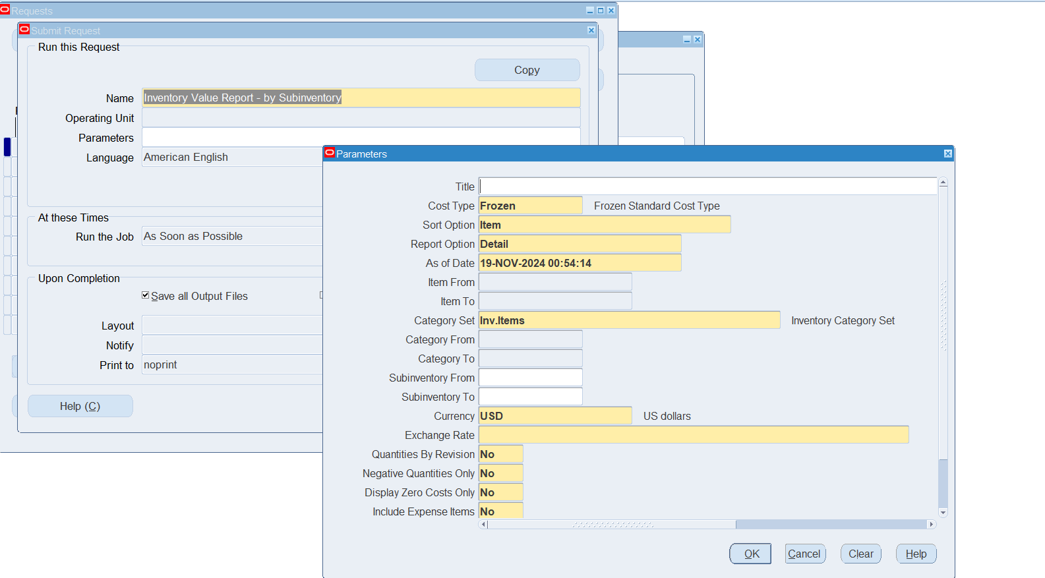

1. **How to change Inventory Organization in the Current responsibility.**  
     
   Inventory > Change Organization  
     
   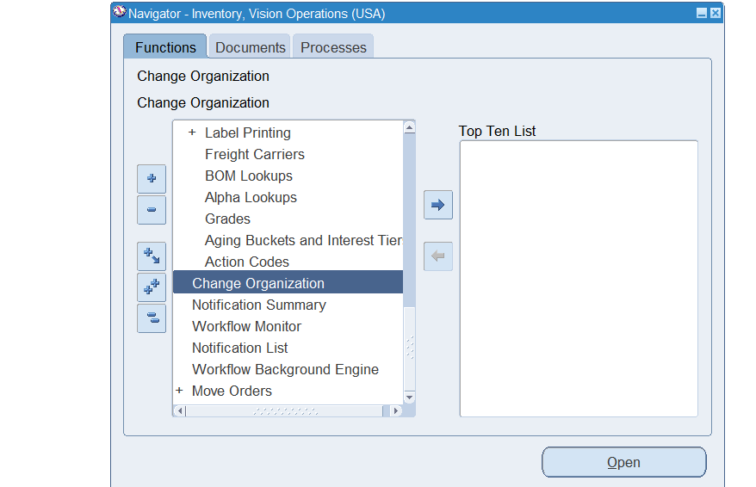

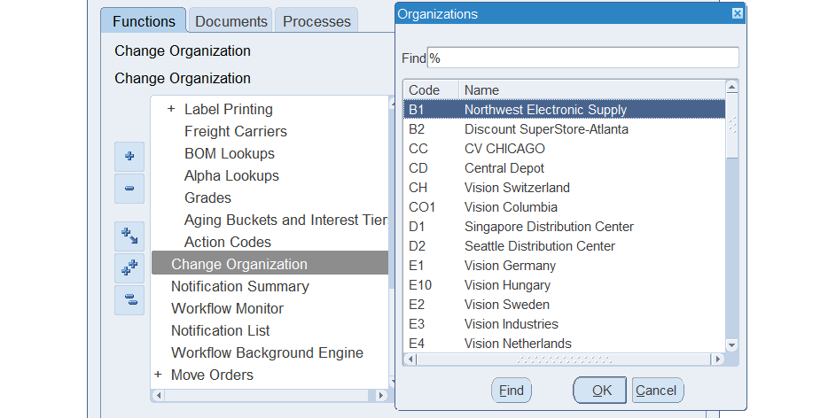

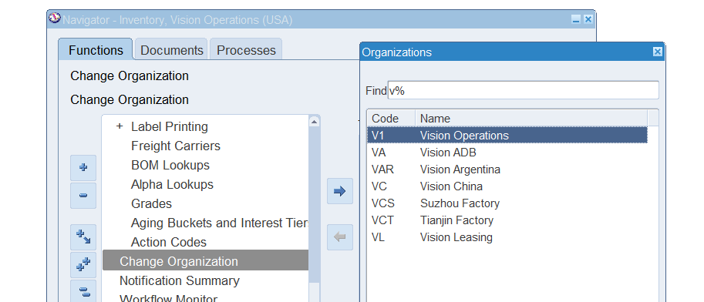

1. **What is Master Data in Oracle Inventory?**

Master level data or Master level items are attributes that are maintained at the master level in Oracle Inventory. This means that the same values are used across the organization and are centrally controlled. This keeps data consistent throughout the management system. For example: If Coca Cola were to use Oracle EBS for their inventory, attributes such as Item number, item category, or description might all be stored in the Master level because that data would be consistent throughout their global operations. However, attributes such as ‘pricing’ would not be stored at the Master level because it would be different across different organizations worldwide.

1. **show the existing ORG with navigation.**

Inventory > Setup > Organizations > Organizations

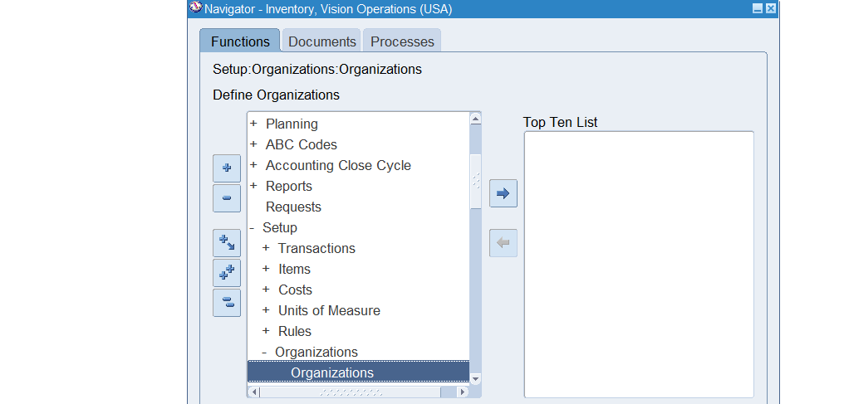

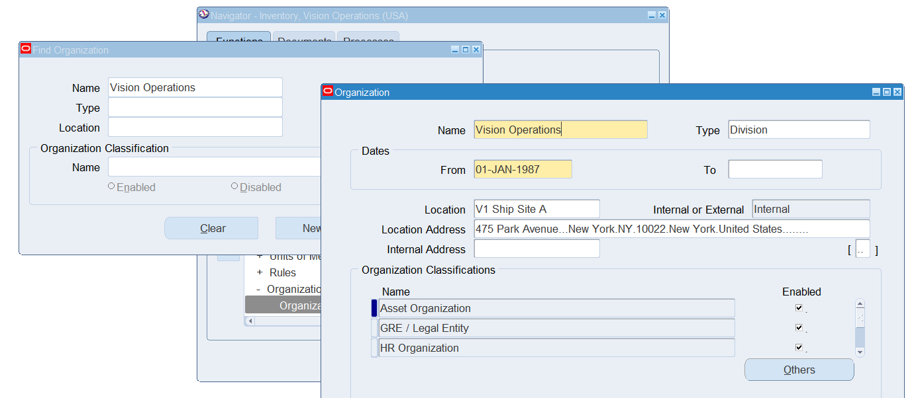

1. **You can manage only finished goods in Oracle Inventory?**

No. You can also manage different types of goods such as raw material, spare parts etc. You can be able to manage all types of goods in different forms.

1. **You need to create an item before performing inventory transactions [True/False].**

True. Its important to define the item first before attempting to perform any inventory transaction. This is because the system has many tools and transactions that you can do such as shipping, receiving, etc. To participate in shipping/receiving/etc (other types of transactions), the item needs to exist in the scope of the system first.

1. **Sub inventories are optional in Oracle Inventory. [True/False].**

False. Sub inventories are important for organizing. Since Companies receive an assortment of goods it's necessary to manage the inventory by categorizing into sub inventory. For Example: A company like Coca-Cola might have Beverages, Ingredients, Packaging, Raw Materials, etc as sub inventories.