**Purpose**: Assignment for Oracle E- Business Suite Order Management

**Student**: Areba Hashmi

1. Order Management Setup

1. Define Order Management System Parameters  
   The parameters are settings that help the module operate based on defining factors. They are critical to the system because they provide criteria to make sure that the order management is running how it is supposed to using conditions and default values.

Order Management Super User, Vision Operations > Setup > System Parameters > Define

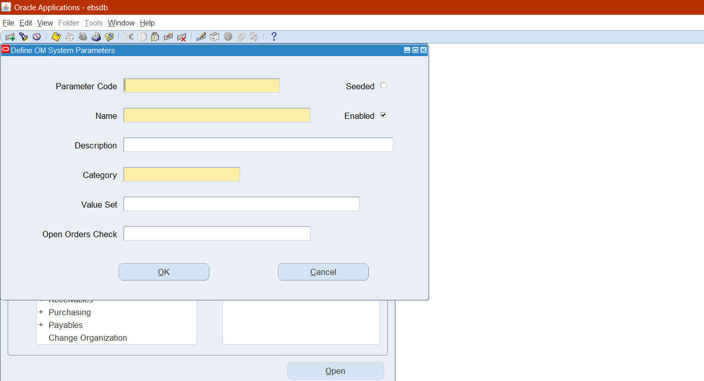

Order Management Super User, Vision Operations > Setup > System Parameters > Values

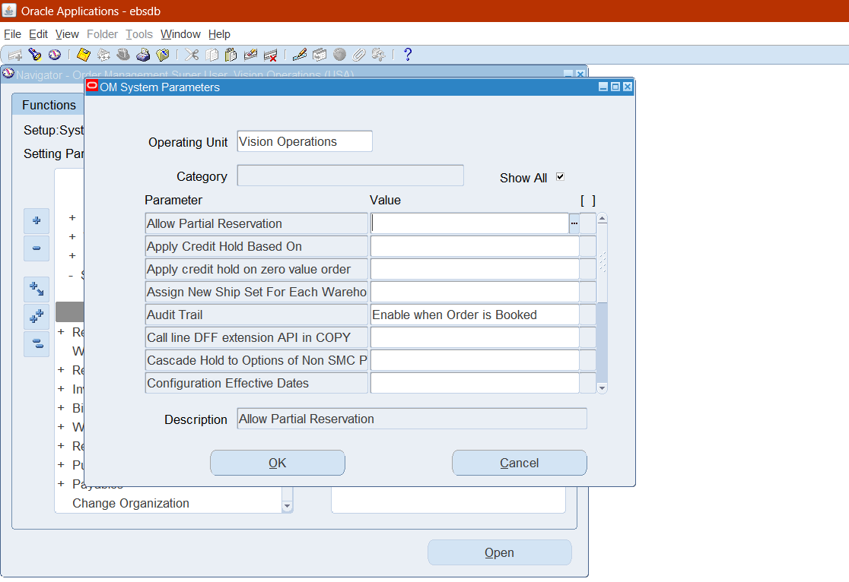

2. Customer Management [Customer Creation]

1. Define and Maintain Customer Accounts and Contacts

Order Management > Customers > Standard.

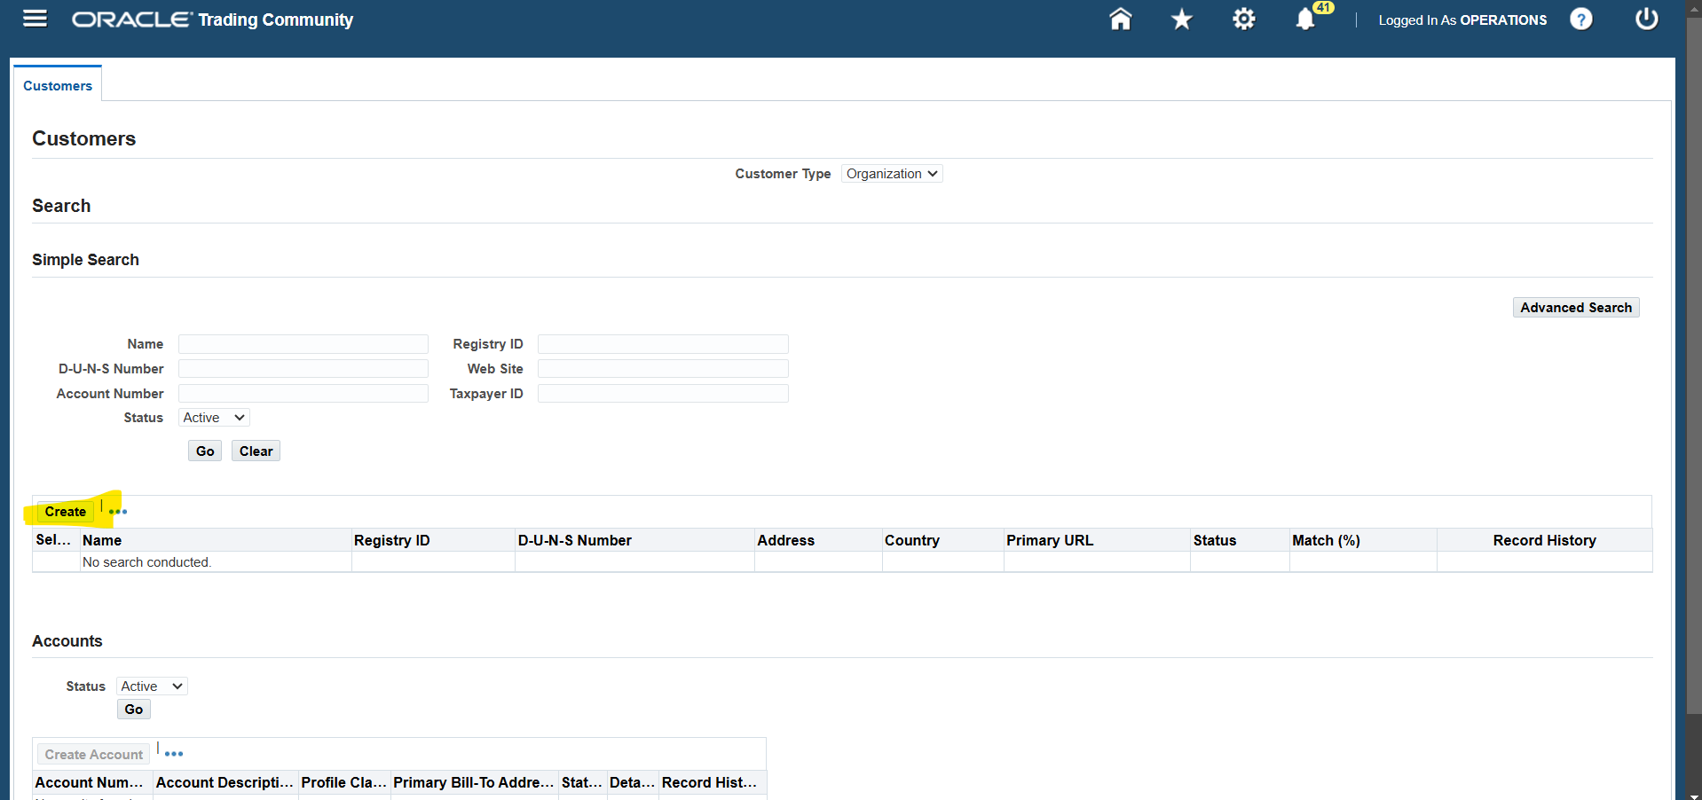

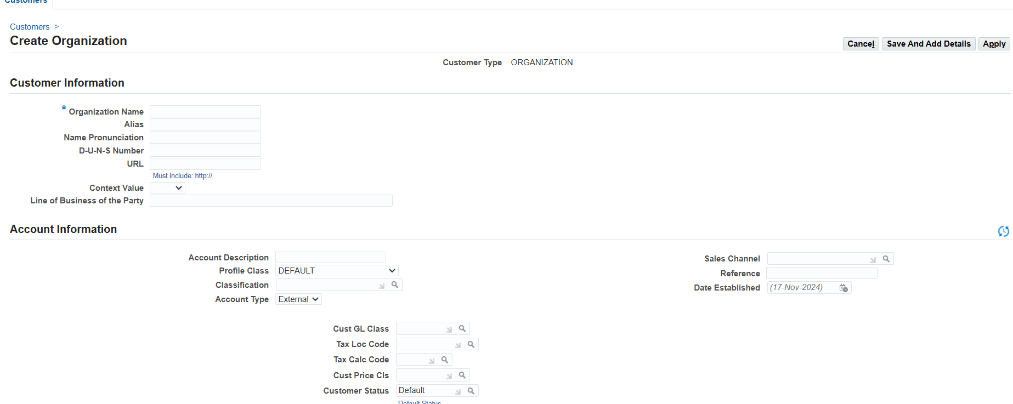For Contacts:

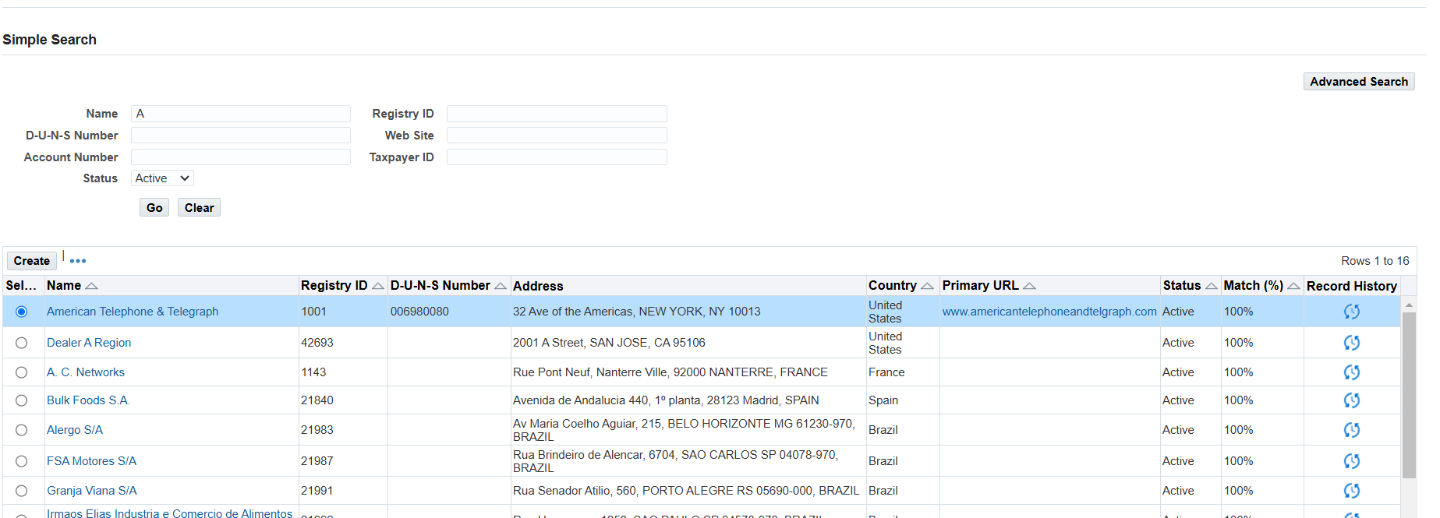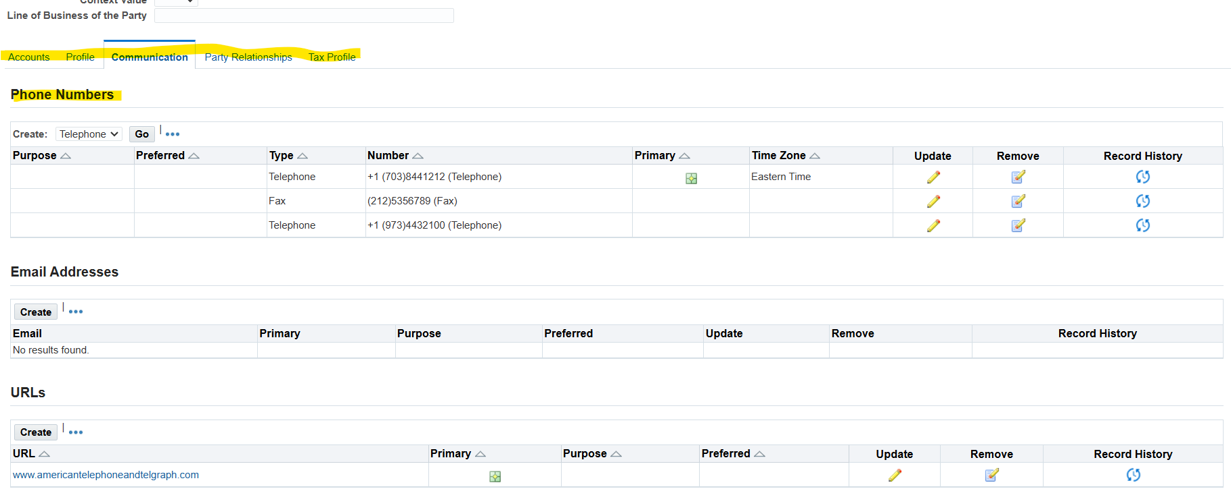

1. Setup Customer Shipping and Billing Information

Order Management > Customers > Standard.

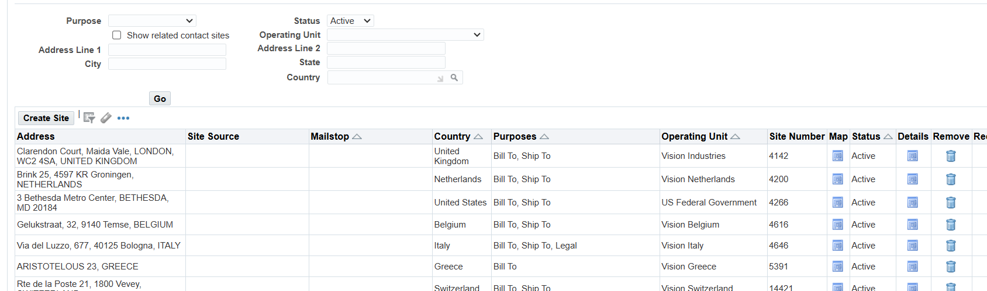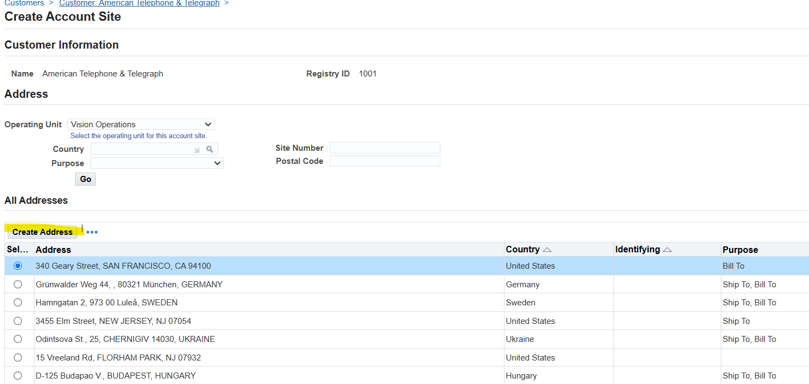

1. Manage Customer-Specific Pricing and Discounts

Order management > Pricing and availability

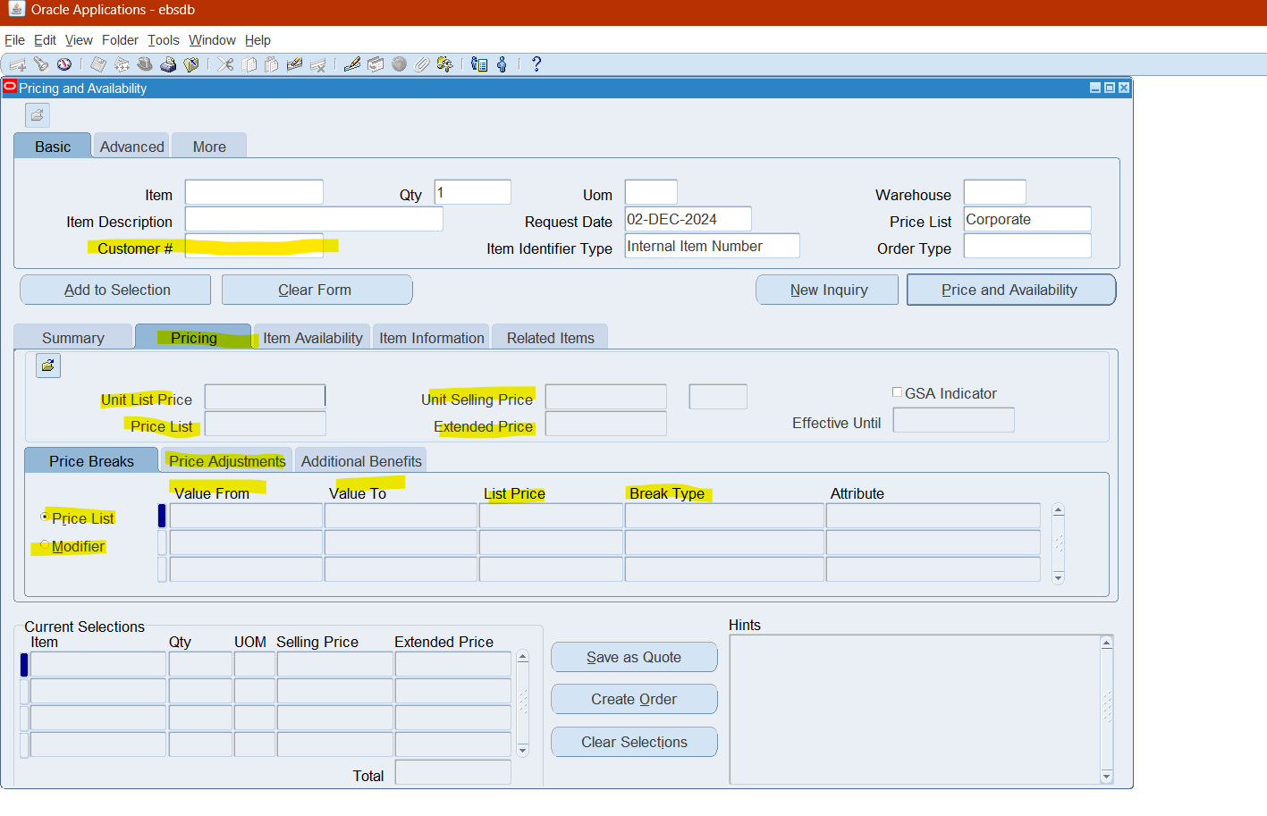

3. Sales Order Creation and Entry

1. Create Sales Orders Manually or Import from External Systems

Order Management Super User > Orders, Returns > Sales Orders.

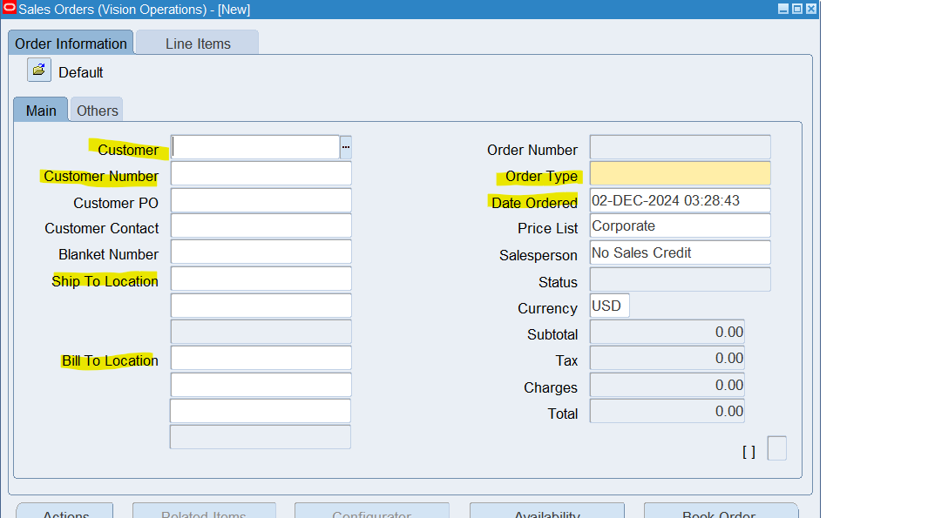Add Line Items

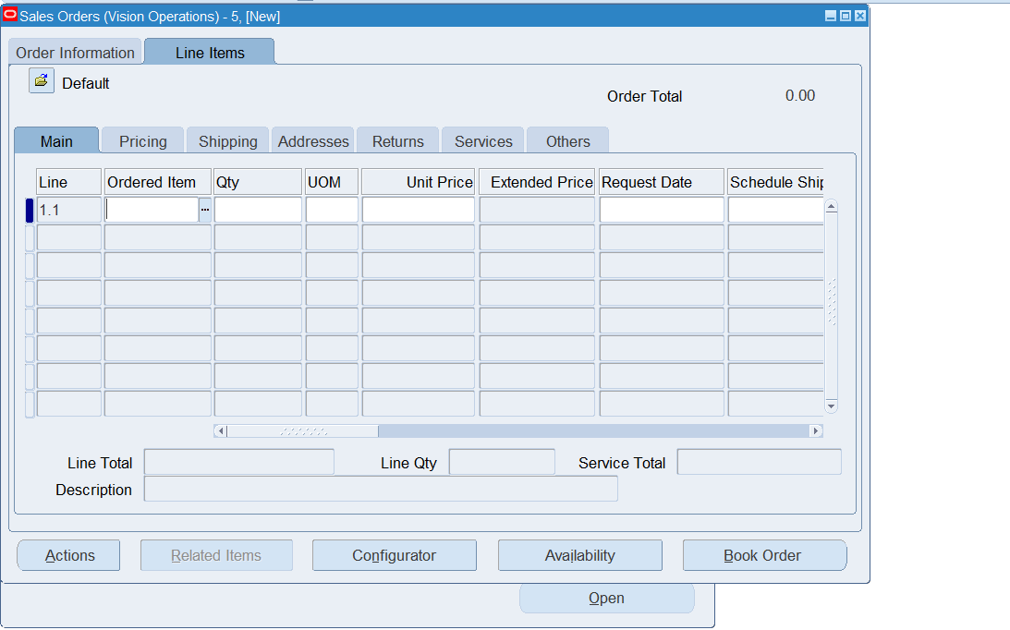After Validating information, book order 