**Purpose**: Assignment for Oracle E- Business Suite Procurement

**Date:** 22nd Nov-2024

**Student**: Areba Hashmi

_________________________________________________________________________

1. **Check one of the existing Supplier, check this Supplier eligible for the Following or not.**   
   **RFQ , Purchasing, Payment**

Purchasing > Supply Base > Suppliers

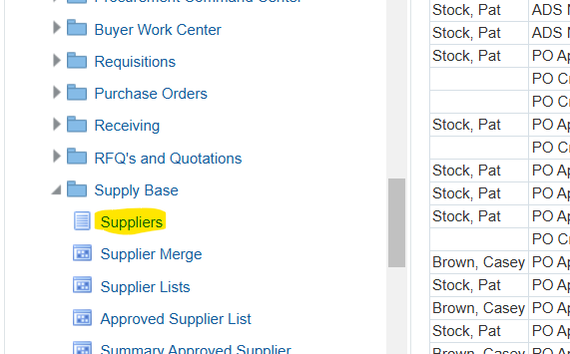

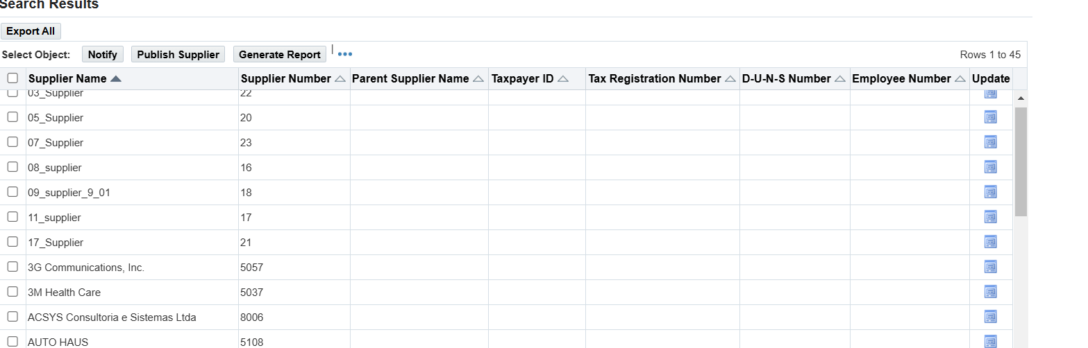

**RFQ**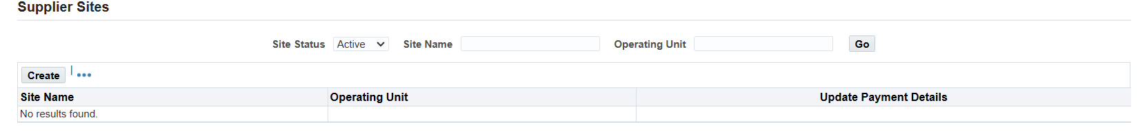

No Active sites ; this insinuates they are not eligible fo procurement activities.

**Purchasing**

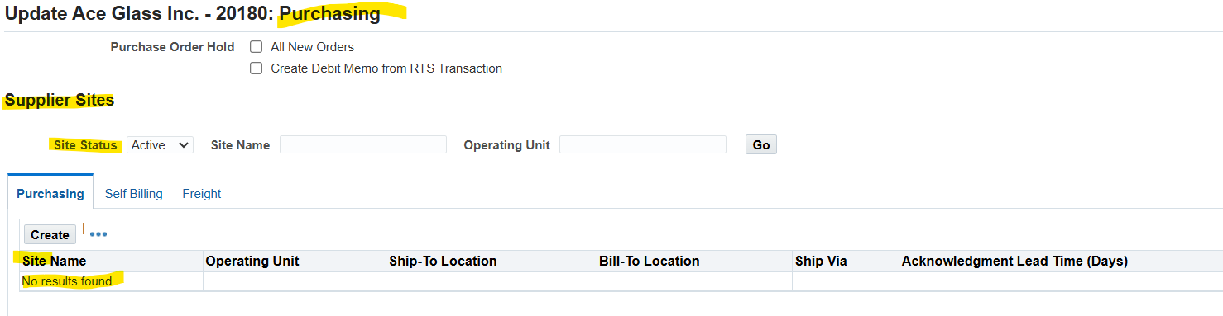

**Payment**

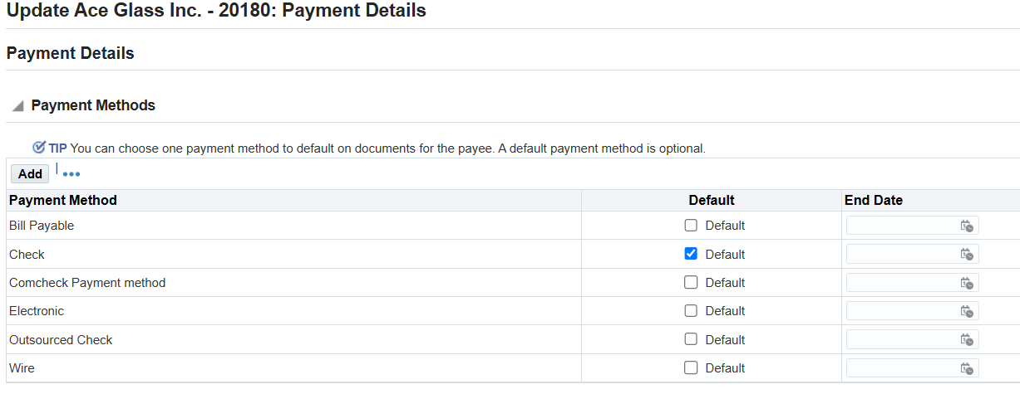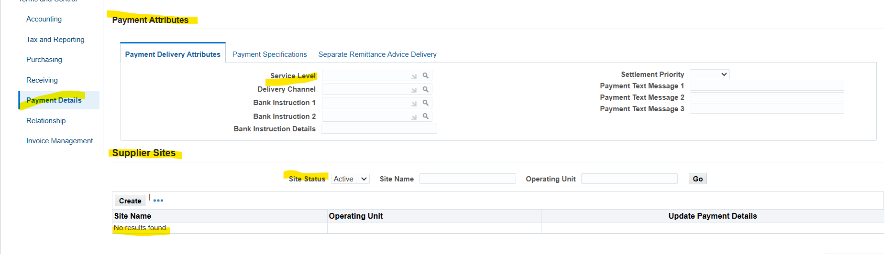

There is no significant payment information. Therefor this supplier is not eligible for the following: **RFQ, Purchasing, Payment.**

1. **For The same above Supplier checks the Bank details & Payment Method.**

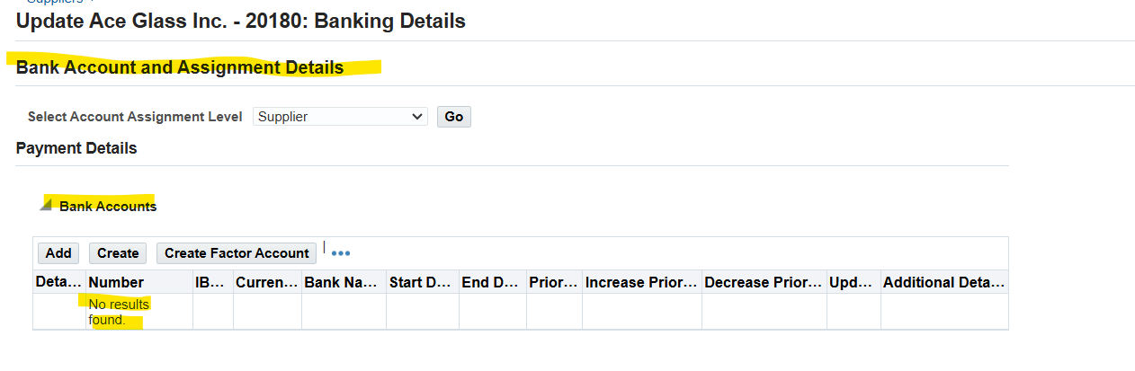There were no banking details

1. **Query one existing Requisition & check what are all information has been captured/update for the respective Requisition.**

Purchasing > Requisition > Requisition Summary

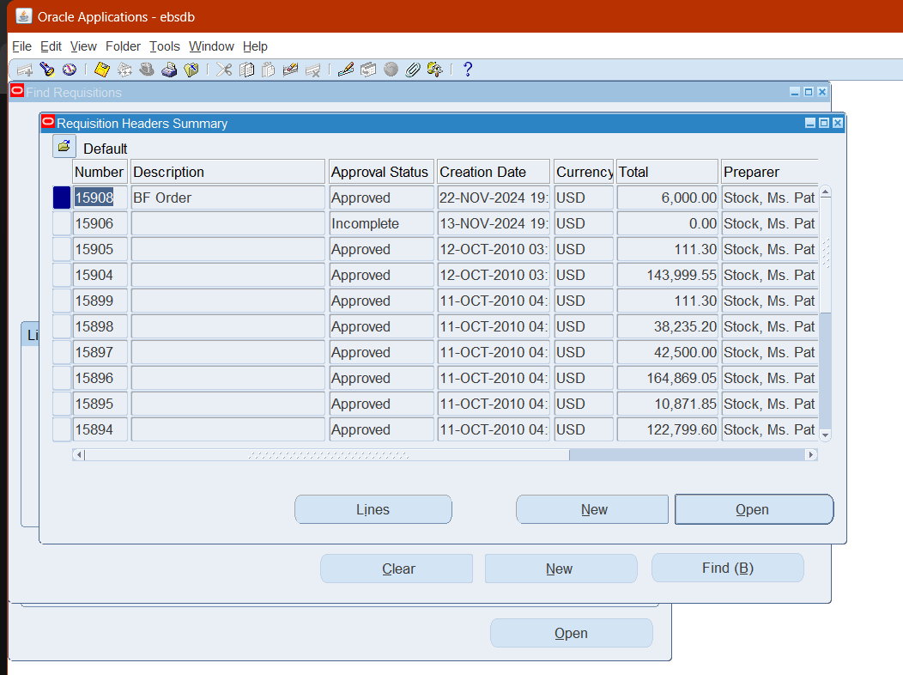

Open one, and check captured information.

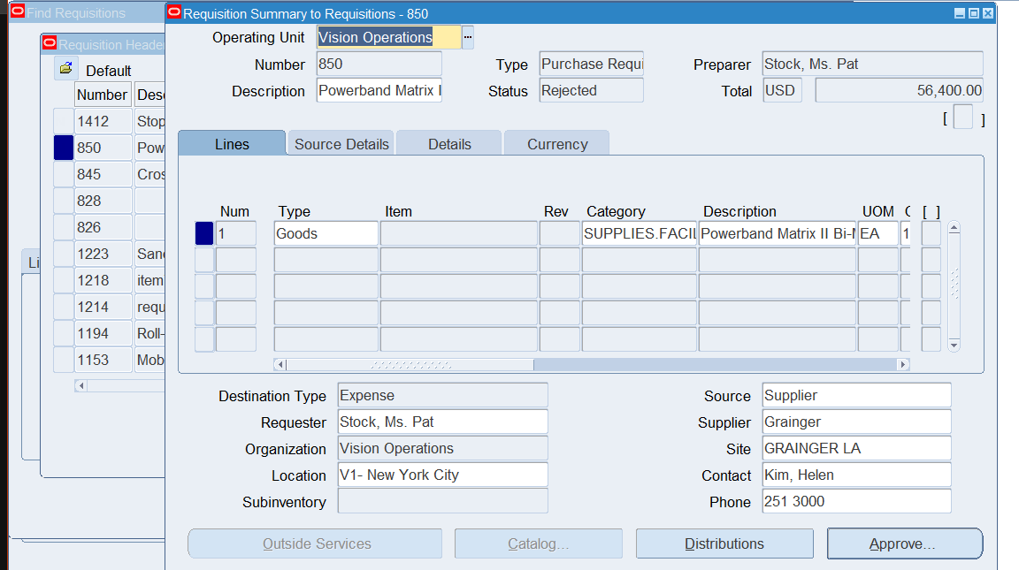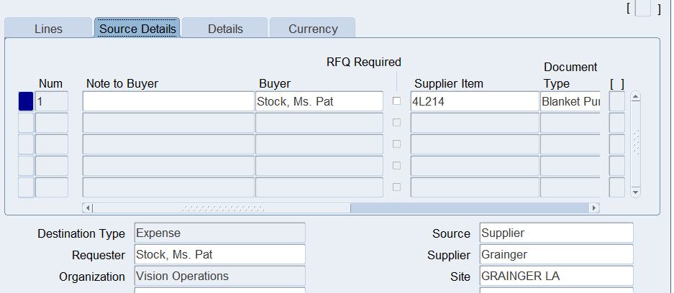

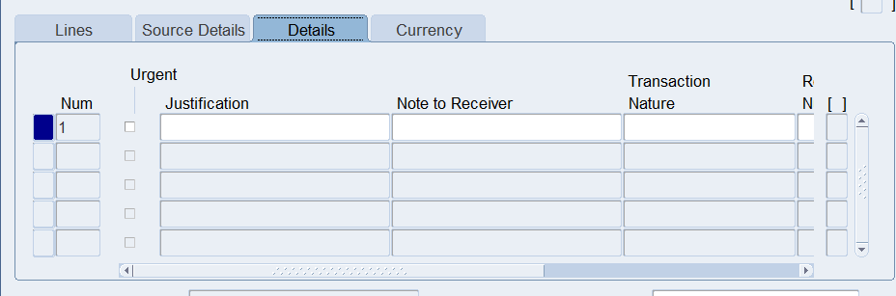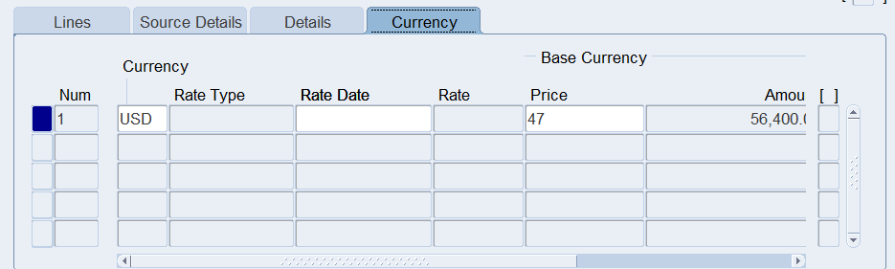

1. **Query one existing PO & check what are all information has been captured/update for the respective PO**

Purchasing >Purchase Order> Purchase Order Summary

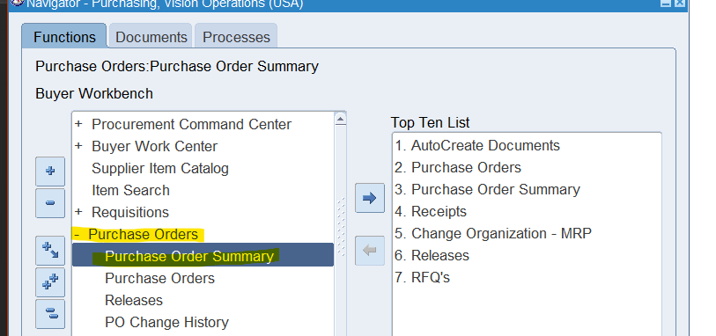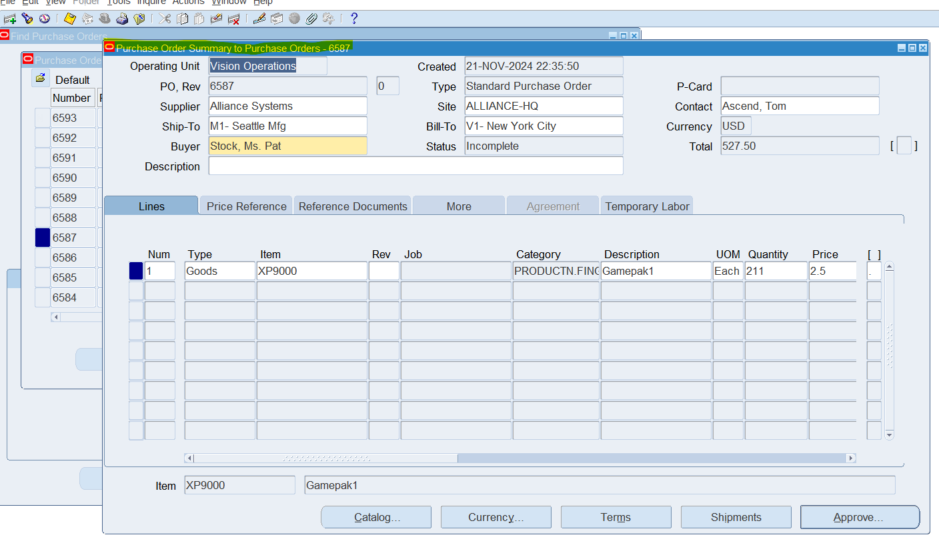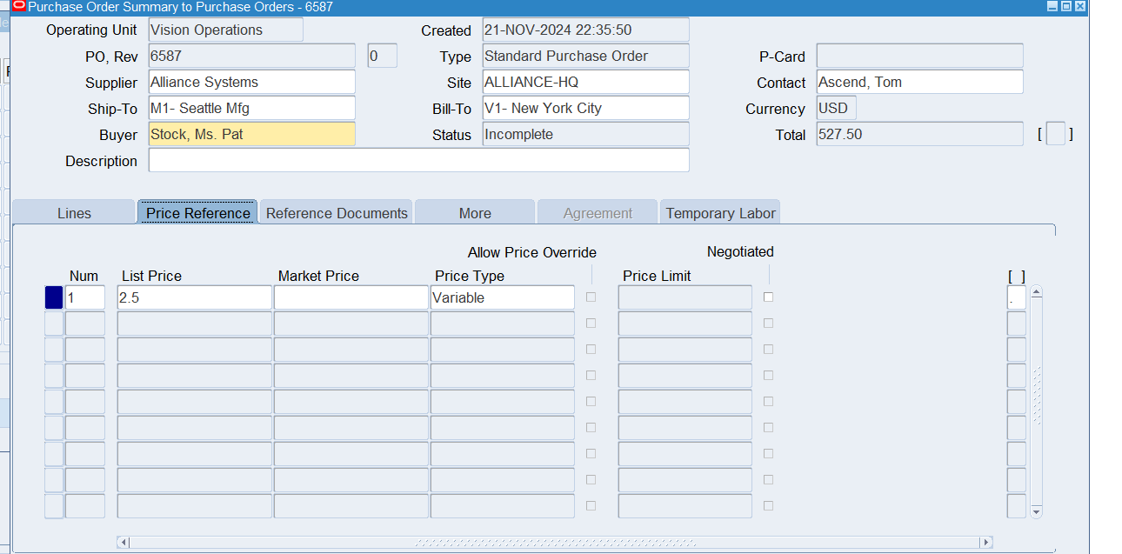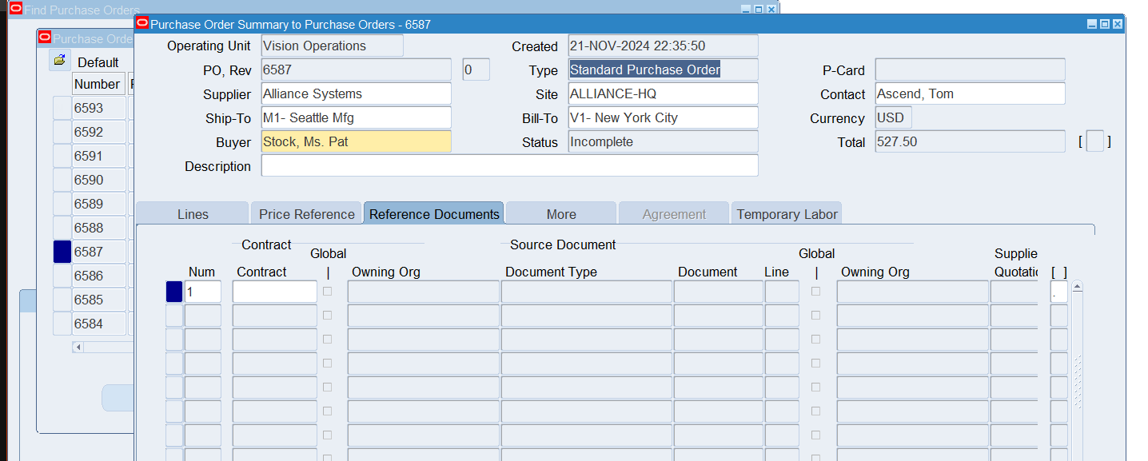

Some of the information that has been captured is Site, Buyer, Ship-to, Supplier, List price, Item, and more.

1. **Explain the key modules of Oracle EBS Procurement Suite.**

Some of the key modules within the Procurement suite are: Purchasing, RFQ (Request for Quotation), Supplier Base, Items, and Requisition. There are others as well but these are they key ones that we have focused on this week. The Purchasing suite is important because it is used to manage and create purchase orders. Purchase orders are a key starting step in the supply chain process. RFQ allows organizations to request quotes in regard to the items they are considering purchasing before anything is officially purchased. RFQ, Requisitions, and Item modules are very important for organizations to consider the items and goods they are willing to purchase. The Supplier Base is important for managing supplier information, payments, shipment info and more. All these modules work together to ensure that the supply chain process is as efficient and accurate as possible.

1. **What is the PROCUREMENT/PURCHASING key Configuration?**  
   **Each of the setup component what are all Information in captured while configuring need to demonstrate.**

* Requisition
  + Formal notice of needing goods to approval hierarchy. Allows organization to take steps in procuring goods.
* Purchase Order
  + Official order of goods. Purchase order notifies to supplier that these goods must be sent to the buyer.
* Receiving
  + Receiving the shipment must be documented and receipt must be uploaded. This notifies all parties involved that the procurement process is completed.

1. **Navigate Provide screenshots or descriptions of the following:**

* **The requisition.**

Purchasing > Requisition > requisition

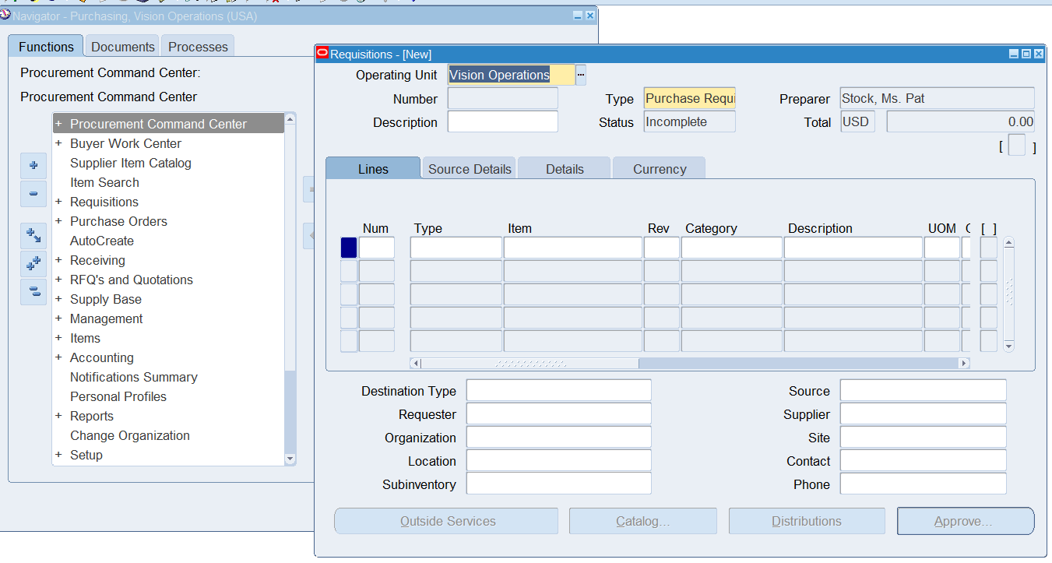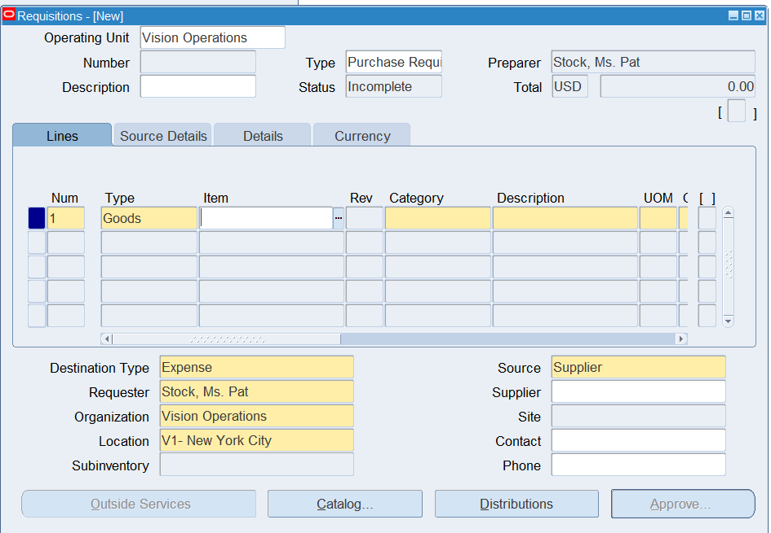

* **Purchase Order.**

Purchasing > Purchase order > Purchase order

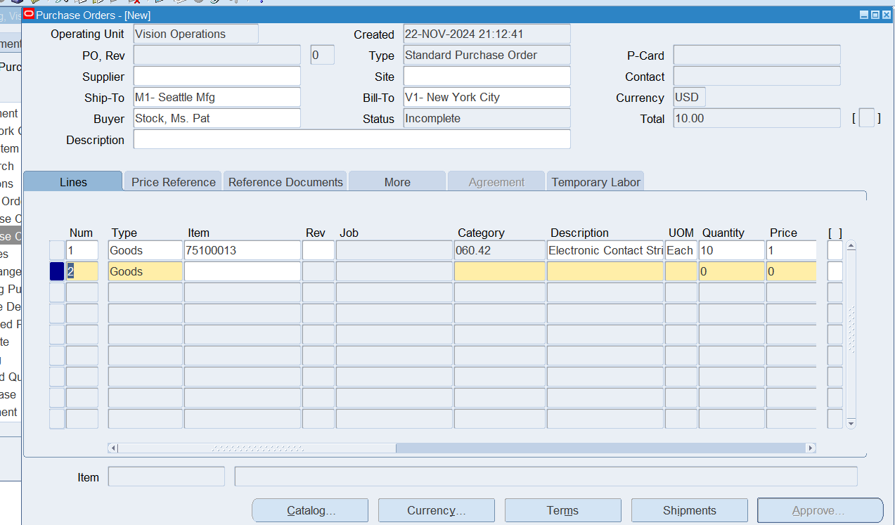

* **Receipt for PO.**

Purchasing > Recieving > Receipts

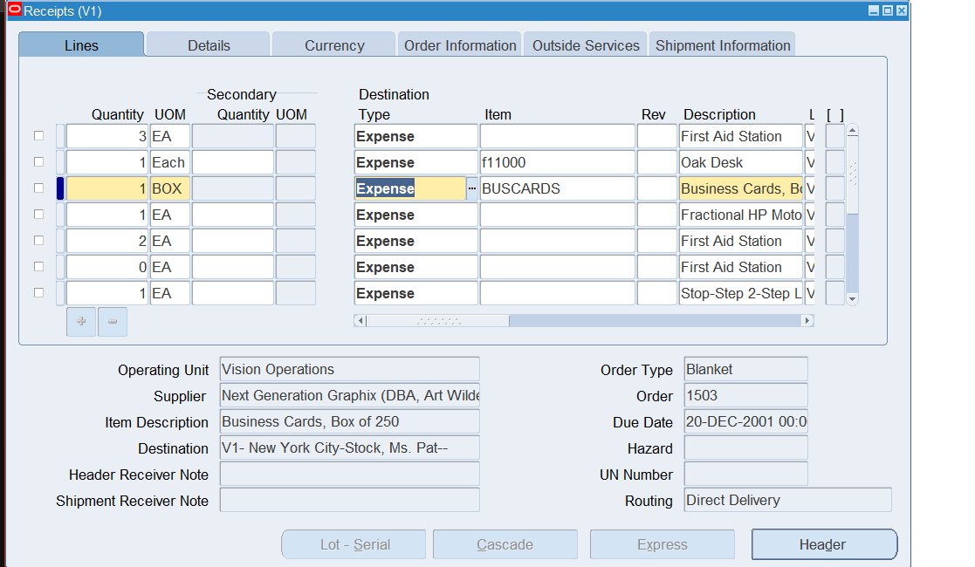

1. **Your company requires the following items for a project:**

* **5 Desktop Computers**
* **10 Office Chairs**

**You are tasked to procure these items using Oracle Procurement.**

Creating the Items

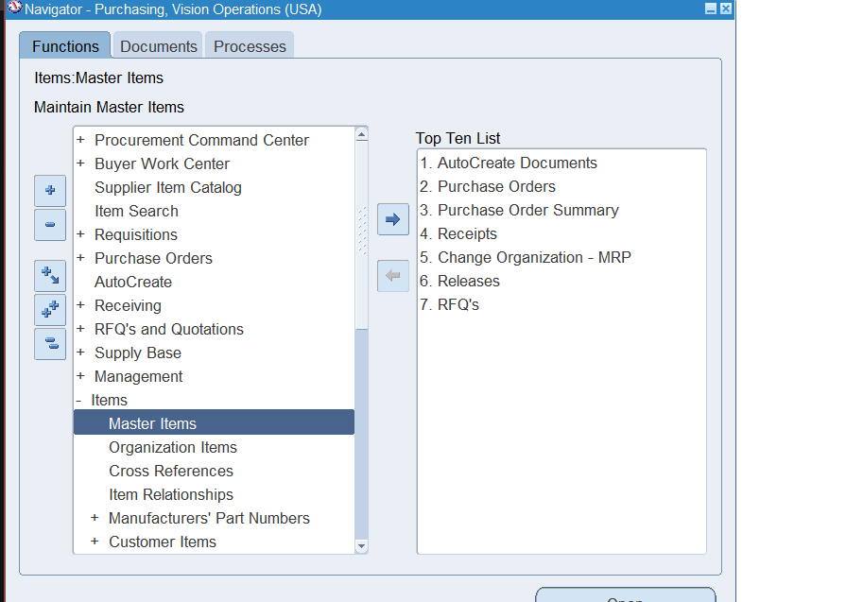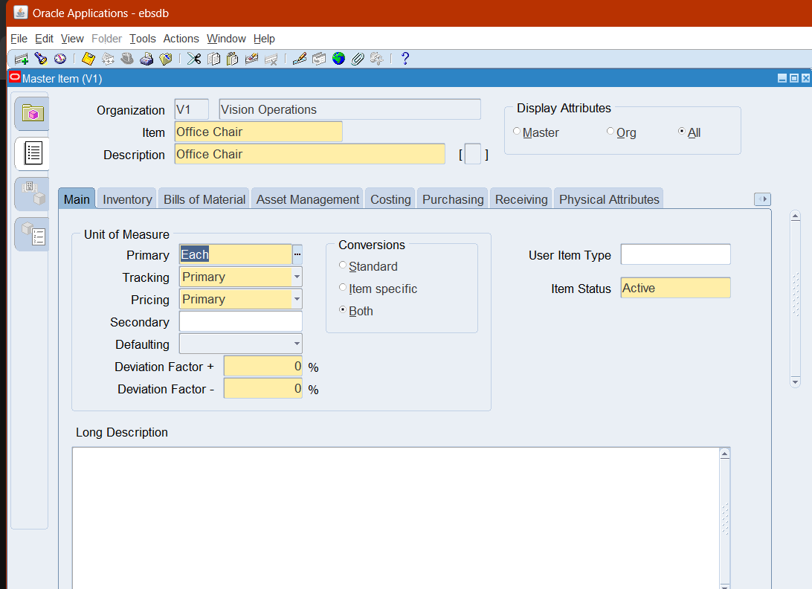

Steps to Complete:

1. **Create a Supplier:**

* **If the supplier doesn't exist, create a new supplier record, including address, contact information, and payment terms.**

This is my supplier, I created earlier on in the course.

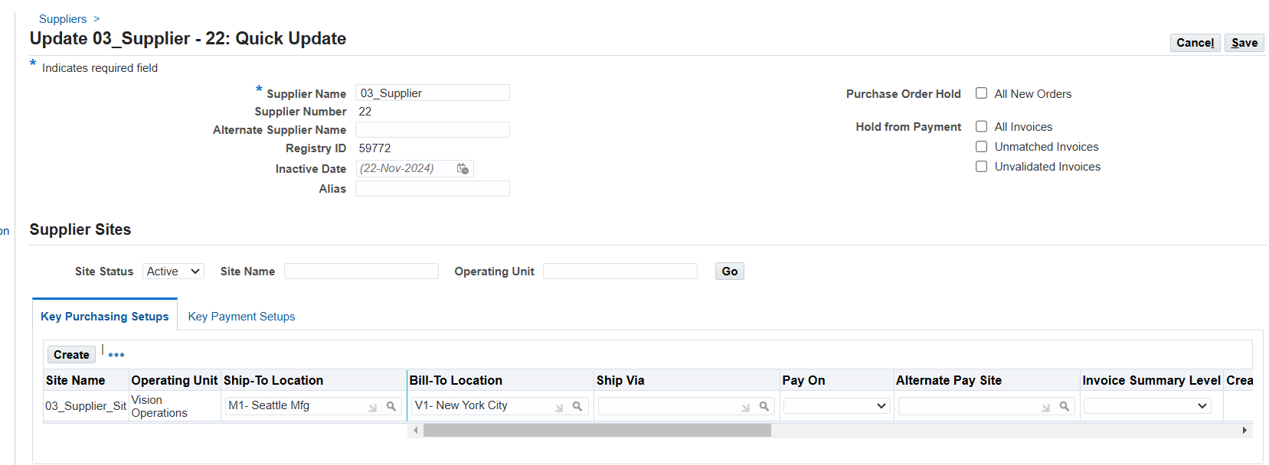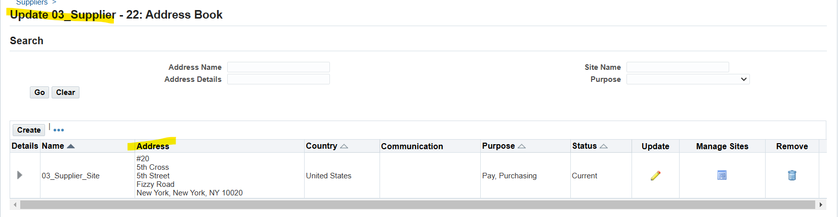

1. **Create a Requisition:**

**Purchasing > requisition > requisition**

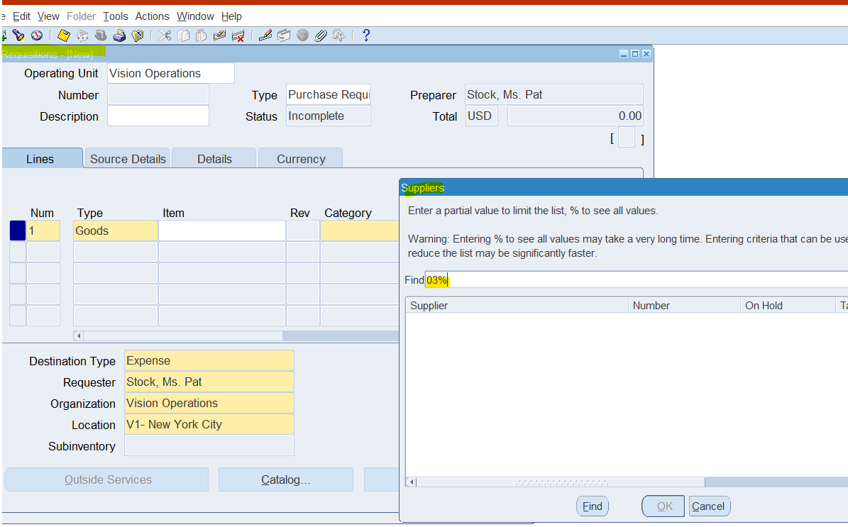

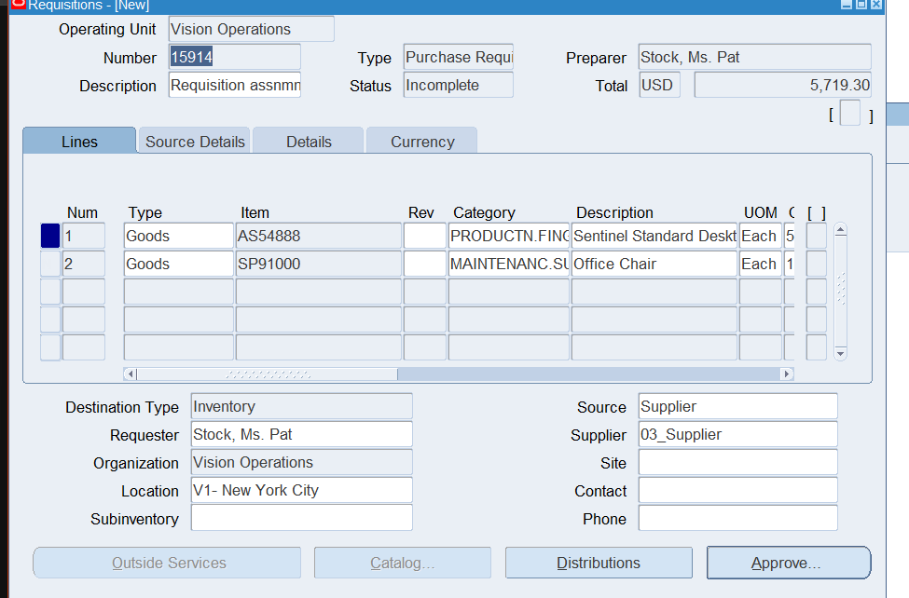

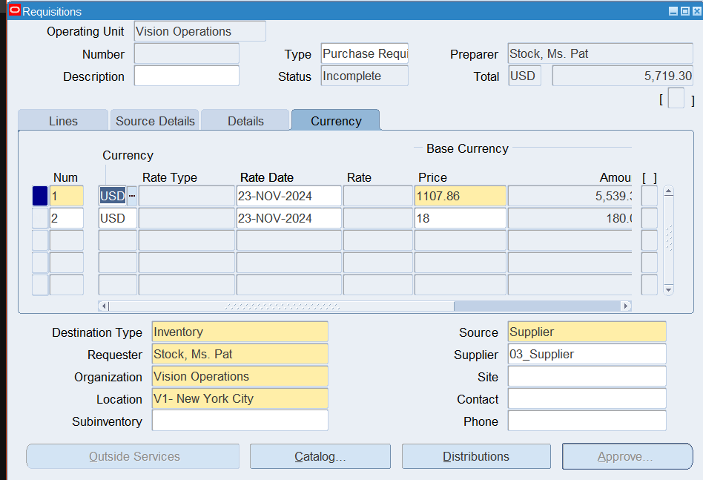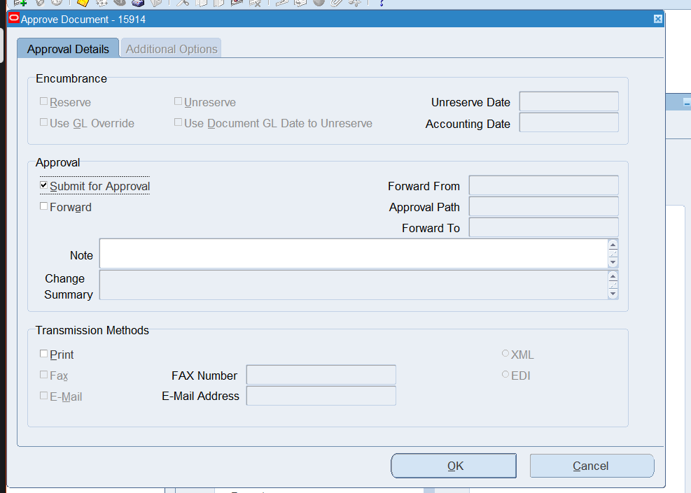

1. **Create a New Purchase Order**: Standard with currency type as USD Enter **Order Information**:

**Supplier**: Select the supplier from the list of available suppliers.

**Order Type**: Choose the appropriate order type (for example, **Standard**).

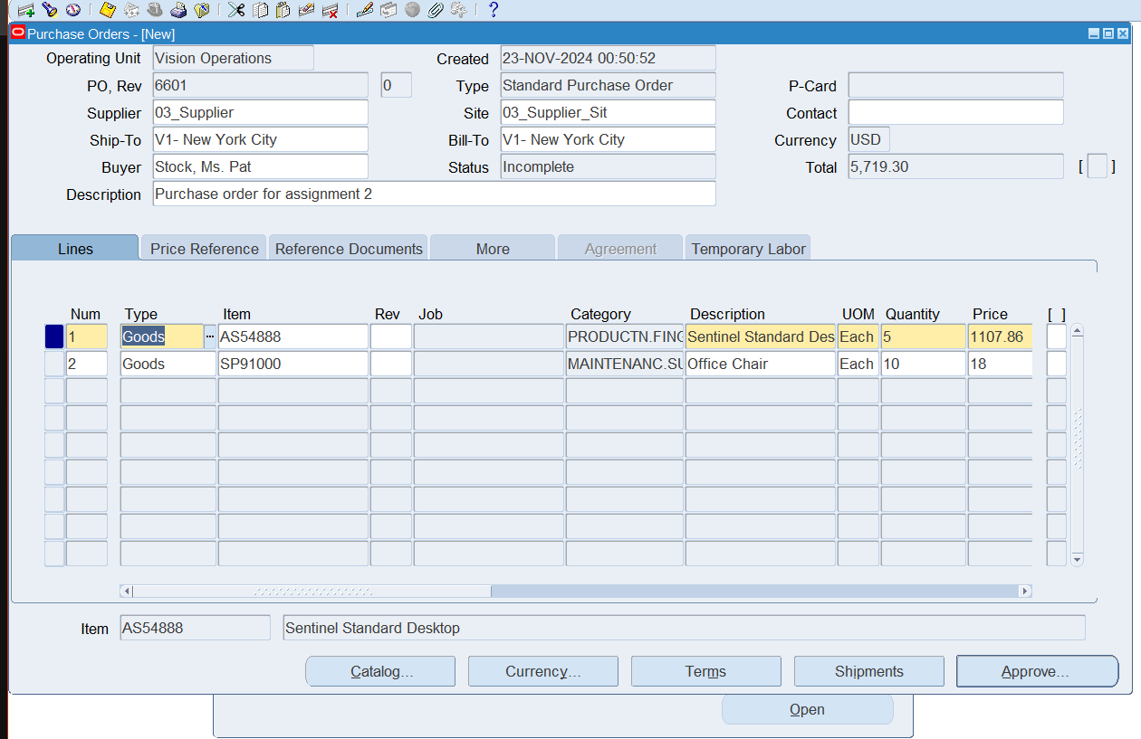

approve

1. **Create a Quotation for any of the existing supplier.**

Purchasing >RFQ>Quotations

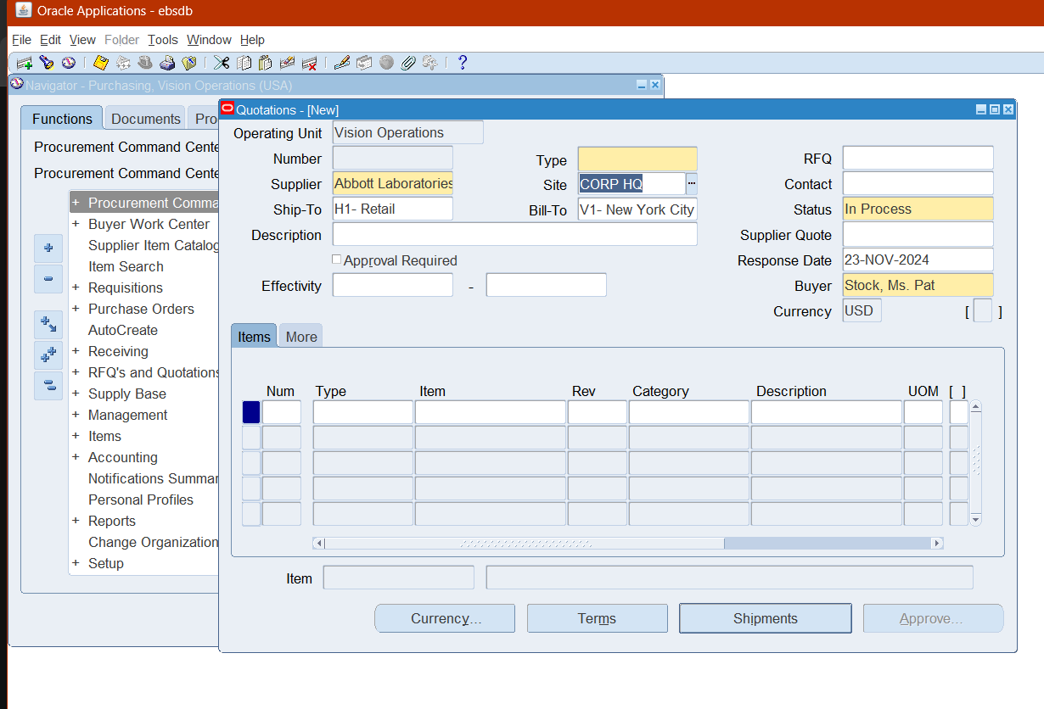

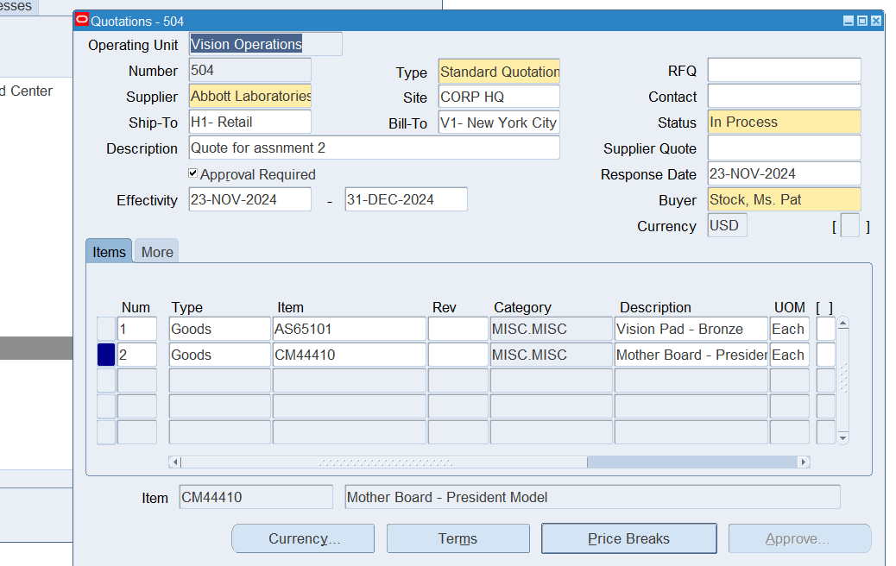

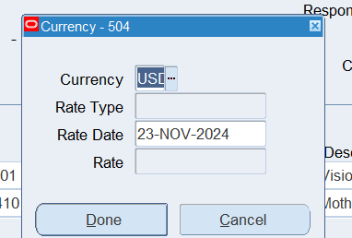

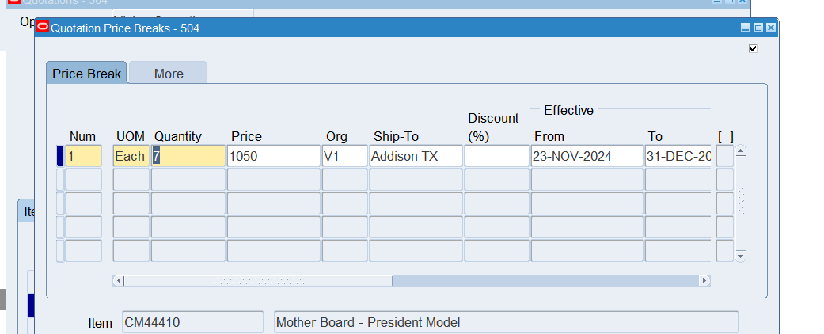

1. **Verify all accounts which are updated for financial options.**

Purchasing >setup > Organizations >financial options

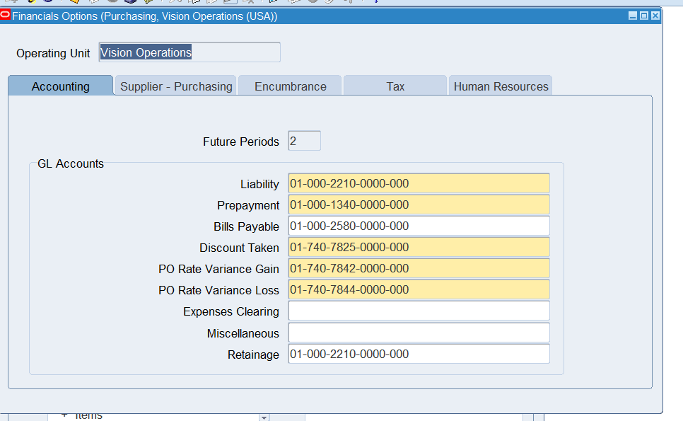

All the accounts with flexfields are updated for financial options.