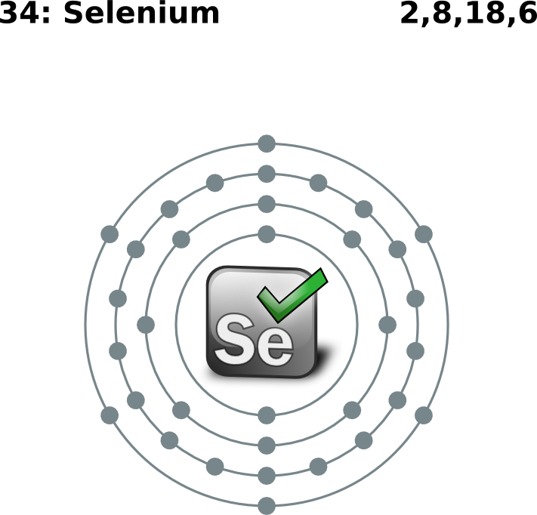

Codelab
Page Object Pattern and how to use Selenium

Created by Michel Racic (rac@gdgzh.ch)

=> http://rac.su/+

Table of contents
Introduction
What is the Page Object Pattern all about?
Target of this codelab
Structure of the codelab files
Where are the files to work during the codelab?
Where are the files for the next stage in case of troubles?
The sample Application under Test (AUT)
How do I start it?
VirtualBox VM
The sample Test Cases (TC)
Lets analyze the AUT and TCs
Screenshots
Step 1 & 2 & 8
Step 3 & 4 & 5
Step 6 & 7
Which are the relevant pages?
What elements do we need from them?
Start page
Login page
THN Menu
Which functionality do we need in the interfaces?
Creating the interfaces
Having a look at the login page
Your turn - Create the interface for the THN Menu
What to do if you finished too fast?
Creating the tests
002_Login_as_User
Login function
Step 1 & 2
Step 3 & 4
Step 5
Step 6
Completed function
The JUnit test
Your turn - Create the test for 001_Login_as_Admin
What to do if you finished too fast?
Creating the Page Objects
Login page
Identify the needed elements
Implement functionality
Top header navigation (THN)
Identify the needed elements
Implement functionality
Your turn - Create the object for the generic article page
What to do if you finished too fast?
Conclusion

Introduction

What is the Page Object Pattern all about?
The Page Object Pattern allows you basically to write tests directly from requirements before even one line of code has been written for the Application. The most important benefit of Page Objects is the maintainability of them and if you have done Test automation in a Project before, you will know that this is a key factor to success in the long term goal of the automation. Take a look at my Credit Suisse Slides and on http://code.google.com/p/selenium/wiki/PageObjects to get some more information.
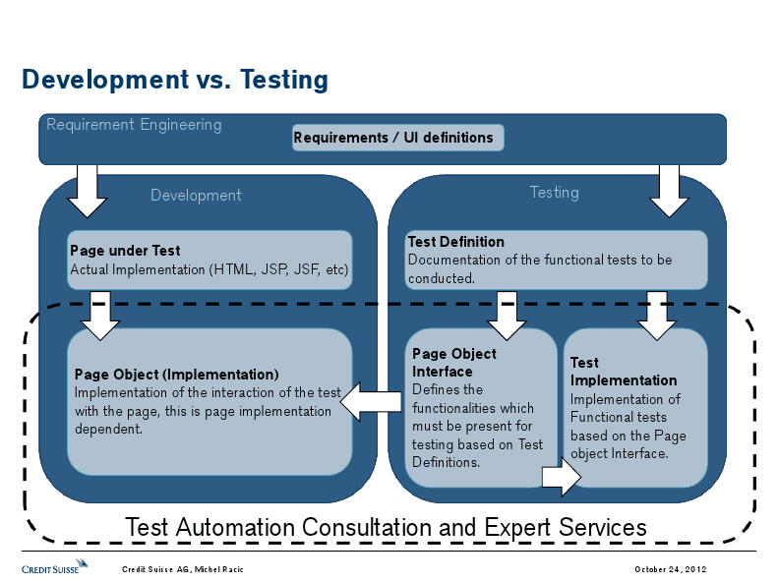
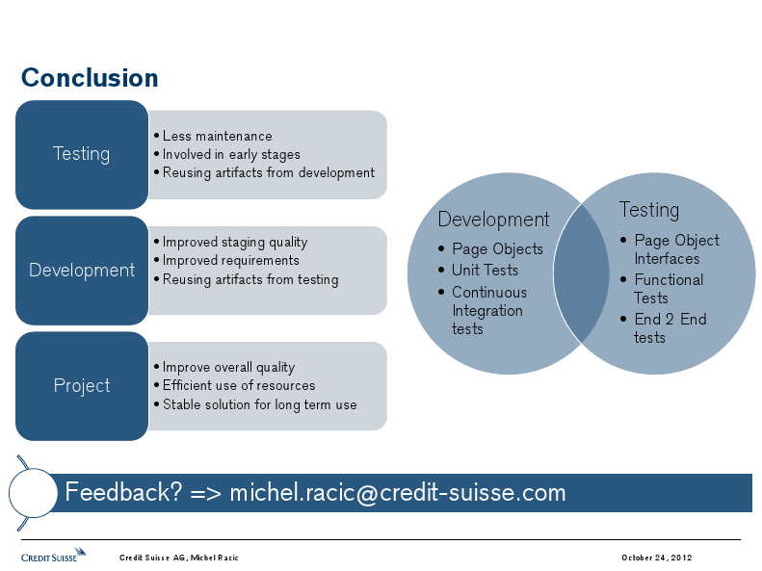

Target of this codelab
Your mission will be to have all the test cases automated without writing any duplicate code and future proof in sense of maintainability. I will guide you through the process of creating the page objects interfaces, building the test cases from them, implementing the page objects itself and debug / maintain after changes in the Application under Test (AUT).

At the end you should be able to write functional tests for your Web-Application in no time and be sure it stays maintainable and fast when you add features to your application and scale up the test coverage. With stuff like parallel execution and nightly runs up and running, I can say mission accomplished and one more well tested application with less bugs will help in getting the bug pains out of the users.

Structure of the codelab files
The file will be given by me on a USB Stick which I give around (or as handout from sponsor) but can also be downloaded at http://goo.gl/uE52d.
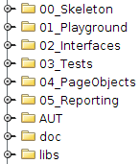
The number in front of the folders shows you at which stage of the script we are. At any time, you can have a look ahead (or back) and copy some content or complete files from this folders into your working folder so you don’t miss something while the codelab continues in the script.

00_Skeleton has the same content as 01_Playground at the beginning but will hopefully change during the codelab.
The folder AUT contains a Jetty Server with a deployed JamWiki installation that we will use as Application under Test, more to this in the next chapter.
The doc folder contains this documentation along with some other stuff.

Where are the files to work during the codelab?
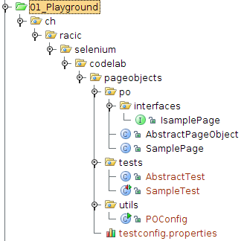
The Playground will be your working area during the codelab. You can just <ctrl>-c / <ctrl>-v some missing code from the other folders. If you messed it up you can just continue at the last stage we have completed, this is up to you. The folder 05_Reporting contains the completed code and gives you an example of a possible use with reporting. Note that this is a very basic reporting and if you are interested in this topic, have a chat with me and I can give you some insights from my daily work.

Where are the files for the next stage in case of troubles?
If you take a look at the numbered folders, you will notice that there are 5 Stages of code (+ a template). We will begin with 01_Playground and work our way through interfaces, tests and the page objects. If you get stuck, you can look at the code of the current stage which is what you should have (or something along those lines) at the end of the stage. Of course, if you get stuck in the middle of a stage while I progress to the next stage, just continue in the folder of the stage that we just finished.

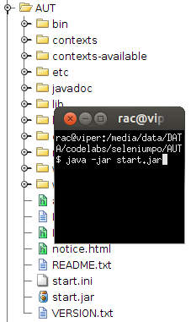
The sample Application under Test (AUT)
To simplify this codelab and make it independent of a working internet connection, you will find Jetty, a lightweight Java Server written in Java, with JamWiki deployed. After starting the server, you can just point your browser to http://localhost/wiki and have your AUT up and running.

How do I start it?
To start the Jetty server, just enter following on a command line after you navigated to the AUT folder:

$ cd seleniumpo/AUT
$ java -jar start.jar

Now all you have to do is starting Google Chrome and navigate to http://localhost:8080/wiki. The first time you access this url, JamWiki will initialize itself so it will take a bit longer.

VirtualBox VM
For the ones that want, feel free to use your own IDE on your laptop and just open the Idea/eclipse project or use the files (all required libraries are included in the lib folder).

If you start the VM, you will be presented already logged in to a xubuntu desktop (user:passwd = gdgzh:gdgzh) and have Chromium as well as InteliJ Idea ready to participate in this codelab.

The sample Test Cases (TC)
If you navigate to the page http://localhost:8080/wiki/en/TestCases you will see 5 very basic sample test cases. At the bottom of the article you find so called macros which contain the content to substitute in the test cases.

Lets analyze the AUT and TCs
For the sake of this codelab, we just take the one example, the rest is up to you.
002_Login_as_User describes a test case about a very basic but also very important action.
If your users can’t login, what the hell should they do with your Application (except if the wiki can be edited from anonymous users).

- Load start page (http://localhost:8080/wiki)
- Click on the Login link in top header navigation (or Anmelden on german)
- Fill the username field with the value “user”
- Fill the password field with the value “user” (I know but for simplicity its user:user)
- Click on the login button
- Check that users display name is visible correctly in top header navigation
- Click on Logout in top header navigation
- Check that the Login link in top header navigation is visible again

Screenshots

Step 1 & 2 & 8
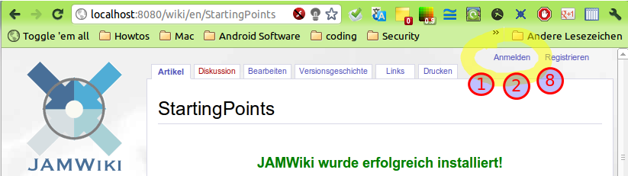

Step 3 & 4 & 5
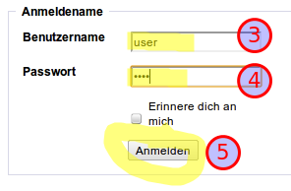

Step 6 & 7
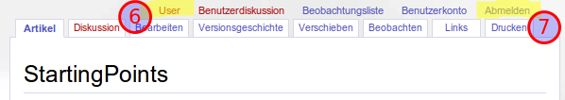

Which are the relevant pages?
We need the start page (http://localhost:8080/wiki/en/StartingPoints)which simply can be bundled as a generic article page, you will see this if you navigate to other article pages. The next page we are interested for this test case is the login page (http://localhost:8080/wiki/en/Special:Login) on which we have to enter the account data.
Thats it? If you had a good look at this page , you notice that there are recurring element visible on all pages in the application like the left hand navigation (LHN) or, and thats what we are interested in for this test case, the top header navigation (THN). This is now a discussion point and I just say, everyone has to decide what he puts in to a page object and I did now just put this as a own page object (even its not exactly a page but a widget used on many pages).
Lets list the page objects we found:
- Start page
- Login page
- THN Menu

What elements do we need from them?

Start page
We don’t really need the start page in this test case as we only need the link in the THN Menu. Why not just create the THN Menu object and use it directly. This object will be dynamically based on the current state (logged in or not) and on the given role of the logged in user (Admin or not) but this is something we can handle inside the implementation later on.

Login page
We have 2 fields, username and password as well as 1 button for the login action.

THN Menu
In state not logged in, we have only the links Login visible that we need.
In state logged in with role user, We have the users display name with a link to his profile and the logout link visible.

Which functionality do we need in the interfaces?
Thats actually a no brainer in this case but can get complicated on larger pages with lots of functionality. In this case we only need following functions:
- Login page
  - Set/Get username
  - Set/Get password
  - Click login
  - Get the error message (in case of wrong login credentials)
- THN Menu
  - Click Login
  - Click Logout
  - Verify logged in users display name

Creating the interfaces
The interface is maybe not really needed as you could just directly implement the page object but having it gives us a big benefit. We can now write the test based on the requirement without having implemented the page object yet, yes we could even write the interface only with requirements without ever having seen the page.

Having a look at the login page
This part will be handled as a live demo but here is the code for documentation purposes.

Create a new class with type interface. I will call it ILoginPage.java located under ch.racic.selenium.codelab.pageobjects.po.interfaces
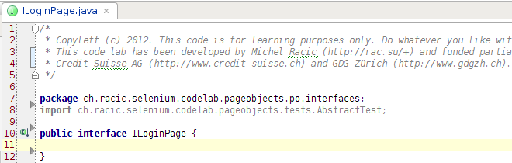
Next step is to define our functions that we identified in the last part.
- Set/Get username and Set/Get password
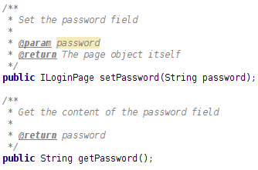
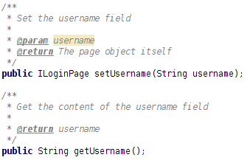

- Click login
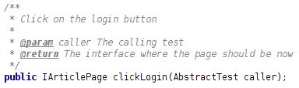
- Get the error message (in case of wrong login credentials)
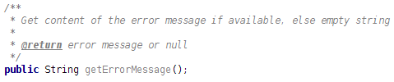

Your turn - Create the interface for the THN Menu
Just look at it like you would cut out that part as a widget and load it in a page without anything else.

What to do if you finished too fast?
Good for you, congratulation.
While others are still working, have a look at the other pages and create those interfaces too.
  - Article Page
  - Edit Article Page
  - Admin Page
  - Maintenance Page

Creating the tests

002_Login_as_User
- Load start page (http://localhost:8080/wiki)
- Click on the Login link in top header navigation (or Anmelden on german)
- Fill the username field with the value “user”
- Fill the password field with the value “user” (I know but for simplicity its user:user)
- Click on the login button
- Check that users display name is visible correctly in top header navigation
- Click on Logout in top header navigation
- Check that the Login link in top header navigation is visible again

First, lets create a new test class in the package ch.racic.selenium.codelab.pageobjects.tests called Login which will contain all our login related test cases. This class extends the AbstractTest which I already created for you (have a look at it when you get some time).

Login function
The login algorithm will get used by multiple test cases and therefor we just create it as a function to be called by our test case. First of all, we need to get our loginPage Page Object:
Now lets start with the steps of the test case.

Step 1 & 2
Loading the start page is no problem with our interface:

Step 3 & 4
Filling the fields using the dot-notation:
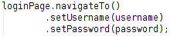

Step 5
Lets click on the login button and get the next page object in the flow which is a normal article:

Step 6
Check if the login worked correctly and not displaying any error message and that the users display name gets shown in the THN area:

Completed function
The completed function takes 3 strings as argument. We need the username and the password to fill in the form and the display name to verify that the correct user is logged in:

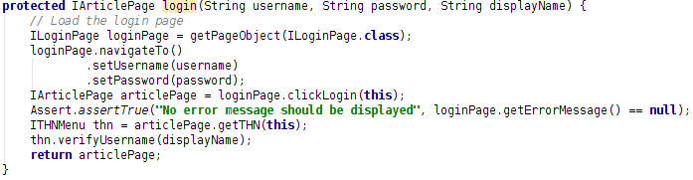

The JUnit test
We have almost all code that we need for this simple test case in our function. Let us just call it with some test data which is saved in the testconfig.properties file. I wrapped it in the POConfig util class and already loaded it as config in the AbstractTest class. Besides the use of the login function, we only have to do a proper logout using the THNMenu Page object with clicking the logout link:
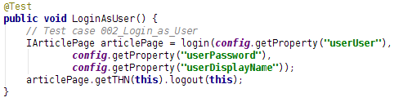
Note that this is really simplified and I hope that your actual tests do some more verifications like checking if the fields get pre filled with data when loading the page or checking that the logout really worked.

Your turn - Create the test for 001_Login_as_Admin
Try out what happens if you login as an administrator (u:p => admin:admin) and think about how you can ensure that we are logged in with the admin role and not a user.

What to do if you finished too fast?
Good for you, congratulation.
While others are still working, have a look at the other test cases and create those too.

Creating the Page Objects

Login page
Lets create a class in the package ch.racic.selenium.codelab.pageobjects.po called LoginPage that extends a AbstractPageObject and implements the ILoginPage interface we created before.

Identify the needed elements
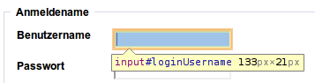
Open Chrome and go to http://localhost:8080/wiki/en/Special:Login for the login page. Do a right-mouse-click on the input field next to username and choose inspect element (see section Top header navigation (THN) for screenshot of how this works in chrome). You will see that the input fields have proper IDs assigned which we can use for identifying the elements. We use the @FindBy annotation provided with selenium to create private fields with the type WebElement in the page object class:
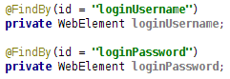
For later maintenance, we don’t need to change a lot of code. If for example the freetext input field changes to a dynamic list (don’t laugh but I had it in a project where they changed from time to time the types of elements without adding/removing any functionality and this always breaks the test code), the only thing you have to update is the locator and the getter/setter functions for this object as a dropdown list needs multiple clicks to be filled.
This changes when we come to the login button, it doesn’t have an ID and type=”submit” or the name attribute don’t have to be unique. We’ll take a look at this in the next section but for now, we just go with the name attribute:
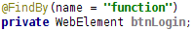
If you now enter some wrong credentials, you will get a red error text and this is the one we need to check if the login failed:
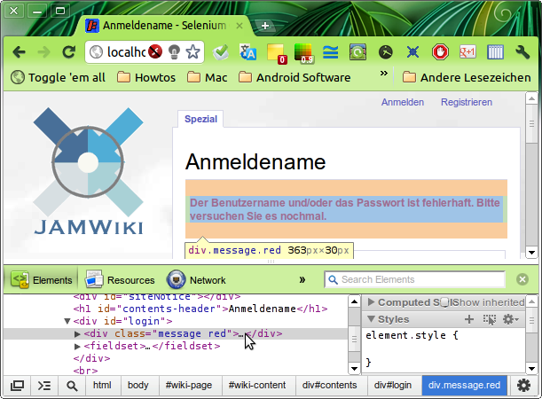

The cool thing on the element inspection by chrome is, that you see the node hierarchy right at the bottom of the developer tools pane. With this you can easily get a proper path for a XPATH locator which we now gonna use for this. We choose now to use the class attribute to identify that div with the error text and not the text contained inside that div as we then can use it as general error field independent of the language set (i18n) or the error text:
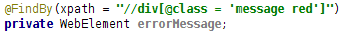
We also define the expected page title and url for this page (note that this should be handled in the properties file and not hardcoded in the page object but that is a task you can do yourself):

Implement functionality
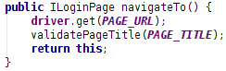
As we can go directly to this page without a menu, we first want to handle the navigateTo() function which will return itself so we can use the dot notation later on to have a good readable test code (there are also some disadvantages with debugging using this notation but this is up to you).
The setter and getter for the fields is a no brainer:
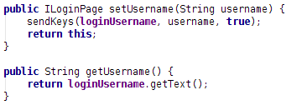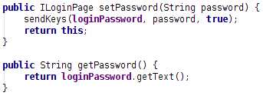
The error message is dynamically available on this page, meaning it is only available if there is an error. We just return null if it is not available instead of throwing an exception and therefore we have to catch the NoSuchElement exception from selenium in this function:
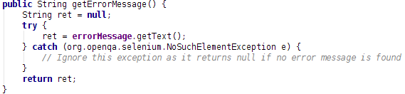
The last step in this page object is to do the actual login. This function will not return itself but the next page object in the flow which happens to be any article page in the wiki:
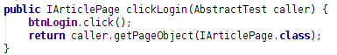
Please have a look at the helper function I used to get an initialized object from the interface class but we won’t go deeper during the codelab (except you all want it?).

Top header navigation (THN)
Lets create a class in the package ch.racic.selenium.codelab.pageobjects.po called THNMenu that extends a AbstractPageObject and implements the ITHNMenu interface we created before.

Identify the needed elements
Open Chrome and go to http://localhost:8080/wiki to get to the starting page. Do a right-mouse-click on the login link displayed at the top-right of the page and choose the inspect element option:
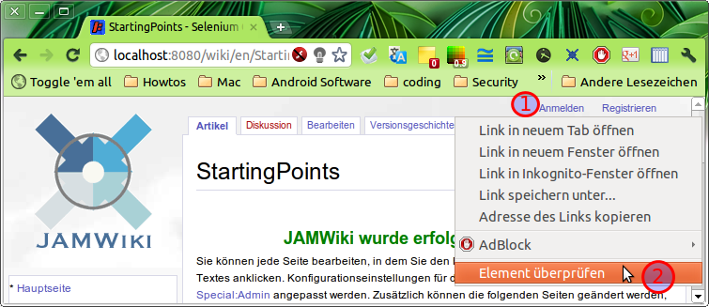

You will see the details of that element in code view, this is where we can get the identification attributes from (there are several other ways to do this).
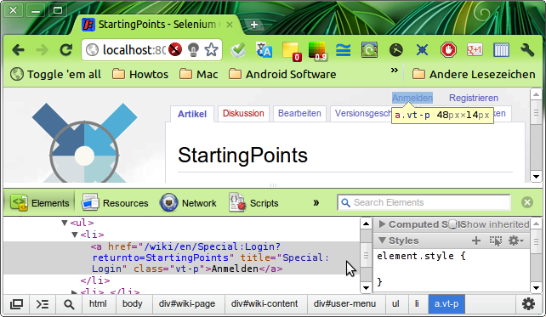
A possible candidate would have been the title attribute but is that always unique? No and not like an ID (which also is not guaranteed to be unique but would turn out in a w3c check to be not compliant) it is likely that the same title gets used for various elements. XPath is a possibility which needs some more language experience and may not always be that human readable (just like regex) but it can save your ass under certain conditions (especially if you don’t have control over the application code).
As the XPath identifies a node from a tree, we have to look a bit higher in the hierarchy to start. It seems that the THN area is inside a <div> with id “user-menu” and we could set this as a starting point for our node search:

// is the search operator and it will only search child nodes of the current parent node. The text directly following the operator is the tag name and inside the square brackets we can restrict it to elements which matches the given attributes (or operators, google XPATH for more info).

Let’s do this for all other elements that appear in THN. You will need to login as user and as admin to get all the elements in the various states.
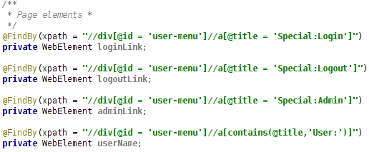

Implement functionality
Now that we identified all the elements, lets get on the implementation of the missing functions from the interface (which our tests rely on):

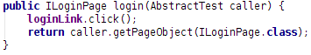

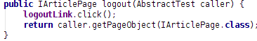

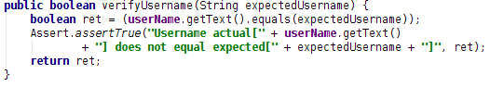

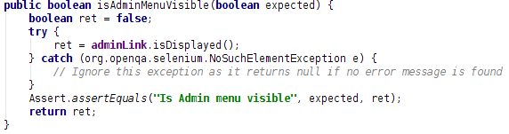

The login test we created in the beginning should now run and pass.

Your turn - Create the object for the generic article page

What to do if you finished too fast?
Good for you, congratulation.
While others are still working, have a look at the other interfaces and create those page objects too.

Conclusion
We Automated the test cases with easily maintainable page objects and on a new version of JAM Wiki, we will have our tests running in no time.
If you take a look at all the code that is available, you should also get some tips and hints on how to create a solution for your project. But please, don’t just copy over the files as they are specifically written for this codelab and you should only get the ideas and maybe some code samples from it but Test automation is an engineering discipline. There are a lot of “we do all” tools out on the market and I played with a lot of them but the strongest, most maintainable and fastest automation solutions that I’ve built where based on open source components combined with some closed source libraries (3rd party) and stuff I or one of my team have written.

If you have any questions, concerns or just want to have a little chitchat on Automation (or other topics as well), feel free to get in contact with me by mail (michel.racic@credit-suisse.com) or g+ (http://rac.su/+).

