FIRST EXERCISE

In order to calibrate the camera, we took photos of a chessboard in multiple angles and directions to train our program getting the best result possible.
It was achieved sucessfully.

Without calibration:
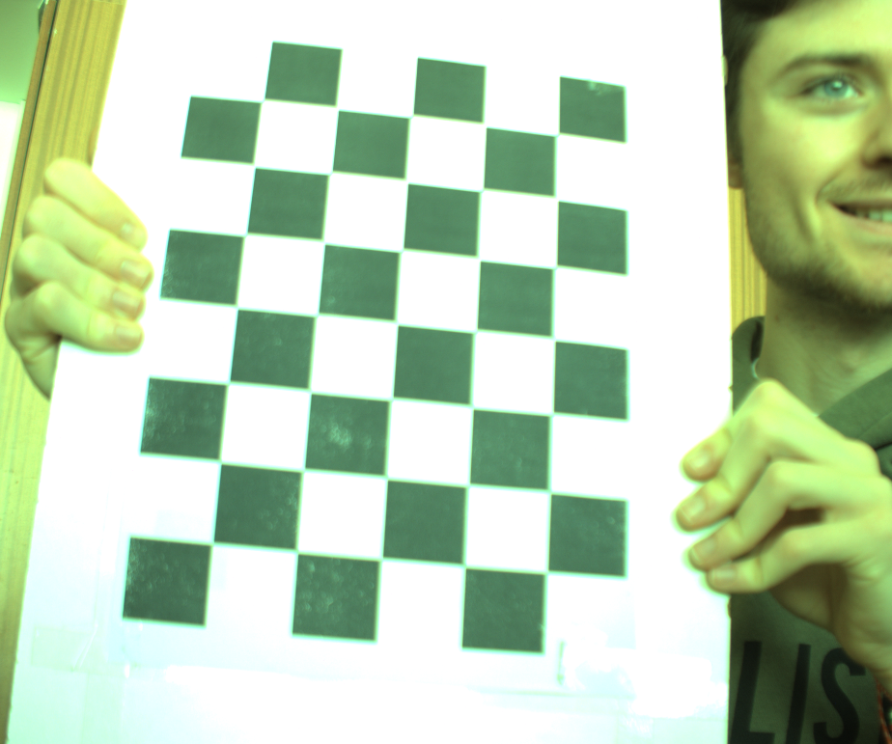

Calibrated:
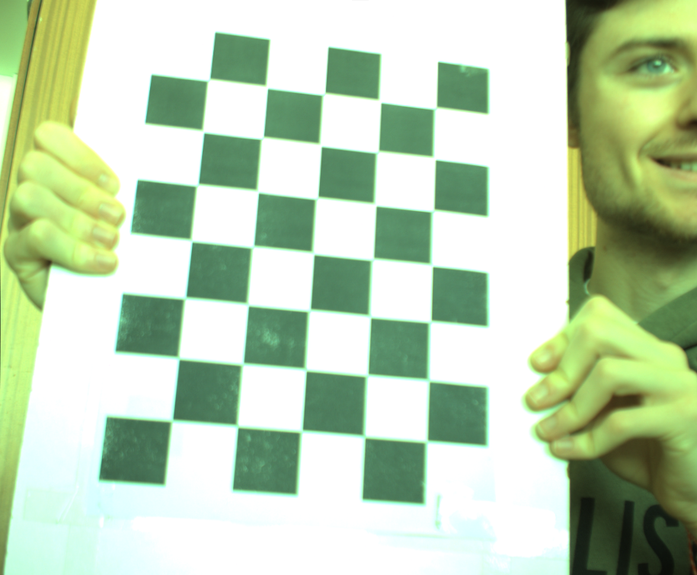

The difference is clear between the two pictures.

SECOND EXERCISE

THIRD EXERCISE

To solve this exercise, we converted the original RGB image to an HSV image, because this way is easier to change the colours and it’s easier to separate de light of the colour. After that we started our thresholding method. We started defining a range of red tones in HSV:

H: 0 is the red. We can see in the image tones that are more orange. So, we decided to have H values from 0 to 25.
S: The S values are high (80, 25) because the colours of our photos are saturated.
V: The V values are high because low values mean darker colours, and in the images, we can see that there is a lot of bright colours, but we made a bigger range because there are some photos of darker colours.

After that, we applied the umbral to the HSV image and created a binary image of 0 and 255, where the 255 are the colour rank previously defined, and 0 are the rest of the colours. We defined this as “Mask”.

Finally, we made a copy of the original image and applied the mask and changed all the 255 pixels to green.

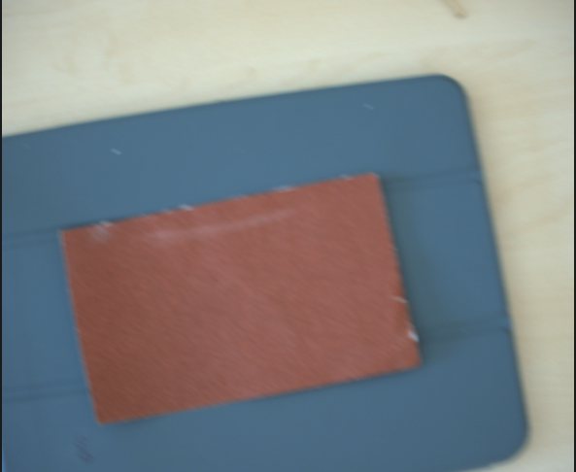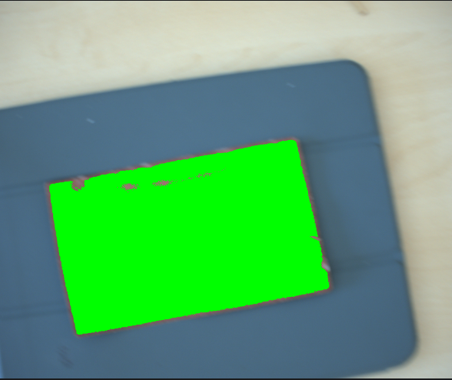
Original photo Final photo

