How to Access the Admin Portal
- Go to the Sign In page: http://localhost:3000/login
- Enter:
  - Email: admin@example.com
  - Password: password123
- Once logged in, navigate to:
  - Admin Dashboard: http://localhost:3000/admin/dashboard
  - User Verification: http://localhost:3000/admin/verification
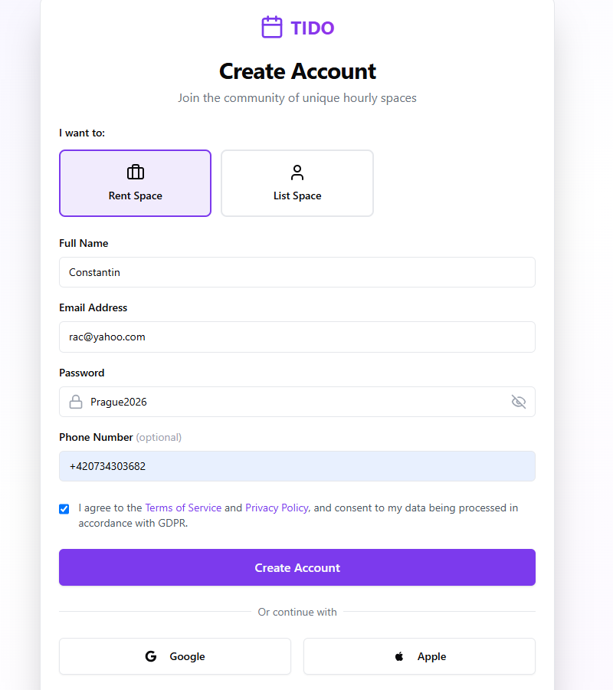

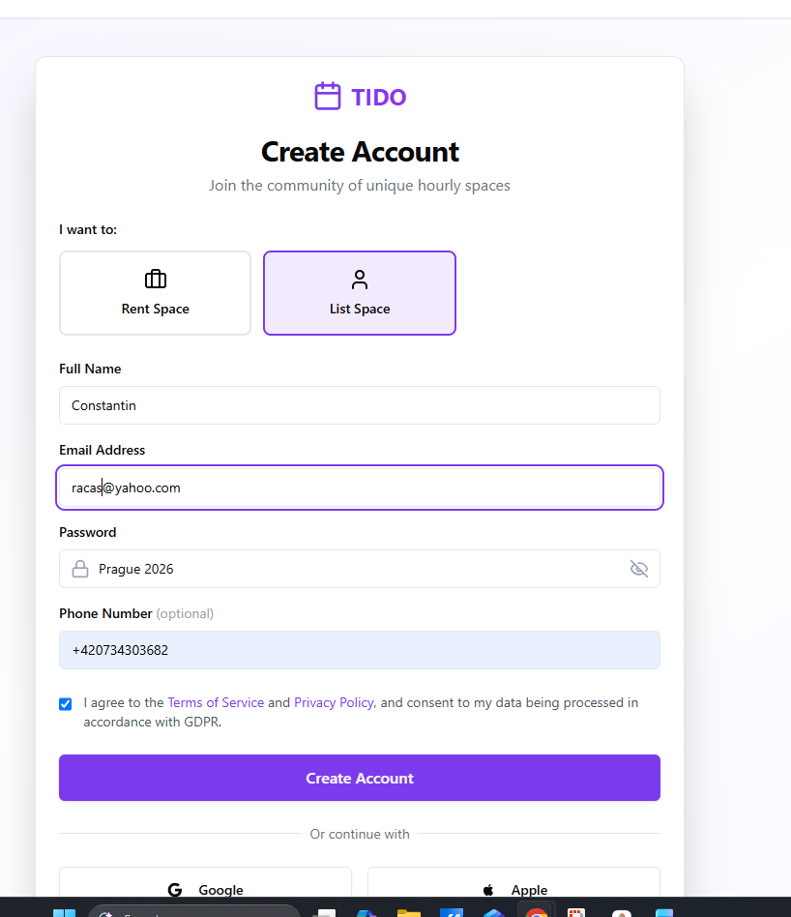

Renter= CLIENT
