CMSC 433 Project 2 - The Oregon Trail

**Team Introduction:**

Rachel Backert (bac2@umbc.edu)

Braxton Dubin (bduin@umcb.edu)

Chen Kuo (ckuo@umbc.edu)

Alec Wieland (aw13@umbc.edu)

**Location of Project:**

Our project is at the following URL: https://swe.umbc.edu/~bac2/oregon_trail_js/src/

**Project Description:**

The goal of this project was to recreate the iconic 1990 video game “The Oregon Trail”. Although the original game was written in Basic and meant to run on MS DOS, our recreation of the game was created using languages that could be run on a web browser. Throughout the design of the game, we strove to create something as close to the original as possible in both graphics and gameplay.

**What was Added/Improvemed if Given Old Code:**

* The ‘Columbia River Navigation Game’ that the player sees at the end of the trail used the ‘*HTML Game Example*’ tutorial from W3Schools as a starting framework. The tutorial can be viewed at: <https://www.w3schools.com/graphics/game_intro.asp>
* Screenshots of artwork from the original game are used throughout our project.
* CommonMethods.php was provided by the instructor.

**Database Setup:**

tombstones

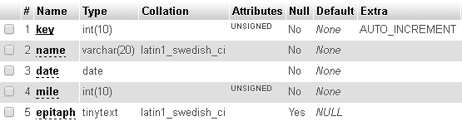

* key: Primary key to uniquely identify records.
* name: Player enters a short name, to be shown on the tombstone.
* date: Records the real day, month, and year the player died. If there are multiple tombstones in a travelled range, the game only asks player about examining the newest
* mile: Records the number of miles travelled before death, so future players encounter the tombstone at the correct mile. Miles travelled is always positive, and less than 2000.
* epitaph: Player can enter a short epitaph to be shown on the tombstone. This is optional, so this field can be null.

oregon_top_ten

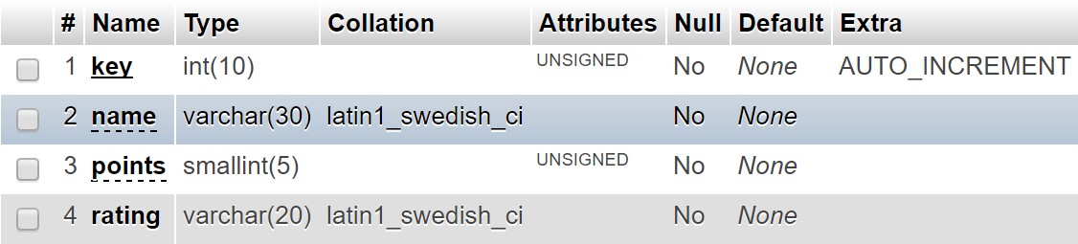

* key: Primary key to uniquely identify records.
* name: Player enters a short name, to be shown when displaying the score.
* points: A calculated score value that the player receives upon successful completion of the game
* rating: A title assigned to a player’s score based on how high many points they earned. From lowest to highest, the possible ratings are “Greenhorn”, “Adventurer”, and “Trail Guide”.

**Languages Used:**

* AJAX
* Javascript
* MySQL
* PHP

*Buying Items at the Store*

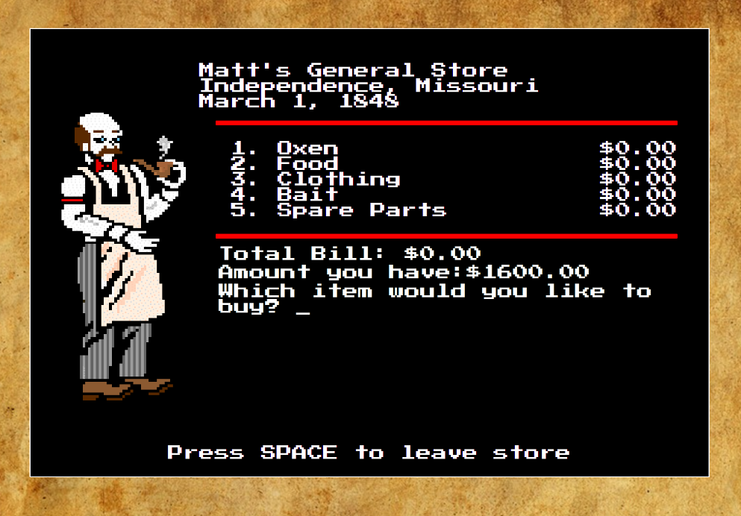

*Journey Between Landmarks on the Trail*

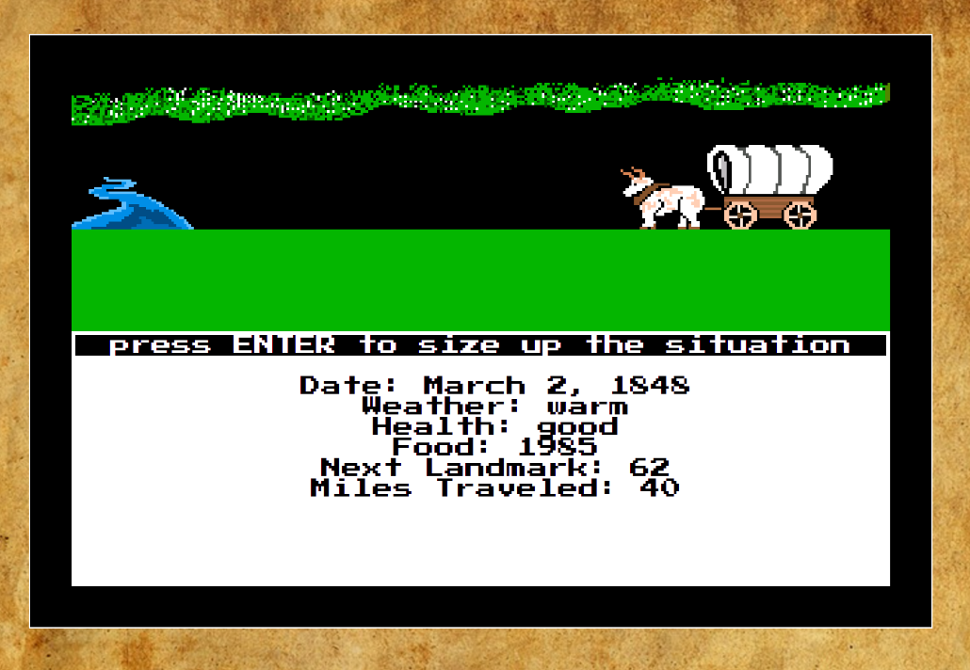

*Crossing a River*

